Supplementary Material

Plastid phylogenomic data offers novel insights into the taxonomic status of the Trichosanthes kirilowii complex (Cucurbitaceae) in South Korea
Inkyu Park, Jun-Ho Song, Sungyu Yang, Sungwook Chae, Byeong Cheol Moon*
*Correspondence: Byeong-Cheol Moon: bcmoon@kiom.re.kr

Supplementary Figures and Tables

Figure S1. Distribution of studied samples of Trichosanthes kirilowii var. kirilowii (blue dots) and of T. kirilowii var. japonica (red dots); the shaded area shows the reported distribution of T. kirilowii var. japonica.

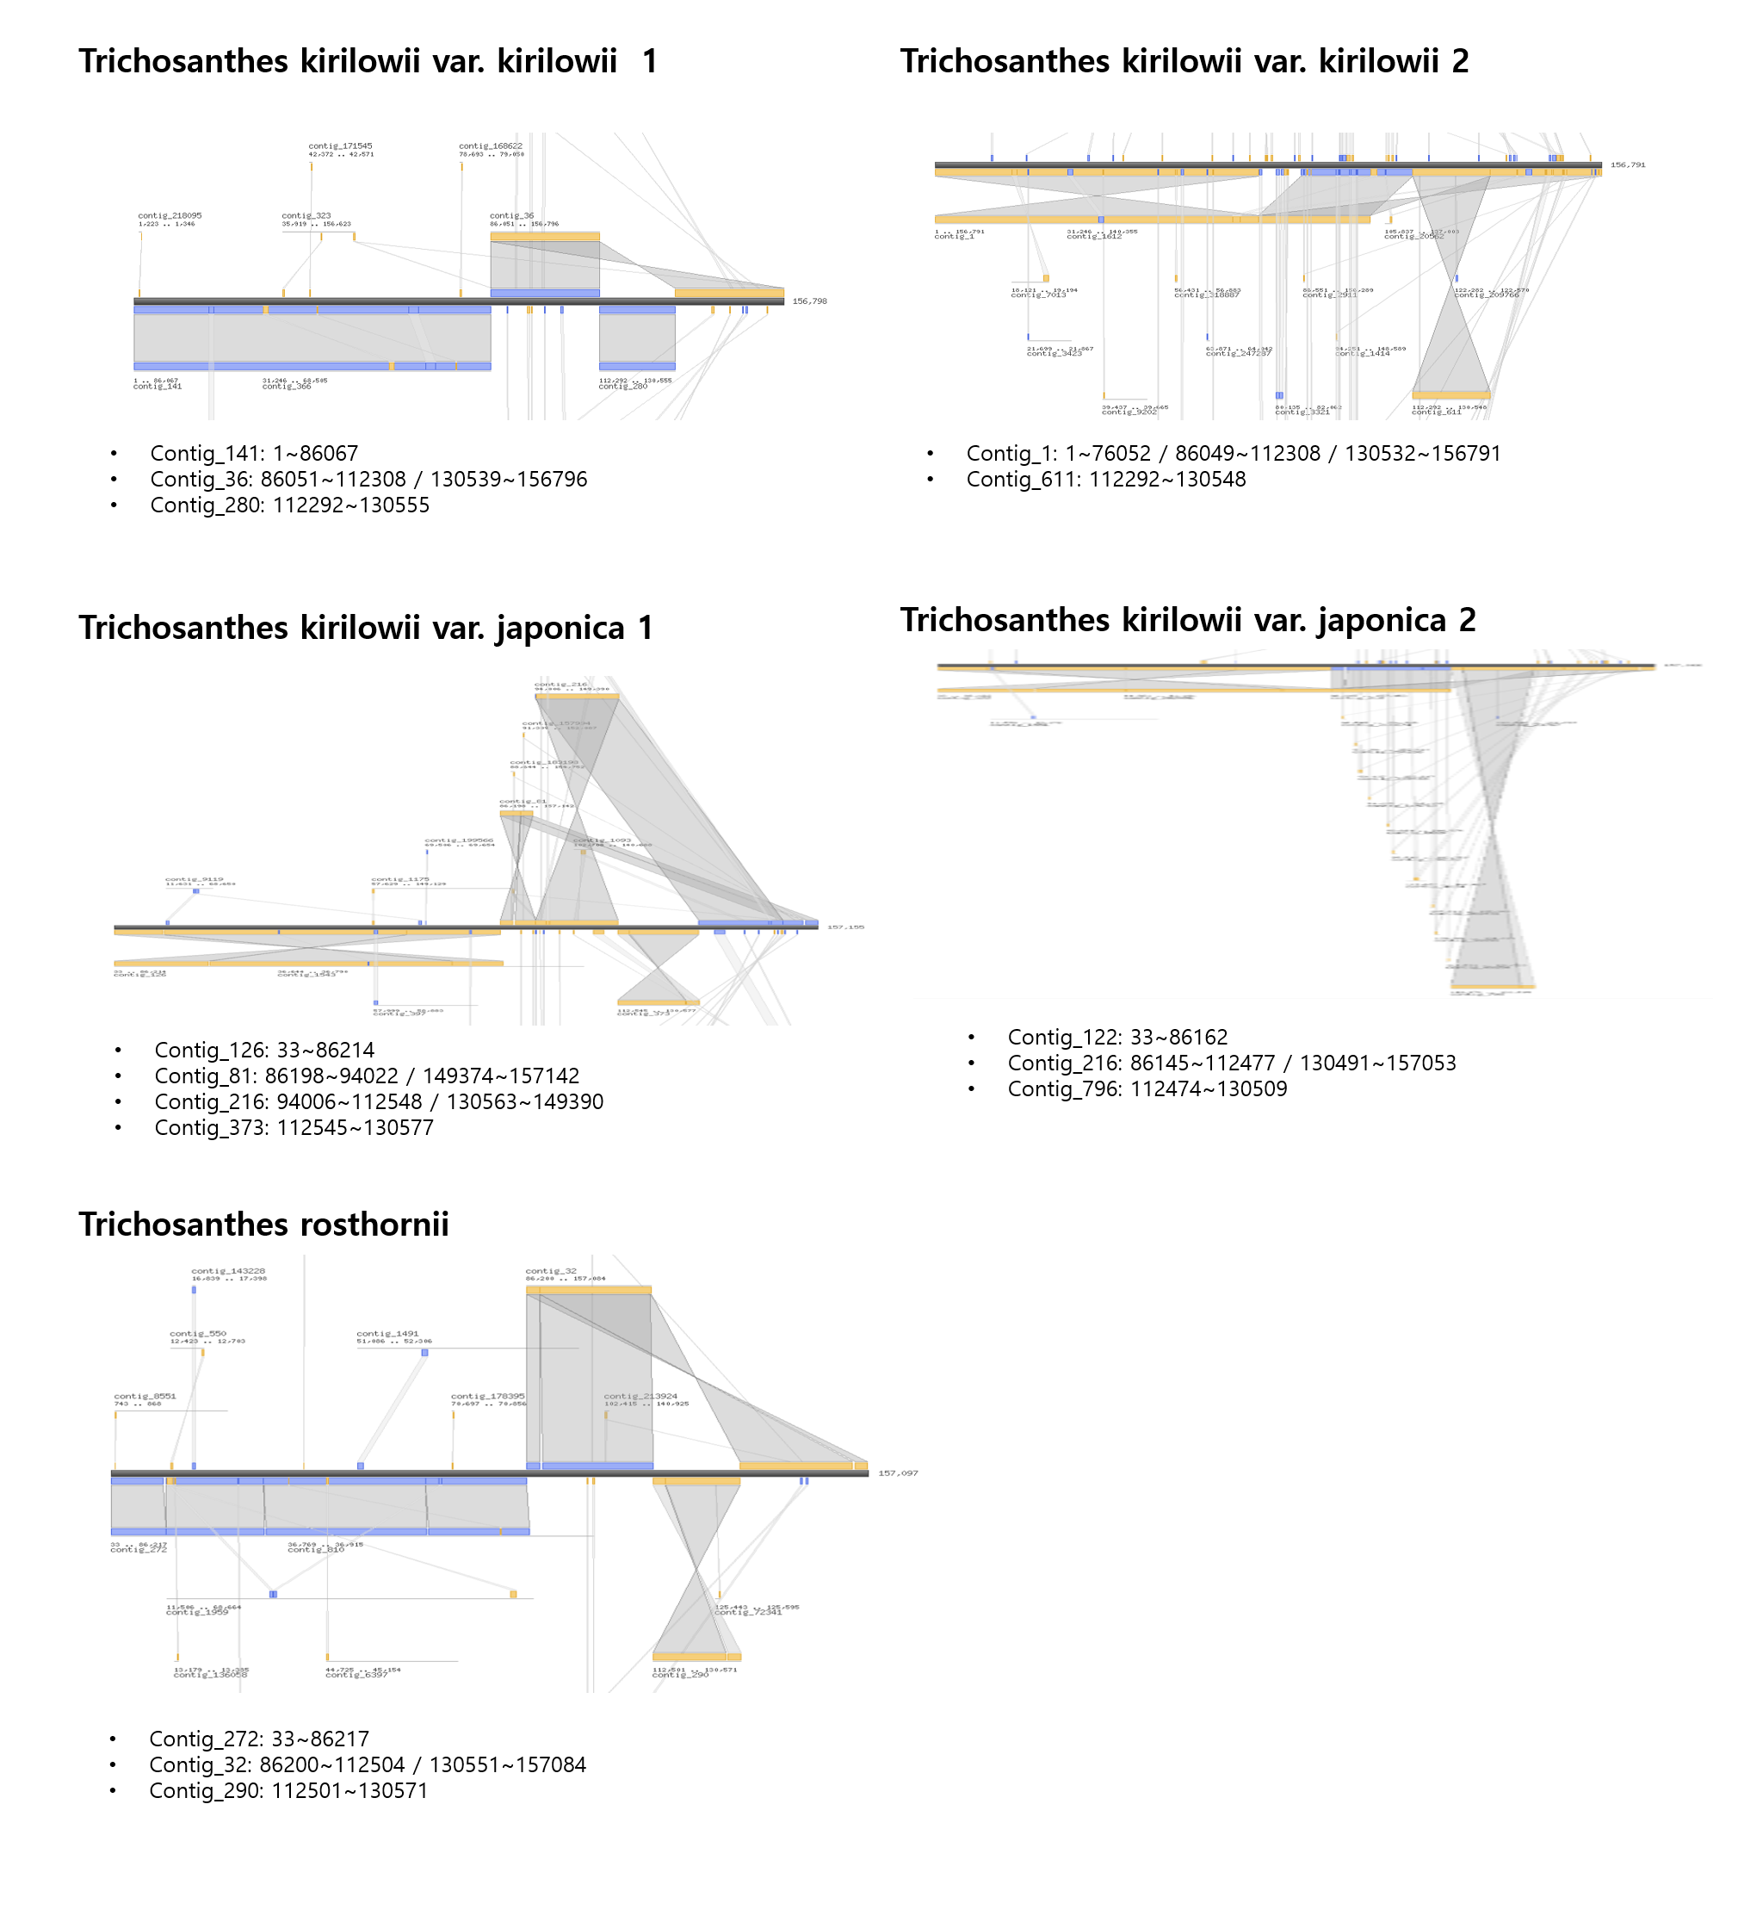
Figure S2 Alignment of the initial contigs representing the plastid genome on the complete plastid genome sequence. The contig numbers are indicated under the contigs and hit positions are under the reference plastid genome sequences for Hodgsonia macrocarpa (NC_039628).

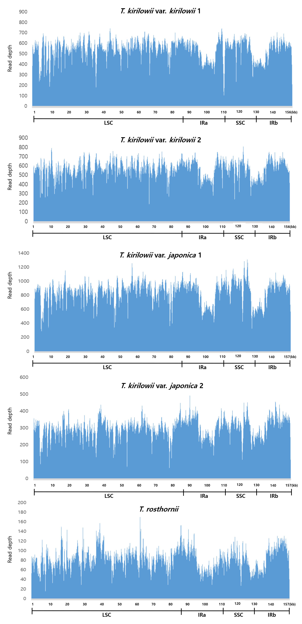
Figure S3 Distribution of paired-end reads mapped onto the complete plastid genomes of two accessions each of Trichosanthes kirilowii var. kirilowii and T. kirilowii var. japonica and one accession of T. rosthornii. LSC, large single-copy region; SSC, small single-copy region; IRa, inverted repeat a; IRb, inverted repeat b

Figure S4 Comparison of the LSC, IR, and SSC junction positions in Trichosanthes species and Hodgsonia macrocarpa plastid genomes. The bp indicate the distance or the overlap between IR boundaries and the closest gene.
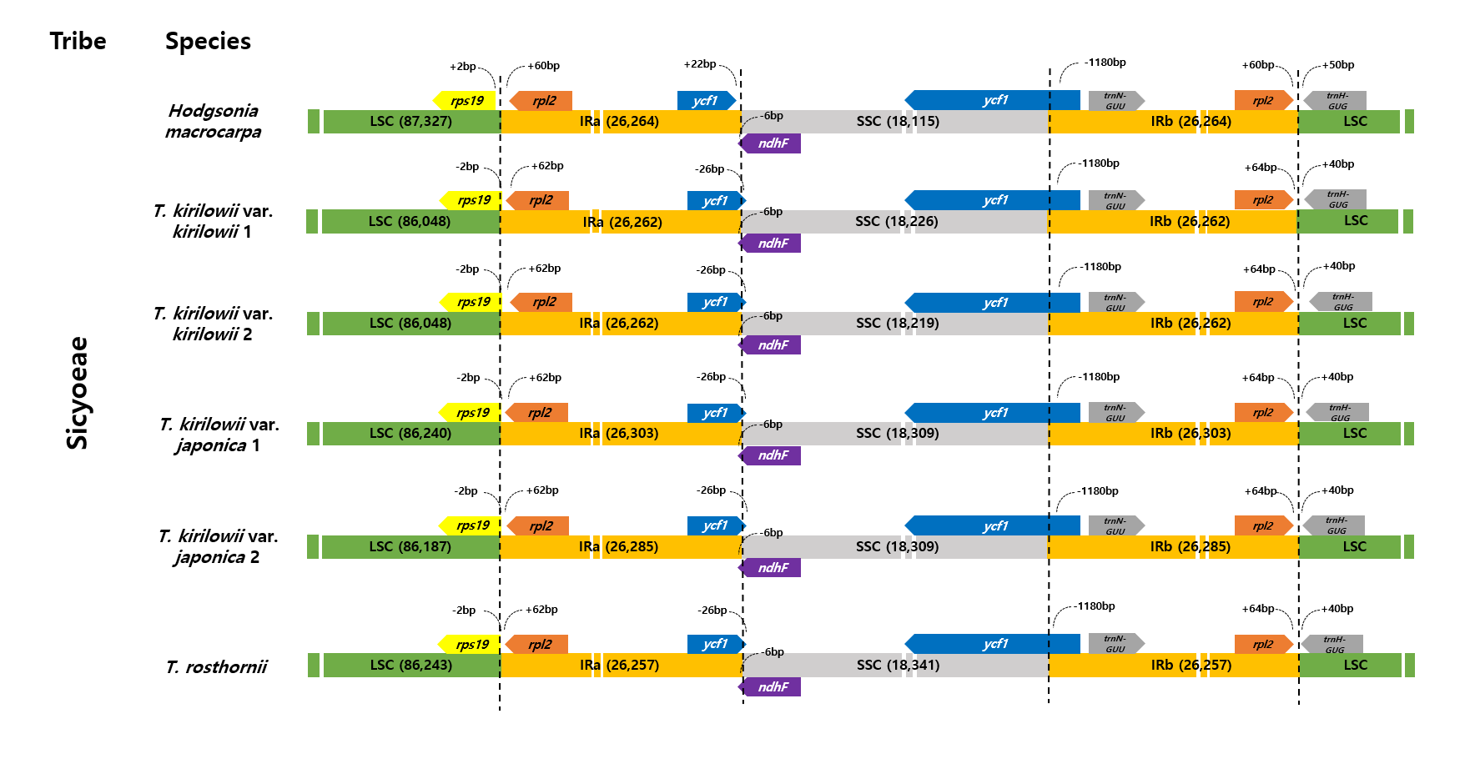
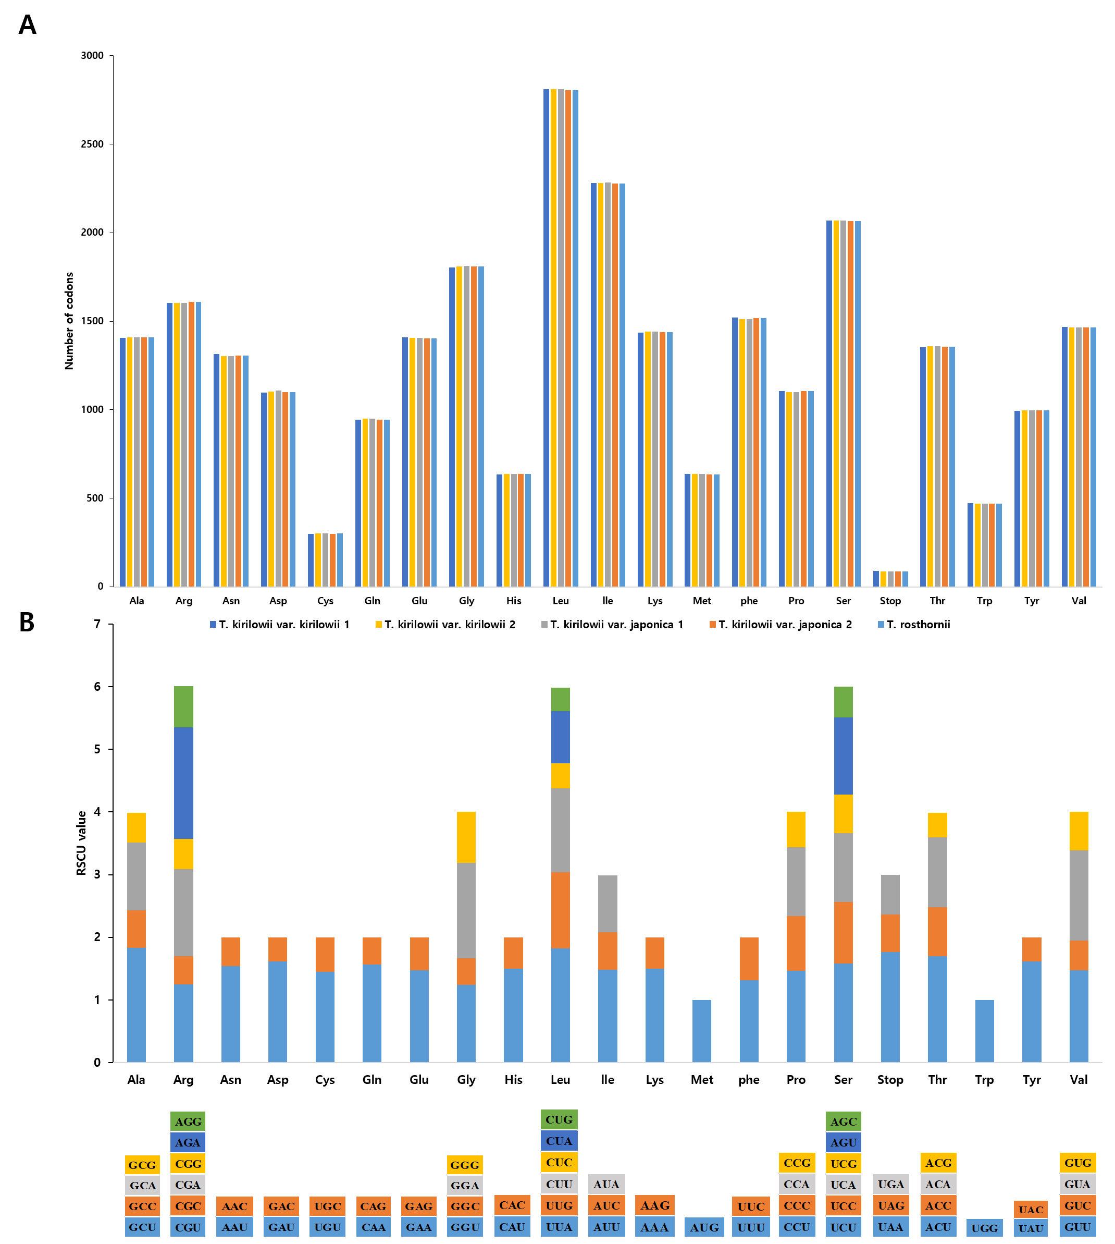
Figure S5 Codon frequencies and relative synonymous codon usage (RSCU) values for Trichosanthes plastid genomes. (A) Amino acid frequencies for 78 protein-coding sequences. (B) RSCU for 20 amino acids and stop codons in 78 protein-coding sequences.
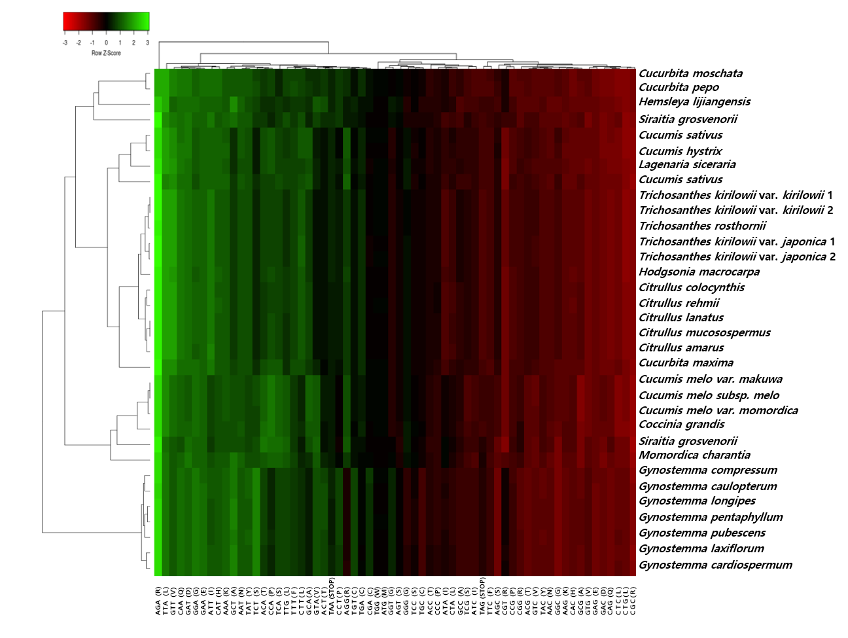
Figure S6 Codon distribution of protein-coding genes in Cucurbitaceae plastid genomes. Green indicates a high relative synonymous codon usage (RSCU) value and red indicates a low RSCU value. Hierarchical clustering (average linkage method) was performed for the codon patterns (x-axis). All RSCU values are normalized using the Z- score.

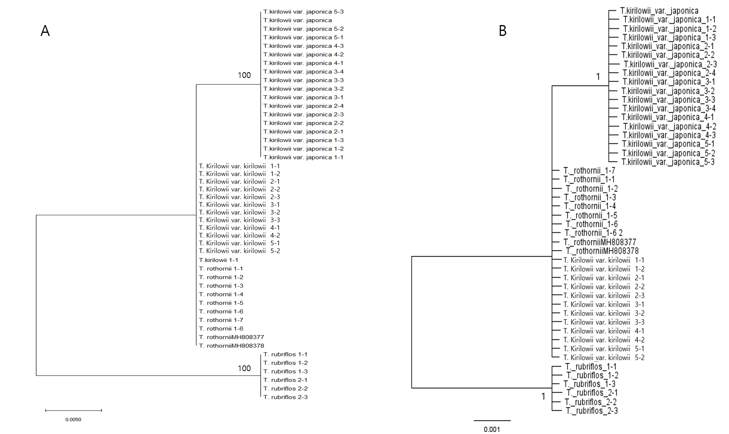
Figure S7. Phylogenetic tree based on ITS from three Trichosanthes species using Maximum likelihood (A) and Bayesian Inference (B). The same samples are shown in supplementary Table S1; additional specimens have been registered in the Korean Herbarium of Standard Herbal Resources (Index Herbarium Code KIOM) at the Korea Institute of Oriental Medicine (KIOM). MH808377 and MH808378 were downloaded from GenBank.
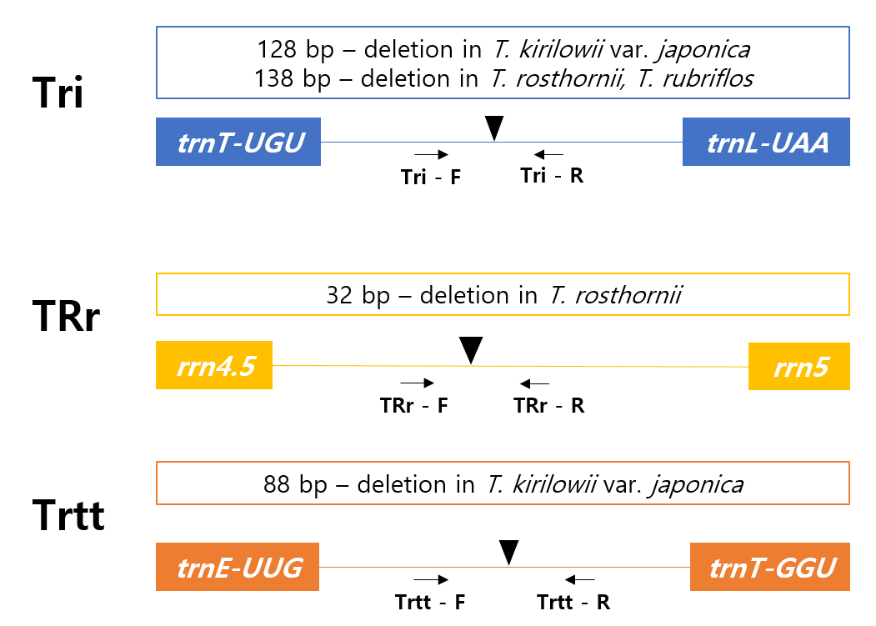 Figure S8. Schematic for diagnostic markers of three Trichosanthes taxa, T. kirilowii var. kirilowii, T. kirilowii var. japonica and T. rosthornii, showing their specific primer position and the indel variation.
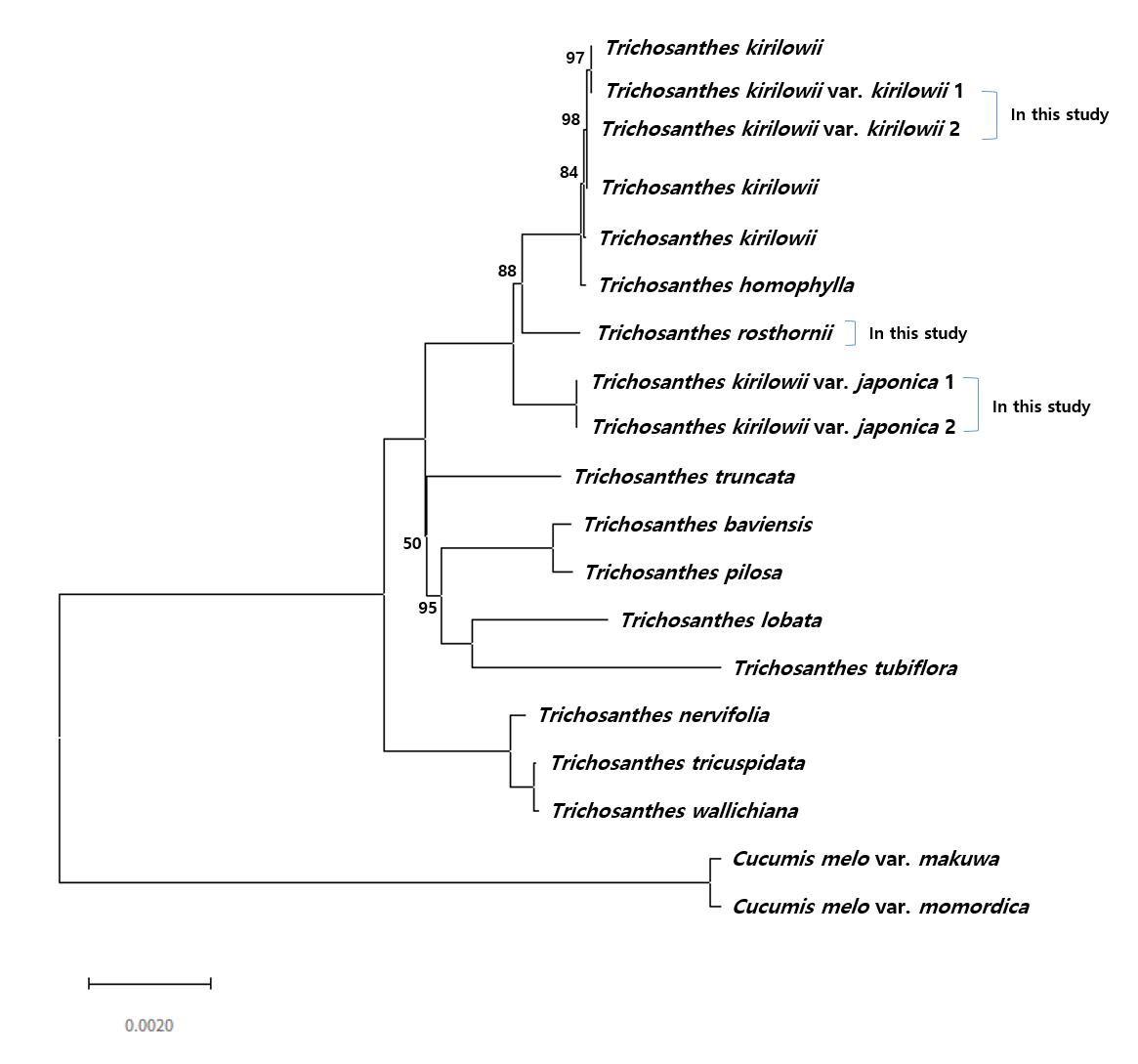
Figure S9. Phylogenetic relationships of Trichosanthes inferred using maximum likelihood of 73 protein-coding genes; numbers at nodes are maximum likelihood bootstrap values (BS); branches without support values have maximum support (BS 100).

Table S1 Voucher specimen information for morphology and chloroplast genomes used in this study
No. | Species | Collection information | Coordinates | Collector collection no. (Herbarium acronym)
1 | Trichosanthes kirilowii var. kirilowii | Cheongju-si,  Chungcheongbuk-do, Korea | 36°32'32.3"N 127°28'50.3"E | B.C. Moon 2017-69-1 (KIOM)^{C, M, B}
 |  |  |  | B.C. Moon 2017-69-2 (KIOM)^{M}
 |  |  |  | B.C. Moon 2017-69-3 (KIOM)^{M}
 |  |  |  | B.C. Moon 2017-69-4 (KIOM)^{M}
 |  |  |  | B.C. Moon 2017-69-5 (KIOM)^{M}
2 |  | Naju-si, Jeollanam-do, Korea | 35°02'12.6"N 126°42'03.4"E | S. Yang 2019-66-1 (KIOM)^{C, M, B}
 |  |  |  | S. Yang 2019-66-2 (KIOM)^{M}
 |  |  |  | S. Yang 2019-66-3 (KIOM)^{M}
 |  |  |  | S. Yang 2019-66-4 (KIOM)^{M}
 |  |  |  | S. Yang 2019-66-5 (KIOM)^{M}
3 |  | Cheongju-si, Chungcheongbuk-do, Korea | 36°43'35.4"N 127°27'37.5"E | S. Yang 2016-26-1 (KIOM)^{M, B}
 |  |  |  | S. Yang 2016-26-2 (KIOM)^{M}
 |  |  |  | S. Yang 2016-26-3 (KIOM)^{M}
 |  |  |  | S. Yang 2016-26-4 (KIOM)^{M}
 |  |  |  | S. Yang 2016-26-5 (KIOM)^{M}
4 |  | Sangju-si, Gyeongsangbuk-do, Korea | 36°32'19.6"N 128°01'06.9"E | B.C. Moon 2017-76-1 (KIOM)^{M, B}
 |  |  |  | B.C. Moon 2017-76-2 (KIOM)^{M}
 |  |  |  | B.C. Moon 2017-76-3 (KIOM)^{M}
 |  |  |  | B.C. Moon 2017-76-4 (KIOM)^{M}
 |  |  |  | B.C. Moon 2017-76-5 (KIOM)^{M}
5 |  | Seongju-gun, Gyeongsangbuk-do, Korea | 36°29'23.3"N 128°22'09.4"E | B.C. Moon 2017-74-1 (KIOM)^{M, B}
 |  |  |  | B.C. Moon 2017-74-2 (KIOM)^{M}
 |  |  |  | B.C. Moon 2017-74-3 (KIOM)^{M}
 |  |  |  | B.C. Moon 2017-74-4 (KIOM)^{M}
 |  |  |  | B.C. Moon 2017-74-5 (KIOM)^{M}
6 | Trichosanthes kirilowii  var. japonica | Sacheon-si,  Gyeongsangnam-do, Korea | 34°57'20.7"N 128°02'03.4"E | S. Yang 2017-18-1 (KIOM)^{C, M, B}
 |  |  |  | S. Yang 2017-18-2 (KIOM)^{M}
 |  |  |  | S. Yang 2017-18-3 (KIOM)^{M}
 |  |  |  | S. Yang 2017-18-4 (KIOM)^{M}
 |  |  |  | S. Yang 2017-18-5 (KIOM)^{M}
7 |  | Seogwipo-si, Jeju-do, Korea | 33°18'50.5"N 126°49'43.5"E | S. Yang 2017-166-1 (KIOM)^{C, M, B}
 |  |  |  | S. Yang 2017-166-2 (KIOM)^{M}
 |  |  |  | S. Yang 2017-166-3 (KIOM)^{M}
 |  |  |  | S. Yang 2017-166-4 (KIOM)^{M}
 |  |  |  | S. Yang 2017-166-5 (KIOM)^{M}
8 |  | Namhae-gun, Gyeongsangnam-do, Korea | 34°55'05.0"N 128°01'54.9"E | B.C. Moon 2016-253-1 (KIOM)^{M, B}
 |  |  |  | B.C. Moon 2016-253-2 (KIOM)^{M}
 |  |  |  | B.C. Moon 2016-253-3 (KIOM)^{M}
 |  |  |  | B.C. Moon 2016-253-4 (KIOM)^{M}
 |  |  |  | B.C. Moon 2016-253-5 (KIOM)^{M}
9 |  | Sacheon-si, Gyeongsangnam-do, Korea | 34°57'20.7"N 128°02'03.4"E | B.C. Moon 2016-245-1 (KIOM)^{M, B}
 |  |  |  | B.C. Moon 2016-245-2 (KIOM)^{M}
 |  |  |  | B.C. Moon 2016-245-3 (KIOM)^{M}
 |  |  |  | B.C. Moon 2016-245-4 (KIOM)^{M}
 |  |  |  | B.C. Moon 2016-245-5 (KIOM)^{M}
10 |  | Seogwipo, Jeju-do, Korea | 33°27'47.9"N 126°54'49.0"E | J.H. Song 2020-135-1 (KIOM)^{M, B}
 |  |  |  | J.H. Song 2020-135-2 (KIOM)^{M}
 |  |  |  | J.H. Song 2020-135-3 (KIOM)^{M}
 |  |  |  | J.H. Song 2020-135-4 (KIOM)^{M}
 |  |  |  | J.H. Song 2020-135-5 (KIOM)^{M}
11 | Trichosanthes rosthornii | Qiubei, Wenshan,  Yunnan, China | 24°06'32.6"N 104°08'02.1"E | X. Zhou n.s. (KIOM)^{C, M, B}
^{C}, plastid genomic study; ^{M}, morphology. ^{B,} ITS phylogenic tree analysis

Table S2 Primers used for validation of junctions among single copy regions (SCs) and Inverted Repeat regions (IR)
Primer name | Primer sequence (5`>3`) | Position
TriLSCF | GCGCTTTGTGAGGGGACATA | LSC_IRa
TriLSCR | GCGCTTTGTGAGGGGACATA
TriISF | CACTTCCGAAACGAAGGGGA | IRa_SSC
TriISR | AGCCGGCTTATTCATCTTTACA
TriSIF | CATCCCGAGCTAGAGTAAGCG | SSC_IRb
TriSIR | GGCAGAATACCGTCACCCAT
TriILF | AATCACACTTGGGAAGGGGG | IRb_LSC
TriILR | AGCTGCTGTTGAAGTTCCATCT

Table S3 PCR-based sequence validation of junctions among single copy regions (SCs) and Inverted Repeat regions (IR)
Species | location | PCR-based sequence (bp) | Plastid sequence (bp) | start | end | Identities | %
T. kirilowii var. kirilowii 1 | LSC_IRa | 699 | 156,797 | 85,624 | 86,322 | 100
 | IRa_SSC | 736 |  | 111,934 | 112,669 | 100
 | SSC_IRb | 739 |  | 130,276 | 131,014 | 100
 | IRb_LSC | 774 |  | 156,338 | 313 | 100
T. kirilowii var. kirilowii 2 | LSC_IRa | 699 | 156,790 | 85,624 | 86,322 | 100
 | IRa_SSC | 736 |  | 111,934 | 112,663 | 100
 | SSC_IRb | 739 |  | 130,269 | 131,007 | 100
 | IRb_LSC | 774 |  | 156,331 | 313 | 100
T. kirilowii var. japonica 1 | LSC_IRa | 701 | 157,155 | 85,814 | 86,514 | 100
 | IRa_SSC | 736 |  | 112,161 | 112,896 | 100
 | SSC_IRb | 745 |  | 130,592 | 131,336 | 100
 | IRb_LSC | 773 |  | 156,695 | 312 | 100
T. kirilowii var. japonica 2 | LSC_IRa | 701 | 157,066 | 85,761 | 86,461 | 100
 | IRa_SSC | 736 |  | 112,090 | 112,825 | 100
 | SSC_IRb | 745 |  | 130,521 | 131,265 | 100
 | IRb_LSC | 773 |  | 156,606 | 312 | 100
T. rosthornii | LSC_IRa | 699 | 157,097 | 85,818 | 86,516 | 100
 | IRa_SSC | 730 |  | 112,123 | 112,852 | 100
 | SSC_IRb | 739 |  | 130,580 | 131,318 | 100
 | IRb_LSC | 768 |  | 156,637 | 307 | 100

Table S4 Plant samples used for validation of the new indel markers.
No. | Species | Collection information | Coordinates | Voucher number
1 | T. kirilowii var. kirilowii | Cheongju-si, Chungcheongbuk-do, Korea | 36°32'32.3"N 127°28'50.3"E | MBC_KIOM-2017-69
2 |  | Naju-si, Jeollanam-do, Korea | 35°02'12.6"N 126°42'03.4"E | YSG_KIOM-2019-66
3 |  | Hadong-gun, Gyeongsangnam-do, Korea | 35°01'55.0"N 127°51'05.0"E | KIOM201701018843
4 | T. kirilowii var. japonica | Sacheon-si, Gyeongsangnam-do, Korea | 35°02'12.6"N 126°42'03.4"E | MBC_KIOM-2017-55
5 |  | Tongyeong-si, Gyeongsangnam-do, Korea | 34°45'57.2"N 128°24'22.3"E | MBC_KIOM-2017-58
6 |  | Geoje-si, Gyeongsangnam-do, Korea | 34°46'20.6"N 128°38'16.6"E | MBC_KIOM-2017-63
7 | T. rosthornii | Wenshan, Yunnan, China | 34°57'20.7"N 128°02'03.4"E | KIOM201701018518
8 | T. rubriflos | Wenshan, Yunnan, China | 34°57'20.7"N 128°02'03.4"E | KIOM201701018768

Table S5 Information regarding the Trichosanthes commercial products
No. | Crude drugs name | Tissue | Commercial product | Origin | Voucher NO.
1 | Trichosanthis Fructus | Fruit | A company | Korea | 2-15-0508
2 |  |  | D company | Korea | 2-12-0154
3 |  |  | C company | Korea | 2-19-0362
4 | Trichosanthis Radix | Root | E company | Korea | 2-11-0140
5 |  |  | F company | Korea | 2-09-0030
6 |  |  | C company | Korea | 2-19-0364
7 |  |  | A company | China | 2-11-0152
8 |  |  | B company | China | 2-15-0175
9 |  |  | D company | Korea | 2-18-0061
10 | Trichosanthis Semen | Seed | D company | Korea | 2-17-0166
11 |  |  | A company | Korea | 2-09-0026
12 |  |  | A company | China | 2-10-0075
13 |  |  | B company | China | 2-15-0044
14 |  |  | G company | Korea | 2-16-0040
15 |  |  | H company | China | 2-16-0110

Table S6 Primer information for indel markers Tri, TRr and TRtt
Primer name | Primer sequence (5`>3`) | Position
Tri_F | GAGAAAAGCCGGCTATCGGA | trnT-UGU-trnL-UAA
Tri_R | TACCCTTAGGGCAGATCCTCT
TRr_F | TGAGGCATCCTAACAGACCG | rrn4.5-rrn5
TRr_R | GGCCCCAATTCTTGACTGGA
TRtt_F | AGATGTCCTGAACCACTAGA | trnE-UUC-trnT-GGU
TRtt_R | TTGTTTCATCATAAGACCGATCC

Table S7 Plastid genomes from NCBI used for phylogenetic analysis
No. | Taxon | GenBank accession number
1 | Trichosanthes kirilowii | MN542395
2 | Trichosanthes kirilowii | MT211646
3 | Trichosanthes kirilowii | MT211647
4 | Trichosanthes baviensis | NC_046864
5 | Trichosanthes tricuspidata | NC_046866
6 | Trichosanthes tubiflora | NC_046867
7 | Trichosanthes homophylla | NC_046868
8 | Trichosanthes truncata | NC_046875
9 | Trichosanthes wallichiana | NC_046882
10 | Trichosanthes nervifolia | NC_046883
11 | Trichosanthes pilosa | NC_046884
12 | Trichosanthes lobata | NC_046885
13 | Cucumis melo var. makuwa | MF536700
14 | Cucumis melo var. momordica | MF536701

Table S8 Raw reads and trimmed reads data
Scientific name | raw reads | Trimmed reads |  | Total raw bases | Trimmed bases
T. kirilowii var. kirilowii 1 | 5,107,006 | 4,381,209 | 85.79% | 1,537,208,806 | 1,157,756,715 | 75.32%
T. kirilowii var. kirilowii 2 | 6,230,038 | 5,388,318 | 86.49% | 1,875,241,438 | 1,502,308,792 | 80.11%
T. kirilowii var. japonica 1 | 5,760,168 | 4,959,166 | 86.09% | 1,727,549,308 | 1,201,963,309 | 69.58%
T. kirilowii var. japonica 2 | 5,343,386 | 4,618,215 | 86.43% | 1,602,100,858 | 1,122,618,478 | 70.07%
T. rosthornii | 6,190,270 | 5,383,287 | 86.96% | 1,855,651,181 | 1,316,515,437 | 70.95%

Table S9 Genome assembly information for five Trichosanthes plastid genomes
Scientific name | Aligned reads (#) | Coverage (x) | Plastid  genome length (bp)
T. kirilowii var. kirilowii 1 | 347,582 | 570.44 | 156,797
T. kirilowii var. kirilowii 2 | 307,368 | 546.97 | 156,790
T. kirilowii var. japonica 1 | 559,386 | 851.56 | 157,155
T. kirilowii var. japonica 2 | 199,436 | 303.12 | 157,066
T. rosthornii | 55,359 | 83.73 | 157,097

Table S10 Genic introns in five Trichosanthes plastid genomes
T. kirilowii var. kirilowii | Gene | region | exon I | intron I | exon II | intron II | exon III
1 | trnK-UUU | LSC | 37 | 2501 (2507) * | 29
2 | rps16 | LSC | 40 | 855 (839) | 215
3 | trnG-UCC | LSC | 21 | 688 (675) | 50
4 | atpF | LSC | 144 | 761 (757) | 411
5 | rpoC1 | LSC | 435 | 755 | 1611
6 | ycf3 | LSC | 126 | 729 | 228 | 740 (739) | 156
7 | trnL-UAA | LSC | 37 | 562 (564) | 50
8 | trnV-UAC | LSC | 38 | 605 | 37
9 | rps12 | LSC | 232 |  | 26 |  | 114
10 | clpP | LSC | 69 | 818 | 294 | 617 | 228
11 | petB | LSC | 6 | 755 | 648
12 | petD | LSC | 9 | 728 | 474
13 | rpl16 | LSC | 9 | 1101 | 399
14 | rpl2 | LSC | 393 | 662 | 435
15 | ndhB | IR | 777 | 686 | 756
16 | trnI-GAU | IR | 56 | 937 | 37
17 | trnA-UGC | IR | 35 | 802 | 38
18 | ndhA | SSC | 552 | 1152 | 540
T. rosthornii | Gene | region | exon I | intron I | exon II | intron II | exon III
1 | trnk-UUU | LSC | 37 | 2507 | 29
2 | rps16 | LSC | 40 | 839 | 215
3 | trnG-UCC | LSC | 21 | 688 | 50
4 | atpF | LSC | 144 | 758 | 411
5 | rpoC1 | LSC | 435 | 764 | 1611
6 | ycf3 | LSC | 126 | 722 | 228 | 740 | 156
7 | trnL-UAA | LSC | 37 | 514 | 50
8 | trnV-UAC | LSC | 38 | 605 | 37
9 | rps12 | LSC | 232 |  | 26 |  | 114
10 | clpP | LSC | 69 | 820 | 294 | 630 | 228
11 | petB | LSC | 6 | 754 | 648
12 | petD | LSC | 9 | 728 | 474
13 | rpl16 | LSC | 9 | 1105 | 399
14 | rpl2 | LSC | 393 | 662 | 435
15 | ndhB | IR | 777 | 686 | 756
16 | trnI-GAU | IR | 56 | 941 | 37
17 | trnA-UGC | IR | 35 | 802 | 38
18 | ndhA | IR | 546 | 1153 | 540
*Parentheses indicate Trichosanthes kirilowii var. japonica, when different

