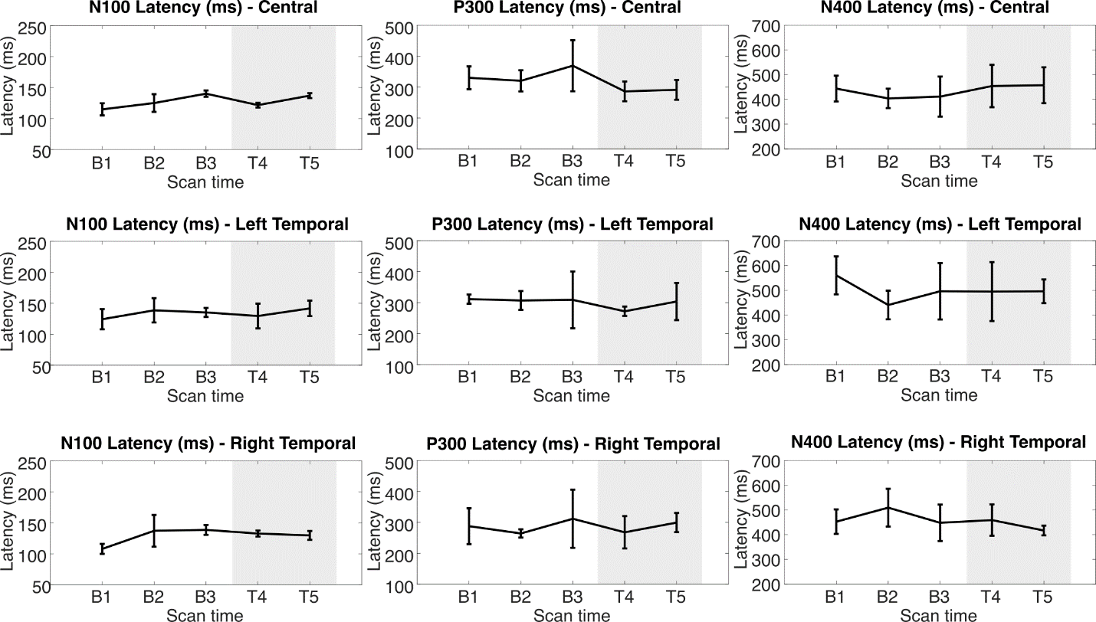
Supplemental Figure 1: N100, P300, and N400 ERP latencies in milliseconds at each assessment across Central, Left Temporal, and Right Temporal electrode groups. Grey area indicates PT+TLNS treatment. * indicates p<0.05 relative to pooled-baseline (FDR corrected).

