Supplementary Material

Supplementary Figures and Table
Supplemental Figure 1. (A) Number of consumer effects studies which examine megafauna species, based on the He & Silliman 2016 data set. 163 marshes studies were examined total, with 44 studies that focused on megafauna (27%). (B) The number of studies that examined domesticated or wild megafauna species within the He & Silliman 2016 consumer effects data set. Of the 44 total megafauna studies, 5 looked at wild animals (11%), and 39 looked at domesticated animals (89%).
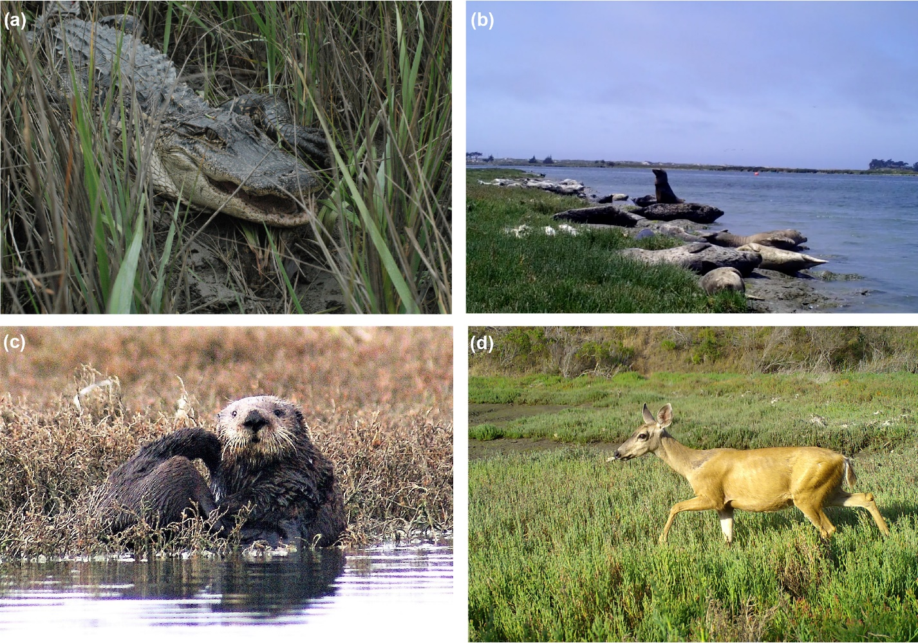
Supplemental Figure 2. Megafauna in salt marshes include (A) American alligator (Alligator mississippiensis; photo: J. Nifong), (B) sea lion (Zalophus californianus) and harbor seals (Phoca vitulina; photo: L. Gaskins), (C) sea otter (Enhydra lutris; photo: R. Eby), (D) mule deer (Odocoileus hemionus; photo: L. Gaskins).
Supplemental Table 1. Megafauna documented in salt marshes through a literature review and through personal observations. Each animal includes the common name, scientific name, density (when available), reference(s), and the country where the animal was observed in a salt marsh.
English Common name | Scientific name | Density | Reference(s) | Country
African Buffalo | Syncerus caffer |  | JB Adams pers obs | South Africa
Alligator Gar | Atractosteus spatula |  | (Selman, 2018) | USA
American Alligator | Alligator mississippiensis | 0.3-6.3 indiv/km of creek, average of 3.45 ind/km (salt marsh), 2.25 ind/km (lake, river, swamp, freshwater marsh) | (Nifong and Silliman, 2013; Nifong et al., 2014; Murray et al., 2015), (Nifong et al., 2015), (O'Brien and Doerr, 1986), Webb unpublished data, (Wood et al., 1985) | USA
American Crocodile | Crocodylus acutus |  | (FNAI, 2010) | USA
Black Bear | Ursus americanus | 0.16-0.30 bears/km², average of 0.23 bears/km² (salt marsh), 0.258 bears/km² (forest) | (Lombardo, 1993; Smith et al., 2012), (Lombardo, 1993), (Schwartz and Franzmann, 1989) | USA
Bottlenose Dolphin | Tursiops truncatus | 3.7-5.4 indiv/km², average of 4.55 indiv/km² (salt marsh), 6.4-14.6 indiv/km², average of 10.5 indiv/km² (gulf) | (Young and Phillips, 2002; Balmer et al., 2011), (Mullin, 1990) (both densities) | USA
Broadnose Sevengill Shark | Notorynchus cepedianus |  | (Russo, 2015) | USA
Brown Bear | Ursus arctos |  | (Smith et al., 2004) | USA
Bull Shark | Carcharhinus leucas |  | (Bangley, 2016) | USA
Cattle | Bos taurus | 0.5-2 indiv/ha (salt marsh) | (Jensen, 1985; Amaral and Jablonski, 2005), JB Adams pers obs, (Andresen et al., 1990) | Denmark, Brazil, South Africa
Common Warthog | Phacochoerus africanus |  | JB Adams per obs | South Africa
Common Zebra | Equus quagga burchellii |  | JB Adams per obs | South Africa
Donkey | Equus africanus asinus |  | JB Adams pers obs | South Africa
Florida Panther | Puma concolor coryi |  | D Onorato pers obs | USA
Gemsbok | Oryx gazella |  | JB Adams pers obs | South Africa
Goat | Capra aegagrus hircus |  | JB Adams per sobs | South Africa
Gray Wolf | Canis lupus |  | (Smith et al., 2004) | USA
Green Turtle | Chelonia mydas |  | (Nagaoka et al., 2012) | Brazil
Harbor Seal | Phoca vitulina | 18.42 ind/km shoreline (salt marsh), 10.1 ind/km shoreline (outer coast) | (Eby et al., 2017), (Form, 2016), (Akeman and Akeman, 2016) | USA
Hippopotamus | Hippopotamus amphibius |  | JB Adams per obs | South Africa
Lion | Panthera leo |  | (Stander, 2019) | Namibia
Loggerhead Turtle | Caretta caretta |  | (Stoneburner et al., 1982) | USA
Mule Deer | Odocoileus hemionus |  | LC Gaskins pers obs | USA
Nile Crocodile | Crocodylus niloticus |  | JB Adams pers obs | South Africa
Ostrich | Struthio camelus |  | JB Adams pers obs | South Africa
Sea Lion | Zalophus californianus |  | LC Gaskins pers obs | USA
Sea Otter | Enhydra lutris | 0.61 indiv/ha (salt marsh), 0.0445 indiv/ha (kelp forest) | (Eby et al., 2017), (Tinker et al., 2018), (Nicholson et al., 2018) | USA
Sheep | Ovis aries | 1.5-10 indiv/ha (salt marsh) | (Ranwell, 1961; Laffaille et al., 2000), JB Adams pers obs, (Berg et al., 1997) | England, France, South Africa
Springbok | Antidorcas marsupialis |  | JB Adams pers obs | South Africa
Water Buffalo | Bubalus bubalis | 1.0-1.3 indiv/ha (salt marsh) | (Amaral and Jablonski, 2005), (Sweers et al., 2013) | Brazil
West Indian Manatee | Trichechus manatus |  | (Wingard and Lorenz, 2014) | USA
White-tailed Deer | Odocoileus virginianus |  | JP Morton pers obs | USA
Wild Boar | Sus scrofa |  | (Sharp and Angelini, 2016) | USA
Wild & Domesticated Horse | Equus ferus, Equus ferus caballus | 0.39 indiv/ha low marsh (wild horse salt marsh), 0.035 indiv/ha (wild horse mountainous national park) | (Beeftink, 1977; Turner, 1987) (wild horse), JB Adams pers obs (domesticated horse), (Taggart, 2008) (density, wild horse), (Dawson and Hone, 2012) (density, mountains) | N&W European countries, USA, South Africa

Supplementary References
[Dataset] Akeman, T., and Akeman, K. (2016). Monterey Bay National Marine Sanctuary’s Bay Net Program Harbor Seal Count Dataset.
Amaral, A.C.Z., and Jablonski, S. (2005). Conservation of marine and coastal biodiversity in Brazil. Conservation Biology 19(3), 625-631.
Andresen, H., Bakker, J., Brongers, M., Heydemann, B., and Irmler, U. (1990). Long-term changes of salt marsh communities by cattle grazing. Vegetatio 89(2), 137-148.
Balmer, B.C., Schwacke, L.H., Wells, R.S., George, R.C., Hoguet, J., Kucklick, J.R., et al. (2011). Relationship between persistent organic pollutants (POPs) and ranging patterns in common bottlenose dolphins (Tursiops truncatus) from coastal Georgia, USA. Science of the Total Environment 409(11), 2094-2101.
Bangley, C. (2016). Delineation of Coastal Shark Habitat Within North Carolina Waters Using Acoustic Telemetry, Fishery-independent Surveys, and Local Ecological Knowledge. East Carolina University.
Beeftink, W. (1977). coastal salt marshes of western and northern Europe: an ecological and phytosociological approach. Ecosystems of the World.
Berg, G., Esselink, P., Groeneweg, M., and Kiehl, K. (1997). Micropatterns in Festuca rubra-dominated salt-marsh vegetation induced by sheep grazing. Plant Ecology 132(1), 1-14.
Dawson, M., and Hone, J. (2012). Demography and dynamics of three wild horse populations in the Australian Alps. Austral Ecology 37(1), 97-109.
Eby, R., Scoles, R., Hughes, B.B., and Wasson, K. (2017). Serendipity in a salt marsh: detecting frequent sea otter haul outs in a marsh ecosystem. Ecology.
FNAI (2010). Guide to the natural communities of Florida: 2010 edition. Florida Natural Areas Inventory, Tallahassee, FL.
[Dataset] Form, S. (2016). Elkhorn Slough National Estuarine Research Reserve (ESNERR) Harbor Seal Counts Dataset.
Jensen, A. (1985). The effect of cattle and sheep grazing on salt-marsh vegetation at Skallingen, Denmark. Vegetatio 60(1), 37-48.
Laffaille, P., Lefeuvre, J.-C., and Feunteun, E. (2000). Impact of sheep grazing on juvenile sea bass, Dicentrarchus labrax L., in tidal salt marshes. Biological Conservation 96(3), 271-277.
Lombardo, C.A. (1993). Population ecology of black bears on Camp Lejeune, North Carolina.
Mullin, K.D. (1990). Comparative seasonal abundance and ecology of Bottlenose Dolphins (Tursiops truncatus) in three habitats of the north-central Gulf of Mexico.
Murray, C., Rheubert, J., Easter, M., Merchant, M., and Crother, B. (2015). Heterophil/Lymphocyte Alterations as a Measure of Stress in American Alligators in Relation to Anthropogenic Disturbance in a Louisiana Intermediate Marsh. Journal of Marine Science and Engineering 3(2), 267-275.
Nagaoka, S.M., Martins, A.S., Dos Santos, R.G., Tognella, M.M.P., de Oliveira Filho, E.C., and Seminoff, J.A. (2012). Diet of juvenile green turtles (Chelonia mydas) associating with artisanal fishing traps in a subtropical estuary in Brazil. Marine Biology 159(3), 573-581.
Nicholson, T.E., Mayer, K.A., Staedler, M.M., Fujii, J.A., Murray, M.J., Johnson, A.B., et al. (2018). Gaps in kelp cover may threaten the recovery of California sea otters. Ecography 41(11), 1751-1762.
Nifong, J.C., Layman, C.A., and Silliman, B.R. (2015). Size, sex and individual‐level behaviour drive intrapopulation variation in cross‐ecosystem foraging of a top‐predator. Journal of Animal Ecology 84(1), 35-48.
Nifong, J.C., Nifong, R.L., Silliman, B.R., Lowers, R.H., Guillette Jr, L.J., Ferguson, J.M., et al. (2014). Animal-borne imaging reveals novel insights into the foraging behaviors and diel activity of a large-bodied apex predator, the American alligator (Alligator mississippiensis). PloS one 9(1), e83953.
Nifong, J.C., and Silliman, B.R. (2013). Impacts of a large-bodied, apex predator (Alligator mississippiensis Daudin 1801) on salt marsh food webs. Journal of Experimental Marine Biology and Ecology 440, 185-191.
O'Brien, T.G., and Doerr, P.D. (1986). Night count surveys for alligators in coastal counties of North Carolina. Journal of herpetology 20(3), 444-448.
Ranwell, D. (1961). Spartina salt marshes in southern England: I. The effects of sheep grazing at the upper limits of Spartina marsh in Bridgwater Bay. The Journal of Ecology, 325-340.
Russo, R.A. (2015). Observations of predation and loss among leopard sharks and brown smoothhounds in San Francisco Bay, California. Calif Fish Game 101, 149-157.
Schwartz, C.C., and Franzmann, A.W. (1989). Bears, wolves, moose, and forest succession, some management considerations on the Kenai Peninsula, Alaska. Alces 25, 1-10.
Selman, W. (2018). LIFE IN SKINNY WATER: OBSERVATIONS OF JUVENILE DIAMONDBACK TERRAPINS (MALACLEMYS TERRAPIN) UTILIZING SHALLOW WATER HABITATS. Herpetological Conservation and Biology 13(2), 399-407.
Sharp, S.J., and Angelini, C. (2016). Whether disturbances alter salt marsh soil structure dramatically affects Spartina alterniflora recolonization rate. Ecosphere 7(11).
Smith, T.S., Oyster, J., Partridge, S.D., Martin, I.E., and Sisson, A. (2012). Assessing American black bear response to human activity at Kenai Fjords National Park, Alaska. Ursus 23(2), 179-192.
Smith, T.S., Partridge, S.T., and Schoen, J.W. (2004). Interactions of brown bears, Ursus arctos, and gray wolves, Canis lupus, at Katmai National Park and Preserve, Alaska. The Canadian Field-Naturalist 118(2), 247-250.
Stander, P. (2019). Lions (Panthera leo) specialising on a marine diet in the Skeleton Coast National Park, Namibia. Namibian J. Environ. 3, 1-10.
Stoneburner, D., Richardson, J., and Williamson, G. (1982). Observations on the movement of hatchling sea turtles. Copeia 1982(4), 963-965.
Sweers, W., Horn, S., Grenzdörffer, G., and Müller, J. (2013). Regulation of reed (Phragmites australis) by water buffalo grazing: use in coastal conservation. Mires & Peat 13.
Taggart, J.B. (2008). Management of feral horses at the North Carolina National Estuarine Research Reserve. Natural Areas Journal 28(2), 187-196.
Tinker, M.T., Espinosa, S.M., Staedler, M.M., Tomoleoni, J.A., Fujii, J., Eby, R., et al. (2018). "The Population Status and Ecology of Sea Otters in Elkhorn Slough, California", in: Final Report for California Coastal Conservancy and U.S. Fish and Wildlife Service.).
Turner, M.G. (1987). Effects of grazing by feral horses, clipping, trampling, and burning on a Georgia salt marsh. Estuaries 10(1), 54-60.
Wingard, G.L., and Lorenz, J.J. (2014). Integrated conceptual ecological model and habitat indices for the southwest Florida coastal wetlands. Ecological indicators 44, 92-107.
Wood, J.M., Woodward, A.R., Humphrey, S.R., and Hines, T.C. (1985). Night counts as an index of American alligator population trends. Wildlife Society Bulletin (1973-2006) 13(3), 262-273.
Young, R.F., and Phillips, H.D. (2002). Primary production required to support bottlenose dolphins in a salt marsh estuarine creek system. Marine Mammal Science 18(2), 358-373.

