Supplementary Information for

**The long-term life-cycle of Nevado de Toluca volcano (Mexico): Insights into the origin of petrologic modes**

Gregor Weber1, Luca Caricchi1 and José L. Arce2

1 Department of Earth Sciences, University of Geneva, Geneva, Switzerland.

2 Instituto de Geología, Universidad Nacional Autónoma de México, Coyoacán, México.

Corresponding author: Gregor Weber ([gregor.weber@unige.ch](mailto:gregor.weber@unige.ch))

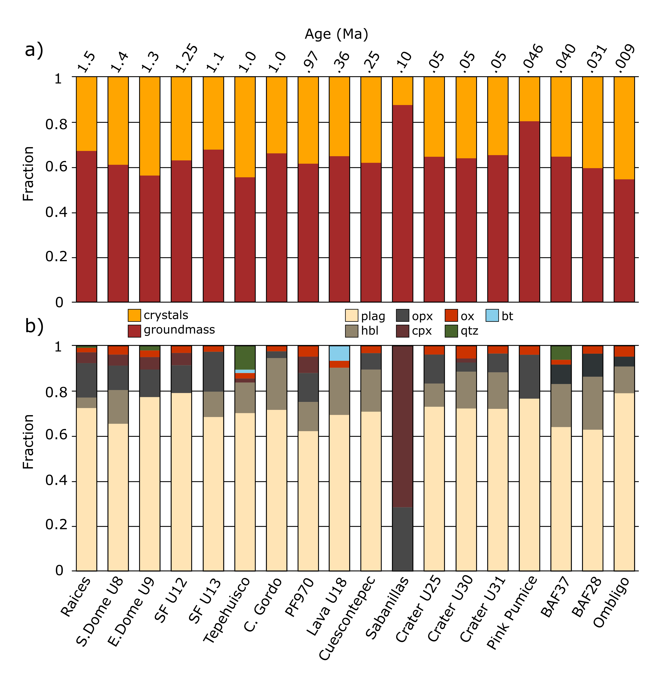

Fig. S1: Mineral and liquid modes for Nevado de Toluca volcano. The fractions were estimated by point counting on at least 5 BSE images and 1 petrographic section for each of the eruptions. a) The fractions of groundmass (red) and macrocrystals (orange) is shown for 18 eruptions from Nevado de Toluca in stratigraphic order with decrasing age from left to right. Age data was taken from Torres-Orozco et al., (2017). b) Fractions of macrocrystal phases in the studied eruptions. Plagioclase (plag, beige), hornblende (hbl, light brown), orthopyroxene (opx, dark grey), clinopyroxene (cpx, dark red), Fe-Ti oxides (ox, red), quartz (qtz, green) and biotite (bt, light blue).

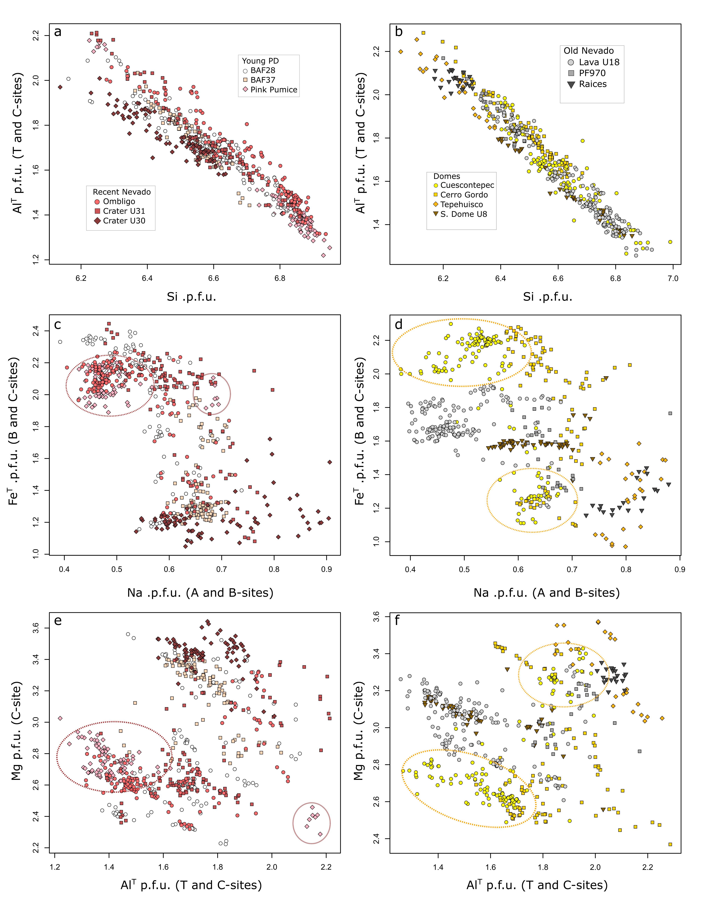

Fig. S2: Bivariate plots of amphibole compositional data. Different symbols reflect different eruptions and color coding was done for eruptive stages. Si per formula unit (p.f.u) versus AlT p.f.u. (T and C-sites) for a) Recent Nevado and Young PD stages and b) for Domes and Old Nevado stages. c) Na p.f.u (A and B-sites) versus FeT p.f.u. (B and C-sites) for Young PD and Recent Nevado stages. d) Na p.f.u (A and B-sites) for Old Nevado and Domes. AlT p.f.u. (T and C-sites) versus Mg p.f.u. (C-sites) for e) Recent Nevado and Young PD stages and f) for Domes and Old Nevado stages. Dashed circles were drawn to illustrate compositional bimodality in amphibole compositions that can be observed for various eruptions.

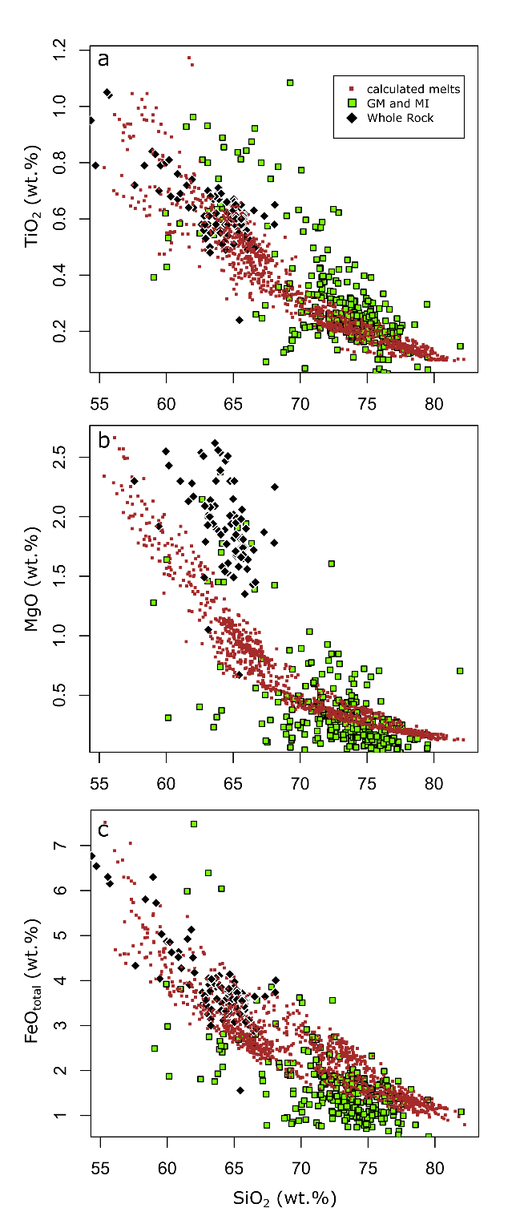

Fig. S3: Comparison of groundmass and melt inclusion compositions (green squares), bulk-rock analyses (black diamonds) and amphibole equilibrium melts calculated using the approach of Zhang et al., (2017). The SiO2 (wt.%) is plotted versus a) TiO2 (wt.%), b) MgO (wt.%) and c) FeOtotal (wt.%). For details on the calculation, the reader is referred to the main text.