Supplementary Material

**Mutations selected after exposure to bacteriocin Lcn972 activate a Bce-like bacitracin resistance module in *Lactococcus lactis***

**Ana Belén Campelo1, Mª Jesús López-González1,2, Susana Escobedo1,2, Thomas Janzen3, Ana Rute Neves3, Ana Rodríguez1,2, Beatriz Martínez1,2,\***

1 DairySafe group. Instituto de Productos Lácteos de Asturias (IPLA), Technology and Biotecnology of Dairy Products Department, Consejo Superior de Investigaciones Científicas (CSIC). Villaviciosa, Asturias, Spain.

2 Instituto de Investigación Sanitaria del Principado de Asturias (ISPA), Oviedo, Asturias, Spain.

3 Chr Hansen A/S. Hørsholm, Denmark.

**\* Correspondence:**

Beatriz Martínez

bmf1@ipla.csic.es

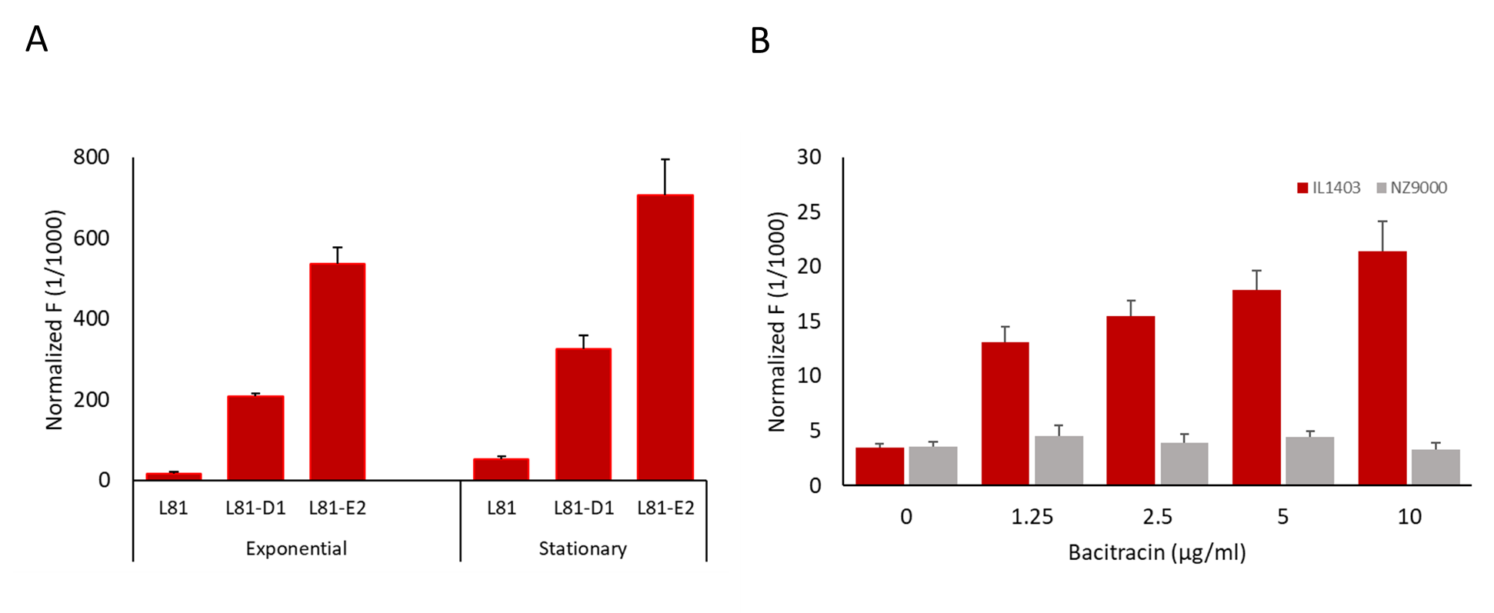

**Supplementary Figure 1. Activity of the P*ysaD* promoter in *L. lactis* determined by the reporter plasmid pPRC_P*ysaD*::*mrfp*.** Detection of mCherry fluorescence (F) was recorded at 605 nm after excitation at a wavelength of 580 nm and normalized by the OD600 of the cell suspensions. A. Cells from *L. lactis* L81, L81-D1 and L81-E2 exponential and stationary phase cultures (only one biological replicate was analyzed, error bars are from technical replicates). B. *L. lactis* IL1403 (red bars) and NZ9000 (grey bars) after induction with bacitracin (X-axis). Average and standard deviation of three biological replicates is depicted.