Electronic Supplementary Information

Table of contents

1. Synthetic procedure of small molecules 2
2. General procedure for polymerization 4
3. NMR spectra 7
4. Optical properties of TQ1-20A and TQ1-20P4 12
5. Thermogravimetric analysis (TGA) 12
6. Cyclic Voltammetry 13
7. Contact angle 14
8. UPS spectra of MoO₃ 15
9. OPVs with MoO₃ as the bifunctional layer 15
10. AFM of films and DSC curve 16
11. Device characteristics 18
12. References 19

Synthetic procedure of small molecules
1,2-bis(3-(3-(dimethylamino)propoxy)phenyl)ethane-1,2-dione (2): To a 500 mL roundbottom, flask, 1,2-bis(3-hydroxyphenyl)ethane-1,2-dione (1) (5.0 g, 20.6 mmol), K₂CO₃ (20.7 g, 150.0 mmol), KI (0.342 g, 2.06 mmol) was added with 200 mL DMSO. The mixture was heated up to 90 °C under stirring. Then 3-dimethylamino-1-propylchloride hydrochloride (15.8 g, 100 mmol) was added in portions and the reaction mixture was stirred under 90 °C for 2 days. The reaction was stopped by cooling to r.t. before 200 mL of water was added. After stirring for 20 min, the mixture was extracted with ethyl acetate, and organic phase was separated, washed with brine and water, dried via NaSO₄, filtered and solvent was removed under rotary evaporation to afford a brown oily crude product. The crude product was purified through column chromatography with DCM : methanol : trimethylamine = 20 : 1 : 1 as the eluent and 1.2 g product was obtained (14.1%). ¹H NMR (300 MHz, DMSO-d₆) δ 7.50 (t, J = 8.0 Hz, 2H), 7.42 – 7.37 (m, 4H), 7.37 – 7.32 (m, 2H), 4.06 (t, J = 6.4 Hz, 4H), 2.34 (t, J = 7.1 Hz, 4H), 2.13 (s, 12H), 1.90 – 1.78 (m, 4H).
3,6-dibromobenzene-1,2-diamine (3): 4,7-dibromobenzo[c][1,2,5]thiadiazole (13.0 g, 44.2 mmol) was added in a 1000 mL flask with EtOH (330 mL). After being stirred at 0 °C in an ice bath for half an hour, NaBH₄ was added to the solution in portions. Then the reaction mixture was stirred at r.t. for 20 h. Through checking thin-layer chromatography (TLC), there was no starting material left, the reaction was quenched by adding water and then stirred for 20 min at r.t.. After that, the mixture was extracted with diethyl ether. The organic phase was washed with saturated NaCl (aq.) and water subsequently prior to being dried via NaSO₄. After filtration, the solvent in filtrate was removed by rotary evaporation, crude product was obtained as light yellow solid. In this reaction process, the generated gas in the mixture caused a small explosion, and some of the mixture was lost due to the spilling. After recrystallization with ethanol and water, the product was dried in a vacuum oven, resulting grey solid (5.7 g, 48.5%). ¹H-NMR (300 MHz, CDCl₃) δ 3.90(b, 4H, NH₂), 6.85(s, 2H, ArH).
5,8-dibromo-2,3-bis(3-(dimethylamino)propoxy)phenyl)quinoxaline (4): 1,2-bis(3-(3-(dimethylamino)propoxy)phenyl)ethane-1,2-dione (2) (1.1 g, 2.67 mmol), 3,6-dibromobenzene-1,2-diamine (3) (0.645 g, 2.42 mmol) was added in a 25 mL round-bottom flask with 10 mL acetic acid. The reaction mixture was stirred under 60 °C overnight before checking TLC and was found no starting materials left. Then the reaction mixture was cooled to r.t. and transferred into K₂CO₃ (aq. pH=12) solution, resulting a yellow emulsion (pH=9). The emulsion was extracted with chloroform, and separated organic phase was washed with brine, dried with NaSO₄. After filtration and removal of solvent, brown oily crude product was purified through column chromatography with DCM : hexane : methanol : trimethylamine = 20 : 10 : 1 : 1 as eluent to afford yellow solid. Then the yellow solid was further purified through crystallization with acetone and water, and pale yellow crystals were obtained (1.5 g, 87.4%). ¹H NMR (300 MHz, DMSO-d₆) δ 8.14 (s, 2H), 7.34 – 7.26 (m, 2H), 7.11 (dd, J = 7.1, 1.3 Hz, 4H), 7.01 – 6.96 (m, 2H), 3.88 (t, J = 6.5 Hz, 4H), 2.28 (t, J = 7.0 Hz, 4H), 2.11 (s, 12H), 1.75 (p, J = 6.7 Hz, 4H).
4-(3-bromopropyl)pyridine hydrobromide (5): 4-pyridinepropanol (3.35 g, 24.4 mmol) was added to a 50 mL round-bottom flask with 30 mL of hydrobromic acid (48 wt. % in H₂O). The reaction mixture was heated under reflux overnight. Then the reaction was stopped by cooling to room temperature and neutralized with potassium carbonate solution (38.2 g in 100 mL water). The neutralized crude was extracted with diethyl ether and washed with water several times. After collecting the organic phase, Mg₂SO₄ was added into the solution for drying. The dried solution was filtered and stirred with adding 2.76 mL HBr (48 wt. % in H₂O) before diethyl ether was removed under rotary evaporator. Then 40 mL of acetonitrile was added to the mixture to assist the evaporation of water before removing solvents again. This procedure was repeated two times. Then 25 mL DCM was added to the mixture before removing solvents. This procedure was repeated two times to yield solid product. After keeping in the vacuum oven overnight at 30 °C, pale yellow solid product was obtained (5.2 g, 75.8%). ¹H NMR (300 MHz, D₂O) δ 8.51 (d, 2H), 7.81 (d, 2H), 3.49 (t, 2H), 2.99 (t, 2H), 2.17-2.29 (m, 2H).
3,3'-(5,8-dibromoquinoxaline-2,3-diyl)diphenol (6): 1,2-bis(3-hydroxyphenyl)ethane-1,2-dione (0.735 g, 3.03 mmol), 3,6-dibromobenzene-1,2-diamine (3) (0.807 g, 3.03 mmol) were mixed with 30 mL acetic acid. After the mixture was stirred at room temperature for one hour, reaction temperature was increased to 60 °C. And the reaction mixture was stirred for one hour at 60 °C. After checking TLC to confirm there is no reactants remaining, the reaction was quenched by adding 80 mL water to the reaction mixture. Then the mixture was cooled down to room temperature to offer a grey suspension. After filtering the suspension, the filter cake was washed with water several time, then dried in the vacuum oven under 30 °C overnight. 1.34 g grey solid product was obtained (93.7%). ¹H NMR (300 MHz, DMSO-d₆) δ 9.60 (s, 2H), 8.12 (s, 2H), 7.16 (t, 2H), 7.05-7.08 (m, 2H), 6.85-6.91 (m, 2H), 6.79-6.85 (m, 2H).
5,8-dibromo-2,3-bis(3-(3-(pyridin-4-yl)propoxy)phenyl)quinoxaline (7): 3,3'-(5,8-di bromoquinoxaline-2,3-diyl)diphenol (6) (0.865 g, 1.83 mmol), potassium carbonate (1.85 g, 13.4 mmol), 18-crown-6 (30 mg) were added with 40 mL acetonitrile into a round-bottom flask. The mixture was heated up to 80 °C under N₂ for 1 hour. Then 4-(3-bromopropyl)pyridine hydrobromide (5) (2.571 g, 9.15 mmol) was dissolved in 7 mL acetonitrile and the solution was slowly transferred to the reaction mixture in portions. After all 4-(3-bromopropyl)pyridine hydrobromide was transferred, reaction temperature was increased to 87 °C to let the solvent reflux under N₂ overnight. After the mixture was reacted for 24 hours, TLC was checked (ethyl acetate: DCM: methanol=12: 12: 1) to confirm no starting material (6) remaining in the reaction mixture. The reaction was stopped by cooling to r.t. and then removing acetonitrile under rotary evaporation. The residue was re-dissolved by adding chloroform and water. The organic phase was separated and washed with water for several times before drying with MgSO₄. Then the solvent in filtered solution was removed by rotary evaporation to offer a brown viscous liquid crude product. The crude product was purified through column chromatography with ethyl acetate: DCM: methanol=14: 14: 1 as the eluent. Yellow solid product was obtained (0.55 g, 42.3%). ¹H NMR (300 MHz, DMSO-d₆) δ 8.44 (d, 4H), 8.15 (s, 2H), 7.25-7.32 (m, 2H), 7.20 (d, 4H), 7.01-7.14 (m, 4H), 6.91-6.99 (m, 2H), 3.84(t, 4H), 2.68 (t, 4H), 1.92-1.99 (m, 4H).

General procedure for polymerization
Poly[3,3'-(((quinoxaline-2,3-diyl)bis(3,1-phenylene))bis(oxy))bis(N,N-dimethylpropan-1-amine)- alt-thiophene] (TQ1A)
Monomer 4 (200.9 mg, 0.3127 mmol) and 2,5-bis(trimethylstannyl)thiophene (128.1 mg, 0.3127 mmol) were added to a dry 25 mL flask, vacuumed and then protected with Nitrogen before 10 mL of degassed dry toluene was added to the flask. The solution was stirred at 90 °C under N₂ protection for 30 min. Then catalysts, tris(dibenzylideneacetone)dipalladium(0) (6 mg) and tri(o-tolyl)phosphine (12 mg) was dissolved in 2 mL degassed toluene and resulting solution was added to the monomer solution. The colour of the mixture turned to deep blue after stirring for half an hour. Depending on the viscosity of the solution, the reaction mixture was stirred at 90 °C for 2 days. Then the solution was precipitated in hexane and filtered to collect solid. The dark blue solid was re-dissolved in 100 mL chloroform and a solution of sodium diethyldithiocarbamate trihydrate (10%, 10 g in 100 mL H₂O) was added to the resulting CHCl₃ solution. The mixture was stirred vigorously at 60 °C for 1 h. Then the organic phase was separated and washed with deionized water for 5 times to remove most of the residual complex agent. The organic phase was concentrated to approximately 10 mL before precipitated in methanol. The polymer was collected by filtration through an extraction thimble, and Soxhlet-extracted subsequently with hexane, acetone, diethyl ether, ethyl acetate and finally chloroform. The chloroform fraction was concentrated to about 10 mL, and precipitated in methanol. The solid was collected by filtration and dried in a vacuum oven under 36 °C to afford 168.7 mg polymer (95.4%). ¹H NMR (600 MHz, CDCl₃) δ 7.81-8.31 (m, 4H), 7.31-7.49 (m, 2H), 7.11-7.23 (m, 4H), 6.87 (s, 2H), 3.79 (bs, 4H), 2.19-2.30 (m, 4H), 2.10-2.12 (m, 12H), 1.75 (bs, 4H).
TQ1-20A
Monomer 4 (37.4 mg, 0.0582 mmol), 5,8-dibromo-2,3-bis(3-(octyloxy)phenyl)quinoxaline (153.4 mg, 0.2328 mmol), 2,5-bis(trimethylstannyl)thiophene (119.3 mg, 0.2910 mmol), tris(dibenzylideneacetone)dipalladium(0) (8 mg), tri(o-tolyl)phosphine (16 mg), toluene (8 mL). Reaction resulted in 112.3 mg (63.5%) polymer as dark blue solid. ¹H NMR (600 MHz, CDCl₃) δ 7.79-8.22 (m, 10H), 7.31-7.44 (m, 5H), 7.10-7.23 (m, 10H), 6.85 (bs, 5H), 3.70 (bs, 10H), 2.19-2.24 (m, 2H), 2.12 (bs, 6H), 1.72 (bs, 2H), 1.51 (bs, 8H), 1.12-1.26 (m, 40 H), 0.80 (bs, 12H).
TQ1-50A
Monomer 4 (99.8 mg, 0.1553 mmol), 5,8-dibromo-2,3-bis(3-(octyloxy)phenyl)quinoxaline (102.3 mg, 0.1553 mmol), 2,5-bis(trimethylstannyl)thiophene (127.3 mg, 0.3017 mmol), tris(dibenzylideneacetone)dipalladium(0) (8 mg), tri(o-tolyl)phosphine (16 mg), toluene (8 mL). Reaction resulted in 108.9 mg (59.2%) polymer as dark blue solid. ¹H NMR (600 MHz, CDCl₃) δ 7.80-8.22 (m, 4H), 7.32-7.49 (m, 2H), 7.11-7.23 (m, 4H), 6.85 (bs, 2H), 3.70-3.78 (m, 4H), 2.19-2.26 (m, 2H), 2.10-2.12 (m, 6H), 1.78 (bs, 2H), 1.12-1.27 (m, 12 H), 0.79 (bs, 3H).
TQ1P4
5,8-dibromo-2,3-bis(3-(3-(pyridin-4-yl)propoxy)phenyl)quinoxaline (7) (278.5 mg, 0.392 mmol), 2,5-bis(trimethylstannyl)thiophene (160.6 mg, 0.392 mmol), tris(dibenzylideneacetone)dipalladium(0) (11 mg), tri(o-tolyl)phosphine (22 mg), toluene (4 mL), DMF (4 mL). Reaction afforded 194.5 mg (78.2%) polymer as dark blue/purple solid. ¹H NMR (600 MHz, CDCl₃) δ 8.30-8.55 (m, 6H), 7.97 (bs, 2H), 7.44-7.60 (m, 2H), 7.01-7.20 (m, 4H), 6.77-6.98 (m, 6H), 3.63 (bs, 4H), 2.77-2.98 (m, 2H), 2.11-2.48 (m, 6H).
TQ1-20P4
5,8-dibromo-2,3-bis(3-(3-(pyridin-4-yl)propoxy)phenyl)quinoxaline (7) (58.5 mg, 0.082 mmol), 5,8-dibromo-2,3-bis(3-(octyloxy)phenyl)quinoxaline (229.4 mg, 0.329 mmol), 2,5-bis(trimethylstannyl)thiophene (168.6 mg, 0.411 mmol), tris(dibenzylideneacetone) dipalladium(0) (10 mg), tri(o-tolyl)phosphine (20 mg), toluene (6 mL), DMF (1.5 mL). Reaction afforded 183 mg (71.4%) polymer as dark blue/purple powder. ¹H NMR (600 MHz, CDCl₃) δ 8.36 (s, 2H), 7.89 (bs, 6H), 7.29-7.50 (m, 4H), 7.05-7.25 (m, 14H), 6.89 (bs, 6H), 3.74 (bs, 10H), 2.43 (bs, 4H), 1.10-1.39 (m, 48 H), 0.82-0.98 (m, 12 H).
TQ1-50P4
5,8-dibromo-2,3-bis(3-(3-(pyridin-4-yl)propoxy)phenyl)quinoxaline (7) (108.8 mg, 0.153 mmol), 5,8-dibromo-2,3-bis(3-(octyloxy)phenyl)quinoxaline (106.7 mg, 0.153 mmol), 2,5-bis(trimethylstannyl)thiophene (125.5 mg, 0.306 mmol), tris(dibenzylideneacetone) dipalladium(0) (8 mg), tri(o-tolyl)phosphine (16 mg), toluene (4 mL), DMF (4 mL). Reaction resulted in 154.0 mg (80.4%) polymer as dark blue solid. ¹H NMR (600 MHz, CDCl₃) δ 8.34 (bs, 2H), 7.90 (bs, 2H), 7.40-7.52 (m, 2H), 7.08-7.25 (m, 6H), 6.87 (m, 4H), 3.68 (bs, 4H), 2.38 (bs, 4H), 1.12-1.39 (m, 12H), 0.82-0.96 (m, 4H).

NMR spectra
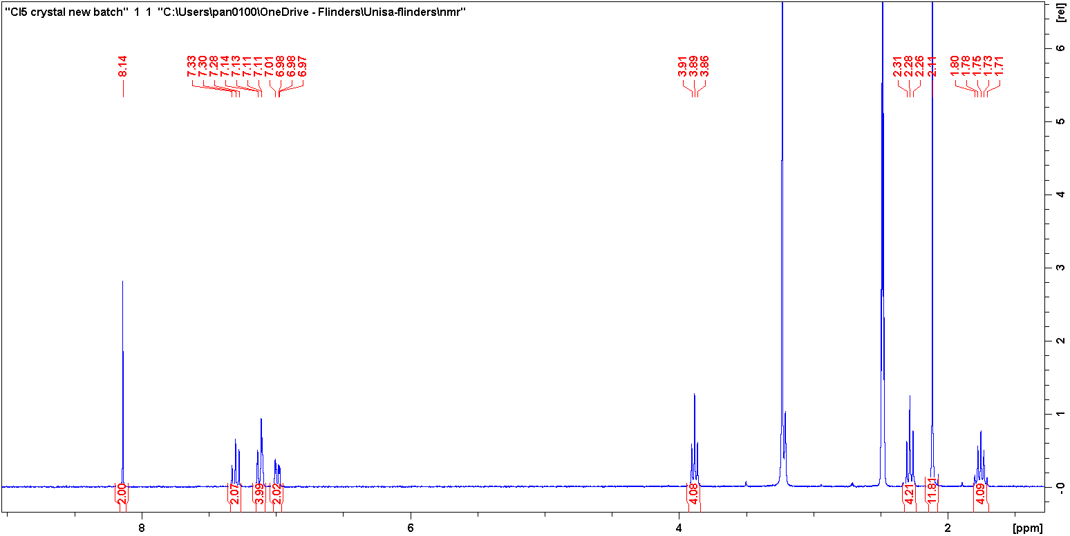
a
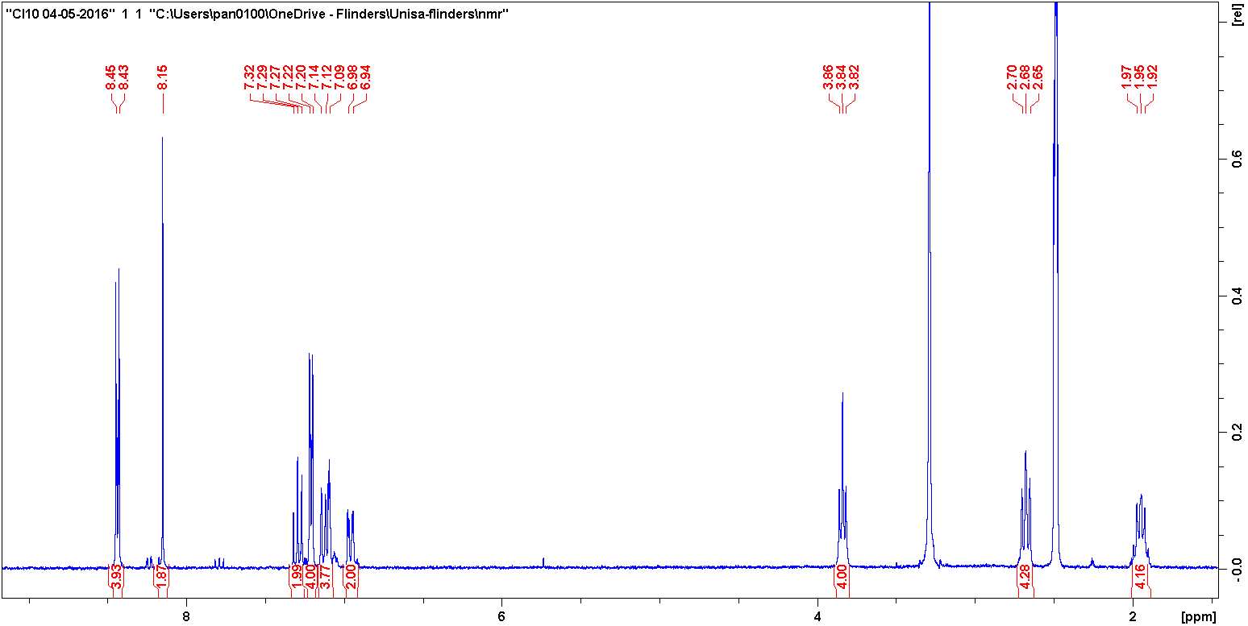
b
Figure S1 ¹H NMR (300 MHz) spectra of (a) TQ1A monomer and (b) TQ1P4 monomer in deuterated DMSO.
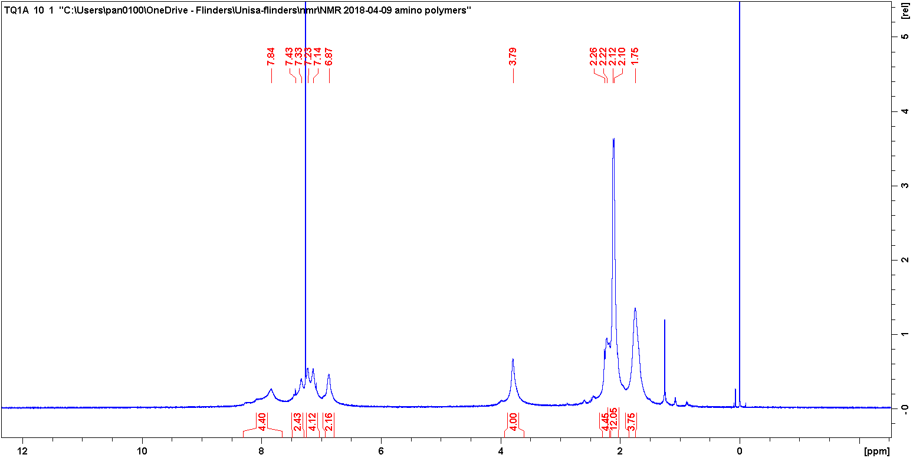
a
TQ1A
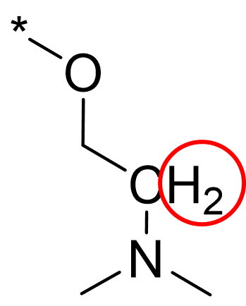
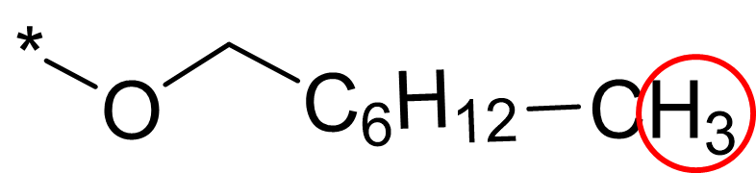
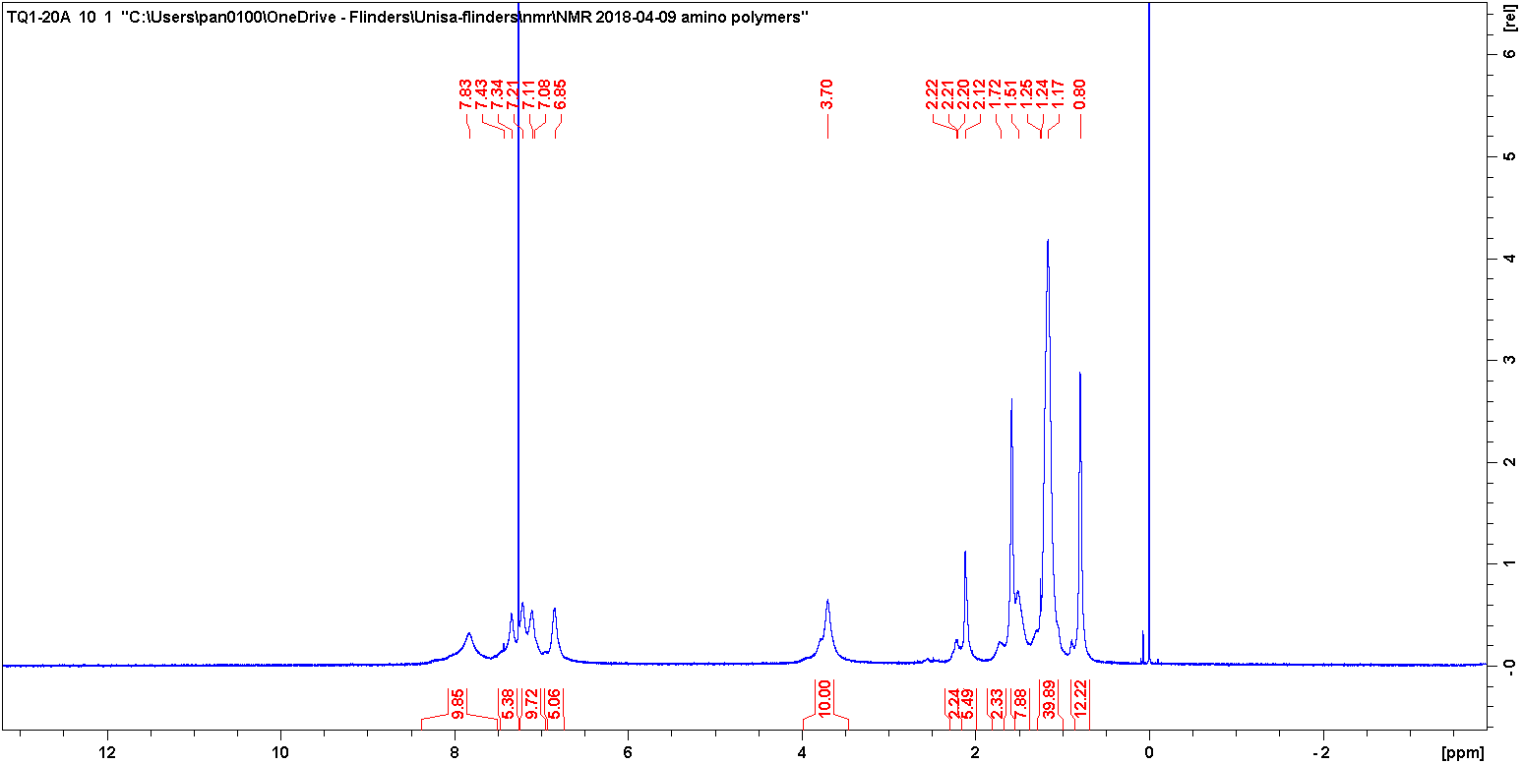
b
TQ1-20A
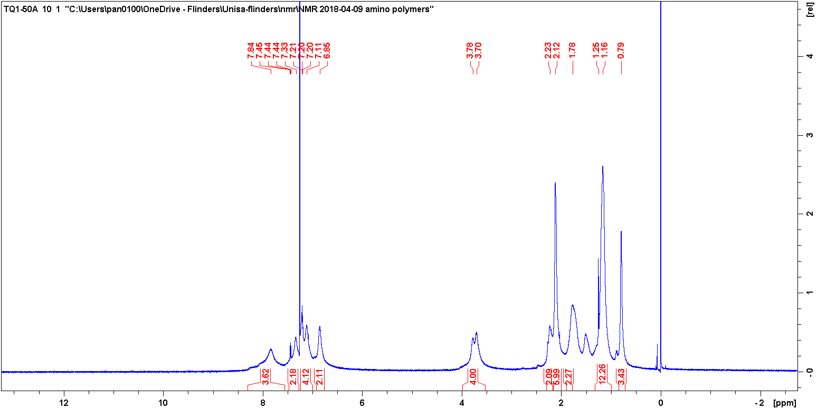
c
TQ1-50A
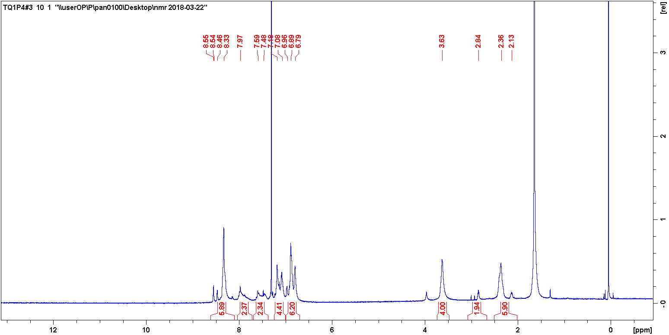
d
TQ1P4

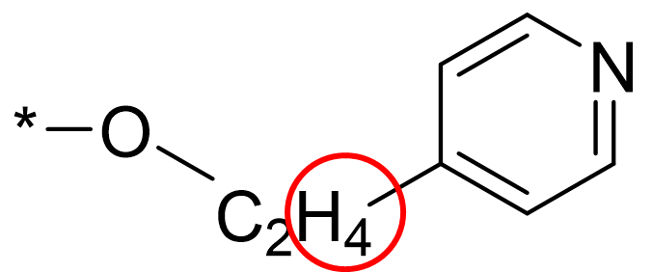
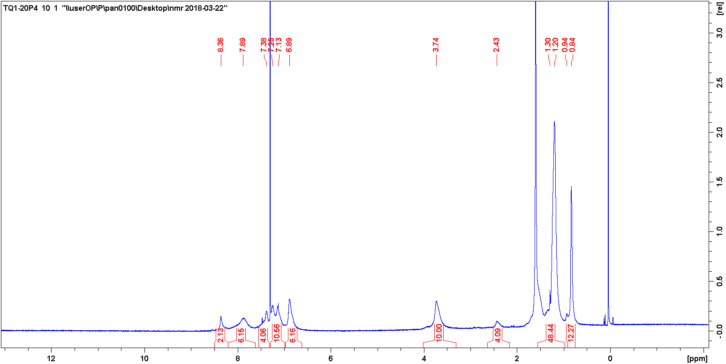
e
TQ1-20P4
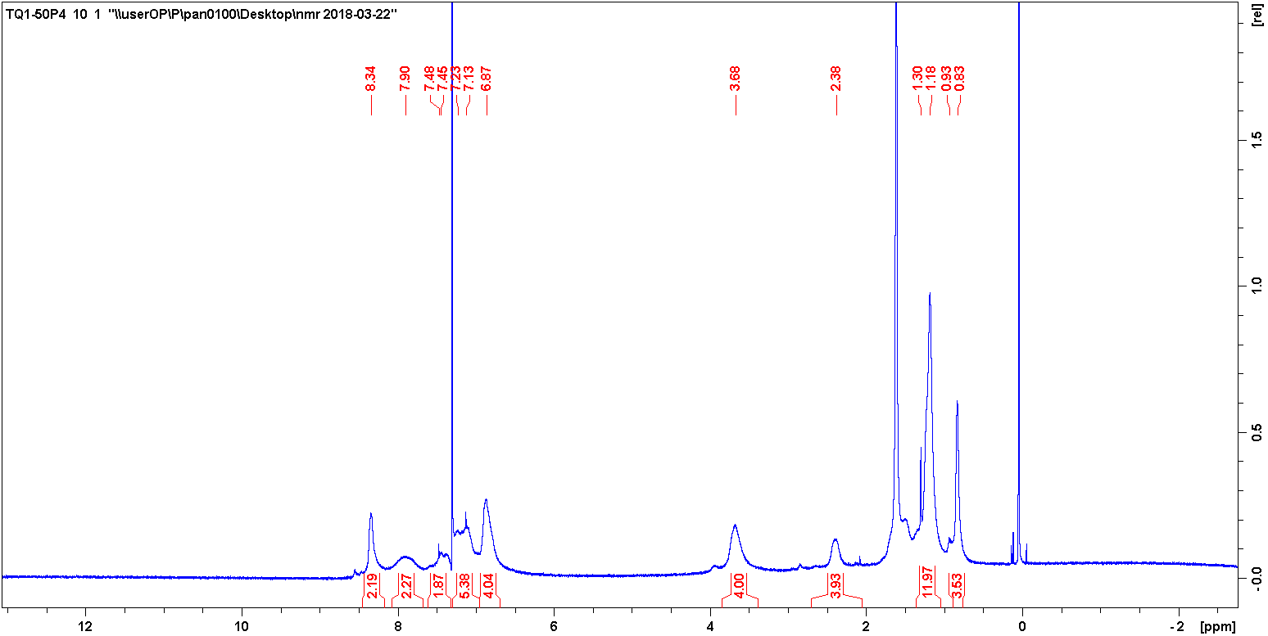
f
TQ1-50P4
Figure S2 ¹H NMR (600 MHz) spectra of (a) TQ1A, (b) TQ1-20A, (c) TQ1-50A, (d) TQ1P4, (e) TQ1-20P4 and (f) TQ1-50P4 in deuterated chloroform. The side groups and arrows inserted illustrate the specific proton signals.
The ratios of side groups on random polymers TQ1-20A, TQ1-50A, TQ1-20P4 and TQ1-50P4 are calculated based on the specific proton signal integrals as illustrated in Figure S2.

Table S1 Ratio of polar functional side groups to octyl side groups calculated by NMR spectra and estimated from monomer feed ratios.
 | TQ1-20A | TQ1-50A | TQ1-20P4 | TQ1-50P4
Calculated from NMR spectra | 1.12:4.07  (21.6% amine) | 1.05:1.14  (47.9% amine) | 1.02:4.09  (20.0% pyridine) | 0.98:1.18  (46.3% pyridine)
Estimated from monomer ratio | 2:8  (20% amine) | 5:5  (50% amine) | 2:8  (20% pyridine) | 5:5  (50% pyridine)

Optical properties of TQ1-20A and TQ1-20P4
Figure S3 Normalized UV-vis absorption spectra of TQ1-20A and TQ1-20P4 in cholorofm solutions and in the solid states.

Thermogravimetric analysis (TGA)
a
b
Figure S4 Formic acid protonated (a) TQ1A and (b) TQ1P4 weight change as a function time in the 120 °C and 110 °C isothermal process, respectively.

Cyclic Voltammetry
The energy levels were estimated as E_{HOMO} = - ($E_{ox}^{onset}$ + 5.13) (eV) and E_{LUMO} = - ($E_{red}^{onset}$ +5.13) (eV), where $E_{ox}^{onset}$ is the onset of the oxidation potential and $E_{red}^{onset}$ is the reduction potential.
Figure S5 Cyclic voltammograms of the polymers.
Table S2 UV-vis absorption, electrochemical properties and energy levels of polymers.
Polymers | λ_{max} (nm) | λ_{onset} (nm) | E_{g}^{opt} (eV) | $E_{ox}^{onset}$ (V) | $E_{red}^{onset}$ (V) | E_{HOMO} (eV) | E_{LUMO} (eV) | E_{g}^{CV} (eV)
TQ1A | 361 606 | 730 | 1.70 | 0.34 | -1.29 | -5.47 | -3.84 | 1.63
TQ1-50A | 358 609 | 719 | 1.73 | 0.40 | -1.61 | -5.53 | -3.52 | 1.83
TQ1-20A | 358 610 | 709 | 1.75 | 0.43 | -1.60 | -5.56 | -3.53 | 1.70
TQ1P4 | 361 610 | 720 | 1.73 | 0.32 | -1.41 | -5.45 | -3.72 | 1.73
TQ1-50P4 | 361 618 | 723 | 1.72 | 0.44 | -1.48 | -5.57 | -3.65 | 1.92
TQ1-20P4 | 361 624 | 725 | 1.72 | 0.47 | -1.46 | -5.60 | -3.67 | 1.93
E_{g}^{CV} = (E_{LUMO} – E_{HOMO})

Contact angle
Table S3 Contact angle results of neat and blend films on ITO coated glass.
Neat film | Contact angle (°) | Blend film | Contact angle (°)
TQ1A | 60 | TQ1A:PC₆₁BM | 60
PC₆₁BM | 78

UPS spectra of MoO₃
Figure S6 UPS spectra of pristine MoO₃ and o-DCB washed MoO₃ reference sample. The red arrow indicates 0.15 eV of work function change after washing.

OPVs with MoO₃ as the bifunctional layer
The lower performance compared to the reported values¹ was resulted from the unoptimized BHJ layer morphology as o-DCB redissolving the TQ1A interlayer that introducing defects in the active layer.
Table S4 Photovoltaic performance parameters of o-DCB processed TQ1:PC₇₁BM (1:2.5) BHJ OPVs using the inverted device structure of ITO/MoO₃/TQ1A/BHJ/MoO₃/Ag, with mean values ± standard deviation from eight devices in parentheses.
BHJ | J_{SC} (mA/cm²) | FF (%) | V_{OC} (V) | PCE (%)
TQ1:PC₇₁BM | 4.69  (4.48 ± 0.19) | 48  (49 ± 3) | 0.59  (0.55 ± 0.03) | 1.31  (1.19 ± 0.06)

AFM of films and DSC curve
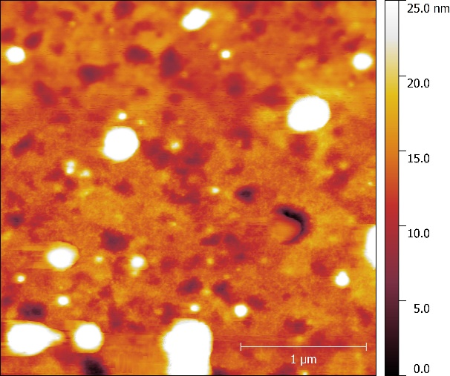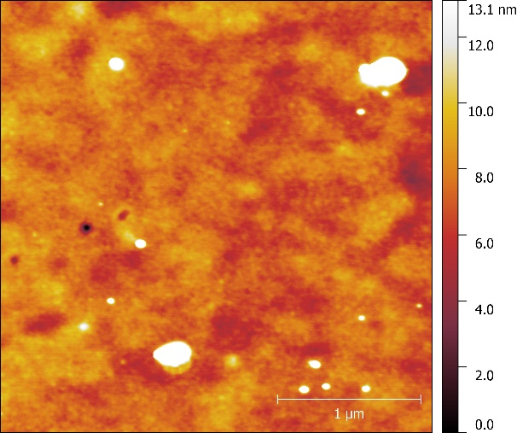
a
b
Figure S7 3 × 3 µm² AFM images of (a) neat TQ1P4, (b) TQ1P4:PC₆₁BM blend films processed from o-DCB solutions.
a
b
c
d
e
Figure S8 DSC thermograms (second scan) showing the melting peak of PC₆₁BM in amino polymer:PC₆₁BM blend in different weight ratios (a-c) with TQ1:PC₆₁BM (1:1) as a reference. (e) DSC thermogram of TQ1-20P4:PC₆₁BM in 1:2.5 weight ratio.

Device characteristics
Table S5 Photovoltaic performance of BHJ OPVs based on TQ1A, TQ1-50A, TQ1-20A, TQ1P4, TQ1-50P4, TQ1-20P4 and low molecular TQ1 (LMW-TQ1) with PC₆₁BM (fixed D:A 1:2.5 weight ratio) blends with device structure of ªITO/ZnO/BHJ/TPD/MoO_{X}/Ag and ^{b}ITO/ZnO/BHJ/MoO_{X}/Ag. The mean values ± standard deviation from eight devices are shown in parentheses.
Polymer | Device structure | BHJ solvent | J_{SC} (mA/cm²) | FF (%) | V_{OC} (V) | PCE (%)
TQ1A | a | o-DCB | 0.94  (0.83 ± 0.05) | 43  (41 ± 1) | 0.34  (0.30 ± 0.02) | 0.13  (0.10 ± 0.01)
TQ1A | b | o-DCB | 0.93  (0.89 ± 0.03) | 39  (39 ± 0) | 0.18  (0.18 ± 0.01) | 0.07  (0.06 ± 0.01)
TQ1-50A | a | o-DCB | 4.17  (3.80 ± 0.21) | 43  (43 ± 0) | 0.46  (0.47 ± 0.01) | 0.82  (0.78 ± 0.04)
TQ1-50A | b | o-DCB | 3.37  (3.04 ± 0.18) | 43  (43 ± 1) | 0.41  (0.39 ± 0.02) | 0.59  (0.52 ± 0.03)
TQ1-20A | a | o-DCB | 3.95  (3.82 ± 0.12) | 46  (46 ± 1) | 0.58  (0.57 ± 0.01) | 1.06  (1.00 ± 0.03)
TQ1-20A | b | o-DCB | 3.94  (3.49 ± 0.19) | 46  (46 ± 0) | 0.54  (0.54 ± 0.01) | 0.97  (0.86 ± 0.04)
TQ1P4 | a | Anisole | 2.19  (2.08 ± 0.11) | 43  (44 ± 1) | 0.60  (0.60 ± 0.02) | 0.57  (0.54 ± 0.01)
TQ1P4 | b | Anisole | 1.53  (1.48 ± 0.04) | 36  (35 ± 1) | 0.47  (0.47 ± 0.01) | 0.26  (0.24 ± 0.01)
TQ1-50P4 | a | Anisole | 4.23  (3.78 ± 0.24) | 54  (54 ± 1) | 0.59  (0.58 ± 0.01) | 1.33  (1.20 ± 0.07)
TQ1-50P4 | b | Anisole | 5.07  (4.82 ± 0.19) | 43  (43 ± 0) | 0.51  (0.51 ± 0.00) | 1.11  (1.06 ± 0.05)
TQ1-20P4 | a | o-DCB | 5.67  (5.44 ± 0.19) | 47  (47 ± 0) | 0.65  (0.64 ± 0.00) | 1.75  (1.64 ± 0.06)
TQ1-20P4 | b | o-DCB | 5.79  (5.21 ± 0.28) | 47  (47 ± 1) | 0.62  (0.62 ± 0.01) | 1.69  (1.53 ± 0.08)
LMW-TQ1 | a | o-DCB | 5.25  (4.98 ± 0.21) | 44  (45 ± 1) | 0.88  (0.88 ± 0.01) | 2.04  (1.97 ± 0.07)
LMW-TQ1 | b | o-DCB | 5.77  (5.66 ± 0.17) | 52  (51 ± 1) | 0.85  (0.84 ± 0.02) | 2.55  (2.43 ± 0.07)

Figure S9 Representative J-V curves of amino polymers and pyridine polymers based OPVs.

References
1. Sharma, A.; Kroon, R.; Lewis, D. A.; Andersson, G. G.; Andersson, M. R., Poly(4-vinylpyridine): A New Interface Layer for Organic Solar Cells. ACS Appl Mater Interfaces 2017, 9 (12), 10929-10936.

