**Type I PRMT inhibition protects against C9ORF72 arginine-rich dipeptide repeat toxicity**

Alan S. Premasiri1*, Anna L. Gill1*, Fernando G.Vieira1**

1*ALS Therapy Development Institute, 300 Technology Square Suite 400, Cambridge, Massachusetts 02139.*

*\*These authors contributed equally to this work.*

*\*\*Correspondence:* [*fvieira@als.net*](mailto:fvieira@als.net) *Telephone: 617-441-7251 Fax: 617-441-7299*

**Supplementary Material**

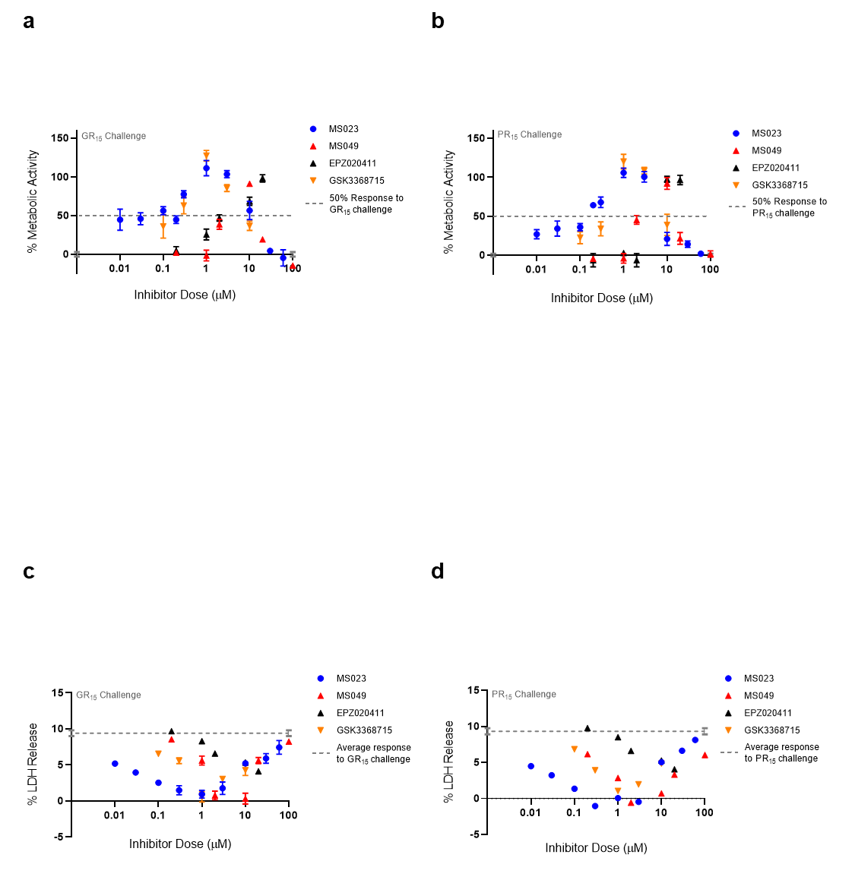

**Supplementary Figure 1**

**Figure S1: Three of four Type I PRMT inhibitor demonstrate a bell-shaped dose-response curve.**

(**a,b**) Full dose-response curves seen in **Fig 1d,e.** of percent metabolic activity after challenging NSC-34 cells with GR15 or PR15 and dosing with Type I PRMT inhibitors (plotted as mean±s.e.m.). (**c,d**) Full dose-response curves seen in **Fig 1f,g.** of percent LDH release after challenging NSC-34 cells with GR15 or PR15 and dosing with Type I PRMT inhibitors (plotted as mean±s.e.m.). For **a,b,** 100% activity represents untreated NSC-34 cells, and 0% activity represents metabolic activity after 3 µM GR15 or PR15 challenge alone. A full listing of *n* for each condition can be found in the **Statistics** section of the methods.

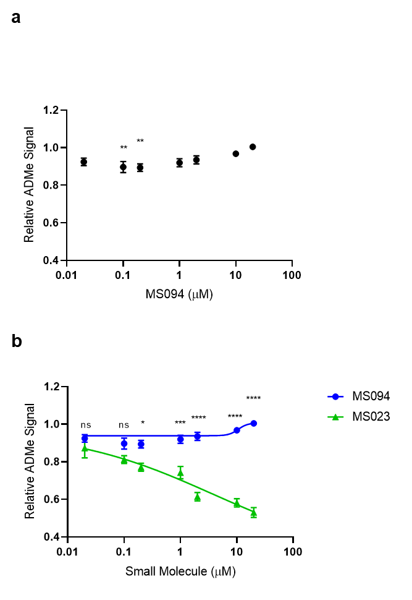

**Supplementary Figure 2**

**Figure S2: MS094 demonstrates minimal to no ability in inhibiting ADMe modification.**

(**a**) Quantified total ADMe signal in NSC-34 cells after dosing with MS094. MS094 caused significant reduction in ADMe signal at 0.1 and 0.2 µM concentrations compared to the signal of the untreated cells (one-way ANOVA with Dunnett’s multiple comparison; n=12 for untreated cells, n=6 for each dosed group; NS P>0.051, control vs 0.1 µM **P=0.0059, control vs 0.2 µM **P=0.0043, mean±s.e.m.). (**b**) Compared total ADMe signal in NSC-34 cells after dosing with MS023 or MS094. MS094 demonstrates a much lower magnitude inhibition of ADMe than that caused by its active analog MS023 (two-way ANOVA with Sidak’s multiple comparison; MS023 data point pulled from **Fig1a.** MS094 data points from (**a**); NS P>0.3656, ****P<0.0001, ***P=0.0003, *P=0.0471, mean±s.e.m.).



**Supplementary Figure 3**

**Figure S3: GSK591 inhibits SDMe modification in NSC-34 cells.**

Quantified total SDMe signal in NSC-34 cells after dosing with GSK591. GSK591 significantly inhibited SDMe modifications at 10 µM and above when compared to the signal of the untreated cells (one-way ANOVA with Dunnett’s multiple comparison; n=10 for untreated cells, n=3 for each dosed group; NS P=0.0703, 10 µM ***P=0.0009, 100 µM ***P=0.0002, **P=0.0029, *P=0.0131, mean±s.e.m.).

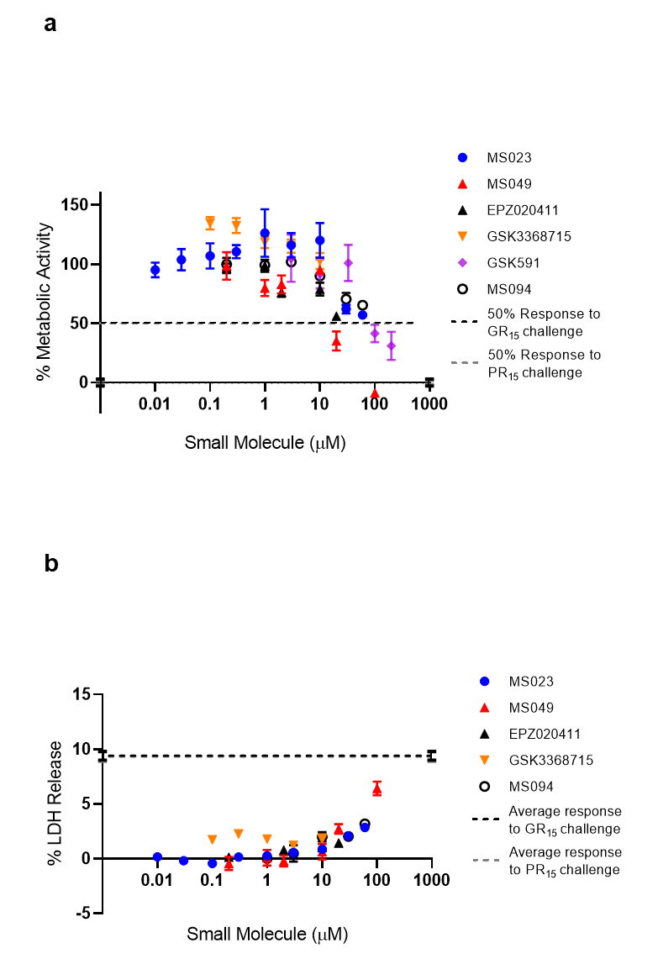

**Supplementary Figure 4**

**Figure S4: Small molecules tested exhibit some toxicity at high doses.**

(**a**) Percent metabolic activity of NSC-34 cells after applying the compounds tested. At concentrations above 10 µM, most compounds go on to show decreased metabolic activity (need table of significances?). (**b**) Percent LDH release by NSC-34 cells after applying the compounds tested. At concentrations above 10 µM, most compounds go on to an increase in LDH release. For **a,** 100% activity represents untreated NSC-34 cells, and 0% activity represents metabolic activity after 3 µM GR15 or PR15 challenge alone. Statistical significance are represented in **Table S1**.

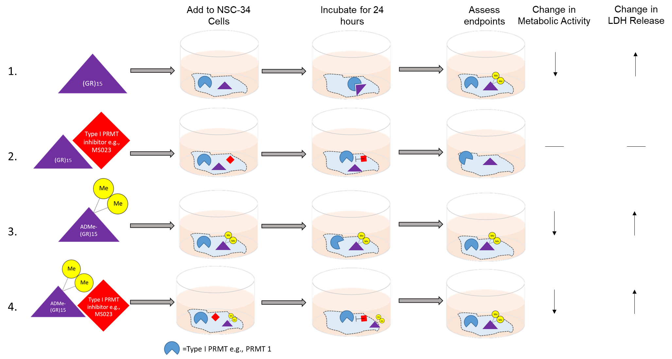

**Supplemental Figure 5**

**Figure S5: Schematic of outcomes of experiments conducted and possible mechanism of toxicity.** Based on the results in the present study the toxicity associated with GR15 and PR15 (not pictured) could be associated with their ability to be asymmetrically dimethylated after 24 hours of incubation (line 1). When a Type I PRMT inhibitor such as MS023 is added, the toxicity is abrogated, though the exact mechanism by which it happens remains unclear (line 2). When challenging cells with GR15 that has been asymmetrically dimethylated, the toxic effects are still present (line 3). However when MS023 was added during the ADMe-GR15 challenge, abrogation of toxicity was not observed, and so it is suggested that because GR15 was already dimethylated, the PRMT inhibition had no influence on the effects seen (line 4). Taken together, the results suggest that the asymmetric dimethylation of GR15 is the driving mechanism of toxicity seen in our assay system.

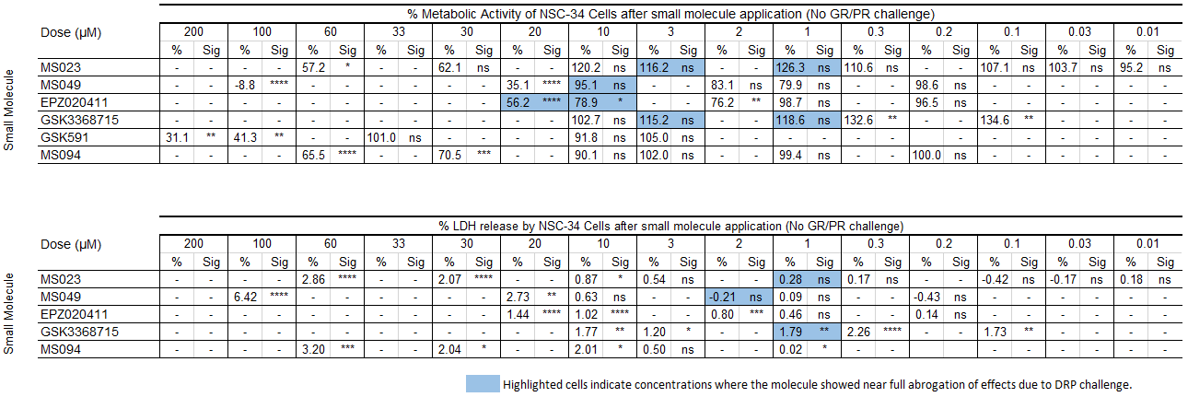

**Table S1. Effects on metabolic activity and LDH release of NSC-34 cells due to molecules in the absence of GR15 or PR15 challenge.** **** indicates p<0.0001, *** indicates p<0.001, ** indicates p<0.01, * indicates p<0.05. Highlighted cells represent concentrations at which molecules showed near complete abrogation of toxic effects due to GR15 or PR15 challenge. One-way ANOVAs with Dunnett’s multiple comparisons were used to assess significance. For the WST-1 analysis, percentage of activity was compared to that after DRP challenge. 100% activity represents untreated NSC-34 cells, and 0% activity represents metabolic activity after 3 µM GR15 or PR15 challenge alone.

**Supplementary Statistics**

**Supplementary Table S2**

|  |  |  |  |  |
| --- | --- | --- | --- | --- |
| **FIGURE 1A.** | *n* | | | |
| Concentration of Inhibitor (µM) | MS023 | MS049 | EPZ020411 | GSK715 |
| 100 | - | 7 | 7 | - |
| 60 | 4 | - | - | - |
| 30 | 4 | - | - | - |
| 20 | 16 | 11 | 11 | 6 |
| 10 | 20 | - | - | 6 |
| 6 | 4 | - | - | - |
| 3 | 4 | - | - | - |
| 2 | 16 | 11 | 11 | 6 |
| 1 | 20 | 11 | 11 | 6 |
| 0.2 | 16 | 11 | 11 | 6 |
| 0.1 | 16 | 4 | 4 | 6 |
| 0.02 | 16 | 4 | 4 | 6 |
| 0 | 42 | 18 | 18 | 12 |

**Supplementary Table S3**

|  |  |  |  |  |
| --- | --- | --- | --- | --- |
| **FIGURE 1B, S1B** | *n* | | | |
| Concentration of Inhibitor (µM) | MS023 | MS049 | EPZ020411 | GSK715 |
| 100 | - | 3 | - | - |
| 60 | 9 | - | - | - |
| 30 | 9 | - | - | - |
| 20 | - | 3 | 3 | - |
| 10 | 12 | 3 | 3 | 6 |
| 3 | 15 | - | - | 6 |
| 2 | - | 3 | 3 | - |
| 1 | 15 | 3 | 3 | 6 |
| 0.3 | 6 | - | - | 6 |
| 0.2 | 3 | 3 | 3 | - |
| 0.1 | 6 | - | - | 6 |
| 0.03 | 3 | - | - | - |
| 0.01 | 3 | - | - | - |
| 0 | 18 | 3 | 3 | 6 |

**Supplementary Table S4**

|  |  |  |  |  |
| --- | --- | --- | --- | --- |
| **FIGURE 1D, S1B** | *n* | | | |
| Concentration of Inhibitor (µM) | MS023 | MS049 | EPZ020411 | GSK715 |
| 100 | - | 3 | - | - |
| 60 | 6 | - | - | - |
| 30 | 6 | - | - | - |
| 20 | - | 3 | 3 | - |
| 10 | 6 | 3 | 3 | 3 |
| 3 | 9 | - | - | 3 |
| 2 | - | 3 | 3 | - |
| 1 | 9 | 3 | 3 | 3 |
| 0.3 | 3 | - | - | 3 |
| 0.2 | 3 | 3 | 3 | - |
| 0.1 | 3 | - | - | 3 |
| 0.03 | 3 | - | - | - |
| 0.01 | 3 | - | - | - |
| 0 | 12 | 3 | 3 | 3 |

**Supplementary Table S5**

|  |  |  |  |  |
| --- | --- | --- | --- | --- |
| **FIGURE 1E, S1C** | *n* | | | |
| Concentration of Inhibitor (µM) | MS023 | MS049 | EPZ020411 | GSK715 |
| 100 | - | 3 | - | - |
| 60 | 6 | - | - | - |
| 30 | 6 | - | - | - |
| 20 | - | 3 | 3 | - |
| 10 | 9 | 3 | 3 | 3 |
| 3 | 9 | - | - | 3 |
| 2 | - | 3 | 3 | - |
| 1 | 9 | 3 | 3 | 3 |
| 0.3 | 3 | - | - | 3 |
| 0.2 | - | 3 | 3 | - |
| 0.1 | 3 | - | - | 3 |
| 0.03 | 3 | - | - | - |
| 0.01 | 3 | - | - | - |
| 0 | 6 | 6 | 6 | 6 |

**Supplementary Table S6**

|  |  |  |  |  |
| --- | --- | --- | --- | --- |
| **FIGURE 1F, S1D** | *n* | | | |
| Concentration of Inhibitor (µM) | MS023 | MS049 | EPZ020411 | GSK715 |
| 100 | - | 3 | - | - |
| 60 | 6 | - | - | - |
| 30 | 6 | - | - | - |
| 20 | - | 3 | 3 | - |
| 10 | 6 | 3 | 3 | 3 |
| 3 | 6 | - | - | 3 |
| 2 | - | 3 | 3 | - |
| 1 | 9 | 3 | 3 | 3 |
| 0.3 | 6 | - | - | 3 |
| 0.2 | - | 3 | 3 | - |
| 0.1 | 3 | - | - | 3 |
| 0.03 | 3 | - | - | - |
| 0.01 | 3 | - | - | - |
| 0 | 6 | 6 | 6 | 6 |

**Tables S2, S3, S4, S5, S6. A full listing of *n* values for figures referenced in the top left corner of each table**. Experiments were performed in technical triplicates or quadruplicates, with n values greater than 3 or 4 indicating combination with biological replicates.