Supplementary files for:

Performance of interferon-gamma release assays in the diagnosis of nontuberculous mycobacterial diseases - a retrospective survey in China from 2011-2019

Chi Yang, Xuejiao Luo, Lin Fan, Wei Sha, Heping Xiao, Haiyan Cui*

Shanghai clinical research center for tuberculosis, Shanghai Pulmonary Hospital, Tongji University School of Medicine, Shanghai 200433, People’s Republic of China

* Address correspondence to Haiyan Cui, Tel: +86 21 65115006, email: cuihaiyan@tongji.edu.cn

Table S1 The quantitative results of IGRAs for NTM, NTM species, PTB and Controls.
Quantitative results | NTM | There major species NTMs |  |  | PTB | Controls
Quantitative results | N = 1407 | M. kansasii  N =36 | M. abscessus  N =151 | MAC  N =232 | N = 1828 | N = 2652
ESAT-6  (SFCs) | 6.93±0.73  n = 521 | − | 5.76±3.37  n = 33 | 3.20±1.03  n = 41 | 17.00±0.77  n = 549 | 3.83±0.24  n = 1288
CFP-10 (SFCs) | 6.66±0.80  n = 521 | − | 4.45±3.052  n = 33 | 3.80±1.50  n = 41 | 23.51±1.33  n = 549 | 3.96±0.31  n = 1288
QFT-G  (IU/ml) | 1.31±0.09  n = 1029 | 0.82±0.34  n =36 | 1.12±0.24  n = 139 | 1.11±0.19  n = 211 | 5.88±0.11  n = 1279 | 1.46±0.08  n = 1364
Data presented as mean ± SD. N represented for enrolled patient number, n represented for patient number with valid data from IGRAs. −: not available.

Table S2. The IGRAs quantitative results comparisons between pairs from NTM, PTB, Controls and species of NTM.
IGRAs |  | M.kansasii | M. abscessus | MAC | NTM
ESAT-6 | PTB | − | P = 0.0025* | P = 0.0000* | P = 0.0000*
ESAT-6 | Controls | − | P = 0.5717 | P = 0.6396 | P = 0.0000*
ESAT-6 | M. abscessus | − | − | P = 0.4305 | P = 0.6982
ESAT-6 | MAC | − | P = 0.4305 | − | P = 0.1554
CFP-10 | PTB | − | P = 0.0000* | P = 0.0000* | P = 0.0000*
CFP-10 | Controls | − | P =0.8031 | P = 0.9280 | P = 0.0017*
CFP-10 | M. abscessus | − | − | P = 0.8397 | P = 0.5001
CFP-10 | MAC | − | P = 0.8397 | − | P = 0.3221
QFT-G | PTB | P = 0.000* | P = 0.000* | P = 0.000* | P = 0.000*
QFT-G | Controls | P = 0.069 | P = 0.1810 | P = 0.0890 | P = 0.1853
QFT-G | M.kansasii | − | P = 0.5549 | P = 0.5389 | P =0.1676
QFT-G | M. abscessus | P = 0.5549 | − | P = 0.9912 | P =0.4547
QFT-G | MAC | P = 0.5389 | P = 0.9912 | − | P =0.3606
*Statistically significance (P < 0.0001) are shown in bold.
−: not available

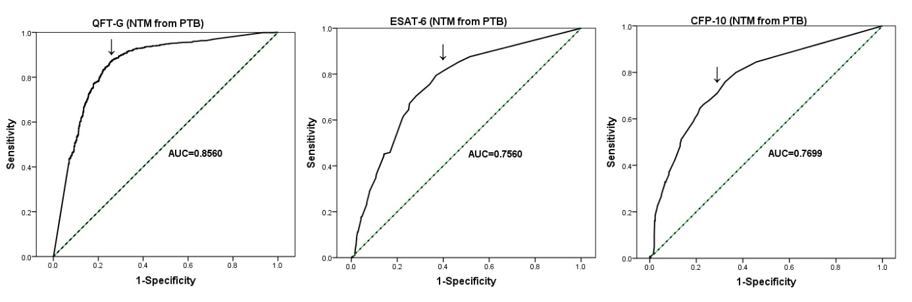
Figure S1. Receiver Operating Characteristic (ROC) curves for ESAT-6, CFP-10 and QFT-G while discriminating NTM from PTB. The dotted diagonal line indicates no discrimination. The optimal cut-off point in ROC is marked with arrow.

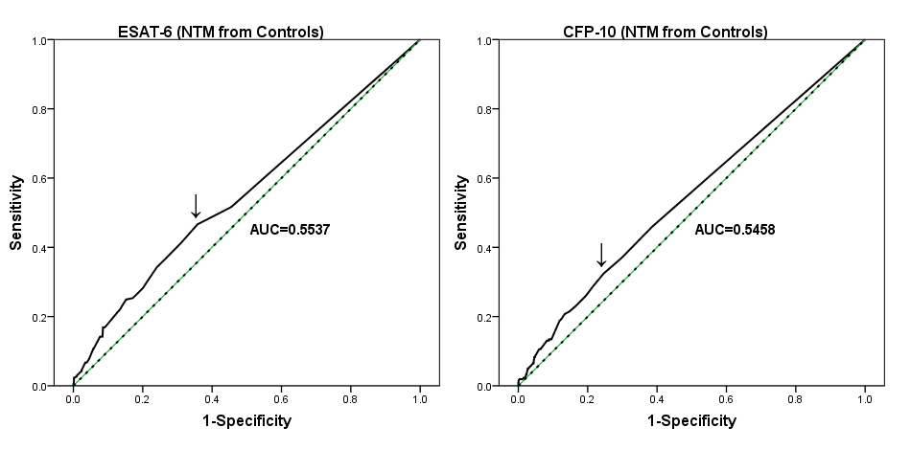
Figure S2. Receiver Operating Characteristic (ROC) curves for ESAT-6 and CFP-10 while discriminating NTM from Controls. The dotted diagonal line indicates no discrimination. The optimal cut-off point in ROC is marked with arrow.

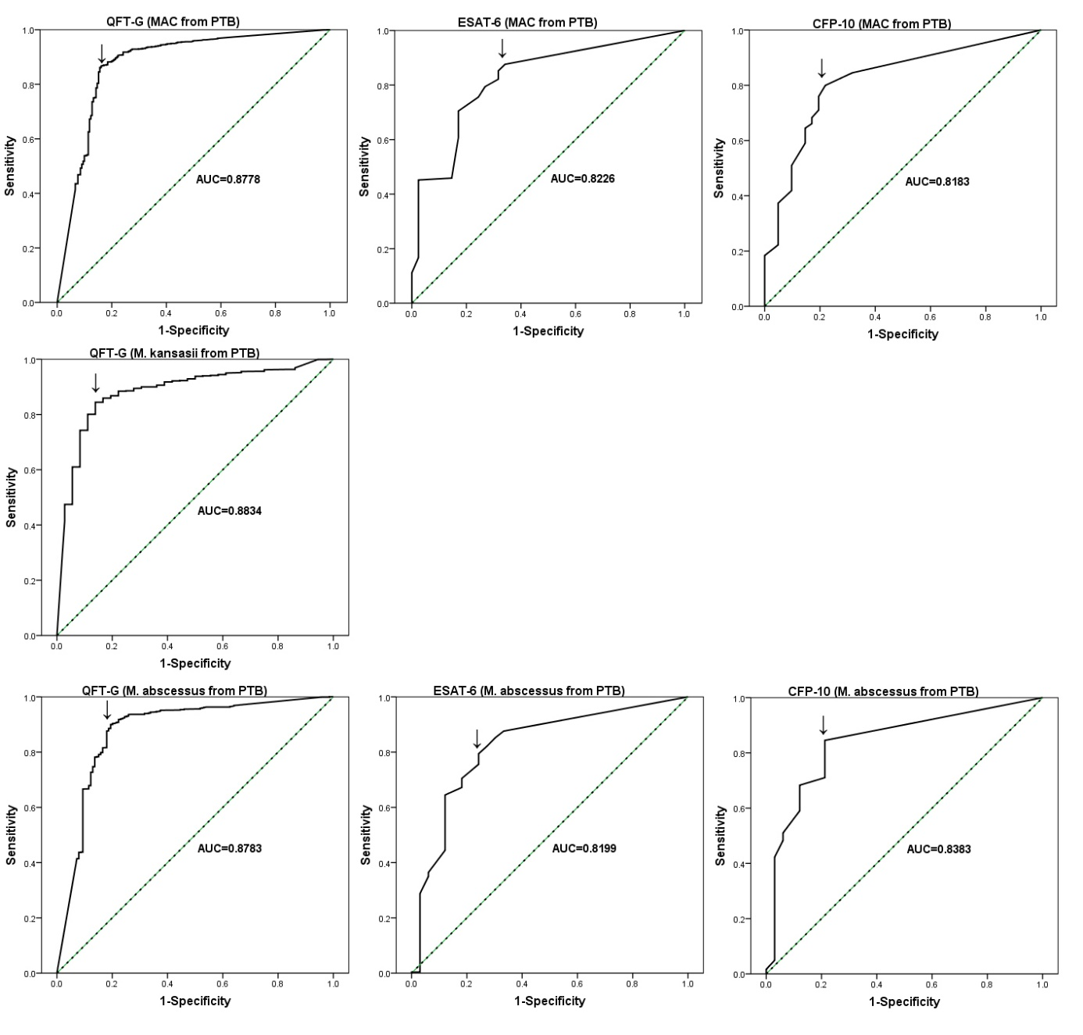
Figure S3. Receiver Operating Characteristic (ROC) curves for ESAT-6, CFP-10 and QFT-G while discriminating species of NTM from PTB. The dotted diagonal line indicates no discrimination. The optimal cut-off point in ROC is marked with arrow.

