**Disease Activity by Number of Stools**

Mantel-Haenszel test of trend: χ²=18.24, *p*<.001

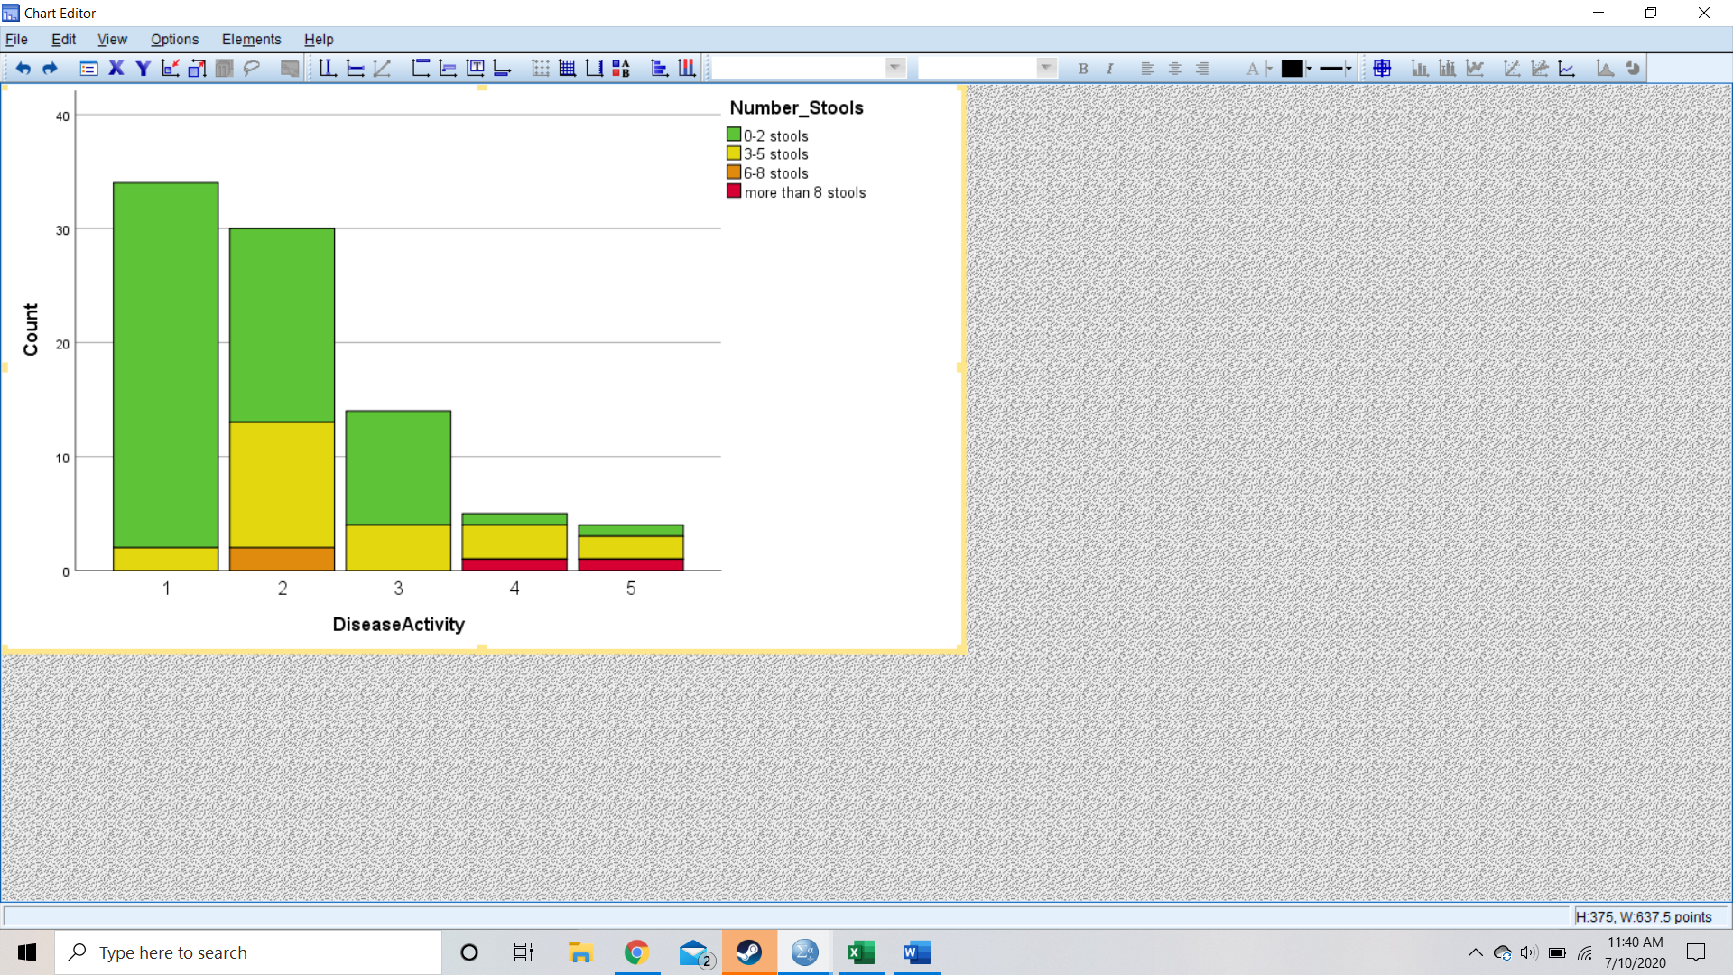

**Disease Activity by Consistency of Stools**

Mantel-Haenszel test of trend: χ²=18.575, *p*<.001

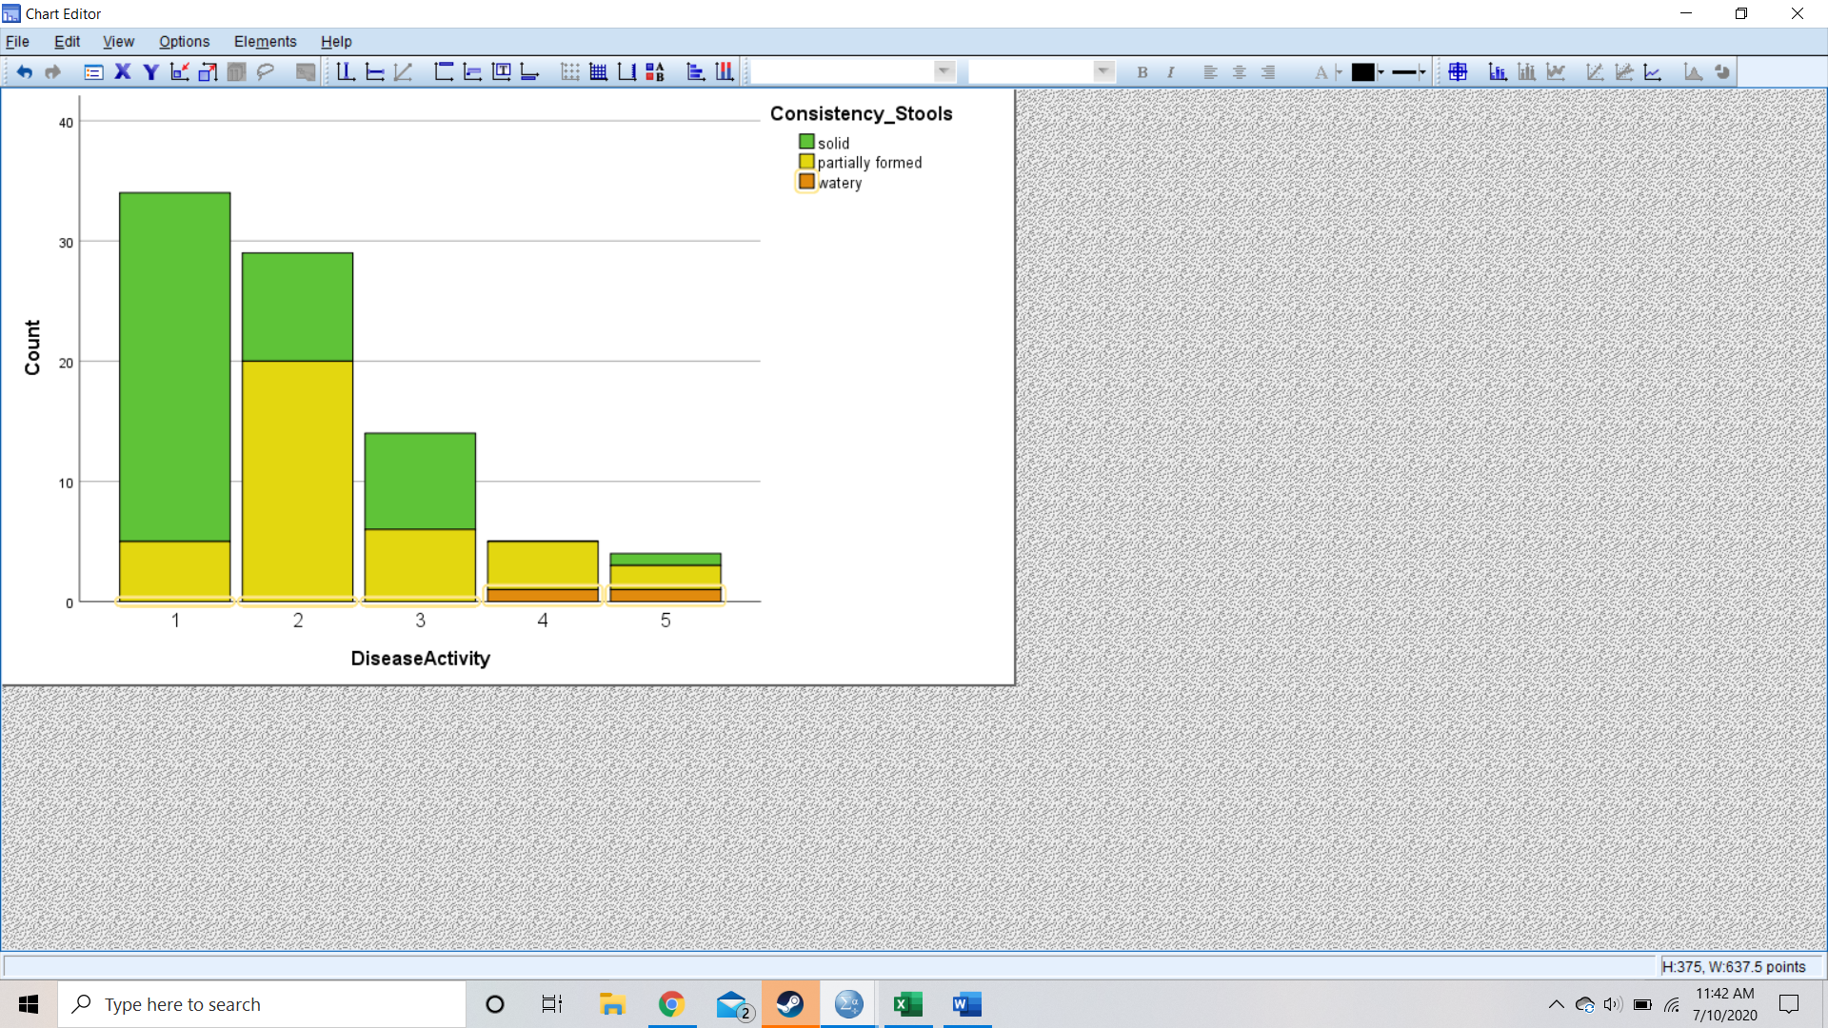

**Disease Activity by Blood in Stools**

Mantel-Haenszel test of trend: χ²=30.327, *p*<.001

