Turmeric is therapeutic in vivo on patient-derived colorectal cancer xenografts: inhibition of growth, metastasis and tumour recurrence

Mingyue Li, Grace Gar-Lee Yue, Lianxiang Luo, Stephen Kwok-Wing Tsui, Kwok-Pui Fung, Simon Siu-Man Ng, Clara Bik-San Lau

Supplement information
Table S1. Gene specific PCR primers
Genes | Forward Primer | Reverse Primer
ABCA13 | AGGAGTGTGAGGCTCTTTGC | GGTGCTGTCCCTTGAACTGA
ABCB1 | CTGCTTGATGGCAAAGAAATAAAG | GGCTGTTGTCTCCATAGGCAAT
ASNS | CACTCCGCGACTCCCTTTT | ACCATTTCCACGGATGCAA
AXIN2 | ATTCGGCCACTGTTCAGACG | GACAACCAACTCACTGGCCTG
CD9 | TGCATCTGTATCCAGCGCCA | CTCAGGGATGTAAGCTGACT
DKK1 | AGCGTTGTTACTGTGGAGAAG | GTGTGAAGCCTAGAAGAATTACTG
E-cadherin | TTGACGCCGAGAGCTACAC | GTCGACCGGTGCAATCTT
EpCAM | AGTTGGTGCACAAAATACTGTCAT | TCCCAAGTTTTGAGCCATTC
EGFR | TCCCTCAGCCACCCATATGTAC | GTCTCGGGCCATTTTGGAGAATTC
GAPDH | CGAGATCCCTCCAAAATCAA | GGTGCTAAGCAGTTGGTGGT
N-cadherin | TCGCCATCCAGACCGACCCA | TGAGGCGGGTGCTGAATTCCC
PDGFRB | AGACACGGGAGAATACTTTTGC | AGTTCCTCGGCATCATTAGGG
RTKN2 | ATGCTCGACTAATGGCCTATACA | CGTCGTGATCGTTCTTTATTGCT
SMAD7 | GACAGCTCAATTCGGACAAC | TCTCGTAGTCGAAAGCCTTG
Snail | ATGCCGCGCTCTTTCCTCGTC | AGCAGGTGGGCCTGGTCGTAG
vimentin | ATTCCACTTTGCGTTCAAGG | CTTCAGAGAGAGGAAGCCGA

Table S2. 14 potential active compounds of turmeric extract
Chemical Component | Pubchem Cid | 2D Structure
Bisdemethoxycurcumin | CID: 5315472 | 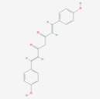
1,7-Bis(4-Hydroxy-3-Methoxyphenyl)-1,4,6-Heptatrien-3-One | CID: 10904292 | 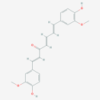
1,5-Bis(4-Hydroxy-3-Methoxyphenyl)-1,4-Pentadien-3-One | CID: 468133 | 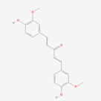
1,7-Bis(4-Hydroxyphenyl)-1,4,6-Heptatrien-3-One | CID: 71346280 | 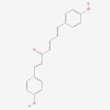
Calebin A | CID: 637429 | 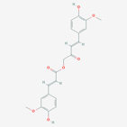
Curcumin | CID: 969516 | 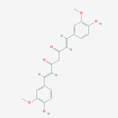
Demethoxycurcumin | CID: 5469424 | 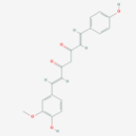
Isoprocurcumenol | CID: 14543198 | 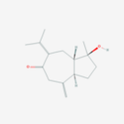
Procurcumadiol | CID: 14633011 | 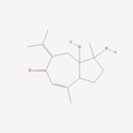
Zedoarondiol | CID: 24834047 | 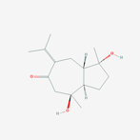
Stigmasterol | CID: 5280794 | 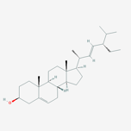
campesterol | CID: 173183 | 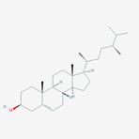
cholesterol | CID: 5997 | 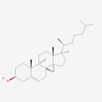
1Îo-Hydroxy-1,7-Bis(4-Hydroxy-3-Methoxyphenyl)-6-Heptene-3,5-Dione | CID: 68548065 | 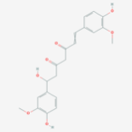

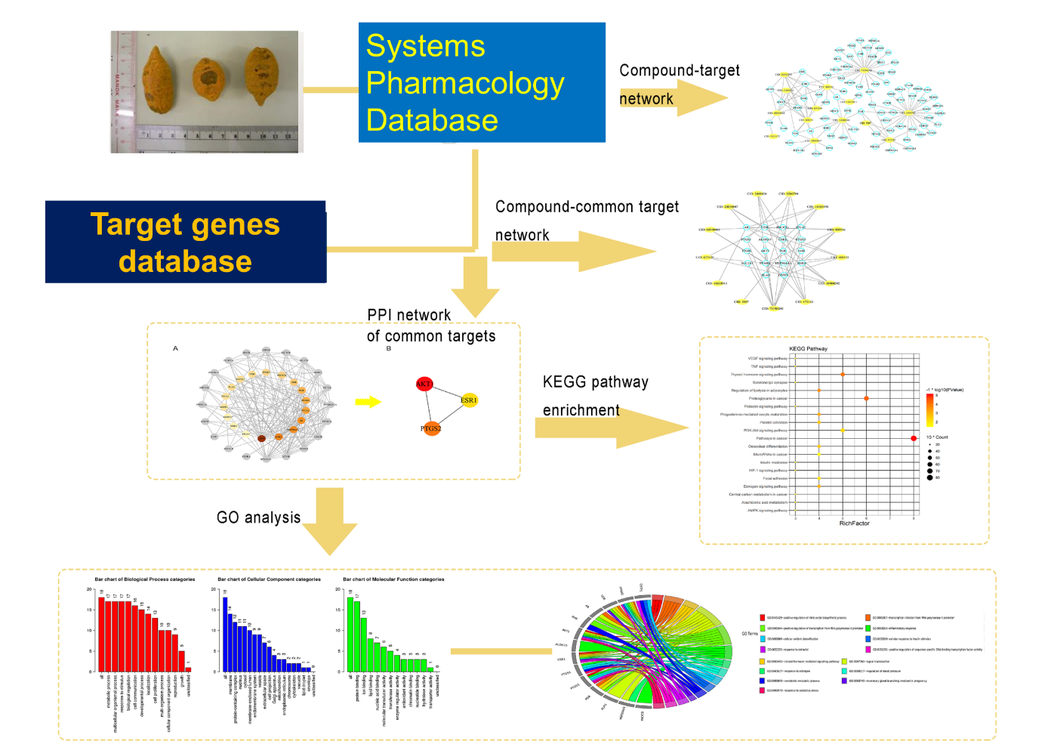
Fig. S1 Network pharmacology workflow

Fig. S2 Compound-target Network of potential targets in Turmeric extract. Yellow nodes stand for bioactive compounds from Turmeric extract. White nodes stand for putative targets.
Fig. S3 Compound-candidate target Network. The white nodes represent candidate targets of Turmeric extract treated colorectal cancer. The colored nodes represent bioactive compounds from Turmeric extract. The darker the color, the greater the degree.

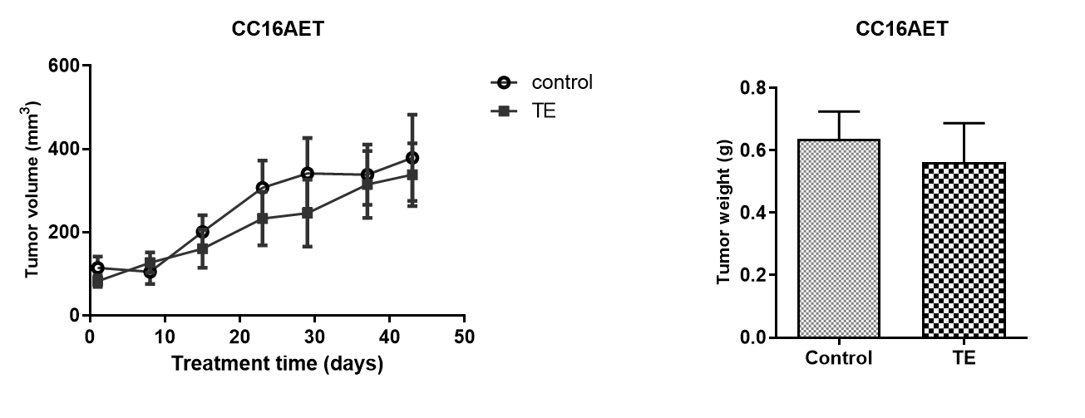

Fig. S4 Effects of TE treatment in PDX sample CC16AET. The (A) tumor volume and (B) weight in the control group and TE treatment groups were shown (n = 7-8). Tumor volume was measured once a week while the final tumor weight was measured at the end of the experiment. Data were presented as mean ± SEM, no significant difference of the tumor weight between two groups.

