Supplementary Material

**Table S1. A. Genetic variants associated with D-dimer levels, homocysteine levels, thrombosis, heparin-induced thrombocytopenia & transldolase-related thrombocytopenia and COVID-19 – allele frequencies in continental populations. B. Gene ontology based classification of these variants, as assigned by XGR tool, is also provided.**

|  |  |  |  |  |  |  |  |  |  |  |
| --- | --- | --- | --- | --- | --- | --- | --- | --- | --- | --- |
| dbSNP identifier rs_ID-effect allele  (reference and alternate alleles)  Gene  @, represents that the effect allele is different from the minor allele | P-value denoting the significance of association | Odds ratio or effect size | Minor allele frequency in continental populations (AFR: Africans; AMR: Ad-mixed Americans; EAS: East Asians; EUR: Europeans; SAS: South Asians) | | | | | | | |
|  | | | **AFR** | **AMR** | **EAS** | **EUR** | **SAS** | **Qatar** | **Iran** | **Kuwait** |
| A.1. Top three SNPs associated with D-dimer levels in GWAS Catalog | | | | | | | | | | |
| rs13109457-A (G_A)  (FGG,FGA) | 3 x 10-18 | 6.3 % increase | 27% | 21% | 43% | 23% | 25% | 20% | 23% | 24% |
| rs12029080-G (T_G)  AC093117.1 | 6 x 10-52 | 10.4 % increase | 7% | 23% | 27% | 30% | 26% | 17% | 29% | 23% |
| rs6687813-A (C_A)  (F5, Z99572.1/SLC19A2) | 2 x 10-14 | 10.1 % increase | 12% | 5% | 0% | 7% | 6% | 13% | NA | 13% |
| A.2. eQTL variant regulating expression of FGG and FGA genes (as annotated in GTeX database) | | | | | | | | | | |
| rs17031315-? (A_T)  protocadherin-23 (DCHS2) | 8.6e-8 (FGG)  1.2e-8 (FGA) | Downregulates FGG and FGA in liver with an effect size of -1.7 | 12% | 13% | 0% | 0.2% | 0% | 1.1% | 0.65% | 1% |
| A.3. Variants associated with homocysteine levels. GWAS Catalog lists 44 variants from 34 genes including VWF (von Willebrand factor), TRDMT1, SLC17A3, (RPL24P4,GNMT), PSPH, (PRDX1,MMACHC), (OLFML3,SYT6), NOX4, MTR, MTHFR, (MMUT,EEF1A1P42), (MIR548G,AC010683.1), MFN2, HNF1a-AS1. GTPBP10, GABBR2, FGF21, FANCA, (DPEP1,CHMP1A), CUBN, CSMD1, CPS1, COLEC12, CD2AP, CBS, ATOH8, ADAMTS13 and ABO. The top 6 association signals with effect size of >0.15 unit increase/decrease in homocysteine levels are as listed below. | | | | | | | | | | |
| [rs234714-T](https://www.ebi.ac.uk/gwas/variants/rs234714) (C_T)  CBS | 3 x 10-26 | 0.404 unit increase | 9% | 51% | 30% | 23% | 28% | 26% | 23% | 26% |
| [rs9296404-T](https://www.ebi.ac.uk/gwas/variants/rs9296404) (C_T)  (RPL24P4,GNMT) | 2 x 10-63 | 0.356 unit increase | 24% | 57% | 83% | 46% | 54% | 40% | NA | 44% |
| [rs505922-C](https://www.ebi.ac.uk/gwas/variants/rs505922) (T_C)  ABO | 2 x 10-30 | 0.3315 unit decrease | 35% | 28% | 38% | 34% | 45% | 29% | 37% | 37% |
| [rs10934753-A](https://www.ebi.ac.uk/gwas/variants/rs10934753) (G_A)  (ALDH1L1, ALDH1L1-AS2) | 7 x 10-13 | 0.193 unit increase | 19% | 31% | 31% | 43% | 31% | 53% | 37% | 46% |
| [rs1047891-A](https://www.ebi.ac.uk/gwas/variants/rs1047891) (C_A)  CPS1 | 9 x 10-13 | 0.191 unit increase | 37% | 34% | 14% | 30% | 28% | 42% | NA | 33% |
| [rs1801133-A](https://www.ebi.ac.uk/gwas/variants/rs1801133) (G_A)  MTHFR  Missense (A_V) | 4 x 10-104 | 0.1563 unit increase | 9% | 47% | 30% | 36% | 12% | 14% | 31% | 18% |
| rs1801131_G (T_G)  MTHFR (E_A) |  |  | 15% | 15% | 22% | 31% | 42% | 35% | 40% | 33% |
| rs1801131_G (T_G)  MTHFR (E_A) |  |  | 15% | 15% | 22% | 31% | 42% | 35% | 40% | 33% |
| A.4. Variants associated with heparin-induced thrombocytopenia in GWAS Catalog | | | | | | | | | | |
| rs1433265-C (T_C)  [AC106799.2](https://www.ebi.ac.uk/gwas/genes/AC106799.2) (lincRNA) | 3 x 10-8 | 2.77 | 59% | 35% | 4% | 32% | 42% | 31% | NA | 31% |
| rs905227-? (G_A)  [ZNF84](https://www.ebi.ac.uk/gwas/genes/ZNF84) | 9 x 10-6 | 2.41 | 49% | 34% | 22% | 43% | 46% | NA | NA | NA |
| rs10066908-A@ (A_C)  AC106799.2 | 5 x 10-6 | 2.41 | 12% | 30% | 47% | 26% | 29% | 26% | NA | 25% |
| [rs4702795-G](https://www.ebi.ac.uk/gwas/variants/rs4702795) (A_G)  AC106799.2 | 5 x 10-6 | 2.41 | 24% | 29% | 3% | 22% | 36% | 22% | NA | 23% |
| rs13156459-C (T_C)  AC106799.2 | 5 x 10-6 | 2.41 | 58% | 35% | 3% | 27% | 41% | 32% | NA | 31% |
| [rs9313082-C](https://www.ebi.ac.uk/gwas/variants/rs9313082)@ (C_T)  AC106799.2 | 5 x 10-6 | 2.41 | 46% | 37% | 84% | 26% | 40% | 31% | 37% | 33% |
| [rs13187757-C](https://www.ebi.ac.uk/gwas/variants/rs13187757)@ (C_T)  AC106799.2 | 5 x 10-6 | 2.41 | 20% | 12% | 0% | 17% | 1.6% | 18% | 16% | NA |
| [rs10069475-A](https://www.ebi.ac.uk/gwas/variants/rs10069475)@ (A_T)  AC106799.2 | 5 x 10-6 | 2.41 | 9% | 2% | 0% | 2% | 2% | 4% | NA | NA |
| [rs13186039-T](https://www.ebi.ac.uk/gwas/variants/rs13186039) (G_T)  AC106799.2 | 5 x 10-6 | 2.41 | 30% | 30% | 3% | 23% | 36% | 22% | 22% | NA |
| [rs12516470-C](https://www.ebi.ac.uk/gwas/variants/rs12516470) (T_C)  AC106799.2 | 5 x 10-6 | 2.41 | 21% | 30% | 3% | 26% | 38% | 27% | 25% | 26% |
| The following two variants associated with heparin-induced thrombocytopenia are from [39]. | | | | | | | | | | |
| rs1887289_? (C_T)  ncRNA near TDAG8. |  | 5.71 | 19% | 12% | 21% | 11% | 30% | 20% | 12.4% | 15% |
| rs3742704_? (A_C) |  | 1.90 | 22% | 15% | 21% | 10% | 29% | 13.5% | NA | 9% |
| A.5. Variants linking taldolase-related thrombocytopenia and COVID-19 | | | | | | | | | | |
| rs77216754_? (T_C)  (TALDO1,PDDC1) |  |  | 33% | 7% | 4% | 9% | 7% | 7.8% | 4.5% | 8% |
| rs12252_? (A_G)  IFITM3 |  |  | 26% | 18% | 53% | 4% | 15% | 14.5% | 10.5% | 10.5% |
| A.6. Variants associated with pulmonary embolism and deep vein thrombosis in GWAS Catalog | | | | | | | | | | |
| [rs6025-T](https://www.ebi.ac.uk/gwas/variants/rs6025) (C_T)  F5 | 4 x 10-137 | 2.927 | 0% | 1% | 0% | 1% | 1% | 0.5% | 0.6% | 0.9% |
| [rs1799963-A](https://www.ebi.ac.uk/gwas/variants/rs1799963) (G_A)  F2 | 1 x 10-24 | 1.95 | 0% | 1% | 0% | 1% | 0% | 1% | 1.3% | 1% |
| [rs529565-C](https://www.ebi.ac.uk/gwas/variants/rs529565) (T_C)  ABO | 7 x 10-63 | 1.38 | 39% | 27% | 38% | 34% | 45% | 30% | NA | 37.3% |
| [rs113092656-A](https://www.ebi.ac.uk/gwas/variants/rs113092656) (G_A)  [AL357518.2](https://www.ebi.ac.uk/gwas/genes/AL357518.2), [AL357518.1](https://www.ebi.ac.uk/gwas/genes/AL357518.1) | 4 x 10-7 | 1.37 | 0% | 1% | 0% | 3% | 2% | 1.9% | 2.6% | NA |
| [rs72798544-G](https://www.ebi.ac.uk/gwas/variants/rs72798544) (T_G)  COX7A2L | 2 x 10-7 | 1.36 | 0% | 1% | 0% | 2% | 1% | 1% | NA | 1% |
| [rs4444878-A](https://www.ebi.ac.uk/gwas/variants/rs4444878) (C_A)  F11-AS1 | 7 x 10-28 | 1.23 | 22% | 34% | 35% | 39% | 34% | 27.3% | NA | 32% |
| [rs7654093-T](https://www.ebi.ac.uk/gwas/variants/rs7654093) (A_T)  [LRAT](https://www.ebi.ac.uk/gwas/genes/LRAT), [FGG](https://www.ebi.ac.uk/gwas/genes/FGG) | 2 x 10-19 | 1.22 | 35% | 21% | 45% | 22% | 24% | 21% | 20% | 26% |
| [rs60942712-T](https://www.ebi.ac.uk/gwas/variants/rs60942712) (G_T)  [GAPDHP50](https://www.ebi.ac.uk/gwas/genes/GAPDHP50), [ICE2P2](https://www.ebi.ac.uk/gwas/genes/ICE2P2) | 8 x 10-7 | 1.20 | 1% | 5% | 0% | 12% | 12% | 10.2% | NA | NA |
| [rs17490626-G](https://www.ebi.ac.uk/gwas/variants/rs17490626)@ (G_C)  [TSPAN15](https://www.ebi.ac.uk/gwas/genes/TSPAN15) | 3 x 10-7 | 1.17 | 1% | 8% | 0% | 13% | 1% | 3.7% | 6.5% | NA |
| [rs114209171-T](https://www.ebi.ac.uk/gwas/variants/rs114209171)@ (T_C)  [FUNDC2](https://www.ebi.ac.uk/gwas/genes/FUNDC2) | 7 x 10-13 | 1.15 | 19% | 31% | 22% | 17% | 37% | 30.6% | NA | NA |
| [rs9797861-T](https://www.ebi.ac.uk/gwas/variants/rs9797861) @ (T_C)  [SLC44A2](https://www.ebi.ac.uk/gwas/genes/SLC44A2) | 6 x 10-9 | 1.15 | 14% | 16% | 29% | 24% | 24% | 31% | 27% | 31% |
| [rs34234989-?](https://www.ebi.ac.uk/gwas/variants/rs34234989) (AA_A)  PROCR | 7 x 10-9 | 1.13 | 72% | 33% | 12% | 28% | 40% | NA | NA | NA |
| [rs710446-?](https://www.ebi.ac.uk/gwas/variants/rs710446) (T_C)  KNG1 | 2 x 10-6 | 0.09 unit decrease | 52% | 47% | 30% | 42% | 36% | 40.3% | 42.2% | 42% |
| A.7. Variants associated with venous thromboembolism. More than 300 association signals are seen in GWAS Catalog. Only those that have an OR of >= 1.75 and P-value <E-08 and those that did not appear in the above list for pulmonary thrombosis are listed in the rows below. | | | | | | | | | | |
| [rs142143628-T](https://www.ebi.ac.uk/gwas/variants/rs142143628) (C_T)  [AC022182.2](https://www.ebi.ac.uk/gwas/genes/AC022182.2) | 4 x 10-8 | 4.97 | 1% | 0% | 0% | 0% | 0% | NA | NA | 0.1% |
| [rs138916004-G](https://www.ebi.ac.uk/gwas/variants/rs138916004) (A_G)  [LEMD3](https://www.ebi.ac.uk/gwas/genes/LEMD3) | 1 x 10-8 | 3.17 | 2% | 0% | 0% | 0% | 0% | 1.4% | NA | 0.2% |
| [rs73692310-T](https://www.ebi.ac.uk/gwas/variants/rs73692310) (C_T)  [AC073115.2](https://www.ebi.ac.uk/gwas/genes/AC073115.2) | 2 x 10-8 | 3.04 | 7% | 0% | 0% | 0% | 0% | 0.5% | NA | NA |
| [rs1018827-A](https://www.ebi.ac.uk/gwas/variants/rs1018827) (G_A)  F5 | 2 x 10-26 | 2.52 | 13% | 5% | 0% | 6% | 6% | 11% | 4% | 12% |
| [rs28496996-G](https://www.ebi.ac.uk/gwas/variants/rs28496996) (T_G)  AP005230.1,AP005262.1 | 6 x 10-8 | 2.40 | 10% | 2% | 0% | 0% | 0% | 0.5% | 1.3% | NA |
| [rs6025-T](https://www.ebi.ac.uk/gwas/variants/rs6025) (C_T)  F5 | 1 x 10-188 | 2.39 | 0% | 1% | 0% | 1% | 1% | 0.5% | 0.6% | 0.9% |
| [rs1799963-A](https://www.ebi.ac.uk/gwas/variants/rs1799963) (G_A)  F2 | 2 x 10-9 | 2.29 | 0% | 1% | 0% | 1% | 0% | 1% | 1.3% | 1% |
| [rs1998081-T](https://www.ebi.ac.uk/gwas/variants/rs1998081) (C_T)  [CD93](https://www.ebi.ac.uk/gwas/genes/CD93), [AL118508.3](https://www.ebi.ac.uk/gwas/genes/AL118508.3) | 5 x 10-8 | 2.28 | 22% | 8% | 3% | 8% | 9% | 7% | 12% | 7% |
| [rs2144940-C](https://www.ebi.ac.uk/gwas/variants/rs2144940) (T_C)  [THBD](https://www.ebi.ac.uk/gwas/genes/THBD), [AL118508.3](https://www.ebi.ac.uk/gwas/genes/AL118508.3) | 2 x 10-8 | 2.18 | 26% | 9% | 3% | 8% | 10% | 15.3% | 14.3% | 10% |
| [rs6427196-C](https://www.ebi.ac.uk/gwas/variants/rs6427196) (G_C)  F5 | 4 x 10-51 | 2.07 | 21% | 5% | 0% | 7% | 6% | 12.7% | 14.3% | 13% |
| [rs16861990-C](https://www.ebi.ac.uk/gwas/variants/rs16861990) (A_C)  NME7 | 2 x 10-12 | 2.02 | 2% | 7% | 6% | 6% | 12% | 5.6% | 11% | 12% |
| [rs191945075-A](https://www.ebi.ac.uk/gwas/variants/rs191945075) (G_A)  [LRP4](https://www.ebi.ac.uk/gwas/genes/LRP4) | 1 x 10-31 | 1.86 | 0% | 2% | 0% | 1% | 0% | 1% | 2.6% | 1% |
| [rs3804476-G](https://www.ebi.ac.uk/gwas/variants/rs3804476) (A_G)  [LY86](https://www.ebi.ac.uk/gwas/genes/LY86) | 2 x 10-8 | 1.83 | 8% | 38% | 27% | 44% | 29% | 41.2% | 30.5% | 31% |
| [rs505922-C](https://www.ebi.ac.uk/gwas/variants/rs505922) (T_C)  ABO | 4 x 10-15 | 1.81 | 35% | 28% | 38% | 34% | 45% | 28.7% | 37% | 37% |
| B. Gene ontology based classification of the variants (as assigned using the XGR tool). | | | | | | | | | | |
| The set of 24 variants, that xGR associated with each of the two parental terms of venous thromboembolism and vascular diseases are: rs1018827 (F5), rs113092656 (AL357518.2, AL357518.1), rs114209171 (FUNDC2), rs138916004 (LEMD3) , rs142143628 (AC022182.2), rs16861990 (NME7), rs17490626 (TSPAN15), rs1799963 (F2), rs1998081 (CD93, AL118508.3), rs2144940 (THBD, AL118508.3), rs28496996 (AP005230.1,AP005262.1), rs34234989 (PROCR), rs3804476 (LY86), rs4444878 (F11-AS1), rs505922 (ABO), rs529565 (ABO), rs6025 (F5), rs60942712 (GAPDHP50, ICE2P2), rs6427196 (F5), rs710446 (KNG1), rs72798544 (COX7A2L), rs73692310 (AC073115.2), rs7654093 (LRAT, FGG), rs9797861 (SLC44A2). | | | | | | | | | | |
| A subset of 13 variants from the above list were associated with each of the parental terms of pulmonary embolism, stroke and cerebrovascular diseases and they are: rs113092656 (AL357518.2, AL357518.1), rs114209171 (FUNDC2), rs17490626 (TSPAN15), rs1799963 (F2), rs34234989 (PROCR), rs4444878 (F11-AS1), rs529565 (ABO), rs6025 (F5), rs60942712 (GAPDHP50, ICE2P2), rs710446 (KNG1), rs72798544 (COX7A2L), rs7654093 (LRAT, FGG), rs9797861 (SLC44A2) | | | | | | | | | | |

**Table S2. Results from Gene network analysis using the XGR tool by considering 0.05 MB region around the study variants. Figure S2 presents pictorial representation of the network.** This table and Figure S2 present resultant gene subnetwork of functional interactions with high confidence score>=700 from the study variants. Red font: genes not seen in our study list but picked by XGR by using GWAS SNPs in LD with the study variants.

|  |  |  |  |  |
| --- | --- | --- | --- | --- |
| Gene | Description | Associated with | Significance (P-value for false discovery rate test) | Score for the gene |
| F5 | coagulation factor V | D-dimer level | 1.00E-10 | 29.96736258 |
| FGG | fibrinogen gamma chain | D-dimer level | 1.00E-10 | 29.96736258 |
| FGA | fibrinogen alpha chain | D-dimer level | 1.00E-10 | 29.96736258 |
| FGB | fibrinogen beta chain | Fibrinogen level | 4.98E-08 | 21.00721865 |
| CBS | cystathionine-beta-synthase | Homocysteine level | 1.00E-10 | 29.96736258 |
| MTHFR | methylenetetrahydrofolate reductase | Homecysteine level | 1.00E-10 | 29.96736258 |
| IGFBP3 | insulin like growth factor binding protein 3 | Obesity-related traits | 0.00039998 | 8.035288949 |
| ADCY1 | adenylate cyclase 1 | Schizophrenia and muscular dystrophy | 0.00039998 | 8.035288949 |
| F2 | coagulation factor II, thrombin | Thrombosis (both vein thrombosis and pulmonary embolism) | 1.00E-10 | 29.96736258 |
| CD93 | CD93 molecule | Venous throboembolism | 0.000811476 | 7.014074204 |
| THBD | Thrombomodulin | Venous throboembolism | 0.018963614 | 2.441082407 |
| KNG1 | kininogen 1 | Thrombosis (both vein thrombosis and pulmonary embolism) | 0.03999808 | 1.333116264 |
| F11 | coagulation factor XI | Venous thromboembolism | 1.00E-10 | 29.96736258 |
| F8 | coagulation factor VIII | Venous thromboembolism | 1.40E-08 | 22.83815167 |
| CHRM4 | cholinergic receptor muscarinic 4 | Abnormal thrombosis | 2.90E-07 | 18.46690079 |
| F3 | coagulation factor III, tissue factor | Intravascular coagulation and carotid artery thrombosis | 0.000133409 | 9.619740986 |
| KLKB1 | kallikrein B1 | Venous thromboembolism | 0.00017759 | 9.206990988 |

**Table S3. Results from Gene network analysis using the XGR tool by considering 0.5 MB region around the study variants. Figure S3 presents pictorial representation of the network.** This table and Figure S3 present resultant gene subnetwork of functional interactions with high confidence score>=700 from the study variants. Red font: genes not seen in our study list but picked by XGR by using GWAS SNPs in LD with the study variants.

|  |  |  |  |  |
| --- | --- | --- | --- | --- |
| Name | Description | Associated with | Significance | Score |
| F5 | coagulation factor V | D-dimer level | 1.00E-10 | 29.59479 |
| FGG | fibrinogen gamma chain | D-dimer level | 1.00E-10 | 29.59479 |
| FGA | fibrinogen alpha chain | D-dimer level | 1.00E-10 | 29.59479 |
| FGB | fibrinogen beta chain | D-dimer level | 1.40E-10 | 29.11165 |
| NME7 | NME/NM23 family member 7 | D-dimer measurement, venous thrombosis, blood pressure, pulse pressure; thromboembolism | 1.00E-10 | 29.59479 |
| F13A1 | coagulation factor XIII A chain | Coagulation factor measurements | 0.04713 | 0.713086 |
| CBS | cystathionine-beta-synthase | Homocysteine level | 1.00E-10 | 29.59479 |
| MTHFR | methylenetetrahydrofolate reductase | Homocysteine level | 1.00E-10 | 29.59479 |
| F11 | coagulation factor XI | Venous thromboembolism | 1.00E-10 | 29.59479 |
| F2 | coagulation factor II, thrombin | Thrombosis (both vein thrombosis and pulmonary embolism) | 1.00E-10 | 29.59479 |
| DGKZ | diacylglycerol kinase zeta | Venous thromboembolism | 1.24E-10 | 29.27868 |
| CHRM4 | cholinergic receptor muscarinic 4 | Abnormal thrombosis | 1.55E-10 | 28.95891 |
| F3 | coagulation factor III, tissue factor | Intravascular coagulation and carotid artery thrombosis | 2.39E-10 | 28.3407 |
| KLKB1 | kallikrein B1 | Venous thromboembolism | 2.44E-10 | 28.30728 |
| F8 | coagulation factor VIII | Venous thromboembolism | 1.40E-08 | 22.46558 |
| CD93 | CD93 molecule | Venous thromboembolism | 0.000415 | 7.610455 |
| THBD | Thrombomodulin | Venous thromboembolism | 0.000614 | 7.044379 |
| S1PR5 | sphingosine-1-phosphate receptor 5 | Venous thromboembolism | 0.000896 | 6.498589 |
| KNG1 | kininogen 1 | Thrombosis (both vein thrombosis and pulmonary embolism) | 0.039998 | 0.960544 |
| SELP | selectin P | Activated partial thromboplastin time | 5.38E-10 | 27.16752 |
| HRG | histidine rich glycoprotein | Activated partial thromboplastin time | 0.060083 | 0.34302 |
| NPPA | natriuretic peptide A | Blood/pulse pressure | 9.72E-10 | 26.31352 |
| NPPB | natriuretic peptide B | Blood/pulse pressure | 1.67E-09 | 25.5326 |
| SELL | selectin L | Eosinophil counts | 5.82E-08 | 20.40953 |
| SELE | selectin E | Blood leucocyte count | 2.54E-07 | 18.28515 |
| LANCL1 | LanC like 1 | Glycine measurement, red blood cell count | 2.18E-05 | 11.86307 |
| TNFRSF8 | TNF receptor superfamily member 8 | Hay fever, asthma, eosinophil counts, | 2.19E-05 | 11.85201 |
| CHD7 | chromodomain helicase DNA binding protein 7 | Eosinophil count, obesity | 0.0033 | 4.614198 |
| ICAM3 | intercellular adhesion molecule 3 | Lymphocyte counts | 0.022419 | 1.821945 |
| ICAM1 | intercellular adhesion molecule 1 | [intercellular adhesion molecule 5 measurement](https://www.ebi.ac.uk/gwas/efotraits/EFO_0008164); ICAM1 measurement; leucocyte/lymphocyte measurement | 0.058431 | 0.385765 |
| ICAM4 | intercellular adhesion molecule 4 (Landsteiner-Wiener blood group) | [adhesion molecule measurement](https://www.ebi.ac.uk/gwas/efotraits/EFO_0004522), [ICAM-1 measurement](https://www.ebi.ac.uk/gwas/efotraits/EFO_0004520) | 0.05639 | 0.44018 |
| ICAM1 | intercellular adhesion molecule 1 | [intercellular adhesion molecule 5 measurement](https://www.ebi.ac.uk/gwas/efotraits/EFO_0008164); ICAM1 measurement; leucocyte/lymphocyte measurement | 0.058431 | 0.385765 |
| PDE4A | phosphodiesterase 4A | Intercellular adhesion molecule | 0.002145 | 5.237004 |
| SRF | serum response factor | cell proliferation and differentiation | 6.89E-07 | 16.84483 |
| SMARCA4 | SWI/SNF related, matrix associated, actin dependent regulator of chromatin, subfamily a, member 4 | Lipids, coronary heart disease | 0.045149 | 0.778013 |
| CARM1 | coactivator associated arginine methyltransferase 1 | Lipids | 0.008996 | 3.159021 |
| NR1H3 | nuclear receptor subfamily 1 group H member 3 | Lipids | 0.000538 | 7.234847 |
| ATP1B1 | ATPase Na+/K+ transporting subunit beta 1 | Blood/pulse pressure, QT interval, Venous thromboembolism | 1.48E-09 | 25.70833 |
| FAT1 | FAT atypical cadherin 1 | Obesity, heel bone density, | 7.96E-05 | 9.991778 |
| IGFBP3 | insulin like growth factor binding protein 3 | Obesity-related traits | 0.0004 | 7.662716 |
| AK8 | adenylate kinase 8 | Obesity-related traits | 0.004543 | 4.151155 |
| SPI1 | Spi-1 proto-oncogene | BMI, C-reactive protein, | 0.072768 | 0.047065 |
| PNPLA2 | patatin like phospholipase domain containing 2 | Waist-hip ratio | 0.237017 | -1.93783 |
| ADIPOQ | adiponectin, C1Q and collagen domain containing | Adiponectin measurement, BMI-adjusted adiponectin measurement | 0.076406 | -0.02899 |
| ADCY1 | adenylate cyclase 1 | Schizophrenia and muscular dystrophy | 0.0004 | 7.662716 |
| CEL | carboxyl ester lipase | Atherosclerosis; Maturity-onset diabetes of the young type 8 | 6.26E-07 | 16.98382 |
| LEMD3 | LEM domain containing 3 | Brain volume measurement, Venous thromboembolism, | 0.0002 | 8.663005 |
| WIF1 | WNT inhibitory factor 1 | Brain volume measurement | 0.000624 | 7.019737 |
| MTNR1A | melatonin receptor 1A | Circadian rhythms | 6.58E-06 | 13.58807 |
| SSTR4 | somatostatin receptor 4 | Cognitive performance | 0.000752 | 6.75099 |
| TACR2 | tachykinin receptor 2 | Breast cancer mortality | 0.009218 | 3.123475 |

**Figure S1. Minor allele frequencies at the variants presented (Table 2.A.) in this study.**

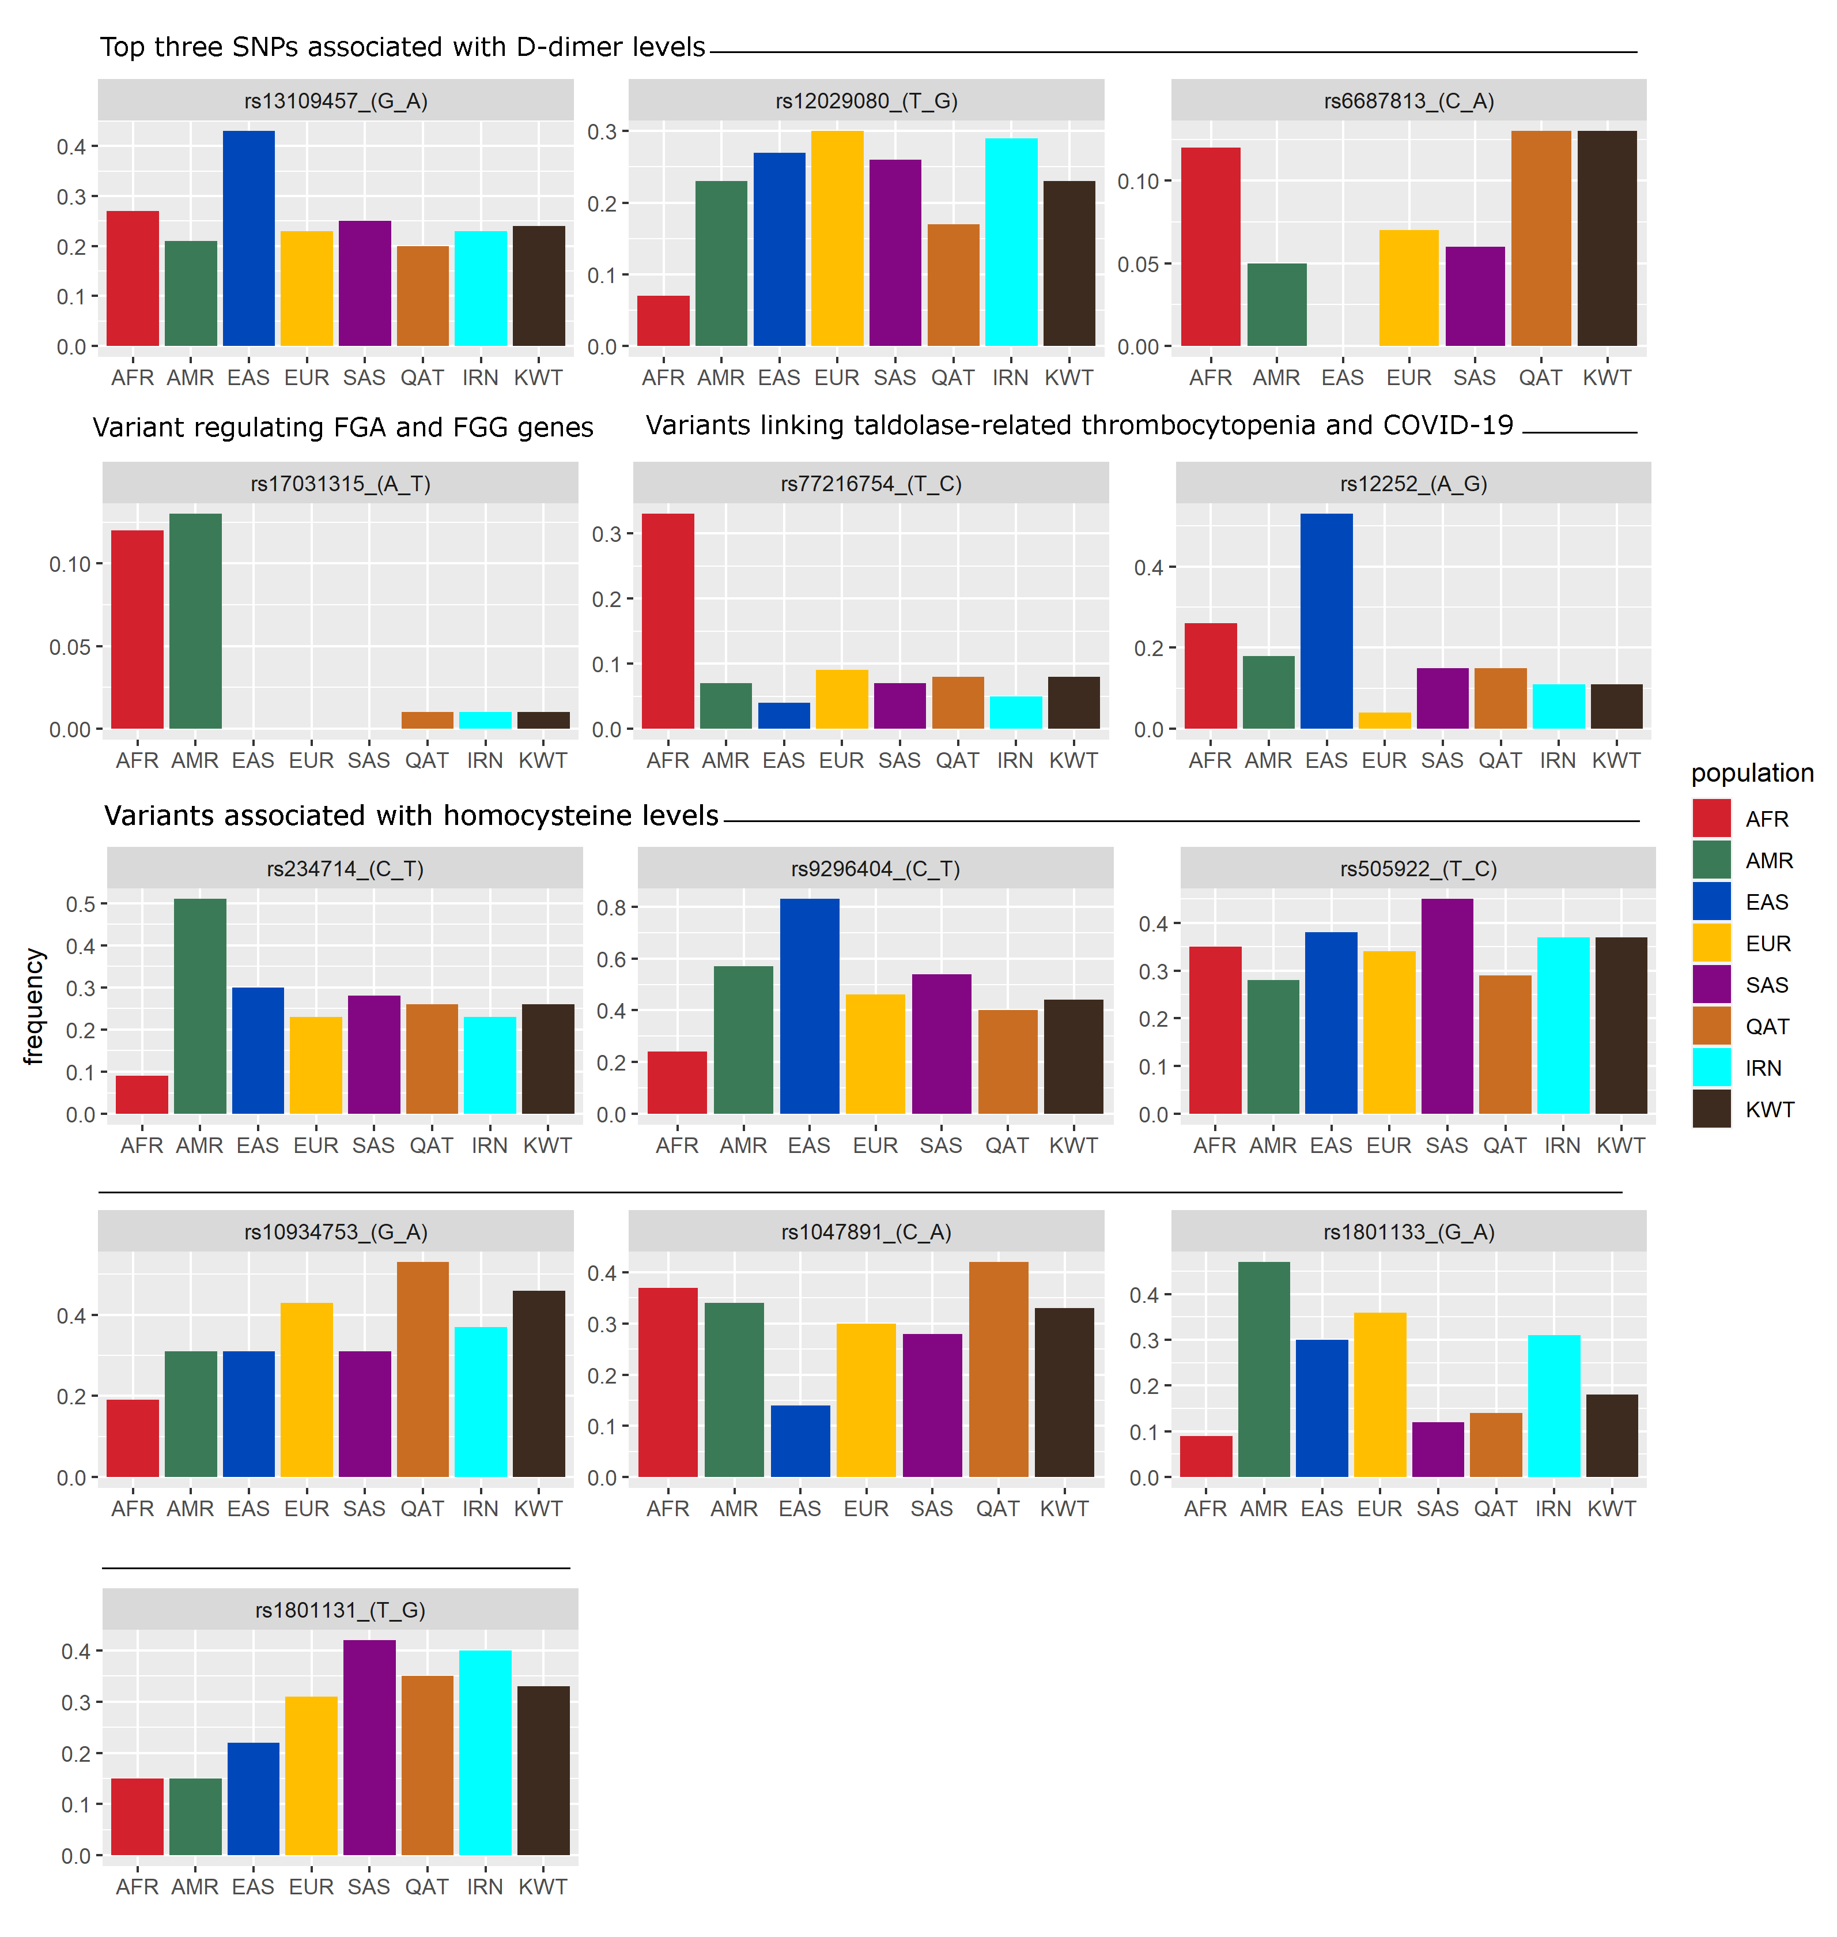

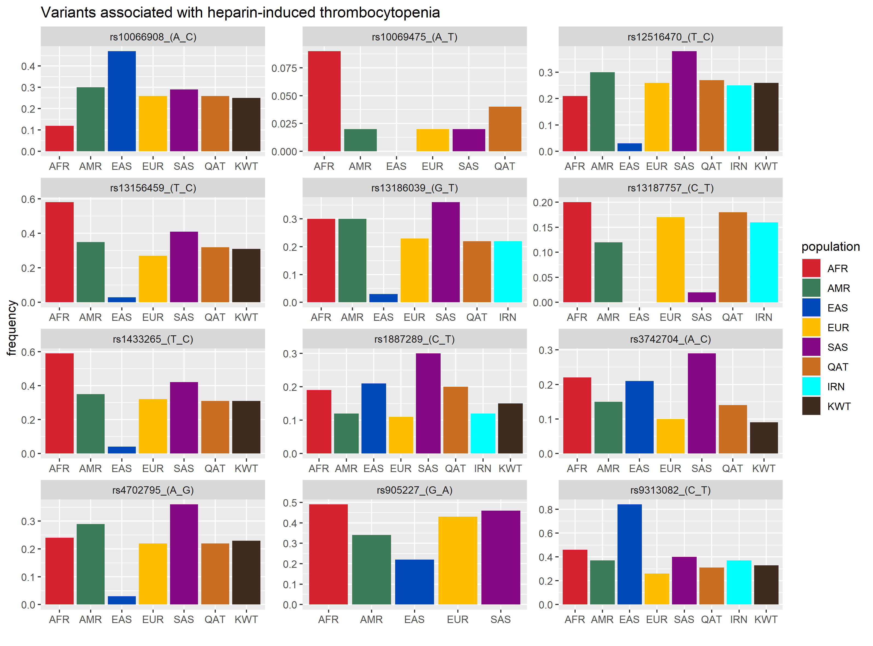

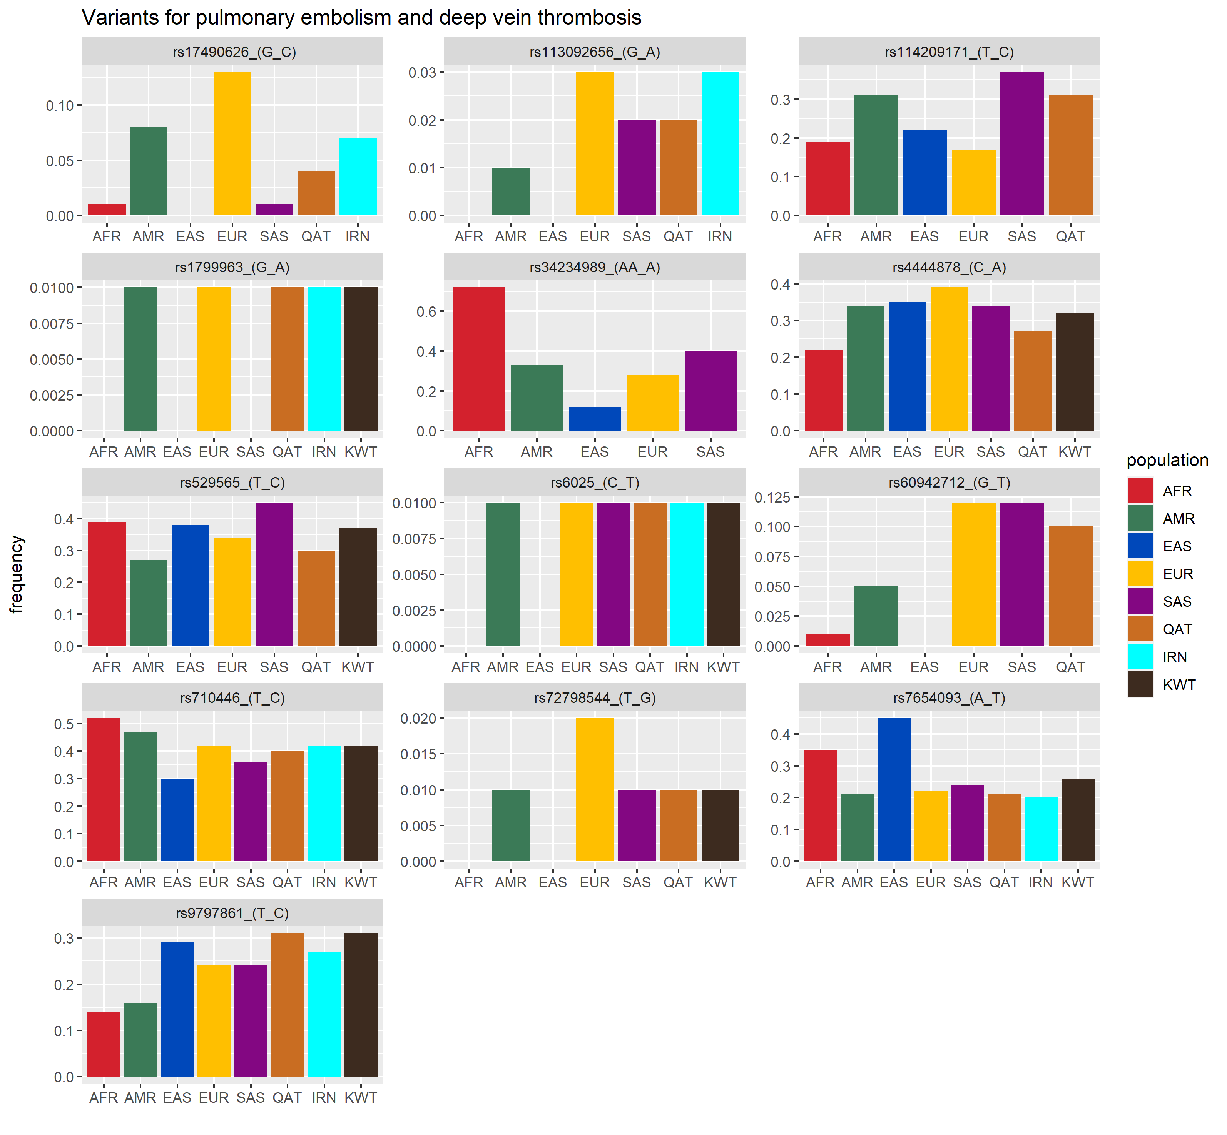

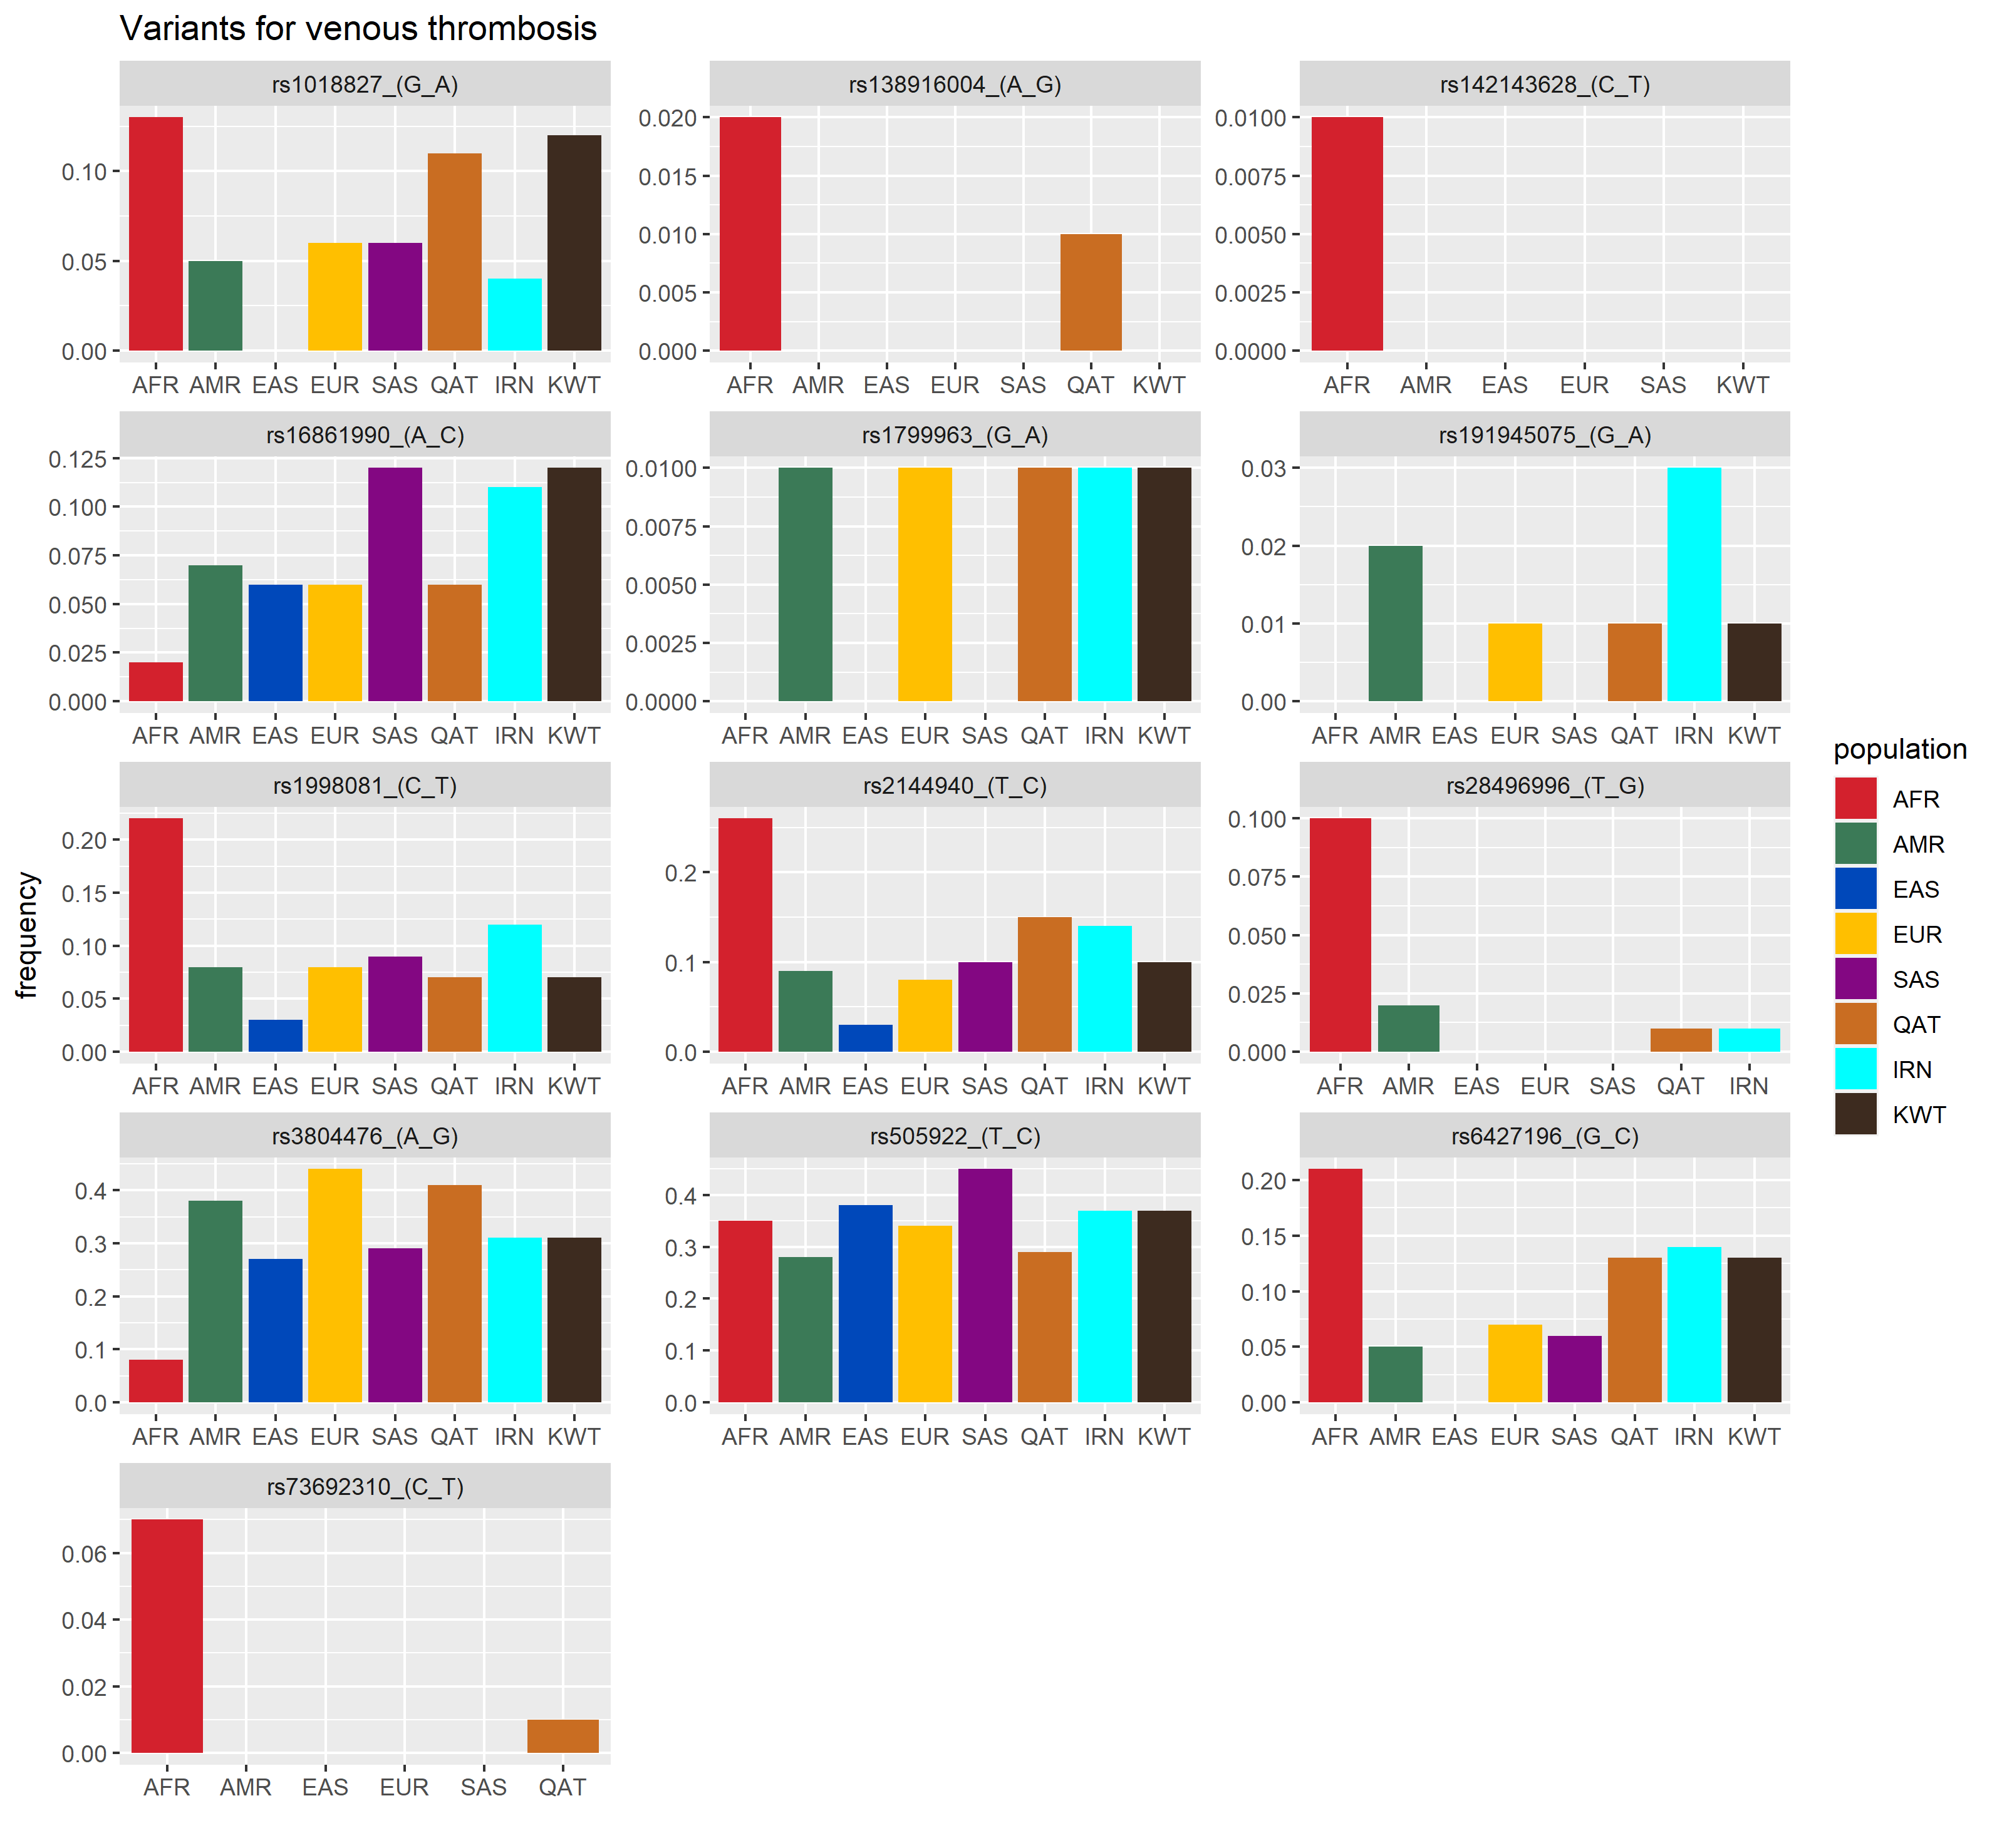

**Figure S2. Gene-gene interaction network derived using the XGR tool by considering 0.05 MB region around the study variants.** The genes forming the nodes of the presented network along with other information are as listed in Table 4.

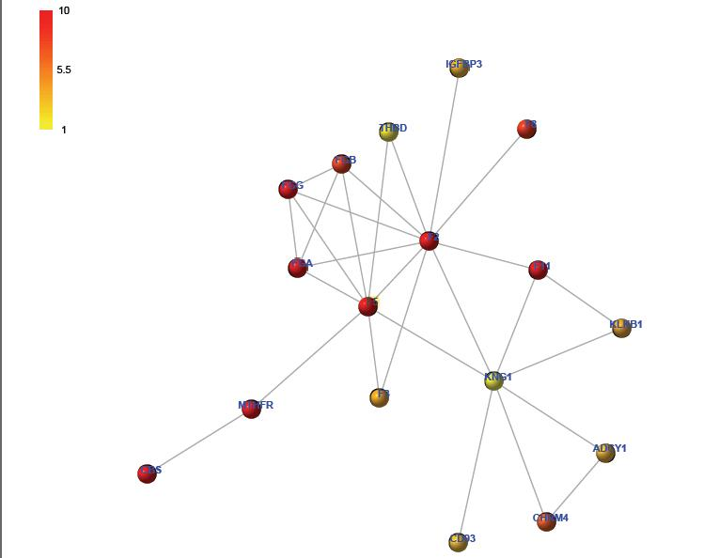

**Figure S3. Gene-gene interaction network derived using the XGR tool by considering 0.5 MB region around the study variants.** The genes forming the nodes of the presented network along with other information are as listed in Table 5.

