Supplementary Material

**Table S1** Primer sequences for qRT-PCR.

|  |  |  |
| --- | --- | --- |
| Primer | Forward primer（5′ to 3′） | Reverse primer（5′ to 3′） |
| *26 S* | GATAACGCAGGTGTCCTAAGATGA | ATTCCGAAGGTCTAAAGGATCGA |
| *ACT* | GTTATTCTTCATCGtCGTCTTCG | CTTCACCATTCCAGTTCCATTGTC |
| *PSY* | CCTCTACTGCTACTATGTTGCTGG | CATTTTCCACTTGTCAGTCACCT |
| *PDS* | GGGTCGTTTCCAGTGGCTAA | GAAAACAACCCAAGACATAGAGC |
| *ZDS* | TGGAAGGGGCAACTTTGTCTGG | TTCTTTCGCAATCCCACCAACTC |
| *CRTISO* | TGCGGGGACATCTTTACCA | GAGCCAGGCACCATATCACTT |
| *LCYb* | GCTTGATCTGGATGGGAGTAGA | TTTAACCAAAGGCAAAGGACAC |
| *CHYb* | GTTGAACCCGAAAAGCCAATA | TTCTTCCTCTTCTTCTTCCACCT |
| *CYP* | AGACTACTTCCGTTTGGAGCCG | CCTTTGGATTCATCCCTTCAGC |
| *ZEP* | AAGGATGGAGGCAAGTGGG | CGATGTAGCTCCGTGGACAGT |
| *NCED* | TCAACCACCCTTTTCACTCCCT | GGCACTGGCTTTGAGGATTTAG |
| *CCD1* | CTCGTGTTCCCGGAGTTACC | CGACCGGGTCAGATGACATT |
| *CCD4* | CCACCTCCACAAAAGCACCA | TGCAGGTAGCGTAGGATCTGT |

**Table S2** Changes in chromatism parameters of apricot fruit during development and ripening.

|  |  |  |  |  |  |  |
| --- | --- | --- | --- | --- | --- | --- |
| Cultivars | Stage | L*±SDb | a*±SD | b*±SD | c* c±SD | h d±SD |
|
| HY | F | 54.97±0.97 | -16.04±0.71 | 34.44±0.77 | 37.99±0.94 | 114.91±0.59 |
|  | E | 55.53±0.87 | -15.08±1.26 | 32.41±1.68 | 33.91±0.59 | 115.17±0.16 |
|  | T | 56.13±0.62 | -14.46±0.18 | 30.95±0.43 | 35.35±0.72 | 112.05±0.54 |
|  | CM | 61.53±0.33 | -13.30±0.53 | 32.74±0.57 | 52.69±13.79 | 72.65±11.25 |
|  | FR | 65.11±0.99 | 12.78±0.29 | 42.51±1.44 | 45.14±1.29 | 72.57±0.40 |
| DX | F | 54.52±0.34 | -20.28±0.26 | 39.02±0.70 | 43.98±0.63 | 117.46±0.53 |
|  | E | 57.41±0.31 | -16.87±3.16 | 37.23±0.38 | 41.78±0.45 | 116.97±0.21 |
|  | T | 63.51±0.84 | -12.31±2.86 | 37.98±1.31 | 44.35±0.39 | 110.43±0.64 |
|  | CM | 65.02±0.32 | -15.51±0.47 | 41.54±0.41 | 42.26±1.04 | 76.26±2.02 |
|  | FR | 55.49±3.42 | 17.97±1.93 | 43.83±1.05 | 47.67±0.52 | 67.36±2.90 |
| SL | F | 47.04±0.57 | -20.71±0.24 | 34.38±0.97 | 40.37±0.73 | 125.31±6.38 |
|  | E | 47.68±0.14 | -19.58±0.17 | 32.09±0.31 | 37.61±0.36 | 121.45±0.01 |
|  | T | 57.11±1.08 | -17.10±0.78 | 37.59±0.53 | 41.34±0.44 | 114.44±1.19 |
|  | CM | 68.35±0.48 | -2.35±0.73 | 51.09±1.35 | 51.41±1.25 | 92.70±0.08 |
|  | FR | 61.93±1.87 | 0.20±1.96 | 44.89±1.70 | 45.00±1.66 | 89.98±2.19 |
| AK | F | 50.02±0.63 | -21.98±0.20 | 40.07±0.13 | 45.56±0.17 | 118.79±0.19 |
|  | E | 50.90±0.16 | -21.76±0.20 | 39.12±0.18 | 44.77±0.25 | 119.15±0.10 |
|  | T | 52.19±0.45 | -19.02±0.19 | 35.71±0.94 | 40.47±0.92 | 118.11±0.40 |
|  | CM | 68.35±0.84 | -4.97±0.90 | 50.10±1.00 | 50.44±0.89 | 95.76±1.08 |
|  | FR | 60.28±1.04 | 4.04±1.12 | 47.02±2.70 | 45.30±1.50 | 84.25±1.50 |
| BX | F | 48.58±0.70 | -21.23±0.51 | 37.80±0.94 | 43.35±1.06 | 119.33±0.04 |
|  | E | 50.91±0.87 | -21.4±0.21 | 36.98±0.84 | 42.72±0.83 | 120.10±0.35 |
|  | T | 54.63±0.82 | -19.24±0.20 | 36.72±0.98 | 41.47±0.95 | 118.30±0.36 |
|  | CM | 67.10±0.59 | -3.06±1.93 | 45.86±1.16 | 46.12±1.17 | 93.71±1.17 |
|  | FR | 63.17±0.99 | -1.58±1.72 | 44.36±1.04 | 44.81±0.87 | 91.69±2.27 |
| LT | F | 49.19±2.11 | -19.84±0.64 | 37.99±2.64 | 42.95±2.68 | 117.95±0.96 |
|  | E | 51.69±0.70 | -20.76±0.24 | 38.80±1.19 | 43.55±0.46 | 118.57±0.37 |
|  | T | 59.03±2.35 | -15.62±0.76 | 39.86±0.62 | 42.90±0.35 | 111.59±1.10 |
|  | CM | 65.24±1.12 | -13.08±0.96 | 41.27±0.85 | 43.33±1.07 | 107.48±1.02 |
|  | FR | 66.26±0.68 | -1.86±1.03 | 43.30±0.66 | 43.37±0.69 | 92.56±1.22 |

a Values with different letters showed statistically significant differences at the 5% level.

b standard deviation

c C* = color intensity (chroma) ) = ( a*2 +b*2)1/2.

d h = hue value = arctan ( b*/ a*).

**Figure S1** HPLC chromatogram of carotenoids from the peel of ‘Danxing’ at the fully ripe stage.

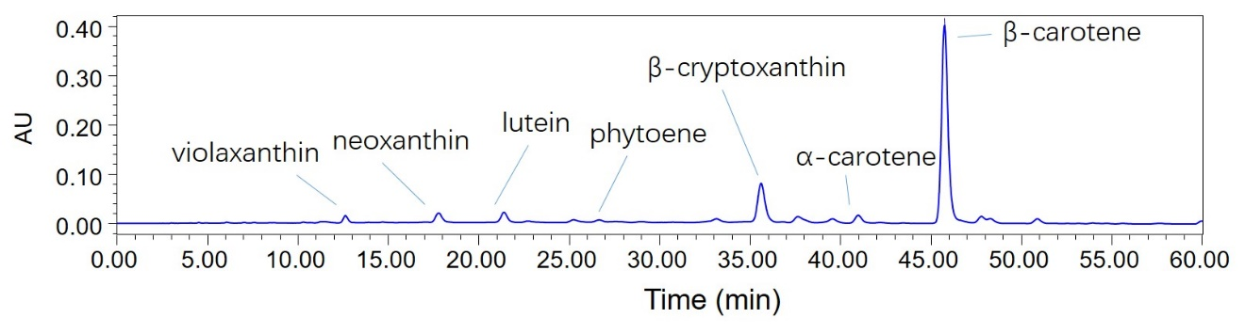

**Figure S2** HPLC chromatogram of carotenoids from the peel of ‘Baixing’ during development and ripening. The black line, blue line, green line, indigo line and pink line represent the fruitlet (F), enlargement (E), turning (T), commercial maturation (CM) and fully ripe (FR) stages.

