Supplementary Material

Age-related immunoreactivity profiles to diverse mycobacterial antigens in BCG vaccinated Chinese population
Qing-yuan Yang^{1,#}, Yu-tong Zhang^{1,#}, Jia-ni Xiao¹, Yu-shuo Liang¹, Ping Ji¹, Shu-jun Wang¹, Ying Wang^{1,2,*}, Yingying Chen^{1,*}
1 Department of Microbiology and Immunology, Shanghai Institute of Immunology, Shanghai Jiao Tong University School of Medicine, Shanghai, China
2 Key Laboratory of Parasite and Vector Biology, Ministry of Health, School of Global Health, Chinese Center for Tropical Diseases Research, Shanghai Jiao Tong University School of Medicine, Shanghai, China

Supplementary Figures
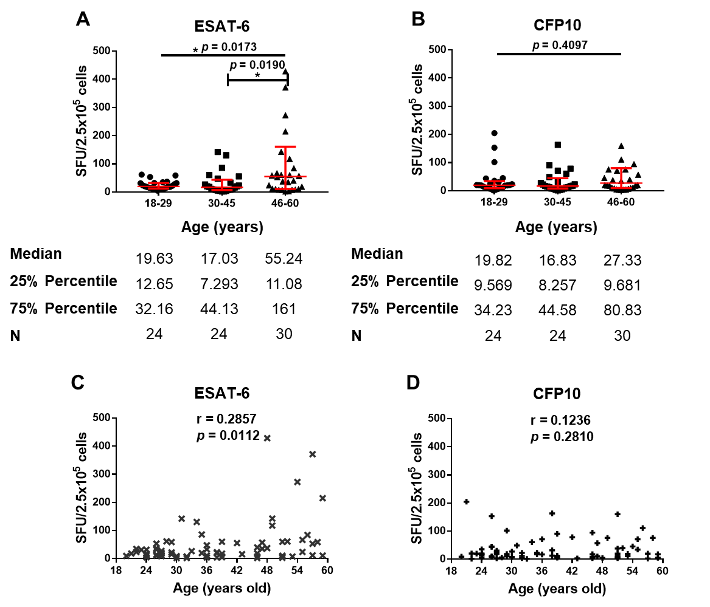
Supplementary Figure 1 Correlations between ESAT-6/CFP10 assay and the ages in E6C10⁺ HD subjects. (A-B) Comparisons of ESAT-6 (A)- and CFP10 (B)-specific IFN-γ releasing cells in different age groups. The p-values were calculated using the Kruskal-Wallis test and Dunn’s multiple comparison test. The p-values above the lines were the p-values of the Kruskal-Wallis test. The p-values above capped lines were the adjusted p-values of Dunn’s multiple comparison test. *: p＜0.05. (C-D) Correlation analyses between the ages and ESAT-6 (C)- and CFP10 (D)-specific IFN-γ releasing cell numbers. Correlations were tested by Spearman’s nonparametric correlation analysis.

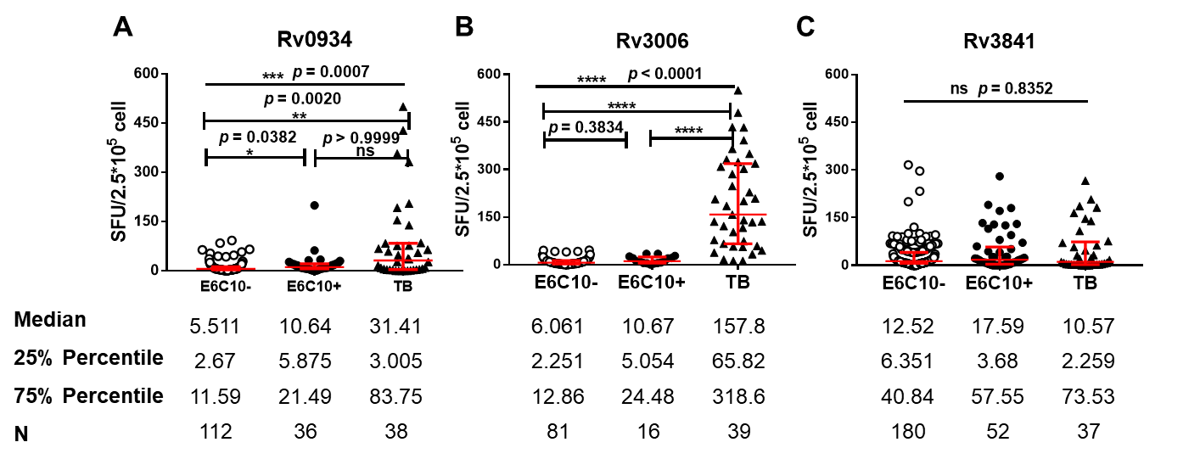
Supplementary Figure 2 Immunoreactivities to three mycobacterial antigens in E6C10⁻ HDs, E6C10⁺ HDs and TB subjects. Numbers of Rv0934 (A)-, Rv3006 (B)-, and Rv3841 (C)- specific IFN-γ releasing cells were compared among E6C10⁻ HDs (open circle), E6C10⁺ HDs (closed circle), and TB patients (closed triangle), respectively. The p-values were calculated using the Kruskal-Wallis test and Dunn’s multiple comparison test. The p-values above the lines were the p-values of the Kruskal-Wallis test. The p-values above capped lines were the adjusted p-values of Dunn’s multiple comparison test. ****: p＜0.0001, ***: p＜0.001, **: p＜0.01, *: p＜0.05.

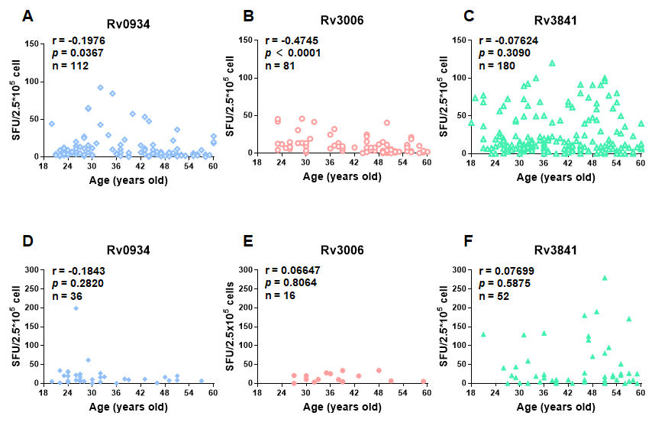
Supplementary Figure 3 Correlation analyses between antigen-specific immune response levels and the ages. (A-C) Correlation analyses between the numbers of Rv0934 (A)-, Rv3006 (B)-, Rv3841 (C)- specific IFN-γ releasing cells and the ages in E6C10⁻ HDs. (D-F) Correlation analyses between the numbers of Rv0934 (D)-, Rv3006 (E)-, Rv3841 (F)- specific IFN-γ releasing cells and the ages in E6C10⁺ subjects. Correlation was tested by Spearman’s non-parametric correlation analysis.

