Quantifying agroforestry yield buffering potential under climate change in the smallholder maize farming systems of Ethiopia

Supplementary Material

**SI1:** Map showing the distribution of the calibrated zones for APSIM runs.

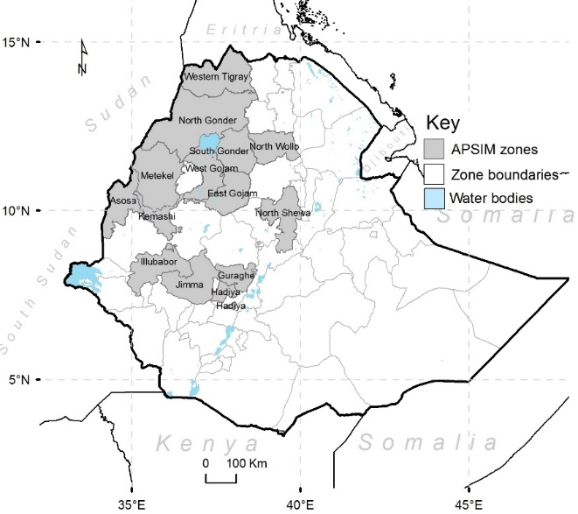

**SI2:** Summary of observed maize yield (in t/ha) in study zones (2006 and 2016)

|  |  |  |  |  |  |
| --- | --- | --- | --- | --- | --- |
| ZoneΦ | Min | Mean | Median | Max | Std. Dev |
| Asosa | 1.54 | 2.52 | 2.64 | 3.40 | 0.56 |
| Guraghe | 2.05 | 3.20 | 3.61 | 3.94 | 0.71 |
| Hadiya | 1.57 | 2.61 | 2.64 | 3.62 | 0.74 |
| Illubabor | 1.91 | 3.02 | 3.16 | 4.23 | 0.75 |
| Jimma | 2.09 | 2.99 | 2.98 | 4.02 | 0.62 |
| Kemashi | 1.86 | 3.16 | 3.06 | 4.17 | 0.92 |
| Metekel | 2.13 | 3.13 | 3.01 | 4.00 | 0.62 |
| North Gonder | 1.78 | 2.58 | 2.73 | 3.20 | 0.42 |
| North Shewa* | 1.62 | 2.37 | 2.25 | 3.01 | 0.49 |
| North Wollo | 1.29 | 1.66 | 1.68 | 2.01 | 0.27 |
| Sidama | 2.10 | 2.93 | 3.26 | 3.61 | 0.58 |
| South Gonder | 1.60 | 2.27 | 2.38 | 3.04 | 0.49 |
| West Gojjam | 2.60 | 3.33 | 3.10 | 4.23 | 0.67 |
| Western Tigray | 1.45 | 2.67 | 3.06 | 3.45 | 0.76 |

Source. Annual Agricultural Sample Surveys (2006-2016), Central Statistical Agency (CSA) of Ethiopia.

Note: Φ2009 data is missing, *North Shewa in Amhara region

**SI3**: Soil profiles for Ethiopia for each zone.

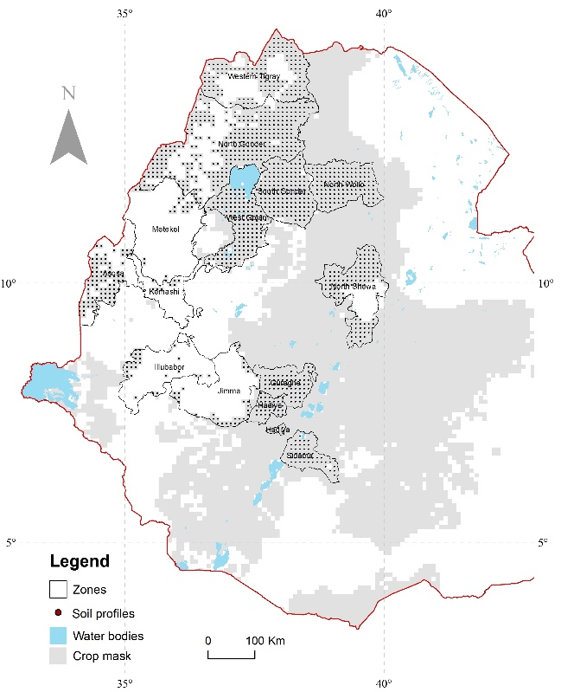

**SI4:** Key soil data for the modeling for each of the zones

|  |  |  |  |  |  |  |  |  |  |  |  |  |
| --- | --- | --- | --- | --- | --- | --- | --- | --- | --- | --- | --- | --- |
| Asosa | BD | DLL | DUL | SAT | pH |  | Guraghe | BD | DLL | DUL | SAT | pH |
|  | 1.03 | 0.23 | 0.35 | 0.43 | 6.02 |  |  | 1.17 | 0.23 | 0.36 | 0.44 | 6.02 |
|  | 1.05 | 0.24 | 0.36 | 0.44 | 6.08 |  |  | 1.19 | 0.24 | 0.37 | 0.45 | 6.09 |
|  | 1.08 | 0.26 | 0.38 | 0.45 | 6.18 |  |  | 1.22 | 0.25 | 0.38 | 0.45 | 6.19 |
|  | 1.13 | 0.27 | 0.39 | 0.46 | 6.29 |  |  | 1.27 | 0.27 | 0.40 | 0.46 | 6.30 |
|  | 1.19 | 0.27 | 0.39 | 0.46 | 6.43 |  |  | 1.33 | 0.27 | 0.40 | 0.46 | 6.43 |
|  | 1.24 | 0.26 | 0.38 | 0.45 | 6.61 |  |  | 1.39 | 0.26 | 0.39 | 0.45 | 6.61 |
|  |  |  |  |  |  |  |  |  |  |  |  |  |
| Hadiya | BD | DLL | DUL | SAT | pH |  | Illubabor | BD | DLL | DUL | SAT | pH |
|  | 1.01 | 0.17 | 0.29 | 0.42 | 6.33 |  |  | 1.08 | 0.22 | 0.34 | 0.43 | 5.18 |
|  | 1.03 | 0.18 | 0.30 | 0.42 | 6.40 |  |  | 1.10 | 0.23 | 0.35 | 0.44 | 5.24 |
|  | 1.06 | 0.20 | 0.32 | 0.43 | 6.50 |  |  | 1.13 | 0.24 | 0.37 | 0.44 | 5.34 |
|  | 1.11 | 0.21 | 0.33 | 0.43 | 6.61 |  |  | 1.18 | 0.26 | 0.38 | 0.45 | 5.45 |
|  | 1.18 | 0.21 | 0.33 | 0.43 | 6.75 |  |  | 1.24 | 0.26 | 0.38 | 0.45 | 5.60 |
|  | 1.23 | 0.20 | 0.32 | 0.43 | 6.93 |  |  | 1.30 | 0.25 | 0.37 | 0.44 | 5.78 |
|  |  |  |  |  |  |  |  |  |  |  |  |  |
| Jimma | BD | DLL | DUL | SAT | pH |  | Kemashi | BD | DLL | DUL | SAT | pH |
|  | 1.17 | 0.24 | 0.37 | 0.45 | 5.84 |  |  | 1.11 | 0.22 | 0.34 | 0.43 | 5.73 |
|  | 1.19 | 0.26 | 0.39 | 0.46 | 5.91 |  |  | 1.13 | 0.23 | 0.36 | 0.44 | 5.80 |
|  | 1.22 | 0.27 | 0.40 | 0.47 | 6.01 |  |  | 1.16 | 0.25 | 0.37 | 0.44 | 5.89 |
|  | 1.27 | 0.28 | 0.41 | 0.48 | 6.12 |  |  | 1.21 | 0.26 | 0.39 | 0.45 | 6.01 |
|  | 1.33 | 0.28 | 0.41 | 0.48 | 6.25 |  |  | 1.27 | 0.26 | 0.38 | 0.45 | 6.14 |
|  | 1.38 | 0.28 | 0.40 | 0.47 | 6.43 |  |  | 1.32 | 0.25 | 0.37 | 0.44 | 6.33 |
|  |  |  |  |  |  |  |  |  |  |  |  |  |
| Metekel | BD | DLL | DUL | SAT | pH |  | North Gonder | BD | DLL | DUL | SAT | pH |
|  | 1.16 | 0.21 | 0.33 | 0.42 | 6.04 |  |  | 1.20 | 0.21 | 0.34 | 0.43 | 6.82 |
|  | 1.18 | 0.22 | 0.34 | 0.43 | 6.11 |  |  | 1.22 | 0.22 | 0.35 | 0.43 | 6.88 |
|  | 1.21 | 0.23 | 0.35 | 0.43 | 6.21 |  |  | 1.25 | 0.24 | 0.36 | 0.44 | 6.98 |
|  | 1.26 | 0.25 | 0.37 | 0.44 | 6.32 |  |  | 1.30 | 0.25 | 0.38 | 0.45 | 7.09 |
|  | 1.32 | 0.25 | 0.37 | 0.44 | 6.45 |  |  | 1.36 | 0.25 | 0.38 | 0.45 | 7.23 |
|  | 1.37 | 0.24 | 0.36 | 0.44 | 6.63 |  |  | 1.42 | 0.24 | 0.37 | 0.44 | 7.41 |
|  |  |  |  |  |  |  |  |  |  |  |  |  |
| North Shewa* | BD | DLL | DUL | SAT | pH |  | North Wollo | BD | DLL | DUL | SAT | pH |
|  | 1.18 | 0.19 | 0.32 | 0.42 | 6.62 |  |  | 1.19 | 0.18 | 0.30 | 0.41 | 6.76 |
|  | 1.20 | 0.20 | 0.33 | 0.43 | 6.69 |  |  | 1.21 | 0.19 | 0.32 | 0.42 | 6.83 |
|  | 1.23 | 0.22 | 0.34 | 0.43 | 6.78 |  |  | 1.24 | 0.21 | 0.33 | 0.42 | 6.92 |
|  | 1.28 | 0.23 | 0.36 | 0.44 | 6.90 |  |  | 1.29 | 0.22 | 0.35 | 0.43 | 7.04 |
|  | 1.34 | 0.23 | 0.36 | 0.44 | 7.04 |  |  | 1.35 | 0.22 | 0.35 | 0.43 | 7.18 |
|  | 1.40 | 0.22 | 0.35 | 0.43 | 7.22 |  |  | 1.41 | 0.21 | 0.33 | 0.42 | 7.36 |
|  |  |  |  |  |  |  |  |  |  |  |  |  |
| Sidama | BD | DLL | DUL | SAT | pH |  | South Gonder | BD | DLL | DUL | SAT | pH |
|  | 1.21 | 0.22 | 0.35 | 0.44 | 5.95 |  |  | 1.16 | 0.19 | 0.32 | 0.42 | 6.60 |
|  | 1.23 | 0.23 | 0.36 | 0.45 | 6.02 |  |  | 1.18 | 0.21 | 0.33 | 0.43 | 6.67 |
|  | 1.26 | 0.25 | 0.38 | 0.46 | 6.12 |  |  | 1.21 | 0.22 | 0.35 | 0.43 | 6.76 |
|  | 1.31 | 0.26 | 0.39 | 0.46 | 6.23 |  |  | 1.26 | 0.23 | 0.36 | 0.44 | 6.88 |
|  | 1.37 | 0.26 | 0.39 | 0.46 | 6.37 |  |  | 1.32 | 0.23 | 0.36 | 0.44 | 7.02 |
|  | 1.42 | 0.25 | 0.38 | 0.46 | 6.55 |  |  | 1.38 | 0.22 | 0.35 | 0.44 | 7.20 |
|  |  |  |  |  |  |  |  |  |  |  |  |  |
| West Gojjam | BD | DLL | DUL | SAT | pH |  | Western Tigray | BD | DLL | DUL | SAT | pH |
|  | 1.18 | 0.22 | 0.35 | 0.44 | 6.60 |  |  | 1.27 | 0.19 | 0.30 | 0.41 | 6.55 |
|  | 1.16 | 0.24 | 0.37 | 0.45 | 6.66 |  |  | 1.28 | 0.20 | 0.31 | 0.41 | 6.63 |
|  | 1.19 | 0.25 | 0.38 | 0.46 | 6.74 |  |  | 1.32 | 0.21 | 0.33 | 0.42 | 6.72 |
|  | 1.23 | 0.27 | 0.40 | 0.47 | 6.85 |  |  | 1.37 | 0.23 | 0.34 | 0.43 | 6.84 |
|  | 1.29 | 0.27 | 0.40 | 0.47 | 6.97 |  |  | 1.43 | 0.23 | 0.34 | 0.43 | 6.98 |
|  | 1.34 | 0.27 | 0.40 | 0.47 | 7.13 |  |  | 1.48 | 0.22 | 0.33 | 0.42 | 7.15 |

Notes: BD= bulk density, DUL = drained upper limit, DLL drained lower limit and SAT = saturation.

**SI5:** Average inorganic fertilizer (N) use for each zone in kg/ha from 2006 to 2016 (original values in quintals/ha). Average calculated as total fertilizer distributed for maize divided by cropped area for maize for each year.

|  |  |  |  |  |  |  |  |  |  |  |  |
| --- | --- | --- | --- | --- | --- | --- | --- | --- | --- | --- | --- |
| District | 2006 | 2007 | 2008 | 2009* | 2010 | 2011 | 2012 | 2013 | 2014 | 2015 | 2016 |
| Asosa | 27.1 | 28.6 | 28.7 | 43.5 | 58.3 | 21.0 | 47.0 | 38.8 | 45.6 | 52.9 | 55.1 |
| Guraghe | 30.5 | 42.3 | 40.2 | 57.7 | 75.1 | 27.1 | 53.1 | 73.8 | 68.0 | 83.6 | 89.1 |
| Hadiya | 41.0 | 41.5 | 36.8 | 54.7 | 72.6 | 49.5 | 79.6 | 55.9 | 68.3 | 69.6 | 72.8 |
| Illubabor | 28.0 | 27.8 | 26.6 | 41.0 | 55.3 | 23.0 | 49.0 | 44.4 | 56.0 | 53.0 | 59.1 |
| Jimma | 43.5 | 44.8 | 40.8 | 58.5 | 76.1 | 21.0 | 47.0 | 58.6 | 68.8 | 64.2 | 80.0 |
| Kemashi | 38.3 | 39.7 | 44.8 | 88.2 | 131.5 | 31.5 | 78.0 | 69.5 | 93.2 | 95.0 | 98.3 |
| Metekel | 44.3 | 47.2 | 34.8 | 54.4 | 74.0 | 22.7 | 48.7 | 40.5 | 60.7 | 60.8 | 49.7 |
| North Gonder | 42.5 | 50.4 | 41.3 | 76.9 | 112.5 | 41.2 | 83.6 | 64.8 | 78.1 | 64.6 | 77.4 |
| North Shewa🗶 | 26.5 | 27.2 | 22.1 | 39.4 | 56.6 | 31.5 | 60.1 | 32.4 | 37.6 | 29.1 | 41.5 |
| North Wollo | 36.2 | 44.5 | 41.9 | 70.5 | 99.0 | 40.4 | 91.2 | 49.2 | 42.4 | 45.7 | 53.5 |
| Sidama | 63.3 | 94.8 | 83.8 | 111.4 | 139.0 | 43.1 | 69.1 | 78.1 | 21.0 | 79.6 | 75.5 |
| South Gonder | 37.9 | 44.3 | 36.4 | 53.0 | 69.6 | 21.0 | 47.0 | 48.5 | 52.5 | 56.3 | 63.9 |
| West Gojam | 67.5 | 84.1 | 88.0 | 116.6 | 145.1 | 29.3 | 55.3 | 101.5 | 118.8 | 94.5 | 118.6 |
| Western Tigray | 34.4 | 44.0 | 44.7 | 68.8 | 92.8 | 54.2 | 112.3 | 48.0 | 62.0 | 60.0 | 64.7 |

*Data for 2009 was not available and was determined as the mean of 2010 and 2008. 🗶North Shewa in Amhara region

**SI6**: Map showing the distribution of the calibrated maize varieties in Ethiopia.

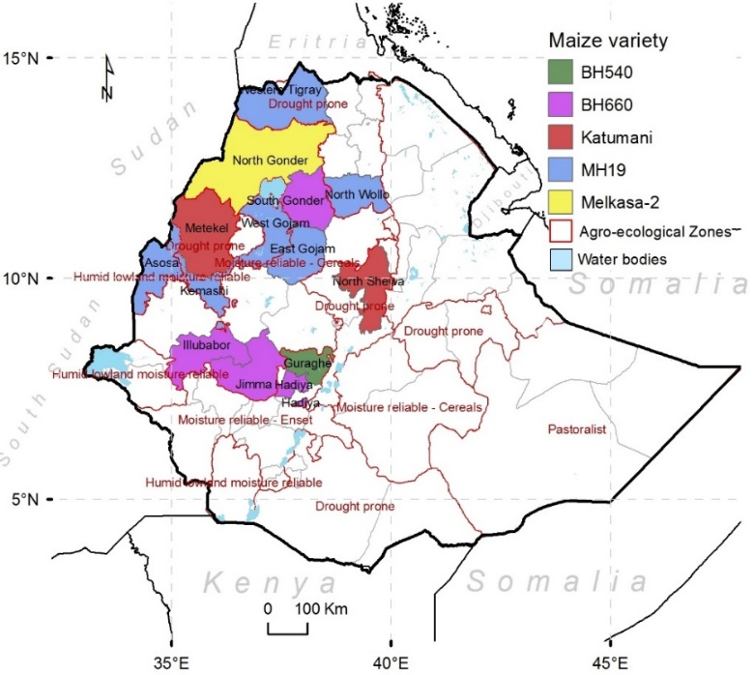

**SI7**: Sample zone (Metekel) random forest model evaluation showing (a) the relationship between radiation and Max T (b) observed versus modelled Max T for independent year 2007, (c) observed versus modelled Max T time series for independent year 2007, (d) the relationship between radiation and Min T (b) observed versus modelled Min T for independent year 2007, (c) observed versus modelled Min T time series for independent year 2007.

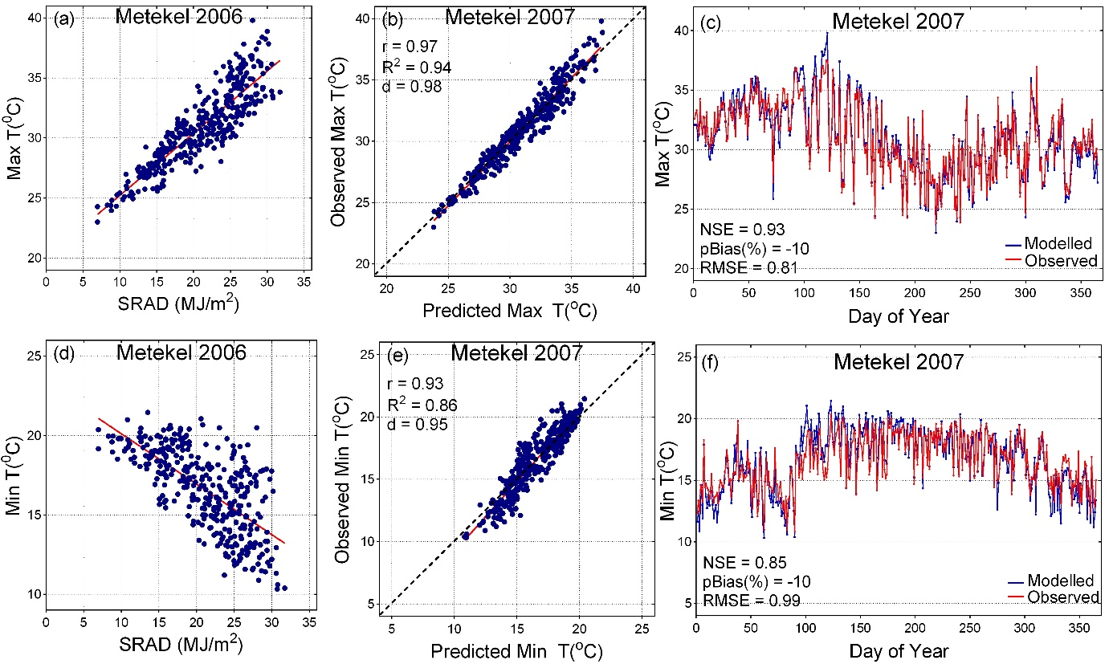

**SI7**: Calibration of maize varieties for use at zonal level in Ethiopia

|  |  |  |  |  |  |  |  |  |  |  |  |  |  |  |  |  |  |  |  |  |
| --- | --- | --- | --- | --- | --- | --- | --- | --- | --- | --- | --- | --- | --- | --- | --- | --- | --- | --- | --- | --- |
| Zone | BH540 | | |  | BH660 | | |  | Katumeni | | |  | Melkasa | | |  | MH19 | | | Allocation |
|  | d | r | R2 |  | d | r | R2 |  | d | r | R2 |  | d | r | R2 |  | d | r | R2 |  |
| Asosa | 0.34 | 0.34 | 0.12 |  | 0.32 | 0.35 | 0.12 |  | 0.55 | 0.34 | 0.12 |  | 0.33 | 0.29 | 0.09 |  | 0.31 | 0.65 | 0.42 | MH19 |
| East Gojjam | 0.56 | 0.53 | 0.28 |  | 0.71 | 0.53 | 0.28 |  | 0.34 | 0.38 | 0.15 |  | 0.58 | 0.50 | 0.25 |  | 0.37 | 0.62 | 0.39 | MH19 |
| Guraghe | 0.81 | 0.67 | 0.46 |  | 0.65 | 0.66 | 0.44 |  | 0.16 | -0.43 | 0.18 |  | 0.71 | 0.62 | 0.39 |  | 0.54 | 0.63 | 0.40 | BH540 |
| Hadiya | 0.44 | 0.57 | 0.33 |  | 0.46 | 0.78 | 0.61 |  | 0.41 | -0.25 | 0.06 |  | 0.45 | 0.73 | 0.54 |  | 0.28 | 0.60 | 0.36 | BH660 |
| Illubabor | 0.74 | 0.55 | 0.30 |  | 0.91 | 0.87 | 0.75 |  | 0.55 | 0.32 | 0.10 |  | 0.83 | 0.71 | 0.50 |  | 0.55 | 0.70 | 0.49 | BH660 |
| Jimma | 0.41 | 0.20 | 0.04 |  | 0.55 | 0.40 | 0.16 |  | 0.58 | 0.48 | 0.23 |  | 0.46 | 0.3 | 0.09 |  | 0.31 | 0.46 | 0.21 | Katumeni |
| Kemashi | 0.77 | 0.64 | 0.41 |  | 0.87 | 0.76 | 0.58 |  | 0.44 | 0.15 | 0.02 |  | 0.83 | 0.71 | 0.51 |  | 0.61 | 0.76 | 0.58 | MH19 |
| Metekel | 0.45 | 0.24 | 0.06 |  | 0.42 | 0.29 | 0.09 |  | 0.70 | 0.51 | 0.26 |  | 0.45 | 0.35 | 0.12 |  | 0.38 | 0.28 | 0.08 | BH660 |
| North Gonder | 0.59 | 0.48 | 0.23 |  | 0.49 | 0.50 | 0.25 |  | 0.26 | 0.30 | 0.09 |  | 0.58 | 0.58 | 0.33 |  | 0.37 | 0.52 | 0.27 | Melkasa |
| North Shewa* | 0.51 | 0.47 | 0.22 |  | 0.59 | 0.62 | 0.38 |  | 0.29 | 0.12 | 0.01 |  | 0.62 | 0.58 | 0.34 |  | 0.40 | 0.58 | 0.34 | Katumeni |
| North Wollo | 0.28 | 0.47 | 0.22 |  | 0.35 | 0.39 | 0.15 |  | 0.26 | 0.19 | 0.03 |  | 0.35 | 0.55 | 0.3 |  | 0.29 | 0.64 | 0.41 | MH19 |
| South Gonder | 0.44 | 0.26 | 0.07 |  | 0.53 | 0.54 | 0.29 |  | 0.28 | 0.24 | 0.06 |  | 0.51 | 0.47 | 0.22 |  | 0.28 | 0.52 | 0.27 | BH660 |
| West Gojjam | 0.91 | 0.84 | 0.70 |  | 0.68 | 0.84 | 0.71 |  | 0.69 | 0.49 | 0.24 |  | 0.81 | 0.81 | 0.65 |  | 0.60 | 0.85 | 0.72 | MH19 |
| Western Tigray | 0.75 | 0.63 | 0.40 |  | 0.83 | 0.81 | 0.66 |  | 0.42 | 0.24 | 0.06 |  | 0.85 | 0.78 | 0.60 |  | 0.78 | 0.86 | 0.74 | MH19 |

Note: *North Shewa in Amhara region.

**SI8**: Adaptation effect of simulated agroforestry shading on maize grain yield changes in Ethiopia. The current is the yield change while the scenarios is the difference between the projected changes with agroforestry and current condition with agroforestry.

|  |  |  |  |  |  |  |  |
| --- | --- | --- | --- | --- | --- | --- | --- |
|  | 10% shade | | |  | 20% shade | | |
| Zone | Current | RCP26 | RCP85 |  | Current | RCP26 | RCP85 |
| Asosa | -4.4 | -0.3 | 1.7 |  | -3.3 | -3.9 | 0.8 |
| Guraghe | -5.1 | -1.7 | 2.3 |  | -9.3 | -2.6 | 5.5 |
| Hadiya | -3.8 | 1.8 | 13.9 |  | -1.8 | -4.4 | 2.9 |
| Illubabor | 1.1 | -11.5 | -8.2 |  | 6.3 | -9.3 | 11.0 |
| Jimma | -5.6 | 6.9 | 9.7 |  | -11.5 | 7.9 | 0.2 |
| Kemashi | 9.8 | -11.7 | -8.8 |  | 19.1 | 2.1 | -3.8 |
| Metekel | -6.7 | -1.1 | -4.6 |  | -12.8 | 2.7 | -0.3 |
| North Gonder | 3.6 | 4.8 | -1.9 |  | 3.6 | 2.9 | -4.9 |
| North Shewa* | -22.7 | 12.5 | 9.8 |  | -18.3 | 3.9 | 1.4 |
| North Wollo | 38.7 | -11.9 | -30.3 |  | 34.0 | 1.0 | -30.6 |
| Sidama | -0.7 | 17.9 | 11.8 |  | -14.6 | 2.1 | 17.7 |
| South Gonder | -10.5 | 30.7 | 26.6 |  | -4.9 | 8.7 | 8.3 |
| West Gojjam | 51.1 | 17.8 | -2.8 |  | 59.4 | -24.0 | -13.2 |
| Western Tigray | -26.0 | 8.1 | 14.5 |  | -22.3 | -0.1 | 13.1 |
| All zones | -1.7 | 4.5 | 2.4 |  | 1.7 | -0.9 | 0.6 |

Note: *North Shewa in Amhara region