**SUPPLEMENTARY MATERIAL**

**CXCL10 is a Tumor Microenvironment and Immune Infiltration Related Prognostic Biomarker in Pancreatic** **Adenocarcinoma**

Huimin Huang1, Wangxiao Zhou2, Renpin Chen3,Bingfeng Xiang4,Shipeng Zhou1, Linhua Lan1*

1Key Laboratory of Diagnosis and Treatment of Severe Hepato-Pancreatic Diseases of Zhejiang Province, The First Affiliated Hospital of Wenzhou Medical University, Wenzhou, China.

2State Key Laboratory for Diagnosis and Treatment of Infectious Diseases, The First Affiliated Hospital, College of Medicine, Zhejiang University, Hangzhou, China.

3Department of Gastroenterology, The First Affiliated Hospital of Wenzhou Medical University, Wenzhou, China.

4Department of Emergency Intensive Care Unit, The Cangnan Affiliated Hospital of Wenzhou Medical University, Wenzhou, China.

**\*Correspondence**

Linhua Lan

E-mail: [paullee90@wmu.edu.cn](mailto:paullee90@wmu.edu.cn)

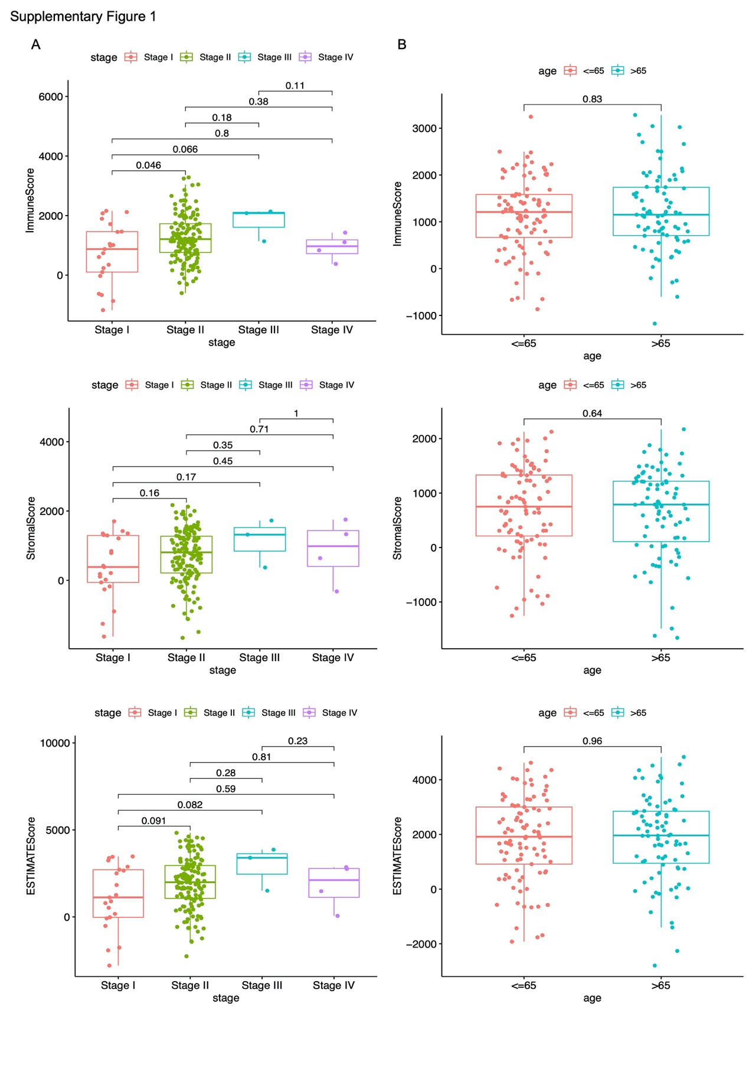

**Supplementary Figure 1.** Correlation between scores and pathology stage and age. **(A)** The immune scores were positively related to stage I and II disease (*p*=0.046). **(B)** No significance was found between the scores and age.

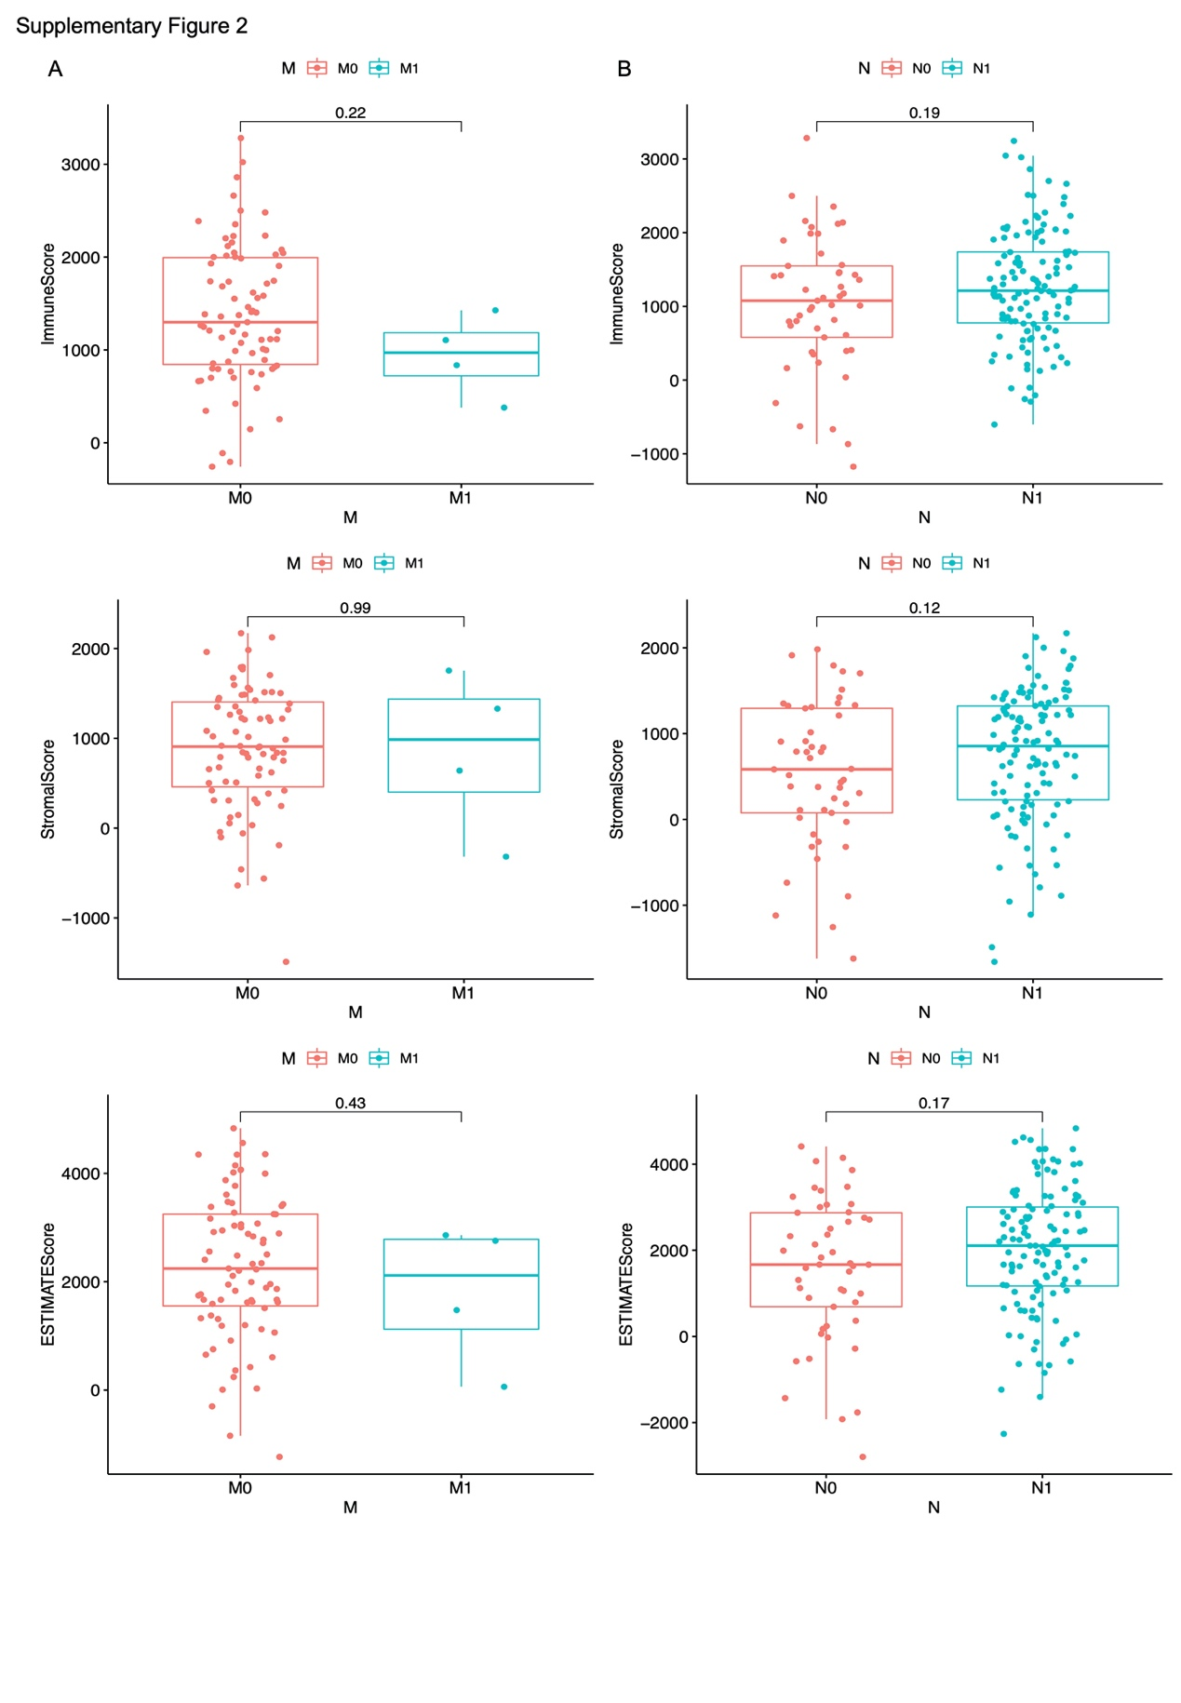

**Supplementary Figure 2.** Correlation between scores and M and N stage. **(A-B)** No significance was found between the scores and M and N stage.

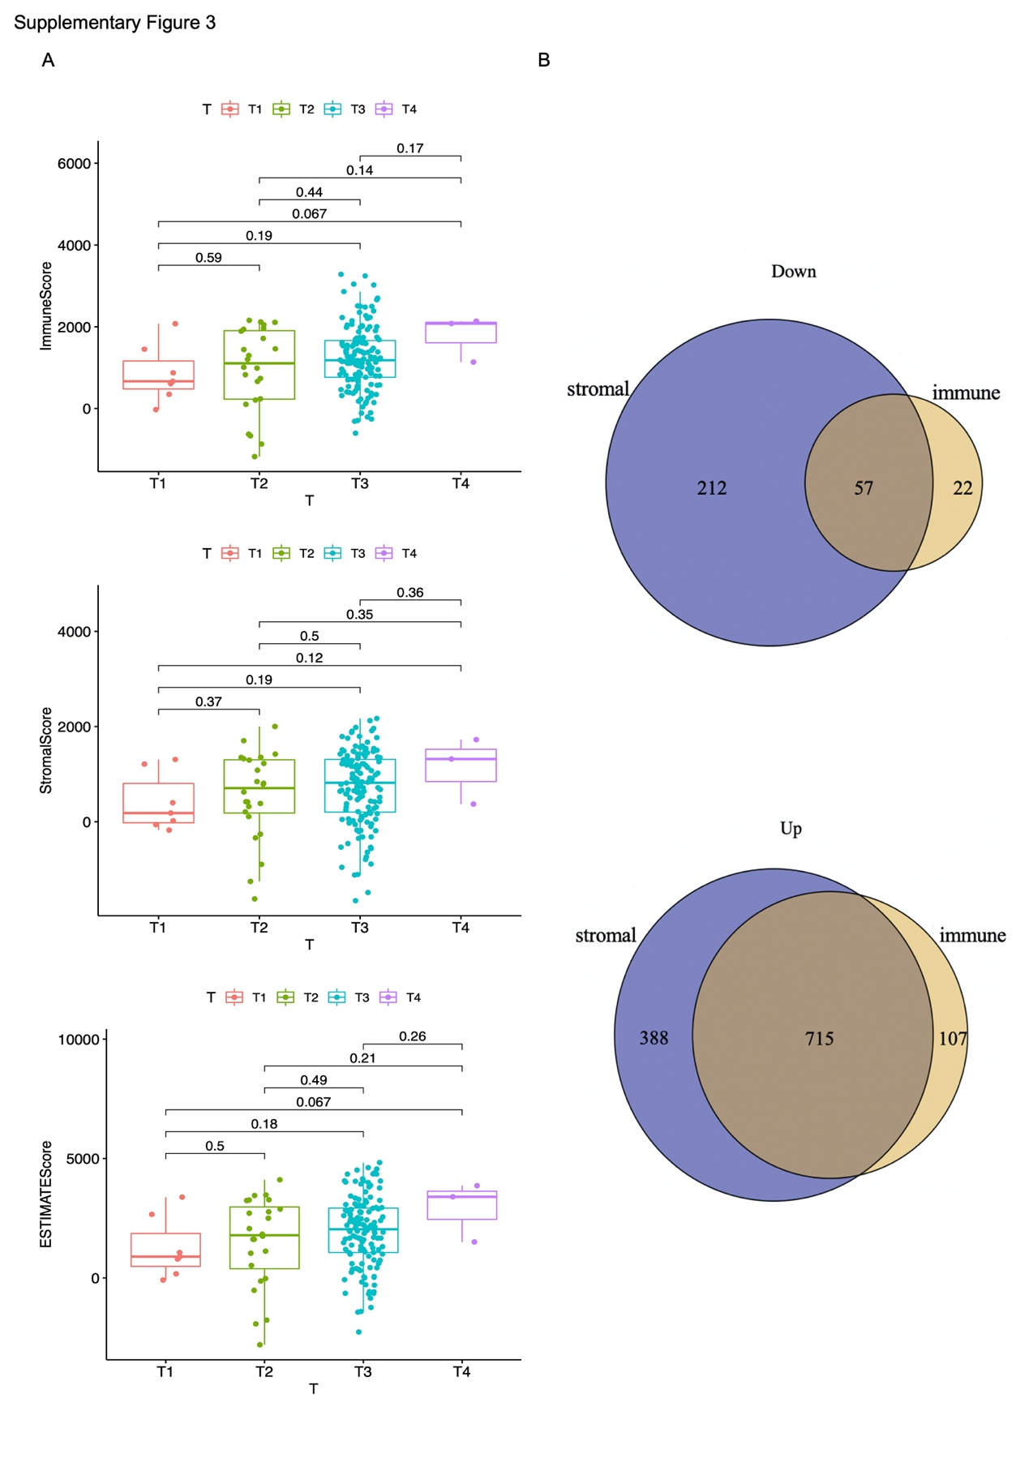

**Supplementary Figure 3.** Correlation between scores and T stage and Venn diagram analysis. **(A)** No significance was found between the scores and T stage. **(B)** Venn diagram analysis of up-regulated and down-regulated differentially expressed genes based on immune scores and stromal scores.

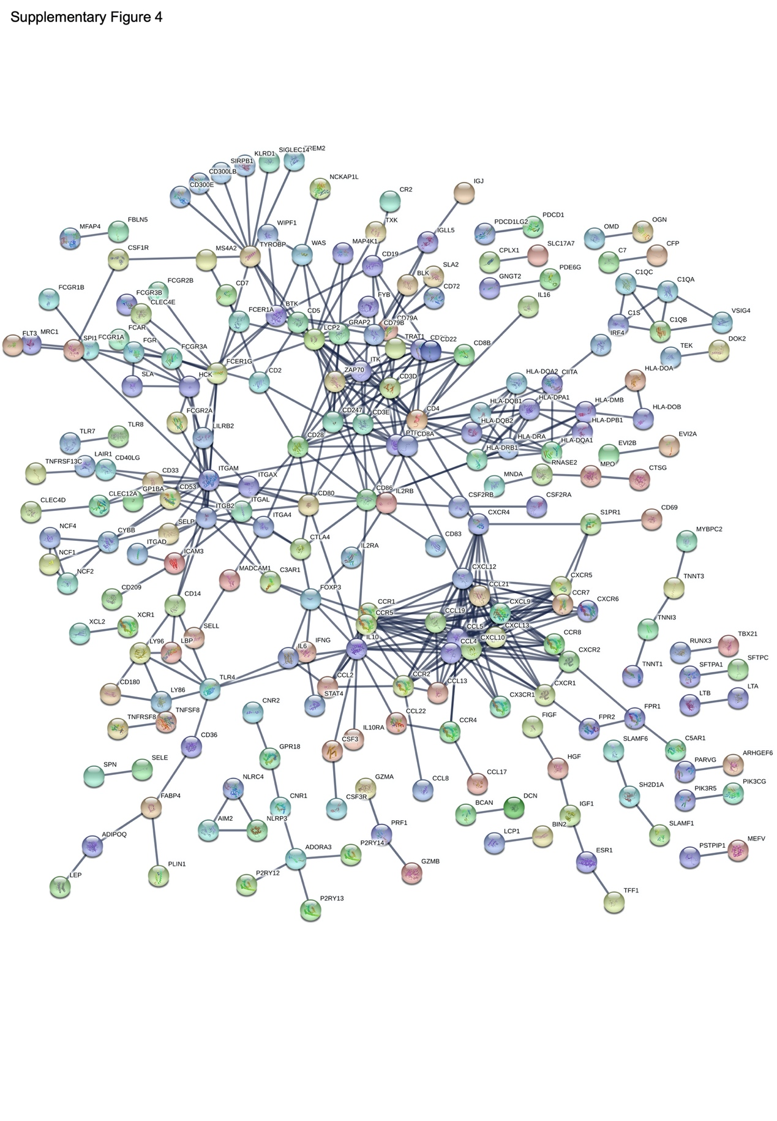

**Supplementary Figure 4.** PPI network construction. PPI network construction based on the STRING database covered 222 nodes and 476 edges with interaction confidence value more than 0.99.

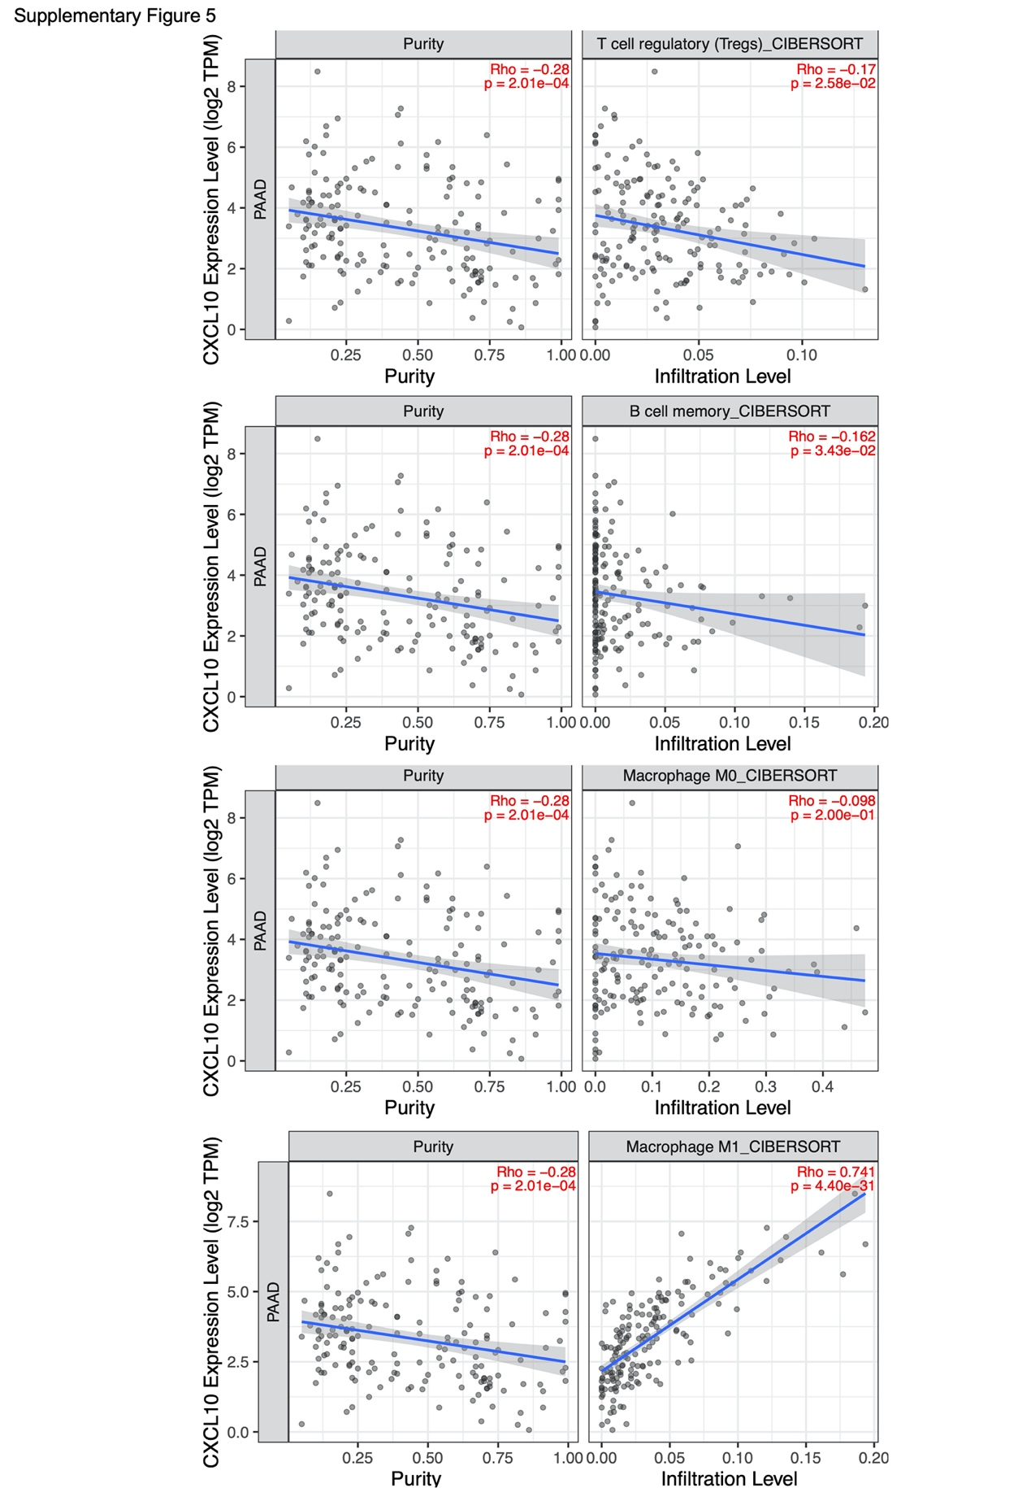

**Supplementary Figure 5.** Cumulative survival analysis. Cumulative survival analysis was performed to validate the correlation of CXCL10 and four immune cells.

Supplementary Table 1. Clinico-pathological characteristics statistics of PAAD patients from TCGA database

|  |  |  |  |  |  |
| --- | --- | --- | --- | --- | --- |
| Clinical characteristics |  | | Total | | % |
| Age at diagnosis (year)  Gender  Grade  Stage  T classification  M classification  N classification | <=65  >65  Female  Male  G1  G2  G3  G4  Ⅰ  Ⅱ  Ⅲ  Ⅳ  T1  T2  T3  T4  M0  M1  N0  N1 | 93  83  80  96  30  94  48  2  21  145  3  4  7  24  140  3  79  4  49  122 | | 52.8  47.2  45.5  54.5  17.2  54.0  27.6  1.1  12.1  83.8  1.7  2.3  4.0  14.0  80.5  1.7  95.2  4.8  28.7  71.3 | |

Supplementary Table 2. Enriched gene sets

|  |  |  |  |  |  |
| --- | --- | --- | --- | --- | --- |
| C7 collection | Gene set name | NES | | NOM p-val | |
| CXCL10 high expression    CXCL10 low expression | GSE13485_CTRL_VS_DAY3_YF17D_VACCINE_PBMC_DN  GSE14000_UNSTIM_VS_4H_LPS_DC_TRANSLATED_RNA_DN  GSE14415_INDUCED_TREG_VS_FOXP3_KO_INDUCED_TREG_IL2_CULTURE_UP  GSE15330_LYMPHOID_MULTIPOTENT_VS_MEGAKARYOCYTE_ERYTHROID_PROGENITOR_IKAROS_KO_DN  GSE19888_ADENOSINE_A3R_INH_VS_ACT_WITH_INHIBITOR_PRETREATMENT_IN_MAST_CELL_UP  GSE2706_UNSTIM_VS_8H_R848_DC_DN  GSE40685_TREG_VS_FOXP3_KO_TREG_PRECURSOR_DN  GSE43863_NAIVE_VS_MEMORY_TH1_CD4_TCELL_D150_LCMV_UP  GSE8835_CD4_VS_CD8_TCELL_CLL_PATIENT_UP  GSE18791_UNSTIM_VS_NEWCATSLE_VIRUS_DC_1H_UP  GSE21670_UNTREATED_VS_TGFB_TREATED_STAT3_KO_CD4_TCELL_UP  GSE34156_UNTREATED_VS_24H_NOD2_AND_TLR1_TLR2_LIGAND_TREATED_MONOCYTE_DN  GSE37533_UNTREATED_VS_PIOGLIZATONE_TREATED_CD4_TCELL_PPARG2_AND_FOXP3_TRASDUCED_UP | 2.41  2.34  2.39  2.36  2.41  2.31  2.31  2.31  2.35  -1.47  -1.39  -1.56  -1.53 | 0  0  0  0  0  0  0  0  0  0.034  0.037  0.022  0.020 | |

C7 collection: c7.all.v.7.1symbols.gmt from MSigDB. NES: normalized enrichment score. NOM: nominal *p-*value. Gene sets with NOM *p*-value less than 0.05 was considered as statistical significance.

Supplementary Table 3. The intersection of difference analysis and correlation analysis

|  |  |  |  |
| --- | --- | --- | --- |
| Tumor infiltrated immune cells | Correlation test（*p*-value） | | Difference test（*p*-value） |
| B-cells memory  T-cells regulatory  macrophages M0  macrophages M1 | 0.004  <0.001  <0.001  <0.001 | 0.032  <0.001  0.013  <0.001 | |