**Supplementary Material**

**Supplementary Materials and Methods**

*Single, isolated rabbit sinoatrial nodal cells (SAN cell) Isolation.* Single, spindle-shaped, spontaneously beating SAN cells were isolated from the hearts of New Zealand rabbits (Charles River Laboratories, Wilmington, MA) as described previously (Vinogradova et al., 2008). New Zealand White rabbits weighing 2.8~3.1kg were deeply anesthetized with sodium pentobarbital (50~90 mg/kg). The heart was removed quickly and placed in Tyrode solution containing (in mmol/L): NaCl, 130; NaHCO3, 24; NaH2PO4, 1.2; MgCl2, 1.0; CaCl2, 1.8; KCl, 4.0; and glucose, 5.6, which was saturated with a mixture of 95% 02 and 5% C02 (pH=7.4 at 36oC). The sinoatrial node region was cut into ~1.0 mm-wide strips, perpendicular to the crista terminalis. The sinoatrial node preparation was washed twice in Ca2+-free Tyrode solution (34oC) containing (in mmol/L): NaCl, 140; KCl, 5.4; MgCl2, 0.5; NaH2PO4, 0.33; HEPES, 5; glucose, 5.5 (pH=6.9); and then incubated at 34oC for 30 min in Ca2+-free Tyrode solution containing elastase type IV (0.6 mg/ml; Sigma, Chemical Co.), collagenase type 2 (0.8mg/ml; Worthington, NJ, USA), protease type XIV (0.18 mg/ml, Sigma, Chemical Co.) and 0.1% bovine serum albumin (Sigma, Chemical Co.). Thereafter, the sinoatrial node preparation was washed in modified Kraft-Bruhe (KB) solution containing (in mmol/L): potassium glutamate, 70; KCl, 30; KH2PO4, 10; MgC12, 1; taurine, 20; glucose, 10; EGTA, 0.3 and HEPES, 10 (pH=7.4 with KOH), and kept at 4oC for 1h in KB solution containing 50 mg/ml polyvinylpyrrolidone (PVP 40, Sigma, Chemical Co.). Cells were dispersed from the sinoatrial node preparation by gentle pipetting in the KB solution and stored at 4oC. Studies in freshly isolated SAN cells were performed within hours following isolation.

*Spontaneous AP Recordings.* Spontaneous APs (number of beats >512) were recorded in subset-sets of SAN cells using the perforated patch-clamp technique with an Axopatch 200B patch-clamp amplifier (Axon Instruments) (Bogdanov et al., 2006). The pipette (~3 MΩ) filling solution contained (in mmol/L) K-gluconate 120, NaCl 10, MgATP 5, HEPES 5, KCl 20 (pH, 7.2) and 50 mol/L -escin (Sigma). Bath superfusion solution contained (in mmol/L): NaCl 140, KCl 5.4, MgCl2 1; HEPES 5, CaCl2, 1.8, Glucose 5.5 (pH=7.4). All functional measurements were performed at 34 ± 0.5oC. Freshly isolated SAN cells were selected for study based on the apparent regularity of their spontaneous beating, the relative smoothness and apparent quality of the cellular surface. Prior to each recording, the spontaneous AP firing was monitored for at least 20 min to insure its stability. The variability of selected AP parameters was measured via a customized program (Bogdanov et al., 2006). In addition to the classic AP characteristics, TTIO (Time to ignition onset) that reflects the onset of the ignition phase of the AP cycle (Lyashkov, Behar, Lakatta, Yaniv, & Maltsev, 2018) was measured. AP firing interval variability was determined from AP recordings over 20 minutes AP beating time series. AP firing interval variability was characterized by the standard deviations (SD) or coefficient of variation (CV, the ratio of SD to the mean).

*Ca2+ Measurements.* Subsets SAN cells were loaded with the Ca2+ indicator fluo-4/AM (5 mol/L, 20min at room temperature, Thermo Scientific) (Vinogradova et al., 2004). Following washout of extracellular fluo-4/AM, AP initiated global Ca2+ transients and spontaneous local Ca2+ releases (LCR) during diastole were measured at 34±0.5oC with a confocal microscope (Zeiss LSM510, Germany) in the line-scan mode, with the scan line oriented along the long axis of the cell, close to the sarcolemma membrane. Ca2+-Image processing, data analysis, and presentation were performed using our original programs written in IDL 6.1 software (Vinogradova et al., 2010) (Interactive Data Language, Harris Corporation). The interval between the peaks of two adjacent AP-triggered Ca2+-transients is defined as Ca2+-transient firing interval (CaTFI). The LCR period is defined as the time from the peak of the prior AP-induced Ca2+ transient to an LCR peak in diastole.

*Drugs.*The synthetic, non-specific -adrenergic receptor agonist isoproterenol (ISO), cholinergic agonist carbachol (CCh) were from SIGMA.

**Supplementary Discussion**

***Links between clock membrane potential and Ca2+ functional parameters measured during spontaneous AP firing and their molecular underpinnings.***The rapid depolarization from the diastolic membrane potential during the AP upstroke, mainly informs on the availability of CaV1.2 L-type Ca2+ channels for activation by the acute depolarization (Adeniran, McPate, Witchel, Hancox, & Zhang, 2011; Altomare et al., 2001; DiPolo & Beauge, 2006; Faber, Silva, Livshitz, & Rudy, 2007) (Figure S2). The greater the availability of channels to respond to a membrane voltage change cue, i.e., to than can be synchronously activated by a membrane voltage change (greater Ca2+ channel availability), the greater **dV/dt** of AP upstroke. The resultant Ca2+ influx via activated L-type Ca2+ channels binds to RyRs and synchronizes their activation via Ca2+-induced Ca2+ release (CICR), resulting in graded, synchronous RyR Ca2+ release that generates the AP-triggered CaT (Koivumaki, Takalo, Korhonen, Tavi, & Weckstrom, 2009; Stern et al., 1999) (Figure S2), depleting the Ca2+ charge on the SR Ca2+ capacitator. L-Type channels also begin to inactivate with time, even at the depolarized membrane potential, facilitated by the synchronous RyR Ca2+ release via CICR. The AP-induced cytosolic transient [Ca2+] due to RyR Ca2+ release and Ca2+ influx via L-type Ca channels activates Ca2+ ATPase (Serca) to pump Ca2+ into SR, and the kinetics of pumping that recharge the Ca2+ capacitor, as reflected in **CaT90** (Figure S2). Because **CaT90**of the AP-induced Ca2+ transient informs, in part, on the kinetics of SR Ca2+ refilling following Ca2+ depletion by the prior AP (Vinogradova et al., 2010), gradations in the mean CaT90 of a given “steady state” are also likely linked to gradations of beat-to-beat Ca-ATPase availability to become activated by Ca2+ (Figure S2). Thus, beat-to-beat variability of Ca2+ removal from the cytosol and pumping into SR is one mechanism that may lead to variability of local LCR periods (Figure S2).

Surface membrane depolarization activates K+ channels and inactivates forward Na-Ca exchange: AP repolarization kinetics, e.g., **APD90**, inform on the combined actions of K+ channels, cytosolic [Ca2+], INCX and If (Figure S2). K+ channel activation repolarizes the surface membrane, reactivating forward Na-Ca exchange, which assists in removing the Ca2+ released via the AP-induced RyR flux (which, in a “steady state” is equal to the amount of all Ca2+ influx via L-Type Ca2+ channels). Ca2+ also activates K+ channels, assisting in cell membrane repolarization(**APD90**), even prior to achieving the full surface membrane repolarization (i.e., MDP) and full If activation. Time from AP upstroke to MDP is regulated by the aforementioned ensemble of molecular activation and inactivation.

Following the reestablishment of the MDP, the membrane potential begins to slowly depolarize (Figure S2), due to removal of K+ channel activation, If activation, and spontaneous asynchronous local RyR activation that generates submembrane LCRs (Figure S2). **LCR periods** inform not only on the RyR activation but also on the kinetics of recharging the SR Ca2+ capacitor (Vinogradova et al., 2010). Summation of individual LCRs regulated, in part, by CICR (Stern et al., 2014), produces an LCR ensemble Ca2+ signal that activates an inward INCX. T-type (CaV3.1) and low voltage-activated L-Type channels (CaV1.3) become activated during diastolic depolarization and likely contribute to the increase in submembrane [Ca2+]. Exponential growth of the LCR ensemble Ca2+ signal (Figure S2), exponentially increasing INCX activation, initiating a rapid acceleration of the DD rate (non-linear DD component) (Lyashkov et al., 2018). Thus, **TTIO** informs on the kinetics of LCR generation and synchronization to generate the LCR ensemble Ca2+ signal that increase INCX activation. If inactivates during late DD Rapid and concurrent dynamic, non-linear feed-forward interactions of membrane potential, If, Ca2+ channel activation and the increase in INCX due in large measure to exponential growth of the LCR ensemble Ca2+ signal, drive the late DD membrane potential to the threshold potential required for activation of CaV1.2 L-Type Ca2+ channels and the next rapid AP upstroke ensues (Lyashkov et al., 2018).

**Supplementary Figures**

**Supplementary Figure S1.** Schematic of experimental data and data analyses

**Supplementary Figure S2.** Molecular drivers of coupled oscillator pacemaker functions.The activation-inactivation schema of molecular functions that underlie AP (Adeniran et al., 2011; Altomare et al., 2001; DiPolo & Beauge, 2006; Faber et al., 2007) and Ca2+ loop (Koivumaki et al., 2009; Stern et al., 1999) functions.

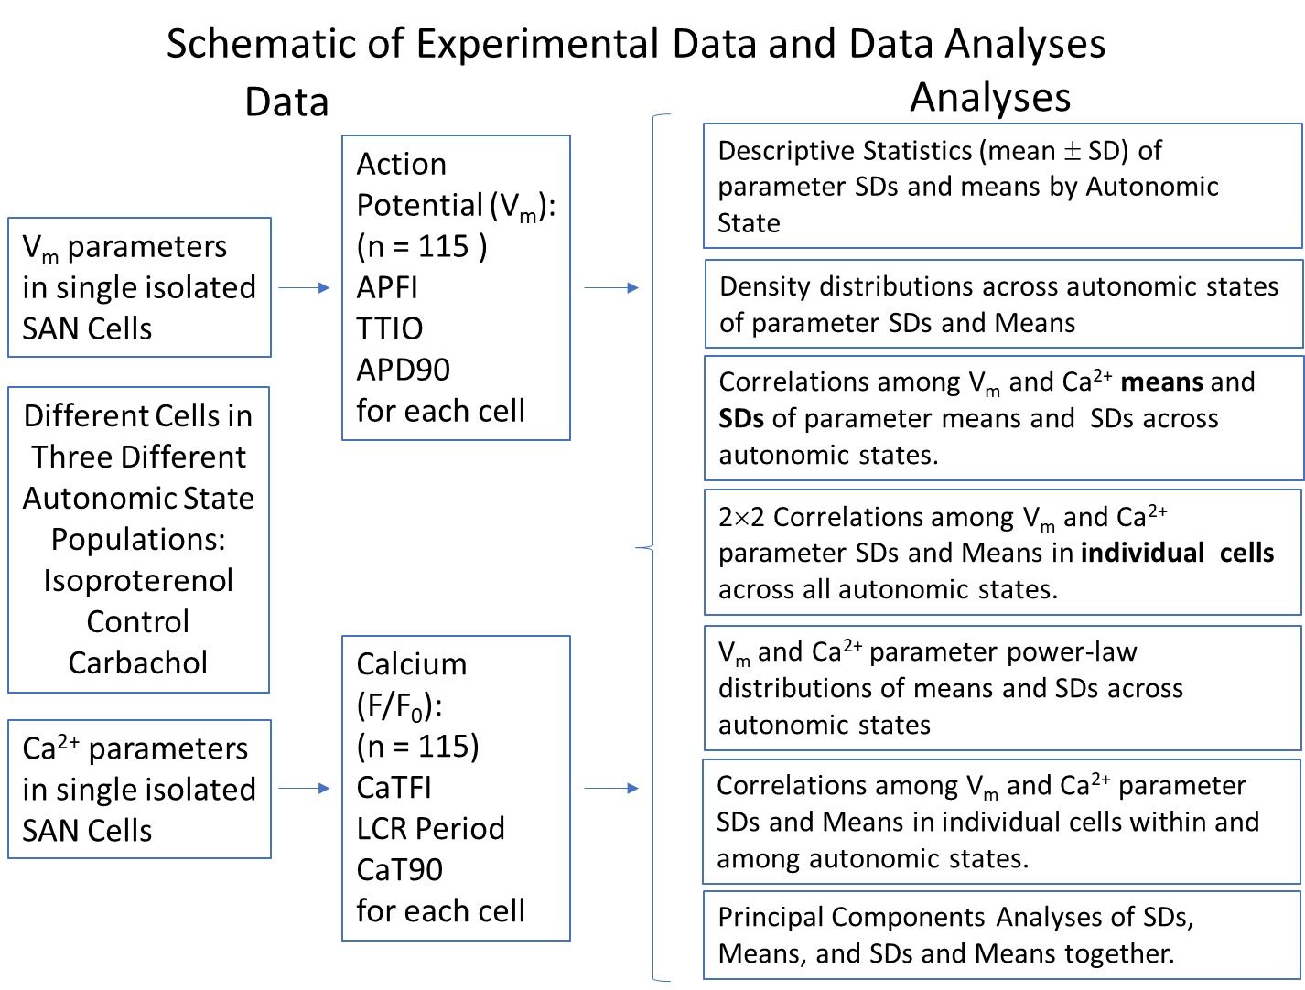

Surface membrane ion channels, electrogenic ion exchange proteins, e.g., NCX, and ion pumps, e.g., Na-K ATPase are ion current oscillators that regulates TTIO (Sirenko et al., 2016) and APD90. The NCX and Na-K ATPase are voltage- and transmembrane gradient-dependent, and actively and exquisitely responsive to effect changes in Na+-Ca2+ electro-chemical gradient oscillations that underline each AP cycle in isolated SAN cells (Sirenko et al., 2016). Molecules within the bi-directionallycoupled oscillator system either directly or indirectly regulate both surface membrane potential and intracellular Ca2+. Variable degrees of self-organized coherence or synchronization among these molecular functions impact on the fidelity to which the Ca2+ oscillators within the system and coupled to the system current oscillators (Yaniv, Lyashkov, & Lakatta, 2013; Yaniv et al., 2014).

The SR oscillates intracellular Ca2+, that includes the LCR (indicated as the white arrows on Ca2+ line-scan image) period and CaT90: SR operates as a Ca2+ capacitor, its Ca2+ charge is regulated by Serca2a that pumps Ca2+ into the SR lumen, and by ryanodine receptors (RyR) that dissipate the Ca2+ charge, via releasing Ca2+ beneath the cell surface membrane. An interaction of PLB with Serca2a modulates the maximum speed of Ca2+ pumping into SR. Ion pumps that operate within each clock are energy dependent. The LCR period is an index of clock coupling that becomes manifest when a SAN cell fires an AP.

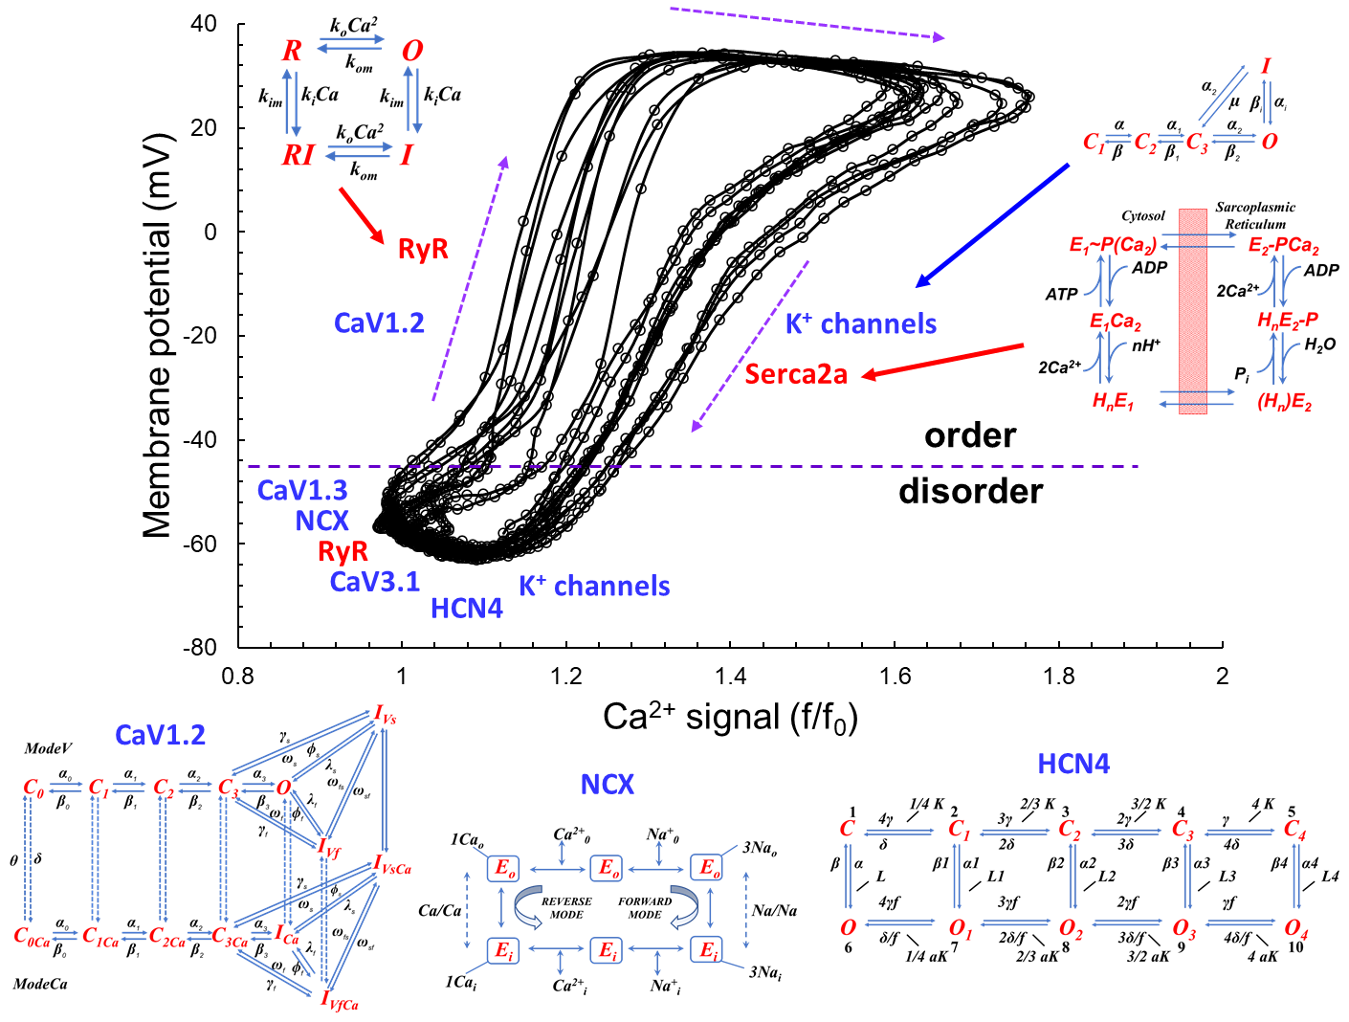

**Supplementary Figure S3.** Heatmaps of correlations by group.

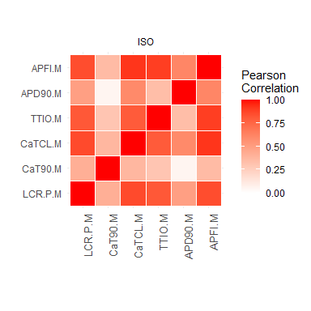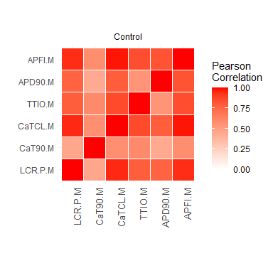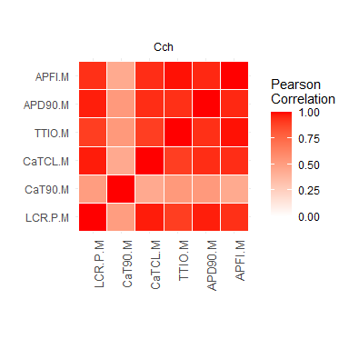

**Supplementary Figure S4.** Principal Component Analyses of modeling data: only 2 PCs explain 93.9% of the variation in these 8 variables!

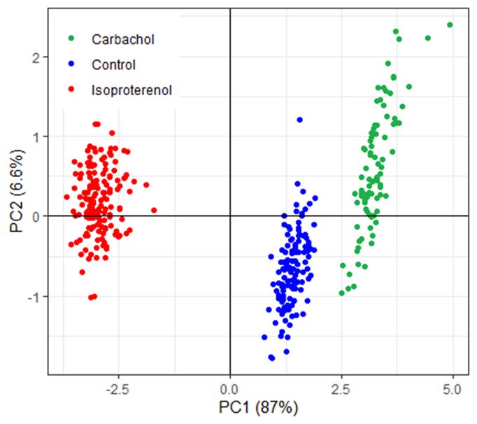

**Supplementary Figure S5.** A Comparison of gradations in the phosphorylation level (**A**) indexed by phosphorylated PLB at Ser16 normalized to total PLB of cells in different steady states (redrawn from published previously data, (Lyashkov et al., 2009; Yang, Lyashkov, Li, Ziman, & Lakatta, 2012)) and the means (**B**) and SDs (**C**) of all 6 parameters in all 3 “steady states” listed in Table 1. Phosphorylation data and functional data are normalized to value in control, as indicated by the dashed blue line in figure panels.

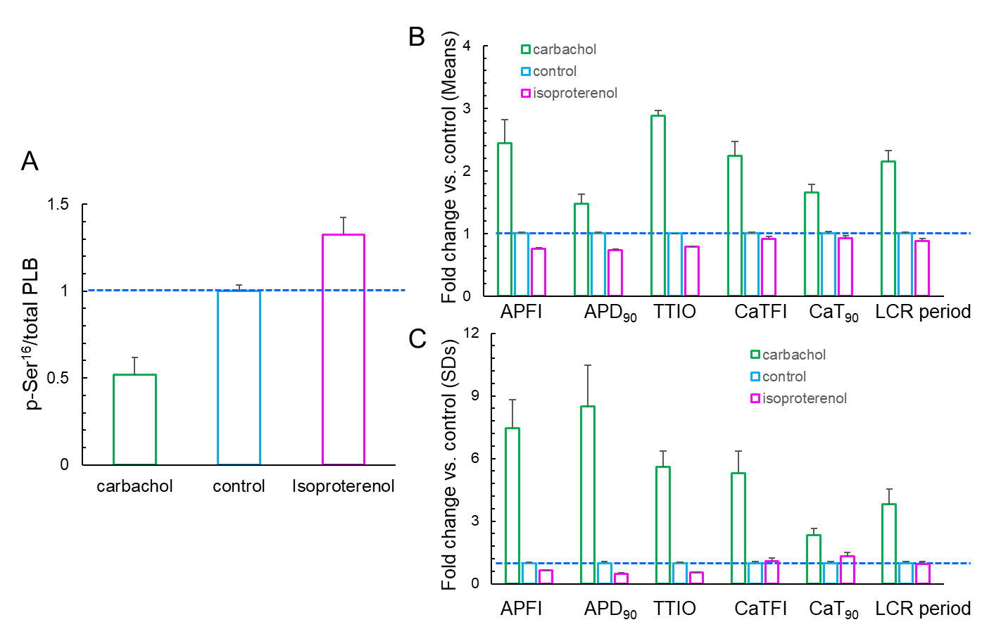

**Supplementary Table S1**. SD1 and SD2 from Ellipse fittings of Poincaré Plot from AP recordings during CCh or ISO super-perfusion and its self-control (the same cells as Figures 4-6).

|  |  |  |  |  |  |  |
| --- | --- | --- | --- | --- | --- | --- |
|  |  | **SD1** | **SD2** | **SD1/SD2** | **Mean** | **SD** |
| **APFI** | CCh | 39.922 | 60.755 | 0.6571 | 910.279 | 53.146 |
| (ms) | con for CCh | 13.501 | 15.381 | 0.8778 | 330.378 | 14.455 |
|  | con for ISO | 7.270 | 13.605 | 0.5344 | 305.486 | 10.906 |
|  | ISO | 2.868 | 6.091 | 0.4708 | 192.680 | 4.758 |
| **APD90** | CCh | 27.061 | 30.152 | 0.8975 | 269.898 | 28.595 |
| (ms) | con for CCh | 8.037 | 8.509 | 0.9445 | 161.196 | 8.266 |
|  | con for ISO | 5.124 | 6.159 | 0.8320 | 142.428 | 5.661 |
|  | ISO | 1.815 | 4.226 | 0.4295 | 106.104 | 3.250 |
| **TTIO** | CCh | 69.653 | 105.826 | 0.6582 | 848.680 | 90.217 |
| (ms) | con for CCh | 16.732 | 28.683 | 0.5833 | 258.300 | 24.099 |
|  | con for ISO | 14.689 | 23.947 | 0.6134 | 242.383 | 19.875 |
|  | ISO | 5.678 | 8.342 | 0.6807 | 145.631 | 7.132 |

**Supplementary Table S2:** Summary table for Principal Component Analyses.

|  |  |  |  |  |
| --- | --- | --- | --- | --- |
| **Data** | **% Explained,**  **Cumulative %** | **SDs** | **Means** | **Means & SDs** |
| Vm data | PC1 | 89.9 | 91.7 | 85.9 |
| PC2 | 8.0, 98.0 | 7.9, 99.6 | 6.8, 92.7 |
| PC3 | 2.0, 100.0 | 0.4, 100.0 | 4.4, 97.1 |
| Ca2+ data | PC1 | 72.0 | 86.4 | 70.7 |
| PC2 | 18.2, 90.2 | 12.9, 99.3 | 11.9, 82.6 |
| PC3 | 9.8, 100.0 | 0.7, 100.0 | 9.2, 91.9 |
| Vm and Ca2+ data | PC1 | 68.4 | 85.8 | 76.7 |
| PC2 | 16.1, 84.6 | 7.8, 93.6 | 9.5, 83.2 |
| PC3 | 6.9, 91.5 | 4.1, 97.8 | 5.7, 88.8 |

**Supplementary Table S3:** Correlations of modeling data (note: ‘m40’ means ‘-40mV’)

|  |  |  |  |  |  |  |  |  |
| --- | --- | --- | --- | --- | --- | --- | --- | --- |
| Correlations and p-values | APFI | TTIO | INCX.m40 | If.m40 | IKr.m40 | ICaL.m40 | ICaT.m40 | Ca.m40.mM |
| APFI : r | 1 | 0.7269 | 0.8556 | 0.8777 | -0.8324 | 0.6578 | 0.8365 | -0.8488 |
| APFI : p | NA | 0 | 0 | 0 | 0 | 0 | 0 | 0 |
| TTIO : r | 0.7269 | 1 | 0.6951 | 0.713 | -0.7081 | 0.5833 | 0.6618 | -0.6905 |
| TTIO : p | 0 | NA | 0 | 0 | 0 | 0 | 0 | 0 |
| INCX.m40 : r | 0.8556 | 0.6951 | 1 | 0.9387 | -0.9789 | 0.8895 | 0.987 | -0.9999 |
| INCX.m40 : p | 0 | 0 | NA | 0 | 0 | 0 | 0 | 0 |
| If.m40 : r | 0.8777 | 0.713 | 0.9387 | 1 | -0.9502 | 0.8639 | 0.9225 | -0.9346 |
| If.m40 : p | 0 | 0 | 0 | NA | 0 | 0 | 0 | 0 |
| IKr.m40 : r | -0.8324 | -0.7081 | -0.9789 | -0.9502 | 1 | -0.9228 | -0.9521 | 0.9778 |
| IKr.m40 : p | 0 | 0 | 0 | 0 | NA | 0 | 0 | 0 |
| ICaL.m40 : r | 0.6578 | 0.5833 | 0.8895 | 0.8639 | -0.9228 | 1 | 0.8621 | -0.8909 |
| ICaL.m40 : p | 0 | 0 | 0 | 0 | 0 | NA | 0 | 0 |
| ICaT.m40 : r | 0.8365 | 0.6618 | 0.987 | 0.9225 | -0.9521 | 0.8621 | 1 | -0.9873 |
| ICaT.m40 : p | 0 | 0 | 0 | 0 | 0 | 0 | NA | 0 |
| Ca.m40.mM : r | -0.8488 | -0.6905 | -0.9999 | -0.9346 | 0.9778 | -0.8909 | -0.9873 | 1 |
| Ca.m40.mM : p | 0 | 0 | 0 | 0 | 0 | 0 | 0 | NA |

**DESCRIPTION OF NUMERICAL MODEL**

We performed simulations using modified Maltsev-Lakatta SA node cell numerical model that features a coupled-clock mechanism (Maltsev & Lakatta, 2009). The original model is freely available and can be downloaded and run in CellML format (<http://models.cellml.org/workspace/maltsev_2009>) using the Cellular Open Resource software developed by Alan Garny at Oxford University in the UK (Garny, Noble, Hunter, & Kohl, 2009) (for recent development of this software see <http://www.opencor.ws/>). We simulated APs, ion currents, and Ca dynamics in three scenarios: basal AP firing, β adrenergic receptor (βAR) stimulation with isoproterenol (ISO), 100 nM, and cholinergic receptor (CR) stimulation with carbachol (CCh), 0.1 μM. The effect of ISO was modelled as previously described in our previous studies (Maltsev & Lakatta, 2010), but the effect of CR stimulation on ICaL was changed to Zaza et al. model (Zaza et al., 1996) as described in details below. All model equations and parameter values are provided below.

**MODEL PARAMETERS**

**Fixed ion concentrations, mM**

*Ca*o = 2: Extracellular Ca2+ concentration.

*K*o = 5.4: Extracellular K+ concentration.

*K*i=140: Intracellular K+ concentration.

*Na*o = 140: Extracellular Na+ concentration.

*Na*i=10: Intracellular Na+ concentration.

*Mg*i = 2.5: Intracellular Mg2+ concentration.

**Cell compartments**

*C*m = 32 pF: Cell electric capacitance.

*L*cell = 70 μm: Cell length.

*R*cell = 4 μm: Cell radius.

*L*sub = 0.02 μm: Distance between jSR and surface membrane (submembrane space).

*V*cell = π·*R*cell2·*L*cell = 3.5185838 pL: Cell volume.

*V*sub = 2π·*L*sub·(*R*cell - *L*sub/2)·*L*cell = 0.035097874 pL: Submembrane space volume.

*V*jSR_part = 0.0012: Part of cell volume occupied by junctional SR.

*V*jSR = *V*jSR_part·*V*cell: Volume of junctional SR (Ca2+ release store).

*V*i_part = 0.46: Part of cell volume occupied with myoplasm.

*V*i = *V*i_part·*V*cell-*V*sub: Myoplasmic volume.

*V*nSR_part = 0.0116: Part of cell volume occupied by network SR.

*V*nSR = *V*nSR_part·*V*cell: Volume of network SR (Ca2+ uptake store).

**The Nernst equation and electric potentials, mV**

EX = (RT/F) · ln([X]o/[X]i) = *E*T · ln([X]o/[X]i), where

F = 96485 C/M is Faraday constant,

T = 310.15 K˚ is absolute temperature for 37˚C,

R = 8.3144 J/(M·K˚) is the universal gas constant,

*E*T is “RT/F” factor = 26.72655 mV,

and [X]o and [X]i are concentrations of an ion “X” out and inside cell, respectively.

*E*Na = *E*T ∙ ln(Nao/Nai): Equilibrium potential for Na+.

*E*K = *E*T ∙ ln(Ko/Ki): Equilibrium potential for K+.

*E*Ks = *E*T ∙ ln[(Ko + 0.12∙ Nao)/(Ki + 0.12 ∙ Nai)]: Reversal potential of *I*Ks.

*E*CaL = 45: Apparent reversal potential of *I*CaL.

*E*CaT = 45: Apparent reversal potential of *I*CaT.

*E*st = 37.4: Apparent reversal potential of *I*st.

**Sarcolemmal ion current types and their parameter values**

*I*CaL: L-type Ca2+ current [*g*CaL,max,basal = 0.58 nS/pF, as in Kurata et al. model (Kurata, Hisatome, Imanishi, & Shibamoto, 2002)].

Steady-state activation parameters: *V*½,d =-13.5 mV; *K*d =6 mV.

Steady-state inactivation parameters: *V*½,f =-35 mV; *K*f =7.3 mV.

*K*mfCa = 0.00035 mM: Dissociation constant of Ca2+ -dependent *I*CaLinactivation.

*β*fCa = 60 mM-1 · ms-1: Ca2+ association rate constant for *I*CaL.

*α*fCa = 0.021 ms-1 : Ca2+ dissociation rate constant for *I*CaL

*I*CaT: T-type Ca2+ current (*g*CaT,max = 0.1832 nS/pF).

*I*f: Hyperpolarization-activated current (*g*If,max = 0.15 nS/pF).

*V*If,1/2,basal = -64 mV: half activation voltage for *I*f current in the basal state.

*s*max = -7.2 mV: maximum ACh-induced shift of *I*f half activation voltage.

*nf* = 0.69 and *K0.5,f* = 12.6 nM: Michaelis-Menten parameters for ACh modulation of *I*f.

*I*st: Sustained non-selective current (*g*st,max = 0.003 nS/pF).

*I*Kr: Delayed rectifier K+ current rapid component (*g*Kr,max = 0.08113973 nS/pF).

*I*Ks: Delayed rectifier K+ current slow component (*g*Ks,max = 0.0259 nS/pF).

*I*to: 4-aminopyridine sensitive transient K+ current (*g*to,max = 0.252 nS/pF).

*I*sus: 4-aminopyridine sensitive sustained K+ current (*g*sus,max = 0.02 nS/pF).

*I*NaK: Na+/K+ pump current (*I*NaK,max = 2.88 pA/pF).

*K*mKp = 1.4 mM: Half-maximal *K*o for *I*NaK.

*K*mNap = 14 mM: Half-maximal *Na*i for *I*NaK.

*I*bCa: Background Ca2+ current (*g*bCa = 0.0006 nS/pF).

*I*bNa: Background Na+ current (*g*bNa = 0.00486 nS/pF).

*I*KACh: Acetylcholine-activated K+ current; *I*KACh =0, when [ACh]=0.

*g*KAch,max =0.14241818 nS/pF.

*I*NCX: Na+/Ca2+ exchanger (NCX) current (*k*NCX = 187.5 pA/pF).

*K*1ni = 395.3: intracellular Na+ binding to first site on NCX.

*K*2ni = 2.289: intracellular Na+ binding to second site on NCX.

*K*3ni = 26.44: intracellular Na+ binding to third site on NCX.

*K*1no = 1628: extracellular Na+ binding to first site on NCX.

*K*2no = 561.4: extracellular Na+ binding to second site on NCX.

*K*3no = 4.663: extracellular Na+ binding to third site on NCX.

*K*ci = 0.0207: intracellular Ca2+ binding to NCX transporter.

*K*co = 3.663: extracellular Ca2+ binding to NCX transporter.

*K*cni = 26.44: intracellular Na+and Ca2+ simultaneous binding to NCX.

*Q*ci:= 0.1369: intracellular Ca2+ occlusion reaction of NCX.

*Q*co=0: extracellular Ca2+ occlusion reaction of NCX.

*Q*n= 0.4315: Na+occlusion reactions of NCX.

**Ca2+ diffusion**

*τ*difCa = 0.04 ms: Time constant of Ca2+ diffusion from the submembrane to myoplasm.

*τ*tr = 40 ms: Time constant for Ca2+ transfer from the network to junctional SR.

**SR Ca2+ ATPase function**

*K*up = 0.6·10-3 mM: Half-maximal Cai for Ca2+ uptake in the network SR.

*P*up,basal = 0.012 mM/ms: Rate constant for Ca2+ uptake by the Ca2+ pump in the network SR.

**RyR function**

*k*oCa = 10 mM-2· ms-1; *k*om = 0.06 ms-1; *k*iCa = 0.5 mM-1· ms-1 ; *k*im = 0.005 ms-1; *EC*50_SR = 0.45 mM; *k*s = 250·103 ms-1; *MaxSR =*15; *MinSR =*1; *HSR =* 2.5;

**Ca2+ and Mg2+ buffering**

*k*bCM=0.542 ms-1: Ca2+ dissociation constant for calmodulin.

*k*bCQ=0.445 ms-1: Ca2+ dissociation constant for calsequestrin.

*k*bTC=0.446 ms-1: Ca2+ dissociation constant for the troponin-Ca2+ site.

*k*bTMC=0.00751 ms-1: Ca2+ dissociation constant for the troponin-Mg2+ site.

*k*bTMM=0.751 ms-1: Mg2+ dissociation constant for the troponin-Mg2+ site.

*k*fCM=227.7 mM-1· ms-1: Ca2+ association constant for calmodulin.

*k*fCQ=0.534 mM-1· ms-1: Ca2+ association constant for calsequestrin.

*k*fTC=88.8 mM/ms: Ca2+ association constant for troponin.

*k*fTMC=227.7 mM/ms: Ca2+ association constant for the troponin-Mg2+ site.

*k*fTMM=2.277 mM/ms: Mg2+ association constant for the troponin-Mg2+ site.

*TC*tot=0.031 mM: Total concentration of the troponin-Ca2+ site.

*TMC*tot=0.062 mM: Total concentration of the troponin-Mg2+ site.

*CQ*tot=10 mM: Total calsequestrin concentration.

*CM*tot=0.045 mM: Total calmodulin concentration.

**FORMULATIONS: ELECTROPHYSIOLOGY**

**Membrane potential, *V*m (variable *y15*)**

*\*dVm*/*dt = -* (*I*CaL + *I*CaT + *I*f + *I*st + *I*Kr + *I*Ks + *I*to + *I*sus + *I*NaK + *I*NCX + *I*bCa + *I*bNa+ *I*KACh) /*C*m

**Gating variables *(y16 - y30)* and their differential equations**

*dyi/dt = (yi,∞ -*  *y)*/*τyi*

(*yi =* *d*L, *f*L, *f*Ca, *d*T, *f*T, *p*aF, *p*aS, *p*i, *n*, *q*, *r*, *y*, *q*a, *q*i, *a*)

*τyi*: Time constant for a gating variable *yi*.

*αyi* and *βyi*: Opening and closing rates for channel gating.

*yi,*∞: Steady-state curve for a gating variable *yi*.

**Ion currents**

**L-type Ca2+ current (*I*CaL),** based on formulations of Kurata et al. (Kurata et al., 2002) that include Ca2+ dependent *I*CaL inactivation. See also Table S4 for comparison of steady-state activation parameters with those in other SAN cell models.

*I*CaL=*C*m·*g*CaL,max ·(*Vm- E*CaL)·*d*L·*f*L·*f*Ca

*d*L,∞ =1/{1+ exp[-(*Vm*- *V*½,d )/ *K*d ]}

*f*L,∞ =1/{1+exp[(*Vm* - *V*½,f )/ *K*f ]}

*α*dL = -0.02839·(*Vm*+ 35)/ {exp[-(*Vm*+35)/2.5] - 1} -0.0849 · *Vm* / [exp(-*Vm*/4.8)- 1]

*β*dL = 0.01143 · (*Vm* - 5)/ {exp[(*Vm*- 5)/2.5] -1}

*τ*dL =1/(*α*dL + *β*dL)

*τ*fL = 257.1 · exp{-[(*Vm*+ 32.5)/13.9]2 }+ 44.3

*f*Ca,∞ =*K*mfCa / (*K*mfCa + *Ca*sub)

*τ*fCa = *f*Ca,∞ / *α*fCa

**βAR stimulation**: I*CaL* traces and their respective IV curves in control vs. in the presence of βAR stimulation are shown in Figure S6.

**CR stimulation:** The fractional block (*b*CaL) of *I*CaL by CR stimulation was adopted from Zaza et al. model given in Figure 2 legend in (Zaza et al., 1996):

*b*CaL = [ACh]^0.348/(2921^0.348+[ACh]^0.348), where [ACh] is given in μM

*g*CaL,max=*C*m·*g*CaL,basal · (1 - *b*CaL)

Thus, the fractional block in the presence of 0.1 μM of CCh (simulated in the present study) is expected relatively small: *b*CaL(0.1) = 0.02728, i.e. <3% (see Figure S7)

**T-type Ca2+ current (*I*CaT),** based on formulations suggested by Demir et al., (Demir, Clark, Murphey, & Giles, 1994) and modified by Kurata et al. (Kurata et al., 2002).

*I*CaT = *C*m∙*g*CaT,max ∙(*Vm*- *E*CaT)∙*d*T∙*f*T

*d*T,∞ =1/ {1 + exp[-(*Vm* + 26.3)/6.0]}

*f*T,∞ = 1/{1+ exp[(*Vm*+ 61.7)/5.6]}

*τ*dT = 1/{1.068∙exp[(*Vm*+ 26.3)/30] + 1.068∙exp[-(*Vm* + 26.3)/30]}

*τ*fT =1/{0.0153∙exp[- (*Vm* + 61.7)/83.3] + 0.015∙exp[(*Vm*+ 61.7)/15.38]}

**Rapidly activating delayed rectifier K+ current (*I*Kr)**, based on formulations suggested by Zhang et al. (Zhang et al., 2000) and modified by Kurata et al. (Kurata et al., 2002).

*I*Kr = *C*m∙*g*Kr,max ∙(*Vm* - *E*K)∙(0.6∙ *p*aF + 0.4∙ *p*aS) ∙ *p*i

*p*a,∞ =1/ {1 + exp[-(*Vm*+23.2)/10.6]}

*p*i,∞ = 1/ {1 + exp[(*Vm* + 28.6)/17.1]}

*τ*paF = 0.84655354/[0.0372 ∙ exp(*Vm*/15.9) + 0.00096 ∙ exp(-*Vm* /22.5)]

*τ*paS = 0.84655354/[0.0042 ∙ exp(*Vm* /17.0) + 0.00015 ∙ exp(-*Vm* /21.6)]

*τ*pi = 1/[0.1 ∙ exp(-*Vm*/54.645) + 0.656 ∙ exp(*Vm*/106.157)]

**Slowly activating delayed rectifier K+ current (*I*Ks)**, based on formulations suggested by Zhang et al. (Zhang et al., 2000).

*I*Ks = *C*m∙*g*Ks,max ∙(*Vm* - *E*Ks)∙ *n*2

*α*n = 0.014/ {1 + exp[-(*Vm*- 40)/9]}

*β*n = 0.001 ∙ exp(-*Vm*/45)

*n*∞ = *α*n/(*α*n + *β*n)

*τ*n =1/(*α*n + *β*n)

**4-aminopyridine-sensitive currents (*I*4AP =*I*to *+ I*sus),** based on formulations suggested by Zhang et al. (Zhang et al., 2000).

*I*to = *C*m ∙ *g*to,max ∙ (*Vm*- *E*K) ∙ *q*∙ *r*

*I*sus = *C*m ∙ *g*sus,max ∙ (*Vm* - *E*K) ∙ *r*

*q*∞ =1/{1 + exp[(*Vm*+ 49)/13]}

*r*∞ =1/{1 + exp[-(*Vm* - 19.3)/15]}

*τ*q = 39.102/{0.57∙exp[-0.08∙(*Vm*+44)]+0.065∙exp[0.1∙(*Vm*+45.93)]}+ 6.06

*τ*r =14.40516/{1.037∙exp[0.09∙(*Vm*+30.61)]+0.369∙exp[-0.12∙(*Vm*+23.84)]}+ 2.75352

**Hyperpolarization-activated, “funny” current (*I*f)**, based onformulations of Wilders at al. (Wilders, Jongsma, & van Ginneken, 1991) and Kurata et al.(Kurata et al., 2002). The shift *s* (in mV) of the *I*f activation curve by ChR stimulation was adopted from Zhang et al. 2002 (Zhang, Holden, Noble, & Boyett, 2002).

*I*f = *I*fNa+ *I*fK

*y*∞ = 1/{1 + exp[(*Vm* - *V*If,1/2) /13.5]}

τy = 0.7166529/{exp[-(*Vm*+ 386.9)/45.302] + exp[(*Vm* - 73.08)/19.231]}

*I*fNa = *C*m∙0.3833 ∙*g*If,max ∙(*Vm* - *E*Na)∙*y*2

*I*fK = *C*m∙0.6167 ∙ *g*If,max ∙(*Vm* - *E*K)∙*y*2

*V*If,1/2 = *V*If,1/2,basal + *s*



**Sustained inward current (*I*st),** based on formulations of Shinigawa et al. (Shinagawa, Satoh, & Noma, 2000) which were adopted for rabbit SAN cells by Kurata et al. (Kurata et al., 2002).

*I*st = *C*m ∙*g*st,max ∙ (*Vm* - *E*st)∙ *q*a∙ *q*i

*q*a,∞ =1/{1 + exp[-(*Vm* + 57)/5]}

*α*qa =1/{0.15 ∙ exp(-*Vm*/11) + 0.2 ∙ exp(-*Vm*/700)}

*β*qa =1/{16 ∙ exp(*Vm*/8) + 15 ∙ exp(*Vm*/50)}

τqa =1/(*α*qa  + *β*qa)

*α*qi =1/{3100 ∙ exp(*Vm*/13) + 700 ∙exp(*Vm*/70)}

*β*qi =1/{95∙ exp(-*Vm*/10) + 50 ∙exp(-*Vm*/700)} + 0.000229/[1 + exp(-*Vm*/5)]

*τ*qi =6.65/(*α*qi  + *β*qi)

*q*i,∞ =*α*qi  /(*α*qi  + *β*qi)

**Na+-dependent background current (*I*bNa)**

*I*b,Na =*C*m∙*g*bNa∙(*Vm* - *E*Na)

**Na+-K+ pump current (*I*NaK),** based on formulations on Kurata et al. (Kurata et al., 2002), which were in turn based on the experimental work of Sakai et al. (Sakai, Hagiwara, Matsuda, Kassanuki, & Hosoda, 1996) for rabbit SAN cells.

*I*NaK= *C*m ∙*I*NaK,max ∙{1+(KmKp/Ko)1.2}-1 ∙ {1+(KmNap/Nai)1.3} -1 ∙ {1+exp[-(*Vm*- *E*Na+120)/30]}-1

**Ca2+- background current (*I*bCa)**

*I*bCa = *C*m∙ *g*bCa ∙(*Vm* - *E*CaL)

**Na+-Ca2+ exchanger current (*I*NCX)**, based on originalformulations from Dokos et al. (Dokos, Celler, & Lovell, 1996).

*I*NCX = *C*m ∙*k*NCX ∙(*k*21 ∙ *x*2 - *k*12 ∙ *x*1) / (*x*1 + *x*2 + *x*3 + *x*4)

*d*o =1+(*Ca*o/*K*co)∙{1+exp(*Q*co∙*Vm*/*E*T)}+(*Na*o/*K*1no)∙{1+(*Na*o/*K*2no)∙(1+*Na*o/*K*3no)}

*k*43 = *Na*i/(*K*3ni +*Na*i)

*k*41 = exp[-*Q*n∙*Vm*/(2*E*T)]

*k*34 = *Na*o/(*K*3no+*Na*o)

*k*21 = (*Ca*o/*K*co)∙exp(*Q*co∙*Vm*/*E*T) /*d*o

*k*23 = (*Na*o/*K*1no)∙(*Na*o/*K*2no)∙(1+*Na*o/*K*3no)∙ exp[-*Q*n∙*Vm*/(2*E*T)]/*d*o

*k*32 = exp[*Q*n∙*Vm*/(2*E*T)]

*x*1 = *k*34 ∙ *k*41 ∙(*k*23 + *k*21) + *k*21 ∙ *k*32 ∙(*k*43 + *k*41)

*d*i = 1+(*Ca*sub/*K*ci)∙{1+exp(-*Q*ci∙*Vm*/*E*T)+*Na*i/*K*cni}+(*Na*i/*K*1ni)∙{1+(*Na*i/*K*2ni)∙(1+*Na*i/*K*3ni)}

*k*12 =(*Ca*sub/*K*ci)∙exp(-*Q*ci∙*Vm*/*E*T)/*d*i

*k*14 = (*Na*i/*K*1ni)∙(*Na*i/*K*2ni)∙(1 +*Na*i/*K*3ni)∙ exp[*Q*n∙*Vm*/(2*E*T)]/*d*i

*x*2 = *k*43∙ *k*32 ∙(*k*14 + *k*12) + *k*41∙ *k*12 ∙*k*34 + *k*32)

*x*3 = *k*43 ∙*k*14 ∙(*k*23 + *k*21) + *k*12 ∙*k*23∙(*k*43 + *k*41)

*x*4 = *k*34 ∙*k*23 ∙(*k*14 + *k*12) + *k*21 ∙*k*14∙(*k*34+ *k*32)

**Acetylcholine-activated K+ current (*I*KACh),** adopted from Demir et al. 1999 (Demir, Clark, & Giles, 1999) (Note ***I*KACh** = 0 when [ACh]=0)

*I*KACh = *a* ⋅ *g*KACh,max ⋅ (*V*m - *E*K)

*beta*=0.001 · 12.32/(1+0.0042/[ACh]) (per ms)

*alfa*= 0.001 · 17⋅exp(0.0133⋅(*Vm*+40)) (per ms)

*a*∞ = *beta* / (*alfa* + *beta*)

*τ*a = 1/(*alfa* + *beta*) (in ms)

**FORMULATIONS: Ca2+ CYCLING**

**Ca2+ release flux (*j*SRCarel) from SR via RyRs**, based on original formulations of Stern et al. (Stern et al., 1999) and modified by Shannon et al. (Shannon, Wang, Puglisi, Weber, & Bers, 2004)

*j*SRCarel = *k*s∙*O*∙(*Ca*jSR - *Ca*sub)

*k*CaSR = *MaxSR*- (*MaxSR* - *MinSR*)/ (1 + (*EC*50_SR/*Ca*jSR)HSR)

*k*oSRCa = *k*oCa/*k*CaSR

*k*iSRCa = *k*iCa∙*k*CaSR

*dR/dt* = (*k*im∙*RI* - *k*iSRCa ∙*Ca*sub∙*R*) - (*k*oSRCa∙*Ca*sub2∙*R* - *k*om∙*O*)

*dO/dt* =(*k*oSRCa∙*Ca*sub2 ∙*R*- *k*om∙*O*) - (*k*iSRCa∙*Ca*sub∙*O* - *k*im∙*I*)

*dI/dt* = (*k*iSRCa∙ *Ca*sub∙*O* - *k*im∙*I*) - (*k*om∙*I* - *k*oSRCa∙*Ca*sub2 ∙*RI*)

*dRI/dt* = (*k*om∙*I* - *k*oSRCa∙*Ca*sub2∙*RI*) - (*k*im∙*RI* - *k*iSRCa∙*Ca*sub∙*R*)

**Intracellular Ca2+ fluxes**

**Ca2+ diffusion flux** **(*j*Ca_dif)** from submembrane space to myoplasm:

*j*Ca_dif = (*Ca*sub - *Ca*i)/τdifCa

**The rate of Ca2+ uptake (pumping) (*j*up)** by the SR, based on formulations of SR Ca2+ pump function suggested by Luo and Rudy (Luo & Rudy, 1994).

*j*up = *P*up /(1 + *K*up/*Ca*i)

Autonomic modulation of Ca2+ uptake was described as reported previously (Maltsev & Lakatta, 2010): β-AR stimulation doubled *P*up from *P*up,basal of 0.012 mM/ms to 0.024 mM/s; by ChR stimulation inhibited *P*up, with fractional block (*b*up) as follows:

*P*up = *P*up,basal · (1 - *b*up)

*bup = bup,max* ⋅ [ACh]/( *K0.5,up* + [ACh])

where *K0.5,up* = 90 nM is the [ACh] for half-maximal inhibition and *bup,max* = 0.7.

**Ca2+ flux between (network and junctional) SR compartments (*j*tr)**:

*j*tr = (*Ca*nSR – *Ca*jSR)/τtr

**Ca2+ buffering**

*df*TC*/dt* = *k*fTC∙*Ca*i∙(1 -*f*TC) - *k*bTC ∙ *f*TC

*df*TMC/*dt* = *k*fTMC ∙*Ca*i ∙(1- *f*TMC - *f*TMM) - *k*bTMC ∙ *f*TMC

*df*TMM/*dt* = *k*fTMM ∙*Mg*i ∙(1-*f*TMC - *f*TMM)- *K*bTMM ∙ *f*TMM

*df*CMi/*dt* = *k*fCM ∙*Ca*i ∙(1- *f*CMi) - *k*bCM ∙ *f*CMi

*df*CMs/*dt* = *k*fCM ∙*Ca*sub∙(1 - *f*CMs) - *k*bCM ∙ *f*CMs

*df*CQ/*dt* = *k*fCQ ∙*Ca*jSR∙(1- *f*CQ) - *k*bCQ ∙ *f*CQ

**Dynamics of Ca2+ concentrations in cell compartments**

*dCa*i/*dt* =(*j*Ca_dif ∙*V*sub - *j*up∙ *V*nSR) /*V*i - (*CM*tot∙*df*CMi*/dt* + *TC*tot∙*df*TC/*dt* + *TMC*tot∙*df*TMC*/dt*)

*dCa*sub*/dt* = *j*SRCarel ∙*V*jSR/*V*sub -(*I*CaL+*I*CaT+*I*bCa-2∙*I*NCX)/(2∙F∙*V*sub)-(*j*Ca_dif + *CM*tot ∙*df*CMs*/dt*)

*dCa*jSR/*dt* = *j*tr - *j*SRCarel - *CQ*tot ∙ *df*CQ*/dt*

*dCa*nSR*/dt* = *j*up - *j*tr ∙*V*jSR/*V*nSR

**Initial values**

Online Table S5 summarizes all model variables (*y1*–*y30*) with their initial values.

**Model modification to generate AP firing interval (APFI) variability**

The original Maltsev-Lakatta model could not be directly used for APFI variability simulations because it is a system of 30 first-order differential equations (ODEs) that is deterministic and showing no APFI variability in limit cycle oscillatory regime of AP steady firing. Thus, we modified the model to generate variability of AP waveforms by supplementing total membrane current (Itot) with an additional current randomly fluctuating around its zero-mean value, known as perturbation current or Iper (as previously implemented by Henggui Zhang (Monfredi et al., 2014)). Computer code implementation for Iper was as follows: Iper = Iper,max* *ξ(t),* where Iper,max was the maximum amplitude of the perturbing current and ξ(t) is a random fluctuation term (‐1≤ξ(t)≤+1) that was generated by a random number generator within the program code. Random numbers were generated every 4 ms. Iper,max was tuned for the APFI variability in the model to match that measured experimentally under respective experimental conditions. We investigated two scenarios of noise generation when Iper was added to either Itot or Ca release flux *j*SRCarel (Itot in pA was recalculated in terms of mM/ms) in three conditions (i) basal AP firing, (ii) ISO 100 nM, and (iii) CCh (0.1 μM) (Figures S8 and S9). Variability of 6 major currents was measured and analyzed: If, INCX, IKr, ICaL, ICaT and IKACh. We also measured variability of [Ca] under cell membrane. For all items we measured variability of their peak amplitudes and amplitudes at -40 mV during DD. An example of analysis for INCX is shown Figure S10 and all results are summarized in Tables S6 and S7.



**Supplementary Figure S6**. Model simulations of β-AR stimulation effect on current-voltage relationship for *I*CaL. *I*CaL traces were simulated by applying testing voltage pulses *Vm* from a holding potential of -80 mV. A and B show simulated traces for *Vm* from -60 mV to 40 mV with a 10mV interval in the basal state (Control), in the presence of β-AR stimulation by ISO. The values of *Vm* are shown by labels at the respective current peaks. D: The current voltage relationships (5 mV voltage step) for *I*CaL peak. Inset illustrates presence of *I*CaL current activation in the model within the voltage range of the diastolic depolarization from -60 mV to -40 mV. Cell electric capacitance is 32 pF

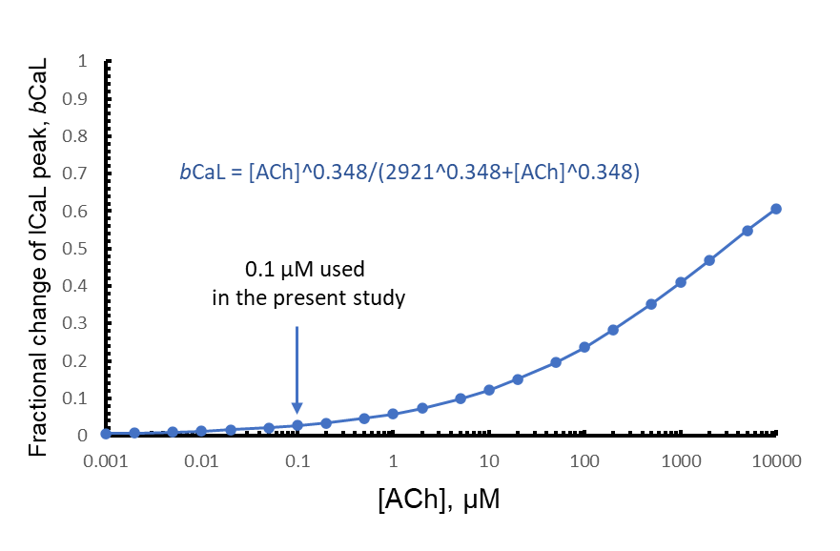

**Supplementary Figure S7**. Fractional block (*b*CaL) of *I*CaL by ChR stimulation adopted from Zaza et al. model given in Figure 2 legend in (Zaza, Robinson, & DiFrancesco, 1996). The fractional block in the presence of 0.1 μM of CCh (simulated in the present study) is expected relatively small: *b*CaL(0.1) = 0.02728, i.e. <3%.

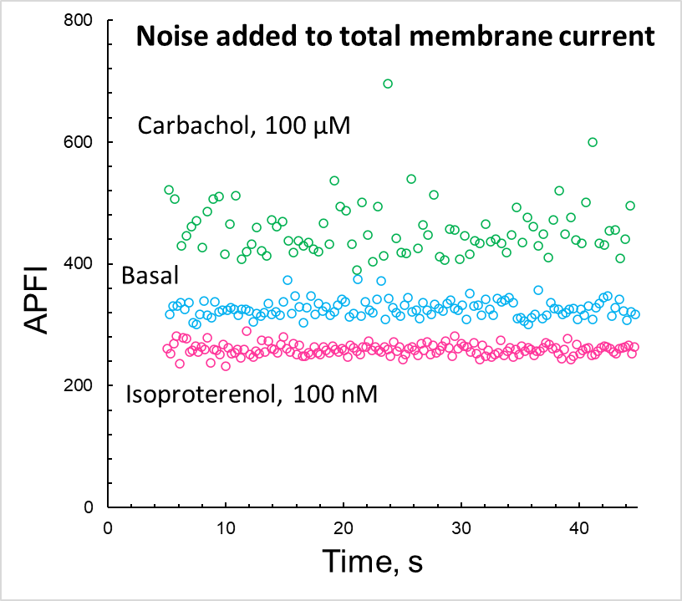

**Supplementary Figure S8.** Intervalogram of AP firing simulated by coupled-clock Maltsev-Lakatta model with noise (Iper) added to total current (Itot). Iper,max (pA) was tuned for the APFI variability in the model to match that measured experimentally: 15 pA, 10, and 5 pA, in ISO, Basal, and CCh, respectively.

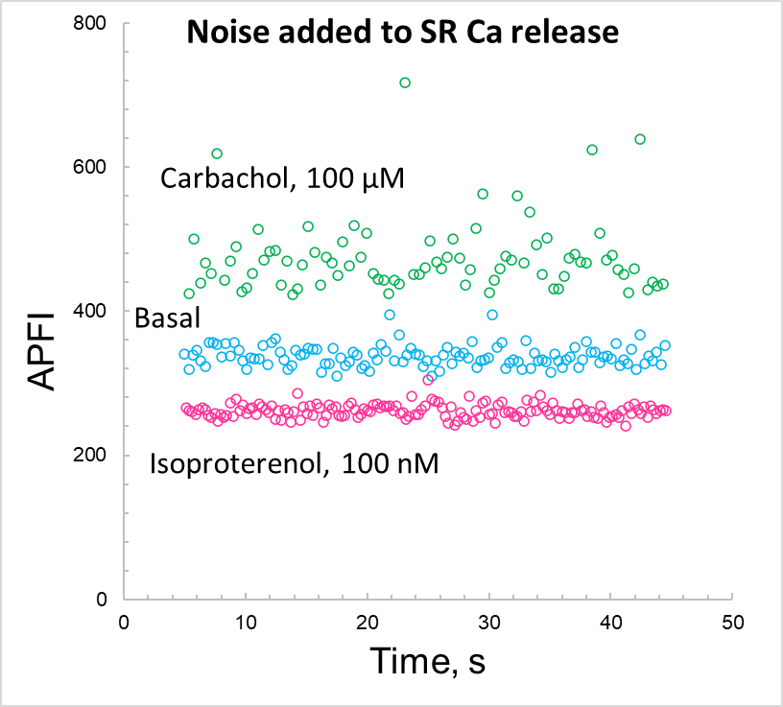

**Supplementary Figure S9**. Intervalogram of AP firing simulated by coupled-clock Maltsev-Lakatta model with noise (Iper) added to SR Ca release flux. Iper,max (pA) was tuned for the APFI variability in the model to match that measured experimentally: 33, 28, and 15 pA, in ISO, Basal, and CCh, respectively.

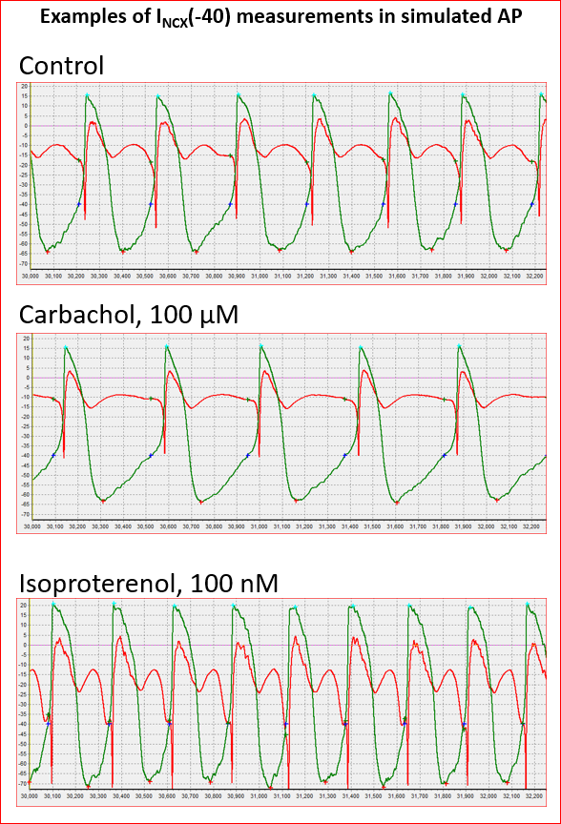

Time, ms

**Supplementary Figure S10**. An example of simulations and analysis of AP firing (green traces) and INCX (red traces) with noise current (Iper) added to total current Itot to match respective CV of APFI measured experimentally. Crosses: red is maximum diastolic potentials; aqua is AP overshoot, blue is -40 mV, green INCX value at -40 mV.

**Supplementary Table S4.** Parameters of steady-state activation and inactivation for *I*CaL in the present model compared to previous rabbit SAN cell models (see main text Methods for details). * Steady state inactivation parameters were set in our model to the respective values measured in our laboratory in an experimental study of isolated rabbit SAN cell by Vinogradova et al. (Vinogradova et al., 2000).

|  |  |  |  |  |
| --- | --- | --- | --- | --- |
| Model | Steady-state activation curve,  *d*L,∞ | | Steady-state inactivation curve,  *f*L,∞ | |
| Midpoint,  *V*½,d (mV) | Slope factor  *K*d (mV) | Midpoint,  *V*½,f (mV) | Slope factor  *K*f (mV) |
| Wilders et al. (Wilders et al., 1991) | -6.6 | 6.6 | -25 | 6 |
| Demir et al. (Demir et al., 1994) | -14.1 | 6 | -25 | 5 |
| Dokos et al. (Dokos et al., 1996) | -6.6 | 6.6 | -25 | 6 |
| Zhang et al. (Zhang et al., 2000) | -23.1 | 6 | -45 | 5 |
| Kurata et al. (Kurata et al., 2002) | -14.1 | 6 | -30 | 5 |
| **Present model** | **-13.5** | **6** | **-35\*** | **7.3\*** |

**Supplementary Table S5.** Model variables: description and initial values. Our SAN cell model is described as a system of 30 first order differential equations (variables *y1 - y30*).

|  |  |  |  |
| --- | --- | --- | --- |
| # | Variable | Description | Initial value |
| ***Ca2+ cycling*** | | | |
| *y1* | *Cai* | [Ca2+] in myoplasm, mM | 0.0001 |
| *y2* | *Casub* | [Ca2+] in submembrane space, mM | 0.000223 |
| *y3* | *Ca*jSR | [Ca2+] in the junctional SR (jSR), mM | 0.029 |
| *y4* | *Ca*nSR | [Ca2+] in the network SR (nSR), mM | 1.35 |
| *y5* | *f*TC | Fractional occupancy of the troponin-Ca2+ site by Ca2+ in myoplasm | 0.02 |
| *y6* | *f*TMC | Fractional occupancy of the troponin-Mg2+ site by Ca2 in myoplasm | 0.22 |
| *y7* | *f*TMM | Fractional occupancy of the troponin-Mg2+ site by Mg2+ in myoplasm | 0.69 |
| *y8* | *f*CMi | Fractional occupancy of calmodulin by Ca2+ in myoplasm | 0.042 |
| *y9* | *f*CMs | Fractional occupancy of calmodulin by Ca2+ in submembrane space | 0.089 |
| *y10* | *f*CQ | Fractional occupancy of calsequestrin by Ca2+ in junctional SR | 0.032 |
| *y11* | *R* | RyR reactivated (closed) state | 0.7499955 |
| *y12* | *O* | RyR open state | 3.4·10-6 |
| *y13* | *I* | RyR inactivated state | 1.1·10-6 |
| *y14* | *RI* | RyR RI state | 0.25 |
| ***Electrophysiology*** | | | |
| *y15* | *Vm* | Membrane potential, mV | -65 |
| *y16* | *d*L | *I*CaL activation | 0 |
| *y17* | *f*L | *I*CaL voltage-dependent inactivation | 1 |
| *y18* | *f*Ca | *I*CaL Ca2+ dependent inactivation | 1 |
| *y19* | *p*aF | *I*Kr fast activation | 0 |
| *y20* | *p*aS | *I*Kr slow activation | 0 |
| *y21* | *p*i | *I*Kr inactivation | 1 |
| *y22* | *n* | *I*Ks activation | 0 |
| *y23* | *y* | *I*f activation | 1 |
| *y24* | *d*T | *I*CaT activation | 0 |
| *y25* | *f*T | *I*CaT inactivation | 1 |
| *y26* | *q* | *I*to inactivation | 1 |
| *y27* | *r* | *I*to and *I*sus activation | 0 |
| *y28* | *qa* | *I*st activation | 0 |
| *y29* | *qi* | *I*st inactivation | 1 |
| *y30* | *a* | *I*KACh activation | 1 |

**Supplementary Table S6**. Results of variability analysis of major ion currents If, IKr, ICaL, ICaT, IKACh, and submembrane Ca simulated by a coupled-clock model **with noise added to total membrane current (Itot)** to match APFI variability observed experimentally. The results are presented for control, β-adrenergic receptor stimulation (ISO, 100 nM), and cholinergic receptor stimulation (CCh 0.1 μM) separately for peak amplitudes and amplitudes at -40 mV at the middle of diastolic depolarization. SD, standard deviation; CV, coefficient of variation (Mean/SD in %). The simulations were 40 s long with the total # of cycles indicated in parentheses. Iper,max (pA) was tuned for the APFI variability in the model to match that measured experimentally: 15 pA, 10, and 5 pA, in ISO, Basal, and CCh, respectively.

|  |  |  |  |  |  |  |  |  |  |
| --- | --- | --- | --- | --- | --- | --- | --- | --- | --- |
|  | ISO (154 cycles) | | | Basal (122 cycles) | | | CCh (87 cycles) | | |
|  | Mean | SD | CV, % | Mean | SD | CV, % | Mean | SD | CV, % |
| APFI (ms) | 259.25 | 9.1321 | 3.5225 | 326.45 | 13.90 | 4.257 | 455.78 | 45.562 | 9.997 |
| **The peak amplitudes of simulated ion currents** | | | | | | | | | |
| INCX (pA) | -74.32 | 3.651 | 4.9128 | -48.52 | 2.498 | 5.148 | -39.11 | 1.893 | 4.840 |
| If (pA) | -3.667 | 0.2350 | 6.4082 | -2.163 | 0.1937 | 8.953 | -1.554 | 0.0780 | 5.018 |
| IKr (pA) | 90.545 | 0.6646 | 0.734 | 56.76 | 0.4128 | 0.727 | 54.55 | 0.3655 | 0.670 |
| ICaL (pA) | -313.5 | 4.9296 | 1.572 | -212.2 | 4.416 | 2.081 | -205.7 | 6.212 | 3.019 |
| ICaT (pA) | -18.69 | 5.6899 | 30.447 | -3.841 | 0.8659 | 22.55 | -2.109 | 0.1317 | 6.248 |
| Casub (mM) | 2.5616 | 0.0986 | 3.8486 | 1.818 | 0.0647 | 3.557 | 1.566 | 0.0513 | 3.276 |
| IKACh (pA) |  |  |  |  |  |  | 6.809 | 0.1323 | 1.943 |
| **The values of simulated currents measured at a membrane potential of -40mV** | | | | | | | | | |
| INCX (pA) | -40.53 | 3.803 | 9.383 | -17.81 | 1.0768 | 6.047 | -10.28 | 0.7026 | 6.837 |
| If (pA) | -1.883 | 0.0857 | 4.553 | -1.291 | 0.0784 | 6.068 | -0.938 | 0.0284 | 3.029 |
| IKr (pA) | 32.95 | 0.8466 | 2.5694 | 19.66 | 0.5984 | 3.043 | 16.208 | 0.3041 | 1.876 |
| ICaL (pA) | -11.66 | 0.4961 | 4.2562 | -8.688 | 0.2449 | 2.819 | -9.081 | 0.1838 | 2.0245 |
| ICaT (pA) | -10.32 | 1.5963 | 15.461 | -3.841 | 0.8659 | 22.55 | -1.334 | 0.1878 | 14.075 |
| [Ca2+] under membrane(mM) | 0.5213 | 0.3625 | 6.954 | 0.3134 | 0.00932 | 2.977 | 0.2491 | 0.0059 | 2.371 |
| IKACh (pA) |  |  |  |  |  |  | 3.8294 | 0.0615 | 1.6061 |

**Supplementary Table S7**. Results of variability analysis of major ion currents If, IKr, ICaL, ICaT, IKACh, and submembrane Ca simulated by a coupled-clock model **with noise added to Ca release flux** to match APFI variability observed experimentally. The results are presented for control, β-adrenergic receptor stimulation (ISO, 100 nM), and cholinergic receptor stimulation (CCh, 0.1 μM) separately for peak amplitudes and amplitudes at -40 mV, i.e. at the middle of diastolic depolarization. SD, standard deviation; CV, coefficient of variation (Mean/SD in %). The simulations were 40 s long with the total # of cycles indicated in parentheses. Iper,max (pA) was tuned for the APFI variability in the model to match that measured experimentally: 33, 28, and 15 pA, in ISO, Basal, and CCh, respectively.

|  |  |  |  |  |  |  |  |  |  |
| --- | --- | --- | --- | --- | --- | --- | --- | --- | --- |
|  | ISO (152 cycles) | | | Basal (118 cycles) | | | CCh (83 cycles) | | |
|  | Mean | SD | CV, % | Mean | SD | CV, % | Mean | SD | CV, % |
| APFI (ms) | 261.44 | 9.321 | 3.565 | 337.43 | 14.61 | 4.331 | 474.59 | 50.42 | 10.62 |
| **The peak amplitudes of simulated ion currents** | | | | | | | | | |
| INCX (pA) | -74.33 | 3.098 | 4.167 | -47.95 | 2.879 | 6.004 | -38.42 | 2.142 | 5.576 |
| If (pA) | -3.710 | 0.2739 | 7.382 | -2.143 | 0.1536 | 7.166 | -1.542 | 0.0704 | 4.564 |
| IKr (pA) | 90.50 | 0.2520 | 0.2784 | 56.70 | 0.2053 | 0.362 | 54.39 | 0.3704 | 0.681 |
| ICaL (pA) | -313.6 | 4.169 | 1.329 | -211.9 | 3.212 | 1.516 | -205.0 | 6.966 | 3.398 |
| ICaT (pA) | -18.98 | 8.052 | 42.43 | -3.312 | 0.7169 | 21.64 | -2.015 | 0.1379 | 6.841 |
| Casub (mM) | 2.551 | 0.079 | 3.096 | 1.815 | 0.0700 | 3.855 | 1.556 | 0.0592 | 3.802 |
| IKACh (pA) |  |  |  |  |  |  | 6.779 | 0.1272 | 1.875 |
| **The values of simulated currents measured at a membrane potential of -40mV** | | | | | | | | | |
| INCX (pA) | -42.80 | 8.284 | 19.36 | -18.49 | 4.359 | 23.57 | -11.72 | 1.887 | 16.10 |
| If (pA) | -1.919 | 0.1128 | 5.881 | -1.321 | 0.0591 | 4.475 | -0.950 | 0.0357 | 3.755 |
| IKr (pA) | 32.78 | 0.5673 | 1.731 | 19.49 | 0.3704 | 1.900 | 16.04 | 0.3277 | 2.043 |
| ICaL (pA) | -11.67 | 0.7497 | 6.422 | -8.797 | 0.2594 | 2.949 | -9.072 | 0.1961 | 2.162 |
| ICaT (pA) | -10.36 | 2.447 | 24.14 | -2.951 | 0.7586 | 25.71 | -1.290 | 0.1494 | 11.58 |
| [Ca2+] under membrane(mM) | 0.5442 | 0.0818 | 15.02 | 0.3198 | 0.03796 | 11.87 | 0.2613 | 0.0160 | 6.109 |
| IKACh (pA) |  |  |  |  |  |  | 3.806 | 0.0600 | 1.577 |

**Supplementary references**

Adeniran, I., McPate, M. J., Witchel, H. J., Hancox, J. C., & Zhang, H. (2011). Increased vulnerability of human ventricle to re-entrant excitation in hERG-linked variant 1 short QT syndrome. *PLoS Comput Biol, 7*(12), e1002313. doi:10.1371/journal.pcbi.1002313

Altomare, C., Bucchi, A., Camatini, E., Baruscotti, M., Viscomi, C., Moroni, A., & DiFrancesco, D. (2001). Integrated allosteric model of voltage gating of HCN channels. *J Gen Physiol, 117*(6), 519-532. Retrieved from <https://www.ncbi.nlm.nih.gov/pubmed/11382803>

Bogdanov, K. Y., Maltsev, V. A., Vinogradova, T. M., Lyashkov, A. E., Spurgeon, H. A., Stern, M. D., & Lakatta, E. G. (2006). Membrane potential fluctuations resulting from submembrane Ca2+ releases in rabbit sinoatrial nodal cells impart an exponential phase to the late diastolic depolarization that controls their chronotropic state. *Circ Res, 99*(9), 979-987. doi:10.1161/01.RES.0000247933.66532.0b

Demir, S. S., Clark, J. W., & Giles, W. R. (1999). Parasympathetic modulation of sinoatrial node pacemaker activity in rabbit heart: a unifying model. *Am J Physiol, 276*(6 Pt 2), H2221-2244. Retrieved from <http://www.ncbi.nlm.nih.gov/entrez/query.fcgi?cmd=Retrieve&db=PubMed&dopt=Citation&list_uids=10362707>

Demir, S. S., Clark, J. W., Murphey, C. R., & Giles, W. R. (1994). A mathematical model of a rabbit sinoatrial node cell. *Am J Physiol, 266*(3 Pt 1), C832-852. Retrieved from <http://www.ncbi.nlm.nih.gov/entrez/query.fcgi?cmd=Retrieve&db=PubMed&dopt=Citation&list_uids=8166247>

DiPolo, R., & Beauge, L. (2006). Sodium/calcium exchanger: influence of metabolic regulation on ion carrier interactions. *Physiol Rev, 86*(1), 155-203. doi:10.1152/physrev.00018.2005

Dokos, S., Celler, B., & Lovell, N. (1996). Ion currents underlying sinoatrial node pacemaker activity: a new single cell mathematical model. *J Theor Biol, 181*(3), 245-272. Retrieved from <http://www.ncbi.nlm.nih.gov/entrez/query.fcgi?cmd=Retrieve&db=PubMed&dopt=Citation&list_uids=8869126>

Faber, G. M., Silva, J., Livshitz, L., & Rudy, Y. (2007). Kinetic properties of the cardiac L-type Ca2+ channel and its role in myocyte electrophysiology: a theoretical investigation. *Biophys J, 92*(5), 1522-1543. doi:10.1529/biophysj.106.088807

Garny, A., Noble, D., Hunter, P. J., & Kohl, P. (2009). CELLULAR OPEN RESOURCE (COR): current status and future directions. *Philos Trans A Math Phys Eng Sci, 367*(1895), 1885-1905. doi:10.1098/rsta.2008.0289

Koivumaki, J. T., Takalo, J., Korhonen, T., Tavi, P., & Weckstrom, M. (2009). Modelling sarcoplasmic reticulum calcium ATPase and its regulation in cardiac myocytes. *Philos Trans A Math Phys Eng Sci, 367*, 2181-2202.

Kurata, Y., Hisatome, I., Imanishi, S., & Shibamoto, T. (2002). Dynamical description of sinoatrial node pacemaking: improved mathematical model for primary pacemaker cell. *Am J Physiol, 283*(5), H2074-2101. Retrieved from <http://www.ncbi.nlm.nih.gov/entrez/query.fcgi?cmd=Retrieve&db=PubMed&dopt=Citation&list_uids=12384487>

Luo, C. H., & Rudy, Y. (1994). A dynamic model of the cardiac ventricular action potential. I. Simulations of ionic currents and concentration changes. *Circ Res, 74*(6), 1071-1096. Retrieved from <http://www.ncbi.nlm.nih.gov/entrez/query.fcgi?cmd=Retrieve&db=PubMed&dopt=Citation&list_uids=7514509>

Lyashkov, A. E., Behar, J., Lakatta, E. G., Yaniv, Y., & Maltsev, V. A. (2018). Positive Feedback Mechanisms among Local Ca Releases, NCX, and ICaL Ignite Pacemaker Action Potentials. *Biophys J, 114*(5), 1176-1189. doi:10.1016/j.bpj.2017.12.043

Lyashkov, A. E., Vinogradova, T. M., Zahanich, I., Li, Y., Younes, A., Nuss, H. B., . . . Lakatta, E. G. (2009). Cholinergic receptor signaling modulates spontaneous firing of sinoatrial nodal cells via integrated effects on PKA-dependent Ca2+ cycling and IKACh. *Am J Physiol Heart Circ Physiol, 297*(3), H949-959. doi:10.1152/ajpheart.01340.2008

Maltsev, V. A., & Lakatta, E. G. (2009). Synergism of coupled subsarcolemmal Ca2+ clocks and sarcolemmal voltage clocks confers robust and flexible pacemaker function in a novel pacemaker cell model. *Am J Physiol Heart Circ Physiol, 296*(3), H594-H615. Retrieved from <https://pubmed.ncbi.nlm.nih.gov/19136600/>

Maltsev, V. A., & Lakatta, E. G. (2010). A novel quantitative explanation for autonomic modulation of cardiac pacemaker cell automaticity via a dynamic system of sarcolemmal and intracellular proteins. *Am J Physiol Heart Circ Physiol, 298*, H2010-H2023. Retrieved from <http://www.ncbi.nlm.nih.gov/pubmed/20228256>

Monfredi, O., Lyashkov, A. E., Johnsen, A. B., Inada, S., Schneider, H., Wang, R., . . . Boyett, M. R. (2014). Biophysical characterization of the underappreciated and important relationship between heart rate variability and heart rate. *Hypertension, 64*(6), 1334-1343. doi:10.1161/HYPERTENSIONAHA.114.03782

Sakai, R., Hagiwara, N., Matsuda, N., Kassanuki, H., & Hosoda, S. (1996). Sodium--potassium pump current in rabbit sino-atrial node cells. *J Physiol, 490 (Pt 1)*, 51-62. Retrieved from <http://www.ncbi.nlm.nih.gov/entrez/query.fcgi?cmd=Retrieve&db=PubMed&dopt=Citation&list_uids=8745278>

Shannon, T. R., Wang, F., Puglisi, J., Weber, C., & Bers, D. M. (2004). A mathematical treatment of integrated Ca dynamics within the ventricular myocyte. *Biophys J, 87*(5), 3351-3371. Retrieved from <http://www.ncbi.nlm.nih.gov/entrez/query.fcgi?cmd=Retrieve&db=PubMed&dopt=Citation&list_uids=15347581>

Shinagawa, Y., Satoh, H., & Noma, A. (2000). The sustained inward current and inward rectifier K+ current in pacemaker cells dissociated from rat sinoatrial node. *J Physiol, 523 Pt 3*, 593-605. Retrieved from <http://www.ncbi.nlm.nih.gov/entrez/query.fcgi?cmd=Retrieve&db=PubMed&dopt=Citation&list_uids=10718740>

Sirenko, S., Maltsev, V. A., Yaniv, Y., Bychkov, R., Yaeger, D., Vinogradova, T. M., . . . Lakatta, E. G. (2016). Electrochemical Na+ and Ca2+ Gradients Drive Coupled-Clock Regulation of Automaticity of Isolated Rabbit Sinoatrial Nodal Pacemaker Cells. *Am J Physiol Heart Circ Physiol*, ajpheart 00667 02015. doi:10.1152/ajpheart.00667.2015

Stern, M. D., Maltseva, L. A., Juhaszova, M., Sollott, S. J., Lakatta, E. G., & Maltsev, V. A. (2014). Hierarchical clustering of ryanodine receptors enables emergence of a calcium clock in sinoatrial node cells. *J Gen Physiol, 143*(5), 577-604. doi:10.1085/jgp.201311123

Stern, M. D., Song, L. S., Cheng, H., Sham, J. S., Yang, H. T., Boheler, K. R., & Rios, E. (1999). Local control models of cardiac excitation-contraction coupling. A possible role for allosteric interactions between ryanodine receptors. *J Gen Physiol, 113*(3), 469-489. Retrieved from <https://www.ncbi.nlm.nih.gov/pubmed/10051521>

Vinogradova, T. M., Brochet, D. X., Sirenko, S., Li, Y., Spurgeon, H., & Lakatta, E. G. (2010). Sarcoplasmic reticulum Ca2+ pumping kinetics regulates timing of local Ca2+ releases and spontaneous beating rate of rabbit sinoatrial node pacemaker cells. *Circ Res, 107*(6), 767-775. doi:10.1161/CIRCRESAHA.110.220517

Vinogradova, T. M., Sirenko, S., Lyashkov, A. E., Younes, A., Li, Y., Zhu, W., . . . Lakatta, E. G. (2008). Constitutive phosphodiesterase activity restricts spontaneous beating rate of cardiac pacemaker cells by suppressing local Ca2+ releases. *Circ Res, 102*(7), 761-769. doi:10.1161/CIRCRESAHA.107.161679

Vinogradova, T. M., Zhou, Y. Y., Bogdanov, K. Y., Yang, D., Kuschel, M., Cheng, H., & Xiao, R. P. (2000). Sinoatrial node pacemaker activity requires Ca2+/calmodulin-dependent protein kinase II activation. *Circ Res, 87*(9), 760-767. Retrieved from <http://www.ncbi.nlm.nih.gov/entrez/query.fcgi?cmd=Retrieve&db=PubMed&dopt=Citation&list_uids=11055979>

Vinogradova, T. M., Zhou, Y. Y., Maltsev, V., Lyashkov, A., Stern, M., & Lakatta, E. G. (2004). Rhythmic ryanodine receptor Ca2+ releases during diastolic depolarization of sinoatrial pacemaker cells do not require membrane depolarization. *Circ Res, 94*(6), 802-809. doi:10.1161/01.RES.0000122045.55331.0F

Wilders, R., Jongsma, H. J., & van Ginneken, A. C. (1991). Pacemaker activity of the rabbit sinoatrial node. A comparison of mathematical models. *Biophys J, 60*(5), 1202-1216. Retrieved from <http://www.ncbi.nlm.nih.gov/entrez/query.fcgi?cmd=Retrieve&db=PubMed&dopt=Citation&list_uids=1722117>

Yang, D., Lyashkov, A. E., Li, Y., Ziman, B. D., & Lakatta, E. G. (2012). RGS2 overexpression or Gi inhibition rescues the impaired PKA signaling and slow AP firing of cultured adult rabbit pacemaker cells. *J Mol Cell Cardiol, 53*(5), 687-694. doi:10.1016/j.yjmcc.2012.08.007

Yaniv, Y., Lyashkov, A. E., & Lakatta, E. G. (2013). Impaired Signaling Intrinsic to Sinoatrial Node Pacemaker Cells Affects Heart Rate Variability during Cardiac Disease. *J. Clin. Trials, 4*, 152.

Yaniv, Y., Lyashkov, A. E., Sirenko, S., Okamoto, Y., Guiriba, T. R., Ziman, B. D., . . . Lakatta, E. G. (2014). Stochasticity intrinsic to coupled-clock mechanisms underlies beat-to-beat variability of spontaneous action potential firing in sinoatrial node pacemaker cells. *J Mol Cell Cardiol, 77*, 1-10. doi:10.1016/j.yjmcc.2014.09.008

Zaza, A., Robinson, R. B., & DiFrancesco, D. (1996). Basal responses of the L-type Ca2+ and hyperpolarization-activated currents to autonomic agonists in the rabbit sino-atrial node. *J Physiol, 491 ( Pt 2)*, 347-355. Retrieved from <http://www.ncbi.nlm.nih.gov/entrez/query.fcgi?cmd=Retrieve&db=PubMed&dopt=Citation&list_uids=8866859>

Zhang, H., Holden, A. V., Kodama, I., Honjo, H., Lei, M., Varghese, T., & Boyett, M. R. (2000). Mathematical models of action potentials in the periphery and center of the rabbit sinoatrial node. *Am J Physiol, 279*(1), H397-421. Retrieved from <http://www.ncbi.nlm.nih.gov/entrez/query.fcgi?cmd=Retrieve&db=PubMed&dopt=Citation&list_uids=10899081>

Zhang, H., Holden, A. V., Noble, D., & Boyett, M. R. (2002). Analysis of the chronotropic effect of acetylcholine on sinoatrial node cells. *J Cardiovasc Electrophysiol, 13*(5), 465-474. Retrieved from <http://www.ncbi.nlm.nih.gov/entrez/query.fcgi?cmd=Retrieve&db=PubMed&dopt=Citation&list_uids=12030529>