# Supplemental Material

List of tables and figures in supplemental.

**Supplementary** **Table 1**. Details of fleet closures in west, central and east on the Scotian Shelf, Canada.

**Supplementary** **Table 2**. Community structure in pre-collapse, post-collapse and recent periods. Species total biomass (BM), species proportion of the community total (prop) and cumulative proportion (cum prop). Species are ordered by dominance in each period.

**Supplementary** **Table 3**. Correlation coefficient and p-values of per capita rate of change between pre and post collapse, and between the most recent (2006-2017) and pre-collapse (1979-1992) periods, and between the most recent period (2006-2017) and post-collapse (1993-2005).

**Supplementary Figure** 1. Log average q-corrected biomass and confidence intervals for each of 24 species within fleet-closed or open areas in 3 sub-regions from 1979-92, in western, central and eastern sub-regions. Biomass were corrected for differences in catchability that arise from length structure and standardized by area of fleet-closed and open management areas.

**Supplementary Figure 2**. Ratio of post-collapse (1993-2005) and most recent (2006-2017) periods for abundance (left-hand panel) and size (right-hand panel). Species are ordered based on recent biomass status as per Figure 2 in main text. Note that abundance is higher than pre-collapse values for most species in both periods whereas size shows the opposite pattern. The majority of species are less than 0.75 of their pre-collapse size. In some cases, the size index may reflect a recruitment pulse but on average reflects a broad scale decline in the average size of individual fish (e.g. Shackell et al., 2010; Shackell et al., 2012; Bundy et al., 2019).

**Supplementary Figure 3**. Correlations between per capita rates of change between pre-collapse (1979-1992) and post-collapse (1993-2005) (left-hand panel), and between post-collapse (1993-2005) and recent (2006-2017) periods.

**Supplementary Figure 4**. Median estimate of per capita rate of change for 24 species in fleet-closed and open areas in 3 periods. Species are ordered based on recent regional-scale biomass status scale relative to the pre-collapse period. See Table 1 for species full names.

**Supplementary** **Table 1**. Details of fleet closures in west, central and east on the Scotian Shelf, Canada.

|  |  |  |  |  |  |  |
| --- | --- | --- | --- | --- | --- | --- |
| Sub-Region | Name | Fleet Excluded | Detail | Objective | StartDate | Ref |
| West | Brown's Bank | groundfish | Closed from ~February 1 to June 15 | Protect haddock spawning aggregations | 1970/72 | Halliday, 1988 |
| Central | Haddock Box | groundfish | annual | Protect haddock nursery area | 1987(mobile)/1993(all groundfish fleets) | Zwanenburg, 1992 |
| East | NAFO 4VSb | groundfish | November 1st to April 30th for fixed gears, and January 1st to April 30th for mobile | Protect Southern Gulf cod migrants | 1993 | Chouinard et al., 2000 |

**Supplementary** **Table 2**. Community structure in pre-collapse, post-collapse and recent periods. Species total biomass (BM), species proportion of the community total (prop) and cumulative proportion (cum prop). Species are ordered by dominance in each period.

**Supplementary** **Table 3**. Correlation coefficient and p-values of per capita rate of change between pre- and post-collapse, and between the most recent (2006-2017) and pre-collapse (1979-1992) periods, and between the most recent (2006-2017) and post-collapse (1993-2005) periods.



*** p < 0.001; ** p < 0.01; * p < 0.05

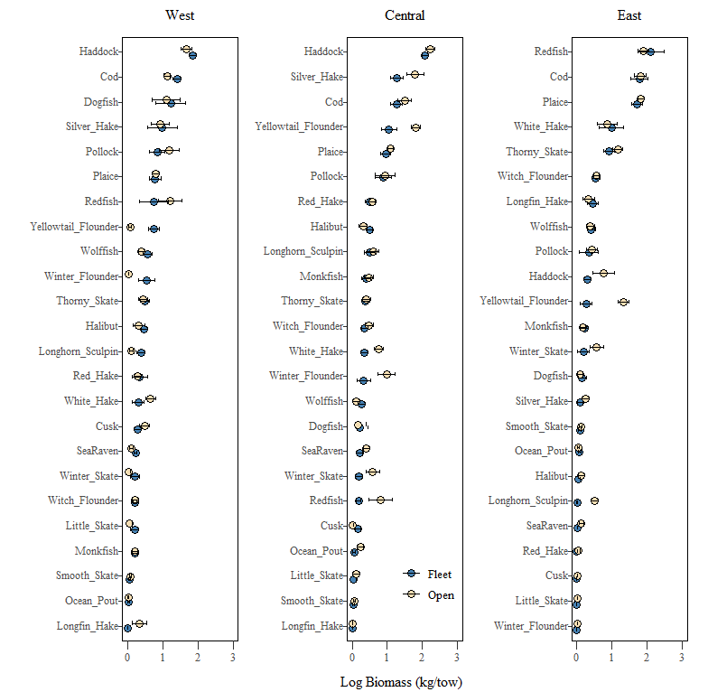

**Supplementary Figure 1**. Log average q-corrected biomass (kg/tow) and confidence intervals for each of 24 species within fleet-closed or open areas in 3 sub-regions from 1979-92, in western, central and eastern sub-regions. Biomass were corrected for differences in catchability that arise from length structure and standardized by area of fleet-closed and open management areas.

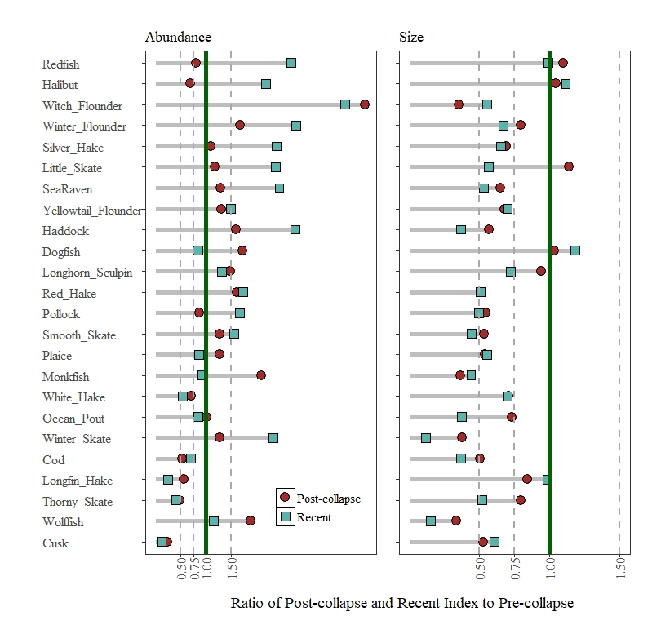

**Supplementary Figure 2**. Ratio of post-collapse (1993-2005) and most recent (2006-2017) periods for abundance (left-hand panel) and size (right-hand panel). Species are ordered based on recent biomass status as per Fig. 2 in main text. Note that abundance is higher than pre-collapse values for most species in both periods whereas size shows the opposite pattern. The majority of species are less than 0.75 of their pre-collapse size. In some cases, the size index may reflect a recruitment pulse but on average reflects a broad scale decline in the average size of individual fish (e.g. Shackell et al., 2010; Shackell et al., 2012; Bundy et al., 2019).

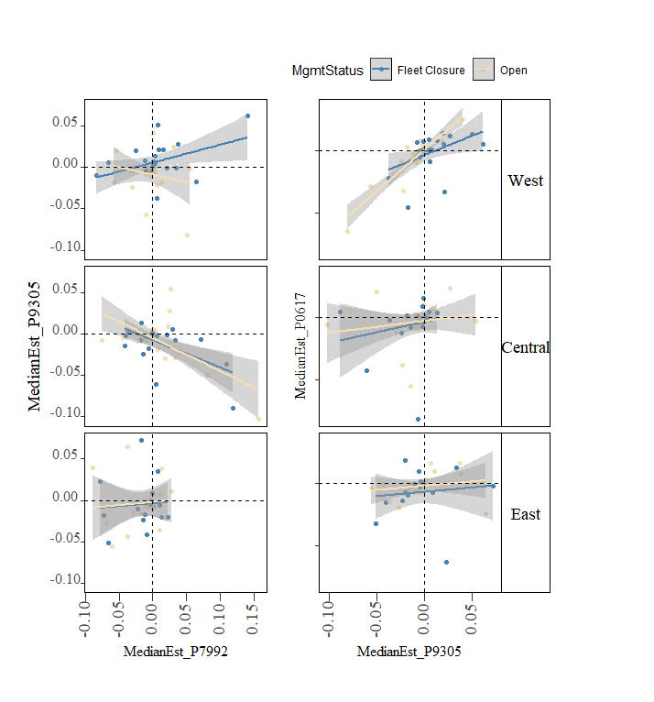

**Supplementary Figure 3**. Correlations between median per capita rates of change between pre-collapse (1979-1992) and post-collapse (1993-2005) (left hand panel), between post-collapse (1993-2005) and recent (2006-2017) periods.

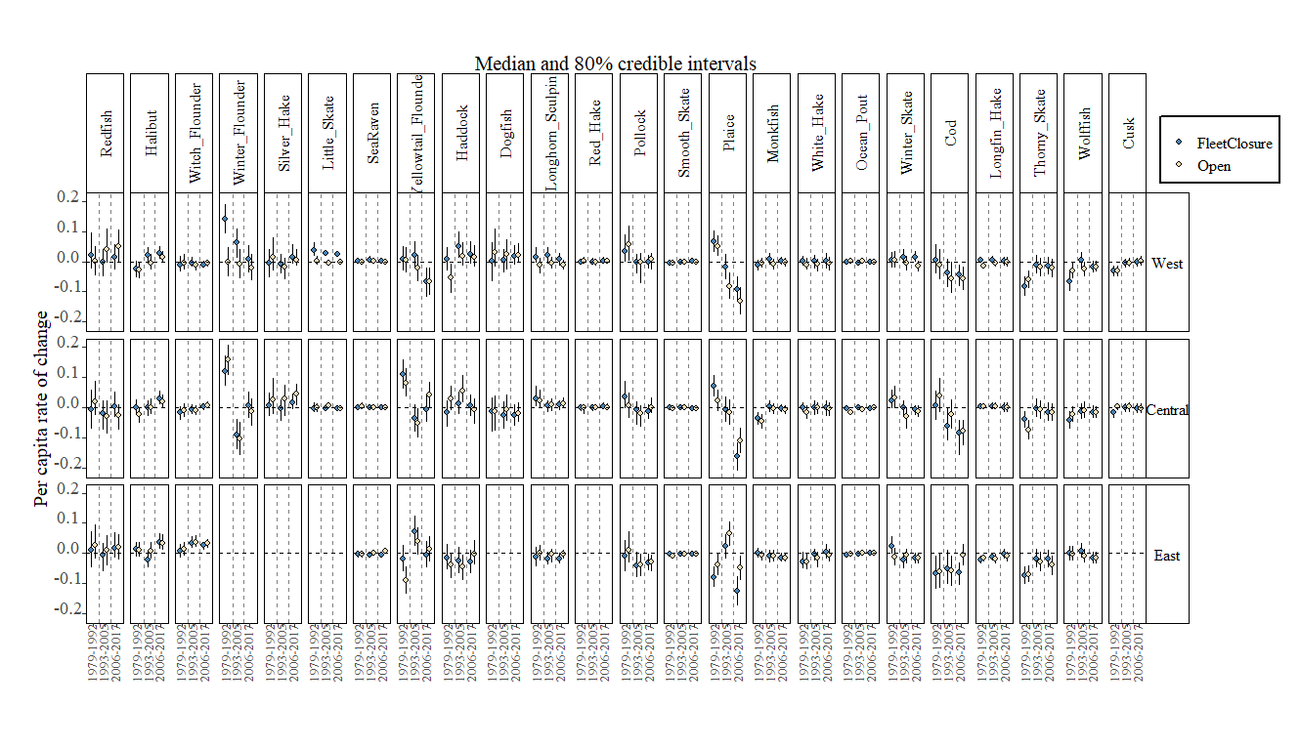

**Supplementary Figure 4**. Median estimate of per capita rate of change for 24 species in fleet-closed and open areas in 3 periods. Species are ordered based on recent regional-scale biomass status scale relative to the pre-collapse period. See Table 1 for species full names.

References

Bundy, A., Gomez, C., and Cook, A. M. (2019). Scrupulous Proxies: Defining and Applying a Rigorous Framework for the Selection and Evaluation of a Suite of Ecological Indicators. *Ecol. Indic.* 104, 737–754. doi:10.1016/j.ecolind.2019.01.031.

Shackell, N. L., Bundy, A., Nye, J. A., and Link, J. S. (2012). Common large-scale responses to climate and fishing across Northwest Atlantic ecosystems. *ICES J. Mar. Sci.* 69, 151–162. doi:10.1093/icesjms/fsr195.

Shackell, N. L., Frank, K. T., Fisher, J. A. D., Petrie, B., and Leggett, W. C. (2010). Decline in top predator body size and changing climate alter trophic structure in an oceanic ecosystem. *Proc. R. Soc. B* 277, 1353–1360. doi:10.1098/rspb.2009.1020.