**Supplementary Information**

**Figure S1.**

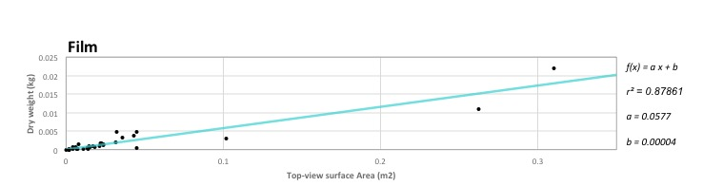

Figure S1 Predictive functions for plastic debris mass based on film subtype and top-view area. A linear regression is plotted against dry weight x top-view area measurements of objects collected during snorkelling surveys at Ashmore Reef (Pulau Pasir)

**Figure S2.**

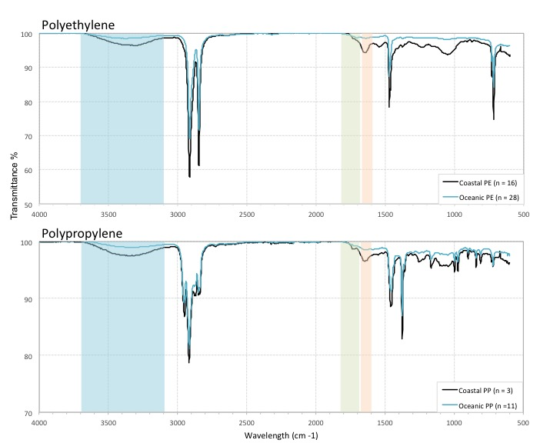

Figure S2 FT-IR spectra for Polyethylene and Propylene found at Ashmore Reef (Pulau Pasir) in black overlayed with spectra from the GPGP, showing similar peaks.