Table 1. Results of D.A.B.I. Analysis: Drivers  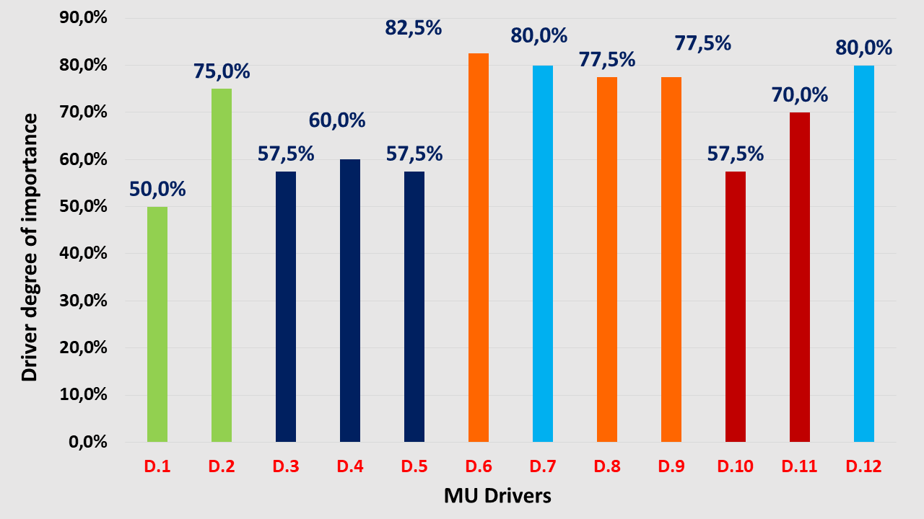 | Drivers for Fisheries-Tourism-Nature Conservation MU in Greece  D.1 Decrease of fishing effort as a means to cope with overfishing (Env).  D.2 Environmental education/awareness raising for fishers and tourists within or close to MPAs (Env).  D.3 Familiarizing fishers and their family-based enterprises with ICT and digital services (i.e fishing tourism platforms) (T)  D.4 Incorporation of innovation in fishing activities (T).  D.5 Establishment of infrastructure for retail sales in ports and fishing shelters in touristic areas (following existing legal provisions) (T).  D.6 Creation of marketing related synergies between different tourist destinations, resulting in mutual profits (Ec).  D.7 Hosting events about the country’s fishing tradition (i.e fishing heritage days, celebration of sardines, etc.) (S).  D.8 Enabling fishers to benefit from EU funds related to cultural fisheries, incl. tourism-based projects within the EMFF framework (Ec)  D.9Understanding of benefits to combine fisheries, tourism and nature conservation, within or close to MPAs (Ec).  D.10 Governmental financial support for further diversification of the fishing activity and the temporary suspension of fishing effort (P).  D.11 Amendment of the existing regulatory framework to enable fishers to expand tourism activities to entertainment and culture-related initiatives (P).  D.12 Fishers’ essential participation in planning and decision-making processes concerning their coastal and marine areas (S).  S=Social, Ec=Economic, P=Political, Env=Environmental, T=Technological

