Table 2. Results of D.A.B.I. Analysis: Added-values  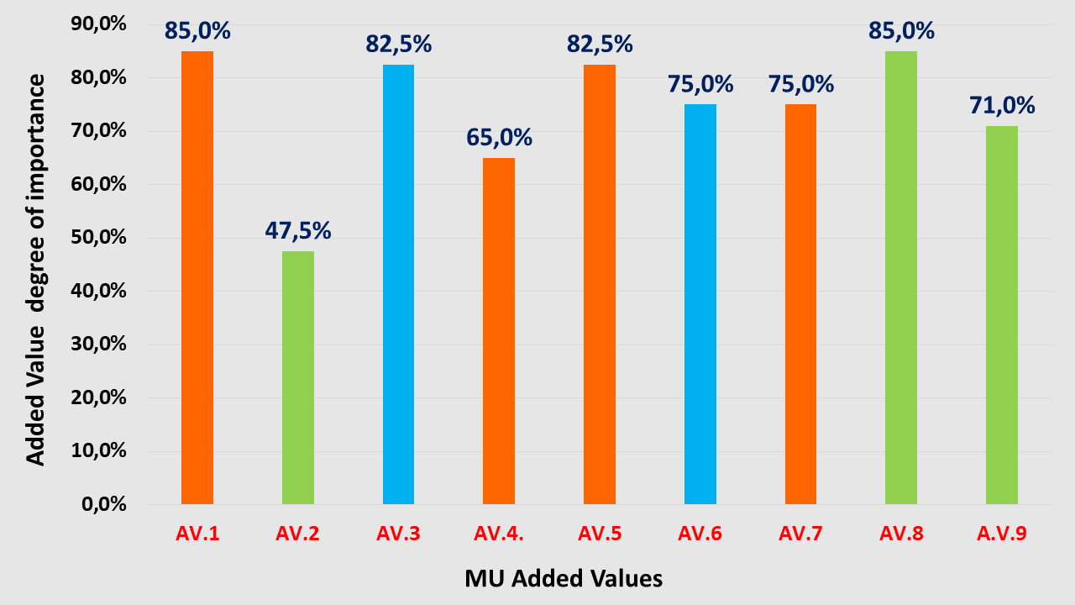 | Added Values from “Fisheries-Tourism-Nature Conservation” MU in Greece  AV.1 Diversification of traditional fishing activities and increase of fishers’ income (Ec).  AV.2 Opportunity for the already reduced fish stocks to recover, following reduction of the fishing effort (Env).  AV.3 Increase of employment and social coherence in coastal and insular communities depending on fisheries (S).  AV.4. Attracting and maintaining young people in the fisher’s profession (Ec).  AV.5 Attraction of visitors seeking authentic experiences - development of niche tourism markets (Ec).  AV.6 Major role of fishers in safeguarding and promoting their cultural identity (S).  AV.7 Promotion of branded local agricultural products (Ec).  AV.8 Raising awareness of tourists on issues related to the negative environmental impact of fishing (e.g. ghost fishing) (Env).  A.V.9 Further involvement of SSF vessels in environmental activities (Env.)  S=Social, Ec=Economic, P=Political, Env=Environmental, T=Technological

