Table 3. Results of D.A.B.I. Analysis, Barriers  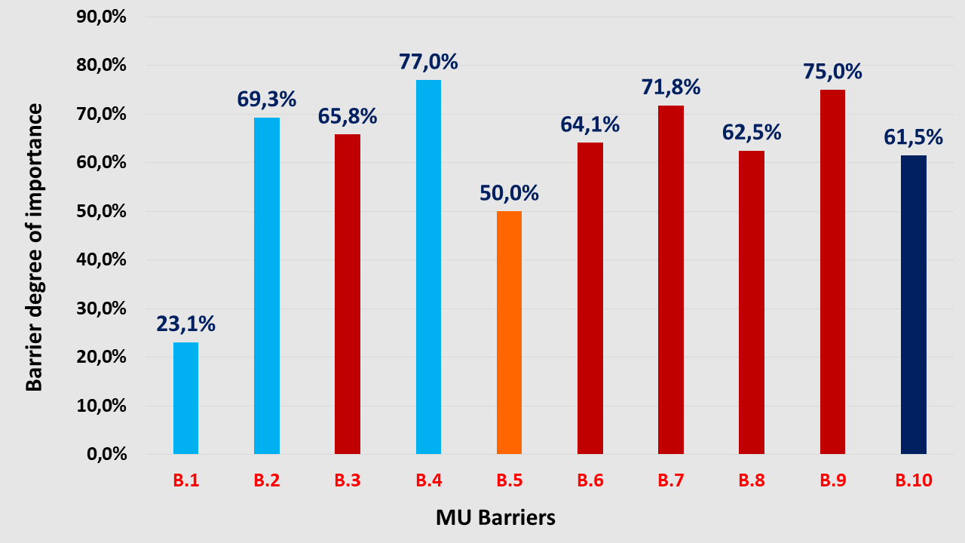 | Barriers to Fisheries-Tourism-Nature Conservation MU in Greece  B.1 Low attraction of special groups of tourists (e.g vegetarian/vegan or other similar groups) (S)  B.2 Lack of training programmes for fishing and traditional shipbuilding (S)  B.3 Inability of public authorities to support local entrepreneurship in coastal/insular areas (P)  B.4 Lack of entrepreneurial culture (S)  B.5 High seasonality of fishing tourism activities (Ec)  B.6 EU and national compensations to fishers for destructing their traditional vessels and quitting their fishing activities (P).  B.7Equity to taxation of traditional boats and modern, higher speed yachts of similar length (P).  B.8 Further delays in the physical and economic completion of C.L.L.D. and the relevant OP measures on fishery for the period 2014-2020 (P).  B.9 Deficiencies of the existing regulatory framework for the development of fishing tourism in inland waters where fisheries is the main income source (P).  B.10 Ageing of the Greek fishing vessels (T).  S=Social, Ec=Economic, P=Political, Env=Environmental, T=Technological

