Supplementary Material

**Supraphysiological levels of IL-2 in Jak3-deficient mice promote strong proliferative responses of adoptively transferred naive CD8+ T cells**

Gil-Woo Lee1,2,3, Sung-Woo Lee1,2,3, Juhee Kim1, Young-Jun Ju4, Hee-Ok Kim3, Cheol-Heui Yun4, and Jae-Ho Cho2,3,*

1Division of Integrative Biosciences and Biotechnology, Pohang University of Science and Technology, Pohang, South Korea.

2Medical Research Center for Combinatorial Tumor Immunotherapy, Department of Microbiology and Immunology, Chonnam National University Medical School, Jeonnam, South Korea.

3Immunotherapy Innovation Center, Chonnam National University Medical School, Hwasun Hospital, Jeonnam, South Korea.

4Department of Agricultural Biotechnology and Research Institute of Agriculture and Life Sciences, Seoul National University, Seoul, South Korea.

**Correspondence:** Jae-Ho Cho**:** jh_cho@chonnam.ac.kr

**Supplementary Figures**

**Supplementary Figure 1**

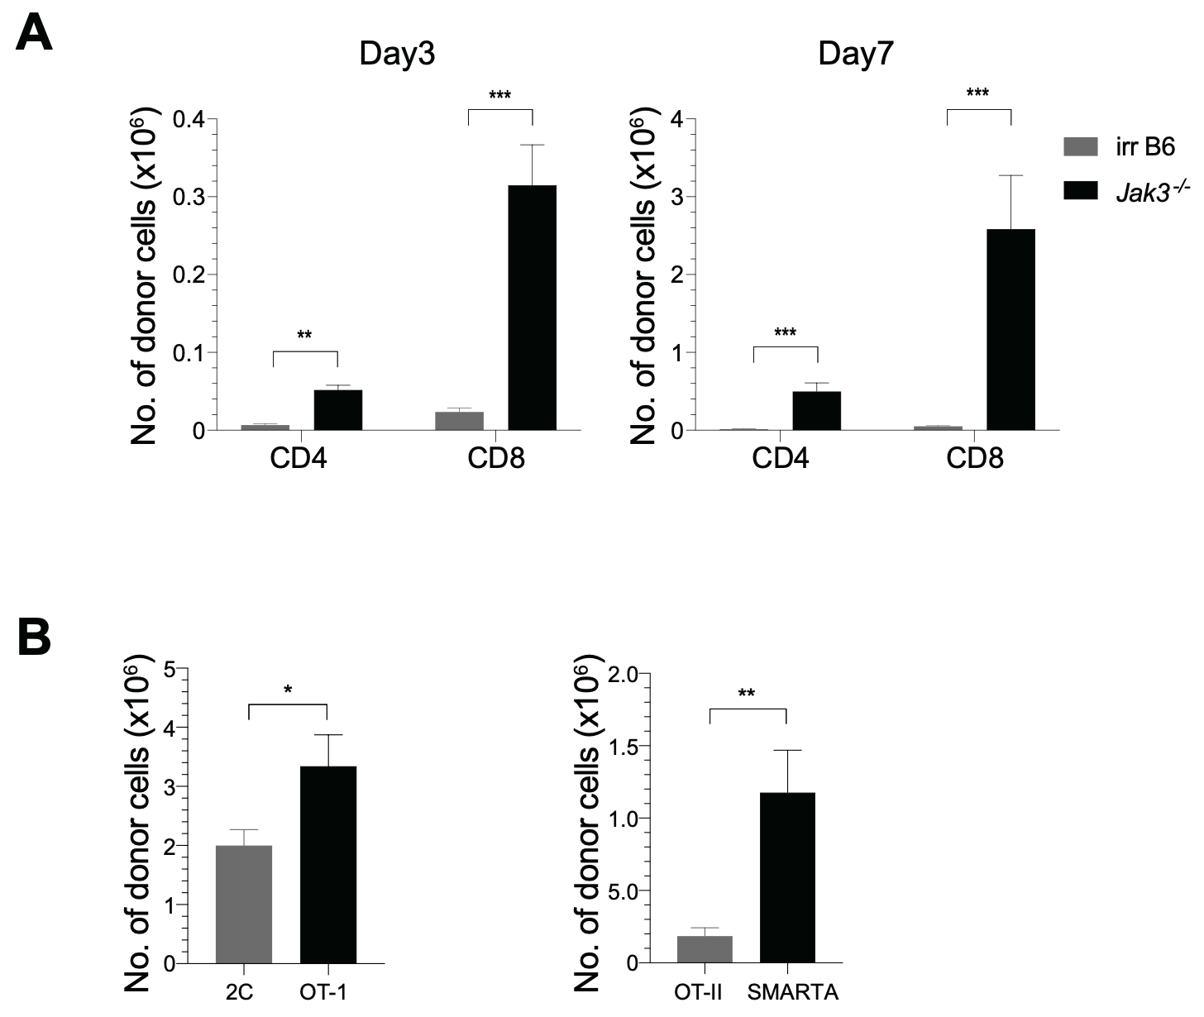

**Supplementary Figure 1**. **Robust proliferation of naive T cells adoptively transferred into *Jak3−/−* mice.** **(A)** A mixture of CFSE-labeled naive CD4+ and CD8+ T cells purified from B6 mice (Thy1.1) was co-injected i.v. into either irradiated (700 rad) B6 mice or unmanipulated *Jak3−/−* mice (1 × 106 cells for each donor per mouse; *n* = 3-5 mice). Spleen cells of the recipient mice were analyzed on days 3 (left) and 7 (right) by flow cytometry for total donor cell recovery. Data shown are the mean ± SD (*n* = 3-5 mice per group). **(B)** A mixture of FACS-purified CFSE-labeled either naive 2C (Ly5.1) and OT-I (Thy1.1) CD8+ or naive OT-II (Thy1.1) and SMARTA (Ly5.1) CD4+ T cells was co-injected i.v. into *Jak3−/−* mice (0.5-1 × 106 cells for each donor per mouse; *n* = 2-3 mice).Spleen cells of the recipient mice were analyzed on day 7 by flow cytometry for total donor cell recovery. Data shown are the mean ± SD (*n* = 2-3 mice per group). * *P < 0.05*, ** *P < 0.01*, *** *P < 0.001.*

**Supplementary Figure 2**

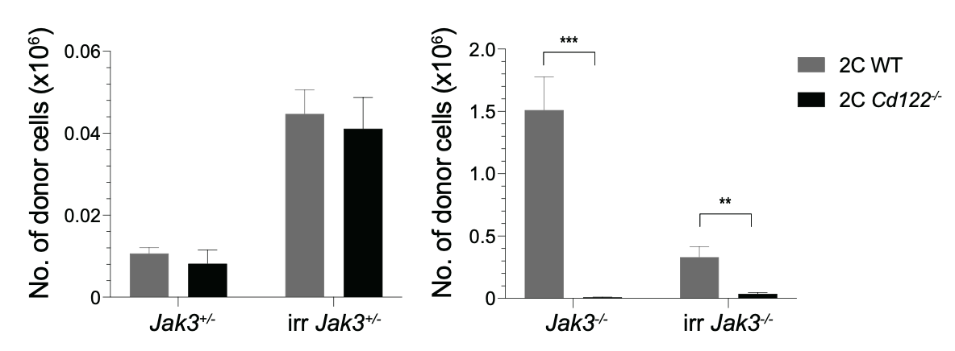

**Supplementary Figure 2**. **Role of IL-2/IL-15Rβ expression for inducing donor T cell expansion in *Jak3−/−* hosts.** A mixture of FACS-purified CFSE-labeled naive WT (Ly5.1) and CD122(IL-2/IL-15Rβ)-deficient 2C CD8+ T cells was co-injected i.v. into either irradiated (700 rad) or unmanipulated *Jak3−/−* and as a control *Jak3+/−* mice (0.5 × 106 cells for each donor per mouse; *n* = 2-3 mice). Spleen cells of the recipient mice were analyzed on day 7 by flow cytometry for total donor cell recovery. Data shown are the mean ± SD (*n* = 2-3 mice per group). ** *P < 0.01*, *** *P < 0.001*.

**Supplementary Figure 3**

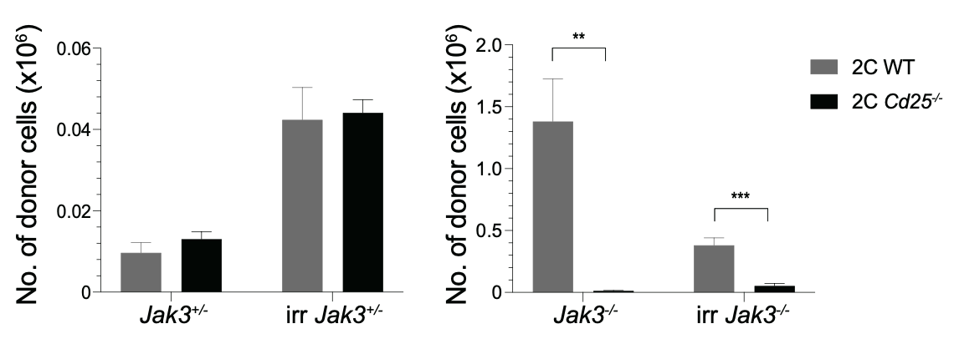

**Supplementary Figure 3**. **Role of IL-2Rα expression for inducing donor T cell expansion in *Jak3−/−* hosts.** Schematic diagram for adoptive transfer experiments. A mixture of FACS-purified CFSE-labeled naive WT (Ly5.1) and CD25(IL-2Rα)-deficient 2C CD8+ T cells was co-injected i.v. into either irradiated (700 rad) or unmanipulated *Jak3−/−* and as a control *Jak3+/−* mice (0.5 × 106 cells for each donor per mouse; *n* = 2-3 mice). Spleen cells of the recipient mice were analyzed on day 7 by flow cytometry for total donor cell recovery. Data shown are the mean ± SD (*n* = 2-3 mice per group). ** *P < 0.01*, *** *P < 0.001*.

**Supplementary Figure 4**

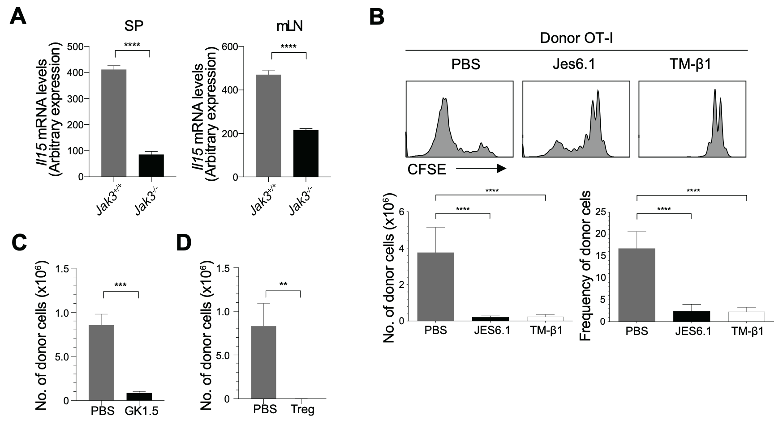

**Supplementary Figure 4**. **Effect of CD4+ T cells on high levels of *in vivo* IL-2 in *Jak3−/−* mice. (A)** Spleen and mesenteric lymph node (mLN) cells from *Jak3−/−* and *Jak3+/+* mice were analyzed for *Il15* mRNA by quantitative RT-PCR (the mean ± SD; *n* = 3-5 mice per group). **(B)** *Jak3−/−* mice were injected i.p. with either anti-IL-2 mAb (JES6.1) or anti-IL-2Rβ mAb (TM-β1) (on days -3 and 0; 100 μg per mouse; *n* = 2-3 mice). The mice were then injected i.v. with FACS-purified CFSE-labeled naive OT-I CD8+ T cells (Thy1.1; 1 × 106 cells per mouse; *n* = 2-3 mice). At day 7 after adoptive transfer, spleen cells of the recipient mice were analyzed by flow cytometry for CFSE dilution and donor cell recovery (the mean ± SD; *n* = 2-3 mice per group). **(C)** *Jak3−/−* mice were injected i.p. with either anti-CD4 mAb (GK1.5) or as a control isotype IgG (total 4 injections every 2 days; 100 μg per mouse; *n* = 2-4 mice). The mice were injected i.v. with FACS-purified CFSE-labeled naive OT-I CD8+ T cells (Thy1.1; 1 × 106 cells per mouse; *n* = 2-4 mice). At day 5 after adoptive transfer, spleen cells of the recipient mice were analyzed by flow cytometry for donor cell recovery (the mean ± SD; *n* = 2-4 mice per group). **(D)** FACS-purified CFSE-labeled naive OT-I CD8+ T cells (Thy1.1; 1 × 106 cells per mouse) were injected i.v. with or without CD4+ Tregs (~0.2 × 106 cells per mouse) purified from Foxp3-GFP mice into *Jak3−/−* mice (*n* = 2-4 mice). Spleen cells of the recipient mice were analyzed on day 5 by flow cytometry for donor cell recovery (the mean ± SD; *n* = 2-4 mice per group). ** *P<0.01*, *** *P < 0.001*,**** *P<0.0001.*