Supporting Information

Role of Electrostatic Hotspots in the Selectivity of Complement Control Proteins toward Human and Bovine Complement Inhibition

Yogesh B. Narkhede,1‡ Avneesh K. Gautam3‡, Rohaine V. Hsu,1‡ Wilson Rodriguez,1‡ Nehemiah T. Zewde,1 Reed E. S. Harrison,1 Pablo R. Arantes,1 Zied Gaieb,1 Ronald D. Gorham Jr.,1 Chris Kieslich,4 Dimitrios Morikis,1 Arvind Sahu5* and Giulia Palermo1,2*

**Table of Contents**

Supplementary Figures (S1-S6) …………………………………………………………..p. S2-S5

Supplementary Tables (S1) ……………………………………..............................................p. S6

Supplementary References (S1-47) ………………………………………………………p. S7-S10

Dedicated to our late beloved mentor Prof. Dimitrios Morikis.

Corresponding authors:

Giulia Palermo ([giulia.palermo@ucr.edu](mailto:giulia.palermo@ucr.edu))

Arvind Sahu ([arvindsahu@nccs.res.in](mailto:arvindsahu@nccs.res.in))

**Supplementary Figures**

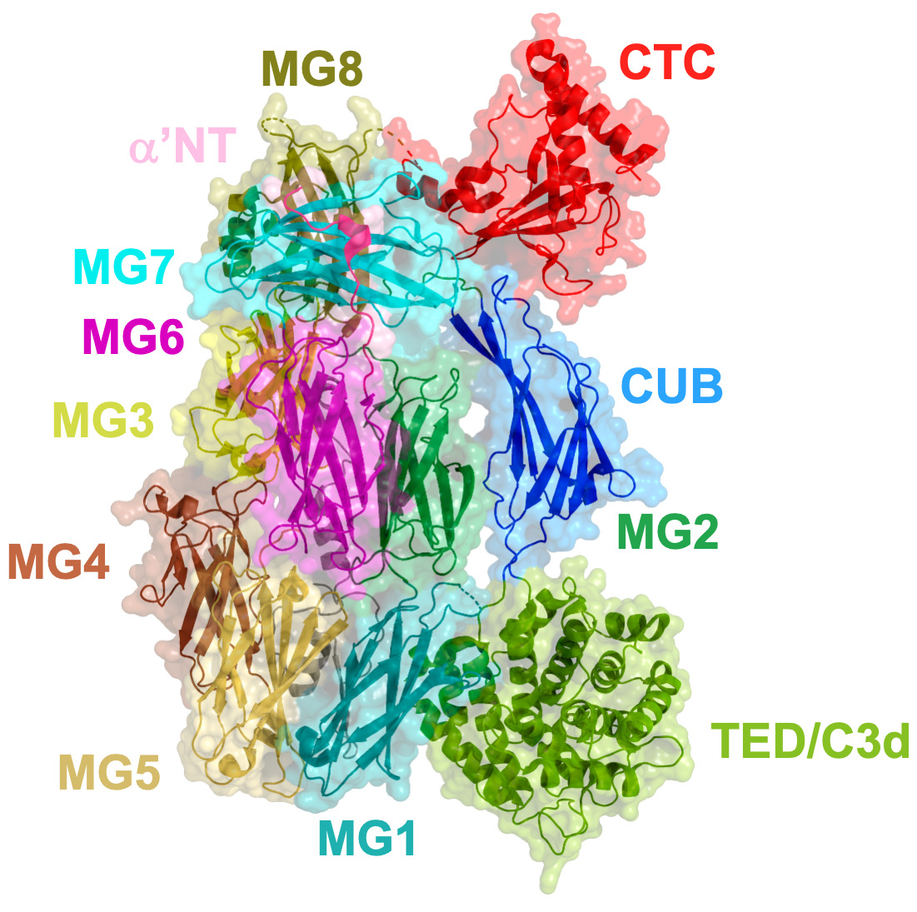

**Figure S1:** Ribbon and surface representations of complement C3b domains shown in different colors.

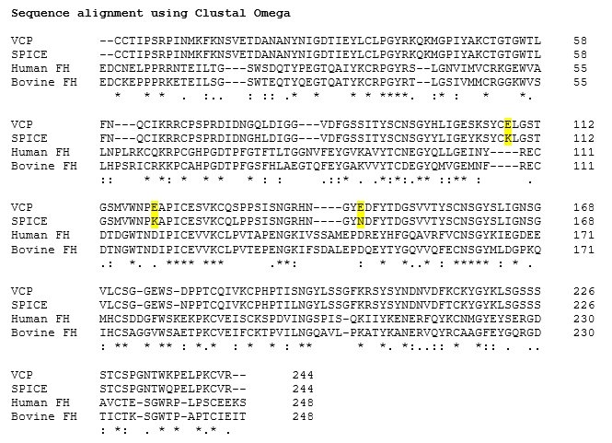

**Figure S2:** Multiple sequence alignment of VCP, SPICE, human factor H, and bovine factor H. The mutated positions have been highlighted in yellow.47

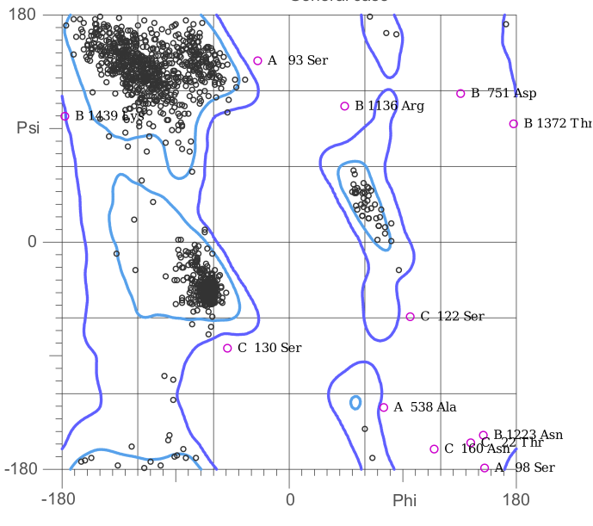

**Figure S3:** Ramachandran plot of Bovine C3b-VCP (wild type).

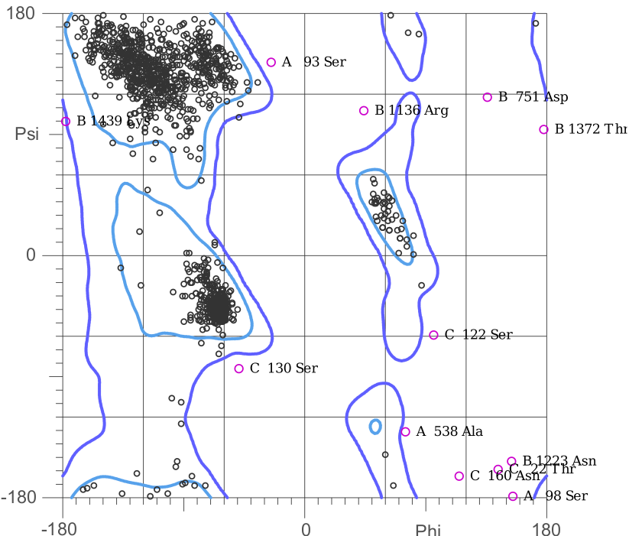

**Figure S4:** Ramachandran plot of Bovine C3b-VCP (mutant)

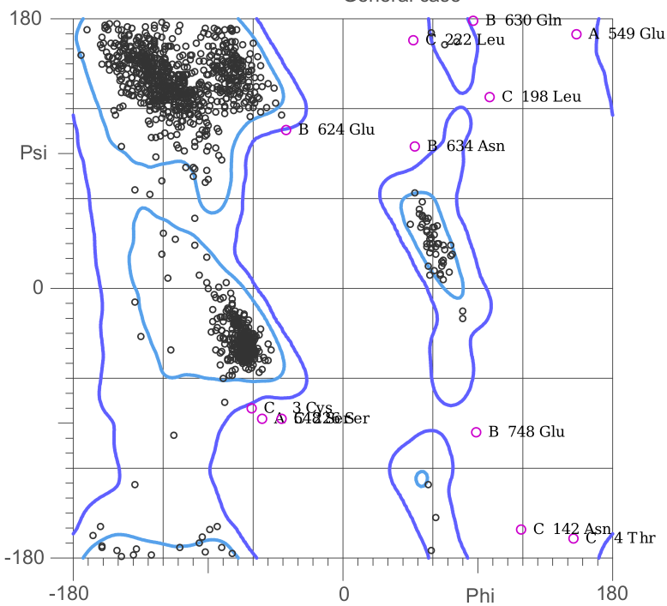

**Figure S5:** Ramachandran plot of Human C3b-SPICE (wild type)



**Figure S6:** Ramachandran plot of Human C3b-SPICE (mutant)

**Supplementary Tables**

**Table S1:** Analysis of homology modelling for complexes of wild type and mutants of SPICE and VCP along with bovine C3b28,46

|  |  |  |  |  |
| --- | --- | --- | --- | --- |
| Complex | ERRAT | Verify3D (%) | Ramachandran (% allowed) | Ramachandran Z-score |
| Bovine C3b-VCP WT | 65.5968 | 85.91 | 96.61 | 0.07 ± 0.18 |
| Bovine C3b-VCP Mutant | 65.6725 | 85.91 | 96.71 | 0.07 ± 0.13 |
| Human C3b-SPICE WT | 76.5037 | 89.42 | 97.11% | 0.33 ± 0.18 |
| Human C3b-SPICE Mutant | 76.6161 | 89.47 | 97.10% | 0.32 ± 0.18 |

**Supplementary References**

1 W. H. Organization, *Wkly. Epidemiol. Rec.*, 1980, **55**, 145–152.

2 Y. K. Gurav, C. G. Raut, P. D. Yadav, B. V Tandale, A. Sivaram, M. D. Pore, A. Basu, D. T. Mourya and A. C. Mishra, *Prev. Vet. Med.*, 2011, **100**, 242–247.

3 G. S. Trindade, G. L. Emerson, D. S. Carroll, E. G. Kroon and I. K. Damon, *Emerg. Infect. Dis.*, 2007, **13**, 965–972.

4 E. S. Reis, D. C. Mastellos, G. Hajishengallis and J. D. Lambris, *Nat. Rev. Immunol.*, 2019, 19, 503–516.

5 K. M. Bennett, S. H. M. Rooijakkers and R. D. Gorham, *Front. Microbiol.*, 2017, 8.

6 P. Agrawal, R. Nawadkar, H. Ojha, J. Kumar and A. Sahu, *Front. Microbiol.*, 2017, 8.

7 A. Rosbjerg, N. Genster, K. Pilely and P. Garred, *Front. Microbiol.*, 2017, **8**, 868.

8 J. D. Lambris, D. Ricklin and B. V Geisbrecht, *Nat. Rev. Microbiol.*, 2008, **6**, 132.

9 H. Ojha, H. S. Panwar, R. D. Gorham, D. Morikis and A. Sahu, *Mol. Immunol.*, 2014, **61**, 89–99.

10 S. F. Altschul, W. Gish, W. Miller, E. W. Myers and D. J. Lipman, *J. Mol. Biol.*, 1990, **215**, 403–410.

11 W. Gish and D. J. States, *Nat. Genet.*, 1993, **3**, 266–272.

12 J. Wu, Y.-Q. Wu, D. Ricklin, B. J. C. Janssen, J. D. Lambris and P. Gros, *Nat. Immunol.*, 2009, **10**, 728–733.

13 V. N. Yadav, K. Pyaram, M. Ahmad and A. Sahu, *J. Immunol.*, 2012, **189**, 1431–1439.

14 F. Forneris, J. Wu, X. Xue, D. Ricklin, Z. Lin, G. Sfyroera, A. Tzekou, E. Volokhina, J. C. Granneman, R. Hauhart, P. Bertram, M. K. Liszewski, J. P. Atkinson, J. D. Lambris and P. Gros, *EMBO J.*, 2016, **35**, 1133–1149.

15 V. N. Yadav, K. Pyaram, J. Mullick and A. Sahu, *J. Virol.*, 2008, **82**, 3283–3294.

16 C. A. Kieslich and D. Morikis, *PLoS Comput. Biol.*, 2012, **8**, e1002840.

17 R. E. S. Harrison, N. T. Zewde, Y. B. Narkhede, R. V. Hsu, D. Morikis, V. I. Vullev and G. Palermo, *ACS Med. Chem. Lett*, 2020, **11**, 1054–1059.

18 R. R. Mohan, R. D. Gorham and D. Morikis, *Mol. Immunol.*, 2015, **64**, 112–122.

19 C. A. Kieslich, H. Vazquez, G. N. Goodman, A. L. de Victoria and D. Morikis, *J. Mol. Graph. Model.*, 2011, **29**, 1047–1055.

20 R. E. S. Harrison, R. D. Gorham and D. Morikis, *Protein Sci.*, 2015, **24**, 789–802.

21 A. M. El-Assaad, C. A. Kieslich, R. D. Gorham and D. Morikis, *Mol. Immunol.*, 2011, **48**, 1844–1850.

22 G. Sfyroera, M. Katragadda, D. Morikis, S. N. Isaacs and J. D. Lambris, *J. Immunol.*, 2005, **174**, 2143–2151.

23 L. Zhang and D. Morikis, *Biophys. J.*, 2006, **90**, 3106–3119.

24 M. K. Liszewski, M. K. Leung, R. Hauhart, C. J. Fang, P. Bertram and J. P. Atkinson, *J. Immunol.*, 2009, **183**, 3150–3159.

25 Z. Adhireksan, G. Palermo, T. Riedel, Z. Ma, R. Muhammad, U. Rothlisberger, P. J. Dyson and C. A. Davey, *Nat. Commun.*, 2017, **8**, 1–11.

26 N. Foloppe, N. Matassova and F. Aboul-ela, *Drug Discov. Today*, 2006, 11, 1019–1027.

27 N. Eswar, B. Webb, M. A. Marti‐Renom, M. S. Madhusudhan, D. Eramian, M. Shen, U. Pieper and A. Sali, *Curr. Protoc. Bioinforma.*, 2006, **15**, 5.6.1-5.6.30.

28 SAVES v5.0 - DOE-MBI Structure Lab UCLA, https://servicesn.mbi.ucla.edu/SAVES/, (accessed 22 December 2020).

29 C. A. Kieslich, D. Morikis, J. Yang and D. Gunopulos, *Biotechnol. Prog.*, 2011, **27**, 316–325.

30 R. E. S. Harrison, R. R. Mohan, R. D. Gorham, C. A. Kieslich and D. Morikis, *Biophys. J.*, 2017, **112**, 1761–1766.

31 R. D. Gorham, C. A. Kieslich and D. Morikis, *Ann. Biomed. Eng.*, 2011, **39**, 1252–1263.

32 C. A. Kieslich, R. D. Gorham and D. Morikis, *J. Non. Cryst. Solids*, 2011, **357**, 707–716.

33 R. D. Gorham, C. A. Kieslich, A. Nichols, N. U. Sausman, M. Foronda and D. Morikis, *Biopolymers*, 2011, **95**, 746–754.

34 R. E. S. Harrison and D. Morikis, *Biophys. J.*, 2019, **116**, 215–226.

35 N. Zewde, R. R. Mohan and D. Morikis, *Front. Phys.*, 2018, **6**, 130.

36 R. R. Mohan, G. A. Huber and D. Morikis, *J. Phys. Chem. B*, 2016, **120**, 8416–8423.

37 C. R. Søndergaard, M. H. M. Olsson, M. Rostkowski and J. H. Jensen, *J. Chem. Theory Comput.*, 2011, **7**, 2284–2295.

38 N. A. Baker, D. Sept, S. Joseph, M. J. Holst and J. A. McCammon, *Proc. Natl. Acad. Sci. U. S. A.*, 2001, **98**, 10037–10041.

39 T. J. Dolinsky, P. Czodrowski, H. Li, J. E. Nielsen, J. H. Jensen, G. Klebe and N. A. Baker, *Nucleic Acids Res.*, 2007, **35**, W522–W525.

40 D. Sitkoff, K. A. Sharp and B. Honig, *J. Phys. Chem.*, 1994, **98**, 1978–1988.

41 E. F. Pettersen, T. D. Goddard, C. C. Huang, G. S. Couch, D. M. Greenblatt, E. C. Meng and T. E. Ferrin, *J. Comput. Chem.*, 2004, **25**, 1605–1612.

42 A. K. Gautam, Y. Panse, P. Ghosh, M. J. Reza, J. Mullick and A. Sahu, *Proc. Natl. Acad. Sci. U. S. A.*, 2015, **112**, 12794–12799.

43 R. Carbó, L. Leyda and M. Arnau, *Int. J. Quantum Chem.*, 1980, **17**, 1185–1189.

44 E. E. Hodgkin and W. G. Richards, *Int. J. Quantum Chem.*, 1987, **32**, 105–110.

45 X. Xue, J. Wu, D. Ricklin, F. Forneris, P. Di Crescenzio, C. Q. Schmidt, J. Granneman, T. H. Sharp, J. D. Lambris and P. Gros, *Nat. Struct. Mol. Biol.*, 2017, **24**, 643–651.

46 C. J. Williams, J. J. Headd, N. W. Moriarty, M. G. Prisant, L. L. Videau, L. N. Deis, V. Verma, D. A. Keedy, B. J. Hintze, V. B. Chen, S. Jain, S. M. Lewis, W. B. Arendall, J. Snoeyink, P. D. Adams, S. C. Lovell, J. S. Richardson and D. C. Richardson, *Protein Sci.*, 2018, **27**, 293–315.

47 F. Madeira, Y. M. Park, J. Lee, N. Buso, T. Gur, N. Madhusoodanan, P. Basutkar, A. R. N. Tivey, S. C. Potter, R. D. Finn and R. Lopez, *Nucleic Acids Res.*, 2019, **47**, W636–W641.