Supplementary Material

# Simulations

In order to define*G* = G’ + iG’’* of the different regions, several parameters have to be set in COMSOL. For our simulations, we employed an isotropic Standard Linear Solid model, in which, according to the Solid Mechanics interface documentation, *G\** is defined as:

$$\begin{aligned}G'=G+ G_{v}\frac{{\left(ωτ\right)}^{2}}{1+ {\left(ωτ\right)}^{2}} \#\left(1\right)\end{aligned}$$

$$G''=G_{v}\frac{ωτ}{1+ {\left(ωτ\right)}^{2}}$$

with $τ= \frac{η_{v}}{G_{v}}$

where $G$ are the shear moduli in the Linear Elastic Material definition node, $G_{v}$ are the parameters in the Viscoelasticity subnode (also named shear modulus in COMSOL), and $η_{v}$ is the viscosity parameter in the Viscoelasticity subnode of the model. This formulation implies that for a given frequency, a set of three variable parameters is required to define the values of *G’* and *G’*’. Therefore, for each region, we fixed $G_{v}$ to obtain the required parameters $η_{v}$ and $G$ by inverting the equations above with respect to $ωτ$. The parameters calculated to obtain the desired values of *G* = 5 + i1.2* kPa in the background and *G* = 4 + i1* kPa in the inclusions at 57 Hz are shown in Supplementary Table 1. The bulk modulus *K* in the Linear Elastic Material node was set to 166.7 kPa and density $ρ$ was set to 1000 kg/m3 everywhere. Finally, a “Free Tetrahedral” mesh node was used with a predefined “Extra fine” setting specified in a Size subnode.

# T1 and T2 mapping

A turbo-spin-echo inversion recovery sequence was used for T1 (inversion times TI: 30, 80, 140, 250, 450, 600, 800, 1400, 2500, 4500, 6500, 7800 ms; TE/TR: 14/8000 ms, voxel size 2 × 2 × 5 mm3), and a spin-echo sequence with 32 echoes and ΔTE = 34 ms for T2 (voxel size 2 × 2 × 5 mm3). Fitting of T1 and T2 relaxation times was performed pixel-wise using a custom MATLAB script.

|  |  |  |  |  |  |
| --- | --- | --- | --- | --- | --- |
|  | $G'$**(kPa)** | $G''$**(kPa)** | $G_{v}$**(kPa)** | $η_{v}$**(Pa·s)** | $G$**(kPa)** |
| **Background** | 5.0 | 1.2 | 8.0 | 3.430 | 4.816 |
| **Inclusions** | 4.0 | 1.0 | 4.0 | 2.993 | 3.732 |

Supplementary Table 1. Summary of COMSOL Multiphysics simulation parameters $G_{v}$, $η_{v}$, $G$ used to obtain the desired *G’* and *G’’* within the different regions for a vibration frequency of 57 Hz.

**B**

**A**

C:\Users\Max\Desktop\AMT\1st paper silicone MRE\figures exported\Figure S1A.tifC:\Users\Max\Desktop\AMT\1st paper silicone MRE\figures exported\Figure S1B.tif

**Supplementary** **Figure** **1.** Frequency sweep rheometrical measurement of the complex shear modulus (filled square: *G’*; empty circle: *G’’*) for the samples with softener composition S1.9 (red) & S2.1 (blue) at week 7 after fabrication. **(A)** entire frequency measurement range 1-100 Hz, **(B)** enlarged range 1-50 Hz.

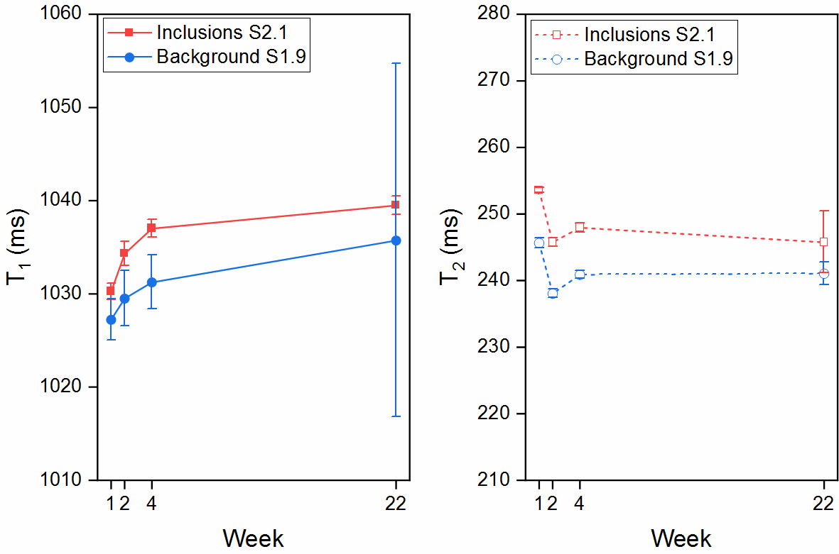

**Supplementary** **Figure** **2.** T1 (left) and T2 (right) values in the inclusions (composition S1.9, red) and in the background (composition S2.1, blue) over time post fabrication.

C:\Users\Max\Desktop\AMT\Paper1\figures exported submitted\Figure 5.tif

**Supplementary** **Figure** **3.** T1 (top) and T2 (bottom) maps of the phantom obtained at 3 T and 4 weeks after fabrication.