Supplementary Figures and Tables for

Taxonomic and enzymatic characterization of *Flocculibacter collagenilyticus* gen. nov., sp. nov., a novel gammaproteobacterium with high collagenase production

Jian Li1,2, Jun-Hui Cheng2, Zhao-Jie Teng2, Zhong-Zhi Sun2, Xiao-Yan He2, Peng Wang3,4, Mei Shi2, Xiao-Yan Song2, Xiu-Lan Chen2, Yu-Zhong Zhang2,3,4, Xinmin Tian1*, Xi-Ying Zhang2*

1 College of Life Science and Technology, Xinjiang University, Urumqi, China

2State Key Laboratory of Microbial Technology, Institute of Marine Science and Technology, Marine Biotechnology Research Center, Shandong University, Qingdao, China

3Laboratory for Marine Biology and Biotechnology, Pilot National Laboratory for Marine Science and Technology, Qingdao, China

4College of Marine Life Sciences, and Frontiers Science Center for Deep Ocean Multispheres and Earth System, Ocean University of China, Qingdao, China

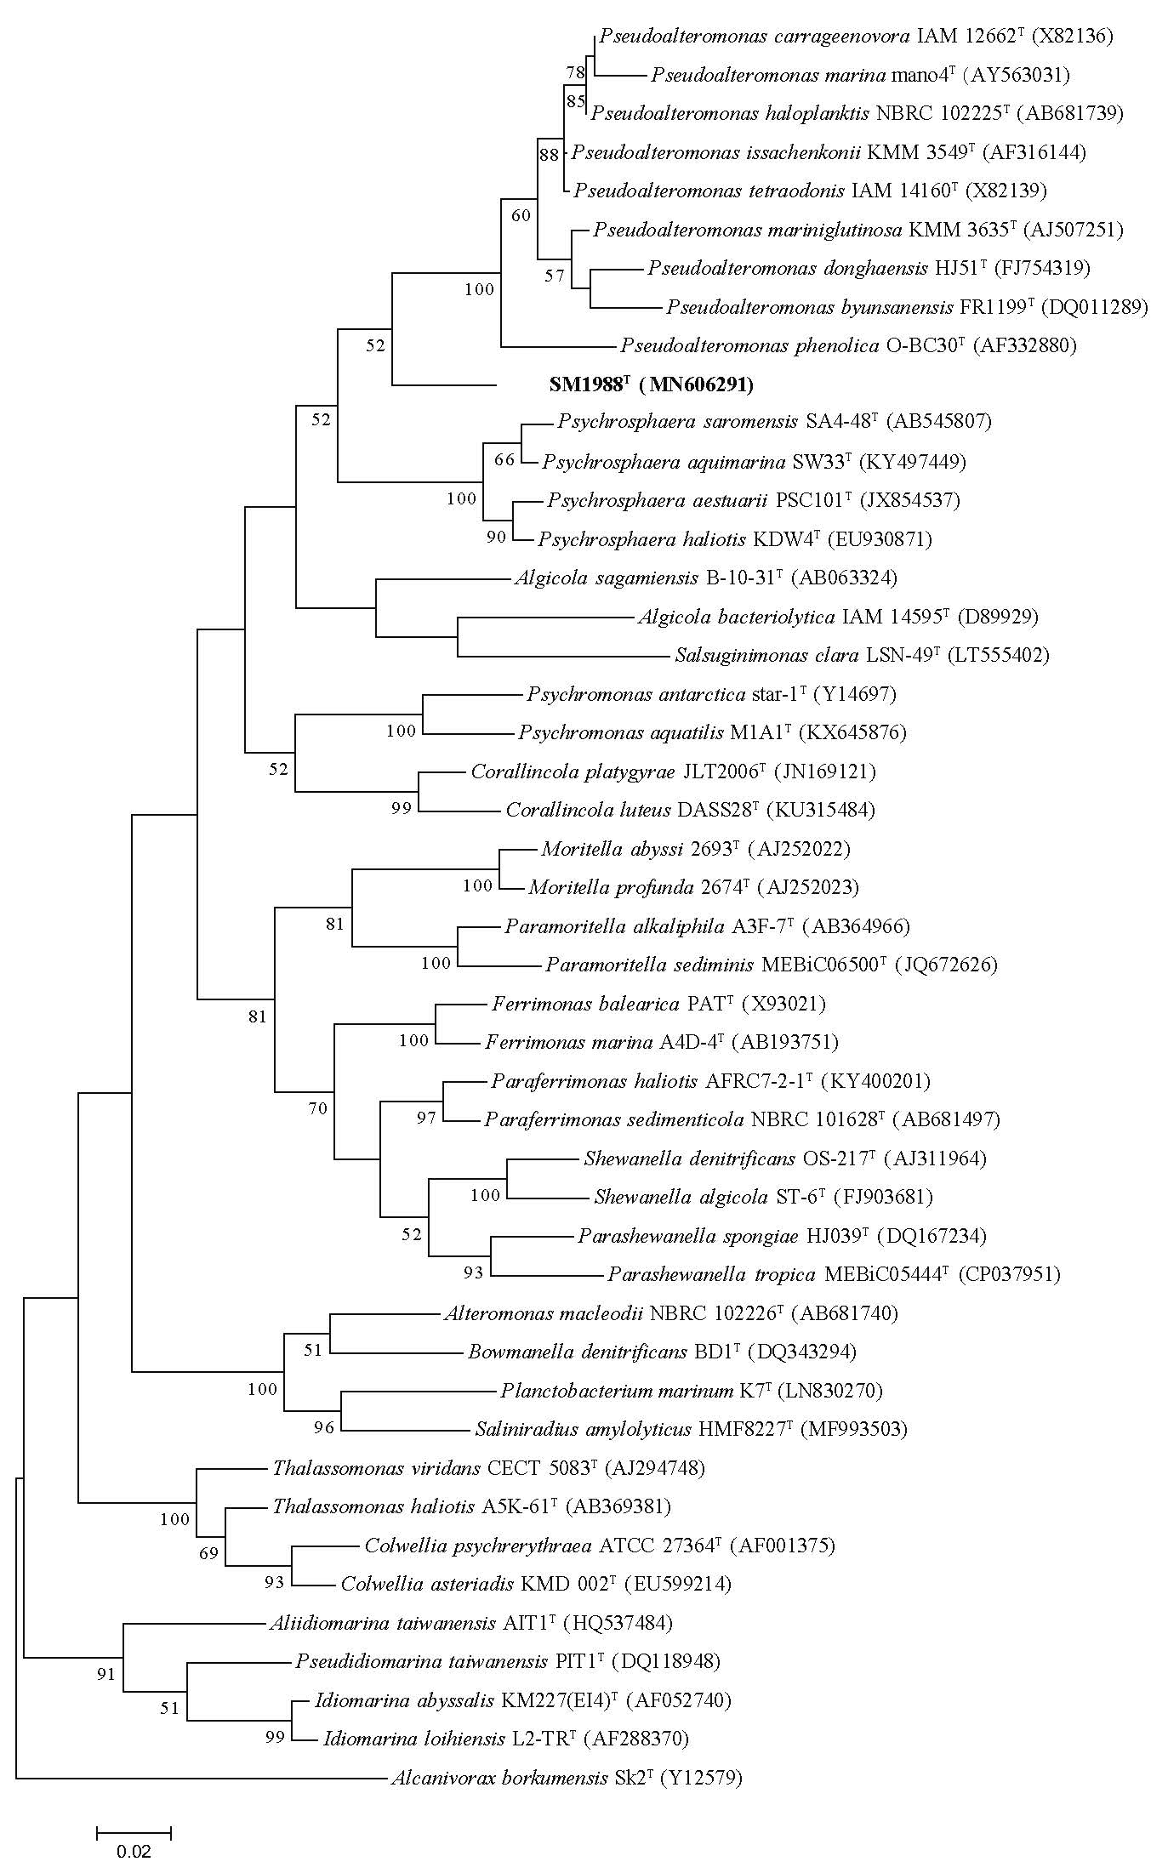

**Supplementary Figure S1**. Maximum-likelihood (ML) phylogenetic tree based on 16S rRNA gene sequences showing the positions of strain SM1988T (in bold) and selected known species in the family *Pseudoalteromonadaceae* and other closely related families in the class *Gammaproteobacteria*. Bootstrap values (>50%) based on 1000 replicates are presented at nodes. *Alcanivorax borkumensis* Sk2T was selected for outgroup. Bar, 0.02 substitutions per nucleotide position.

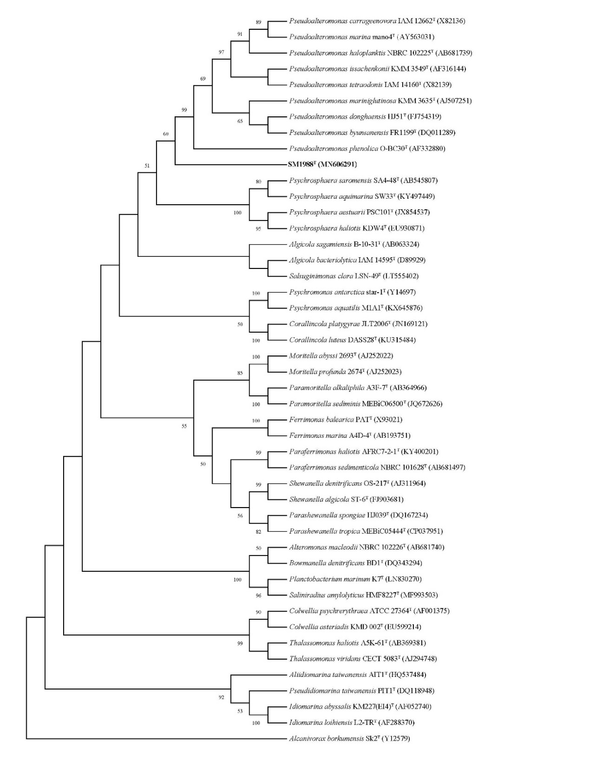

**Supplementary Figure S2**. Maximum-parsimony (MP) phylogenetic tree based on 16S rRNA gene sequences showing the positions of strain SM1988T (in bold) and selected known species in the family *Pseudoalteromonadaceae* and other closely related families in the class *Gammaproteobacteria*. Bootstrap values (>50%) based on 1000 replicates are presented at nodes. *Alcanivorax borkumensis* Sk2T was selected for outgroup.

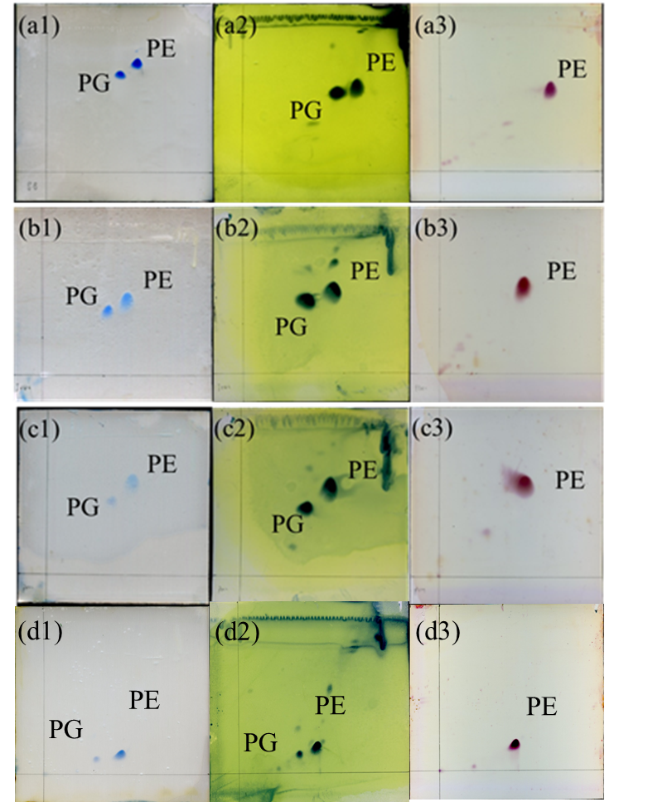

**Supplementary Figure S3**. Two-dimensional TLCs of polar lipids of *Flocculibacter collagenilyticus* SM1988T (a), *Pseudoalteromonas mariniglutinosa* DSM 15203T (b), *Psychrosphaera haliotis* JCM 16340T (c), and *Pseudoalteromonas haloplanktis* MCCC 1A06496T (d),which respectively stained by molybdenum blue (a1, b1, c1 and d1), ethanolic molybdophosphoric acid (a2, b2, c2 and d2) and ninhydrin reagent (a3, b3, c3 and d3). PE, phosphatidylethanolamine; PG, phosphatidylglycerol.

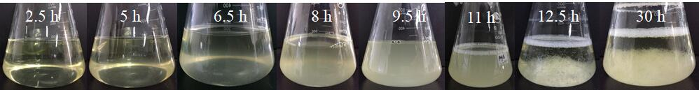

**Supplementary** **Figure S4**. The flocs formation of SM1988T during the culturing course (2.5-30 h).

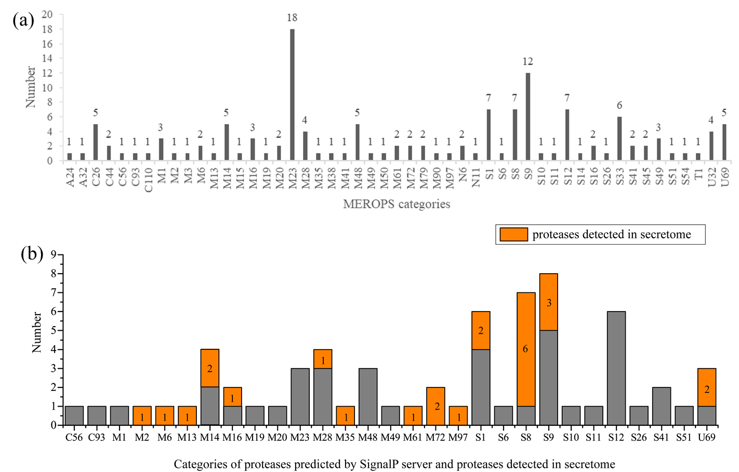

**Supplementary Figure S5**. The categories and numbers of the all proteases of strain SM1988T predicted by MEROPS (a) and of the proteases predicted by SignalP server and detected in secretome (b). The proteases detected in secretome are in orange, and their counts are marked.

**Supplementary Table S1.** Average nucleotide identity (ANI) and Genome-to-Genome-Distance (GGDC) comparisons between strain SM1988T and type strains of closely related species in the family *Pseudoalteromonadaceae*.

|  |  |  |  |  |
| --- | --- | --- | --- | --- |
| Strains | ANI value (%) | | GGDC value (%) | Accession numbers |
| ANIb | ANIm |
| *Algicola sagamiensis* DSM 14643T | 67.4 | 84.4 | 22.1 | NZ_ARFX00000000 |
| *Psychrosphaera saromensis* SA4-48T | 68.3 | 84.4 | 23.4 | NZ_MSCH00000000 |
| *Pseudoalteromonas mariniglutinosa* KCTC 22327T | 68.2 | 84.3 | 21.7 | NZ_BDDU01000000 |
| *Pseudoalteromonas issachenkonii* KMM 3549T | 68.2 | 83.9 | 21.9 | NZ_CP011030, NZ_CP011031 |
| *Pseudoalteromonas tetraodonis* GFCT | 68.3 | 84.2 | 22.4 | NZ_CP011041,  NZ_CP011042 |

**Supplementary Table S2**. The Average Amino Acid Identity (AAI) and the Percentage of Conserved Proteins (POCP) values between strain SM1988T and type strains of closely related species in the family *Pseudoalteromonadaceae*.

|  |  |  |  |
| --- | --- | --- | --- |
| Strains | AAI value (%) | POCP value (%) | Accession numbers |
| *Algicola sagamiensis* DSM 14643T | 54.9 | 41.8 | NZ_ARFX00000000 |
| *Psychrosphaera saromensis* SA4-48T | 55.1 | 46.8 | NZ_MSCH00000000 |
| *Pseudoalteromonas mariniglutinosa* KCTC 22327T | 55.5 | 45.2 | NZ_BDDU01000000 |
| *Pseudoalteromonas issachenkonii* KMM 3549T | 55.7 | 47.4 | NZ_CP011030, NZ_CP011031 |
| *Pseudoalteromonas tetraodonis* GFCT | 55.5 | 47.2 | NZ_CP011041,  NZ_CP011042 |

**Supplementary Table S3**. Fatty acid compositions (%) of strain SM1988T (1) and type strains of *Pseudoalteromonas mariniglutinosa* DSM 15203T (2), *Psychrosphaera haliotis* JCM 16340T (3), and *Pseudoalteromonas haloplanktis* MCCC 1A06496T (4). $

|  |  |  |  |  |
| --- | --- | --- | --- | --- |
| Fatty acids | 1 | 2 | 3 | 4 |
| Straight-chain fatty acids |  |  |  |  |
| C9:0 | 0.8 | - | 1.4 | - |
| C10:0 | 1.1 | - | - | - |
| C12:0 | 2.4 | 1.3 | 0.7 | 1.9 |
| C13:0 | 1.7 | 1.1 | 1.6 | 1.5 |
| C14:0 | 1.1 | 1.5 | 0.8 | 2.2 |
| C16:0 | 6.8 | **13.5** | **10.6** | **10.8** |
| C17:0 | 5.9 | 6.5 | 9.2 | 3.1 |
| C18:0 | 3.0 | 0.8 | 1.0 | 0.7 |
| Unsaturated fatty acids |  |  |  |  |
| C15:1 *ω*6*c* | 0.3 | 0.7 | 0.3 | 1.5 |
| C15:1 *ω*8*c* | 1.6 | 4.9 | **13.1** | 6.7 |
| C17:1 *ω*6*c* | - | 1.1 | - | 0.8 |
| C17:1 *ω*8*c* | **19.5** | **13.6** | **22.5** | **11.6** |
| C18:1 *ω*7*c* 11-methyl | - | - | 3.7 | - |
| Branched fatty acids |  |  |  |  |
| iso-C14:0 | - | 1.1 | 0.6 | 1.0 |
| iso-C15:0 | - | 0.2 | 0.1 | 1.6 |
| iso-C16:0 | 1.3 | **11.0** | 5.3 | 5.6 |
| iso-C17:0 | 0.2 | 0.9 | 0.3 | 1.9 |
| iso-C18:0 | 0.9 | 2.2 | 1.2 | 0.5 |
| Hydroxy fatty acids |  |  |  |  |
| C10:0 3-OH | 3.4 | 0.2 | 2.0 | 0.5 |
| C11:0 3-OH | 1.4 | 0.8 | 2.7 | 1.3 |
| C12:0 3-OH | 2.6 | 2.4 | 0.2 | 3.7 |
| iso-C11:0 3-OH | 0.5 | 0.2 | 0.4 | 1.0 |
| iso-C12:0 3-OH | 0.1 | 4.5 | 1.0 | 2.3 |
| Summed feature* |  |  |  |  |
| 1 | 0.88 |  | 0.03 | 1.0 |
| 3 | **17.5** | **22.8** | **12.5** | **29.4** |
| 8 | **20.9** | 4.2 | 3.5 | 2.2 |

$ The strains were grown on TYS agar at 25°C for 3 d. All data listed in the table are from this study. “-”, not detected; fatty acids present at > 10% are indicated in bold.

* Summed feature 3 consisted of C16:1 *ω*7*c*/C16:1 *ω*6*c*, and summed feature 8 consisted of C18:1 *ω*7*c*/C18:1 *ω*6*c*.

**Supplementary Table S4**. A list of predicted proteases of strain SM1988#

|  |  |  |  |  |  |  |  |
| --- | --- | --- | --- | --- | --- | --- | --- |
| Predicted protease | MEROPS analysis | | | | Predicted signal peptide | Secretome analysis | |
|  | Closest homolog | Annotation | Identity (%) | E-value |  | Detected | PSMs |
| Aa2_0049 | MER0124066 | subfamily S8B unassigned peptidases | 32.075 | 1.71E-07 | Y | Y | 6 |
| Aa2_0055 | MER0326619 | subfamily S9C trilobed protease | 90.347 | 1.39E-174 | Y | Y | 8 |
| Aa2_0068 | MER0841469 | family M20D unassigned peptidases | 73.096 | 0 | Y | N | - |
| Aa2_0098 | MER0147154 | subfamily M16B unassigned peptidases | 33.107 | 5.17E-101 | Y | N | - |
| Aa2_0115 | MER0243846 | subfamily M28F unassigned peptidases | 46.97 | 2.1E-81 | Y | N | - |
| Aa2_0146 | MER0064803 | family M19 unassigned peptidases | 73.656 | 0 | Y | N | - |
| Aa2_0187 | MER0283261 | family U69 unassigned peptidases | 33.333 | 2.77E-13 | Y | Y | 29 |
| Aa2_0210 | MER0057864 | family S33 unassigned peptidases | 42.515 | 5.69E-84 | N | N | - |
| Aa2_0265 | MER0083657 | subfamily M28F unassigned peptidases | 61.29 | 4.27E-136 | Y | N | - |
| Aa2_0266 | MER0246330 | subfamily S1C unassigned peptidases | 67.55 | 6.26E-68 | Y | N | - |
| Aa2_0291 | MER0501945 | family U32 unassigned peptidases | 53.03 | 6.09E-13 | N | N | - |
| Aa2_0299 | MER0052732 | family M1 unassigned peptidases | 87.556 | 8.03E-147 | Y | N | - |
| Aa2_0332 | MER0275241 | family U69 unassigned peptidases | 41.297 | 1.7E-38 | N | N | - |
| Aa2_0334 | MER0469311 | family S6 unassigned peptidases | 41.096 | 5.84E-09 | Y | N | - |
| Aa2_0406 | MER0487223 | family M97 unassigned peptidases | 31.797 | 7.61E-28 | Y | Y | 40 |
| Aa2_0430 | MER0501642 | subfamily M23B unassigned peptidases | 33.898 | 2.55E-16 | N | N | - |
| Aa2_0438 | MER0080478 | subfamily M14B unassigned peptidases | 64.669 | 1.12E-144 | Y | N | - |
| Aa2_0440 | MER0092587 | family S33 unassigned peptidases | 48.718 | 2.75E-72 | N | N | - |
| Aa2_0451 | MER0195833 | family N11 unassigned peptide lyase | 36.25 | 5.3E-10 | N | N | - |
| Aa2_0457 | MER0501642 | subfamily M23B unassigned peptidases | 48.864 | 2.31E-17 | N | N | - |
| Aa2_0495 | MER0503884 | subfamily S1A unassigned peptidases | 51.899 | 2.17E-74 | Y | Y | 2 |
| Aa2_0517 | MER0089738 | subfamily M23B unassigned peptidases | 63.158 | 1.6E-78 | N | N | - |
| Aa2_0522 | MER0689043 | subfamily A24A unassigned peptidases | 66.818 | 2.12E-106 | N | N | - |
| Aa2_0527 | MER0241943 | family A32 unassigned peptidases | 50.365 | 4.06E-38 | N | N | - |
| Aa2_0579 | MER0192182 | subfamily S9A unassigned peptidases | 80.986 | 1.97E-171 | Y | Y | 13 |
| Aa2_0587 | MER0503884 | subfamily S1A unassigned peptidases | 61.373 | 3.59E-98 | Y | Y | 49 |
| Aa2_0588 | MER0501642 | subfamily M23B unassigned peptidases | 34.921 | 6.8E-18 | N | N | - |
| Aa2_0606 | MER0250065 | subfamily S9B unassigned peptidases | 65.679 | 0 | Y | N | - |
| Aa2_0613 | MER0076303 | family M49 unassigned peptidases | 79.874 | 4.41E-88 | Y | N | - |
| Aa2_0627 | MER0501642 | subfamily M23B unassigned peptidases | 32.995 | 1.11E-17 | Y | N | - |
| Aa2_0668 | MER0501642 | subfamily M23B unassigned peptidases | 47.5 | 1.18E-15 | N | N | - |
| Aa2_0671 | MER0060859 | family T1B HslV component of HslUV peptidase | 86.628 | 2.99E-109 | N | N | - |
| Aa2_0682 | MER0248680 | family C44 unassigned peptidases | 61.569 | 1.57E-109 | N | N | - |
| Aa2_0830 | MER0042035 | family M6 unassigned peptidases | 40.702 | 5.3E-56 | Y | Y | 12 |
| Aa2_0841 | MER0504954 | subfamily M23B Mername AA292 peptidase | 56.522 | 3.51E-133 | Y | N | - |
| Aa2_0861 | MER0889419 | subfamily M48C GSU1437 putative peptidase | 71.121 | 1.77E-122 | Y | N | - |
| Aa2_0874 | MER0935533 | family M79 unassigned peptidases | 66.892 | 3.75E-61 | N | N | - |
| Aa2_0883 | MER0118163 | family S12 unassigned peptidases | 66.462 | 1.65E-161 | Y | N | - |
| Aa2_0903 | MER0014731 | family C56 unassigned peptidases | 54.217 | 2.85E-57 | Y | N | - |
| Aa2_0915 | MER0239797 | family M38 unassigned peptidases | 50 | 1.01E-128 | N | N | - |
| Aa2_0983 | MER0254557 | family U69 unassigned peptidases | 39.815 | 1.75E-10 | Y | Y | 220 |
| Aa2_0987 | MER0939438 | family M79 unassigned peptidases | 32.558 | 5.1E-14 | N | N | - |
| Aa2_0988 | MER1152098 | subfamily M14A unassigned peptidases | 72.897 | 1.94E-171 | Y | Y | 59 |
| Aa2_0992 | MER0042396 | subfamily M48C unassigned peptidases | 35.827 | 4.72E-46 | N | N | - |
| Aa2_0994 | MER0145363 | family S9 unassigned peptidases | 56.818 | 1.27E-87 | Y | N | - |
| Aa2_1010 | MER0388172 | subfamily S8A Apr peptidase | 70.552 | 3.13E-163 | Y | Y | 9 |
| Aa2_1026 | MER0249591 | subfamily M48C Oma1 peptidase | 65.086 | 9.15E-109 | Y | N | - |
| Aa2_1034 | MER0501642 | subfamily M23B unassigned peptidases | 32.663 | 1.2E-18 | N | N | - |
| Aa2_1066 | MER0405435 | family N6 FlhB protein | 67.647 | 9.78E-177 | N | N | - |
| Aa2_1140 | MER0501642 | subfamily M23B unassigned peptidases | 40 | 3.17E-15 | N | N | - |
| Aa2_1157 | MER0493483 | subfamily S49B unassigned peptidases | 51.94 | 9.12E-120 | N | N | - |
| Aa2_1212 | MER0838207 | subfamily M15B unassigned peptidases | 52.795 | 9.96E-55 | N | N | - |
| Aa2_1213 | MER0248202 | subfamily M20A DapE peptidase | 73.315 | 0 | N | N | - |
| Aa2_1254 | MER0159794 | family S12 unassigned peptidases | 68.06 | 4.55E-174 | Y | N | - |
| Aa2_1294 | MER0083865 | family S12 unassigned peptidases | 75 | 4.36E-172 | Y | N | - |
| Aa2_1306 | MER0357921 | family S14 peptidase Clp | 89.796 | 1.05E-132 | N | N | - |
| Aa2_1308 | MER0297133 | family S16 Lon A peptidase | 82.186 | 2.74E-142 | N | N | - |
| Aa2_1342 | MER0995275 | subfamily S9A unassigned peptidases | 60.156 | 1E-114 | Y | N | - |
| Aa2_1365 | MER0816779 | family M2 unassigned peptidases | 78.772 | 0 | Y | Y | 5 |
| Aa2_1389 | MER0501642 | subfamily M23B unassigned peptidases | 30.682 | 2.22E-13 | N | N | - |
| Aa2_1430 | MER1062362 | subfamily S41A unassigned peptidases | 56.962 | 1.29E-119 | Y | N | - |
| Aa2_1433 | MER0273788 | family M1 unassigned peptidases | 68.9 | 0 | N | N | - |
| Aa2_1472 | MER0501945 | family U32 unassigned peptidases | 46.377 | 3.55E-06 | N | N | - |
| Aa2_1482 | MER0066012 | subfamily S49B unassigned peptidases | 63.068 | 4.01E-71 | N | N | - |
| Aa2_1501 | MER0904425 | family M61 unassigned peptidases | 52.837 | 0 | N | Y | 6 |
| Aa2_1511 | MER0309080 | subfamily M14A unassigned peptidases | 67.626 | 1.07E-141 | N | N | - |
| Aa2_1521 | MER0320677 | subfamily S49B unassigned peptidases | 54.655 | 0 | N | N | - |
| Aa2_1524 | MER0075049 | family M6 unassigned peptidases | 79.026 | 8.45E-159 | N | Y | 11 |
| Aa2_1532 | MER0501642 | subfamily M23B unassigned peptidases | 31.977 | 2.85E-20 | N | N | - |
| Aa2_1612 | MER0244753 | family N6 unassigned peptide lyases | 40.762 | 1.63E-79 | N | N | - |
| Aa2_1641 | MER0132866 | family S33 unassigned peptidases | 50.192 | 1.11E-87 | N | Y | 4 |
| Aa2_1734 | MER0473019 | family S12 unassigned peptidases | 32.68 | 1.14E-49 | Y | N | - |
| Aa2_1742 | MER0627270 | family C110 unassigned peptidases | 66.667 | 7.41E-28 | N | N | - |
| Aa2_1743 | MER0296109 | subfamily M48B HtpX peptidase | 75 | 2.26E-132 | N | N | - |
| Aa2_1865 | MER0441860 | family C26 unassigned peptidases | 36.567 | 1.39E-21 | N | N | - |
| Aa2_1883 | MER0097251 | family S54 unassigned peptidases | 48.193 | 4.1E-48 | N | N | - |
| Aa2_1884 | MER0055868 | subfamily S8A unassigned peptidases | 44.301 | 1.92E-123 | Y | Y | 143 |
| Aa2_1900 | MER0386463 | family M72 unassigned peptidases | 65.116 | 5.25E-102 | Y | Y | 26 |
| Aa2_1930 | MER0947272 | family S10 unassigned peptidases | 36.047 | 4.77E-09 | Y | N | - |
| Aa2_1967 | MER0333307 | subfamily S26A PA1303 peptidase | 59.162 | 1.54E-78 | Y | N | - |
| Aa2_1979 | MER0923943 | subfamily M16C unassigned peptidases | 50.27 | 1.56E-125 | N | N | - |
| Aa2_1984 | MER1152098 | subfamily M14A unassigned peptidases | 60.372 | 4.17E-141 | Y | Y | 24 |
| Aa2_1991 | MER0991337 | subfamily S9A unassigned peptidases | 74.725 | 2.21E-144 | Y | N | - |
| Aa2_1993 | MER0286455 | family U69 unassigned peptidases | 39.024 | 1.14E-20 | Y | N | - |
| Aa2_1994 | MER0501642 | subfamily M23B unassigned peptidases | 38.053 | 1.4E-11 | N | N | - |
| Aa2_2022 | MER0230219 | subfamily M28F unassigned peptidases | 63.023 | 1.53E-149 | Y | Y | 4 |
| Aa2_2033 | MER0889051 | subfamily M48C unassigned peptidases | 63.303 | 3.2E-100 | Y | N | - |
| Aa2_2052 | MER0511016 | family U32 unassigned peptidases | 53.061 | 1.37E-09 | N | N | - |
| Aa2_2071 | MER0355131 | family S12 unassigned peptidases | 57.895 | 4.46E-77 | Y | N | - |
| Aa2_2106 | MER0040692 | family S33 unassigned peptidases | 38.267 | 2.98E-67 | N | N | - |
| Aa2_2194 | MER0286452 | family U69 unassigned peptidases | 31.982 | 1.71E-08 | N | N | - |
| Aa2_2196 | MER0057986 | family C44 unassigned peptidases | 75.889 | 3.1E-153 | N | N | - |
| Aa2_2299 | MER0209375 | family S33 unassigned peptidases | 46.502 | 6.59E-77 | N | N | - |
| Aa2_2311 | MER0247856 | family C26 At1g63660 | 82.379 | 3.94E-139 | N | N | - |
| Aa2_2323 | MER0224489 | family U32 collagenase | 74.208 | 0 | N | N | - |
| Aa2_2326 | MER1064530 | family S45 unassigned peptidases | 45.64 | 1.41E-164 | N | N | - |
| Aa2_2366 | MER0876950 | family M41 unassigned peptidases | 86.383 | 9.43E-148 | N | N | - |
| Aa2_2372 | MER0441007 | family C26 unassigned peptidases | 76.359 | 0 | N | N | - |
| Aa2_2407 | MER0393879 | family C93 unassigned peptidases | 39.13 | 1.63E-50 | Y | N | - |
| Aa2_2422 | MER0125414 | subfamily S8A unassigned peptidases | 83.911 | 0 | Y | Y | 5 |
| Aa2_2425 | MER0247157 | family M72 unassigned peptidases | 40.435 | 6.42E-43 | Y | Y | 4 |
| Aa2_2475 | MER0092560 | subfamily M50b RseP peptidase | 55.481 | 0 | N | N | - |
| Aa2_2501 | MER0120057 | family M61 unassigned peptidases | 58.29 | 0 | Y | Y | 78 |
| Aa2_2514 | MER0097150 | family S9 unassigned peptidases | 49.412 | 2.01E-56 | N | N | - |
| Aa2_2542 | MER0087690 | family S16 unassigned peptidases | 71.747 | 2.78E-133 | N | N | - |
| Aa2_2553 | MER0087689 | family S11 unassigned peptidases | 76.338 | 0 | Y | N | - |
| Aa2_2577 | MER0206392 | subfamily M28D unassigned peptidases | 60 | 4.03E-99 | Y | N | - |
| Aa2_2584 | MER0115129 | family C26 unassigned peptidases | 73.092 | 8.33E-132 | N | N | - |
| Aa2_2598 | MER0071533 | family S9 unassigned peptidases | 43.162 | 7.53E-69 | N | N | - |
| Aa2_2599 | MER0071533 | family S9 unassigned peptidases | 42.188 | 4.76E-09 | Y | N | - |
| Aa2_2635 | MER0921032 | subfamily M16B unassigned peptidases | 79.29 | 0 | Y | Y | 5 |
| Aa2_2658 | MER1062703 | family S51 unassigned peptidases | 39.427 | 9.09E-59 | Y | N | - |
| Aa2_2699 | MER0469749 | family S12 unassigned peptidases | 46.392 | 1.63E-22 | N | N | - |
| Aa2_2775 | MER0501642 | subfamily M23B unassigned peptidases | 31.959 | 5.31E-17 | N | N | - |
| Aa2_2779 | MER0353939 | family S12 unassigned peptidases | 64.13 | 6.15E-85 | Y | N | - |
| Aa2_2801 | MER0094991 | family C26 unassigned peptidases | 43.519 | 2.06E-58 | N | N | - |
| Aa2_2814 | MER0831538 | family M13 unassigned peptidases | 67.702 | 0 | Y | Y | 5 |
| Aa2_2850 | MER0819368 | subfamily M3A unassigned peptidases | 69.311 | 0 | N | Y | 31 |
| Aa2_2852 | MER0071528 | family M35 EcpA peptidase | 81.818 | 2.97E-96 | Y | Y | 12 |
| Aa2_2853 | MER0478108 | family S9 unassigned peptidases | 61.257 | 8.88E-82 | N | N | - |
| Aa2_2880 | MER0285676 | subfamily S1C unassigned peptidases | 66.867 | 1.09E-153 | Y | N | - |
| Aa2_2881 | MER0407922 | subfamily S1C DegS peptidase | 58.759 | 3.12E-107 | N | N | - |
| Aa2_2902 | MER0087708 | subfamily S8A MCP 01 peptidase | 68.033 | 0 | Y | Y | 59 |
| Aa2_2955 | MER0191870 | subfamily S8A unassigned peptidases | 61.86 | 8.54E-175 | Y | Y | 14 |
| Aa2_2986 | MER0038629 | family M14 unassigned peptidases | 52.871 | 3.16E-158 | Y | N | - |
| Aa2_3071 | MER0501642 | subfamily M23B unassigned peptidases | 30.899 | 7.93E-18 | N | N | - |
| Aa2_3080 | MER0026721 | subfamily S41A unassigned peptidases | 43.438 | 1.01E-84 | Y | N | - |
| Aa2_3091 | MER0191945 | subfamily S8A unassigned peptidases | 54.91 | 4.51E-164 | Y | Y | 15 |
| Aa2_3100 | MER0952361 | subfamily S1A unassigned peptidases | 82.629 | 1.2E-130 | Y | N | - |
| Aa2_3121 | MER0501642 | subfamily M23B unassigned peptidases | 35.233 | 2.38E-19 | N | N | - |
| Aa2_3164 | MER0501642 | subfamily M23B unassigned peptidases | 48.889 | 2.64E-17 | N | N | - |
| Aa2_3165 | MER0501642 | subfamily M23B unassigned peptidases | 50 | 1.03E-19 | N | N | - |
| Aa2_3200 | MER0246142 | subfamily S1C unassigned peptidases | 59.893 | 8.82E-75 | Y | N | - |
| Aa2_3220 | MER1064953 | family S45 unassigned peptidases | 47.232 | 1.55E-176 | N | N | - |
| Aa2_3224 | MER0214273 | family S33 unassigned peptidases | 39.011 | 3.25E-43 | N | N | - |
| Aa2_3284 | MER0815771 | family M1 unassigned peptidases | 74.348 | 9.86E-118 | N | N | - |
| Aa2_3301 | MER0999757 | subfamily S9B unassigned peptidases | 57.563 | 1.35E-98 | N | N | - |
| Aa2_3306 | MER0998060 | subfamily S9B unassigned peptidases | 80.469 | 3.28E-152 | Y | N | - |
| Aa2_3358 | MER0286881 | family M90 MtfA peptidase | 65 | 2.84E-113 | N | N | - |
| Aa2_3361 | MER0501642 | subfamily M23B unassigned peptidases | 33.333 | 1.12E-19 | Y | N | - |

# “Y” means that a protease has a predicted signal peptide or was identified in the secretome, and “N” means that a protease has not a predicted signal peptide or was not identified in the secretome in the table. PSMs, peptide spectrum matches.