**Supplementary**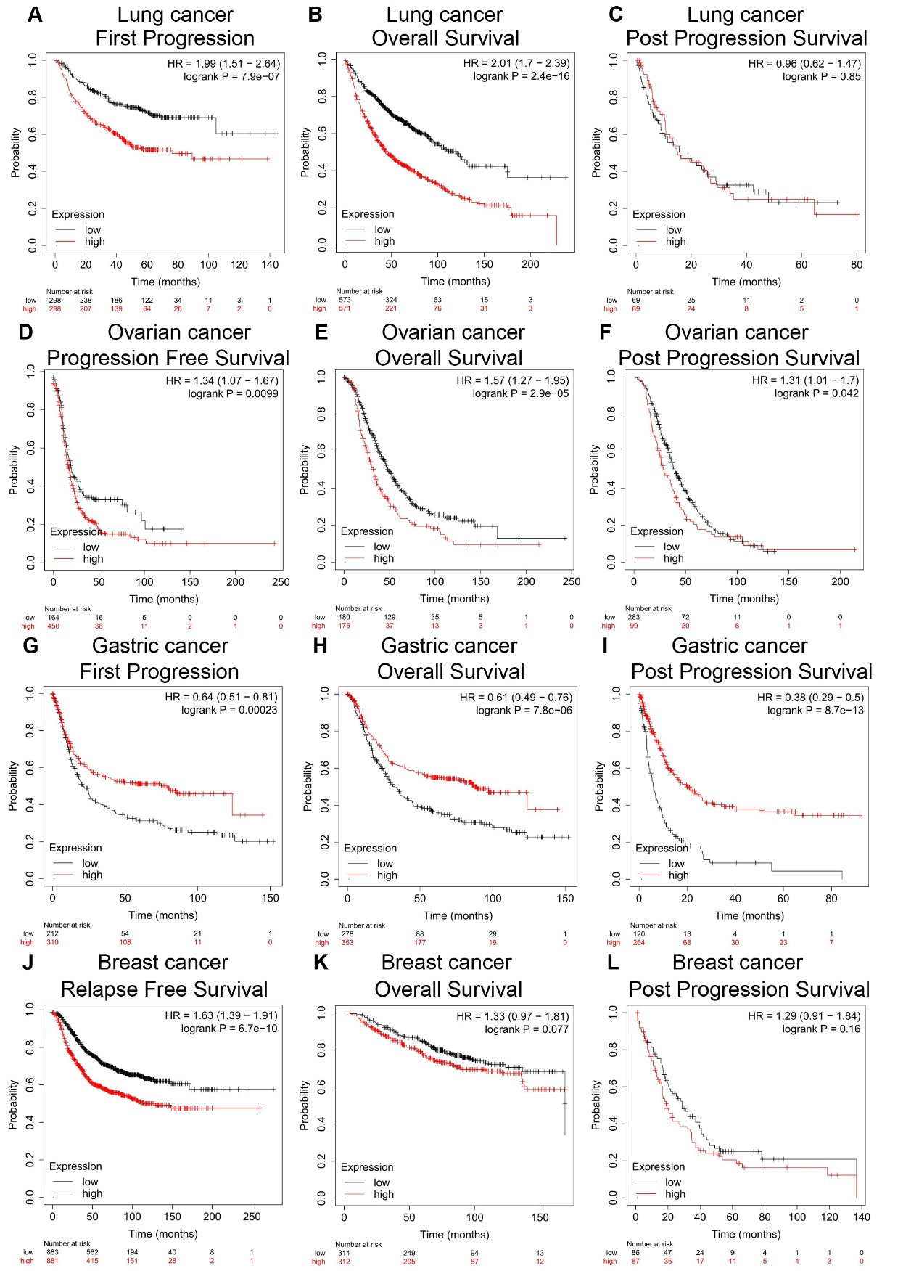

Figure S1 Correlation analysis between *Nuf2* expression and prognostic survival of cancer patients via Kaplan-Meier plotter analysis. (A-C) Lung cancer; (D-F) Gastric cancer, (G-I) Ovarian cancer; (J-L) Breast cancer.

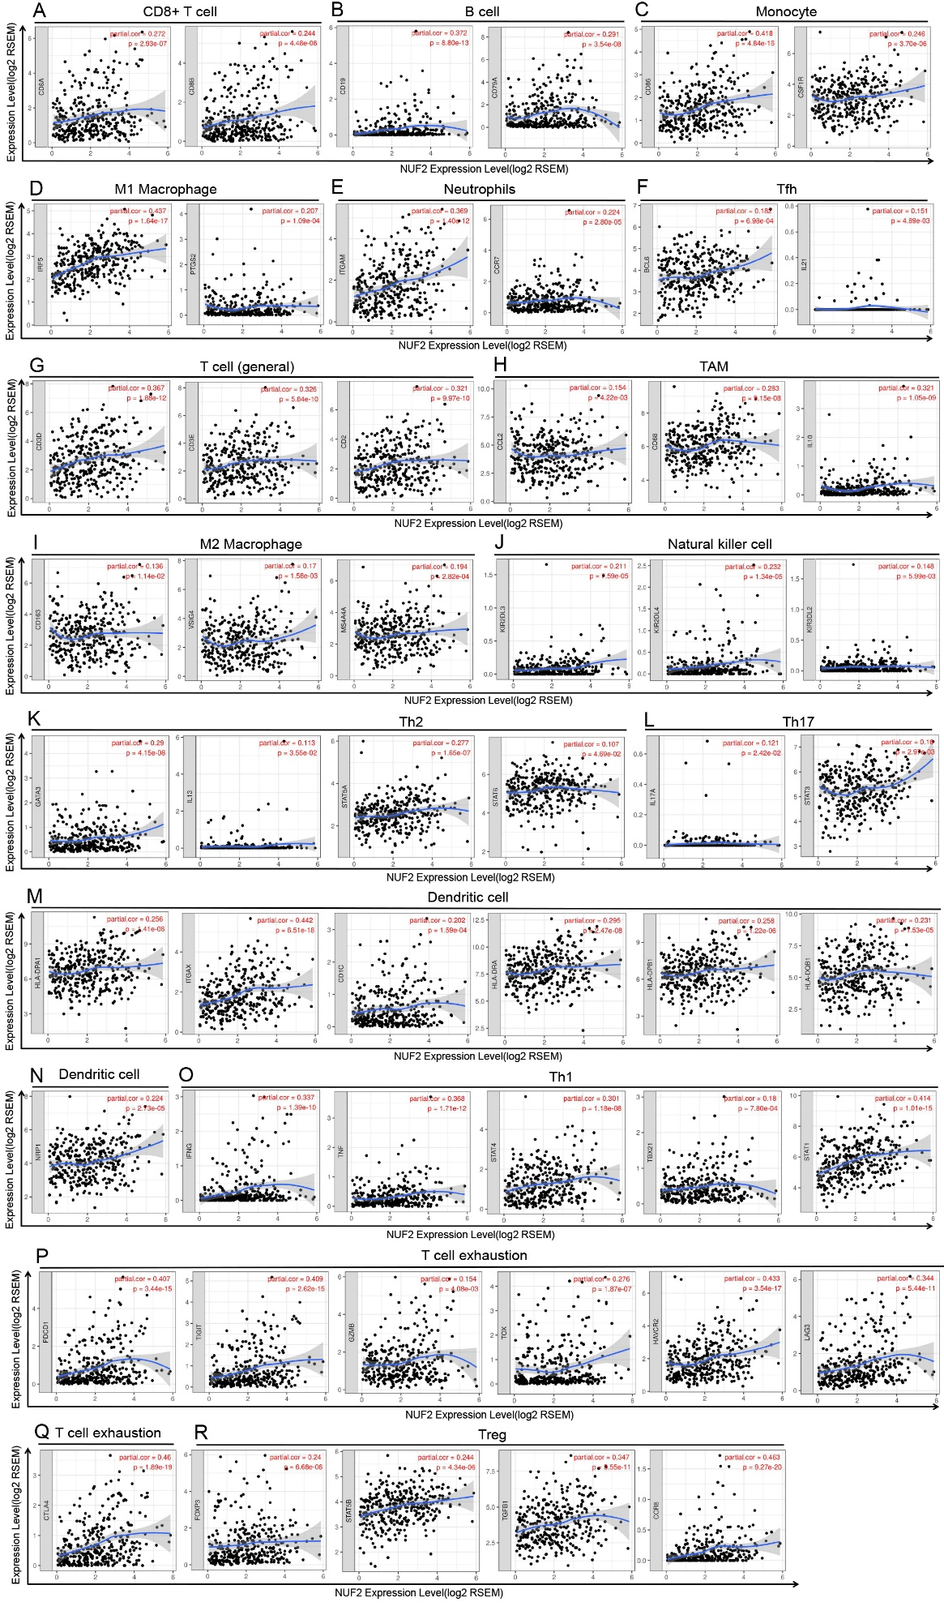

Figure S2. Correlation between *Nuf2* expression and biomarker gene expression of infiltrating immune cells in HCC analyzed via TIMER (n = 371).