**Supplementary Figures**

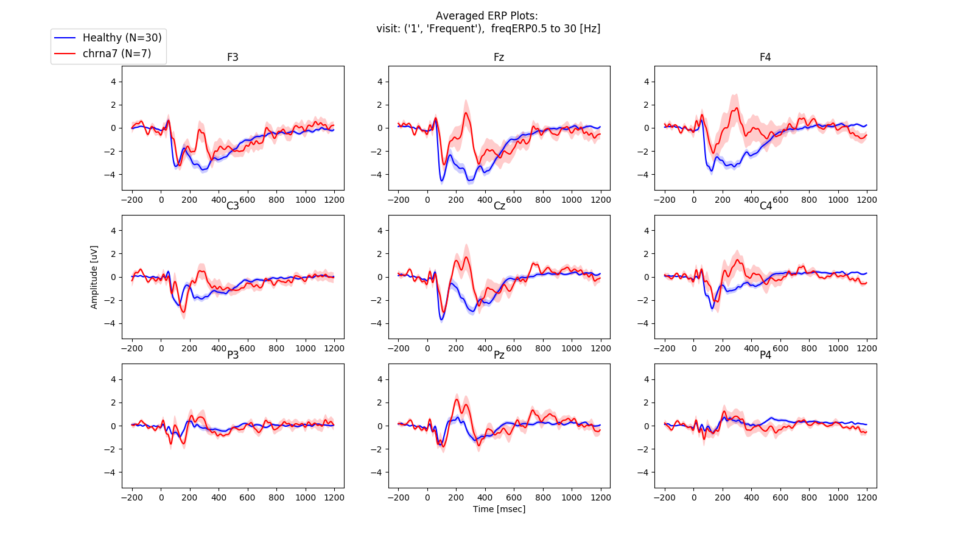

**Supplementary Figure 1**: By-group averaged ERP plots, blue line - healthy group, red line - CHRNA7 group. the brighter envelope indicates the standard error.  
**First visit, AOB task, 'Frequent' condition**. Filtration is set to 0.5-30 Hz

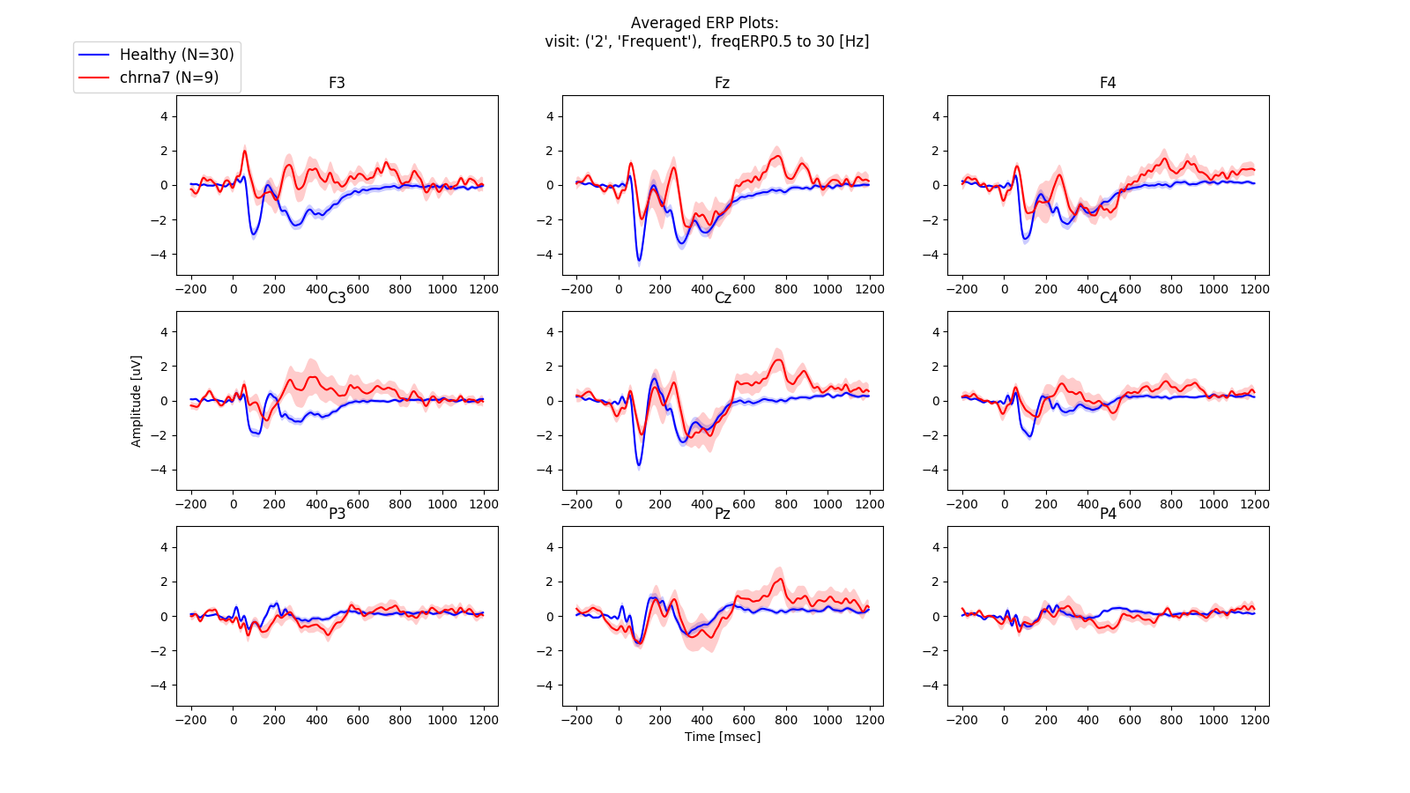

**Supplementary Figure** **2**: By-group averaged ERP plots, blue line - healthy group, red line - CHRNA7 group. the brighter envelope indicates the standard error.  
**Second visit, AOB task, 'Frequent' condition**. Filtration is set to 0.5-30 Hz

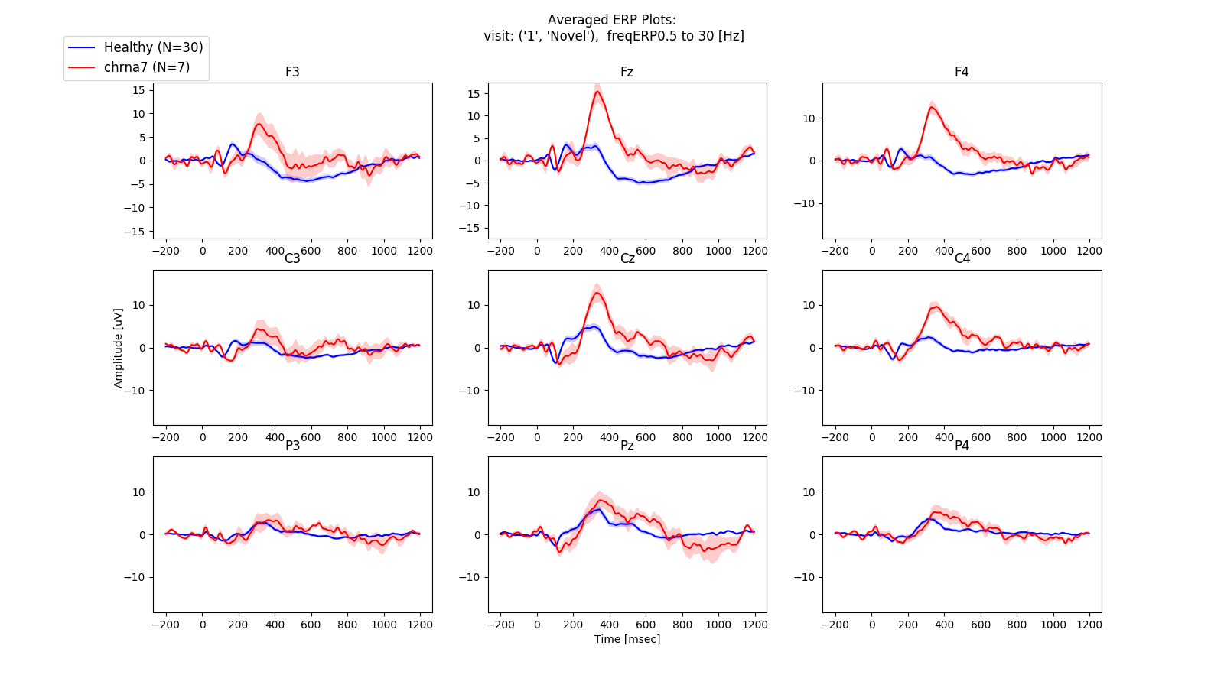**Supplementary Figure** **3**: By-group averaged ERP plots, blue line - healthy group, red line - CHRNA7 group. the brighter envelope indicates the standard error.  
**First visit, AOB task, 'Novel' condition**. Filtration is set to 0.5-30 Hz

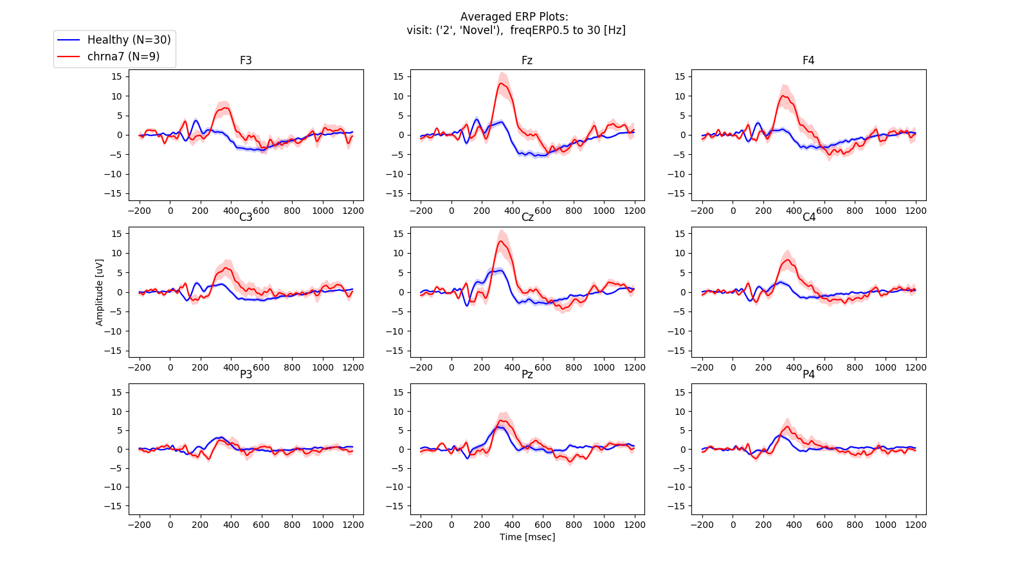**Supplementary Figure** **4**: By-group averaged ERP plots, blue line - healthy group, red line - CHRNA7 group. the brighter envelope indicates the standard error.  
**Second Visit, AOB task, 'Novel' condition**. Filtration is set to 0.5-30 Hz

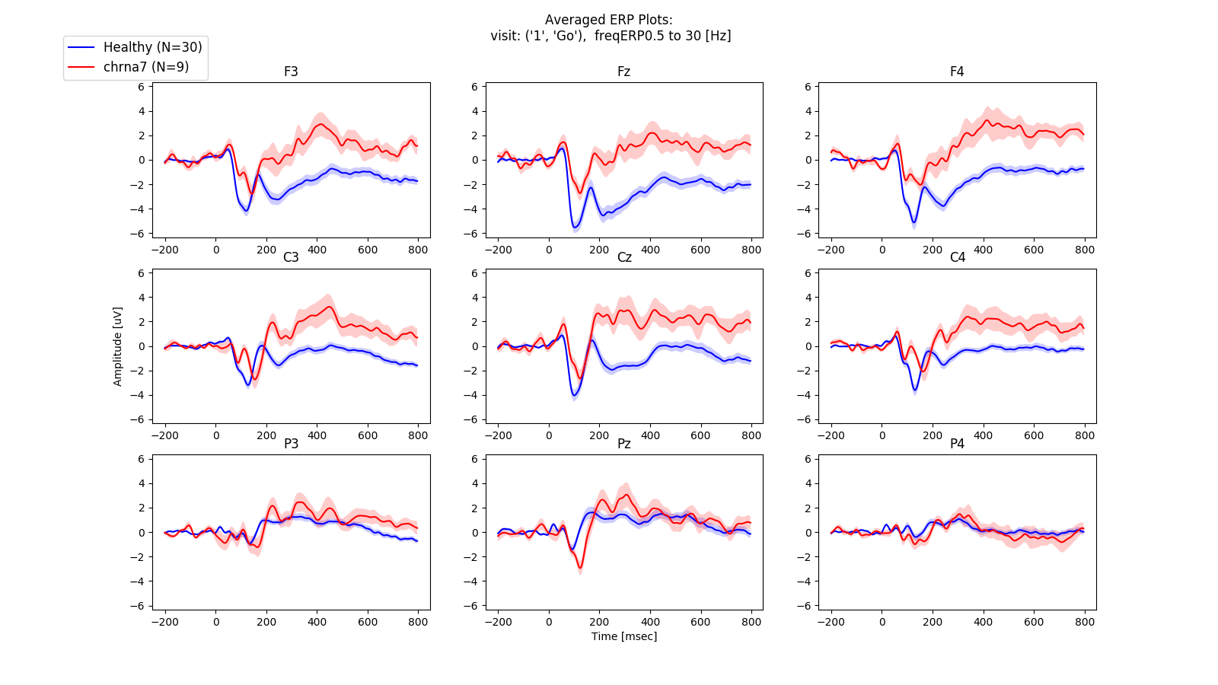

**Supplementary Figure** **5**: By-group averaged ERP plots, blue line - healthy group, red line - CHRNA7 group. the brighter envelope indicates the standard error.  
**First visit, GNG task, 'Go' condition**. Filtration is set to 0.5-30 Hz

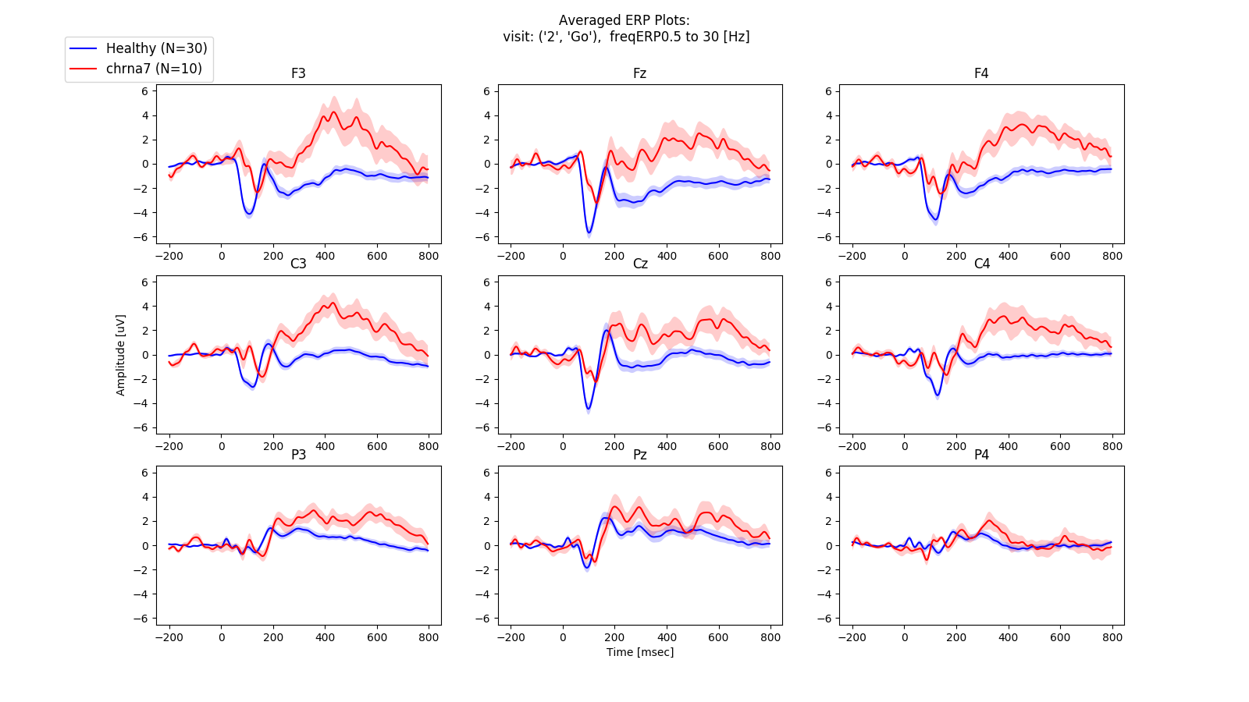

**Supplementary Figure** **6**: By-group averaged ERP plots, blue line - healthy group, red line - CHRNA7 group. the brighter envelope indicates the standard error.  
**Second visit, GNG task, 'Go' condition**. Filtration is set to 0.5-30 Hz

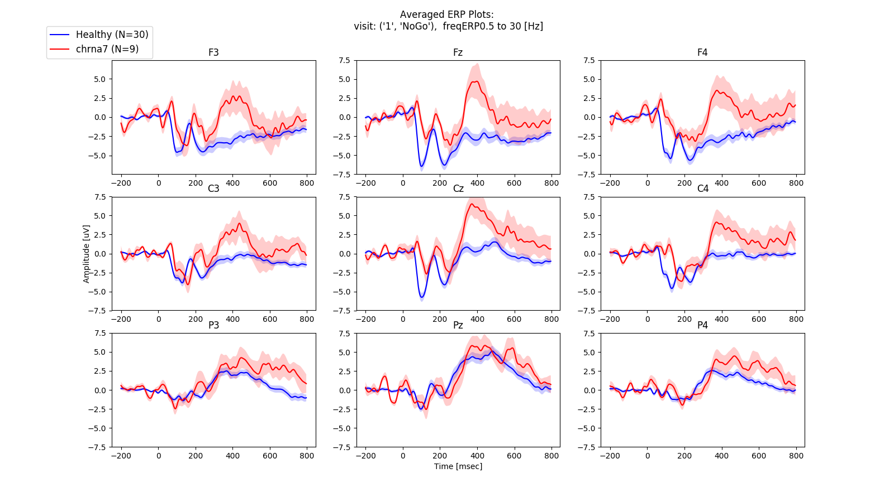**Supplementary Figure** **7**: By-group averaged ERP plots, blue line - healthy group, red line - CHRNA7 group. the brighter envelope indicates the standard error.  
**First visit, GNG task, 'NoGo' condition**. Filtration is set to 0.5-30 Hz

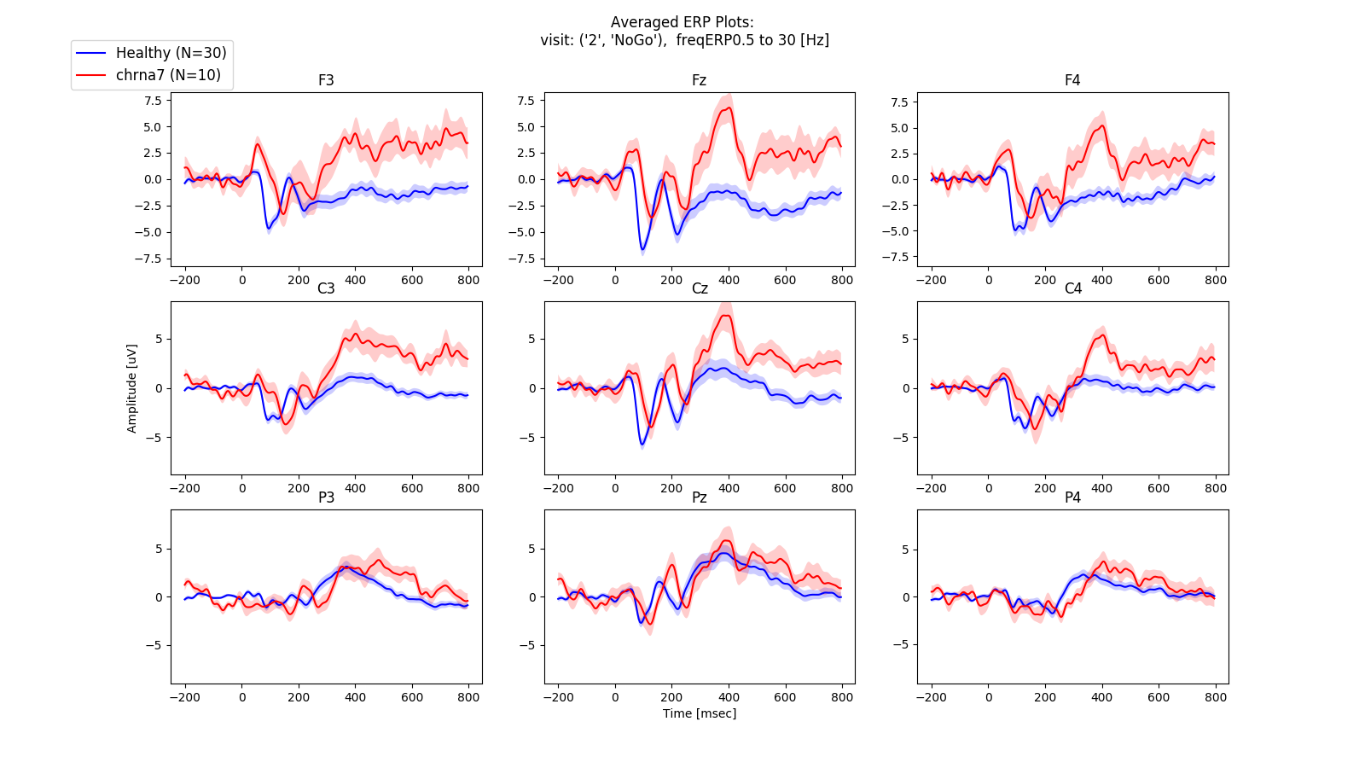**Supplementary Figure** **8**: By-group averaged ERP plots, blue line - healthy group, red line - CHRNA7 group. the brighter envelope indicates the standard error.  
**Second visit, GNG task, 'NoGo' condition**. Filtration is set to 0.5-30 Hz