**Carbonaceous fractions contents and carbon stable isotope compositions of aerosols collected in the atmosphere of Montreal (Canada): Seasonality, sources and implications**

Yasser Morera-Gómez1,2*, Zhiyuan Cong3, David Widory1

1Geotop/Université du Québec à Montréal (UQAM), 201 Ave Président Kennedy, Montréal, QC, Canada

2Centro de Estudios Ambientales de Cienfuegos. AP 5, Ciudad Nuclear, CP 59350, Cienfuegos, Cuba

3Key Laboratory of Tibetan Environment Changes and Land Surface Processes, Institute of Tibetan Plateau Research, Chinese Academy of Sciences, Beijing 100101, China

Supplementary material

Table S1. Concentrations (µg m-3) and carbon stable isotope composition (13C; ‰) of the different carbon fractions in TSP aerosols collected at four monitoring stations in Montreal during 2013.

| **Date** | **Station #** | **δ13CWSOC** | **unc.a** | **WSOC** | **unc.** | **TC** | **unc.** | **EC+OC** | **unc.** | **Carb.** | **unc.** | **δ13CEC+OC** | **unc.** |
| --- | --- | --- | --- | --- | --- | --- | --- | --- | --- | --- | --- | --- | --- |
| 04/01/2013 | 3 | -24.36 | 0.53 | 1.01 | 0.09 |  |  |  |  |  |  |  |  |
| 16/01/2013 | 3 | -23.95 | 0.53 | 0.86 | 0.08 | 5.59 | 1.03 | 3.44 | 0.50 | 2.15 | 0.50 | -26.08 | 0.82 |
| 09/02/2013 | 3 | -24.30 | 0.53 | 0.96 | 0.09 |  |  |  |  |  |  |  |  |
| 21/02/2013 | 3 | -24.90 | 0.53 | 0.75 | 0.08 | 3.75 | 0.84 | 2.69 | 0.46 | 1.06 | 0.30 | -25.95 | 0.82 |
| 11/03/2013 | 3 | -24.35 | 0.53 | 0.68 | 0.08 |  |  |  |  |  |  |  |  |
| 23/03/2013 | 3 | -24.95 | 0.53 | 0.36 | 0.06 | 4.19 | 0.89 | 2.52 | 0.45 | 1.67 | 0.46 | -26.72 | 0.82 |
| 10/04/2013 | 3 | -24.88 | 0.53 | 0.81 | 0.08 | 5.93 | 1.08 | 4.32 | 0.56 | 1.61 | 0.36 | -26.24 | 0.82 |
| 22/04/2013 | 3 | -24.75 | 0.53 | 0.73 | 0.08 |  |  |  |  |  |  |  |  |
| 10/05/2013 | 3 | -24.86 | 0.53 | 1.92 | 0.13 |  |  |  |  |  |  |  |  |
| 22/05/2013 | 3 | -25.44 | 0.53 | 0.68 | 0.08 | 4.03 | 0.89 | 3.21 | 0.51 | 0.82 | 0.22 | -25.59 | 0.82 |
| 09/06/2013 | 3 | -25.94 | 0.53 | 1.45 | 0.11 |  |  |  |  |  |  |  |  |
| 21/06/2013 | 3 | -25.10 | 0.53 | 2.02 | 0.14 | 7.48 | 1.28 | 5.94 | 0.68 | 1.53 | 0.32 | -25.70 | 0.82 |
| 09/07/2013 | 3 | -25.62 | 0.53 | 2.65 | 0.17 | 7.66 | 1.29 | 6.21 | 0.69 | 1.46 | 0.29 | -25.77 | 0.82 |
| 15/07/2013 | 3 | -26.53 | 0.53 | 2.58 | 0.16 |  |  |  |  |  |  |  |  |
| 08/08/2013 | 3 | -25.21 | 0.53 | 1.26 | 0.10 |  |  |  |  |  |  |  |  |
| 20/08/2013 | 3 | -24.50 | 0.53 | 2.35 | 0.15 | 9.21 | 1.46 | 6.95 | 0.74 | 2.26 | 0.43 | -24.86 | 0.82 |
| 07/09/2013 | 3 | -27.61 | 0.53 | 1.22 | 0.10 |  |  |  |  |  |  |  |  |
| 19/09/2013 | 3 | -28.76 | 0.53 | 1.95 | 0.13 | 11.65 | 1.69 | 6.41 | 0.70 | 5.23 | 0.95 | -25.27 | 0.82 |
| 07/10/2013 | 3 | -26.78 | 0.53 | 1.20 | 0.10 | 6.49 | 1.16 | 5.80 | 0.66 | 0.69 | 0.15 | -25.08 | 0.82 |
| 19/10/2013 | 3 | -23.63 | 0.53 | 1.53 | 0.12 |  |  |  |  |  |  |  |  |
| 12/11/2013 | 3 | -32.00 | 0.53 | 0.49 | 0.07 | 5.31 | 1.01 | 3.09 | 0.48 | 2.22 | 0.55 | -26.90 | 0.82 |
| 30/11/2013 | 3 | -25.83 | 0.53 | 1.57 | 0.12 |  |  |  |  |  |  |  |  |
| 12/12/2013 | 3 | -30.77 | 0.53 | 0.65 | 0.07 |  |  |  |  |  |  |  |  |
| 30/12/2013 | 3 | -25.41 | 0.53 | 0.61 | 0.08 | 3.09 | 0.80 | 2.15 | 0.45 | 0.95 | 0.32 | -24.52 | 0.82 |
| 10/01/2013 | 6 | -24.11 | 0.53 | 0.59 | 0.07 | 4.74 | 0.92 | 3.18 | 0.47 | 1.56 | 0.38 | -26.39 | 0.82 |
| 16/01/2013 | 6 | -23.49 | 0.53 | 0.99 | 0.09 | 7.50 | 1.24 | 5.20 | 0.61 | 2.30 | 0.47 | -26.29 | 0.82 |
| 09/02/2013 | 6 | -24.79 | 0.53 | 0.99 | 0.09 | 6.58 | 1.17 | 4.48 | 0.58 | 2.10 | 0.46 | -26.10 | 0.82 |
| 21/02/2013 | 6 | -23.65 | 0.53 | 0.75 | 0.08 | 2.96 | 0.75 | 2.21 | 0.43 | 0.75 | 0.24 | -25.46 | 0.82 |
| 11/03/2013 | 6 | -23.19 | 0.53 | 0.86 | 0.08 | 10.69 | 1.61 | 7.48 | 0.76 | 3.22 | 0.58 | -25.98 | 0.82 |
| 17/03/2013 | 6 | -23.55 | 0.53 | 0.61 | 0.07 | 9.72 | 1.49 | 4.87 | 0.59 | 4.85 | 0.95 | -26.58 | 0.82 |
| 10/04/2013 | 6 | -23.79 | 0.53 | 0.66 | 0.08 | 11.21 | 1.68 | 6.64 | 0.71 | 4.57 | 0.84 | -25.50 | 0.82 |
| 22/04/2013 | 6 | -24.04 | 0.53 | 0.75 | 0.08 | 8.07 | 1.33 | 6.88 | 0.73 | 1.20 | 0.24 | -26.04 | 0.82 |
| 10/05/2013 | 6 | -25.78 | 0.53 | 1.43 | 0.11 | 9.06 | 1.43 | 7.07 | 0.74 | 1.98 | 0.37 | -25.26 | 0.82 |
| 22/05/2013 | 6 | -24.93 | 0.53 | 1.02 | 0.09 | 7.44 | 1.27 | 5.07 | 0.62 | 2.38 | 0.50 | -26.08 | 0.82 |
| 09/06/2013 | 6 | -26.13 | 0.53 | 1.34 | 0.11 | 4.63 | 0.95 | 4.33 | 0.57 | 0.30 | 0.07 | -25.19 | 0.82 |
| 21/06/2013 | 6 | -25.38 | 0.53 | 2.12 | 0.14 | 9.07 | 1.42 | 8.27 | 0.81 | 0.80 | 0.15 | -25.44 | 0.82 |
| 09/07/2013 | 6 | -25.93 | 0.53 | 3.00 | 0.18 | 9.59 | 1.51 | 7.04 | 0.75 | 2.55 | 0.48 | -25.74 | 0.82 |
| 21/07/2013 | 6 | -27.34 | 0.53 | 0.85 | 0.08 | 4.31 | 0.91 | 3.54 | 0.52 | 0.77 | 0.20 | -25.62 | 0.82 |
| 08/08/2013 | 6 | -25.03 | 0.53 | 1.55 | 0.12 | 7.96 | 1.32 | 6.36 | 0.70 | 1.60 | 0.32 | -25.28 | 0.82 |
| 20/08/2013 | 6 | -24.59 | 0.53 | 2.43 | 0.16 | 11.35 | 1.67 | 8.97 | 0.87 | 2.38 | 0.42 | -25.45 | 0.82 |
| 07/09/2013 | 6 | -27.64 | 0.53 | 1.31 | 0.11 | 6.42 | 1.16 | 5.39 | 0.65 | 1.03 | 0.22 | -25.78 | 0.82 |
| 19/09/2013 | 6 | -26.38 | 0.53 | 1.57 | 0.12 | 13.06 | 1.87 | 8.97 | 0.88 | 4.09 | 0.71 | -25.93 | 0.82 |
| 07/10/2013 | 6 | -24.26 | 0.53 | 1.08 | 0.09 | 6.70 | 1.18 | 6.41 | 0.70 | 0.29 | 0.06 | -24.84 | 0.82 |
| 19/10/2013 | 6 | -23.52 | 0.53 | 1.47 | 0.11 | 7.04 | 1.22 | 5.65 | 0.65 | 1.39 | 0.29 | -23.76 | 0.82 |
| 12/11/2013 | 6 | -27.37 | 0.53 | 0.22 | 0.06 | 6.48 | 1.17 | 4.22 | 0.57 | 2.26 | 0.51 | -26.58 | 0.82 |
| 24/11/2013 | 6 | -25.61 | 0.53 | 0.30 | 0.06 | 5.22 | 1.00 | 3.30 | 0.50 | 1.91 | 0.47 | -26.57 | 0.82 |
| 12/12/2013 | 6 | -24.99 | 0.53 | 0.48 | 0.07 | 6.76 | 1.16 | 4.15 | 0.54 | 2.61 | 0.56 | -26.19 | 0.82 |
| 30/12/2013 | 6 | -25.45 | 0.53 | 0.80 | 0.08 | 4.64 | 0.93 | 3.14 | 0.48 | 1.50 | 0.38 | -25.68 | 0.82 |
| 10/01/2013 | 13 | -24.48 | 0.53 | 0.66 | 0.08 | 3.14 | 0.78 | 2.02 | 0.42 | 1.12 | 0.36 | -25.65 | 0.82 |
| 16/01/2013 | 13 | -24.18 | 0.53 | 0.96 | 0.09 | 6.38 | 1.14 | 3.48 | 0.51 | 2.89 | 0.67 | -25.91 | 0.82 |
| 09/02/2013 | 13 | -23.48 | 0.53 | 0.83 | 0.08 | 4.94 | 0.95 | 3.99 | 0.53 | 0.95 | 0.22 | -25.60 | 0.82 |
| 21/02/2013 | 13 | -23.48 | 0.53 | 0.64 | 0.07 | 5.54 | 1.04 | 4.21 | 0.55 | 1.33 | 0.30 | -25.72 | 0.82 |
| 05/03/2013 | 13 | -24.30 | 0.53 | 1.01 | 0.09 | 7.30 | 1.23 | 4.95 | 0.60 | 2.35 | 0.49 | -23.93 | 0.82 |
| 23/03/2013 | 13 | -23.34 | 0.53 | 0.68 | 0.08 | 4.88 | 0.98 | 3.76 | 0.53 | 1.12 | 0.28 | -24.71 | 0.82 |
| 10/04/2013 | 13 | -24.57 | 0.53 | 1.10 | 0.09 | 8.19 | 1.32 | 6.32 | 0.68 | 1.87 | 0.36 | -25.15 | 0.82 |
| 22/04/2013 | 13 | -24.98 | 0.53 | 0.64 | 0.07 | 9.43 | 1.46 | 4.98 | 0.59 | 4.45 | 0.87 | -26.00 | 0.82 |
| 10/05/2013 | 13 | -24.11 | 0.53 | 2.03 | 0.13 | 13.27 | 1.86 | 11.13 | 0.91 | 2.14 | 0.35 | -24.91 | 0.82 |
| 22/05/2013 | 13 | -23.37 | 0.53 | 1.19 | 0.09 | 8.98 | 1.39 | 7.34 | 0.73 | 1.64 | 0.30 | -25.14 | 0.82 |
| 09/06/2013 | 13 | -25.23 | 0.53 | 1.59 | 0.11 | 6.66 | 1.12 | 6.48 | 0.67 | 0.18 | 0.04 | -25.12 | 0.82 |
| 21/06/2013 | 13 | -25.15 | 0.53 | 2.13 | 0.14 | 8.55 | 1.34 | 7.32 | 0.73 | 1.24 | 0.23 | -24.73 | 0.82 |
| 09/07/2013 | 13 | -25.29 | 0.53 | 2.74 | 0.16 | 11.22 | 1.60 | 9.62 | 0.82 | 1.61 | 0.27 | -24.77 | 0.82 |
| 21/07/2013 | 13 | -25.13 | 0.53 | 1.01 | 0.09 | 4.99 | 0.94 | 3.79 | 0.50 | 1.20 | 0.28 | -25.25 | 0.82 |
| 08/08/2013 | 13 | -25.30 | 0.53 | 1.51 | 0.11 | 9.28 | 1.44 | 6.49 | 0.69 | 2.79 | 0.53 | -25.54 | 0.82 |
| 20/08/2013 | 13 | -25.70 | 0.53 | 2.62 | 0.16 | 11.26 | 1.62 | 9.73 | 0.84 | 1.53 | 0.26 | -24.71 | 0.82 |
| 07/09/2013 | 13 | -25.22 | 0.53 | 1.53 | 0.11 | 6.11 | 1.07 | 5.22 | 0.60 | 0.89 | 0.19 | -25.50 | 0.82 |
| 19/09/2013 | 13 | -26.72 | 0.53 | 1.43 | 0.11 | 13.00 | 1.79 | 9.40 | 0.81 | 3.60 | 0.59 | -25.35 | 0.82 |
| 07/10/2013 | 13 | -25.42 | 0.53 | 1.16 | 0.09 | 7.28 | 1.19 | 5.64 | 0.62 | 1.64 | 0.32 | -25.17 | 0.82 |
| 19/10/2013 | 13 | -24.62 | 0.53 | 1.15 | 0.09 | 6.22 | 1.09 | 4.84 | 0.58 | 1.38 | 0.29 | -23.84 | 0.82 |
| 12/11/2013 | 13 | -25.03 | 0.53 | 0.43 | 0.06 | 6.00 | 1.05 | 4.48 | 0.54 | 1.51 | 0.32 | -25.62 | 0.82 |
| 24/11/2013 | 13 | -24.77 | 0.53 | 0.38 | 0.06 | 5.06 | 0.94 | 3.30 | 0.47 | 1.76 | 0.41 | -25.99 | 0.82 |
| 12/12/2013 | 13 | -25.32 | 0.53 | 0.59 | 0.07 | 8.42 | 1.31 | 6.13 | 0.65 | 2.29 | 0.43 | -21.50 | 0.82 |
| 30/12/2013 | 13 | -24.79 | 0.53 | 0.60 | 0.07 | 5.57 | 1.00 | 4.33 | 0.53 | 1.24 | 0.27 | -25.70 | 0.82 |
| 04/01/2013 | 99 | -23.63 | 0.53 | 0.62 | 0.07 |  |  |  |  |  |  |  |  |
| 16/01/2013 | 99 | -21.91 | 0.53 | 0.65 | 0.07 | 2.19 | 0.60 | 1.48 | 0.33 | 0.71 | 0.25 | -23.01 | 0.82 |
| 09/02/2013 | 99 | -24.15 | 0.53 | 0.38 | 0.06 |  |  |  |  |  |  |  |  |
| 21/02/2013 | 99 | -26.49 | 0.53 | 0.38 | 0.06 | 1.11 | 0.49 | 2.97 | 0.44 |  |  | -25.79 | 0.82 |
| 11/03/2013 | 99 | -24.07 | 0.53 | 0.76 | 0.07 |  |  |  |  |  |  |  |  |
| 23/03/2013 | 99 | -24.01 | 0.53 | 0.17 | 0.05 | 0.88 | 0.48 | 0.50 | 0.29 | 0.38 | 0.30 | -25.42 | 0.82 |
| 10/04/2013 | 99 | -25.14 | 0.53 | 0.74 | 0.07 | 2.36 | 0.63 | 1.90 | 0.37 | 0.46 | 0.15 | -25.29 | 0.82 |
| 22/04/2013 | 99 | -23.65 | 0.53 | 0.63 | 0.07 |  |  |  |  |  |  |  |  |
| 10/05/2013 | 99 | -24.50 | 0.53 | 1.80 | 0.12 |  |  |  |  |  |  |  |  |
| 22/05/2013 | 99 | -25.07 | 0.53 | 1.20 | 0.09 | 5.49 | 0.96 | 4.71 | 0.54 | 0.78 | 0.16 | -25.40 | 0.82 |
| 15/06/2013 | 99 | -26.81 | 0.53 | 1.10 | 0.09 |  |  |  |  |  |  |  |  |
| 21/06/2013 | 99 | -25.16 | 0.53 | 1.93 | 0.13 | 4.40 | 0.86 | 3.33 | 0.46 | 1.07 | 0.26 | -25.10 | 0.82 |
| 09/07/2013 | 99 | -26.16 | 0.53 | 2.52 | 0.15 | 6.78 | 1.11 | 5.82 | 0.61 | 0.96 | 0.19 | -25.06 | 0.82 |
| 15/07/2013 | 99 | -26.06 | 0.53 | 2.27 | 0.14 |  |  |  |  |  |  |  |  |
| 08/08/2013 | 99 | -25.17 | 0.53 | 1.12 | 0.09 |  |  |  |  |  |  |  |  |
| 20/08/2013 | 99 | -24.18 | 0.53 | 2.03 | 0.13 | 4.90 | 0.93 | 4.66 | 0.56 | 0.24 | 0.05 | -24.27 | 0.82 |
| 07/09/2013 | 99 | -26.02 | 0.53 | 0.95 | 0.08 |  |  |  |  |  |  |  |  |
| 19/09/2013 | 99 | -25.39 | 0.53 | 1.07 | 0.09 | 5.08 | 0.94 | 3.60 | 0.49 | 1.48 | 0.34 | -23.50 | 0.82 |
| 07/10/2013 | 99 | -25.62 | 0.53 | 0.57 | 0.06 | 3.75 | 0.78 | 2.99 | 0.44 | 0.75 | 0.19 | -24.56 | 0.82 |
| 19/10/2013 | 99 | -23.65 | 0.53 | 1.11 | 0.09 |  |  |  |  |  |  |  |  |
| 12/11/2013 | 99 | -23.54 | 0.53 | 0.16 | 0.04 | 1.67 | 0.54 | 0.69 | 0.28 | 0.98 | 0.51 | -22.48 | 0.82 |
| 24/11/2013 | 99 | -23.10 | 0.53 | 0.13 | 0.05 |  |  |  |  |  |  |  |  |
| 12/12/2013 | 99 | -24.44 | 0.53 | 0.41 | 0.05 |  |  |  |  |  |  |  |  |
| 30/12/2013 | 99 | -24.45 | 0.53 | 0.35 | 0.05 | 2.12 | 0.59 | 1.27 | 0.32 | 0.85 | 0.32 | -24.83 | 0.82 |

aCalculated overall uncertainty.

Table S2. Chemical and stable isotope compositions of total carbon (TC) and water-soluble organic carbon (WSOC) fractions reported in aerosols worldwide.

| **Location** | **Size fraction** | **Study area** | **Sampling period** | **WSOC (µg m-3)** | | | | **δ13CWSOC (‰)** | | | | **TC (µg m-3)** | | | | **δ13CTC (‰)** | | | | | **References** | |
| --- | --- | --- | --- | --- | --- | --- | --- | --- | --- | --- | --- | --- | --- | --- | --- | --- | --- | --- | --- | --- | --- | --- |
| Ave | SD | min | max | Ave | SD | min | max | Ave | SD | min | max | | Ave | SD | min | max | |  |
| Ibaraki, Japan | PM2.5 | Urban | 2007 (Jul-Nov) |  |  |  |  | -25.8 | 0.4 | -26.5 | -25.0 |  |  |  |  | |  |  |  |  | | [1] |
| Stockholm, Sweden | TSP | Urban | 2009 (Aug-Oct) | 1.0 | 0.3 |  |  | -25.3 | 0.3 | -25.6 | -25.1 |  |  |  |  | |  |  |  |  | | [2] |
| Sapporo forest, Japan | TSP | Rural | 2009-2010 (Jun-Dec) |  |  | 0.5* | 4.1 |  |  | -27.0 | -21.0 |  |  |  |  | |  |  |  |  | | [3] |
| Sapporo forest, Japan | TSP | Urban | 2009-2010 (Sep-Oct) | 1.0 | 0.3 | 0.5 | 1.7 | -24.2 | 1.6 | -26.7 | -21.2 | 5.1 | 1.4 | 2.3 | 8.4 | | -24.8 | 0.7 | -25.6 | -23.1 | | [4] |
| Millbrook, NY, USA | TSP | Rural | 2006 (Aug) |  |  |  |  | -25.2 | 0.2 | -26.0 | -23.9 |  |  |  |  | |  |  |  |  | | [5] |
| Harcum, VA, USA | TSP | Rural | 2007 (Jan) |  |  |  |  | -25.3 | 0.6 | -27.6 | -21.1 |  |  |  |  | |  |  |  |  | |  |
| Zurich, Switzerland | - | Urban | - |  |  |  |  | -24.0 | 0.7 |  |  |  |  |  |  | |  |  |  |  | | [6] |
|  |  |  |  |  |  |  |  | -25.5 | 0.6 |  |  |  |  |  |  | |  |  |  |  | |  |
| Hong Kong | PM2.5 | Urban and background | 2000-2001 (winter) | 3.2 | 0.7 |  |  |  |  |  |  |  |  |  |  | |  |  |  |  | | [7] |
|  |  |  | 2000-2001 (summer) | 1.7 | 0.7 |  |  |  |  |  |  |  |  |  |  | |  |  |  |  | |  |
|  | PM10 | Urban and background | 2000-2001 (winter) | 3.6 | 0.8 |  |  |  |  |  |  |  |  |  |  | |  |  |  |  | |  |
|  |  |  | 2000-2001 (summer) | 1.9 | 0.8 |  |  |  |  |  |  |  |  |  |  | |  |  |  |  | |  |
| Sinhagad, India | TSP | Regional | 2008-2009 | 2.6 | 2.2 | 0.1* | 10.5* | -20.4 | 0.5 | -22.2 | -19.6 |  |  |  |  | |  |  |  |  | | [8] |
| Hanimaadhoo island, Republic of Maldives | TSP | Regional | 2008-2009 | 0.4 | 0.4 | 0.1* | 2.0* | -18.5 | 0.5 | -20.8 | -17.5 |  |  |  |  | |  |  |  |  | |  |
| New Delhi, India | PM2.5 | Urban | 2010-2011 | 22.0 | 12.0 | 6.4 | 55.0 |  |  | -26.3 | -22.4 |  |  |  |  | |  |  |  |  | | [9] |
| Zurich, Switzerland |  | Urban | 2002-2003 |  |  | 1.0 | 13.0 | -23.8 |  |  |  | 8.1 |  | 1.0* | 20.0 | |  |  | -27.6* | -25.5 | | [10] |
| Mangshan, China | TSP | Suburban | 2007 (Sep-Oct) |  |  | 0.8 | 12.9 |  |  |  |  |  |  | 3.5 | 51.3 | |  |  | -29.0 | -21.2 | | [11] |
| Guangzhou, China | TSP | Urban | 2012 (Dec) | 4.6 | 1.7 | 1.5 | 6.5 | -23.7 | 1.2 | -25.7 | -22.2 |  |  |  |  | |  |  |  |  | | [12] |
| Guangzhou, China | PM10 | Urban | 2013 (Jun-Jul) | 8.9 | 4.0 | 4.7 | 23.6 |  |  |  |  | 15.0 | 6.3 | 8.9 | 37.8 | |  |  |  |  | | [13] |
|  | PM2.5 |  |  | 5.9 | 2.8 | 3.5 | 14.3 |  |  |  |  | 9.6 | 4.1 | 5.9 | 22.8 | |  |  |  |  | |  |
| Nanjing, China | PM2.5 | Suburban | 2015 (Jan) |  |  | 3.0 | 32.0 |  |  | -26.2 | -23.4 |  |  | 5.0* | 70.0* | |  |  | -26.8 | -22.5 | | [14] |
| Gosan, Korea | PM2.5 | Rural | 2011 (Mar) |  |  | 0.5* | 2.3 |  |  | -23.5* | -22.5* |  |  |  |  | |  |  |  |  | | [15] |
|  | TSP |  |  |  |  | 0.4* | 3.5 |  |  | -23.0* | -21.0* |  |  |  |  | |  |  |  |  | |  |
| Jorhat, India | PM10 | Urban | 2007-2008 |  |  | 26.0 | 29.2 |  |  |  |  |  |  | 137.0 | 142.8 | |  |  |  |  | | [16] |
|  | PM2.5 |  |  |  |  | 21.8 | 22.9 |  |  |  |  |  |  | 101.0 | 110.4 | |  |  |  |  | |  |
| Kanpur, India | PM10 | Urban | 2008-2009 |  |  | 5.0* | 50.0* |  |  |  |  |  |  |  |  | |  |  |  |  | | [17] |
|  | PM2.5 |  |  |  |  | 1.0* | 35.0* |  |  |  |  |  |  |  |  | |  |  |  |  | |  |
| Hisar, India | TSP | Urban | 2004 (Dec) | 20.3 | 8.5 | 6.7 | 42.0 |  |  |  |  |  |  |  |  | |  |  |  |  | | [18] |
| Manora Peak, India | TSP | Rural |  | 3.9 | 1.3 | 1.4 | 6.0 |  |  |  |  |  |  |  |  | |  |  |  |  | |  |
| Chennai, India | PM10 | Urban | 2007 | 4.2 | 1.4 | 2.6 | 7.0 |  |  |  |  |  |  |  |  | |  |  |  |  | | [19] |
| Zürich, Switzerland | PM10 | Urban | 2002 (Aug-Sep) |  |  | 1.0 | 3.1 |  |  |  |  |  |  | 2.5 | 7.2 | |  |  | -26.6 | -25.7 | | [20] |
| Sapporo, Japan | TSP |  | 2009-2010 | 1.2 | 0.5 | 0.6 | 2.4 |  |  |  |  |  |  |  |  | |  |  |  |  | | [21] |
| Atlanta, USA | PM2.5 | Urban | 2005 (Jul) | 4.7 | 0.7 |  |  |  |  |  |  |  |  |  |  | |  |  |  |  | | [22] |
|  |  | Urban |  | 4.3 | 0.8 |  |  |  |  |  |  |  |  |  |  | |  |  |  |  | |  |
|  |  | Urban |  | 6.7 | 1.4 |  |  |  |  |  |  |  |  |  |  | |  |  |  |  | |  |
|  |  | Rural |  | 6.3 | 1.3 |  |  |  |  |  |  |  |  |  |  | |  |  |  |  | |  |
| Guangzhou, China | PM2.5 | Traffic-Tunnel | 2013 |  |  | 6.2 | 8.0 |  |  |  |  |  |  |  |  | |  |  | -26.1 | -25.4 | | [23] |
| Xi'an, China | PM2.5 | Urban | 2008-2009 | 9.2 | 6.8 | 2.1 | 36.0 |  |  |  |  |  |  |  |  | |  |  |  |  | | [24] |
| Ahmedabad, India | PM10 | Urban | 2011 (May-Jun) | 2.1 |  | 1.1 | 7.9 |  |  |  |  | 7.5 |  | 4.7 | 25.8 | | -28.9 |  | -31.0 | -27.1 | | [25] |
|  | PM2.5 |  |  | 1.4 |  | 0.56 | 6.8 |  |  |  |  | 4.2 |  | 2.3 | 16.5 | |  |  |  |  | |  |
| Jodhpur, India | PM10 | Semi-urban | 2011 (Aug-Sep) | 18.9 |  | 1.5 | 81.4 |  |  |  |  | 40.1 |  | 8.3 | 135.0 | | -27.5 |  | -29.6 | -25.8 | |  |
|  | PM2.5 |  |  | 2.1 |  | 0.68 | 9.9 |  |  |  |  | 7.5 |  | 1.9 | 34.0 | |  |  |  |  | |  |

*Read from figure.



Figure S1. Isotope calibration curve established for the 13C analysis by LC/IRMS from selected laboratory reference samples.



Figure S2. Relationships between the measured and corrected δ13C, the C content and the peak area for benzoic acid standards. Total peak areas correspond to mass m/z=44.



Figure S3. Linearity (a and b) and reproducibility (c and d) tests with random selected aerosol samples collected in 2013. Total peak areas correspond to mass m/z=44. Error bars correspond to the standard deviation (SD, 1σ) of triplicate measurements by LC/IRMS.

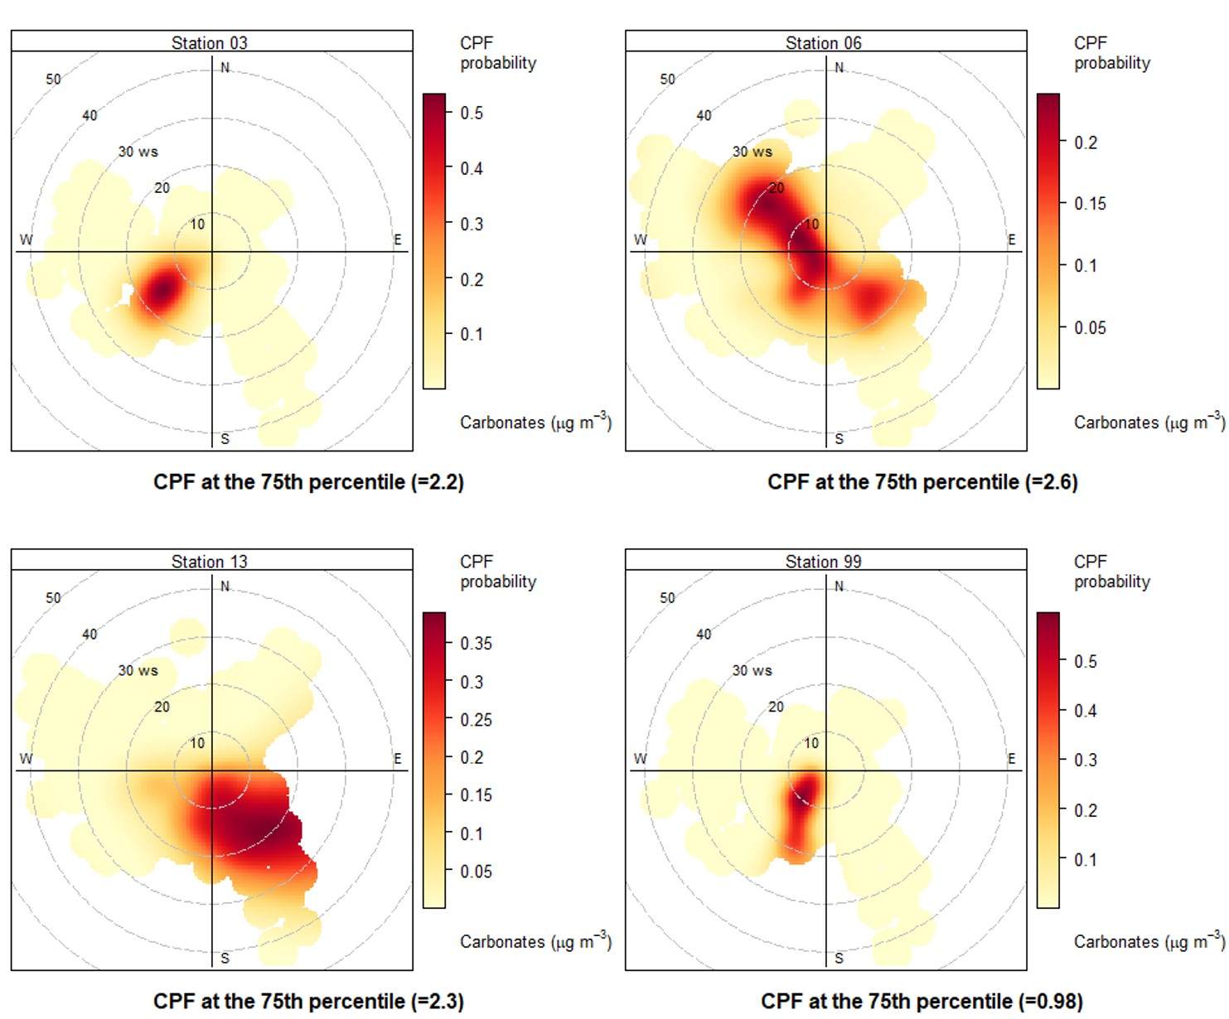

Figure S4. Conditional bivariate probability function (CBPF) at the 75th percentile calculated for carbonate concentrations in our TSP samples. Results indicate that each station is most probably impacted by sources located in different sectors. This suggest that each station is influenced by specific local sources. WS: Wind speed expressed in km h-1.



Figure S5. EC+OC percentage in TSP samples from four monitoring stations in Montreal during 2013. Solid lines correspond to the locally weighted polynomial regression LOWESS function. Error bars corresponds to the overall uncertainty.



Figure S6. Hourly NO2 concentration from selected monitoring stations on Montreal island during 2013. Stations 07 and 61 are in the vicinity of monitoring stations 06 and 13 [26], respectively. The local NO2 peaks that are observed between late April and early May and between late September and early October coincide with the highest total C concentrations we measured in TSP samples (Figure 4). Solid red lines correspond to the locally weighted polynomial regression LOWESS function.

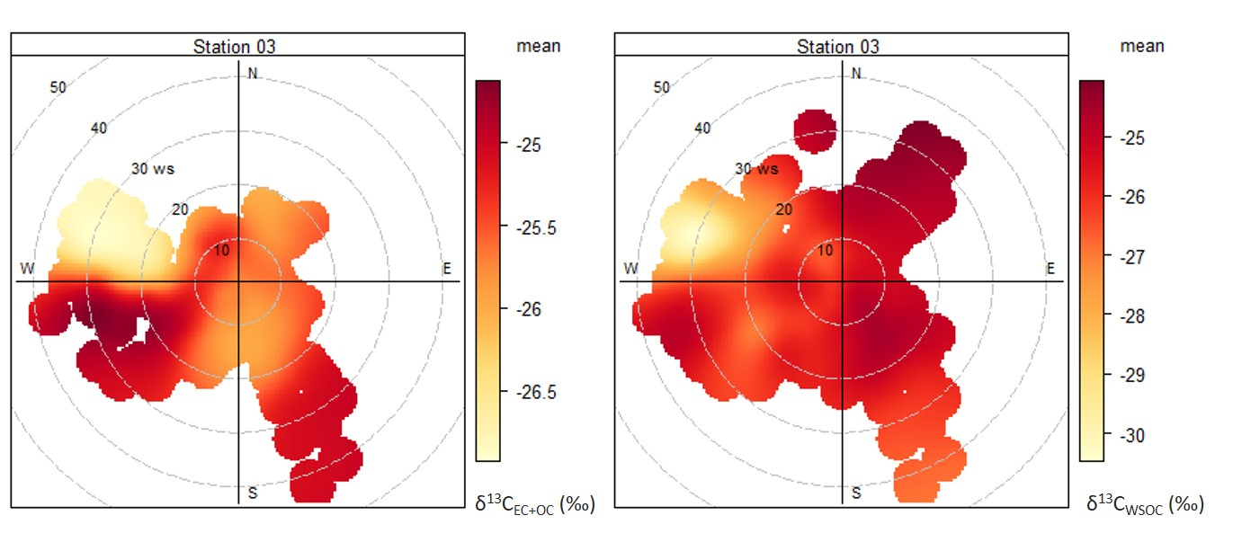

Figure S7. Polar plots of the carbon stable isotope composition of the EC+OC (13CEC+OC) and WSOC (13CWSOC) fractions at station 03 in Montreal during 2013. WS: Wind speed expressed in km h-1.



Figure S8. Hourly CO concentrations at station 61 in Montreal during 2013 [26]. A CO peak is observed on July 9 that coincides with the maximum WSOC concentration we measured in our TSP samples (Figure 4). The solid red line corresponds to the locally weighted polynomial regression LOWESS function.

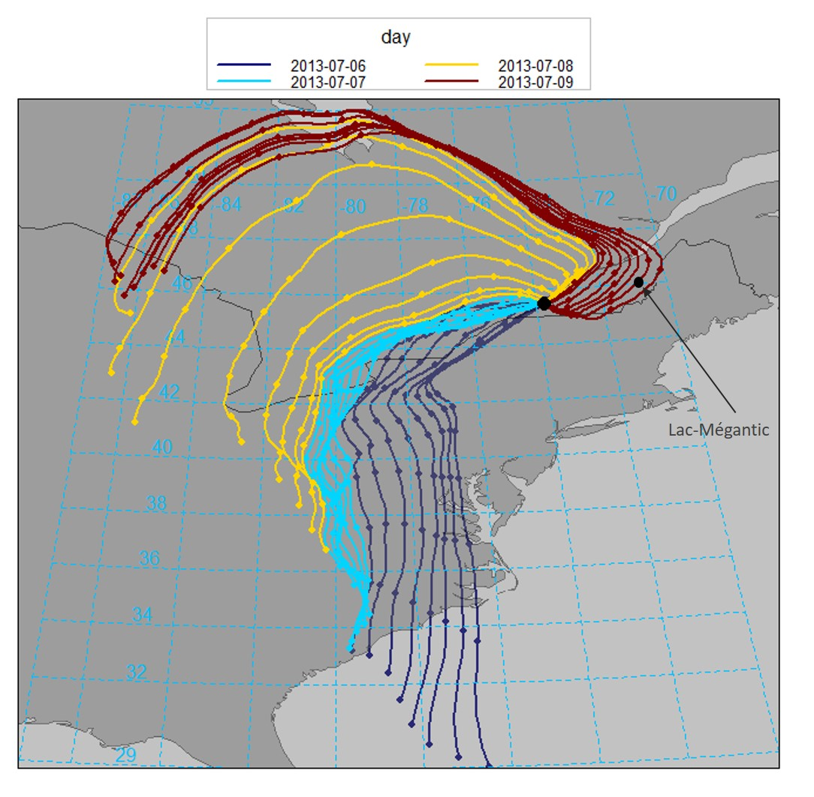

Figure S9. Modeled 5-days back-trajectories for aerosols arriving at 10 m in Montreal between July 6 and 9 2013.



Figure S10. Hourly O3 concentrations from selected monitoring stations on Montreal island during 2013. Station 61 is in the vicinity of monitoring station 13 [26]. Solid red lines correspond to the locally weighted polynomial regression LOWESS function.

References

[1] N. Suto, H. Kawashima, Rapid Commun. Mass Spectrom. 32 (2018) 1668–1674. doi:10.1002/rcm.8240.

[2] E.N. Kirillova, R.J. Sheesley, A. Andersson, Ö. Gustafsson, Anal. Chem. 82 (2010) 7973–7978. doi:10.1021/ac1014436.

[3] Y. Miyazaki, P.Q. Fu, K. Kawamura, Y. Mizoguchi, K. Yamanoi, Atmospheric Chem. Phys. 12 (2012) 1367–1376. doi:https://doi.org/10.5194/acp-12-1367-2012.

[4] C.M. Pavuluri, K. Kawamura, Acta Geochim. 36 (2017) 355–358. doi:10.1007/s11631-017-0157-3.

[5] A.S. Wozniak, J.E. Bauer, R.M. Dickhut, Atmos. Environ. 46 (2012) 181–188. doi:10.1016/j.atmosenv.2011.10.001.

[6] R. Fisseha, M. Saurer, M. Jäggi, S. Szidat, R.T.W. Siegwolf, U. Baltensperger, Rapid Commun. Mass Spectrom. RCM. 20 (2006) 2343–2347. doi:10.1002/rcm.2586.

[7] K. &nbsp;F. Ho, S. &nbsp;C. Lee, J. &nbsp;J. Cao, Y. &nbsp;S. Li, J. &nbsp;C. Chow, J. &nbsp;G. Watson, et al., Atmospheric Chem. Phys. 6 (2006) 4569–4576. doi:10.5194/acp-6-4569-2006.

[8] E.N. Kirillova, A. Andersson, R.J. Sheesley, M. Kruså, P.S. Praveen, K. Budhavant, et al., J. Geophys. Res. Atmospheres. 118 (2013) 614–626. doi:10.1002/jgrd.50130.

[9] E.N. Kirillova, A. Andersson, S. Tiwari, A.K. Srivastava, D.S. Bisht, Ö. Gustafsson, J. Geophys. Res. Atmospheres. 119 (2014) 3476–3485. doi:10.1002/2013JD020041.

[10] R. Fisseha, M. Saurer, M. Jäggi, R.T.W. Siegwolf, J. Dommen, S. Szidat, et al., Atmos. Environ. 43 (2009) 431–437. doi:10.1016/j.atmosenv.2008.08.041.

[11] N. He, K. Kawamura, Y. Kanaya, Z. Wang, Atmos. Environ. 123 (2015) 18–24. doi:10.1016/j.atmosenv.2015.10.052.

[12] J. Liu, Y. Mo, P. Ding, J. Li, C. Shen, G. Zhang, Sci. Total Environ. 633 (2018) 1571–1578. doi:10.1016/j.scitotenv.2018.03.293.

[13] J. Liu, P. Ding, Z. Zong, J. Li, C. Tian, W. Chen, et al., J. Geophys. Res. Atmospheres. 123 (2018) 4712–4726. doi:10.1029/2017JD027952.

[14] W. Zhang, Y.-L. Zhang, F. Cao, Y. Xiang, Y. Zhang, M. Bao, et al., Atmospheric Chem. Phys. 19 (2019) 11071–11087. doi:10.5194/acp-19-11071-2019.

[15] E.N. Kirillova, A. Andersson, J. Han, M. Lee, Ö. Gustafsson, Atmospheric Chem. Phys. 14 (2014) 1413–1422. doi:https://doi.org/10.5194/acp-14-1413-2014.

[16] P. Khare, B.P. Baruah, P.G. Rao, Tellus B. 63 (2011) 990–1000. doi:10.1111/j.1600-0889.2011.00564.x.

[17] K. Ram, M.M. Sarin, S.N. Tripathi, Environ. Sci. Technol. 46 (2012) 686–695. doi:10.1021/es202857w.

[18] R. Rengarajan, M.M. Sarin, A.K. Sudheer, J. Geophys. Res. Atmospheres. 112 (2007). doi:10.1029/2006JD008150.

[19] C.M. Pavuluri, K. Kawamura, S.G. Aggarwal, T. Swaminathan, Atmospheric Chem. Phys. 11 (2011) 8215–8230. doi:https://doi.org/10.5194/acp-11-8215-2011.

[20] S. Szidat, T.M. Jenk, H.W. Gäggeler, H.-A. Synal, R. Fisseha, U. Baltensperger, et al., Radiocarbon. 46 (2004) 475–484. doi:10.1017/S0033822200039783.

[21] C.M. Pavuluri, K. Kawamura, M. Uchida, M. Kondo, P. Fu, J. Geophys. Res. Atmospheres. 118 (2013) 2362–2371. doi:10.1002/jgrd.50244.

[22] R.J. Weber, A.P. Sullivan, R.E. Peltier, A. Russell, B. Yan, M. Zheng, et al., J. Geophys. Res. Atmospheres. 112 (2007). doi:10.1029/2007JD008408.

[23] S. Dai, X. Bi, L.Y. Chan, J. He, B. Wang, X. Wang, et al., Atmospheric Chem. Phys. 15 (2015) 3097–3108. doi:10.5194/acp-15-3097-2015.

[24] Z. Zhao, J. Cao, T. Zhang, Z. Shen, H. Ni, J. Tian, et al., Atmos. Environ. 185 (2018) 253–261. doi:10.1016/j.atmosenv.2018.05.008.

[25] A.K. Sudheer, M.Y. Aslam, M. Upadhyay, R. Rengarajan, R. Bhushan, J.S. Rathore, et al., Atmospheric Res. 178–179 (2016) 268–278. doi:10.1016/j.atmosres.2016.03.026.

[26] D. Boulet, S. Melançon, R. Mallet, Air Quality in Montréal. 2013 Environmental Assessment Report, Ville de Montréal, Service de l’environnement, Division de la planification et du suivi environnemental, Réseau de surveillance de la qualité de l’air (RSQA), 2013.