Detailed information of OSL results
K1-1

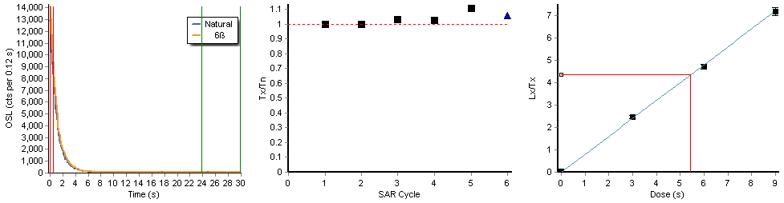
Recycling ratio = 1.09± 0.04 (R 5/R 1)
Recuperation = 0.8± 0.1 % (R4/N)
K1-2
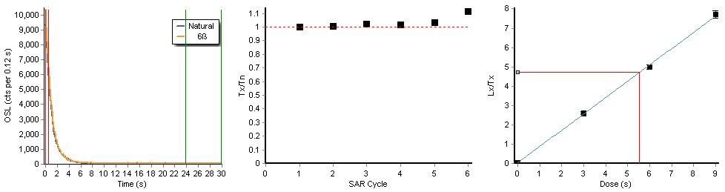Recycling ratio = 1.02± 0.04 (R 5/R 1)
Recuperation = 0.7± 0.1 % (R4/N)
K1-3
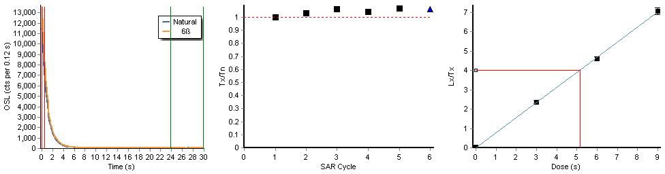
Recycling ratio = 1.14± 0.04 (R 5/R 1)
Recuperation = 0.9± 0.1 % (R4/N)

K1-4
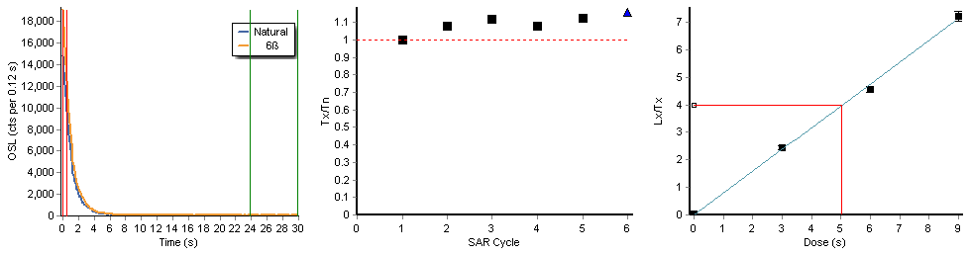
Recycling ratio = 1.05± 0.03 (R 5/R 1)
Recuperation = 0.9± 0.1 % (R4/N)
K1-5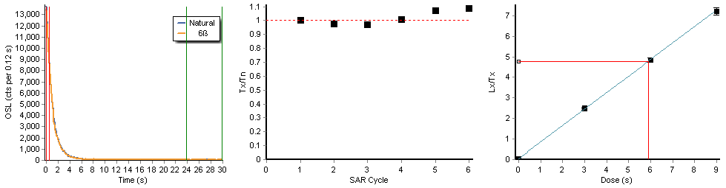Recycling ratio = 1.01± 0.03 (R 5/R 1)
Recuperation = 1.1± 0.1 % (R4/N)
K2-1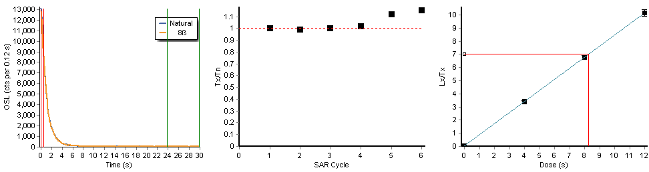Recycling ratio = 1.00± 0.03 (R 5/R 1)
Recuperation = 0.4± 0.0 % (R4/N)

K2-2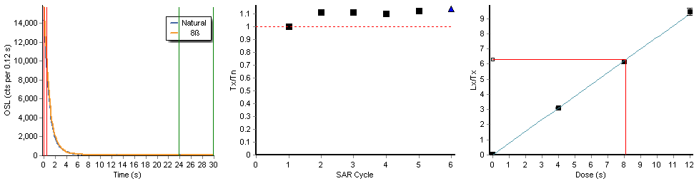
Recycling ratio = 1.13± 0.04 (R 5/R 1)
Recuperation = 0.7± 0.0 % (R4/N)
K2-3
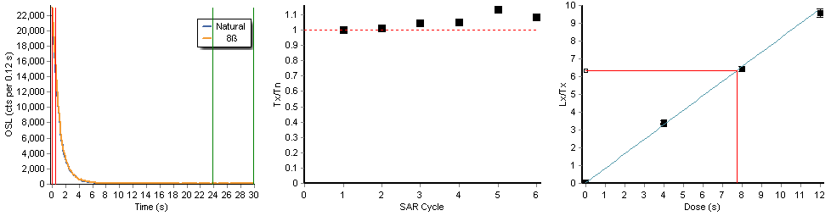Recycling ratio = 1.04± 0.03 (R 5/R 1)
Recuperation = 0.6± 0.0 % (R4/N)
K2-4
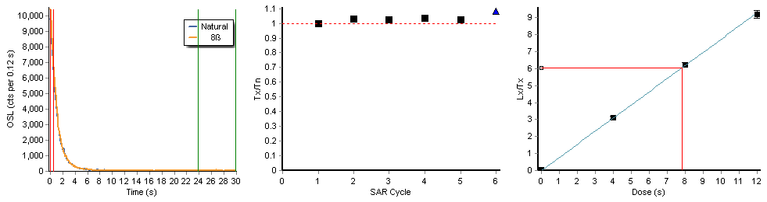Recycling ratio = 1.08± 0.04 (R 5/R 1)
Recuperation = 0.9± 0.1 % (R4/N)
K2-5
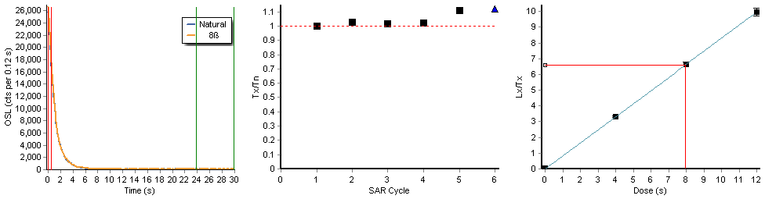Recycling ratio = 1.05± 0.03 (R 5/R 1)
Recuperation = 0.4± 0.0 % (R4/N)
K3-1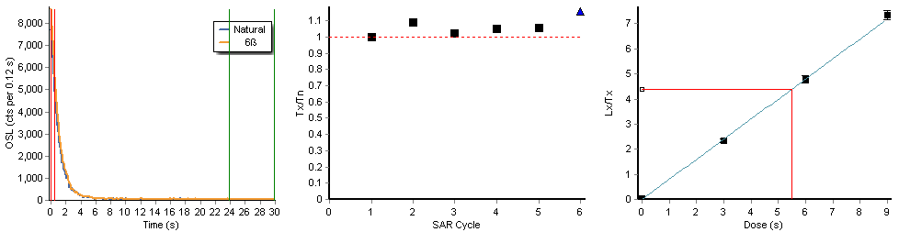
Recycling ratio = 1.08± 0.04 (R 5/R 1)
Recuperation = 0.9± 0.1 % (R4/N)
K3-2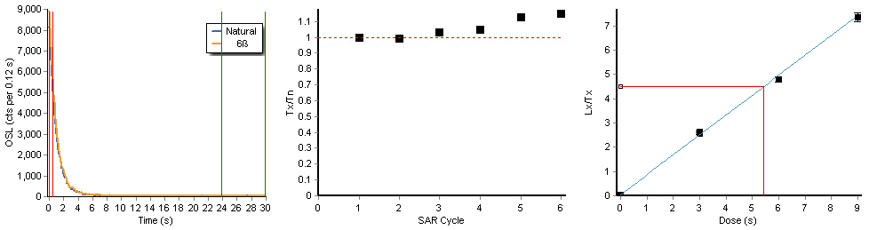Recycling ratio = 0.97± 0.03 (R 5/R 1)
Recuperation = 1.0± 0.1 % (R4/N)
K3-3
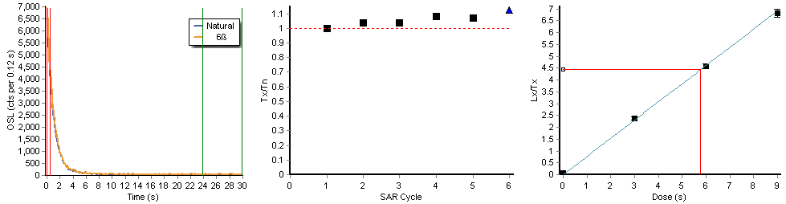
Recycling ratio = 1.07± 0.04 (R 5/R 1)
Recuperation = 1.2± 0.1 % (R4/N)
K3-4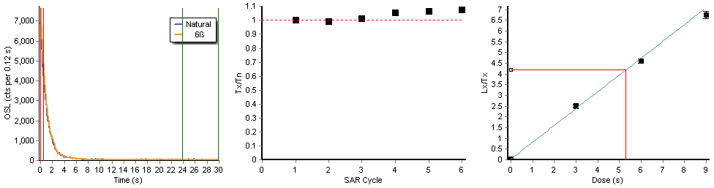Recycling ratio = 1.02± 0.04 (R 5/R 1)
Recuperation = 0.9± 0.1 % (R4/N)
K3-5
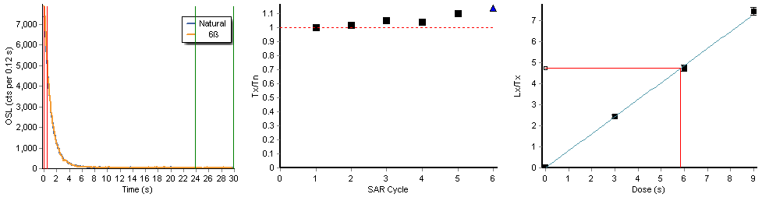
Recycling ratio = 1.05± 0.04 (R 5/R 1)
Recuperation = 0.6± 0.1 % (R4/N)
K4-1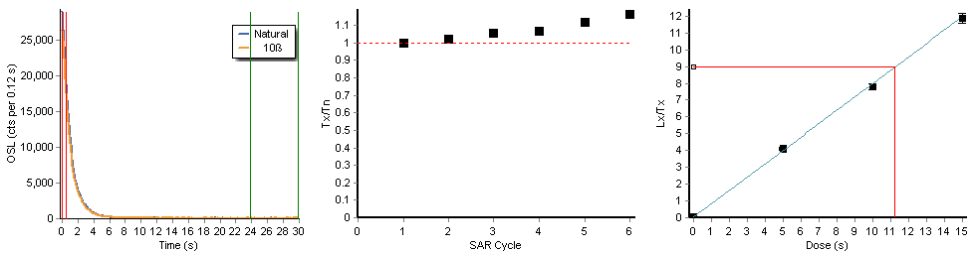Recycling ratio = 1.02± 0.03 (R 5/R 1)
Recuperation = 0.4± 0.0 % (R4/N)
K4-2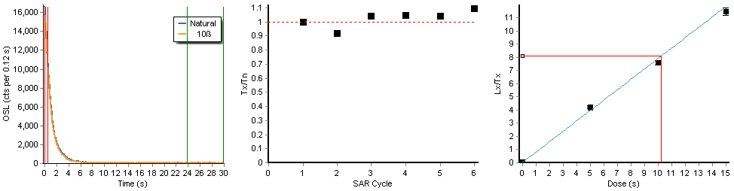Recycling ratio = 0.99± 0.03 (R 5/R 1)
Recuperation = 0.4± 0.0 % (R4/N)
K4-3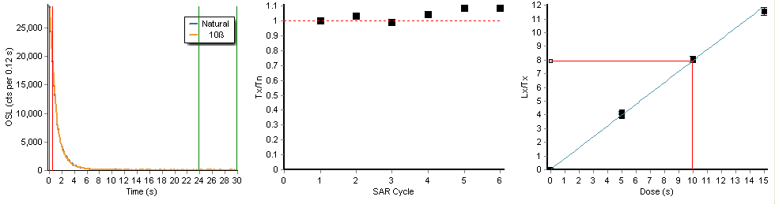Recycling ratio = 1.06± 0.03 (R 5/R 1)
Recuperation = 0.4± 0.0 % (R4/N)
K4-4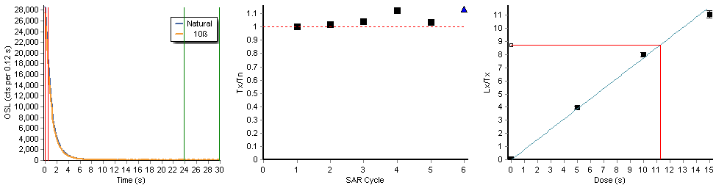
Recycling ratio = 1.04± 0.03 (R 5/R 1)
Recuperation = 0.4± 0.0 % (R4/N)
K4-5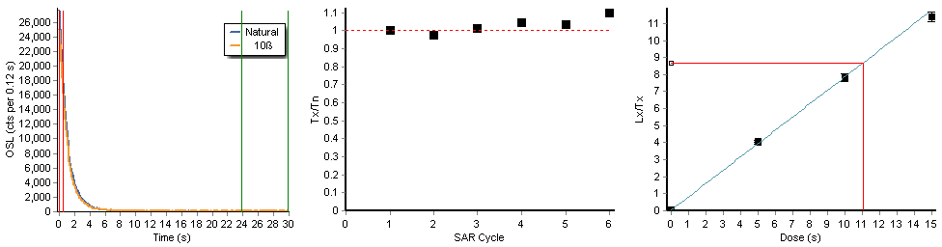Recycling ratio = 1.01± 0.03 (R 5/R 1)
Recuperation = 0.5± 0.0 % (R4/N)
K5-1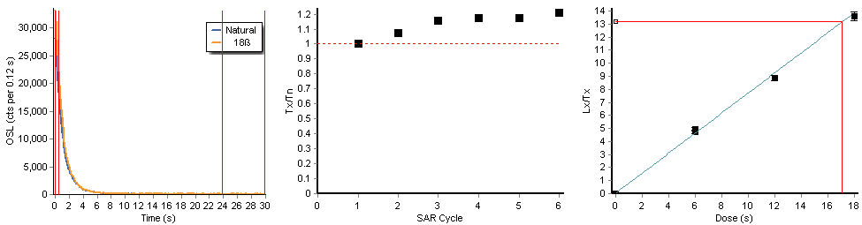Recycling ratio = 1.05± 0.04 (R 5/R 1)
Recuperation = 0.2± 0.0 % (R4/N)
K5-2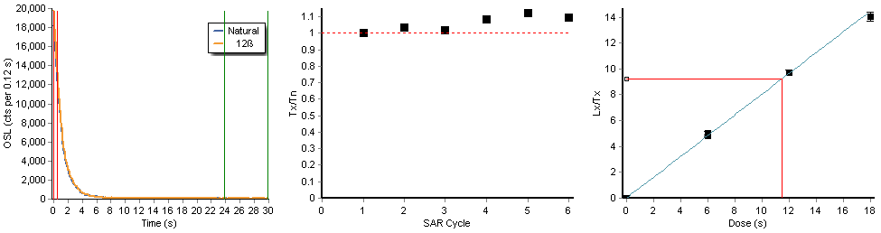Recycling ratio = 1.05± 0.04 (R 5/R 1)
Recuperation = 0.3± 0.0 % (R4/N)
K5-3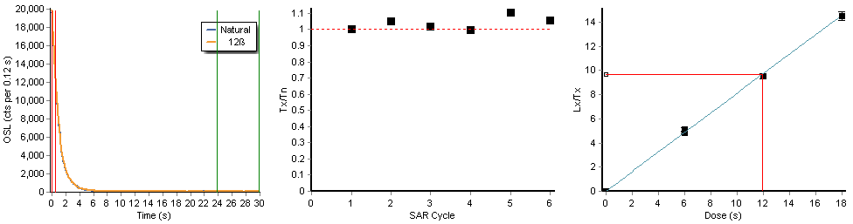Recycling ratio = 1.07± 0.04 (R 5/R 1)
Recuperation = 0.2± 0.0 % (R4/N)
K5-4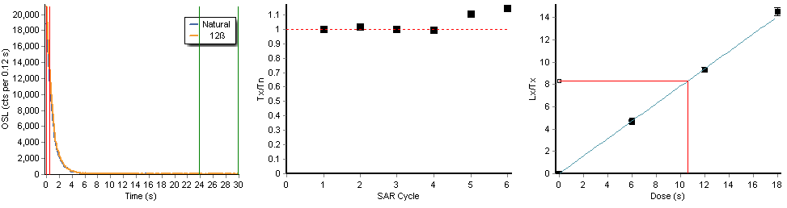Recycling ratio = 0.98± 0.03 (R 5/R 1)
Recuperation = 0.4± 0.0 % (R4/N)
K5-5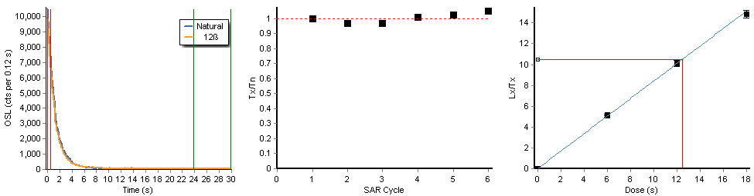Recycling ratio = 1.00± 0.04 (R 5/R 1)
Recuperation = 0.2± 0.0 % (R4/N)
K6-1
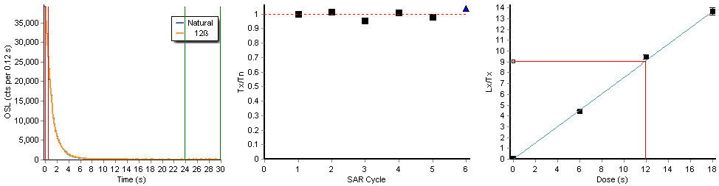
Recycling ratio = 1.13± 0.04 (R 5/R 1)
Recuperation = 0.6± 0.0 % (R4/N)
K6-2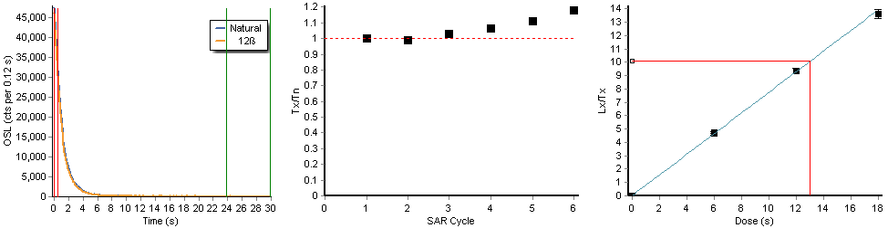Recycling ratio = 1.00± 0.03 (R 5/R 1)
Recuperation = 0.3± 0.0 % (R4/N)
K6-3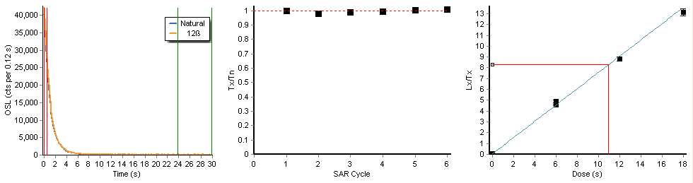Recycling ratio = 1.08± 0.03 (R 5/R 1)
Recuperation = 0.7± 0.0 % (R4/N)
K6-4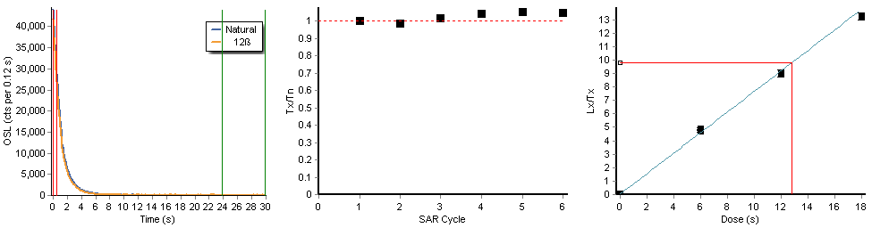Recycling ratio = 1.04± 0.03 (R 5/R 1)
Recuperation = 0.4± 0.0 % (R4/N)
K6-5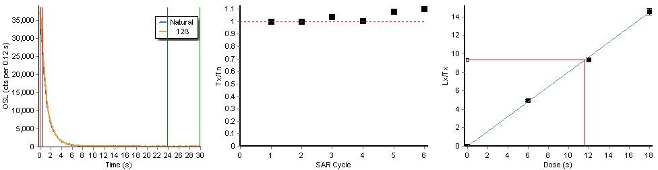Recycling ratio = 1.01± 0.03 (R 5/R 1)
Recuperation = 0.3± 0.0 % (R4/N)
K7-1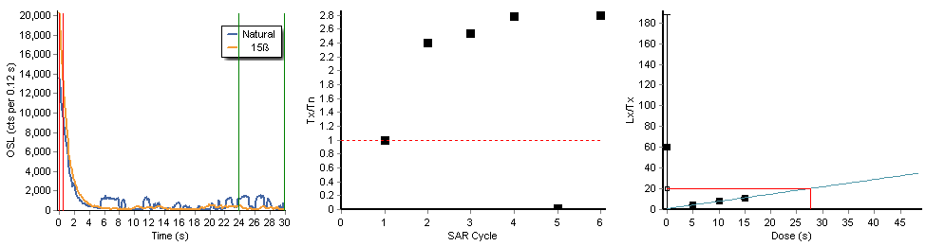Recycling ratio = 1.00± 0.04 (R 5/R 1)
Recuperation = 295.9±627.1 % (R4/N)
K7-2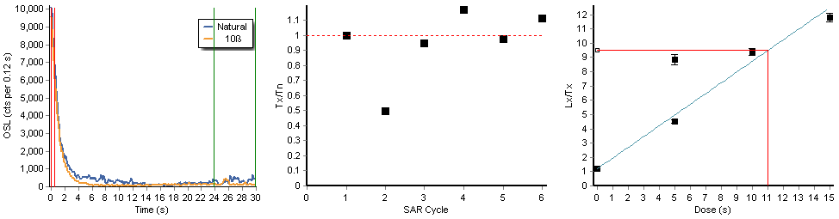Recycling ratio = 0.51± 0.02 (R 5/R 1)
Recuperation = 12.6± 0.5 % (R4/N)
K7-3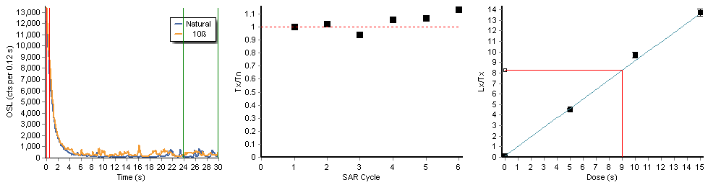Recycling ratio = 1.01± 0.04 (R 5/R 1)
Recuperation = 1.7± 0.1 % (R4/N)
K7-4
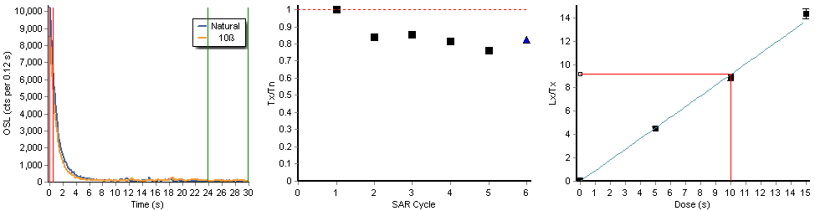
Recycling ratio = 1.11± 0.04 (R 5/R 1)
Recuperation = 0.8± 0.1 % (R4/N)
K7-5
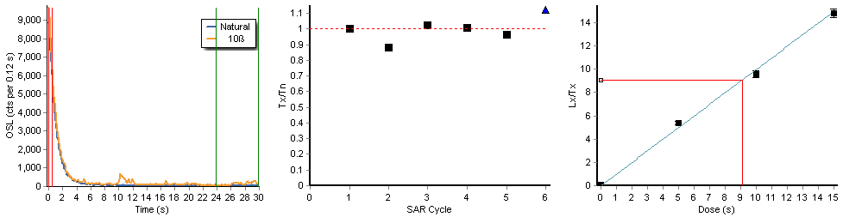
Recycling ratio = 0.89± 0.04 (R 5/R 1)
Recuperation = 0.5± 0.1 % (R4/N)
K7-6
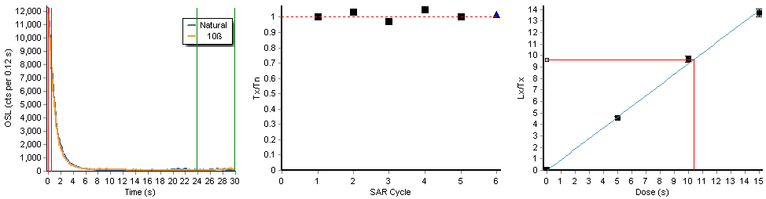
Recycling ratio = 1.09± 0.04 (R 5/R 1)
Recuperation = 1.0± 0.1 % (R4/N)
K7-7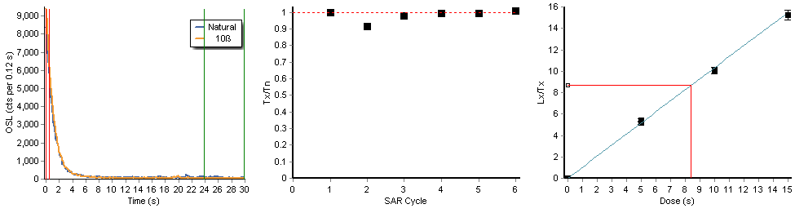Recycling ratio = 1.04± 0.04 (R 5/R 1)
Recuperation = 0.2± 0.1 % (R4/N)
K8-1
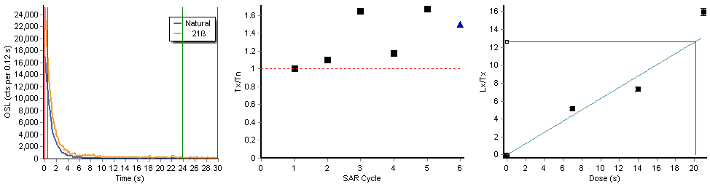
Recycling ratio = 0.90± 0.03 (R 5/R 1)
Recuperation = -0.3± 0.0 % (R4/N)
K8-2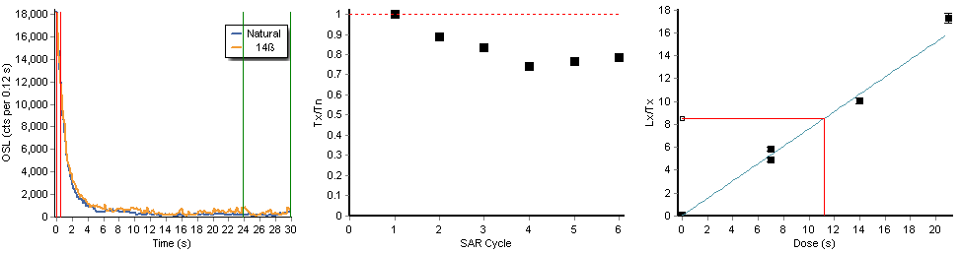Recycling ratio = 1.19± 0.04 (R 5/R 1)
Recuperation = 0.6± 0.1 % (R4/N)
K8-3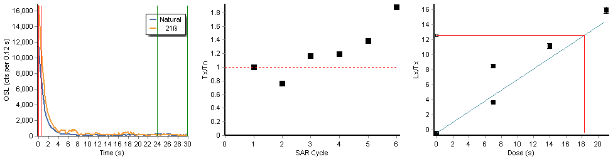Recycling ratio = 0.43± 0.02 (R 5/R 1)
Recuperation = -3.1± -0.1 % (R4/N)
K8-4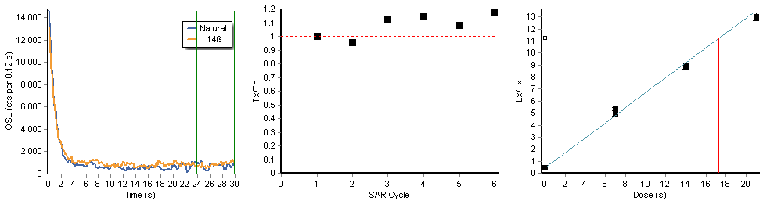Recycling ratio = 0.92± 0.04 (R 5/R 1
Recuperation = 4.1± 0.2 % (R4/N)
K8-5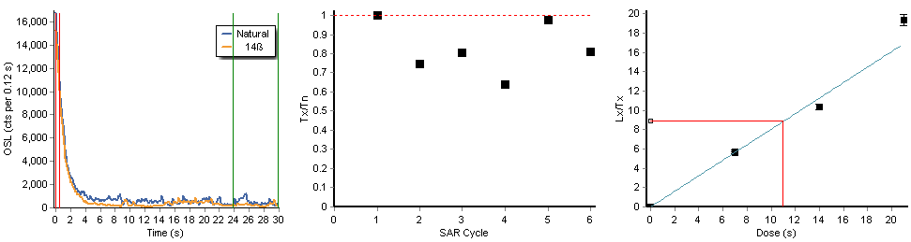Recycling ratio = 0.97± 0.04 (R 5/R 1)
Recuperation = 0.1± 0.0 % (R4/N)
K9-1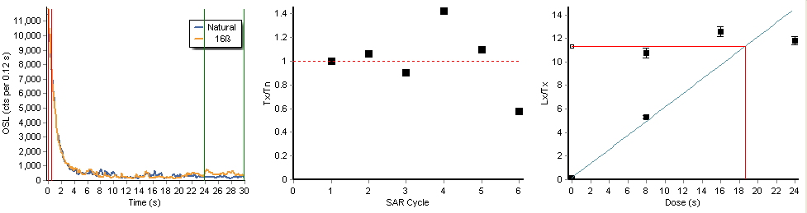Recycling ratio = 2.03± 0.10 (R 5/R 1)
Recuperation = 1.5± 0.1 % (R4/N)
K9-2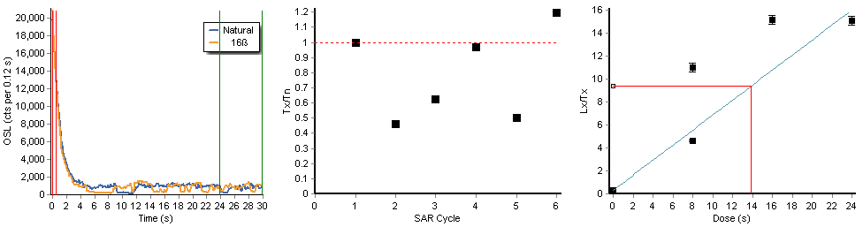Recycling ratio = 0.42± 0.02 (R 5/R 1)
Recuperation = 3.5± 0.2 % (R4/N)
K9-3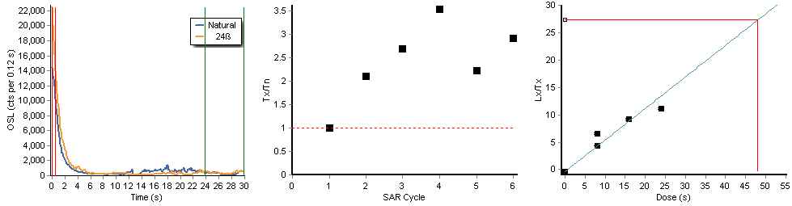Recycling ratio = 0.67± 0.03 (R 5/R 1)
Recuperation = -1.4± -0.1 % (R4/N)
K9-4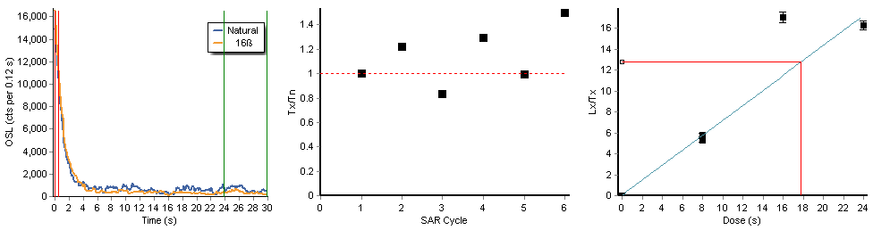Recycling ratio = 0.91± 0.03 (R 5/R 1)
Recuperation = 0.3± 0.1 % (R4/N)
K9-5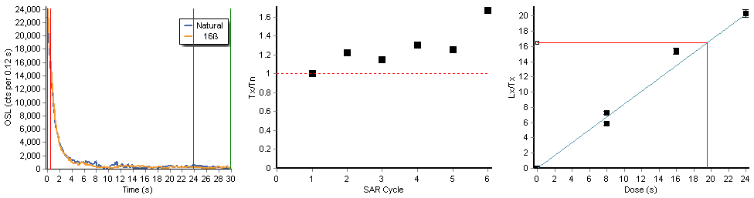Recycling ratio = 0.81± 0.03 (R 5/R 1)
Recuperation = 0.3± 0.0 % (R4/N)
K10-1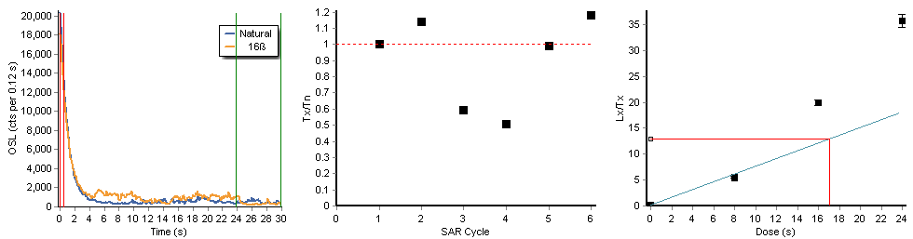Recycling ratio = 1.05± 0.04 (R 5/R 1)
Recuperation = 1.9± 0.1 % (R4/N)
K10-2
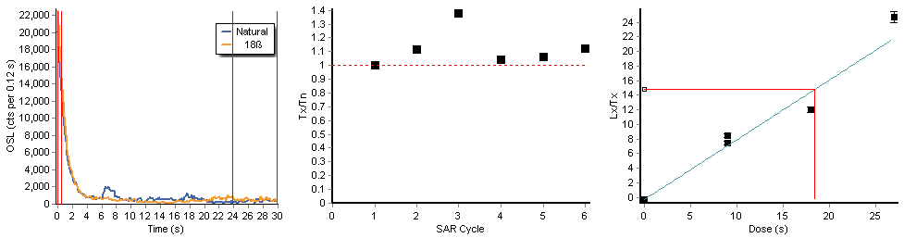Recycling ratio = 1.14± 0.04 (R 5/R 1)
Recuperation = -1.9± -0.1 % (R4/N)
K10-3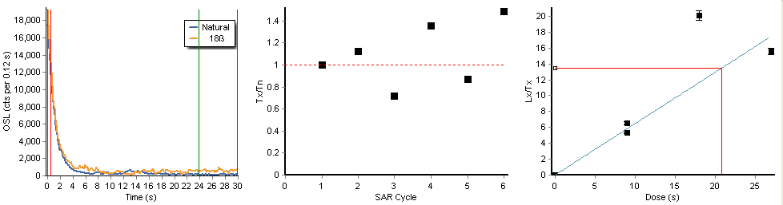Recycling ratio = 0.81± 0.03 (R 5/R 1)
Recuperation = 0.2± 0.1 % (R4/N)
K10-4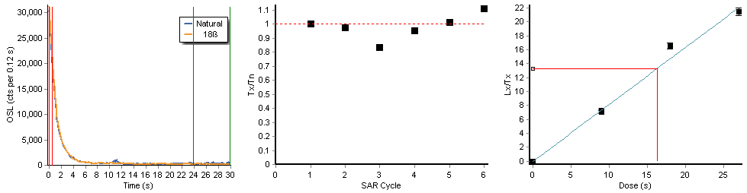Recycling ratio = 0.97± 0.03 (R 5/R 1)
Recuperation = -0.1± 0.0 % (R4/N)
K10-5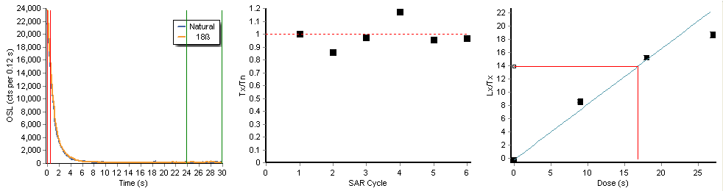Recycling ratio = 1.04± 0.04 (R 5/R 1)
Recuperation = -1.2± -0.1 % (R4/N)

