Supplementary Material

Figure S1. Effect of area sampled (a), species richness (b), total number of individuals (c) and number of families (d) on SAD shape (best model selected) for each individual community (continues in next pages). Plots were built using the function geom_density from the ggplot package in R (Wickham, 2009), which computes smoothed versions of histograms for continuous variables.
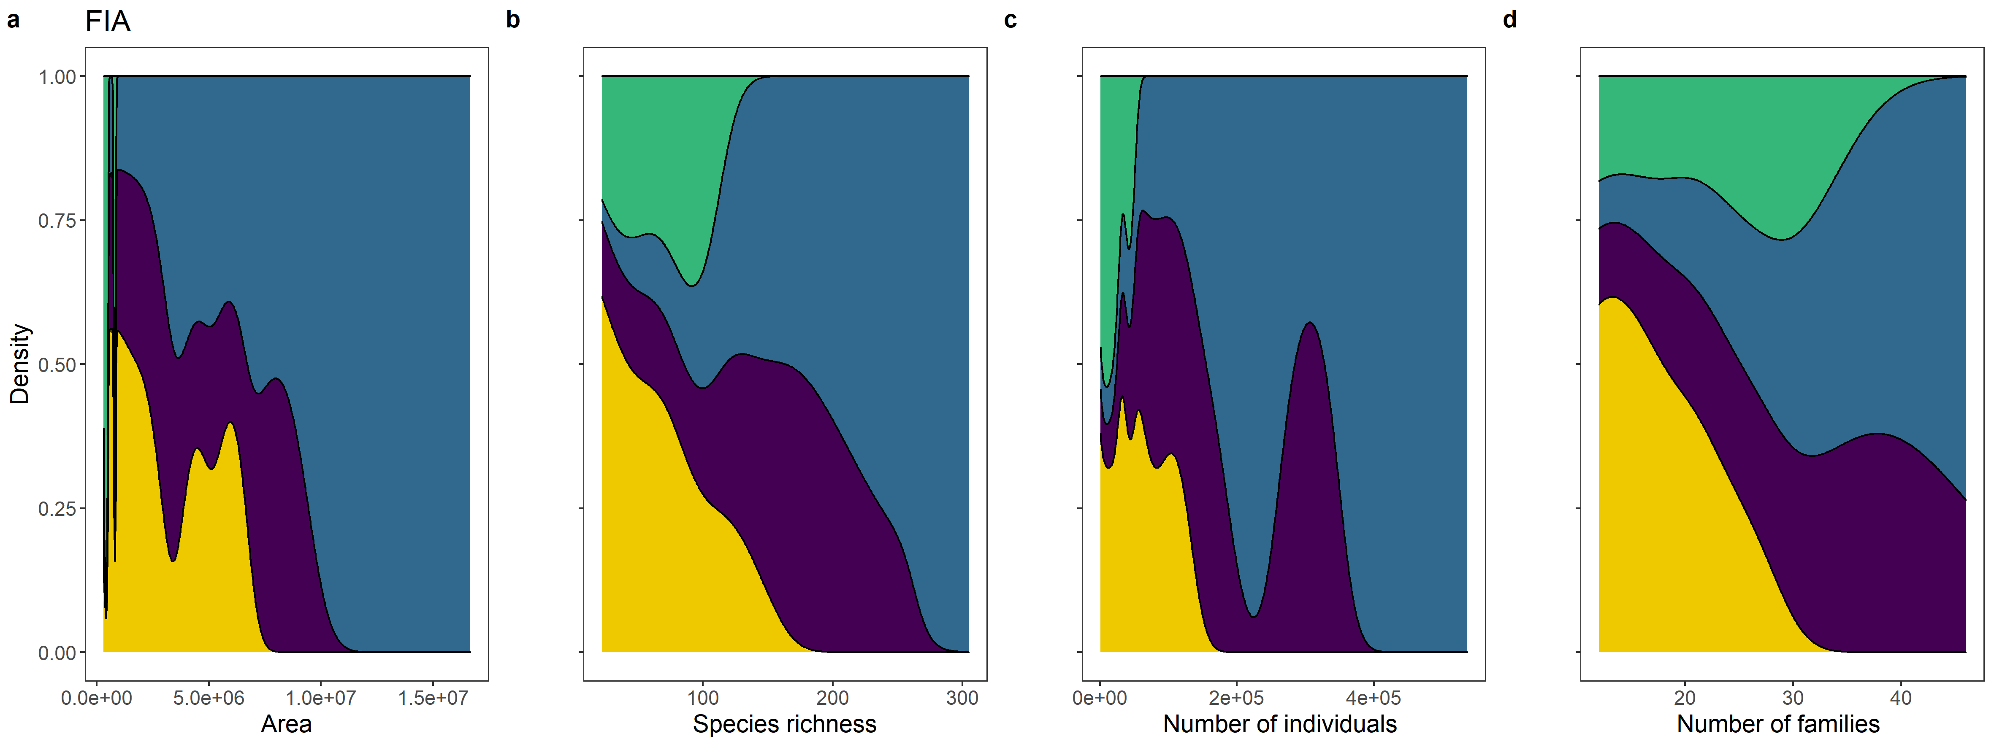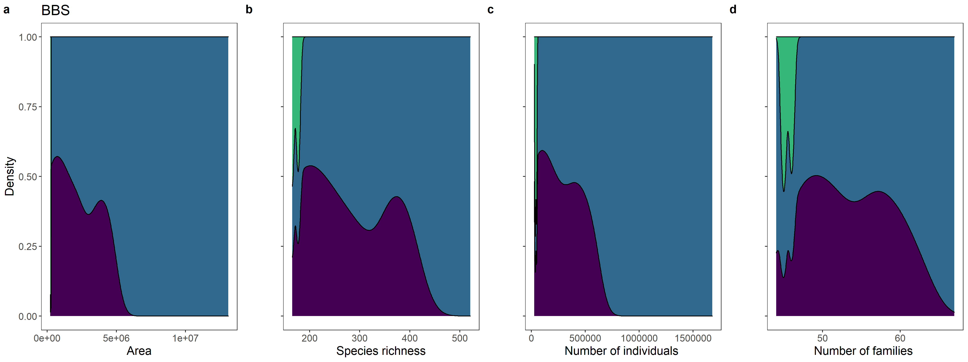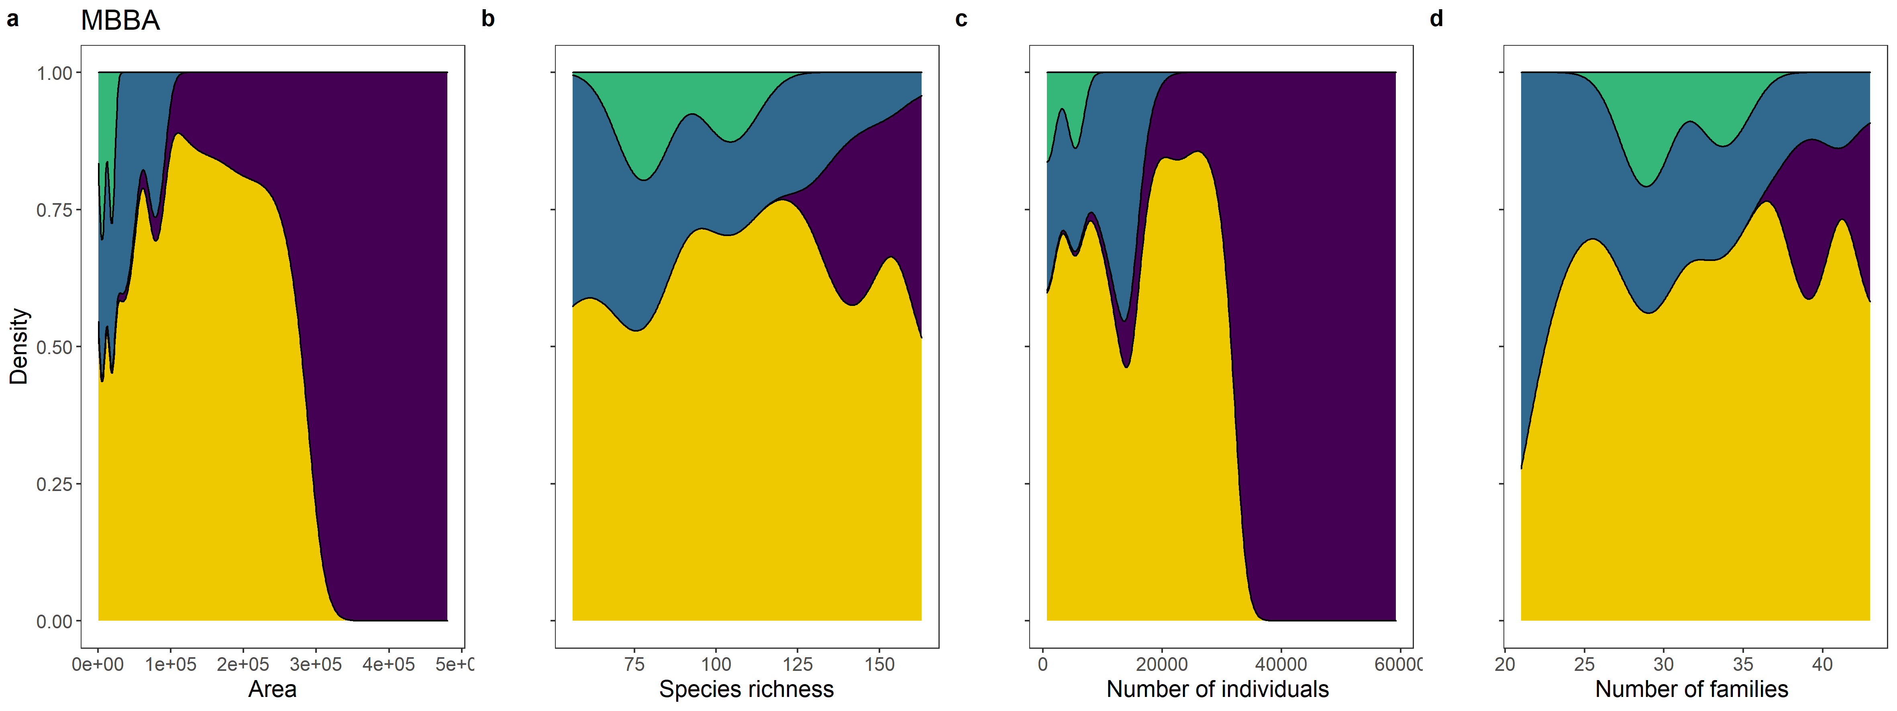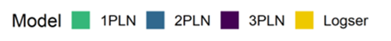

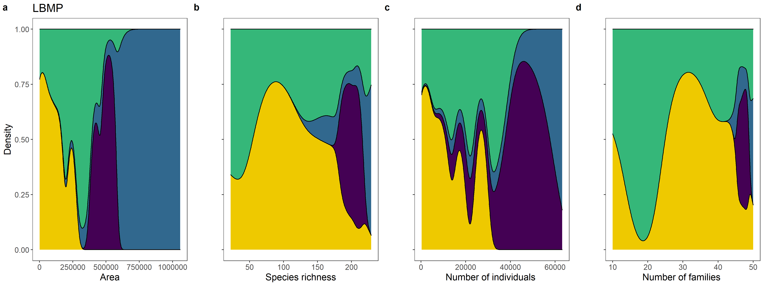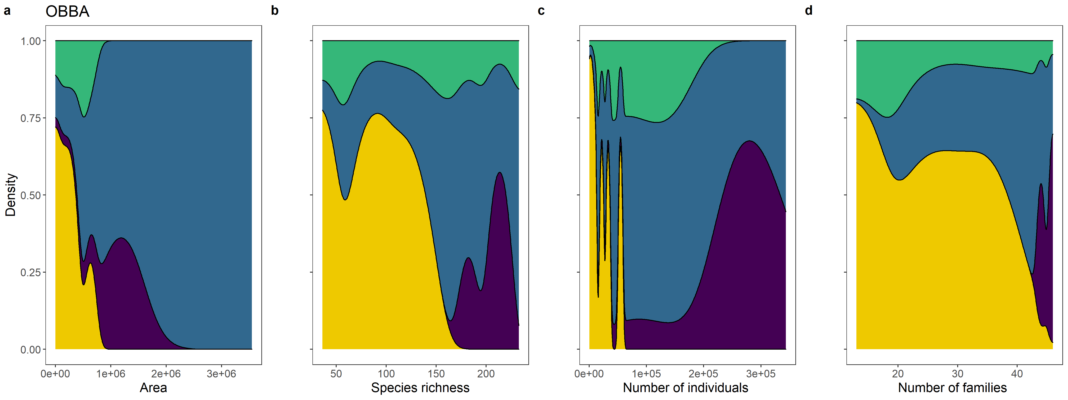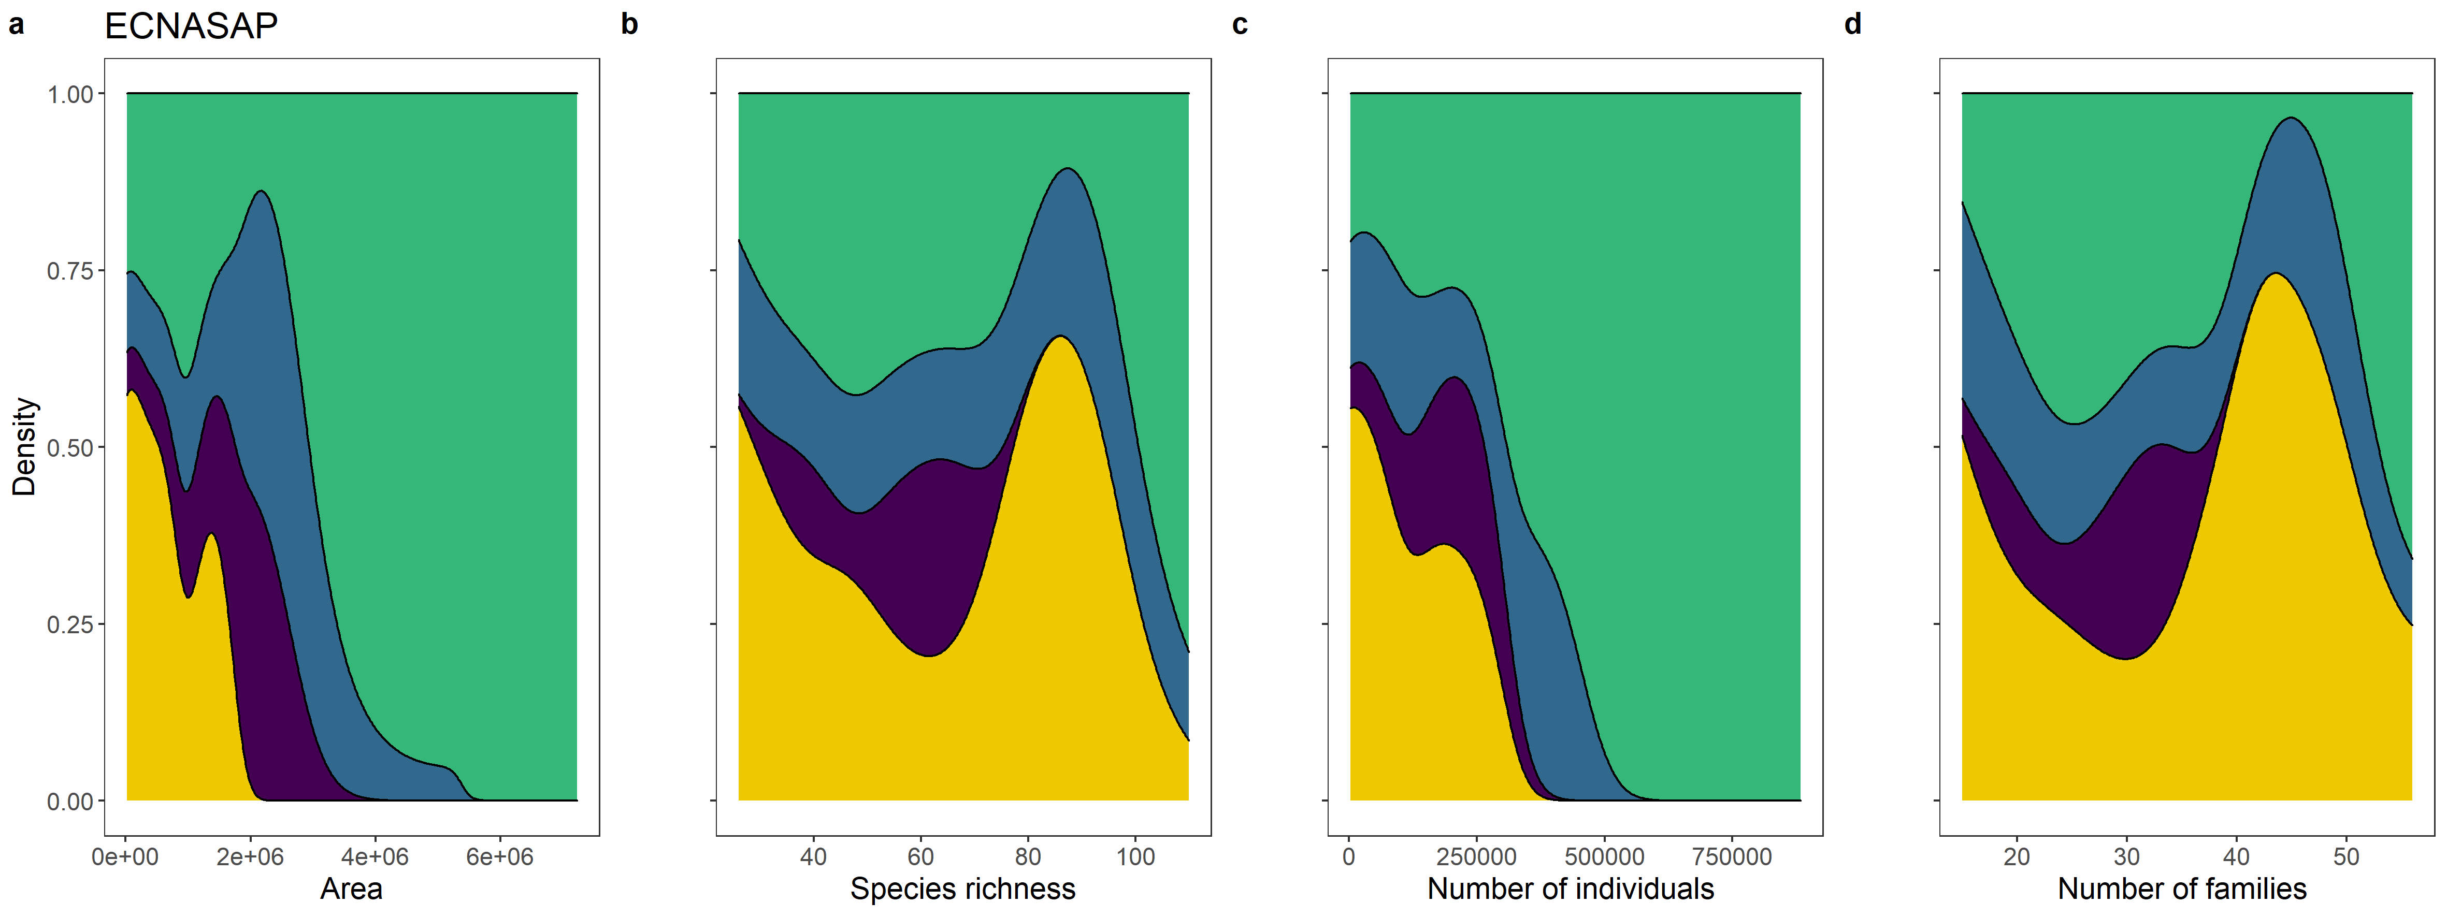

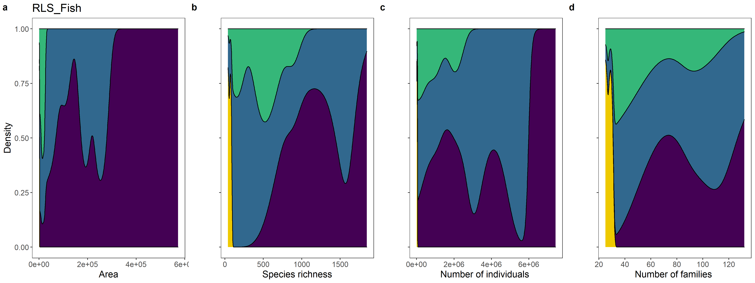
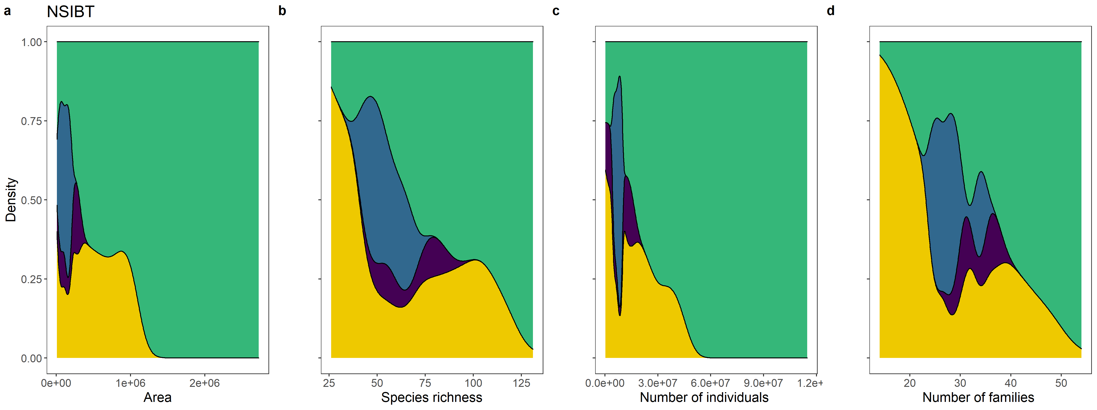
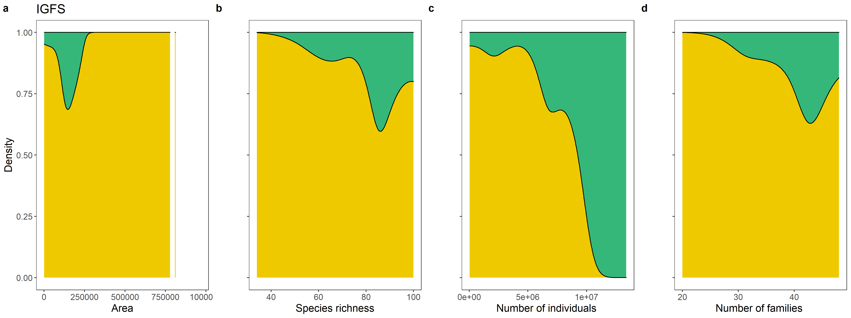

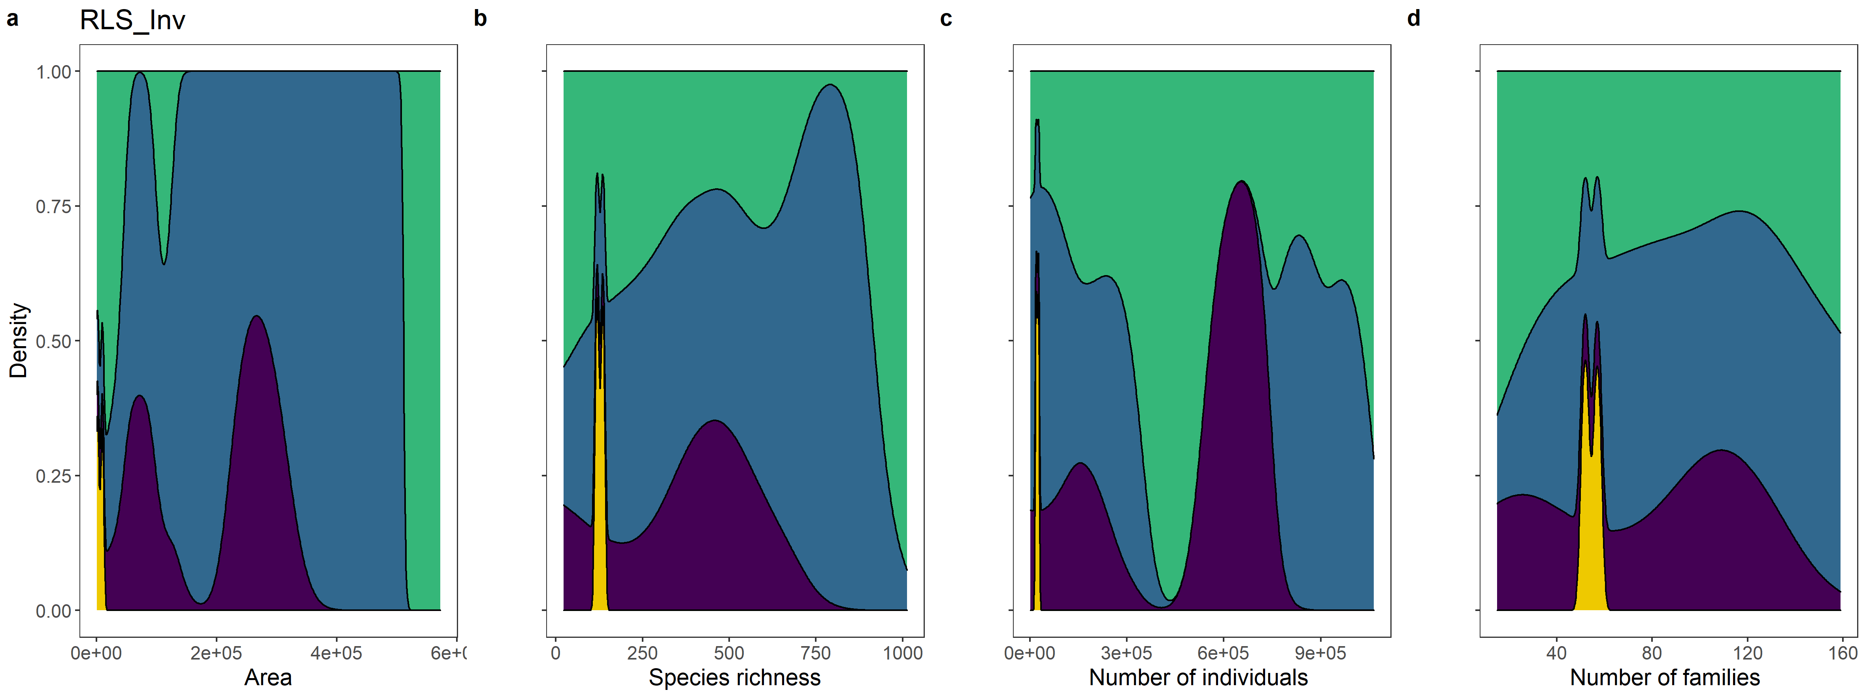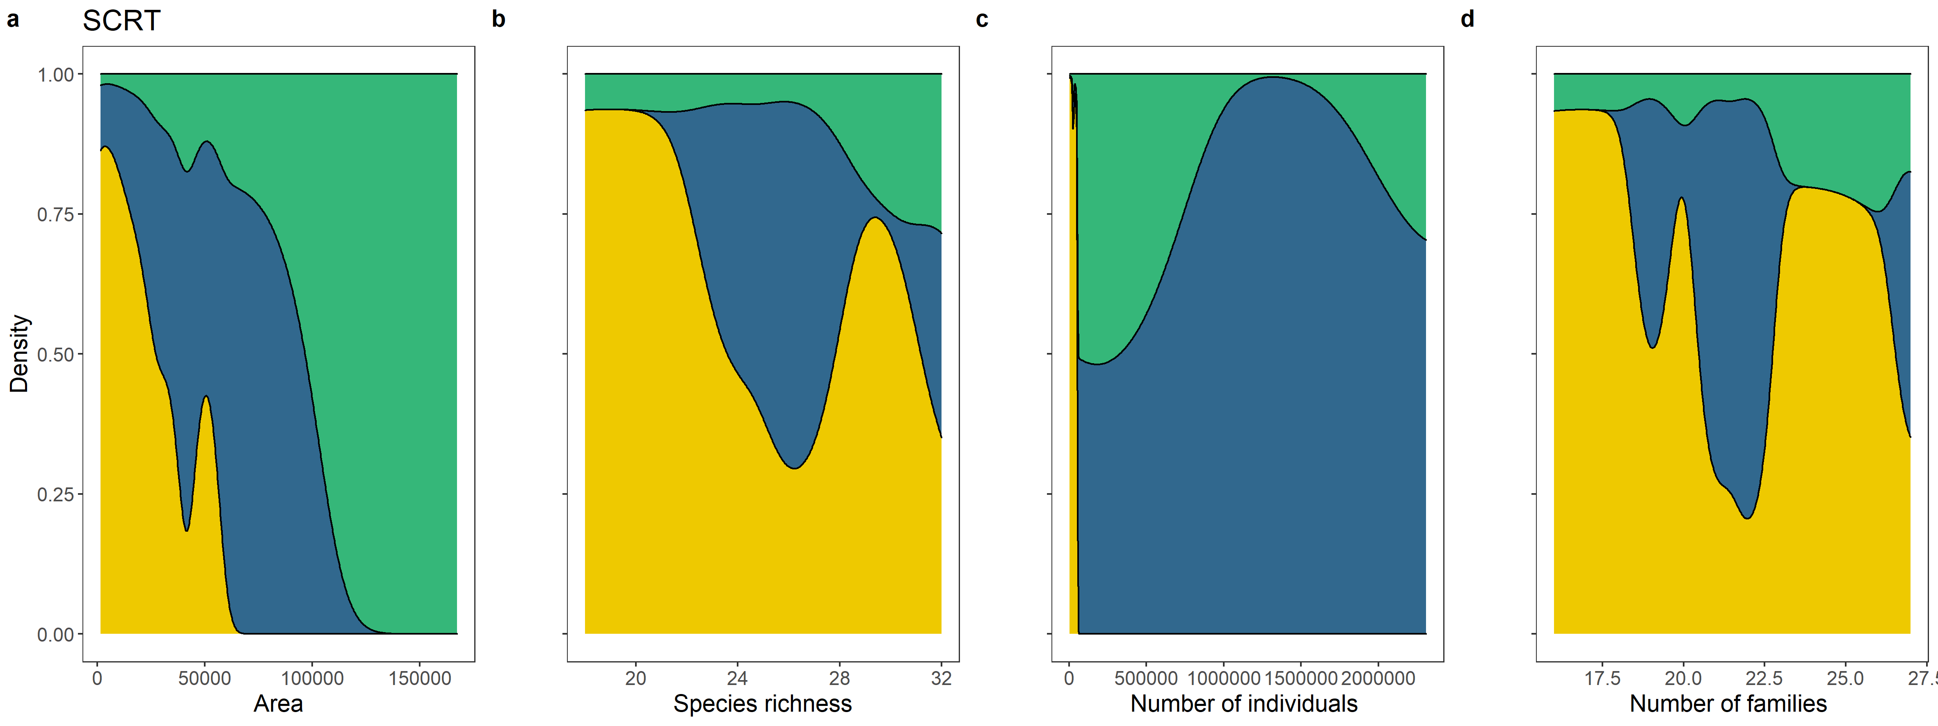

Figure S2. Comparison of the mean empirical SADs and the mean fitted models for each level of the scale gradient; each community is identified by the corresponding acronym at the top of each panel (each dataset is shown per page).
Left panel – Empirical SADs plotted with bins representing true doubling classes of abundance, i.e. octaves (Gray et al., 2006). The y-axis shows the number of species and the x-axis the species abundance in log2 classes (the first octave represents species with abundance 1, the second one species with abundances 2-3, then 4-7, 8-15, etc). Lines show the best-fit parameterization for the four different models fitted to each SAD.
Right panel – Deviation between the empirical SADs and the best-fit parameterization of each alternative model, calculated as the difference between the proportion of species observed and predicted by each model for each octave of abundance. In both plots, 1PLN is shown in blue, 2PLN in green, 3PLN in orange, and logseries in red.

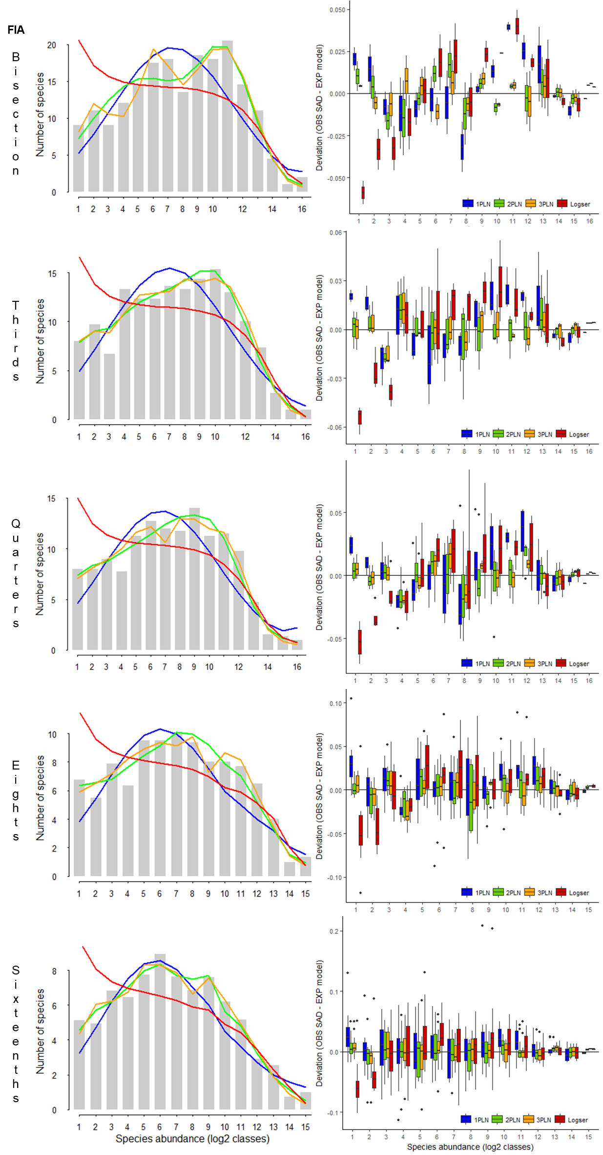

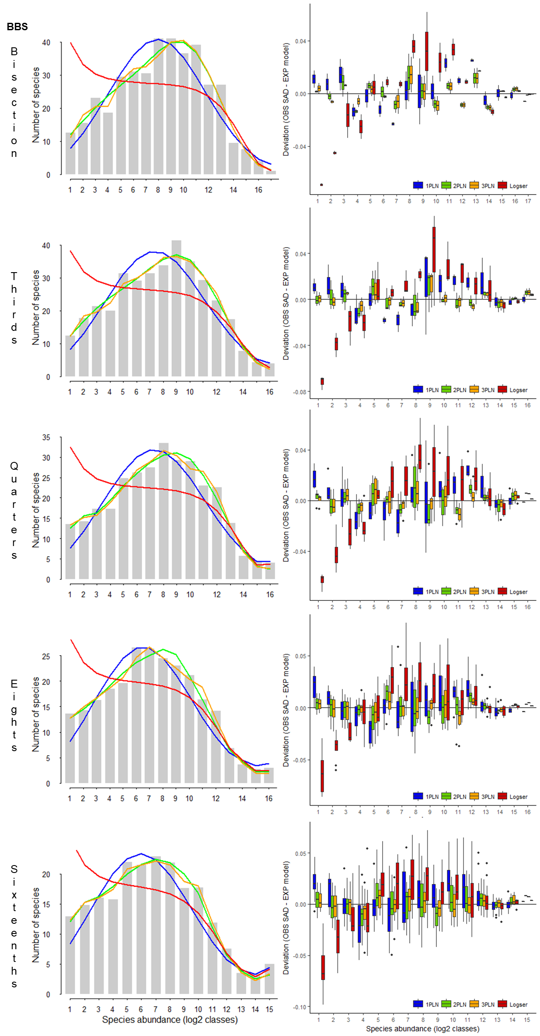

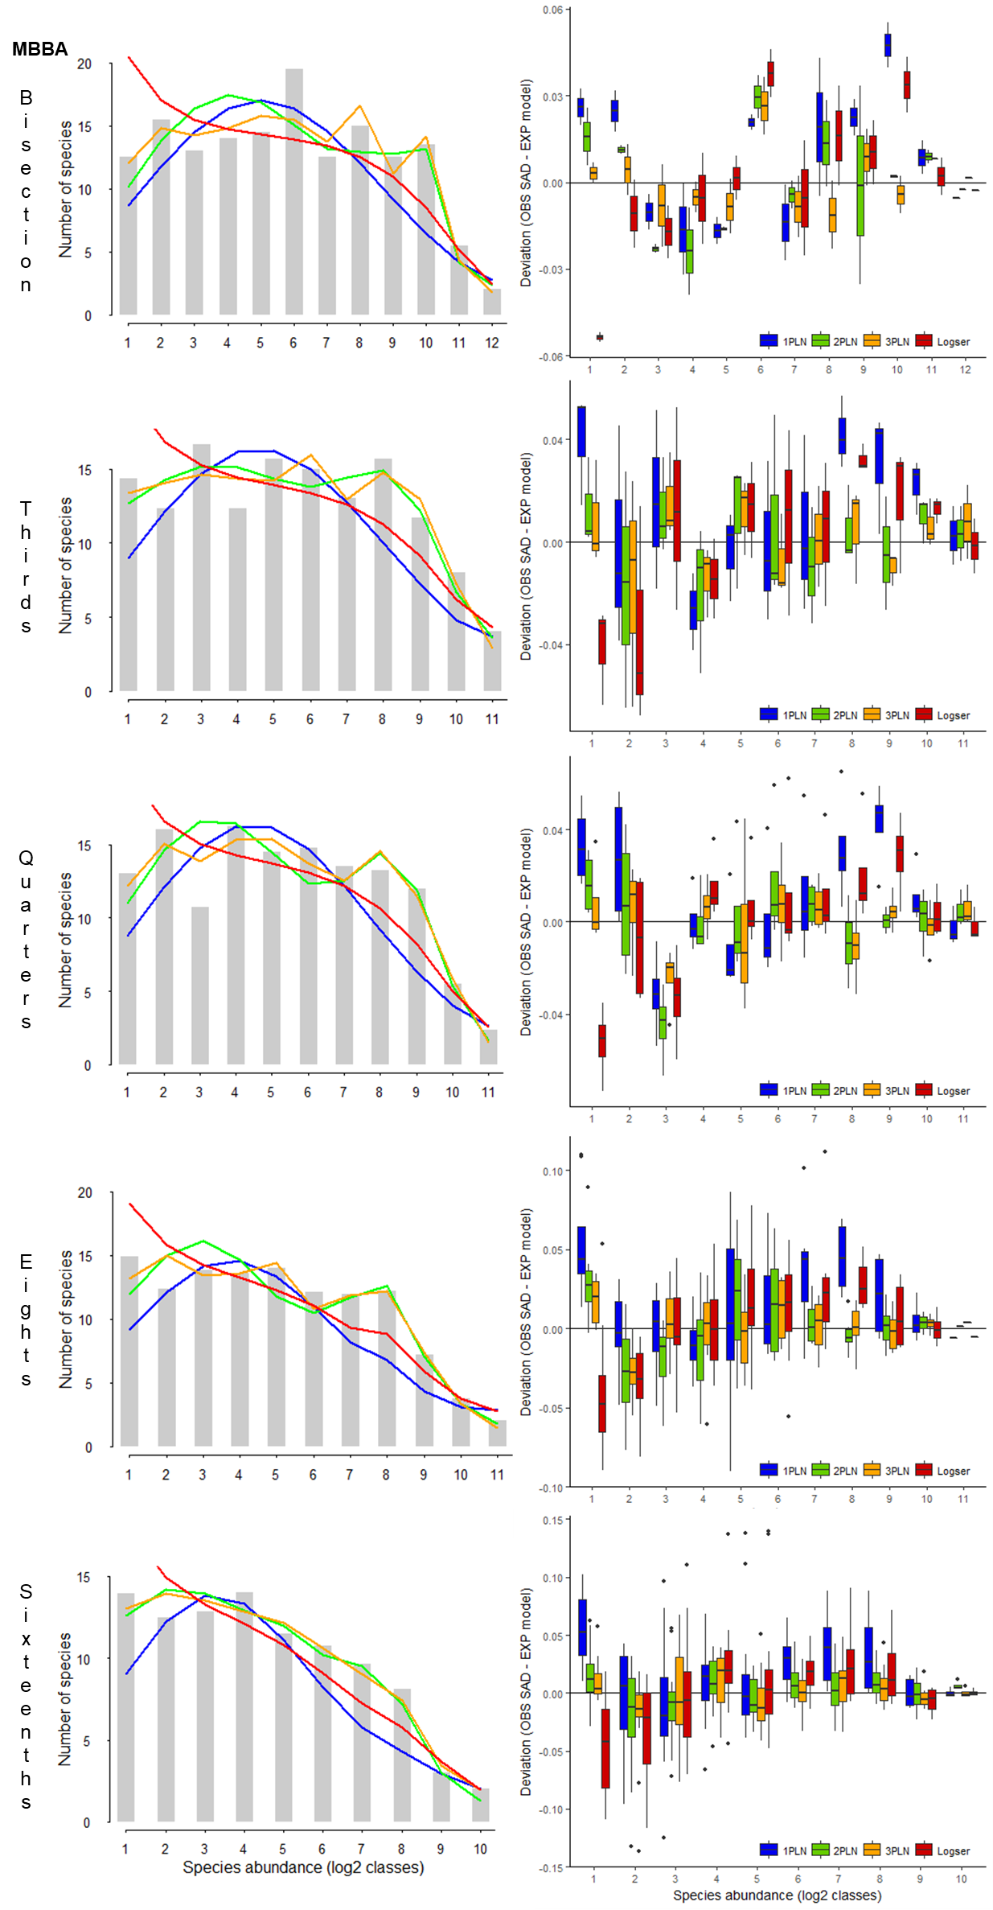

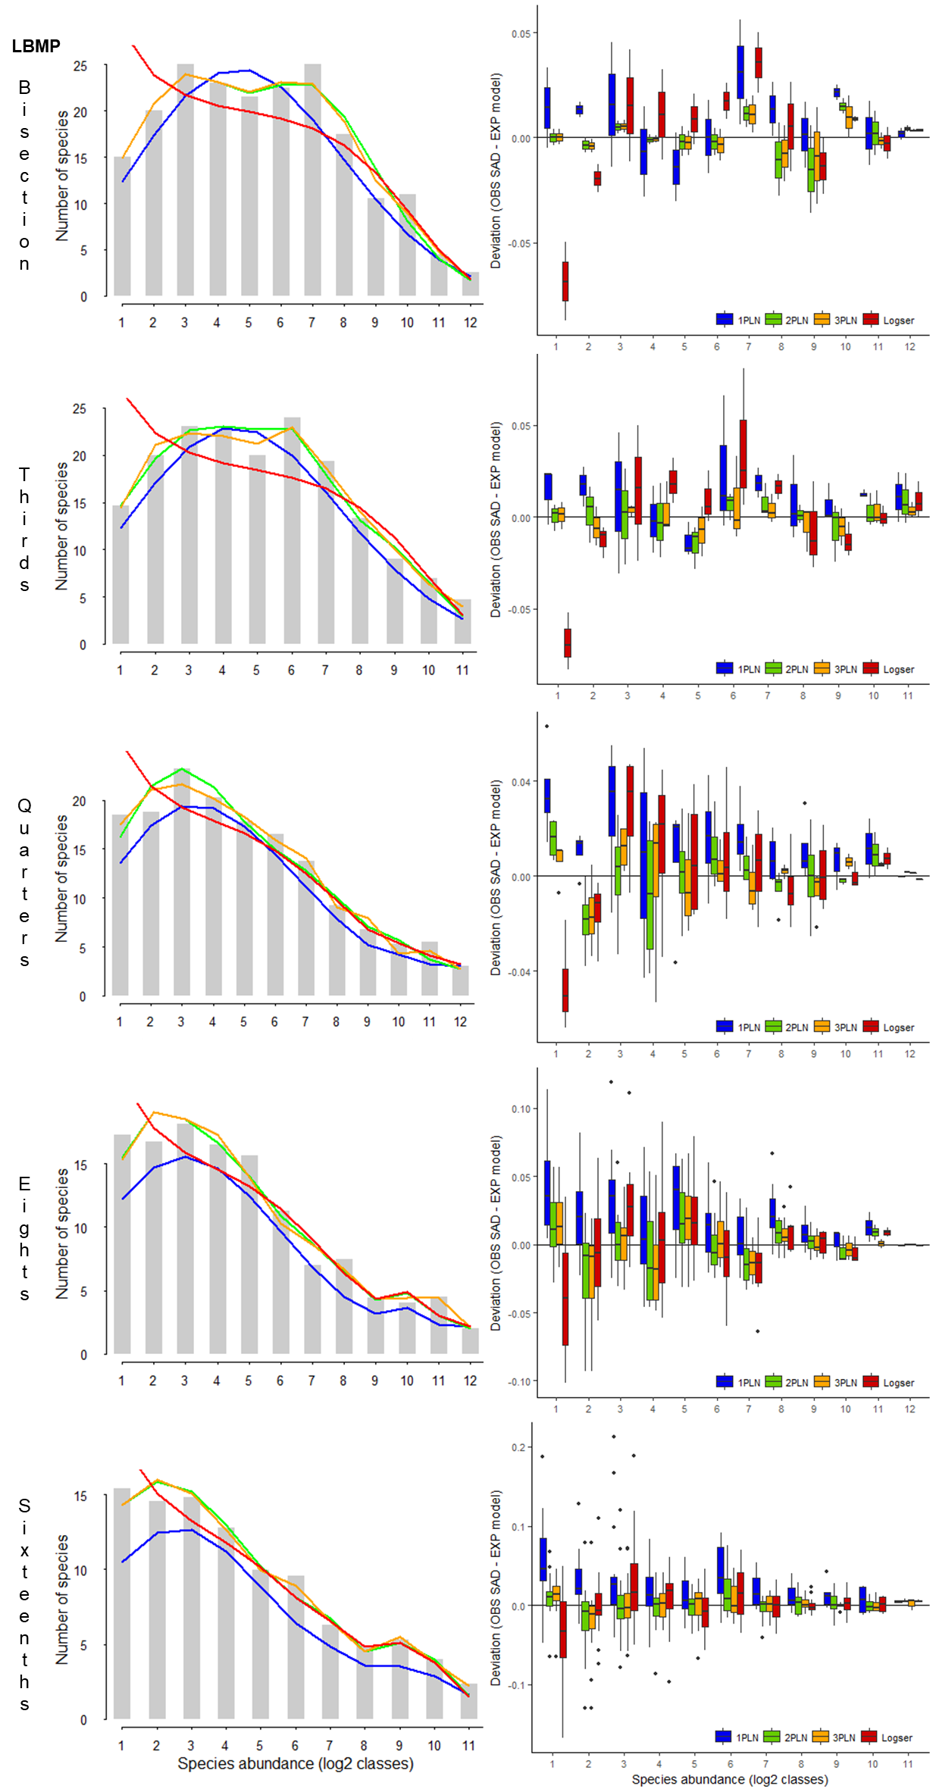

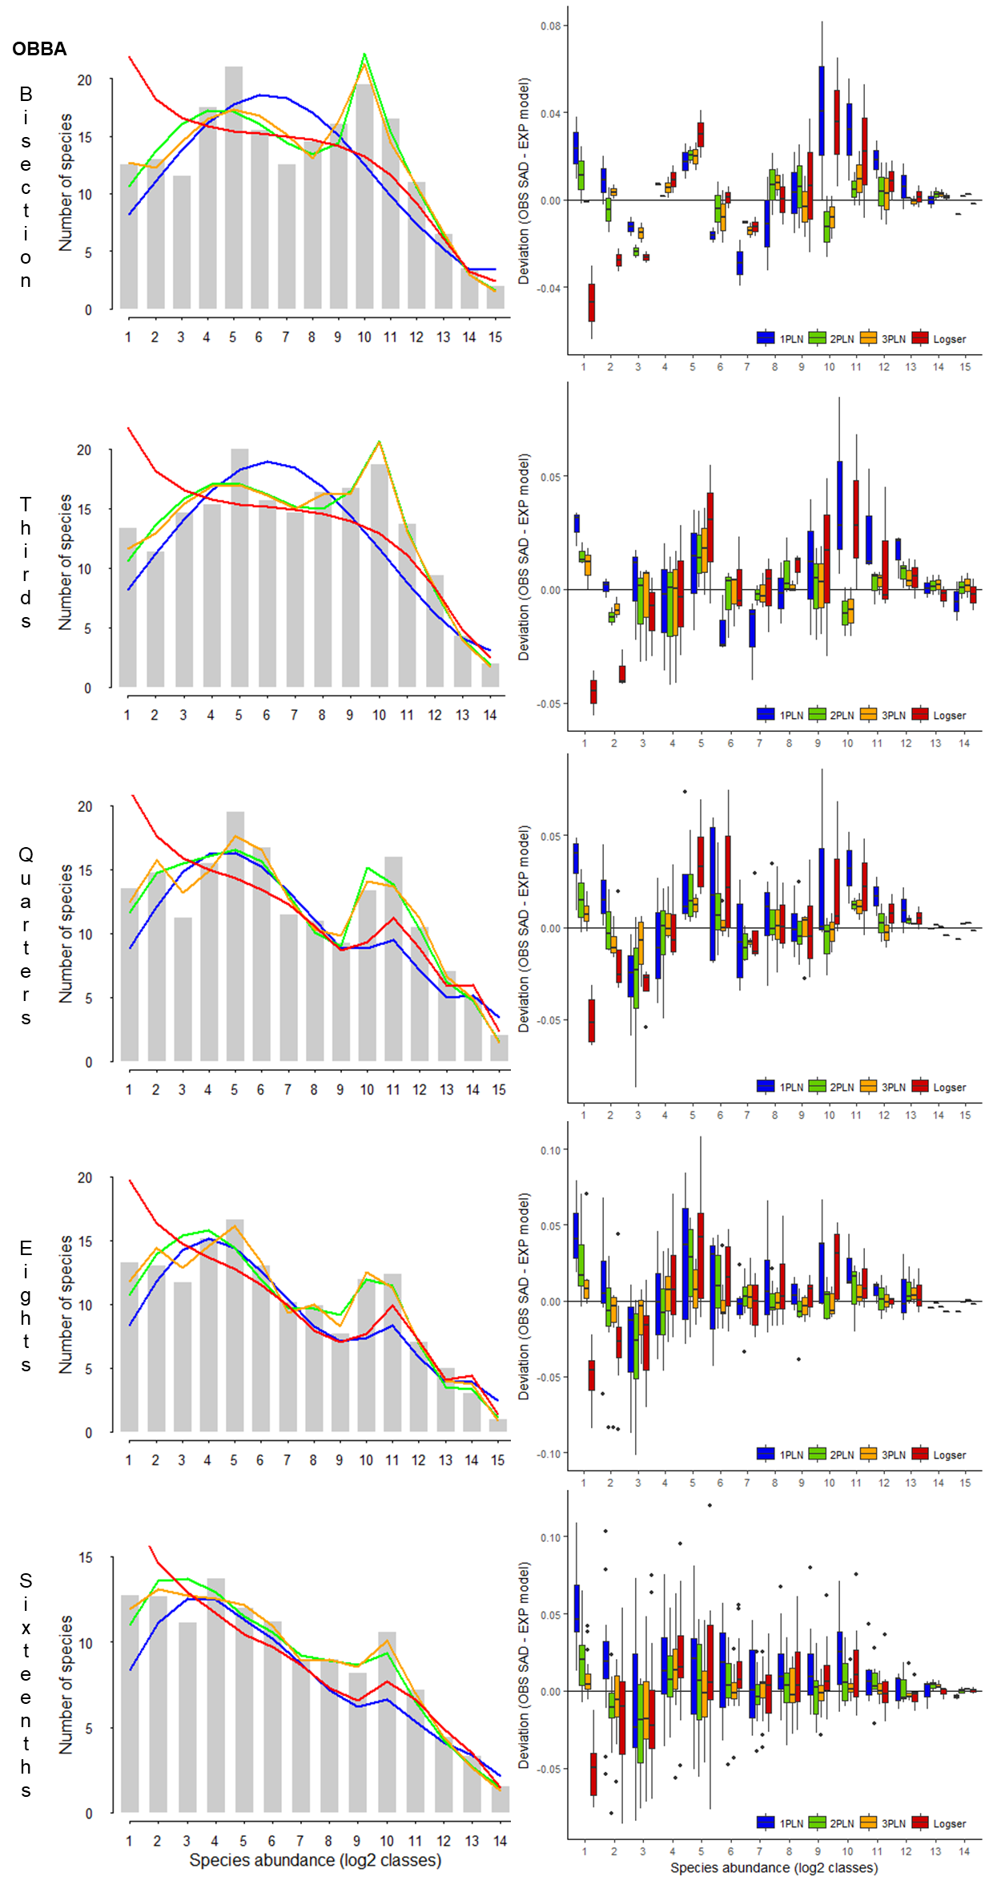

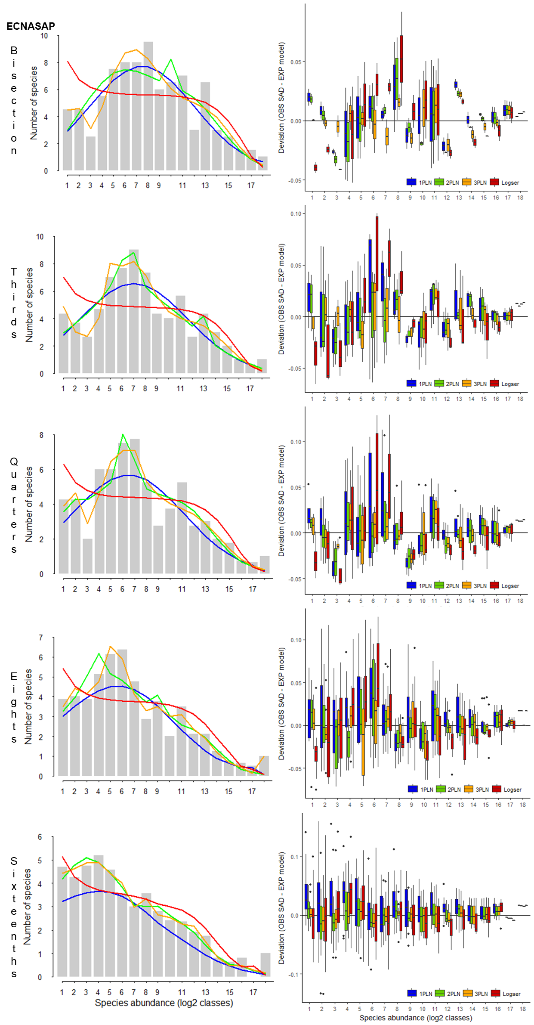

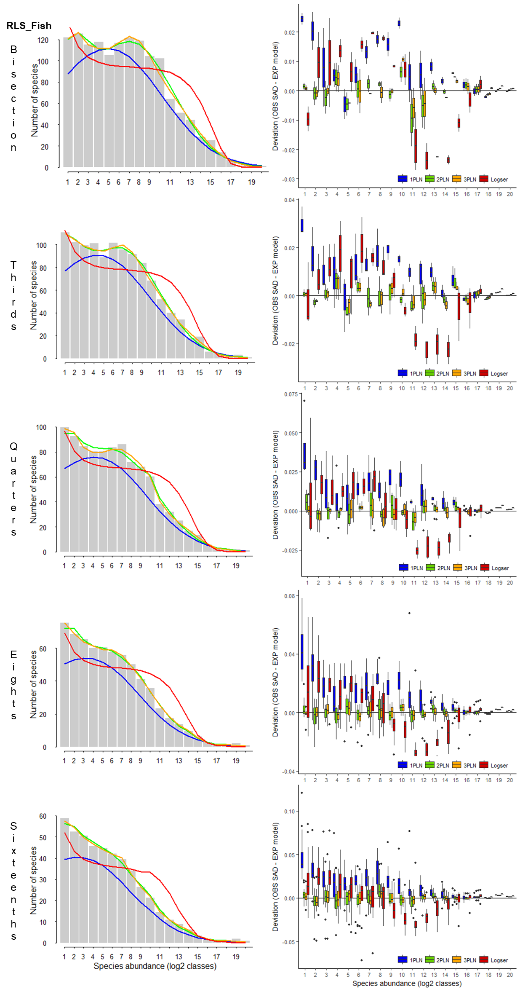

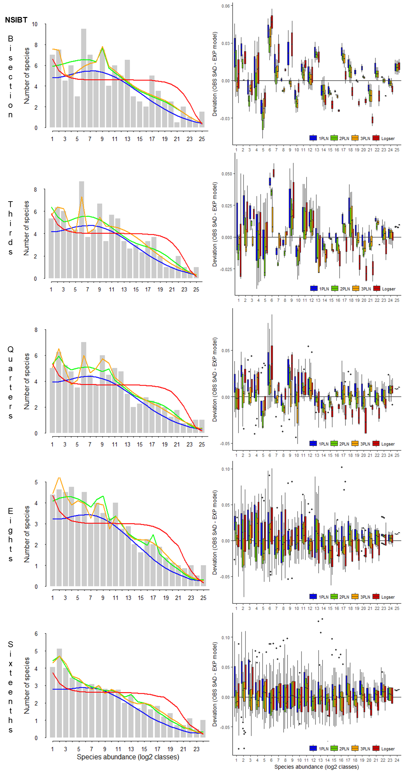

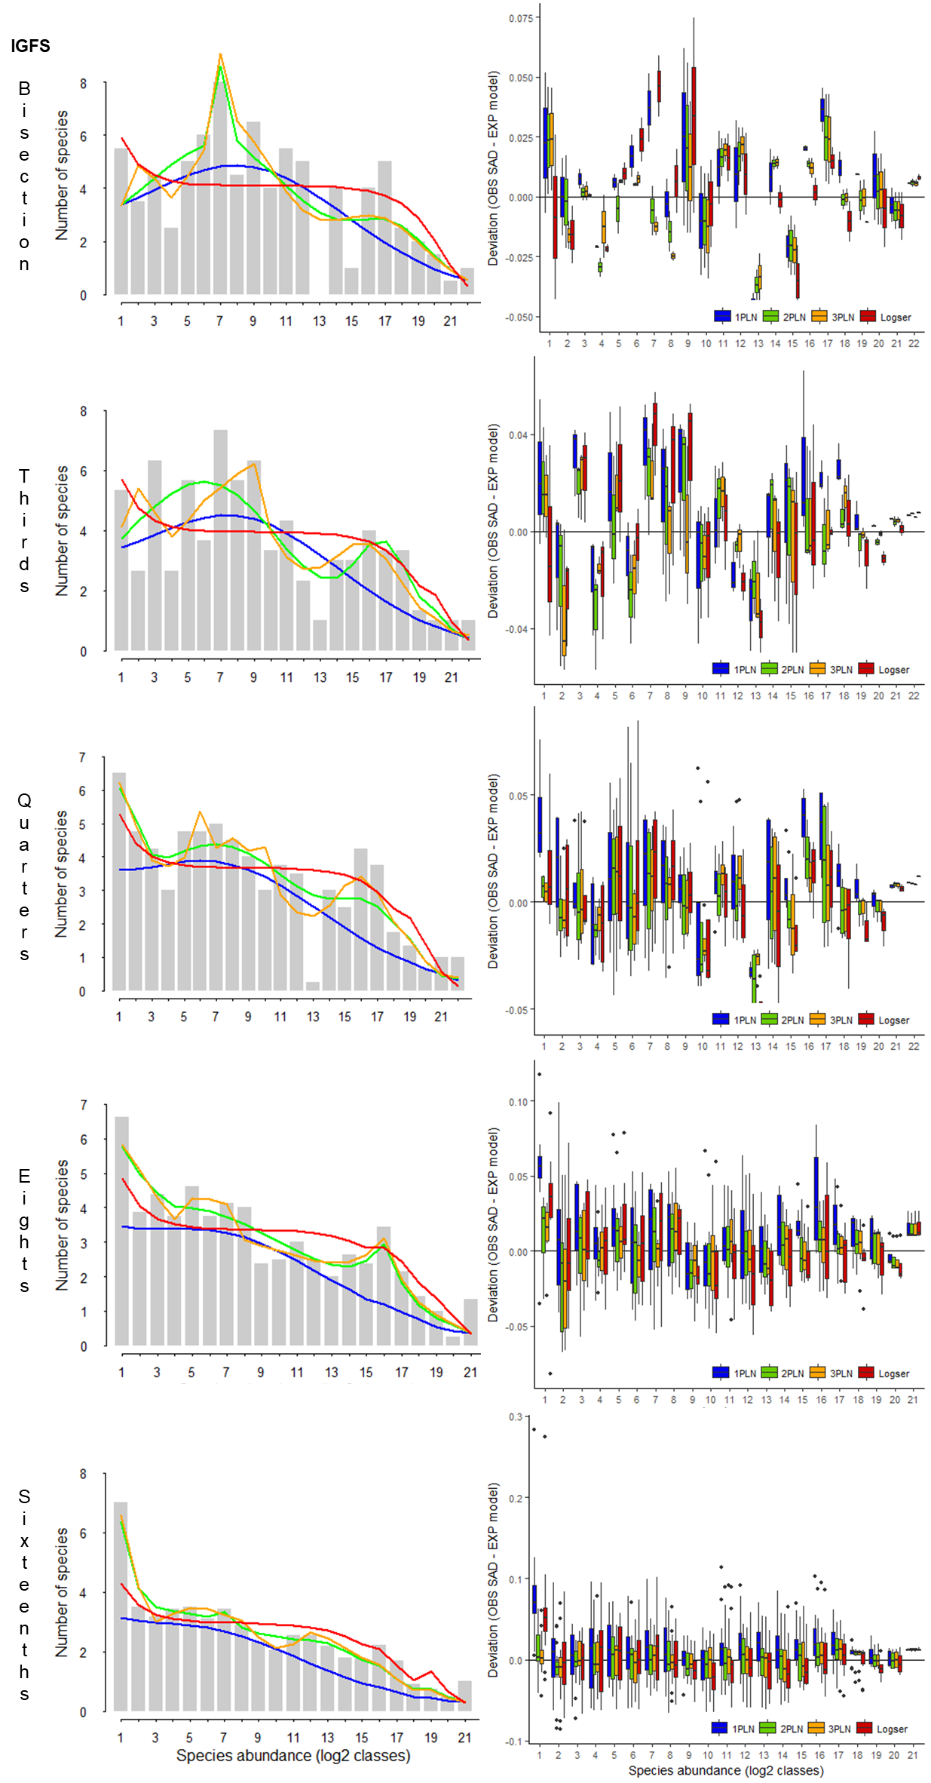

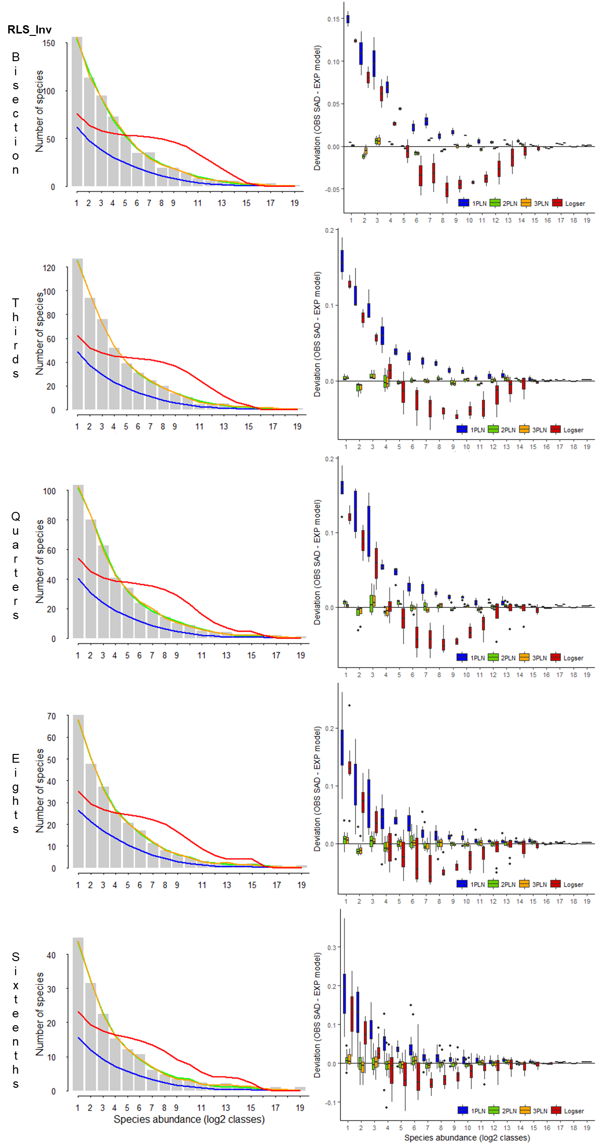

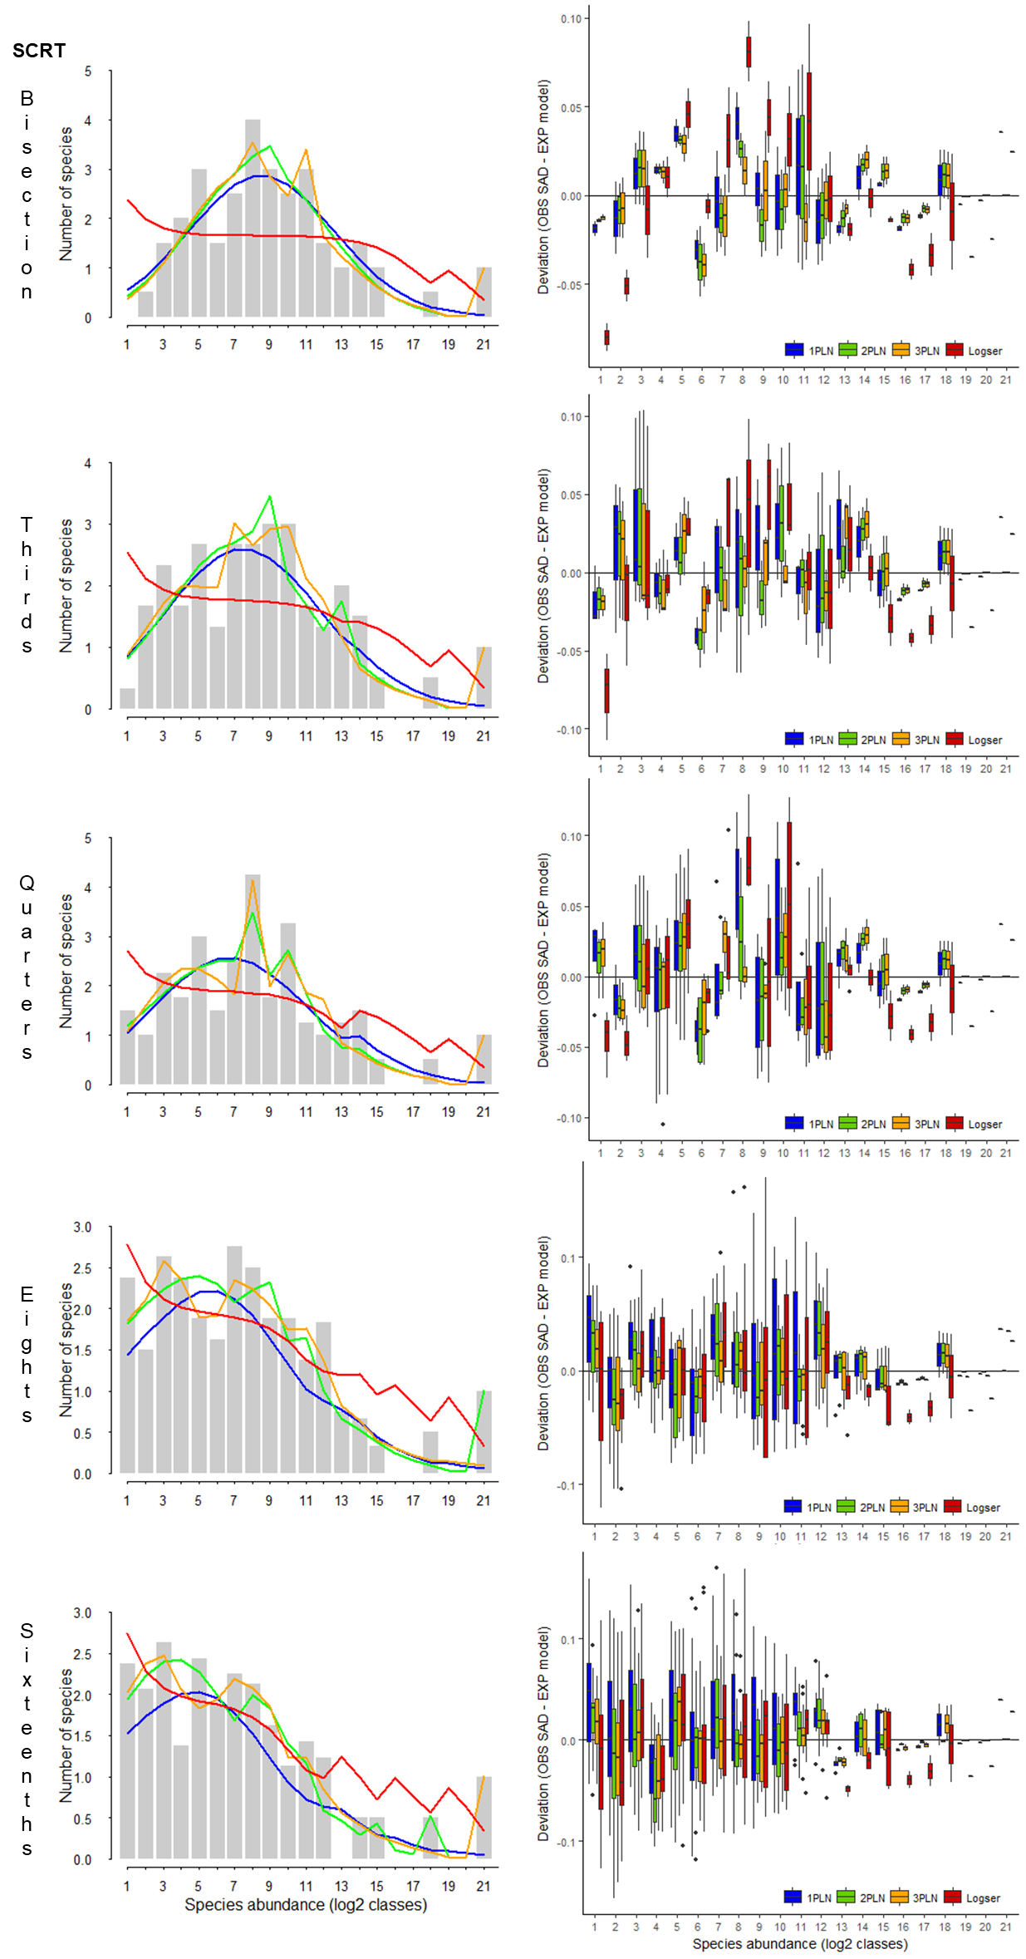

References
Gray, J. S., Bjørgesæter, A., and Ugland, K. I. (2006). On plotting species abundance distributions. J. Anim. Ecol. 75, 752–756. doi:10.1111/j.1365-2656.2006.01095.x.
Wickham, H. (2009). ggplot2: Elegant Graphics for Data Analysis. New York: Springer-Verlag New York.

