Supplementary Material

## Supplementary Figures

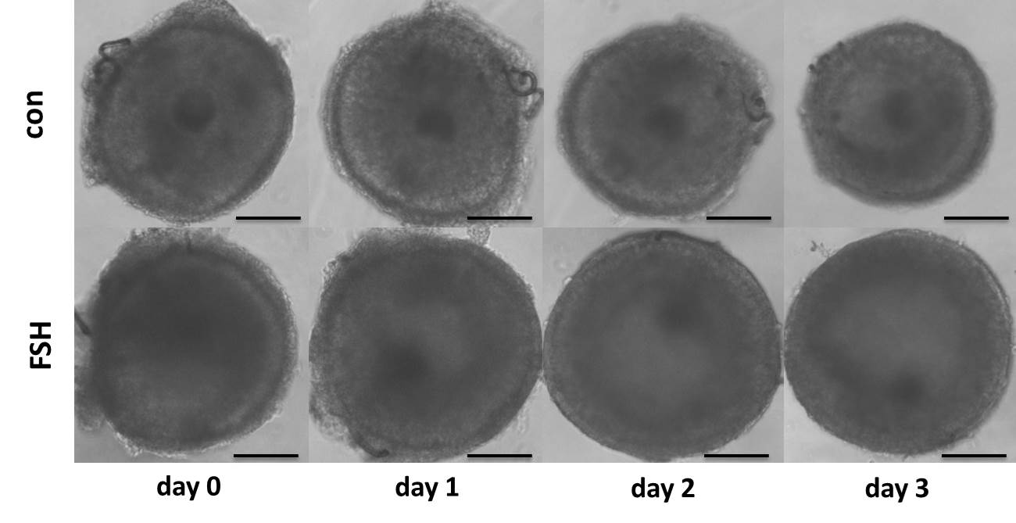

**Figure S1. Representative photomicrographs of porcine follicles before and after culture**

Porcine follicles were cultured in DMEM/F12 medium containing 0.01 IU/mL FSH for 24 h, 48 h, and 72 h (Bars, 100 μm).

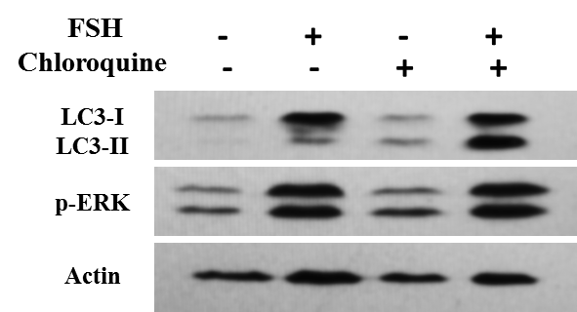

**Figure S2. FSH can potentiate autophagy flux in porcine primary granulosa cells**

Porcine primary granulosa cells were cultured in DMEM/F12 medium containing 0.01 IU/mL FSH for 18 h and then chloroquine (10 μM) was added for a further 6 h. LC3-II levels were detected by western blotting.