Supplementary information

**Accounting and management of natural resource consumption based on Input-output method: A global bibliometric analysis**

Siyun Wang1, Xu Tang1,2 *, Baosheng Zhang1, Wenhuan Wang3

1.School of Economics and Management, China University of Petroleum-Beijing, Beijing, China

2.Research Center for China's Oil and Gas Industry Development, China University of Petroleum-Beijing, Beijing, China

3.School of Public Administration, Zhejiang University of Technology, Hangzhou, China

* Corresponding author.

E-mail address: [tangxu@cup.edu.cn](mailto:tangxu@cup.edu.cn)

**Table A. Top 15 most highly cited articles.**

|  |  |  |  |  |  |  |
| --- | --- | --- | --- | --- | --- | --- |
| Article | Author(s) | Journal | Country | TC | Year | TC/Y |
| Growth in emission transfers via international trade from 1990 to 2008[1] | Peters, G.; Minx, J.; Weber, C.L.; Edenhofer, O. | PNAS | Norway | 655 | 2011 | 65.5 |
| The material footprint of nations[2] | Wiedmann, T.O.; Schandl, H.; Lenzen, M.; Moran, D.; Suh, S.; West, J.; Kanemoto, K. | PNAS | Australia | 468 | 2013 | 58.5 |
| The drivers of Chinese CO2 emissions from 1980 to 2030[3] | Guan, D.B.; Hubacek, K.; Weber, C.L.; Peters, G.P.; Reiner, D.M. | Global Environmental Change | China | 363 | 2008 | 27.9 |
| Mapping the Structure of the World Economy[4] | Lenzeiy, M.; Kanemoto, K.; Moran, D.; Geschke, A. | Environmental Science & Technology | Australia | 358 | 2012 | 39.8 |
| Life cycle GHG emission analysis of power generation systems: Japanese case[5] | Hondo, H. | Energy | Japan | 318 | 2005 | 19.9 |
| Affluence drives the global displacement of land use[6] | Weinzettel, J.; Hertwich, E.G.; Peters, G.P.; Steen-Olsen, K.; Galli, A. | Global Environmental Change | Norway | 287 | 2013 | 35.9 |
| The carbon footprint of UK households 1990-2004: A socio-economically disaggregated, quasi-multi-regional input-output model[7] | Druckman, A.; Jackson, T. | Ecological Economics | England | 283 | 2009 | 23.6 |
| Quantifying the global and distributional aspects of American household carbon footprint[8] | Weber, C.L.; Matthews, H.S. | Ecological Economics | USA | 267 | 2008 | 20.5 |
| Energy input-output analysis in Turkish agriculture[9] | Ozkan, B.; Akcaoz, H.; Fert, C. | Renewable Energy | Turkey | 251 | 2004 | 14.8 |
| A modified ecological footprint method and its application to Australia[10] | Lenzen, M.; Murray, S.A. | Ecological Economics | Australia | 242 | 2001 | 12.1 |
| Energy and carbon embodied in the international trade of Brazil: an input-output approach[11] | Machado, G; Schaeffer, R; Worrell, E | Ecological Economics | Brazil | 241 | 2006 | 16.1 |
| Environment impacts of products - A detailed review of studies[12] | Tukker, Arnold; Jansen, Bart | Journal of Industrial Ecology | Netherlands | 237 | 2011 | 23.7 |
| Methodology and Indicators of Economy-wide Material Flow Accounting[13] | Fischer-Kowalski, M.; Krausmann, F.; Giljum, S.; Lutter, S.; Mayer, A.; Bringezu, S.; Moriguchi, Y.; Schuetz, H.; Schandl, H.; Weisz. | Journal of Industrial Ecology | Austria | 234 | 2008 | 18.0 |
| Normalization in product life cycle assessment: An LCA of the global and European economic systems in the year 2000[14] | Sleeswijk, Anneke Wegener; van Oers, Lauran F. C. M.; Guinee, Jeroen B.; Struijs, Jaap; Huijbregts, Mark A. J. | Science of the Total Environment | Netherlands | 234 | 2016 | 46.8 |
| Consumption-based emission accounting for Chinese cities[15] | Mi, Zhifu; Zhang, Yunkun; Guan, Dabo; Shan, Yuli; Liu, Zhu; Cong, Ronggang; Yuan, Xiao-Chen; Wei, Yi-Ming | Applied Energy | China | 232 | 2006 | 15.5 |

Year: publication year; Country: the country of the first author; TC: total citation; TC/Y: annual citations.

**Table B. Research topic and lead papers of each cluster**

|  |  |  |  |  |
| --- | --- | --- | --- | --- |
| Cluster# | No. of Paper | Area of Research Focus | Average Publication Year | Lead Paper in Terms of Total Link Strength |
| 1 | 51 | embodied energy; CO2 emission; countries; households | 2007 | Guan et al. (2008)[3]; Hondo (2005)[5]; Druckman and Jackson (2009)[7]; Lenzen and Murray (2001)[10]; Machado et al. (2001)[11] |
| 2 | 43 | Material consumption; MRIO; sustainable resource management; international supply chain; cities; database | 2014 | Wiedmann et al. (2013)[2]; Lenzeiy et al. (2012)[4]; Weinzettel et al. (2013)[6]; Mi et al. (2016)[15]; Wood et al. (2015)[16] |
| 3 | 34 | Environmental impact; LCA; circular economy; MRIO; hybrid LCA | 2010 | Tukker and Jansen (2006)[12]; Genovese et al. (2017)[17]; Wiedmann et al. (2011)[18]; Nassen et al. (2007)[19]; Crawford (2008)[20] |
| 4 | 30 | International trade; inter-regional trade; emission transfer; structural decomposition analysis; China | 2013 | Peters et al. (2011)[1]; Su and Ang (2014)[21]; Guan et al. (2014)[22]; Lin and Sun (2010)[23]; Su and Ang (2013)[24] |
| 5 | 25 | Household; consumer behavior; CO2 footprint; international trade; geographic distribution | 2009 | Weber et al. (2008)[8]; Weber et al. (2007)[25]; Baiocchi et al. (2010)[26]; Pachauri and Spreng (2002)[27]; Liu et al. (2011)[28] |
| 6 | 17 | Greenhouse gas emission; material; natural resources; final consumption; international trade | 2011 | Chen and Zhang (2010)[29]; Chen and Chen (2010)[30]; Bruckner et al. (2012)[31]; Chen et al. (2010)[32]; Chen and Chen (2011)[33] |
| 7 | 4 | Rebound; energy efficiency; | 2012 | Hanley et al. (2009)[34]; Thomas and Azevedo (2013)[35]; Wiebe et al. (2012)[36] |
| 8 | 3 | Interdependencies; CGE; GIS | 2009 | Zhang and Peeta (2011)[37]; Irwin et al. (2010)[38]; Van der Veen and Logtmeijer (2005)[39] |

**The performances of institutions and authors**

Over the past 20 years, 4015 scholars from 1278 institutions have made outstanding contributions to the field. In this paper, 90 institutions with no less than 10 publications and 209 authors with no less than 5 publications were analyzed deeply. The results are shown in Figure C, Figure D, Table E and Table F.

From the perspective of institutions, half of the top 10 cited institutions is from China, while the rest are from Australia, UK, Norway, and the USA, although the average publication year of China is relatively late. The University of Sydney (64 articles, 3917 citations), the Chinese Academy of Sciences (156 articles, 3695 citations) and Peking University (112 articles, 3393 citations) ranked top three among 90 institutions in terms of citation frequency. Beijing Normal University (165 articles, 3087 citations) ranked first in terms of publication volume. Carnegie Mellon University (17 articles,2054 citations), the University of York (10 articles,1025 citations) and the Norwegian University of Science and Technology (32 articles,2472 citations) rank among the top in the world with 120.82 citations per article, 102.50, and 77.25 citations per article, respectively, occupying a key position in this field. Thus, the main research strength in this field can be found from the number of citations, the number of publications and the number of citations per article.

Authors with more citations and publications can be defined as core authors in this field. It can be seen from Table E that 40% of the top 20 core authors are composed of Chinese scholars. This demonstrates once again that China occupies a high academic position in this field from both quantitatively and qualitatively, and contributes a great deal to the advancement of this field. From the perspective of publication volume, Pro. Chen B. from Beijing Normal University (44 articles, 1320 citations), Pro. Chen G.Q. from Peking University (42 articles, 2188 citations) and Pro. Liang S. from Beijing Normal University (40 articles, 893 citations) are the top three scholars. Pro. Guan D.B. from the University of Cambridge (40 articles, 2936 citations) and Pro. Hubacek, K. from the University of Maryland (39 articles, 2825 citations) and Pro. Lenzen, M. from the University of Sydney (32 articles, 2371 citations) were in the top three in terms of cumulative citations. Pro. Weber, CI. (7 articles,1461 citations) from the World Wildlife Fund, Pro. Peters, GP., (9 articles, 1826 citations) and Pro. Moran, D. (8 articles,1120 citations) of Norwegian University of Science and Technology, with fewer than 10 articles, but rank among the top three in the field in terms of the average number of citations per article.

Researchers actively communicate with each other based on inter-institutional cooperation, and gradually form close cooperation partners both at home and abroad. Pro. Feng, KS., and Pro. Hubacek, K., from the University of Maryland, for example, have jointly published 23 articles. Pro. Peters, GP., and Pro. Ang, BW., from the National University of Singapore, co-authored 10 articles. Pro. Wood, R., and Pro. Hertwich, EG., of the Norwegian University of Science and Technology, published 7 articles in total. Pro. Guan, DB. Of the University of Cambridge and Pro. Meng, J., from the University of London, United Kingdom, jointly published 15 articles. Pro. Tukker, A., from Leiden University, and Pro. Wood, R., from the Norwegian University of Science and Technology, have co-authored 10 articles. Pro. Liang, S., from Beijing Normal University, and Pro. Xu, M., from the University of Michigan, have jointly published 16 articles.

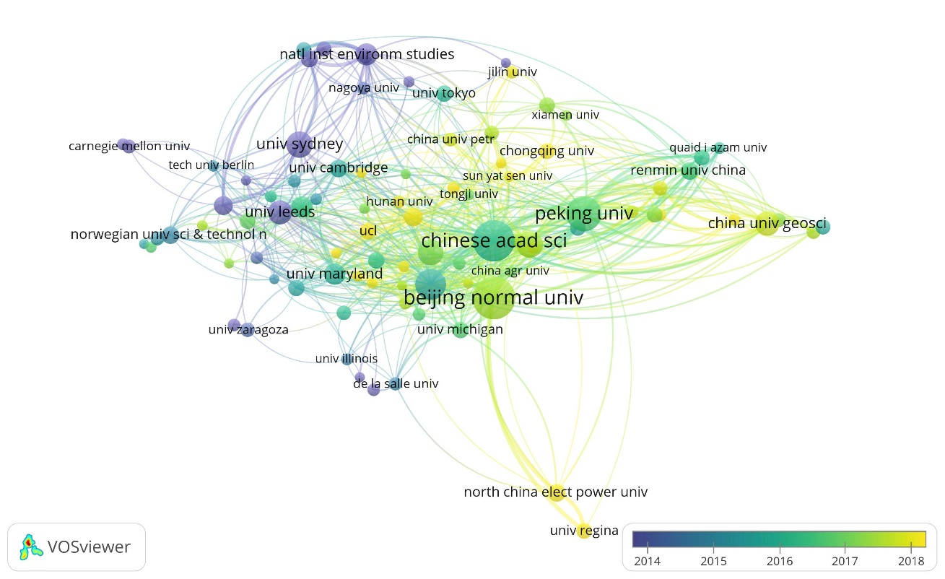

Figure C. Institutions’ collaboration.

Note: The color bar represents the average year of publication of national articles.

Table D. The top 10 institutions or institutions in terms of cumulative citations.

|  |  |  |  |
| --- | --- | --- | --- |
| Institution, Country | TP (%) | TC (%) | TC/TP |
| University of Sydney, Australia | 64(2.86%) | 3917(5.99%) | 61.20 |
| China Academy of Sciences, China | 156(6.97%) | 3695(5.56%) | 23.69 |
| Peking University, China | 112(5.00%) | 3393(5.19%) | 30.29 |
| University of Leeds, UK | 52(2.32%) | 3199(4.89%) | 61.52 |
| Beijing Normal University, China | 165(7.37%) | 3087(4.72%) | 18.71 |
| Norwegian University of Science and Technology, Norway | 32(1.43%) | 2472(3.78%) | 77.25 |
| Tsinghua University, China | 87(3.89%) | 2279(3.48%) | 26.20 |
| Carnegie Mellon University, USA | 17(0.76%) | 2054(3.14%) | 120.82 |
| University of Maryland, USA | 41(1.83%) | 2013(3.08%) | 49.10 |
| Beijing Institute of Technology, China | 59(2.64%) | 1950(2.98%) | 33.05 |

Note: TC/TP is the average number of citations per article, the same as below.

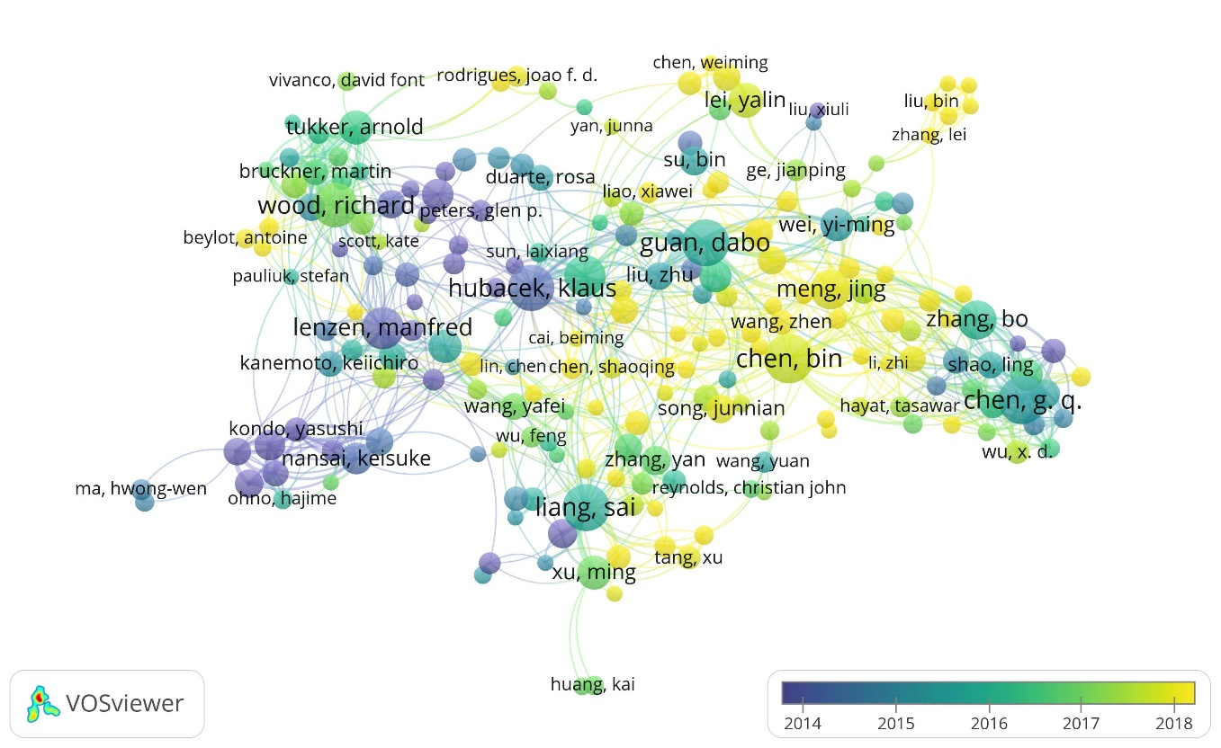

Figure E. Author collaboration.

Note: The color bar represents the average year of publication of national articles.

Table F. The top 20 authors in terms of cumulative citations.

|  |  |  |  |  |  |  |  |  |  |
| --- | --- | --- | --- | --- | --- | --- | --- | --- | --- |
| No. | Name | TP (%) | TC (%) | TC/TP | No. | Name | TP (%) | TC (%) | TC/TP |
| 1 | Guan, DB | 40(1.93%) | 2936(3.97%) | 73.40 | 11 | Chen, B. | 44(2.12%) | 1320(1.78%) | 30.00 |
| 2 | Hubacek, K. | 39(1.88%) | 2825(3.82%) | 72.44 | 12 | Ang, BW. | 11(0.53%) | 1317(1.78%) | 119.73 |
| 3 | Lenzen, M. | 32(1.54%) | 2371(3.20%) | 74.09 | 13 | Kanemoto, K. | 12(0.58%) | 1315(1.78%) | 109.58 |
| 4 | Chen, GQ. | 42(2.03%) | 2188(2.96%) | 52.10 | 14 | Weinzettel, J. | 15(0.72%) | 1192(1.61%) | 79.47 |
| 5 | Peters, GP. | 9(0.43%) | 1826(2.47%) | 202.89 | 15 | Tukker, A | 21(1.01%) | 1179(1.59%) | 56.14 |
| 6 | Liu, ZX. | 14(0.68%) | 1530(2.07%) | 109.29 | 16 | Hertwich, EG. | 18(0.87%) | 1169(1.58%) | 64.94 |
| 7 | Feng, KS. | 31(1.50%) | 1472(1.99%) | 47.48 | 17 | Moran, D. | 8(0.39%) | 1120(1.51%) | 140.00 |
| 8 | Weber, CI. | 7(0.34%) | 1461(1.97%) | 208.71 | 18 | Wiedmann, T. | 20(0.97%) | 1066(1.44%) | 53.30 |
| 9 | Wei, YM. | 20(0.97%) | 1454(1.96%) | 72.70 | 19 | Wood, R. | 36(1.74%) | 1064(1.44%) | 29.56 |
| 10 | Su, B. | 16(0.77%) | 1386(1.87%) | 86.63 | 20 | Meng, J. | 29(1.40%) | 975(1.32%) | 33.62 |

**Reference**

1. Peters, G. P., Minx, J. C., Weber, C. L., and Edenhofer, O. (2011). Growth in emission transfers via international trade from 1990 to 2008. Proc. Natl. Acad. Sci. U.S.A. 108, 8903–8908. doi: 10.1073/pnas.1006388108
2. Wiedmann, T., Schandl, H., Lenzen, M., Moran, D., Suh, S., West, J., et al. (2013). The material footprint of nations. Proc. Natl. Acad. Sci. U.S.A. 112, 6271–6276.
3. Guan, D. B., Hubacek, K., Weber, C. L., Peters, G. P., and Reiner, D. M. (2008). The drivers of Chinese CO2 emissions from 1980 to 2030. Global Environ. Change 18, 626–634. doi: 10.1016/j.gloenvcha.2008.08.001
4. Lenzeiy, M., Kanemoto, K., Moran, D., and Geschke, A. (2012). Mapping the structure of the world economy. Environ. Ence Technol. 46:8374.
5. Hondo, H. (2005). Life cycle GHG emission analysis of power generation systems: Japanese case. Energy 30, 2042–2056. doi: 10.1016/j.energy.2004.07.020
6. Weinzettel, J., Hertwich, E. G., Peters, G. P., Steen-Olsen, K., and Galli, A. (2013). Affluence drives the global displacement of land use. Global Environ. Change 23, 433–438. doi: 10.1016/j.gloenvcha.2012.12.010
7. Druckman, A., and Jackson, T. (2009). The carbon footprint of UK households 1990-2004: a socio-economically disaggregated, quasi-multi-regional input-output model. Ecol. Econ. 68(7), 2066-2077. doi: 10.1016/j.ecolecon.2009.01.013
8. Weber, C. L., and Matthews, H. S. (2008). Quantifying the global and distributional aspects of American household carbon footprint. Ecol. Econ. 66, 379–391. doi: 10.1016/j.ecolecon.2007.09.021
9. Ozkan, B., Akcaoz, H., and Pert, C. (2004). Energy input–output analysis in Turkish agriculture. Renewable Energy, 29(1), 39-51. doi: 10.1016/S0960-1481(03)00135-6
10. Lenzen, M., and Murray, S. A. (2001). A modified ecological footprint method and its application to Australia. Ecol. Econ. 37, 229–255. doi: 10.1016/s0921-8009(00)00275-5
11. Machado, G., Schaeffer, R., and Worrell, E. (2001). Energy and carbon embodied in the international trade of Brazil: an input-output approach. Ecol. Econ. 39, 409–424. doi: 10.1016/s0921-8009(01)00230-0
12. Tukker, A., and Jansen, B. (2006). Environmental Impacts of Products: A Detailed Review of Studies. J. Ind. Ecol. 10(3), 159–182. doi:10.1162/jiec.2006.10.3.159
13. Fischer-Kowalski, M., Krausmann, F., Giljum, S., Lutter, S., Mayer, A., Bringezu, S., et al. (2011). Methodology and indicators of economy-wide material flow accounting. J. Ind. Ecol. 15, 855–876. doi: 10.1111/j.1530-9290.2011.00366.x
14. Sleeswijk, A. W., Oers, L. F., Guinee, J. B., Struijs, J., and Huijbregts, M. A. J. (2008). Normalisation in product life cycle assessment: an LCA of the global and European economic systems in the year 2000. Ence Total Environ. 390, 227–240. doi: 10.1016/j.scitotenv.2007.09.040
15. Mi, Z. F., Zhang, Y. K., Guan, D. B., Shan, Y. L., Liu, Z., Cong, R. G., et al. (2016). Consumption-based emission accounting for Chinese cities. Appl. Energy 184, 1073–1081. doi: 10.1016/j.apenergy.2016.06.094
16. Wood, R., Stadler, K., Bulavskaya, T., Lutter, S., Giljum, S., de Koning, A., et al. (2015). Global sustainability accounting—developing EXIOBASE for multiregional footprint analysis. Sustainability 7, 138–163. doi: 10.3390/su7010138
17. Genovese, A., Acquaye, A. A., Figueroa, A., and Koh, S. C. L. (2017). Sustainable supply chain management and the transition towards a circular economy: evidence and some applications. Omega 66, 344–357. doi: 10.1016/j.omega.2015.05.015
18. Wiedmann, T., Wilting, H. C., Lenzen, M., Lutter, S., and Palm, V. (2011). Quo Vadis MRIO? methodological, data and institutional requirements for multi-region input–output analysis. Ecol. Econ. 70, 1937–1945. doi: 10.1016/j.ecolecon.2011.06.014
19. Nssén, J., Holmberg, J., Wadeskog, A., and Nyman, M. (2007). Direct and indirect energy use and carbon emissions in the production phase of buildings: an input–output analysis. Energy. 32(9), 1593-1602. doi: 10.1016/j.energy.2007.01.002
20. Crawford, R. H. (2008). Validation of a hybrid life-cycle inventory analysis method. J. Environ. Manag. 88, 496–506. doi: 10.1016/j.jenvman.2007.03.024
21. Su, B., and Ang, B. W. (2014). Input–output analysis of CO2 emissions embodied in trade: a multi-region model for china. Appl. Energy 114, 377–384. doi: 10.1016/j.apenergy.2013.09.036
22. Guan, D. B., Su, X., Zhang, Q., Peters, G. P., Liu, Z., Lei, Y., et al. (2014). The socioeconomic drivers of China’s primary PM2.5 emissions. Environ. Res. Lett. 9:024010. doi: 10.1088/1748-9326/9/2/024010
23. Lin, B., and Sun, C. (2010). Evaluating carbon dioxide emissions in international trade of china. Energy Policy 38, 613–621. doi: 10.1016/j.enpol.2009.10.014
24. Su, B., and Ang, B. W. (2013). Input–output analysis of CO2 emissions embodied in trade: competitive versus non-competitive imports. Energy Policy 56, 83–87. doi: 10.1016/j.enpol.2013.01.041
25. Weber, C. L., and Matthews, H. S. (2007). Embodied environmental emissions in U.S. international trade, 1997-2004. Environ. Sci. Technol. 41, 4875–4881. doi: 10.1021/es0629110
26. Baiocchi, G., Minx, J., and Hubacek, K. (2010). The impact of social factors and consumer behavior on carbon dioxide emissions in the United Kingdom. J. Ind. Ecol. 14, 50–72. doi: 10.1111/j.1530-9290.2009.00216.x
27. Pachauri, S., and Spreng, D. (2002). Direct and Indirect Energy Requirements of Households in India. Berlin: Springer.
28. Liu, L. C., Wu, G., Wang, J. N., and Wei, Y. M. (2011). China’s carbon emissions from urban and rural households during 1992–2007. J. Clean. Prod. 19, 1754–1762. doi: 10.1016/j.jclepro.2011.06.011
29. Chen, G. Q., and Zhang, B. (2010). Greenhouse gas emissions in china 2007: inventory and input-output analysis. Energy Policy 38, 6180–6193. doi: 10.1016/j.enpol.2010.06.004
30. Chen, G. Q., and Chen, Z. M. (2010). Carbon emissions and resources use by Chinese economy 2007: a 135-sector inventory and input–output embodiment. Commun. Nonlinear Sci. Numer. Simul. 15, 3647–3732. doi: 10.1016/j.cnsns.2009.12.024
31. Bruckner, M., Giljum, S., Lutz, C., and Wiebe, K. S. (2012). Materials embodied in international trade – global material extraction and consumption between 1995 and 2005. Global Environ. Change 22, 568–576. doi: 10.1016/j.gloenvcha.2012.03.011
32. Chen, Z. M., Chen, G. Q., Zhou, J. B., Jiang, M. M., and Chen, B. (2010). Ecological input-output modeling for embodied resources and emissions in Chinese economy 2005. Commun. Nonlinear Sci. Numer. Simul. 15, 1942–1965. doi: 10.1016/j.cnsns.2009.08.001
33. Chen, Z. M., and Chen, G. Q. (2011). Embodied carbon dioxide emission at supranational scale: a coalition analysis for G7, BRIC, and the rest of the world. Energy Policy 39, 2899–2909. doi: 10.1016/j.enpol.2011.02.068
34. Hanley, N., McGregor, P. G., Swales, J. K., and Turner, K. (2009). Do increases in energy efficiency improve environmental quality and sustainability? Ecol. Econ. 68, 692–709. doi: 10.1016/j.ecolecon.2008.06.004
35. Thomas, B. A., and Azevedo, I. L. (2013). Estimating direct and indirect rebound effects for U.S. households with input–output analysis Part 1: theoretical framework. Ecol. Econo. 86, 199–210. doi: 10.1016/j.ecolecon.2012.12.003
36. Wiebe, K. S., Bruckner, M., Giljum, S., Lutz, C., and Polzin, C. (2012). Carbon and materials embodied in the international trade of emerging economies. J. Ind. Ecol. 16, 636–646. doi: 10.1111/j.1530-9290.2012.00504.x
37. Zhang, P., and Peeta, S. (2011). A generalized modeling framework to analyze interdependencies among infrastructure systems. Transp. Res. B Methodol. 45, 553–579. doi: 10.1016/j.trb.2010.10.001
38. Irwin, E. G., Isserman, A. M., Kilkenny, M., and Partridge, M. D. (2010). A century of research on rural development and regional issues. Am. J. Agric. Econ. 92, 522–553.
39. Van Der Veen, A. V. D., and Logtmeijer, C. (2005). Economic hotspots: visualizing vulnerability to flooding. Nat. Hazards 36, 65–80. doi: 10.1007/s11069-004-4542-y