Supplementary Material

# Supplementary Figures and Tables

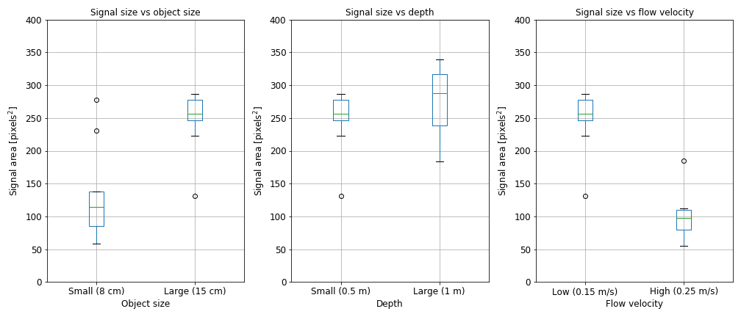

Figure : Results controlled tests in the pool regarding the influence of object size, depth, and flow velocity on the sonar backscatter dimensions.

Table : Items (with dimensions) used for the semi-controlled tests in the Rio de San Pedro.

|  |  |  |  |
| --- | --- | --- | --- |
| 1 | 2 | 3 | 4 |
|  |  |  |  |
| Height (cm): 12.5  Width (cm): 6.5-9 | Height (cm): 38  Width (cm): 26 | Height (cm): 12  Width (cm): 6.5 | Height (cm): 23  Width (cm): 6 |
| 5 | 6 | 7 | 8 |
|  |  |  |  |
| Height (cm): 27  Width (cm): 8.5 | Height (cm): 19  Width (cm): 6 | Height (cm): 12.5  Width (cm): 4.5 | Height (cm): 16.5  Width (cm): 9  Depth (cm): 6 |