Supplementary Fig.1 Phenotype of maize during drought stress and rewatering
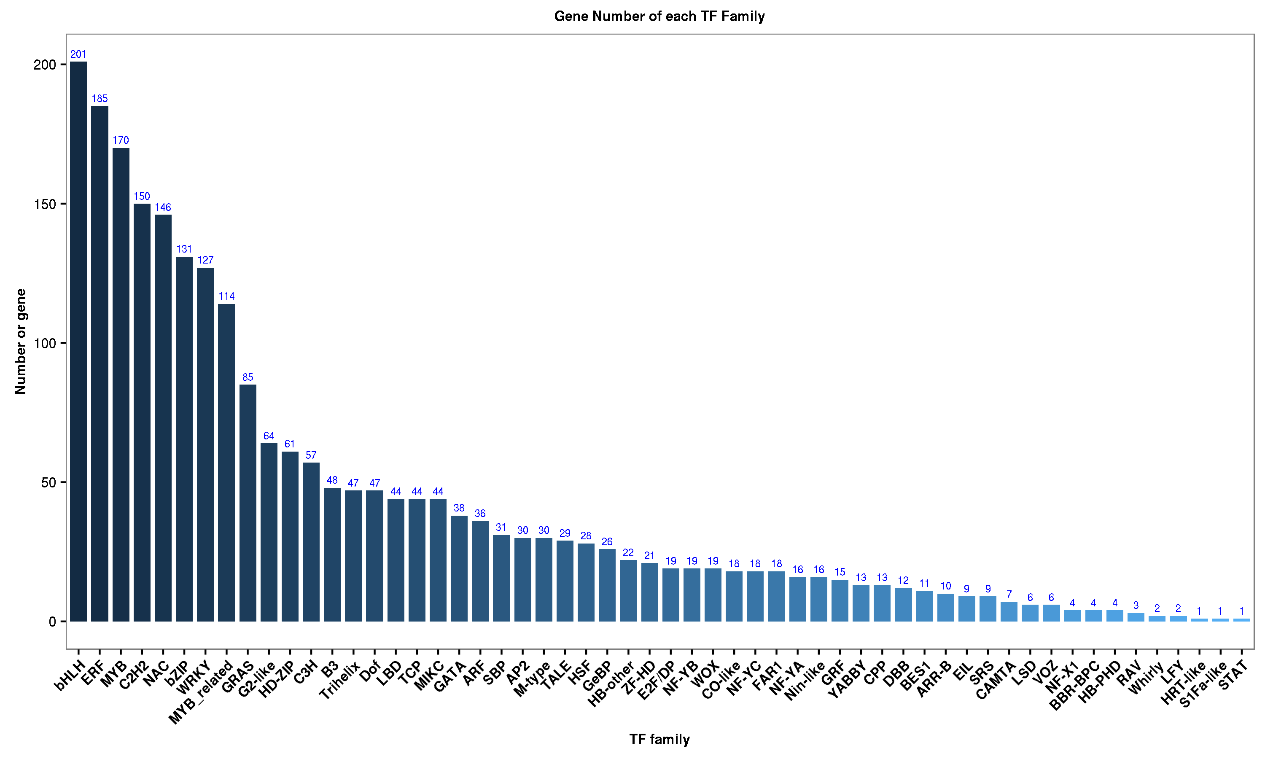
Supplementary Fig.2 Transcription factors identified by transcriptome sequencing

Supplemental Table S1. Expression of genes involved in ABA signaling pathway
ID | TF Family | log2(FC) | log2(FC) | log2(FC) | Pathway_ID | shot name
AC232238.2_FG004 | bZIP | -0.473 | 1.449 | 0.191 | - | ZmbZIP1
GRMZM2G000171 | bZIP | -0.32 | -0.346 | 0.137 | - | ZmbZIP2
GRMZM2G000842 | bZIP | 1.073 | 1.199 | 2.181 | - | ZmbZIP3
GRMZM2G002075 | bZIP | 0.818 | -0.074 | 0.128 | K14432 | ZmbZIP4
GRMZM2G008166 | bZIP | 0.989 | 2.507 | -1.519 | - | ZmbZIP5
GRMZM2G011932 | bZIP | 0.557 | 1.574 | 0.194 | - | ZmbZIP6
GRMZM2G019106 | bZIP | 0.349 | 0.399 | 0.324 | - | ZmbZIP7
GRMZM2G025812 | bZIP | -0.879 | 0.221 | -0.752 | - | ZmbZIP8
GRMZM2G030280 | bZIP | -0.014 | 0.272 | 0.159 | K14431 | ZmbZIP9
GRMZM2G033230 | bZIP | 1.4 | 1.93 | 0.151 | - | ZmbZIP10
GRMZM2G033413 | bZIP | 0.612 | 0.887 | 0.642 | - | ZmbZIP11
GRMZM2G045236 | bZIP | 0.363 | 0.17 | -0.512 | - | ZmbZIP12
GRMZM2G050912 | bZIP | 0.079 | 1.337 | -0.464 | - | ZmbZIP13
GRMZM2G055413 | bZIP | -0.266 | -0.008 | -0.115 | - | ZmbZIP14
GRMZM2G056099 | bZIP | 0.141 | 0.259 | -0.112 | K14431 | ZmbZIP15
GRMZM2G060290 | bZIP | 0.343 | 0.62 | 0.134 | K14431 | ZmbZIP16
GRMZM2G066734 | bZIP | 2.485 | 0.075 | -1.582 | - | ZmbZIP17
GRMZM2G073892 | bZIP | -0.287 | -0.468 | 0.597 | - | ZmbZIP18
GRMZM2G079365 | bZIP | 0.054 | 0.287 | -0.672 | - | ZmbZIP19
GRMZM2G088140 | bZIP | 0.113 | 0.5 | -0.127 | - | ZmbZIP20
GRMZM2G112483 | bZIP | -0.447 | -0.294 | -1 | - | ZmbZIP21
GRMZM2G118870 | bZIP | -0.259 | 0.039 | -0.419 | - | ZmbZIP22
GRMZM2G120167 | bZIP | -0.159 | 0.126 | 0.375 | - | ZmbZIP23
GRMZM2G122846 | bZIP | 0.543 | 0.66 | -1.314 | - | ZmbZIP24
GRMZM2G125243 | bZIP | 0.296 | 0.446 | -0.904 | - | ZmbZIP25
GRMZM2G129247 | bZIP | 0.46 | 0.701 | -0.144 | K14432 | ZmbZIP26
GRMZM2G132868 | bZIP | 0.669 | 0.339 | -0.208 | K14432 | ZmbZIP27
GRMZM2G133331 | bZIP | 0.492 | -0.641 | 0.212 | - | ZmbZIP28
GRMZM2G134863 | bZIP | -0.169 | -0.465 | -0.793 | - | ZmbZIP29
GRMZM2G136266 | bZIP | 0.406 | 0.162 | -0.342 | - | ZmbZIP30
GRMZM2G149150 | bZIP | 0.749 | -0.324 | -1.918 | - | ZmbZIP31
GRMZM2G157722 | bZIP | 1.124 | 1.624 | -0.783 | K14432 | ZmbZIP33
GRMZM2G171912 | bZIP | -1.011 | 1.98 | -0.123 | - | ZmbZIP32
GRMZM2G336766 | bZIP | 0.389 | 1.659 | -2.472 | - | ZmbZIP34
GRMZM2G361611 | bZIP | -1.406 | -1.119 | 1.495 | - | ZmbZIP35
GRMZM2G425920 | bZIP | 0.346 | 0.486 | -0.208 | K16241 | ZmbZIP36
GRMZM2G438293 | bZIP | 0.498 | 0.467 | -0.649 | - | ZmbZIP37
GRMZM2G444748 | bZIP | 0.004 | -0.093 | 0.165 | - | ZmbZIP38
GRMZM2G445575 | bZIP | 0.124 | 0.78 | 0.271 | - | ZmbZIP39
GRMZM2G448607 | bZIP | -0.653 | -0.583 | 0.273 | - | ZmbZIP40
GRMZM5G858197 | bZIP | 0.47 | 1.151 | -0.871 | - | ZmbZIP41
XLOC_045567 | MYB | 0.056 | -0.477 | 0.141 | K14432 | ZmMYB1
GRMZM5G889719 | DREB | -1.466 | -0.866 | -3.358 | - | ZmDREB1
AC187157.4_FG005 | HD-Zip | 2.641 | 1.494 | -0.995 | - | ZmZIP1
GRMZM2G469551 | HD-Zip | 1.273 | 1.447 | -1.107 | - | ZmZIP3
XLOC_025615 | HD-Zip | -0.451 | -0.154 | 1.008 | - | ZmZIP2
AC206901.3_FG005 | MYB | 1.128 | -1.112 | -4.191 | - | ZmMYB2
GRMZM2G002128 | MYB | -0.711 | -0.377 | 0.509 | - | ZmMYB3
GRMZM2G022686 | MYB | -0.654 | 0.517 | 0.084 | - | ZmMYB4
GRMZM2G047626 | MYB | -1.771 | -0.664 | -0.954 | - | ZmMYB5
GRMZM2G050305 | MYB | 0.287 | 1.278 | -0.335 | - | ZmMYB6
GRMZM2G051256 | MYB | -0.502 | -0.04 | -3.108 | - | ZmMYB7
GRMZM2G078820 | MYB | 1.628 | -0.311 | -3.539 | - | ZmMYB8
GRMZM2G096358 | MYB | 1.849 | 0.633 | -1.84 | - | ZmMYB9
GRMZM2G098179 | MYB | -1.506 | 1.109 | -2.728 | - | ZmMYB10
GRMZM2G145444 | MYB | -1.567 | -2.565 | -2.73 | - | ZmMYB11
GRMZM2G169316 | MYB | 0.231 | -0.219 | -0.277 | - | ZmMYB12
GRMZM5G803308 | MYB | 0.047 | -0.376 | -1.918 | - | ZmMYB13
AC196475.3_FG005 | NAC | 0.205 | 0.02 | -1.16 | - | ZmNAC1
AC203535.4_FG002 | NAC | 0.486 | 0.645 | -1.021 | - | ZmNAC2
AC212859.3_FG008 | NAC | -1.796 | -0.344 | 1.227 | - | ZmNAC3
GRMZM2G003715 | NAC | 0.64 | -0.132 | -1.84 | - | ZmNAC4
GRMZM2G042494 | NAC | 2.956 | -0.678 | -8.835 | - | ZmNAC5
GRMZM2G068973 | NAC | -0.961 | -1.902 | -1.937 | - | ZmNAC6
GRMZM2G074358 | NAC | -0.978 | -1.8 | -2.078 | - | ZmNAC7
GRMZM2G081930 | NAC | 3.806 | 4.69 | -5.119 | - | ZmNAC8
GRMZM2G109627 | NAC | 1.589 | 0.374 | -1.732 | - | ZmNAC9
GRMZM2G123667 | NAC | 0.023 | -0.005 | -1.773 | - | ZmNAC10
GRMZM2G126936 | NAC | -0.353 | 0.084 | -8.261 | - | ZmNAC11
GRMZM2G167018 | NAC | 0.668 | -1.626 | 1.42 | - | ZmNAC12
GRMZM2G167492 | NAC | -0.151 | 0.448 | -1.128 | - | ZmNAC13
GRMZM2G171395 | NAC | -1.968 | 3.511 | -3.005 | - | ZmNAC14
GRMZM2G180328 | NAC | 1.094 | 2.322 | -3.015 | - | ZmNAC15
GRMZM2G181605 | NAC | 0.931 | -2.767 | -2.654 | - | ZmNAC16
GRMZM2G336533 | NAC | 0.425 | -0.659 | -3.915 | - | ZmNAC17
GRMZM2G347043 | NAC | 0.016 | 0.303 | -1.039 | - | ZmNAC18
GRMZM2G430849 | NAC | 2.84 | 1.132 | -1.793 | - | ZmNAC19
GRMZM2G439903 | NAC | -0.628 | -2.945 | -2.385 | - | ZmNAC20

Supplemental Table S2. Primer sequences for constructing cloning vectors
Primer names | Primer sequences(5’-3’) | Function
ZmbZIP33-F | CATTACTGACCGCCTGAATCG | qRT-PCR
ZmbZIP33-R | AGATGACGCTGGAGGAGTTC | qRT-PCR
ZmbZIP33-F-AscI | AGGCGCGCCATGGATCTCAACGAAT | Transform
ZmbZIP33-R-BamHI | CGGGATCCTTACCAGGGACCTGTCA | Transform
ZmbZIP33-GFP-SpeI-F | GGACTAGT ATGGATCTCAACGAAT | SL
ZmbZIP33-GFP-BamHI-R | CGGGATCC TTACCAGGGACCTGTCA | SL
ZmSRK2E-GFP-SpeI-F | GGACTAGT ATGGAGGAGAGGTACGAG | SL
ZmSRK2E-GFP-BamHI-R | CGGGATCC TCAGTAGGTGTCATCGGCGTC | SL
ZmPP2C7-GFP-SpeI-F | GGACTAGT ATGGAGGACCTCGCCCCG | SL
ZmPP2C7-GFP- BamHI-R | CGGGATCC TTATGTTCTGCTCTTGAACTTTCT | SL
ZmbZIP33-KT-ECORI-F | TCATATGGCCATGGAGGCCAGTGAATTCATGGATCTCAACGAATGC | YTH
ZmbZIP33-KT- BamHI-R | ATCTGCAGCTCGAGCTCGATGGATCCTTACCAGGGACCTGTCAATG | YTH
ZmSRK2E-AT- ECORI-F | TCATATGGCCATGGAGGCCAGTGAATTCATGGAGGAGAGGTACGAG | YTH
ZmSRK2E-AT- BamHI-R | ATCTGCAGCTCGAGCTCGATGGATCCTTATGTTCTGCTCTTGAAC | YTH
ZmPP2C7-KT-ECORI-F | TCATATGGCCATGGAGGCCAGTGAATTCATGGAGGACCTCGCCCCG | YTH
ZmPP2C7-KT- BamHI-R | ATCTGCAGCTCGAGCTCGATGGATCCTCAGTAGGTGTCATCGGCGT | YTH
ZmPYL10-AT- ECORI-F | TCATATGGCCATGGAGGCCAGTGAATTCATGGAAGACGTCGTAGCAGT | YTH
ZmPYL10-AT- BamHI-R | ATCTGCAGCTCGAGCTCGATGGATCCTCAGTTTTGCTCTTGAACTTG | YTH
ZmbZIP33-YN- ECORI-F | AGATCTCGAGCTCAAGCTTCGAATTCATGGATCTCAACGAATGC | BIFC
ZmbZIP33-YN- KPNI-R | CAGGATCCCGGGCCCGCGGTACCGCCAGGGACCTGTCAATGTT | BIFC
ZmSRK2E-YC- ECORI-F | AGATCTCGAGCTCAAGCTTCGAATTCATGGAGGAGAGGTACGAG | BIFC
ZmSRK2E-YC-KPNI-R | CAGGATCCCGGGCCCGCGGTACCGGTAGGTGTCATCGGCGTCTGC | BIFC
ZmPP2C7-YN- ECORI-F | AGATCTCGAGCTCAAGCTTCGAATTCATGGAGGACCTCGCCCCG | BIFC
ZmPP2C7-YN- KPNI-R | CAGGATCCCGGGCCCGCGGTACCGTGTTCTGCTCTTGAACTTTC | BIFC
ZmPYL10-YC- ECORI-F | AGATCTCGAGCTCAAGCTTCGAATTCATGGAAGACGTCGTAGCAGT | BIFC
ZmPYL10-YC- KPNI-R | CAGGATCCCGGGCCCGCGGTACCGAGTTTTGCTCTTGAACTTG | BIFC
ZmbZIP33-NCOI-F | CATGCCATGGGGAGATCCGAGAGGAAGT | VIGS
ZmbZIP33- AvrII-R | CTAG CCTAGGGTTGTCACTGCTCTCCCT | VIGS

ZmSRK2E-Q-F | GAGGAGAGGTACGAG | qRT-PCR
ZmSRK2E-Q-R | TATGTTCTGCTCTTGAAC | qRT-PCR
ZmPP2C7-Q-F | GGAGGACCTCGCCCCG | qRT-PCR
ZmPP2C7-Q-R | TCCTCAGTAGGTGTCATCGGCGT | qRT-PCR
ZmPYL10-Q-F | GAAGACGTCGTAGCAGT | qRT-PCR
ZmPYL10-Q-R | TCAGTTTTGCTCTTGAACTTG | qRT-PCR
NCED-F | CGACAAGTTCATCTACGGCG | qRT-PCR
NCED-R | CGTTGACGACGAGCATTTCC | qRT-PCR
ZEP-F | TTGGTTGGTGCCGATGGAAT | qRT-PCR
ZEP-R | CGTATCGATATCGGGCAGCA | qRT-PCR

Note: SL stands for subcellular localization, YTH stands for yeast two-hybrid, and BIFC stands for bimolecular fluorescence complementation.

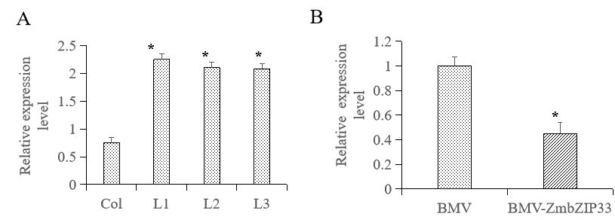
Supplementary Fig.3.The expression level of ZmbZIP33 in transgenic lines. (A) Analysis of ZmbZIP33 expression in transgenic lines and Col is wild type Arabidopsis, L1 ~ L3 are transgenic Arabidopsis lines.(B) Analysis of ZmbZIP33 expression in BMV (WT) and BMV-ZmbZIP33 transgenic line.

Supplementary Table S3. T1 segregation of bar and bZIP33 transgenes and test goodness of fit for Medellian patterns
Events | Genes | Positive | Negative | Total seeds | Chi-square
bZIP1-1 (L1) | bZIP33 | 100 | 35 | 135 | 0.06173
 | bar | 95 | 40 | 135 | 1.54321
bZIP1-3 | bZIP33 | 98 | 73 | 171 | 28.53996
 | bar | 113 | 58 | 171 | 7.25341
bZIP2-2 | bZIP33 | 66 | 40 | 106 | 9.16981
 | bar | 70 | 36 | 106 | 4.54088
bZIP2-5 (L2) | bZIP33 | 200 | 60 | 260 | 0.51282
 | bar | 190 | 70 | 260 | 0.51282
bZIP2-7 | bZIP33 | 53 | 56 | 109 | 40.44343
 | bar | 70 | 39 | 109 | 6.75535
bZIP2-10 | bZIP33 | 63 | 60 | 123 | 37.09756
 | bar | 81 | 42 | 123 | 5.48780
bZIP3-1 | bZIP33 | 64 | 40 | 104 | 10.05128
 | bar | 68 | 36 | 104 | 5.12821
bZIP3-3 (L3) | bZIP33 | 91 | 38 | 129 | 1.36693
 | bar | 98 | 31 | 129 | 0.06460

