**Supplementary S1.** Table of the GLMM model results on taxonomic and functional indices of collembolan communities depending on land uses: (1) forest (n=25). (2) grassland (n=46). (3) arable land (n=304). (4) vineyard (n=136). (5) urban vegetable garden (n=30). (6) SUITMA (n=217).

1. Main test results of the fixed effects (land use) model with the random variable (climate). Data were fitted with the glmer function from the lme4 package in R by specifying the following R code: (glmer (Functional Eveness / Richness / Divergence / Dispersion / Richness / Density ~ Land uses + (1|Climate). family = Binomial / Poisson). F value and P value were obtained from GLMM

|  |  |  |  |  |  |
| --- | --- | --- | --- | --- | --- |
|  | **Df** | **AIC** | **F statistic** | **P value** | **Distribution** |
| **Richness** |  | 4442 | 120.1 | < 2.2e-16 | Poisson |
| **Density** | 5 | 39317 | 1421.0 | < 2.2e-16 | Poisson |
| **Functional Eveness** | 5 | 879 | 8.0 | 7.485e-08 | Binomial |
| **Functional Richness** | 5 | -1526 | 148.6 | 3.857e-12 | Poisson |
| **Functional Divergence** | 5 | 16268 | 33.4 | < 2.2e-16 | Poisson |
| **Functional Dispersion** | 5 | 6197 | 54.2 | < 2.2e-16 | Poisson |

1. P values with pairwise comparisons of land uses for each index

-Taxonomic richness

|  |  |  |  |  |  |
| --- | --- | --- | --- | --- | --- |
|  | **Forest** | **Urban vegetable garden** | **Grassland** | **SUITMA** | **Vineyard** |
| **Arable land** | <0.0001 | <0.0001 | <0.0001 | <0.0001 | 0.0004 |
| **Forest** |  | <0.0001 | 0.006 | <0.0001 | <0.0001 |
| **Urban vegetable garden** |  |  | <0.0001 | <0.0001 | <0.0001 |
| **Grassland** |  |  |  | 0.7433 | <0.0001 |
| **SUITMA** |  |  |  |  | <0.0001 |
| **Vineyard** |  |  |  |  |  |

-Density

|  |  |  |  |  |  |
| --- | --- | --- | --- | --- | --- |
|  | **Forest** | **Urban vegetable garden** | **Grassland** | **SUITMA** | **Vineyard** |
| **Arable land** | <0.0001 | <0.0001 | <0.0001 | <0.0001 | 0.0002 |
| **Forest** |  | <0.0001 | 1 | <0.0001 | <0.0001 |
| **Urban vegetable garden** |  |  | <0.0001 | <0.0001 | <0.0001 |
| **Grassland** |  |  |  | <0.0001 | <0.0001 |
| **SUITMA** |  |  |  |  | <0.0001 |
| **Vineyard** |  |  |  |  |  |

-Functional Eveness

|  |  |  |  |  |  |
| --- | --- | --- | --- | --- | --- |
|  | **Forest** | **Urban vegetable garden** | **Grassland** | **SUITMA** | **Vineyard** |
| **Arable land** | 0.8408 | 0.0578 | 0.8814 | 0.0191 | 0.0033 |
| **Forest** |  | 0.8756 | 0.991 | 0.2339 | 0.1277 |
| **Urban vegetable garden** |  |  | 0.5302 | 0.0016 | 0.0006 |
| **Grassland** |  |  |  | 0.1025 | 0.0377 |
| **SUITMA** |  |  |  |  | 0.9527 |
| **Vineyard** |  |  |  |  |  |

- Functional richness

|  |  |  |  |  |  |
| --- | --- | --- | --- | --- | --- |
|  | **Forest** | **Urban vegetable garden** | **Grassland** | **SUITMA** | **Vineyard** |
| **Arable land** | <0.0001 | <0.0001 | <0.0001 | 0.0054 | <0.0001 |
| **Forest** |  | 0.0337 | 0.0163 | <0.0001 | <0.0001 |
| **Urban vegetable garden** |  |  | <0.0001 | <0.0001 | <0.0001 |
| **Grassland** |  |  |  | <0.0001 | <0.0001 |
| **SUITMA** |  |  |  |  | <0.0001 |
| **Vineyard** |  |  |  |  |  |

-Functional dispersion

|  |  |  |  |  |  |
| --- | --- | --- | --- | --- | --- |
|  | **Forest** | **Urban vegetable garden** | **Grassland** | **SUITMA** | **Vineyard** |
| **Arable land** | <0.0001 | <0.0001 | 0.0177 | 0.9156 | <0.0001 |
| **Forest** |  | 0.9052 | 0.0217 | <0.0001 | <0.0001 |
| **Urban vegetable garden** |  |  | 0.0841 | <0.0001 | <0.0001 |
| **Grassland** |  |  |  | 0.0028 | <0.0001 |
| **SUITMA** |  |  |  |  | <0.0001 |
| **Vineyard** |  |  |  |  |  |

-Functional divergence

|  |  |  |  |  |  |
| --- | --- | --- | --- | --- | --- |
|  | **Forest** | **Urban vegetable garden** | **Grassland** | **SUITMA** | **Vineyard** |
| **Arable land** | 1 | <0.0001 | 0.5853 | 0.9999 | 0.0133 |
| **Forest** |  | <0.0001 | 0.9168 | 1 | 0.2576 |
| **Urban vegetable garden** |  |  | <0.0001 | <0.0001 | <0.0001 |
| **Grassland** |  |  |  | 0.7701 | 0.0049 |
| **SUITMA** |  |  |  |  | 0.0447 |
| **Vineyard** |  |  |  |  |  |

**Supplementary S2.** Comparison of attributes from eight morphological traits weighted by the taxa-relative abundance of species (CWM) of collembolan communities depending on land uses: (1) forest (n=25). (2) grassland (n=46). (3) arable land (n=304). (4) vineyard (n=136). (5) urban vegetable garden (n=30). (6) SUITMA (n=217). Lower case letters indicate significant differences between land uses.

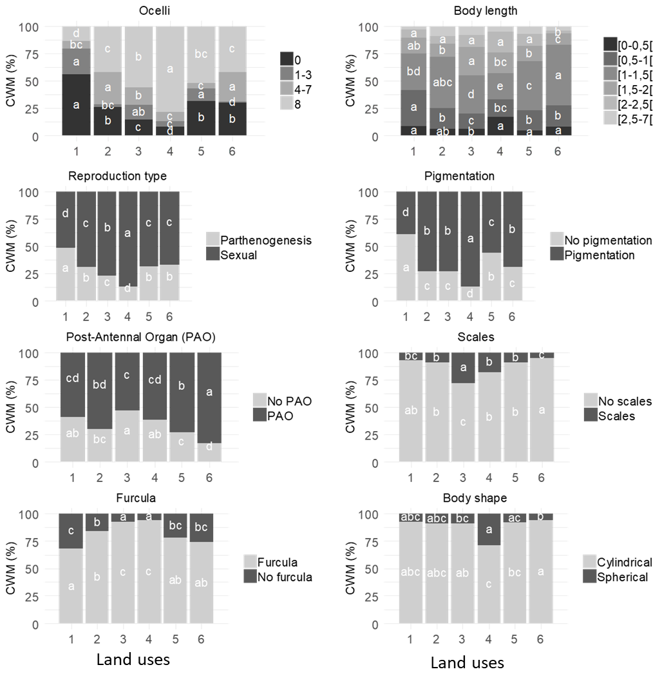

**Supplementary S3.** Graphical display of Partial Redundancy Analyses (pRDA) on the functional (a.13% explained) and taxonomic composition (b.13% explained) of collembolan communities. Functional composition corresponds to community -weighted means (CWM) of 8 functional traits resulting a list of 27 attributes. whereas taxonomic composition corresponds to community assemblage named by **GEN**US_**SPE**CIES(129 species) depending on land uses: (LU_1) forest (n=25). (LU_2) grassland (n=46). (LU_3) arable land (n=304). (LU_4) vineyard (n=136). (LU_5) urban vegetable garden (n=30). (LU_6) SUITMA (n=217). The statistical significance of the pRDA was assessed by the Monte Carlo Permutation test (Pr = 0.005).

a.

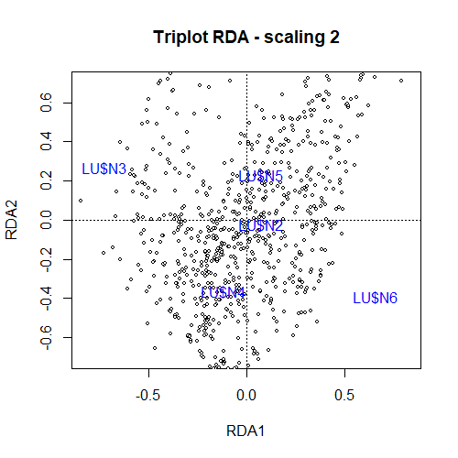 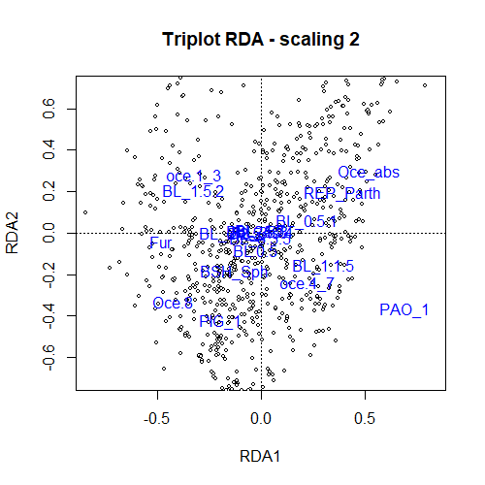

b.

