HIF-1α Protects Granulosa Cells from Hypoxia-Induced Apoptosis during Follicular Development by Inducing Autophagy
Zonghao Tang, Renfeng Xu, Zhenghong Zhang, Congjian Shi, Yan Zhang, Hongqin Yang, Qingqiang Lin, Yiping Liu, Fengping Lin, Baorong Gen, and Zhengchao Wang
Supplementary Material

Supplementary Figures and Tables

Supplementary Figures
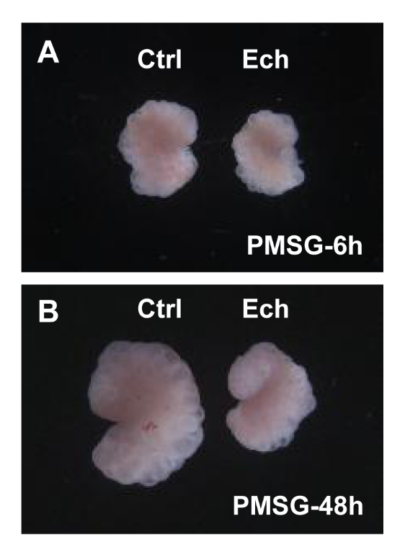
Supplementary Figure 1. Effect of inhibited HIF-1α on follicular development. Three-week old female Sprague–Dawley rats were treated with PMSG to induce follicular development, and HIF-1α was inhibited by Ech for 6 and 48 h. (A): Morphology of rat ovary at 6 h after Ech treatment. (B): Morphology of rat ovary at 48 h after Ech treatment. The magnification is 40×. Ech: echinomycin.

Supplementary Tables

Supplementary Table S1 Antibody informations for western blotting
Antibody Name | Company and City | Dilution Degree
LC-3I/II | Abcam, Cambridge, MA, USA | 1:1000
Beclin1 | Protein Tech Group, Wuhan, China | 1:2000
β-actin | Protein Tech Group, Wuhan, China | 1:5000
p62 | Abcam, Cambridge, MA, USA | 1:1000
Caspase-3 | Protein Tech Group, Wuhan, China | 1:500
cleaved caspase-3 | Cell Signaling Technology, Boston, MA, USA | 1:1000
Bax | Protein Tech Group, Wuhan, China | 1:500
Bcl-2 | Cell Signaling Technology, Boston, MA, USA | 1:1000
HIF-1 | Santa Cruz Biotechnology, Dallas, TX, USA | 1:500
BNIP3 | Abcam, Cambridge, MA, USA | 1:1000
Goat anti-Mouse IgG | Beyotime Institute of Biotechnology, Haimen, China | 1:5000
Goat anti-Rabbit IgG | Beyotime Institute of Biotechnology, Haimen, China | 1:5000

