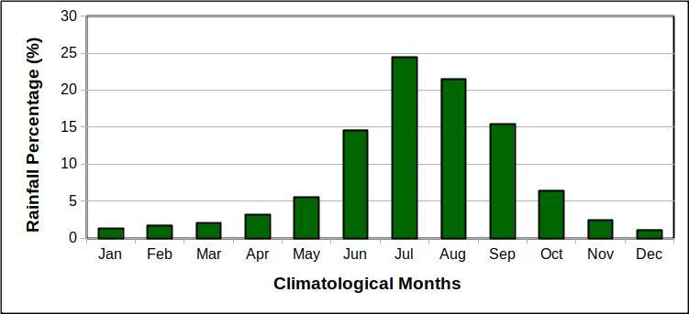

**Figure S1:** Percentage of climatological rainfall of each month over the Indian land region, calculated using the GPCP (Adler et al., 2003) precipitation data for the period of CE 1979 to 2018.

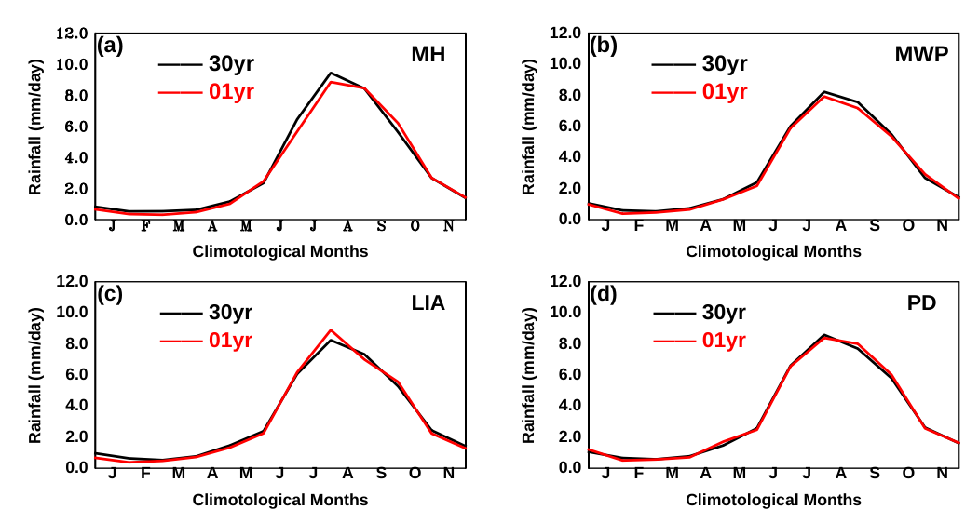

**Figure S2:** area-averaged rainfall (mm/day) comparison between the ensemble mean of 30-year control simulations and 1-year control simulations for the four-time periods. The descriptor string shows the corresponding panel’s time period.

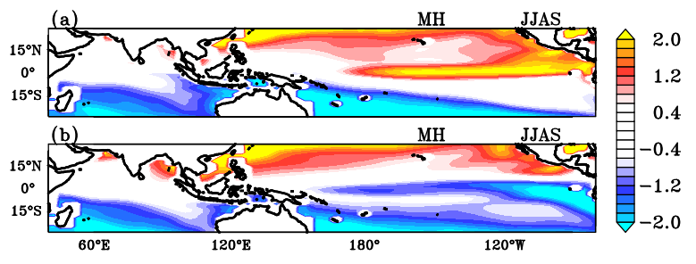

**Figure S3:** The sea surface temperature (°C) anomalies imposed in these SST sensitivity experiments for the MH period over tropical Indo-Pacific oceans (a) El Nino (b) La Nina.

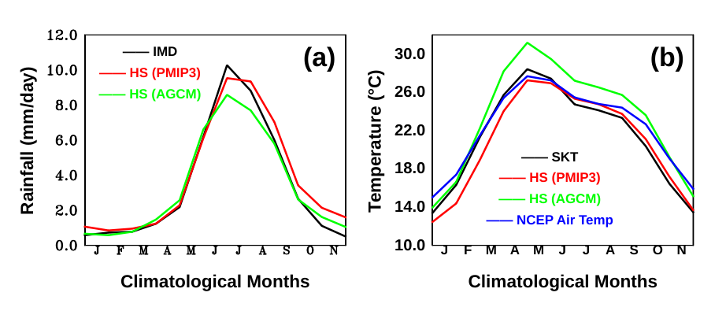

**Figure S4** Comparisons of PMIP3/CMIP5 CCSM4 simulated area-averaged climatological cycle of rainfall and surface temperature with AGCM simulation rainfall and surface temperatures, with the observational rainfall and surface temperatures respectively. (a) for rainfall; (b) for surface temperature for HS; The are calculated over the Indian land region (66.5°E–101.5°E; 6.5°N–39.5°N). IMD rainfall climatology calculated from CE 1901-2009, SKT climatology calculated from CE 1901-2009, Climate Prediction Center (CPC) Global Land Surface Air Temperature data from CE 1948-2020.

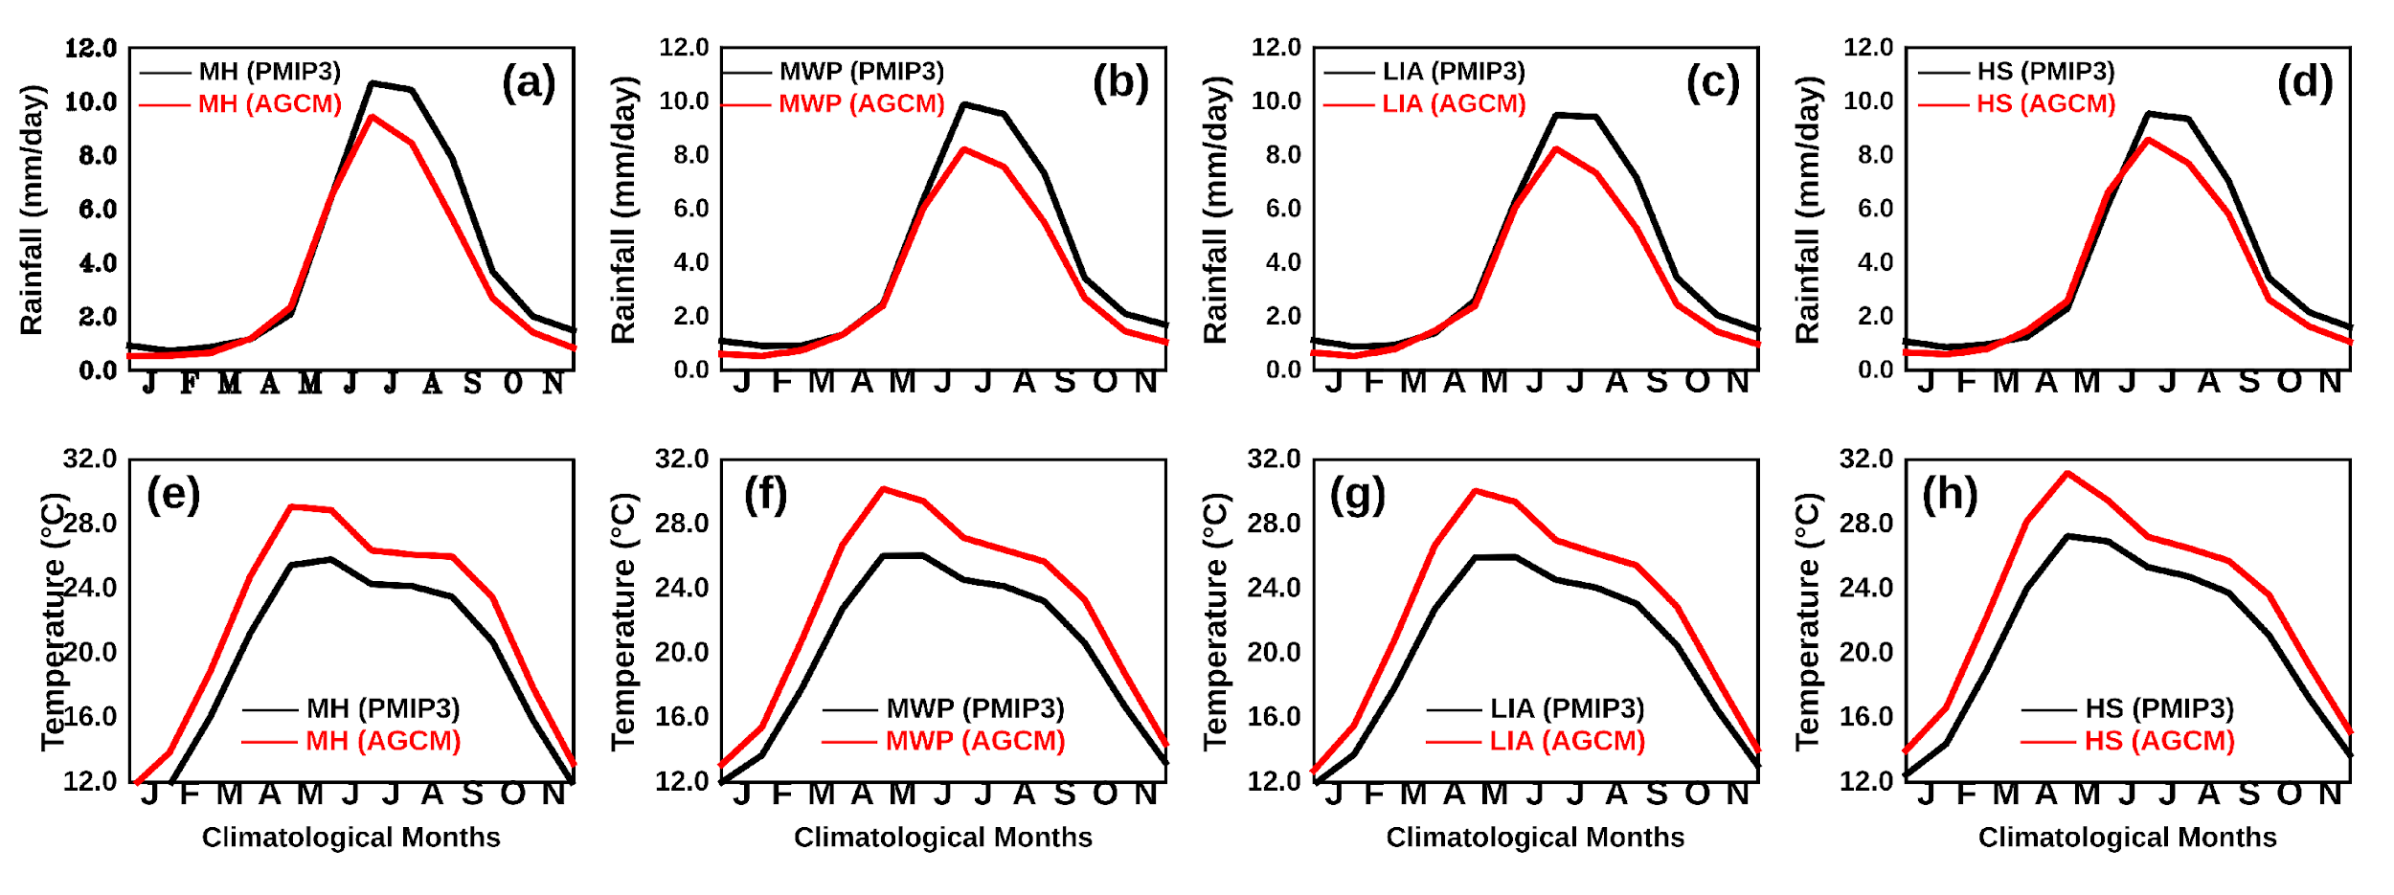

**Figure S5** Comparisons of PMIP3/CMIP5 CCSM4 simulated area-averaged climatological cycle of rainfall and surface temperature with AGCM simulation rainfall and surface temperatures, respectively. (a), (b), (c), and (d) for rainfall; (e), (f), (g), (h) for surface temperature for past climate periods; The are calculated over the Indian land region (66.5°E–101.5°E; 6.5°N–39.5°N). The legend string of each panel indicates the name of the type of the simulation and the period over which the difference is calculated.

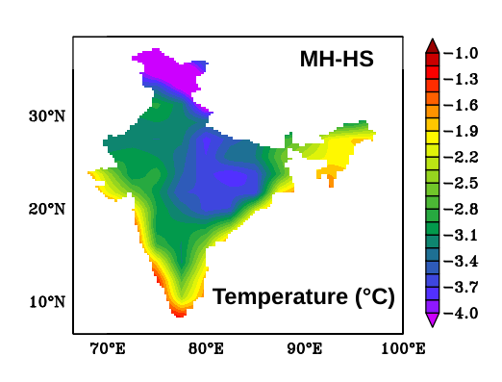

**Figure S6:** Spatial distribution of simulated pre-monsoon (March, April, and May) surface temperatures (°C) difference between the MH and HS.

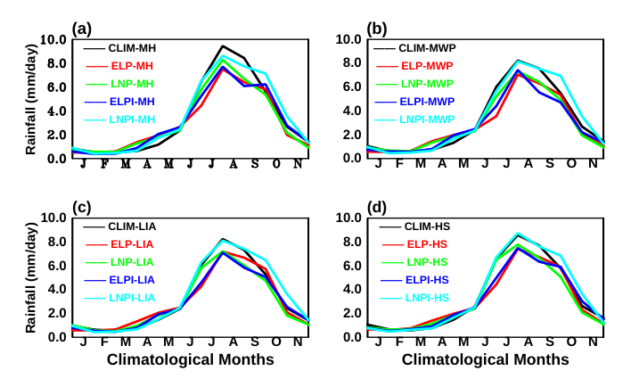

**Figure S7:** Comparision between the area-averaged seasonal cycle of AGCM sea-surface temperature (SST) sensitivity experiments for four climate periods, MH, MWP, LIA, and HS. Panel (a) during MH, Panel (b) during MWP, Panel (c) during LIA, and Panel (d) during HS. Legend strings explain the type of simulation in each panel. For example, From Panel (a) CLIM(MH) - MH Control simulations, ELP(MH) - MH simulation with El Niño type SSTs in the tropical Pacific Ocean, LNP(MH) - MH simulation with La Niña type SSTs in the tropical Pacific Ocean, ELPI(MH) - MH simulation with El Niño type SSTs in the tropical Indo-Pacific Ocean, LNPI(MH) - MH simulation with La Niña type SSTs in the tropical Indo-Pacific Ocean.