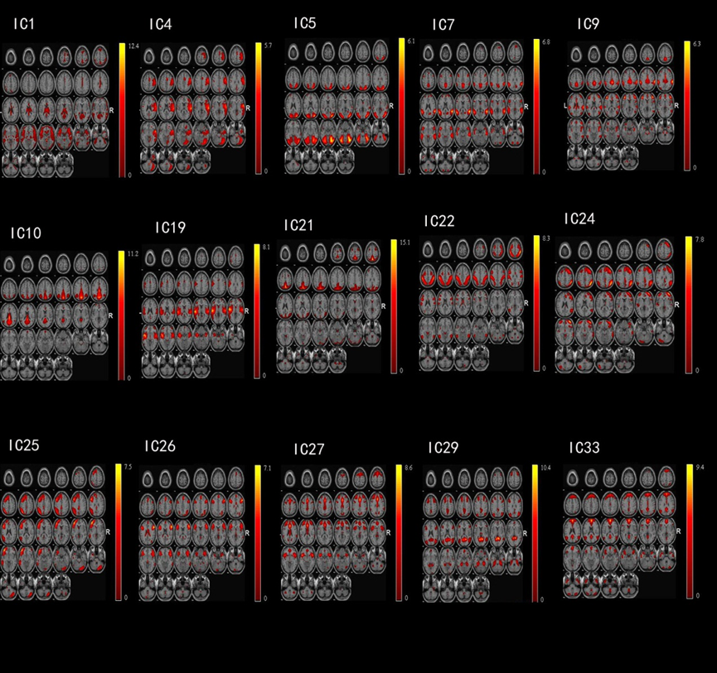

**Fig.1s 15 valid components left after discarding artifacts.**