Supplementary Material

# Supplementary Methods

## Bulk density calculation

The bulk density (BD) was calculated according to Strauss et al (2012) using the following equation:

$BD [{10}^{3}kg/m^{3}]=(n-1)∙(-ϱ_{s})$

were *n* is the pore volume (%) and *ρs* is the mineral density in 103 kg/m3. Given that the sediment was saturated with water in unfrozen and ice in frozen conditions, the pore volume was derived from the volumetric ratio of ice/water and dry sample whereby a constant ice density of 0.9127 · 103 kg/m3 at 0 °C and a water density of 0.999 · 103 kg/m3 at 2 °C was assumed (Lide et al., 2008). For the mineral density (*ρs*), the density of quartz of 2.65*103 kg/m3 was taken (Rowell, 1994).

## Grain size analyses

Grain size analyses were carried out with the laser particle size analyser Malvern Mastersizer 3000. Beforehand, the samples were treated with hydrogen peroxide (3 % and 30 %) to remove all organic material. The samples were then washed, freeze-dried, manually homogenized and sieved (< 1 mm fraction measured, the larger fraction was weighted) before measuring. Grain size statistics were calculated following Folk and Ward (1957) using the GRADISTAT software after Blott and Pye (2001). For grain size classification, the international ISO 14688-1:2017 scale was used, classifying clay as particles ≤ 2 μm, silt ranging from 2 to 63 μm and sand ranging from 63 μm to 2 mm (ISO, EN, 2017).

## Optical luminescence dating

For optically stimulated luminescence dating, 3 core segments were selected in the field from the Uomullyakh core, and 2 from the Polar Fox core, and delivered in frozen state to Aarhus University’s Nordic Laboratory for Luminescence Dating (Roskilde, Denmark). Luminescence measurements were made using a Risø TL/OSL reader, model TLDA 20. The quartz OSL signal was detected through a glass U-340 filter and the feldspar IRSL through a blue filter combination (Thomsen et al., 2008). Multi-grain quartz aliquots were 8 mm diameter, and feldspar 2 mm.

A standard SAR protocol was used for quartz dose estimation, with blue light stimulation at 125 °C for 40s, a 260 °C preheat for 10 s, a 220 °C cut heat, and an elevated temperature (280 °C) blue-light resetting at the end of each SAR cycle (Murray & Wintle, 2000; 2003). For feldspar, a post-IR IRSL SAR protocol with a preheat of 320 °C for 60 s was used. Aliquots were stimulated at 50 °C with IR for 200 s (IR50 signal) and then at 290 °C with IR for 200 s (post-IR IRSL290 signal, pIRIR290). Since the feldspar signals were measured to test the completeness of bleaching of the quartz prior to sedimentation, the stability of the feldspar signals was not investigated (Murray et al., 2012; Möller & Murray, 2015; Möller et al., 2019).

Radionuclide concentrations were measured using high resolution gamma spectrometry (Murray et al., 1987; 2018), calibrated using Certified Reference Materials produced by Natural Resources Canada (NRCAN) and analytical grade K2SO4. Dry infinite-matrix dose rates were calculated following Guérin et al., (2011), water content corrections are based on those described by Aitken (1985) and cosmic ray dose rates on Prescott & Hutton (1994).

Thus there is no evidence for any significant disequilibrium in the first part of the 238U decay series, and so it is unlikely that the dose rate was significantly time dependent. Dose recovery measurements on quartz gave an average dose recovery ratio of 1.01±0.12 (n=12), indicating that the quartz SAR protocol used here is able to accurately measure a known dose given to these samples before any laboratory heating. The feldspar results (pIRIR: 1.31±0.07; n=14, andIR50: 0.62±0.02; n=15) are less satisfactory, but this is not of particular concern, because the feldspar data are used primarily to test whether the quartz is well bleached, rather than to give independent finite ages.

The pIRIR and the IR50 ages are, however, smaller than the quartz OSL ages. Age underestimates of 30-40% from the IR50 signal are to be expected, because the signal is well known to be unstable, but any age underestimate from the pIRIR signal should be very much smaller (Buylaert et al., 2011). Indeed, the average ratio of the pIRIR to quartz OSL ages is 0.84 ± 0.05, and some part of this ~15 % underestimate may be associated with the poor dose recovery. But in any case, since the pIRIR signal bleaches very much more slowly than the quartz OSL signal, we conclude it is very likely that the quartz was well bleached at deposition (Möller and Murray, 2015; Möller et al., 2019). Because no correction has been made for possible signal instability, and because the dose recovery ratio for feldspar was not satisfactory, we take the quartz OSL results as the best age estimates.

## Sediment temperature processing

A GeoPrecision temperature chain with an accuracy of ± 0.1 °C and a resolution of 0.01 °C was installed in the Uomullyakh Lagoon borehole for 11 days in a PVC tube with 1-inch inner diameter. After installation, the top of the PVC tube was blocked with fabric to prevent cold air convection. The temperatures deeper than 9.2 m decreased during the installation period (Figure A1). All depths in this appendix are reported from the ice/sediment boundary. After 11 days, each node almost approached its equilibrium temperature, therefore implying that most of the heat introduced by drilling activity had dissipated. To calculate the equilibrium temperature for the temperature nodes from 14.2 to 29.2 m depths, we assumed that the borehole behaved as a line source of heat. We also assumed a constant thermal conductivity in the sediment, no latent heat, as well as no cooling events during drilling activity interruptions. The undisturbed temperature (*To*; Figure A2) is calculated as shown in Equation A1 (Lachenbruch and Brewer 1959) where T*obs* is the observed temperature, *t* is the time elapsed since the drill bit first reached the depth in question, *s* is the duration of the drilling process at a given depth, and *A* is a constant equal to *Q/(4πK)*. Here, *Q* is equal to the units of heat flow per unit depth during the drilling period (*s*) and *K* is the thermal conductivity.

https://lh6.googleusercontent.com/chLyVqlLgN2fL4KZHyZgr-D8wqjO_cHrJsOowVXw2_wL-uWHEYE0GCYiegxCS5fEntZVeHJ6cTSNibMJf1yi31mj59D9iIcmOYA0jz9zCKKaMHo5pO0PxpFfB1n4QWsj5b_PFoC6                                  **Equation A.1**

To calculate variables *t* and *s*, we assumed 10-hour drilling times that began at 09:00 each day and assumed a constant drilling speed to determine the time at which the drill bit reached the temperature node depth. For simplicity, any sediment cooling effect between drilling sequences was ignored. The undisturbed temperature (*To*) is the Y-intercept of Equation A.1 and can be solved by plotting the line of best fit through the observed temperatures as a function of log*e*(t/(t-s)). The first 500 minutes of installation time were not considered in the calculations. Since the temperature nodes shallower than or equal to 9.2 m displayed a negligible temperature cooling trend, drilling heat corrections were only applied to the deeper nodes. The final observed temperatures were close to equilibrium, as the maximum drilling heat correction was only -0.1 °C.

Lastly, the temperatures were also corrected for sensor offsets measured at 0 °C. The sensors were immersed in a water-ice bath and temperatures were recorded every minute. The mean temperatures recorded at 0 °C (Toffset) over the course of a 480-minute period (Figure A3) were used in Equation A.2 to determine the final calibrated temperature (*Tcalib*). All sensors recorded a water temperature within the accuracy specifications (+/- 0.1 °C). The 19.2 m sensor showed a slight positive drift during submergence, but this was considered negligible in the final result.

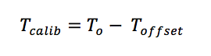                                        **Equation A.2**

The final observed temperatures are plotted together with the temperatures corrected for drilling heat, as well as the temperatures corrected for drilling heat and sensor calibration (Figure A4).

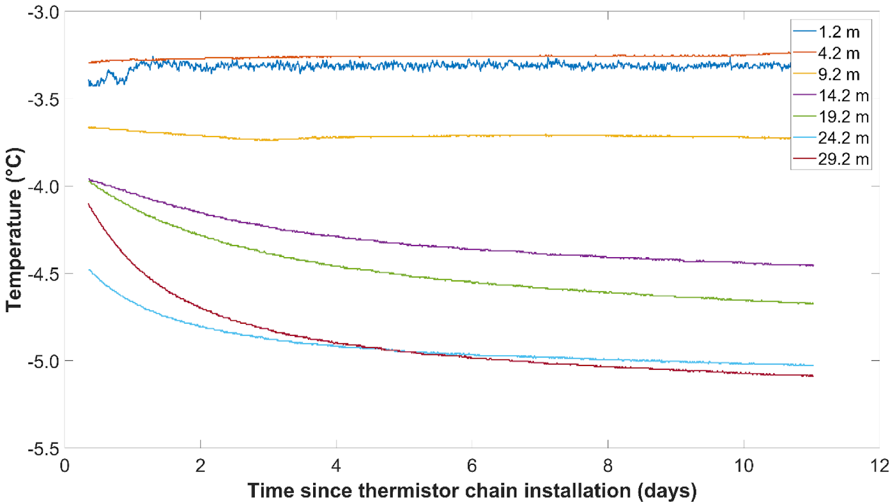

**Figure A1:** Temperature decay curves for all thermistors below the ice/sediment boundary. The first 500 minutes of temperature data are not shown. Diurnal temperature fluctuations are visible for the 1.2 m node.

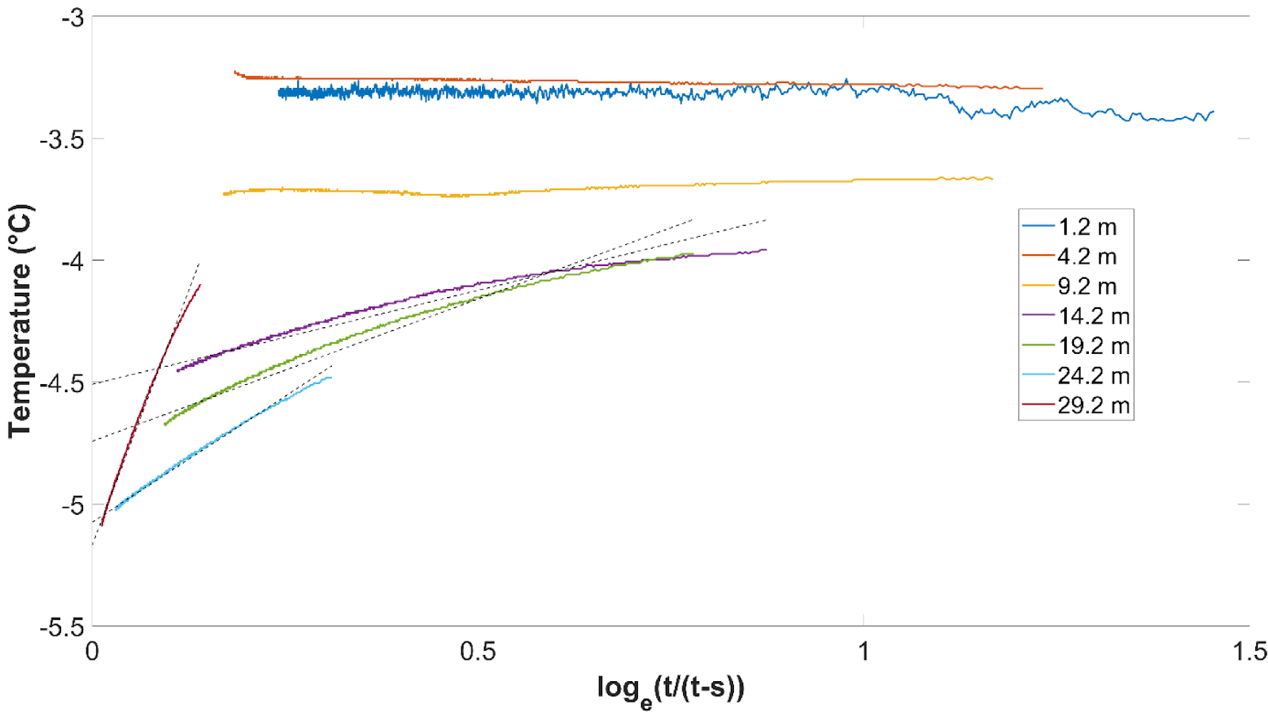

**Figure A2:** The undisturbed equilibrium temperature was calculated by solving for the Y-intercept of Equation A.1. Since the temperature nodes shallower than or equal to 9.2 m displayed a negligible cooling trend, drilling heat corrections were only applied to temperature nodes from 19.2 to 29.2 m. For nodes shallow to or equal to 9.2 m, the final observed temperature before cable extraction was used.

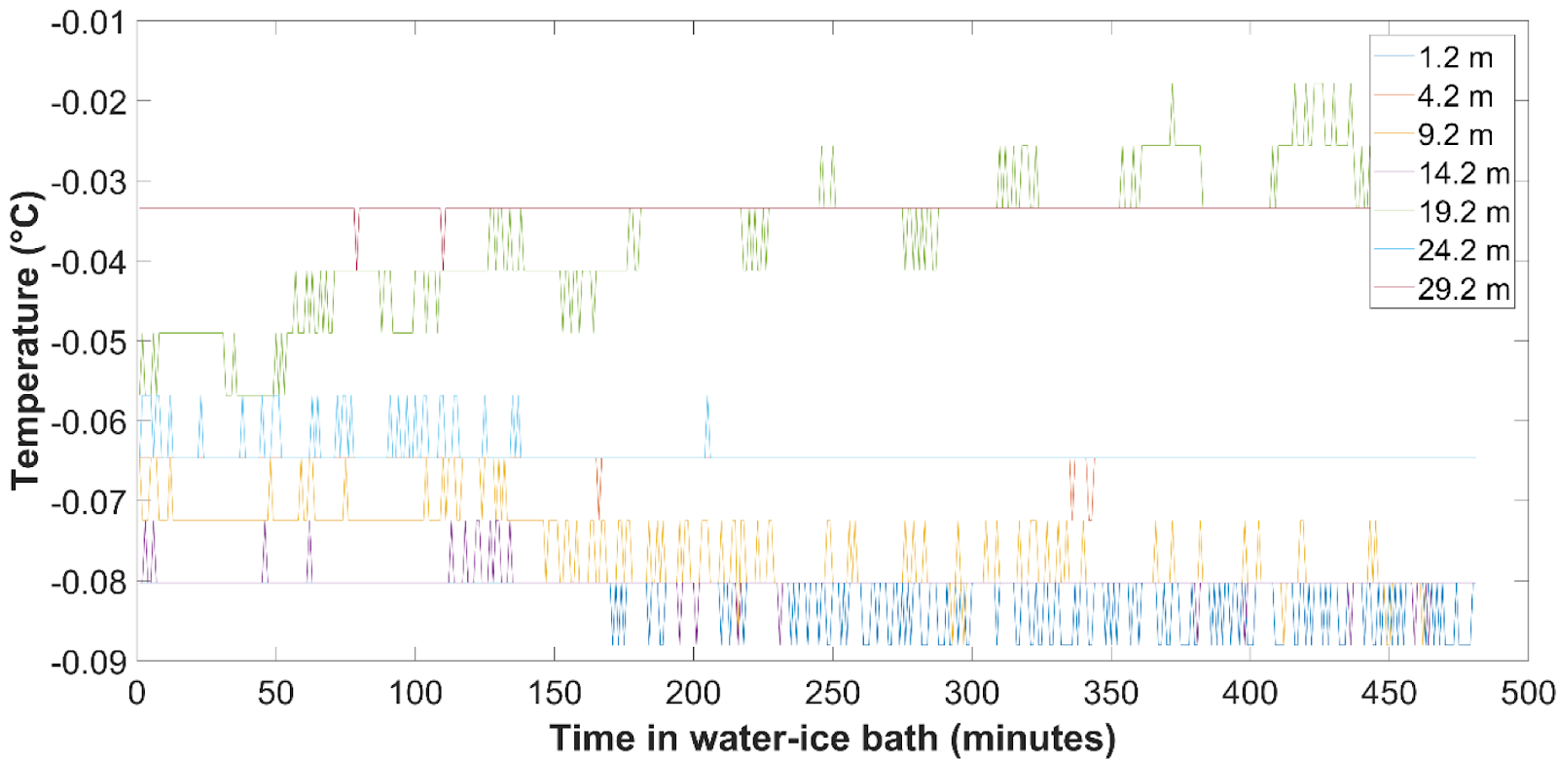

**Figure A3:** The thermistors were immersed in a water-ice bath to measure sensor offsets at 0 °C. Stable conditions for 480 minutes of submergence are shown. The mean offset for each node was used as a correction for calibration shown in Equation A.2.

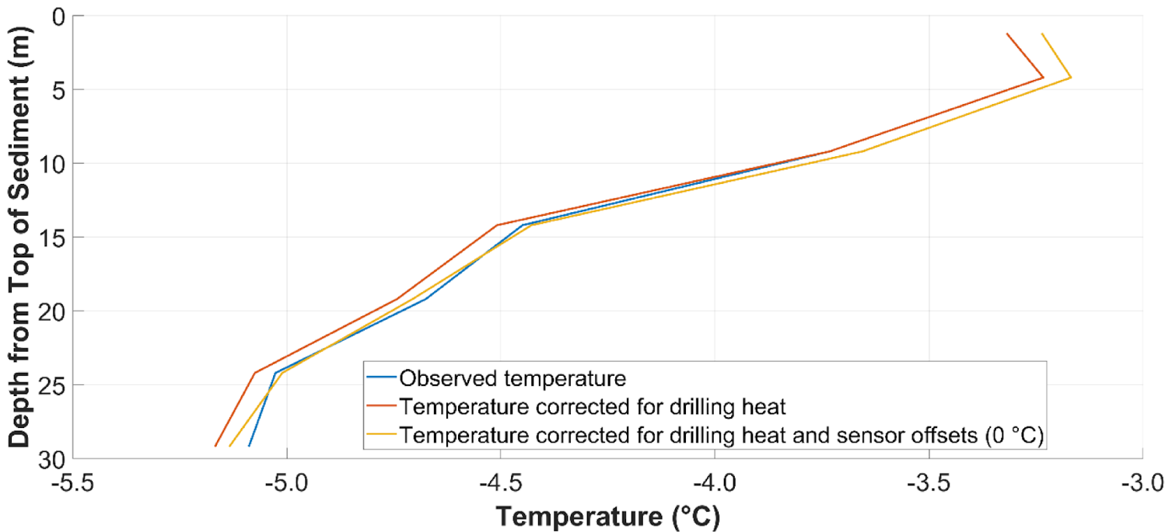

**Figure A4:** The observed temperatures (blue curve) are plotted together with the drilling heat corrected temperatures (red curve), as well as the final temperature profile corrected for drilling heat and sensor offsets at 0 °C (yellow curve).

# Supplementary Figures and Tables

## Supplementary Figures

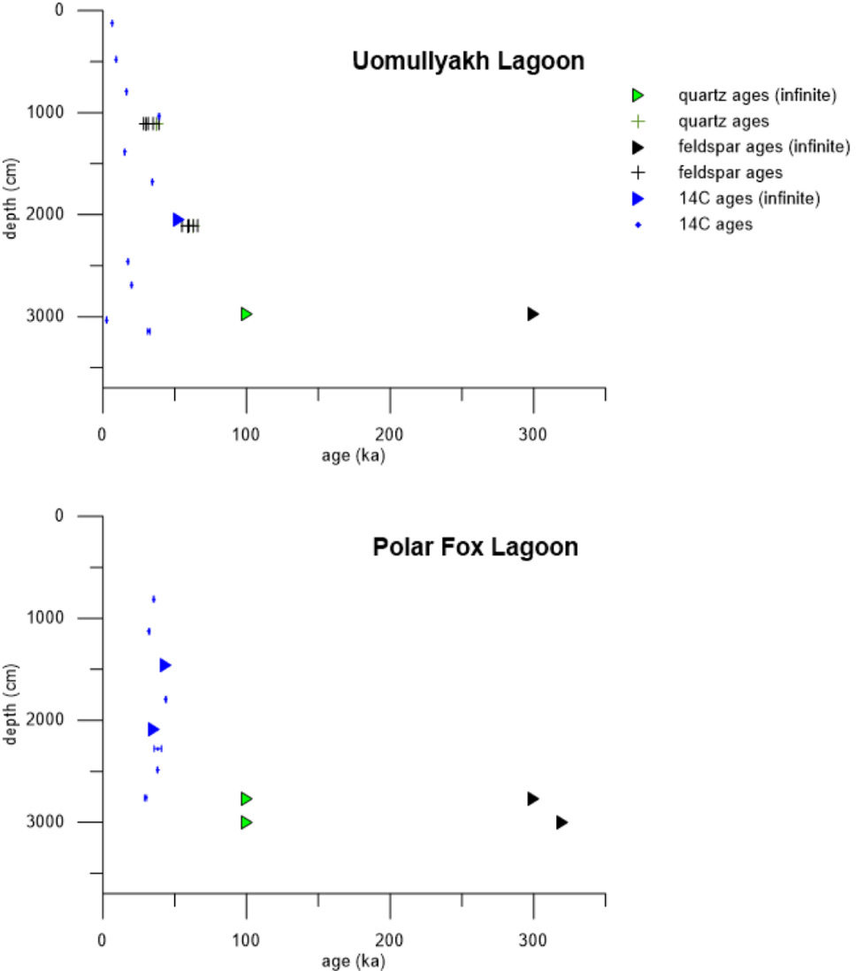

**Supplementary Figure S1.** Geochronology of the Uomullyakh core (top) and Polar Fox core (bottom) - Uncalibrated radiocarbon ages (blue), pIRIR290 feldspar ages (black) and IR-OSL quartz ages (green). Triangles mark infinite ages. Error bars indicate the uncertainty.

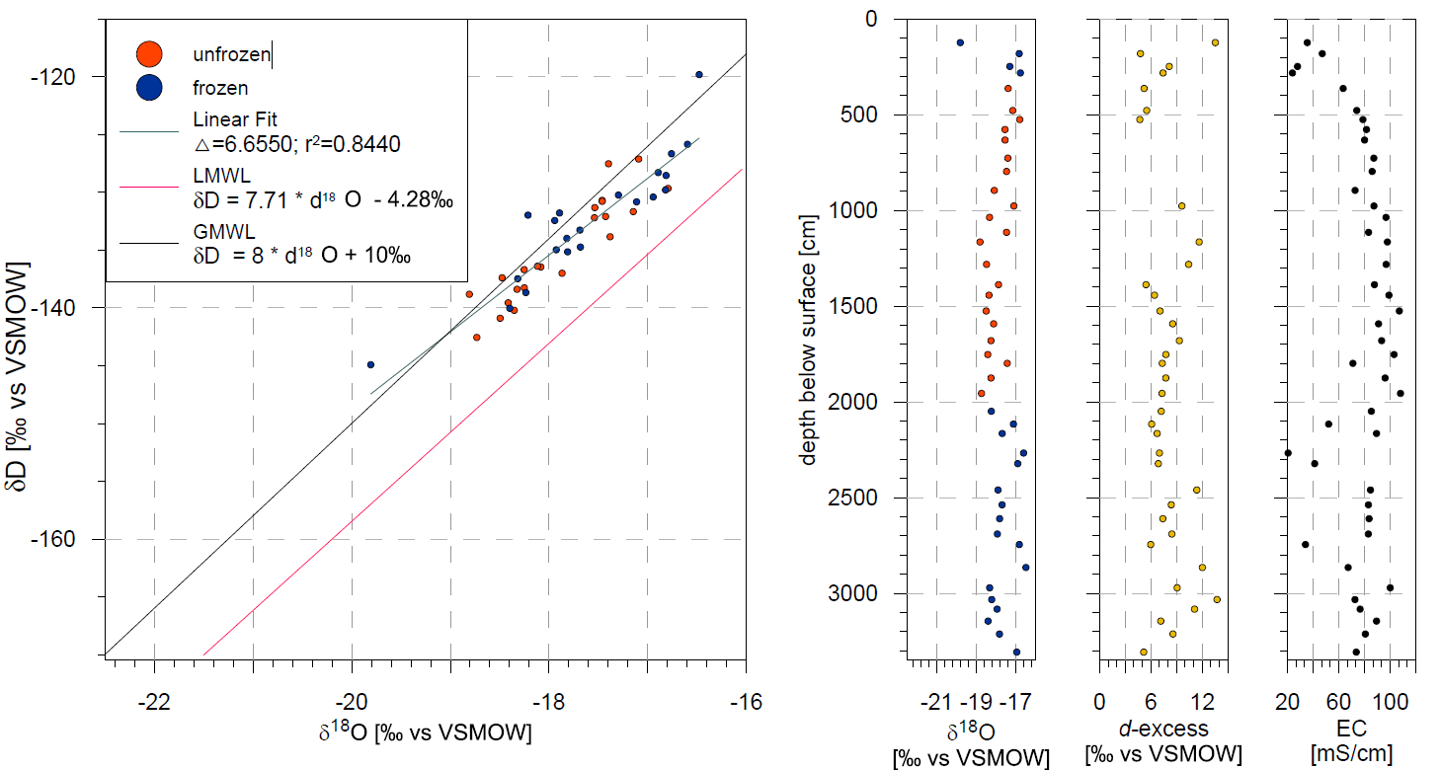

**Supplementary Figure S2.** Stable water isotope composition of Uomullyakh Lagoon core pore water: a) δD versus δ18O; b) δ18O distribution over depth; and c) High scattering of d-excess values over depth indicating secondary fractionation processes.

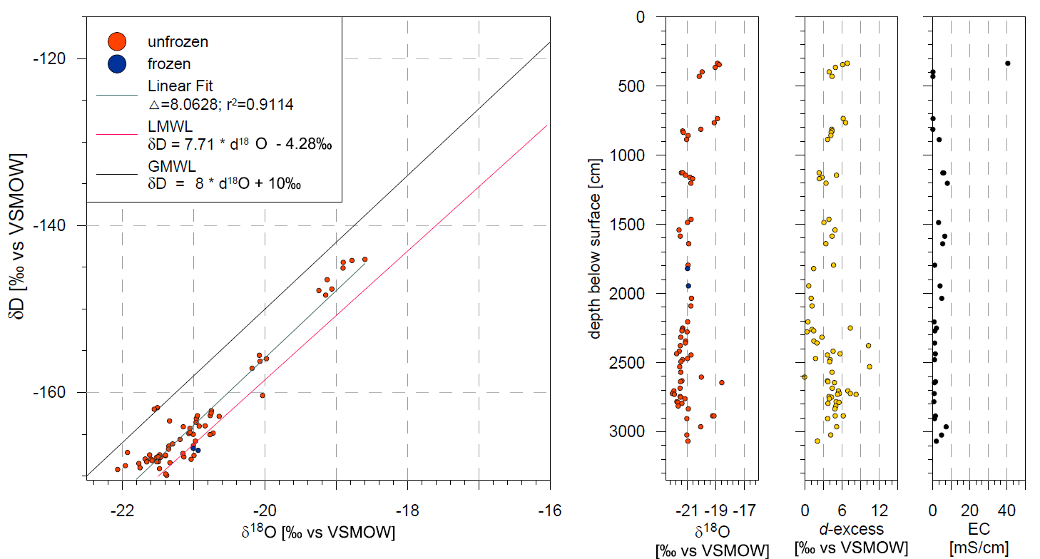

**Supplementary Figure S3.** Stable water isotopic composition of Polar Fox Lagoon core pore water: a) δD versus δ18O; b) δ18O distribution over depth; and c) Scattering of d-excess values over depth indicating secondary fractionation processes.

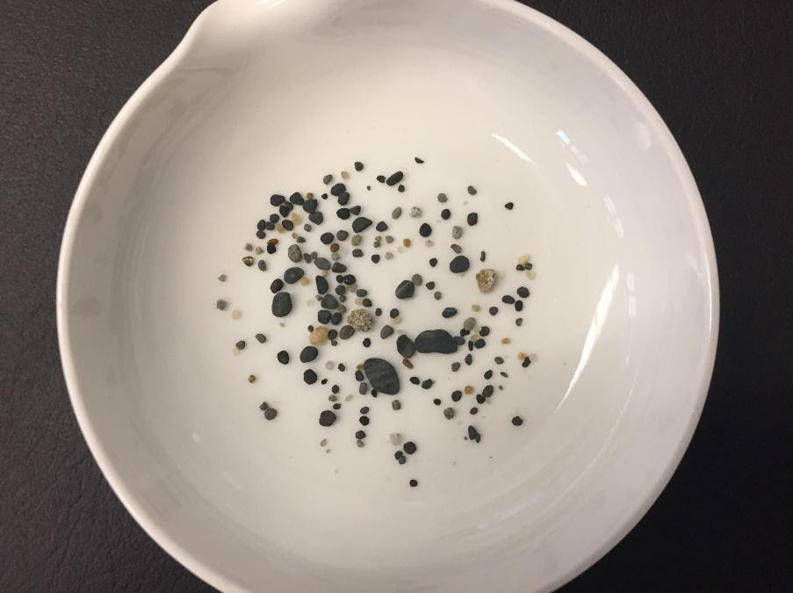

**Supplementary Figure S4.** Rounded gravel and pebbles >1mm indicating alluvial deposition from Uomullyakh core in 2400 cm depth (Unit UoL-III).

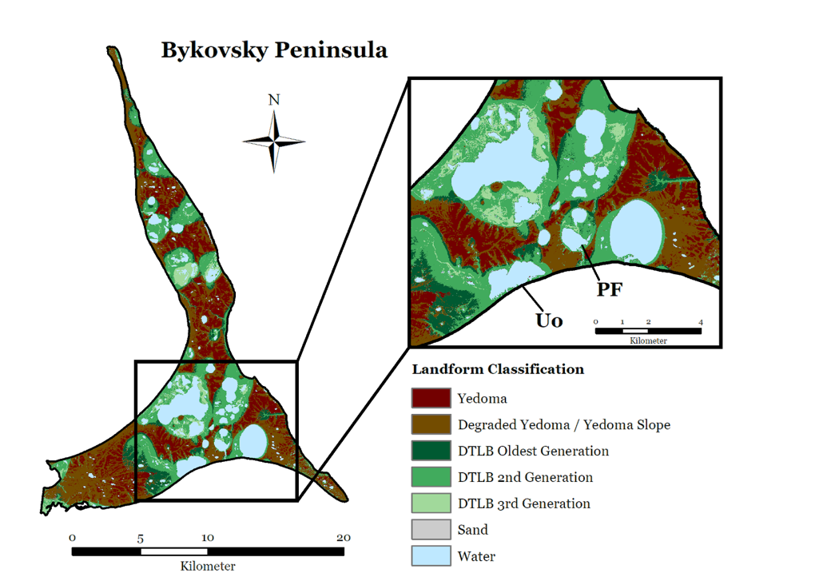

**Supplementary Figure S5.** Drained thermokarst lake basins (DTLB) of different generations suggest preferred drainage directions; Figure modified after Fuchs et al. 2018. Thermokarst lagoons described in this study indicated: Uomullyakh Lagoon (UoL) and Polar Fox Lagoon (PFL).

## Supplementary Tables

**Supplementary Table S1.** Electrical conductivity (EC) of pore water (at standard reference temperature (T)) and surface water (at field temperature) measured at different locations. High seasonal variability is driven by freshwater input of Lena River discharge and ice melt with peaks in summer.

|  |  |  |  |  |
| --- | --- | --- | --- | --- |
| Site | Sampling information | T [°C] | EC [mS/cm] | Citation |
| Uomullyakh  Lagoon | SW in July 2017 | 5.4 – 8.8 | 0.5 – 0.9 | Angelopoulos (unpublished data) |
| PW April 2017 | 25°C | 21 – 108 | this study |
| Polar Fox  Lagoon | SW April 2017  SW July 2017  SW April 2019 | - 0.75  8.5 – 9.5  -2.4 to -2.0 | 11.0  1.0  24.8 - 33.2 | Spangenberg et al. (2020)  Angelopoulos et al. (2020a)  Angelopoulos et al. (2020a) |
| PW April 2017 | 25°C | 0.6 – 41.0 | this study |
| Ivashkina  Lagoon | SW late summer 2016 |  | 5.8 – 6.4 | Overduin (unpublished data) |
| PW May 1999 | 25°C | 0.4 – 2.9 | Schirrmeister et al. (2018) |
| Goltsovoye  Lake | SW April 2017 | 0 – 1.8 | 0.3 | Spangenberg et al. (2020) |
| Tiksi Bay | SW 03/04 2011–15  SW April 2017  SW July 2017 | - 1 – 0  - 0.8  6 – 7 | 7.8 – 11.1  3.8  0.8 – 1.0 | Charkin et al. (2017)  Angelopoulos et al. (2020a)  Angelopoulos et al. (2019; 2020a) |
| SW – surface water; PW – pore water; | | | | |

Supplementary Table S2. δ13C and atomic TOC/TN ranges for plants from different environments; *C4 plants are not present in the Arctic

|  |  |  |  |
| --- | --- | --- | --- |
| Environment | δ 13C range | C/N range | Reference |
| Marine | -21.7‰ to -17.3‰ | 4 to 10 | Meyers (1994) |
| Brackish | -24‰ to -22‰ | 4 to 27 | Gearing (1988); Voß and Struck (1997); Westman and Hedenström (2002); Emeis et al. (2003); Mackie et al. (2005) |
| Freshwater  - plants  - plankton | -50‰ to -10‰  -33‰ to -24‰  -30‰ to -25‰ | 4 to 10 | Osmond et al. 1981; Keeley and Sandquist (1992); Meyers (1994) |
| Terrestrial  - C3 plants  - C4 plants* | -32‰ to -20‰  -15‰ to -12‰ | >20 | Smith and Epstein (1971); O´Leary (1988);  Meyers (1994) |

**Supplementary Table S3.** Radiocarbon ages of Uomullyakh Lagoon (PG2410) and Polar Fox Lagoon (PG2411) sediment core. Dated material were either plant and wood remains or the total organic fraction of the sediment. The calibrations were carried out using the CALIB 7.1 software and the IntCal13.

|  |  |  |  |  |  |  |  |  |
| --- | --- | --- | --- | --- | --- | --- | --- | --- |
| **MICADAS ID** | **Lab ID** | **Composite depth range [cm]** | **Material** | **TOC [wt%]** | **weight [µgC]** | **14C age with error [ka]** | **2σ-range [cal.]** | **Rounded cal. ages with error [cal ka BP]** |
| 4319.1.1 | PG2410-01 | 120-126 | bulk TOC | 2.03 | 627 | 6.429 ± 0.027 | 7293-7423 | 7.4 ± 0.1 |
| 4320.1.1 | PG2410-05-6 | 476-479 | bulk TOC | 4.12 | 594 | 9.267 ± 0.029 | 7160-7262 | 10.5 ± 0.1 |
| 4321.1.1 | PG2410-08-1 | 793-799 | bulk TOC | 3.59 | 613 | 16.468 ± 0.041 | 19666-20054 | 19.9 ± 0.2 |
| 4322.1.1 | PG2410-09-2 | 1032-1040 | bulk TOC | 3.01 | 560 | 39.096 ± 0.366 | 42378-43496 | 43.0 ± 0.6 |
| 4337.1.1 | PG2410-12-11 | 1385-1390 | Plant/Wood |  | 198 | 15.179 ± 0.128 | 18103-18722 | 18.4 ± 0.3 |
| 4323.1.1 | PG2410-14-1 | 1670-1690 | bulk TOC | 1.09 | 655 | 34.292 ± 0.132 | 38443-39101 | 38.8 ± 0.3 |
| 4552.1.1 | PG2410-16-4 | 2045-2053 | Plant/Wood |  | 700 | >53.228 |  | >53.2 |
| 4324.1.1 | PG2410-18-1 | 2450-2470 | bulk TOC | 0.55 | 541 | 17.522 ± 0.045 | 20946-21379 | 21.2 ± 0.2 |
| 4325.1.1 | PG2410-18-11 | 2675-2705 | bulk TOC | 0.57 | 272 | 19.955 ± 0.203 | 23512-24481 | 24.0 ± 0.5 |
| 4551.1.1 | PG2410-20-3 | 3030-3035 | Plant/Wood |  | 245 | 2.520 ± 0.054 | 2427-2751 | 2.6 ± 0.2 |
| 4326.1.1 | PG2410-21-2 | 3140-3150 | Bulk | 0.43 | 418 | 31.973 ± 0.826 | 34379-38151 | 36.3± 1.9 |
| 4327.1.1 | PG2411-02 | 805-820 | Bulk | 2.00 | 695 | 35.387 ± 0.240 | 39348-40593 | 40.0 ± 0.6 |
| 4328.1.1 | PG2411-03 | 1120-1135 | Bulk | 1.00 | 520 | 32.201 ± 0.117 | 35764-36381 | 36.1± 0.4 |
| 4335.1.1 | PG2411-04-1 | 1460-1468 | Plant/Wood |  | 838 | >53259 |  | >53.3 |
| 4336.1.1 | PG2411-06-1 | 1790-1800 | Plant/Wood |  | 750 | 43.859 ± 0.30 | 46240-47894 | 47.1 ± 0.8 |
| 4329.1.1 | PG2411-9-4 | 2085-2095 | Bulk | 0.59 | 367 | >35500 |  | >35.5 |
| 4330.1.1 | PG2411-11 | 2275-2280 | Bulk | <0.1 | 336 | 38.179 ± 2.544 | 36744-46603 | 41.7 ± 0.5 |
| 4331.1.1 | PG2411-12-3 | 2484-2487 | Bulk | NA | 356 | 38.012 ± 0.214 | 41902-42581 | 42.2 ± 0.3 |
| 4332.1.1 | PG2411-15 | 2760-2762 | Bulk | 0.52 | 203 | 29.640 ± 0.655 | 32013-34887 | 33.5 ± 0.1 |

**Supplementary Table S4.** Results of luminescence dating of Uomullyakh Lagoon (UoL) and Polar Fox Lagoon (PFL) sediment cores. **W.c.** – water content, is assumed mean lifetime water content, based on measured saturation values, **IR50 De** – dose of infrared stimulated luminescence, **n** – is the number of aliquots measured to give the equivalent dose (De), **pIRIR De** – dose of post-infrared infrared stimulated luminescence, **OSL De** – dose of optic stimulated luminescence. **Dose rates** include the effects of water content, grain attenuation, and (in the case of feldspar) an internal dose rate largely arising from the assumed K content of 12.5±0.5%. A cosmic ray contribution has also been included.

|  |  |  |  |  |  |  |  |  |  |  |  |  |  |  |  |  |
| --- | --- | --- | --- | --- | --- | --- | --- | --- | --- | --- | --- | --- | --- | --- | --- | --- |
| Site | OSL-Lab code | Depth (cm) | w.c.  (%) | IR50De  (Gy) | n | pIRIR De (Gy) | n | | OSL De  (Gy) | n | feldspar dose rate  (Gy/ka) | quartz dose rate  (Gy/ka) | IR50 age (ka) | | pIRIR age  (ka) | OSL age  (ka) |
| UoL | 1950  01 | 1107 | 44 | 55 ± 3 | 9 | 100 ± 4 | 9 | | 90 ± 5 | 30 | 3.36 ± 0.10 | 2.42 ± 0.08 | 17.6 ± 1.2 | | 29.9 ± 1.6 | 37 ± 2 |
| UoL | 1950  02 | 2108 | 28 | 114 ± 13 | 8 | 162 ± 10 | 8 | | 115 ± 4 | 27 | 2.75 ± 0.09 | 1.81 ± 0.07 | 41 ± 5 | | 59 ± 4 | 63 ± 3 |
| UoL | 1950  03 | 2978 | 25 | >500 | 9 | >900 | 9 | | >200 | 35 | 3.04 ± 0.10 | 2.10 ± 0.08 | >160 | | >300 | >100 |
| PFL | 1950  04 | 2771 | 21 | >500 | 9 | >900 | 8 | | >200 | 26 | 2.85 ± 0.10 | 1.91 ± 0.07 | >180 | | >320 | >100 |
| PFL | 1950  05 | 3002 | 31 | >500 | 7 | >900 | 8 | | >200 | 24 | 2.53 ± 0.09 | 1.59 ± 0.06 | >200 | | >360 | >130 |
| GoL | 1950 06 | 1534 | 34 | 94 ± 6 | 9 | 155 ± 6 | 9 | 113 ± 5 | | 23 | 3.55 ± 0.11 | 2.61 ± 0.09 | 26 ± 2 | 44 ± 2 | | 43 ± 2 |
| GoL | 1950 07 | 1763 | 23 | 101 ± 8 | 8 | 158 ± 9 | 8 | | 114 ± 6 | 25 | 3.76 ± 0.13 | 2.82 ± 0.11 | 27 ± 2 | | 42 ± 3 | 41 ± 3 |
| GoL | 1950 08 | 3156 | 27 | 145 ± 9 | 8 | 235 ± 12 | 8 | | 169 ± 10 | 20 | 3.30 ± 0.11 | 2.36 ± 0.09 | 44 ± 3 | | 71 ± 5 | 71 ± 5 |
| GoL | 1950 09 | 3513 | 35 | >500 | 6 | >900 | 5 | | >200 | 17 | 3.25 ± 0.10 | 2.31 ± 0.08 | >150 | | >280 | >90 |

**Supplementary Table S5.** Summary of radionuclide concentrations and resulting infinite matrix dry dose rates. The dose rates are calculated assuming a 222Rn/226Ra activity ratio of 0.80±0.10. The 226Ra/238U ratio, averaged over all the samples, is 0.93±0.11 (n=5). There is no evidence for any significant disequilibrium in the first part of the 238U decay series.

|  |  |  |  |  |  |  |  |  |
| --- | --- | --- | --- | --- | --- | --- | --- | --- |
| Site | OSL-Lab code | Depth (cm) | 238U  (Bq. kg-1) | 226Ra (Bq. kg-1) | 232Th  (Bq. kg-1) | 40K  (Bq. kg-1) | beta dose rate (Bq. kg-1) | gamma dose rate (Bq. kg-1) |
| UoL | 1950  01 | 1107 | 42 ± 6 | 35.9 ± 0.6 | 45.0 ± 0.6 | 730 ± 13 | 2.51 ± 0.04 | 1.36 ± 0.03 |
| UoL | 1950  02 | 2108 | 29 ± 5 | 16.5 ± 0.4 | 23.0 ± 0.5 | 556 ± 9 | 1.72 ± 0.02 | 0.82 ± 0.02 |
| UoL | 1950  03 | 2978 | 13 ± 2 | 15.7 ± 0.2 | 20.8 ± 0.2 | 681 ±6 | 2.02 ± 0.02 | 0.89 ± 0.01 |
| PFL | 1950  04 | 2771 | 18 ± 2 | 16.1 ± 0.2 | 21.6 ± 0.2 | 566 ±5 | 1.74 ± 0.02 | 0.81 ± 0.01 |
| PFL | 1950  05 | 3002 | 9 ± 1 | 9.9 ± 0.2 | 13.0 ± 0.2 | 577 ±6 | 1.64 ± 0.02 | 0.68 ± 0.01 |

**Supplementary Table S6.** Statistical summary of biogeochemical results for Uomullyakh Lagoon. The atomic TOC/TN value was calculated by multiplying the obtained values with 1.167, which is the division of the atomic weight of nitrogen (14.007 amu) and carbon (12.001 amu).

|  |  |  |  |  |  |  |  |  |  |
| --- | --- | --- | --- | --- | --- | --- | --- | --- | --- |
| **Statistics of biogeochemical results for Uomullyakh Lagoon** | | | | | | | | | |
| Statistical  parameter | TC [wt%] | TIC [wt%] | TOC [wt%] | TN [wt%] | TOC/TN | | δ13C  [‰ VPDB] | δ15N [‰] |
| obtained value | atomic |
| minimum | 0.23 | 0.00 | 0.00 | 0.00 | 11.33 | 13.22 | -27.71 | 1.26 |
| maximum | 7.09 | 0.80 | 6.70 | 0.42 | 16.35 | 19.08 | -24.11 | 3.28 |
| mean | 1.96 | 0.33 | 1.63 | 0.09 | 13.61 | 15.88 | -25.99 | 2.75 |
| median | 1.62 | 0.35 | 1.11 | 0.00 | 13.66 | 15.94 | -26.14 | 2.57 |

**Supplementary Table S7.** Statistical summary of biogeochemical results for Polar Fox Lagoon. The atomic TOC/TN value was calculated by multiplying the obtained values with 1.167, which is the division of the atomic weight of nitrogen (14.007 amu) and carbon (12.001 amu).

|  |  |  |  |  |  |  |  |  |
| --- | --- | --- | --- | --- | --- | --- | --- | --- |
| **Statistics of biogeochemical results for Polar Fox Lagoon** | | | | | | | | |
| Statistical  parameter | TC [wt%] | TIC [wt%] | TOC [wt%] | TN [wt%] | TOC/TN | | δ13C [‰ VPDB] | δ15N [‰] |
| obtained value | atomic |
| minimum | 0.22 | 6.79 | 0.00 | 0.00 | 6.79 | 7.93 | -27.52 | 1.90 |
| maximum | 4.13 | 15.39 | 4.03 | 0.27 | 15.39 | 17.97 | -23.35 | 3.30 |
| mean | 1.15 | 11.16 | 0.76 | 0.04 | 11.16 | 13.02 | -25.02 | 2.79 |
| median | 0.77 | 10.73 | 0.51 | 0.00 | 10.73 | 12.53 | -24.68 | 2.80 |

**Supplementary Table S8.** Statistics summary of hydrochemical results for Uomullyakh Lagoon (UoL) and Polar Fox Lagoon (PFL)

|  |  |  |  |  |  |  |  |  |  |  |  |  |  |  |  |  |  |  |  |  |  |  |  |  |  |  |  |  |  |  |
| --- | --- | --- | --- | --- | --- | --- | --- | --- | --- | --- | --- | --- | --- | --- | --- | --- | --- | --- | --- | --- | --- | --- | --- | --- | --- | --- | --- | --- | --- | --- |
| Statistical para-meter | pH | | | | | EC (mS/cm) | | | | | DOC (mg/l) | | | | | δ18O (‰ vs. SMOW) | | | | | δD (‰ vs. SMOW) | | | | | d-excess (‰ vs. SMOW) | | | | |
| UoL | | PFL | | UoL | | | PFL | | UoL | | | PFL | | UoL | | | PFL | | UoL | | | PFL | | UoL | | | PFL | |
| minimum | 6.9 | 6.8 | | 20.5 | | | 0.6 | | 14.9 | | | 24.6 | | -19.8 | | | -22.1 | | -144.9 | | | -169.9 | | 4.7 | | | -0.1 | |
| maximum | 8.1 | 8.82 | | 108.1 | | | 40.5 | | 282.4 | | | 221.4 | | -16.5 | | | -18.6 | | -119.8 | | | -144.0 | | 13.7 | | | 10.4 | |
| mean | 7.5 | 7.9 | | 76.6 | | | 6.5 | | 81.6 | | | 71.2 | | -17.7 | | | -20.9 | | -133.7 | | | -163.4 | | 8.1 | | | 4.1 | |
| median | 7.5 | 8.0 | | 83.1 | | | 3.3 | | 58.0 | | | 50.0 | | -17.8 | | | -21.1 | | -133.3 | | | -166.3 | | 7.4 | | | 4.2 | |
| standard deviation | 0.27 | 0.52 | | 22.82 | | | 9.82 | | 61.17 | | | 43.39 | | 0.70 | | | 0.84 | | 5.07 | | | 7.08 | | 2.36 | | | 2.10 | |

# References

Aitken, M. J. 1985. “Thermoluminescence Dating: Past Progress and Future Trends.” *Nuclear Tracks and Radiation Measurements (1982)*, Special Issue Theory and Practice of Thermally Stimulated Luminescence and Related Phenomena, 10 (1): 3–6. https://doi.org/10.1016/0735-245X(85)90003-1.

Blott, S.J., and Pye, K. (2001). GRADISTAT: A Grain Size Distribution and Statistics Package for the Analysis of Unconsolidated Sediments. *Earth Surface Processes and Landforms* 26 (11): 1237–48. https://doi.org/10.1002/esp.261.

Emeis, Kay-Christian, Ulrich Struck, Thomas Blanz, Alexander Kohly, and Maren Voβ. 2003. “Salinity Changes in the Central Baltic Sea (NW Europe) over the Last 10000 Years:” *The Holocene*. https://doi.org/10.1191/0959683603hl634rp.

Folk, R.L., and Ward, W.C. (1957). Brazos River Bar [Texas]; a Study in the Significance of Grain Size Parameters. *Journal of Sedimentary Resea*

Fuchs, M., Grosse, G., Strauss, J., Günther, F., Grigoriev, M., Maximov, G.M. and Hugelius, G. (2018). Carbon and Nitrogen Pools in Thermokarst-Affected Permafrost Landscapes in Arctic Siberia. *Biogeosciences* 15 (3): 953–71. https://doi.org/10.5194/bg-15-953-2018.

Gearing, J. N. 1988. “The Use of Stable Isotope Ratios for Tracing the Nearshore-Offshore Exchange of Organic Matter.” In *Coastal-Offshore Ecosystem Interactions*, edited by Bengt-Owe Jansson, 69–101. Lecture Notes on Coastal and Estuarine Studies. Berlin, Heidelberg: Springer. https://doi.org/10.1007/978-3-642-52452-3_4.

GISTEMP Team, 2020: *GISS Surface Temperature Analysis (GISTEMP), version 4*. NASA Goddard Institute for Space Studies. Dataset accessed 2020-22-26 at data.giss.nasa.gov/gistemp/.

Guérin, G, N Mercier, and G Adamiec. 2011. “Dose-Rate Conversion Factors: Update” 29: 4.

Keeley, J. E., and D. R. Sandquist. 1992. “Carbon: Freshwater Plants.” *Plant, Cell & Environment* 15 (9): 1021–35. https://doi.org/10.1111/j.1365-3040.1992.tb01653.x.

Lachenbruch, Arthur H., and Max C. Brewer. 1959. *Dissipation of the Temperature Effect of Drilling a Well in Arctic Alaska*. U.S. Government Printing Office.

Lenssen, N., Schmidt, G., Hansen, J., Menne, M., Persin, A., Ruedy, R. and Zyss, D. (2019).

Improvements in the GISTEMP uncertainty model. *J. Geophys. Res. Atmos.*, **124**, no. 12, 6307-6326, doi:10.1029/2018JD029522.

Lide, D. R., G. Baysinger, H. V. Kehiaian, L. I. Berger, K. Kuchitsu, R. N. Goldberg, D. L. Roth, W. M. Haynes, and D. Zwillinger (2008), Proper- ties of ice and supercooled water, in CRC Handbook of Chemistry and Physics, edited by D. R. Lide et al., p. 1101, CRC Press, Boca Raton, Florida.

Mackie, Elizabeth A. V., Melanie J. Leng, Jeremy M. Lloyd, and Carol Arrowsmith. 2005. “Bulk Organic Δ13C and C/N Ratios as Palaeosalinity Indicators within a Scottish Isolation Basin.” *Journal of Quaternary Science* 20 (4): 303–12. https://doi.org/10.1002/jqs.919.

Möller, P., and Murray, A.S. (2015). Drumlinised Glaciofluvial and Glaciolacustrine Sediments on the Småland Peneplain, South Sweden – New Information on the Growth and Decay History of the Fennoscandian Ice Sheets during MIS 3. *Quaternary Science Reviews* 122 (August): 1–29. https://doi.org/10.1016/j.quascirev.2015.04.025.

Murray, A. S.; Helsted, L. M.; Autzen, M.; Jain, M.; Buylaert, J. P. (2018). Measurement of natural radioactivity: Calibration and performance of a high-resolution gamma spectrometry facility. Radiation Measurements 120, 215-220. https://doi.org/10.1016/j.radmeas.2018.04.006.

Murray A.S., Thomsen K.J., Masuda N., Buylaert J.P. and Jain M. (2012). Identifying well-bleached quartz using the different bleaching rates of quartz and feldspar luminescence signals. Radiation Measurements 47, 688-695. https://doi.org/10.1016/j.radmeas.2012.05.006.

Murray A.S. and Wintle A.G. (2003). The single aliquot regenerative dose protocol: potential for improvements in reliability. Radiation Measurements 37, 377-381. https://doi.org/10.1016/S1350-4487(03)00053-2.

Murray A.S. and Wintle A.G (2000). Luminescence dating of quartz using an improved single-aliquot regenerative-dose protocol. Radiation Measurements 32, 57-73. https://doi.org/10.1016/S1350-4487(99)00253-X.

Murray A.S., Marten R., Johnston A., Martin P.  (1987). Analysis for naturally occuring radionuclides at environmental concentrations by gamma spectrometry. Journal of Radioanalytical and Nuclear Chemistry 115, 263–288

Murray A.S. and Wintle A.G. (2003). The single aliquot regenerative dose protocol: potential for improvements in reliability. Radiation Measurements 37, 377-381. https://doi.org/10.1016/S1350-4487(03)00053-2.

Murray A.S. and Wintle A.G (2000). Luminescence dating of quartz using an improved single-aliquot regenerative-dose protocol. Radiation Measurements 32, 57-73. https://doi.org/10.1016/S1350-4487(99)00253-X.

O´Leary, Marion H. 1988. “Carbon Isotopes in Photosynthesis.” *BioScience* 38 (5): 9.

Osmond, C. B., N. Valaane, S. M. Haslam, P. Uotila, and Z. Roksandic. 1981. “Comparisons of Δ13C Values in Leaves of Aquatic Macrophytes from Different Habitats in Britain and Finland; Some Implications for Photosynthetic Processes in Aquatic Plants.” *Oecologia* 50 (1): 117–24. https://doi.org/10.1007/BF00378804.

Prescott, J. R., Hutton, J. T. (1994). Cosmic ray contributions to dose rates for luminescence and ESR dating: large depths and long-term variations. *Radiation Measurements* 23, 497–500. https://doi.org/10.1016/1350-4487(94)90086-8

Rowell, David L. 1994. *Soil Science: Methods and Applications*. Longman Scientific & Technical.

Smith, Bruce N., and Samuel Epstein. 1971. “Two Categories of 13C/12C Ratios for Higher Plants 1.” *Plant Physiology* 47 (3): 380–84.

Thomsen K.J., Bøtter-Jensen L., Jain M., Denby P.M. and Murray A.S. 2008. Recent instrumental developments for trapped electron dosimetry. Radiation Measurements 43, 414-421. https://doi.org/10.1016/j.radmeas.2008.01.003

Voβ, Maren, and Ulrich Struck. 1997. “Stable Nitrogen and Carbon Isotopes as Indicator of Eutrophication of the Oder River (Baltic Sea).” *Marine Chemistry* 59 (1): 35–49. https://doi.org/10.1016/S0304-4203(97)00073-X.

Westman, Per, and Anna Hedenström. 2002. “Environmental Changes during Isolation Processes from the Litorina Sea as Reflected by Diatoms and Geochemical Parameters -a Case Study:” *The Holocene*. https://doi.org/10.1191/0959683602hl560rp.