**Supplementary Material**

for paper 638441

“Linking the variation of Sediment Accumulation Rate to short term sea-level change using cyclostratigraphy: case study of the Lower Berriasian hemipelagic sediments in central Tunisia (Southern Tethys)”

**Hamdi Omar1,2*, Anne-Christine Da Silva3 and Chokri Yaich1,2**

1Department of Geological Engineering, National Engineering School of Sfax, Sfax University, Tunisia.

2Laboratory of Georessources, Materials Environment and Global Change, Faculty of Sciences of Sfax, Street of Soukra km 3.5, PB 1171, 3000, Univ. of Sfax, Tunisia.

3Sedimentary Petrology Laboratory, Liège University, Allée du Six Août, 12, 4000 Liège, Belgium

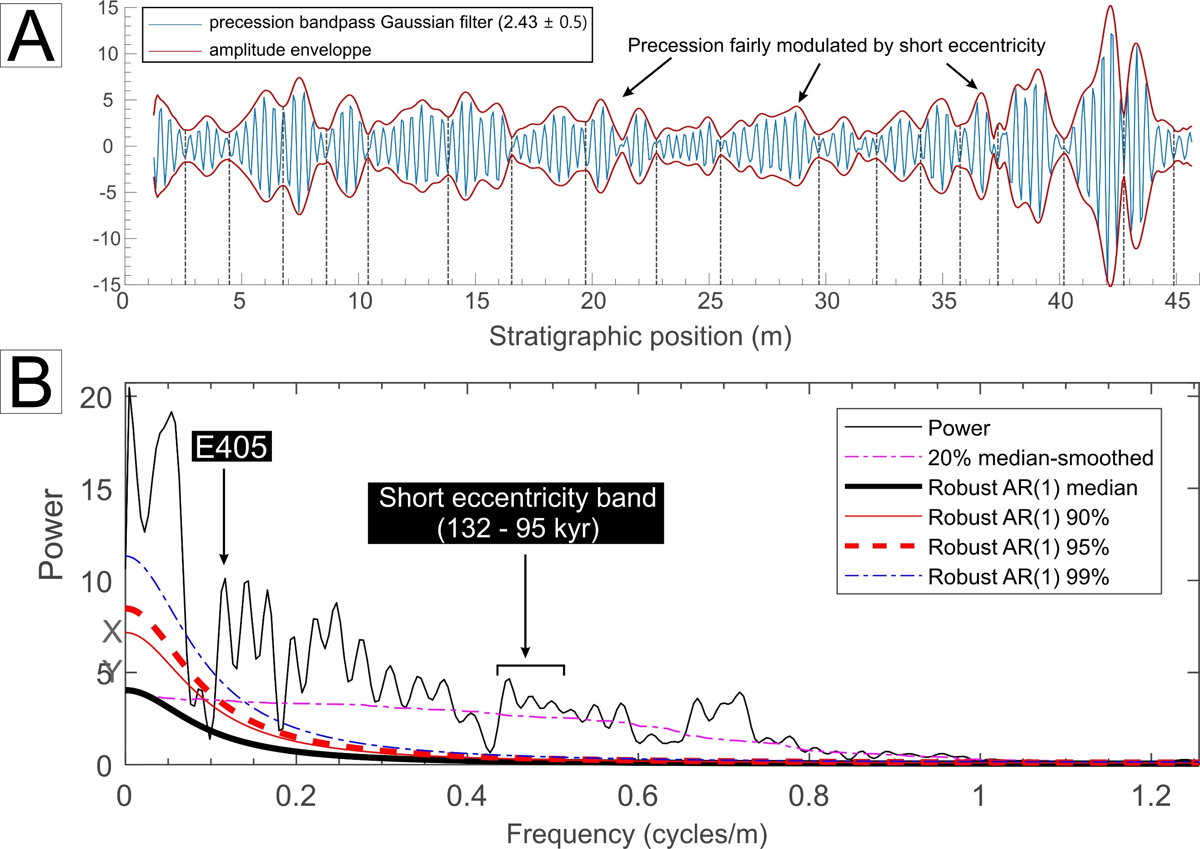

**Supplementary Figure S1.** Amplitude modulation applied on the frequency bandwidth that we consider to be the precession band. (**A**) The MS time series was filtered at a bandwidth centered around the frequency of 2.45 m-1 (precession band) and the MTM applied on the envelope of the amplitude variation yields a power spectrum (**B**) with a significant peak at the frequency that corresponds to short eccentricity (0.411 m-1). This result supports our interpreted Milankovitch frequencies revealed by the MTM in **Figure 5**.

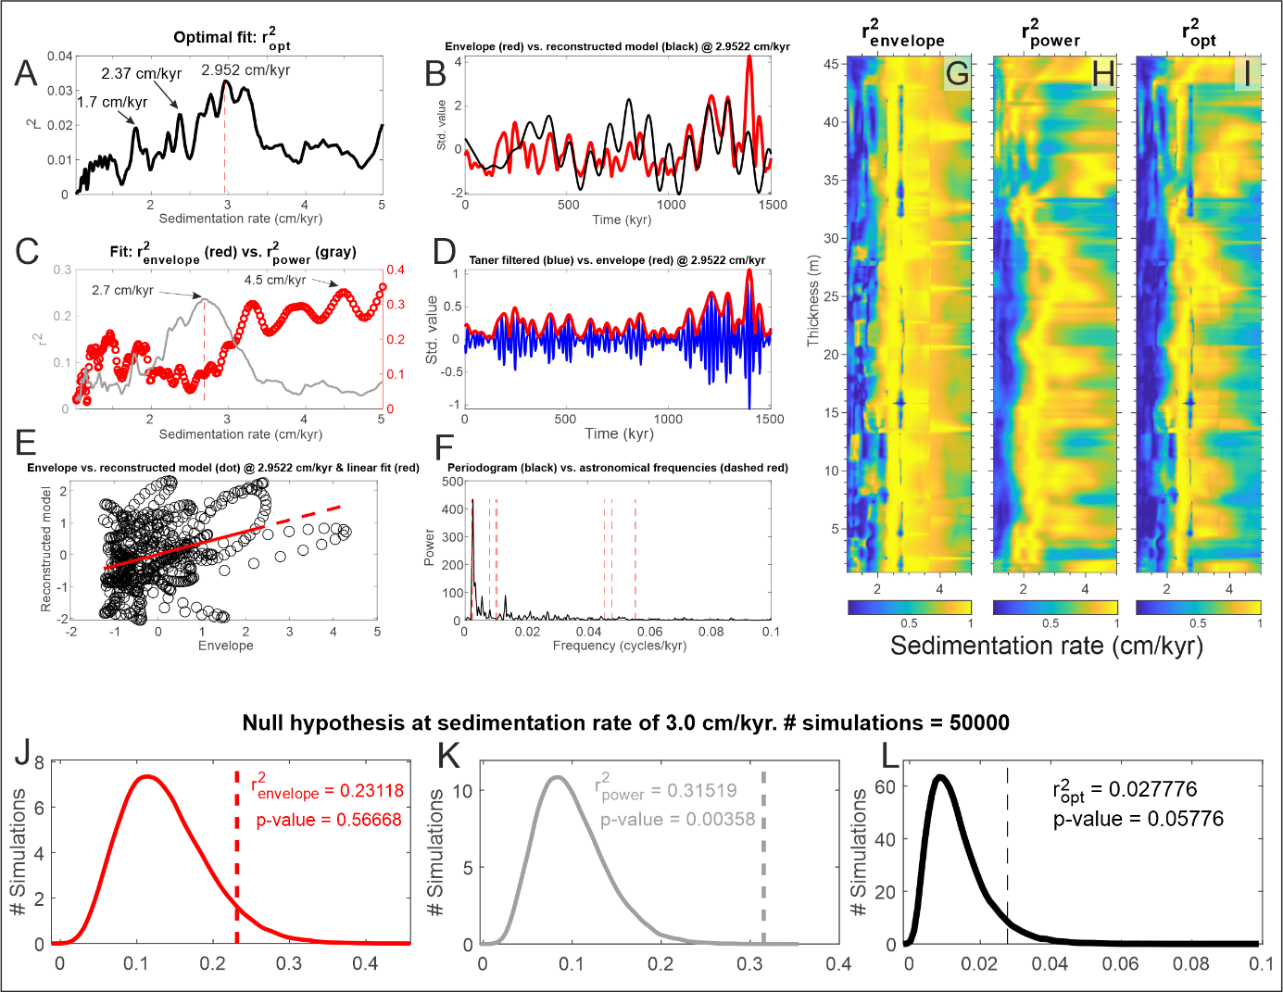

**Supplementary Figure S2.** TimeOpt (**A–F**) analysis, evolutive TimeOpt (eTimeOpt) (**G–I**) analysis using a moving normalized) window of 12 meters (**G–I**) and Monte Carlo simulation (**J–L**) results for the lower Sidi Khalif MS series for 200 test sedimentation rates from 1 to 5 cm/kyr. The Taner filter passband was set to flow = 0.045 cycles/kyr and fhigh = 0.069 cycles/kyr; the roll-off was set to 1012. The input orbital eccentricity model frequencies and precession index frequencies are from the La2004 solution. (**A**) The combined Pearson correlation coefficient r2opt = r2envelope × r2power indicating an optimal sedimentation rate of 2.952 cm/kyr. (**B**) Comparison of the precession band amplitude envelope (red) and eccentricity model (black) for the optimal sedimentation rate of 2.9522 cm/kyr. (**C**) Pearson correlation coefficient vs. test sedimentation rate for the amplitude envelope of the precession index band (r2envelope) and eccentricity model (r2power). (**D**) Taner-filtered precession band and amplitude envelope. (**E**) Paired amplitude envelope and eccentricity model points illustrating the correlation at the optimal sedimentation rate of 2.952 cm/kyr. (**F**). Unsmoothed power spectrum of the MS series evaluated as a time series at the optimal sedimentation rate of 4.642 cm/kyr. (**G**) Squared Pearson correlation coefficient for the amplitude envelope fit (r2envelope). (**H**) Squared Pearson correlation coefficient for the spectral power fit (r2power). (**I**) Results from the combined envelope and spectral fit (r2opt). (**J**) 50000 Monte Carlo simulations of AR1 red noise at the sedimentation rate indicated by the amplitude envelope of the precession index band (4.5 cm/kyr; r2envelope = 0.23118; p = 0.56668). (**K**) 50000 Monte Carlo simulations of AR1 red noise at the sedimentation rate indicated by the orbital eccentricity model (2.7 cm/kyr; r2power = 0.31519; p = 0.00358). (**L**) 50000 Monte Carlo simulations of AR1 red noise at the optimal sedimentation rate (2.9522 cm/kyr; r2opt = 0.027776, p = 0.05776).

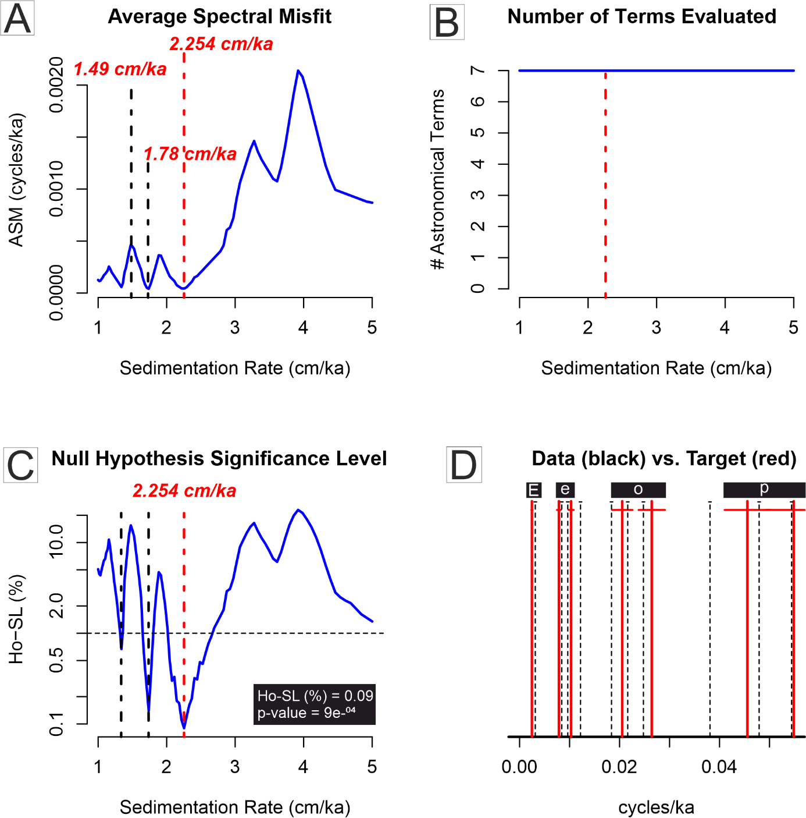

**Supplementary Figure S3.** ASM of untuned MS series applied over a range of sedimentation rates from 1 to 5 cm/kyr, using the astronomical target frequencies of Berger et al., 1992 around 145 Ma. The analysis was performed using Astrochron package (Meyers, 2014) under R software as updated in Meyers et al., 2012 (following the approach outlined in Meyers and Sageman (2007), and the improvements of Meyers et al., (2012)).

**Supplementary Table S1.** Frequency ratios of orbital periods of the Berriasian stage (Laskar et al., 2004)

|  |  |  |  |  |  |  |  |
| --- | --- | --- | --- | --- | --- | --- | --- |
| in kyr | *P2 (18)* | *P1 (22)* | *O (27)* | *O (36)* | *O (45)* | *e (100)* | *E (405)* |
| *P2 (18)* | 1 |  |  |  |  |  |  |
| *P1 (18)* | 0.81 | 1 |  |  |  |  |  |
| *O (27)* | 0.66 | 0.81 | 1 |  |  |  |  |
| *O (36)* | 0.5 | 0.61 | 0.75 | 1 |  |  |  |
| *O (45)* | 0.4 | 0.48 | 0.6 | 0.8 | 1 |  |  |
| *e (100)* | 0.18 | 0.22 | 0.27 | 0.36 | 0.45 | 1 |  |
| *E (405)* | 0.044 | 0.054 | 0.066 | 0.088 | 0.11 | 0.246 | 1 |

**Supplementary Table S2.** Frequency ratios of the untuned MS (black) and %CaCO3 (dark blue) MTM significant peaks

|  |  |  |  |  |  |  |  |
| --- | --- | --- | --- | --- | --- | --- | --- |
| in meter | 0.34 | 0.41 | 0.57 | 0.66 | 0.87 | 2.25 | 10 |
| 0.34 | 1 |  |  |  |  |  |  |
| 0.41 | 0.81 | 1 |  |  |  |  |  |
| 0.57 | 0.66 | 0.81 | 1 |  |  |  |  |
| 0.66 | 0.5 | 0.61 | 0.75 | 1 |  |  |  |
| 0.87 | 0.4 | 0.48 | 0.6 | 0.8 | 1 |  |  |
| 2.25 | 0.18 | 0.22 | 0.27 | 0.36 | 0.45 | 1 |  |
| 10 | 0.044 | 0.054 | 0.066 | 0.088 | 0.11 | 0.246 | 1 |
| in meter | **0.31** | **0.43** | **0.56** | **0.63** | **0.83** | **2.14** | **10.15** |
| 0.34 | 1 |  |  |  |  |  |  |
| 0.43 | 0.72 | 1 |  |  |  |  |  |
| 0.56 | 0.55 | 0.76 | 1 |  |  |  |  |
| 0.63 | 0.49 | 0.68 | 0.88 | 1 |  |  |  |
| 0.83 | 0.37 | 0.51 | 0.67 | 0.75 | 1 |  |  |
| 2.14 | 0.14 | 0.2 | 0.26 | 0.29 | 0.38 | 1 |  |
| 10.15 | 0.03 | 0.04 | 0.055 | 0.062 | 0.081 | 0.21 | 1 |