**Supplementary Table S1** Primers used for absolute quantification of microbial populations in cecal digesta of weaned piglets.

|  |  |  |  |
| --- | --- | --- | --- |
| Item | Primer (5′-3′) | Annealing temperature (℃) | Product length (bp) |
| Lactobacillus | Forward: GAGGCAGCAGTAGGGAATCTTC | 60 | 118 |
|  | Reverse: CAACAGTTACTCTGACACCCGTTCTTC |  |  |
| Clostridium_sensu_stricto_1 | Forward: ATGCAAGTCGAGCGAKG | 55 | 120 |
|  | Reverse: TATGCGGTATTAATCTYCCTTT |  |  |
| Terrisporobacter | Forward: CGCAACCCTTGCCTTTAGT | 57.5 | 220 |
|  | Reverse: CCCTCTGTACCACCCATTGT |  |  |

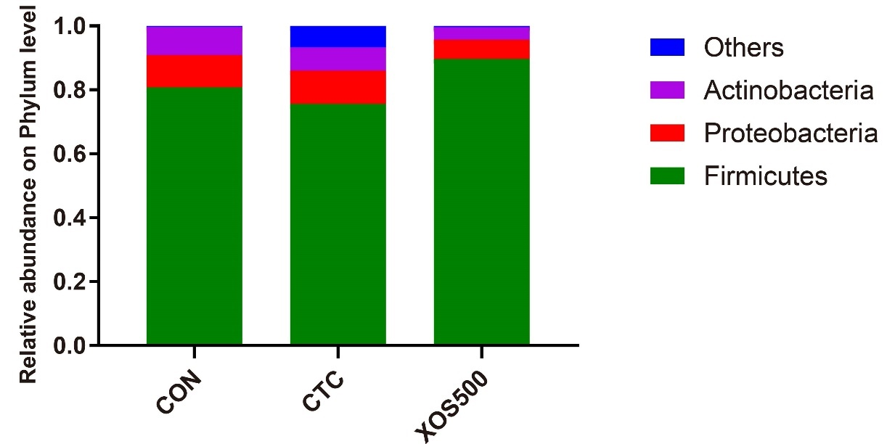

**Supplementary Figure S1** Characterization of the ileum microbiota at the phylum level. Kruskal-Wallis H test bar plot showed the major ileal bacterial phylum during the different treatment groups. CON: control; CTC: chlortetracycline; XOS500: 500mg/kg XOS.

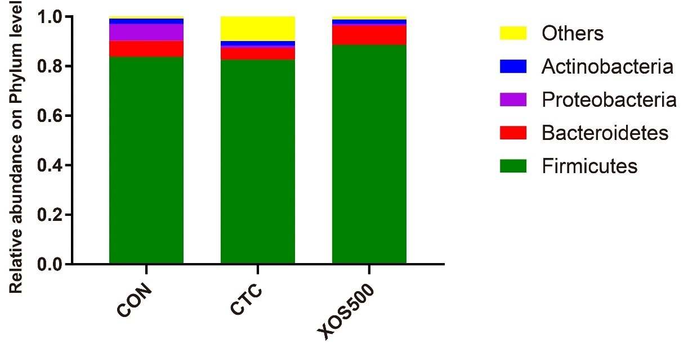

**Supplementary Figure S2** Characterization of the cecum microbiota at the phylum level. Kruskal-Wallis H test bar plot showed the major ileal bacterial phylum during the different treatment groups. CON: control; CTC: chlortetracycline; XOS500: 500mg/kg XOS.

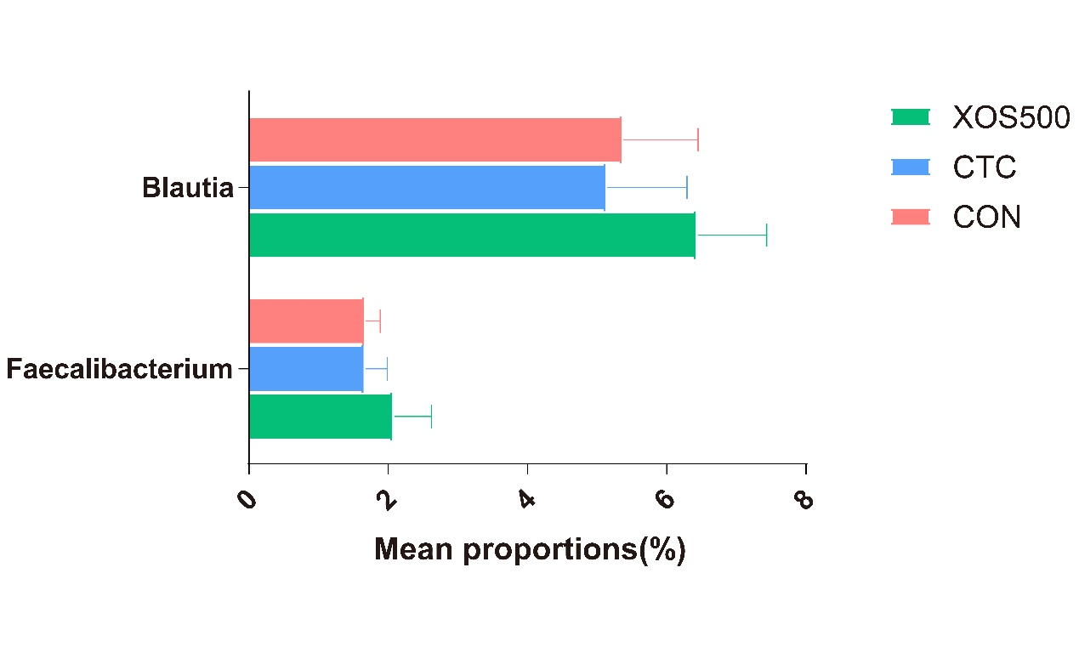

**Supplementary Figure S3** Kruskal-Wallis H test bar plot showed effect of dietary treatments on cecal Blautia and Faecalibacterium genus abundance of weaned piglets. CON: control; CTC: chlortetracycline; XOS500: 500mg/kg XOS.

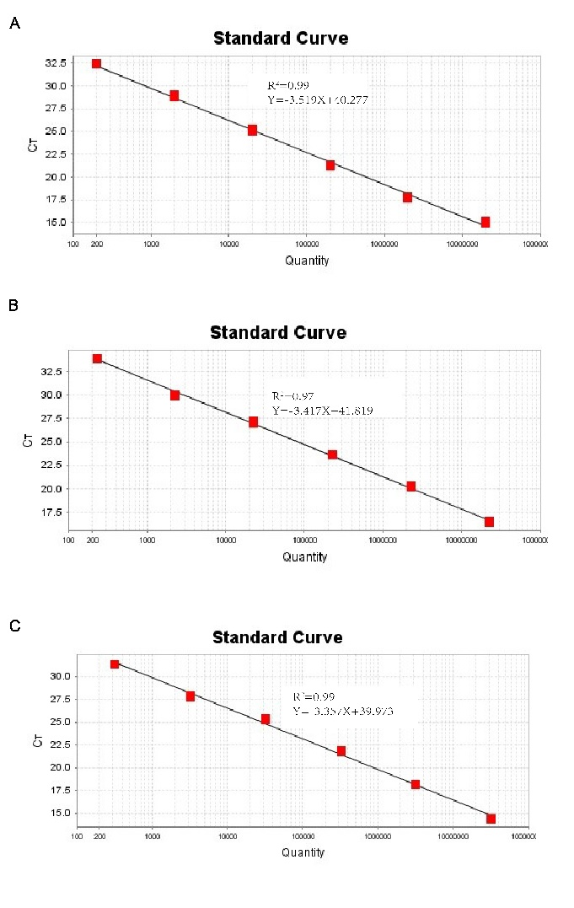

**Supplementary Figure S4** The standard curve for absolute quantification of specific bacteria in cecal sample. (**A**) Lactobacillus (**B**) Clostridum_sensus_stricto_1 (**C**) Terrisporobacter Standard curves produced from 10-fold serial dilutions ranging from 1×102 to 1×108 copies/ul cecal sample DNA, showing the relationship between Ct-values and copies/ul for qPCR assays. Ct, cycle threshold.