***Supplementary Material***

# Those Who Did Not Identify as Male or Female

Figure A1 shows the responses to the battery of nine trust, mistrust and distrust questions from those who did not identify as Male or Female in the survey. In total, eight respondents chose ‘In another way’ or ‘Prefer not to say’ when asked *“Which of the following describes how you think of yourself?”* and they were aged between 23 and 68 years old. The graph shows that these individuals overall are not politically trusting. For the questions capturing the *trust* concept, most responses were ‘Strongly disagree’ and similarly for both the *mistrust* and *distrust* concepts the majority of answers given were ‘Strongly agree’.

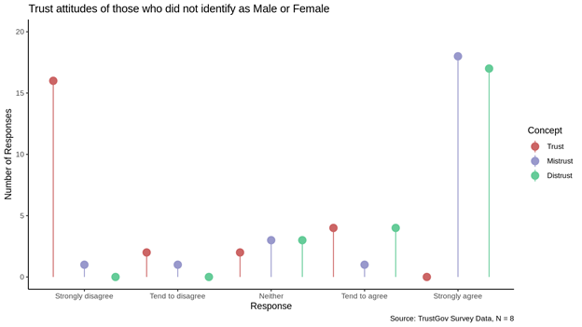

**Figure A1.** Trust attitudes of those who did not identify as male or female.

The number of respondents who indicated a non-binary gender is unfortunately too small to perform an EFA. However, Figure A2 shows the correlation matrix for these eight individuals’ responses to the *trust, mistrust* and *distrust* battery of questions. It shows that the trust questions are strongly correlated with each other, have no correlation with Q4, and are moderate-strongly negatively correlated with the mis- and distrust questions. This is mirrored by the mistrust and distrust questions, which are also all correlated, apart from Q4. This indicates that there may be two factors for these individuals -- the first trust, and the second a combination of mistrust and distrust -- with one question that does not fit. Interestingly, it is not the same statement that was problematic for those identifying as male or female. More work needs to be done with a larger sample of non-binary individuals to investigate differences in understandings and operationalisings that cover a more inclusive definition of gender.

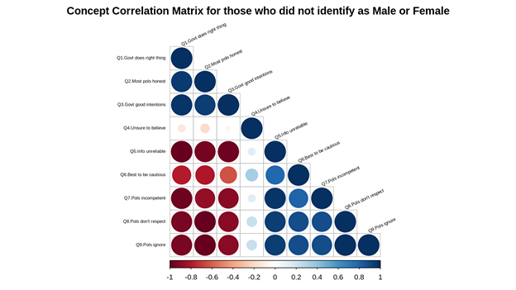

**Figure A2.** Correlation Matrix for those who did not identify as male or female.