**Appendix**

Table A1. Incremental regression models for trust in representative authorities and institutions (direct effects)

|  | **Model 1** | **Model 2** | **Model 3** | **Model 4** | **Model 5** |
| --- | --- | --- | --- | --- | --- |
| (Intercept) | 3.77 (0.20)*** | 3.92 (0.19)*** | 3.84 (0.19)*** | 3.86 (0.17)*** | 3.86 (0.17)*** |
| **Individual-level predictors** |  |  |  |  |  |
| Procedural justice | 5.54 (0.06)*** |  | 5.38 (0.06)*** | 5.38 (0.06)*** | 5.38 (0.06)*** |
| Equality of opportunity (egocentric) |  | 0.24 (0.05)*** | 0.01 (0.05) | 0.01 (0.05) | 0.01 (0.05) |
| Equality of opportunity (sociotropic) |  | 1.25 (0.05)*** | 0.53 (0.05)*** | 0.53 (0.05)*** | 0.53 (0.05)*** |
| *Income justice (egocentric): fair* |  | *Reference* | *Reference* | *Reference* | *Reference* |
| Income justice (egocentric): unfair, low |  | -0.12 (0.03)*** | -0.05 (0.03)* | -0.05 (0.03)* | -0.05 (0.03)* |
| Income justice (egocentric): unfair, high |  | 0.14 (0.06)* | 0.07 (0.05) | 0.07 (0.05) | 0.07 (0.05) |
| *Income justice (sociotropic): fair* |  | *Reference* | *Reference* | *Reference* | *Reference* |
| Income justice (sociotropic): unfair, low |  | -0.08 (0.03)** | -0.03 (0.03) | -0.03 (0.03) | -0.03 (0.03) |
| Income justice (sociotropic): unfair, high |  | -0.08 (0.05) | -0.10 (0.05)* | -0.10 (0.05)* | -0.10 (0.05)* |
| Subj. feeling about hh-income | -0.12 (0.04)** | 0.03 (0.04) | -0.19 (0.04)*** | -0.19 (0.04)*** | -0.19 (0.04)*** |
| Satisfaction w/ economy | 2.91 (0.05)*** | 4.16 (0.05)*** | 2.78 (0.05)*** | 2.78 (0.05)*** | 2.78 (0.05)*** |
| Gender (female) | 0.14 (0.02)*** | 0.10 (0.02)*** | 0.15 (0.02)*** | 0.15 (0.02)*** | 0.15 (0.02)*** |
| Age | 0.40 (0.04)*** | 0.38 (0.04)*** | 0.41 (0.04)*** | 0.41 (0.04)*** | 0.41 (0.04)*** |
| Education (years) | 0.30 (0.15)* | 1.62 (0.17)*** | 0.33 (0.15)* | 0.33 (0.15)* | 0.33 (0.15)* |
| **Country-level predictors** |  |  |  |  |  |
| Unequal resource distribution |  |  | -4.89 (2.67)+ |  | 1.59 (3.42) |
| Corruption |  |  |  | -2.76 (0.82)*** | -3.15 (1.19)** |
| AIC | 131546.80 | 138445.32 | 131421.41 | 131417.30 | 131414.80 |
| BIC | 131622.79 | 138563.53 | 131556.51 | 131552.41 | 131558.35 |
| N (individuals) | 34335 | 34335 | 34335 | 34335 | 34335 |
| N (country) | 27 | 27 | 27 | 27 | 27 |
| Var: country level | 1.06 | 1.00 | 0.95 | 0.74 | 0.77 |
| Var: individual level | 2.68 | 3.28 | 2.67 | 2.67 | 2.67 |

Unstandardized regression coefficients with standard errors in parentheses. Levels of statistical significance: ***p < 0.001; **p < 0.01; *p < 0.05; +p < 0.1. All individual-level variables standardized to range from 0-1.

Table A2. Incremental regression models for trust in regulative authorities and institutions (direct effects)

|  | **Model 1** | **Model 2** | **Model 3** | **Model 4** | **Model 5** |
| --- | --- | --- | --- | --- | --- |
| (Intercept) | 5.67 (0.21)*** | 5.76 (0.21)*** | 5.73 (0.19)*** | 5.76 (0.15)*** | 5.76 (0.15)*** |
| **Individual-level predictors** |  |  |  |  |  |
| Procedural justice | 3.40 (0.07)*** |  | 3.11 (0.07)*** | 3.11 (0.07)*** | 3.11 (0.07)*** |
| Equality of opportunity (egocentric) |  | 0.48 (0.05)*** | 0.35 (0.05)*** | 0.35 (0.05)*** | 0.35 (0.05)*** |
| Equality of opportunity (sociotropic) |  | 1.21 (0.06)*** | 0.79 (0.06)*** | 0.79 (0.06)*** | 0.79 (0.06)*** |
| *Income justice (egocentric): fair* |  | *Reference* | *Reference* | *Reference* | *Reference* |
| Income justice (egocentric): unfair, low |  | -0.06 (0.03)+ | -0.02 (0.03) | -0.02 (0.03) | -0.02 (0.03) |
| Income justice (egocentric): unfair, high |  | 0.07 (0.06) | 0.03 (0.06) | 0.03 (0.06) | 0.03 (0.06) |
| *Income justice (sociotropic): fair* |  | *Reference* | *Reference* | *Reference* | *Reference* |
| Income justice (sociotropic): unfair, low |  | -0.07 (0.03)* | -0.04 (0.03) | -0.04 (0.03) | -0.04 (0.03) |
| Income justice (sociotropic): unfair, high |  | -0.14 (0.05)* | -0.15 (0.05)** | -0.15 (0.05)** | -0.15 (0.05)** |
| Subj. feeling about hh-income | 0.22 (0.04)*** | 0.22 (0.05)*** | 0.09 (0.05)* | 0.09 (0.05)* | 0.09 (0.05)* |
| Satisfaction w/ economy | 2.88 (0.05)*** | 3.45 (0.05)*** | 2.66 (0.06)*** | 2.66 (0.06)*** | 2.66 (0.06)*** |
| Gender (female) | 0.11 (0.02)*** | 0.10 (0.02)*** | 0.13 (0.02)*** | 0.13 (0.02)*** | 0.13 (0.02)*** |
| Age | 0.04 (0.05) | 0.08 (0.05)+ | 0.10 (0.05)* | 0.10 (0.05)* | 0.10 (0.05)* |
| Education (years) | 0.15 (0.17) | 0.66 (0.18)*** | -0.08 (0.17) | -0.08 (0.17) | -0.08 (0.17) |
| **Country-level predictors** |  |  |  |  |  |
| Unequal resource distribution |  |  | -7.47 (2.62)** |  | 0.75 (3.00) |
| Corruption |  |  |  | -3.81 (0.72)*** | -4.00 (1.04)*** |
| AIC | 140858.96 | 142447.94 | 140505.96 | 140496.22 | 140494.14 |
| BIC | 140934.96 | 142566.15 | 140641.06 | 140631.33 | 140637.69 |
| N (individuals) | 34335 | 34335 | 34335 | 34335 | 34335 |
| N (country) | 27 | 27 | 27 | 27 | 27 |
| Var: country level | 1.18 | 1.15 | 0.92 | 0.57 | 0.59 |
| Var: individual level | 3.52 | 3.69 | 3.48 | 3.48 | 3.48 |

Unstandardized regression coefficients with standard errors in parentheses. Levels of statistical significance: ***p < 0.001; **p < 0.01; *p < 0.05; +p < 0.1. All individual-level variables standardized to range from 0-1.

Table A3. Incremental regression models for trust in representative authorities and institutions (cross-level interactions)

|  | **Model 1** | **Model 2** | **Model 3** | **Model 4** |
| --- | --- | --- | --- | --- |
| (Intercept) | 3.88 (0.13)*** | 3.88 (0.13)*** | 3.88 (0.13)*** | 3.89 (0.13)*** |
| **Individual-level predictors** |  |  |  |  |
| Procedural justice | 5.40 (0.06)*** | 5.36 (0.06)*** | 5.37 (0.06)*** | 5.38 (0.06)*** |
| Equality of opportunity (egocentric) | 0.01 (0.05) | 0.02 (0.05) | 0.01 (0.05) | 0.01 (0.05) |
| Equality of opportunity (sociotropic) | 0.54 (0.05)*** | 0.53 (0.05)*** | 0.54 (0.05)*** | 0.53 (0.05)*** |
| *Income justice (egocentric): fair* |  |  |  |  |
| Income justice (egocentric): unfair, low | -0.05 (0.03)+ | -0.05 (0.03)+ | -0.01 (0.03) | -0.01 (0.03) |
| Income justice (egocentric): unfair, high | 0.07 (0.05) | 0.07 (0.05) | 0.11 (0.05)* | 0.11 (0.05)* |
| *Income justice (sociotropic): fair* |  |  |  |  |
| Income justice (sociotropic): unfair, low | -0.03 (0.03) | -0.03 (0.03) | -0.07 (0.03)* | -0.07 (0.03)* |
| Income justice (sociotropic): unfair, high | -0.10 (0.05)* | -0.10 (0.05)* | -0.15 (0.05)** | -0.15 (0.05)** |
| Subj. feeling about hh-income | -0.19 (0.04)*** | -0.19 (0.04)*** | -0.18 (0.04)*** | -0.19 (0.04)*** |
| Satisfaction w/ economy | 2.80 (0.05)*** | 2.77 (0.05)*** | 2.78 (0.05)*** | 2.78 (0.05)*** |
| Gender (female) | 0.15 (0.02)*** | 0.15 (0.02)*** | 0.15 (0.02)*** | 0.15 (0.02)*** |
| Age | 0.41 (0.04)*** | 0.42 (0.04)*** | 0.41 (0.04)*** | 0.42 (0.04)*** |
| Education (years) | 0.30 (0.15)* | 0.33 (0.15)* | 0.34 (0.15)* | 0.30 (0.15)* |
| **Country-level predictors** |  |  |  |  |
| Unequal resource distribution | 2.48 (2.57) | 2.48 (2.57) | 2.80 (2.60) | 2.94 (2.60) |
| Corruption | -0.76 (1.04) | -0.76 (1.04) | -0.89 (1.05) | -0.86 (1.05) |
| GDP per capita (in 100k Euro) | 4.58 (1.03)*** | 4.58 (1.03)*** | 4.57 (1.03)*** | 4.58 (1.03)*** |
| **Cross-level interactions** |  |  |  |  |
| Procedural justice X Resource distribution | -1.07 (0.99) |  |  | -0.75 (1.08) |
| Procedural justice X Corruption | -0.54 (0.35) |  |  | -0.93 (0.38)* |
| Equality of opportunity (egocentric) X Resource distribution |  | -0.90 (0.89) |  | -0.96 (0.90) |
| Equality of opportunity (egocentric) X Corruption |  | -0.70 (0.29)* |  | -0.58 (0.30)* |
| Equality of opportunity (sociotropic) X Resource distribution |  | -0.48 (0.97) |  | -0.29 (1.02) |
| Equality of opportunity (sociotropic) X Corruption |  | 1.17 (0.33)*** |  | 1.41 (0.34)*** |
| Income justice (egocentric): unfair, low X Resource distributiona |  |  | -0.48 (0.57) | -0.60 (0.58) |
| Income justice (egocentric): unfair, high X Resource distributiona |  |  | -0.24 (1.22) | -0.20 (1.22) |
| Income justice (egocentric): unfair, low X Corruptiona |  |  | 0.75 (0.21)*** | 0.73 (0.21)*** |
| Income justice (egocentric): unfair, high X Corruptiona |  |  | 0.62 (0.40) | 0.60 (0.40) |
| Income justice (sociotropic): unfair, low X Resource distributiona |  |  | 0.10 (0.61) | 0.03 (0.61) |
| Income justice (sociotropic): unfair, high X Resource distributiona |  |  | -1.51 (1.18) | -1.64 (1.18) |
| Income justice (sociotropic): unfair, low X Corruptiona |  |  | -0.57 (0.22)** | -0.58 (0.22)** |
| Income justice (sociotropic): unfair, high X Corruptiona |  |  | -0.12 (0.37) | -0.09 (0.37) |
| AIC | 131390.47 | 131373.82 | 131395.48 | 131353.64 |
| BIC | 131559.35 | 131559.58 | 131615.03 | 131623.85 |
| N (individuals) | 34335 | 34335 | 34335 | 34335 |
| N (country) | 27 | 27 | 27 | 27 |
| Var: country level | 0.43 | 0.43 | 0.43 | 0.43 |
| Var: individual level | 2.67 | 2.67 | 2.67 | 2.67 |

Unstandardized regression coefficients with standard errors in parentheses. Levels of statistical significance: ***p < 0.001; **p < 0.01; *p < 0.05; +p < 0.1. Group-mean centered individual-level variables and grand-mean centered contextual-level variables. aReference category: Income justice (egocentric/sociotropic): fair.

Table A4. Incremental regression models for trust in regulative authorities and institutions (cross-level interactions)

|  | **Model 1** | **Model 2** | **Model 3** | **Model 4** |
| --- | --- | --- | --- | --- |
| (Intercept) | 5.78 (0.13)*** | 5.78 (0.13)*** | 5.77 (0.13)*** | 5.77 (0.13)*** |
| **Individual-level predictors** |  |  |  |  |
| Procedural justice | 3.08 (0.07)*** | 3.09 (0.07)*** | 3.10 (0.07)*** | 3.07 (0.07)*** |
| Equality of opportunity (egocentric) | 0.35 (0.05)*** | 0.35 (0.05)*** | 0.35 (0.05)*** | 0.35 (0.05)*** |
| Equality of opportunity (sociotropic) | 0.78 (0.06)*** | 0.78 (0.06)*** | 0.80 (0.06)*** | 0.78 (0.06)*** |
| *Income justice (egocentric): fair* | *Reference* | *Reference* | *Reference* | *Reference* |
| Income justice (egocentric): unfair, low | -0.02 (0.03) | -0.02 (0.03) | 0.01 (0.03) | 0.01 (0.03) |
| Income justice (egocentric): unfair, high | 0.03 (0.06) | 0.03 (0.06) | 0.05 (0.06) | 0.05 (0.06) |
| *Income justice (sociotropic): fair* | *Reference* | *Reference* | *Reference* | *Reference* |
| Income justice (sociotropic): unfair, low | -0.04 (0.03) | -0.04 (0.03) | -0.06 (0.03)* | -0.06 (0.03)* |
| Income justice (sociotropic): unfair, high | -0.15 (0.05)** | -0.16 (0.05)** | -0.19 (0.06)*** | -0.19 (0.06)*** |
| Subj. feeling about hh-income | 0.09 (0.05)* | 0.10 (0.05)* | 0.10 (0.05)* | 0.11 (0.05)* |
| Satisfaction w/ economy | 2.64 (0.06)*** | 2.64 (0.06)*** | 2.65 (0.06)*** | 2.63 (0.06)*** |
| Gender (female) | 0.13 (0.02)*** | 0.12 (0.02)*** | 0.13 (0.02)*** | 0.12 (0.02)*** |
| Age | 0.09 (0.05)* | 0.10 (0.05)* | 0.10 (0.05)* | 0.10 (0.05)* |
| Education (years) | -0.03 (0.17) | -0.09 (0.17) | -0.08 (0.17) | -0.04 (0.17) |
| **Country-level predictors** |  |  |  |  |
| Unequal resource distribution | 1.35 (2.61) | 1.35 (2.61) | 1.25 (2.63) | 1.51 (2.64) |
| Corruption | -2.34 (1.06)* | -2.35 (1.06)* | -2.41 (1.06)* | -2.64 (1.07)* |
| GDP per capita (in 100k Euro) | 3.15 (1.05)** | 3.15 (1.05)** | 3.14 (1.04)** | 3.11 (1.04)** |
| **Cross-level interactions** |  |  |  |  |
| Procedural justice X Resource distribution | -4.23 (1.13)*** |  |  | -3.48 (1.23)** |
| Procedural justice X Corruption | 2.76 (0.40)*** |  |  | 2.28 (0.44)*** |
| Equality of opportunity (egocentric) X Resource distribution |  | 2.21 (1.01)* |  | 2.47 (1.02)* |
| Equality of opportunity (egocentric) X Corruption |  | -1.36 (0.33)*** |  | -1.44 (0.34)*** |
| Equality of opportunity (sociotropic) X Resource distribution |  | -4.46 (1.11)*** |  | -3.65 (1.16)** |
| Equality of opportunity (sociotropic) X Corruption |  | 3.00 (0.37)*** |  | 2.49 (0.39)*** |
| Income justice (egocentric): unfair, low X Resource distributiona |  |  | -0.13 (0.65) | -0.28 (0.66) |
| Income justice (egocentric): unfair, high X Resource distributiona |  |  | -1.06 (1.39) | -1.14 (1.39) |
| Income justice (egocentric): unfair, low X Corruptiona |  |  | 0.57 (0.23)* | 0.69 (0.24)** |
| Income justice (egocentric): unfair, high X Corruptiona |  |  | 0.56 (0.46) | 0.60 (0.46) |
| Income justice (sociotropic): unfair, low X Resource distributiona |  |  | 0.39 (0.70) | 0.17 (0.70) |
| Income justice (sociotropic): unfair, high X Resource distributiona |  |  | -2.30 (1.35)+ | -2.32 (1.35)+ |
| Income justice (sociotropic): unfair, low X Corruptiona |  |  | -0.51 (0.25)* | -0.34 (0.25) |
| Income justice (sociotropic): unfair, high X Corruptiona |  |  | 0.30 (0.43) | 0.35 (0.43) |
| AIC | 140438.54 | 140419.84 | 140484.58 | 140390.03 |
| BIC | 140607.42 | 140605.61 | 140704.12 | 140660.23 |
| N (individuals) | 34335 | 34335 | 34335 | 34335 |
| N (country) | 27 | 27 | 27 | 27 |
| Var: country level | 0.44 | 0.44 | 0.44 | 0.44 |
| Var: individual level | 3.48 | 3.48 | 3.48 | 3.47 |

Unstandardized regression coefficients with standard errors in parentheses. Levels of statistical significance: ***p < 0.001; **p < 0.01; *p < 0.05; +p < 0.1. Group-mean centered individual-level variables and grand-mean centered contextual-level variables. aReference category: Income justice (egocentric/sociotropic): fair.

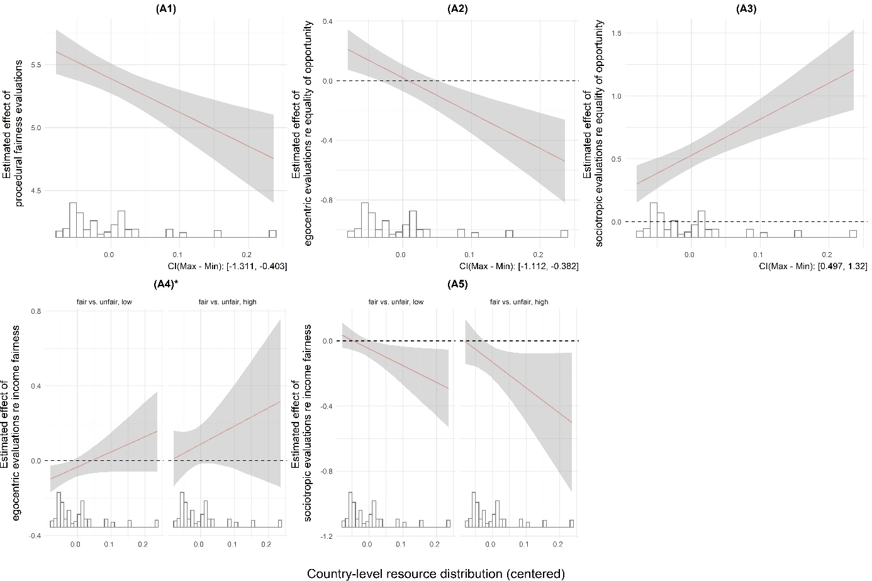

Figure A1. Marginal effects of subjective evaluations of justice on trust in representative authorities and institutions, conditional on country-level resource distribution. All predictions based on Model 3a in Table 2. Panels marked with an asterisk indicate statistically non-significant cross-level interactions.

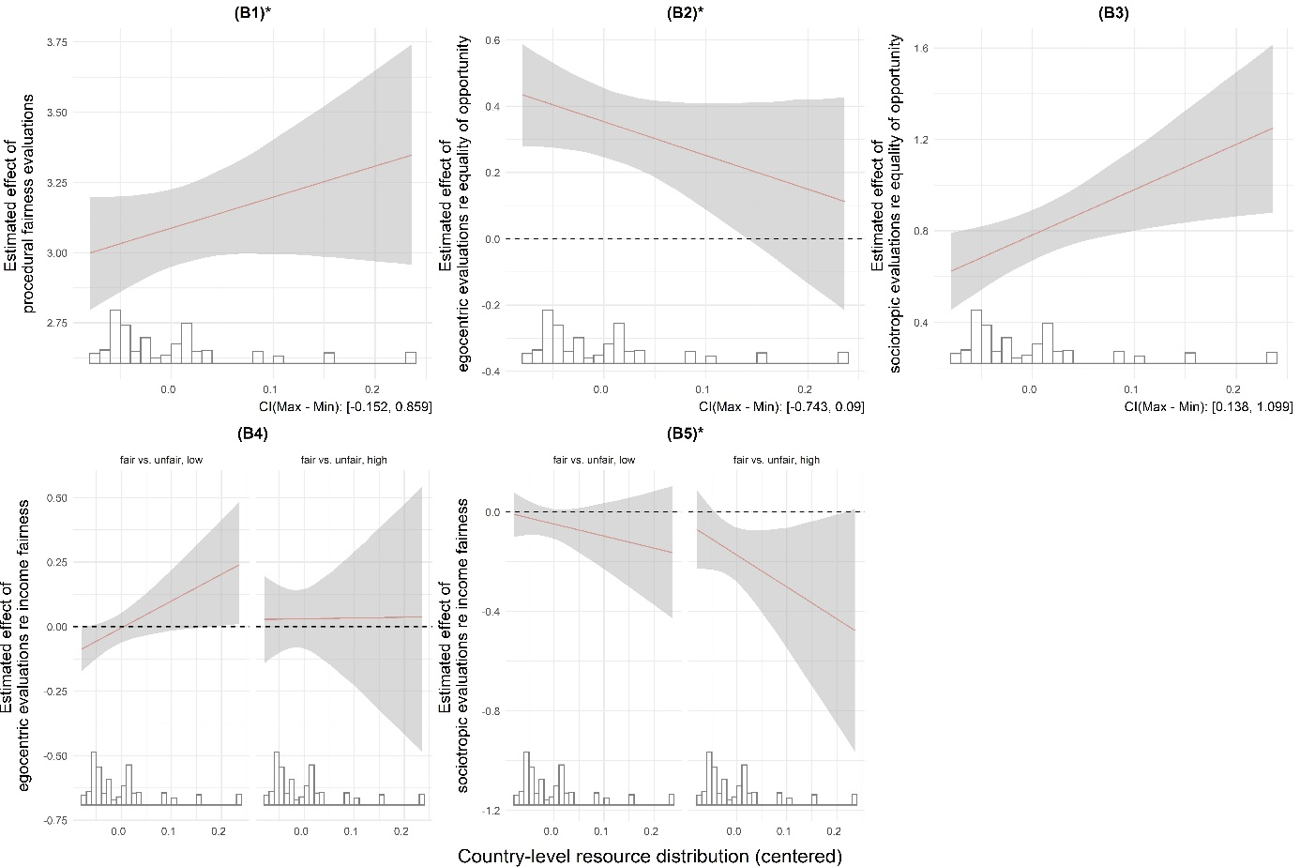

Figure A2. Marginal effects of subjective evaluations of justice on trust in regulative authorities and institutions, conditional on country-level resource distribution. All predictions based on Model 4a in Table 2. Panels marked with an asterisk indicate statistically non-significant cross-level interactions.

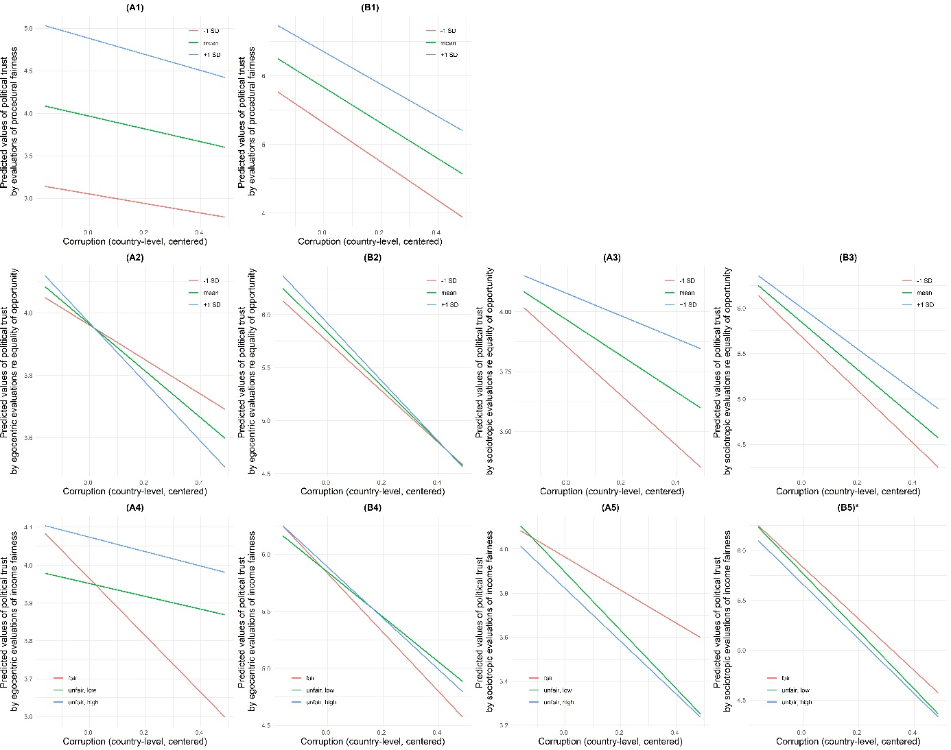

Figure A3. Predicted values of trust in representative (Panels A) and regulative (Panels B) authorities and institutions across different levels of corruption, holding model covariates constant. All predictions based on Model 3b (Panels A1-5) and Model 4b (Panels B1-5) in Table 2. Panels marked with an asterisk indicate statistically non-significant cross-level interactions (see Figures 2 and 3 in the main text).

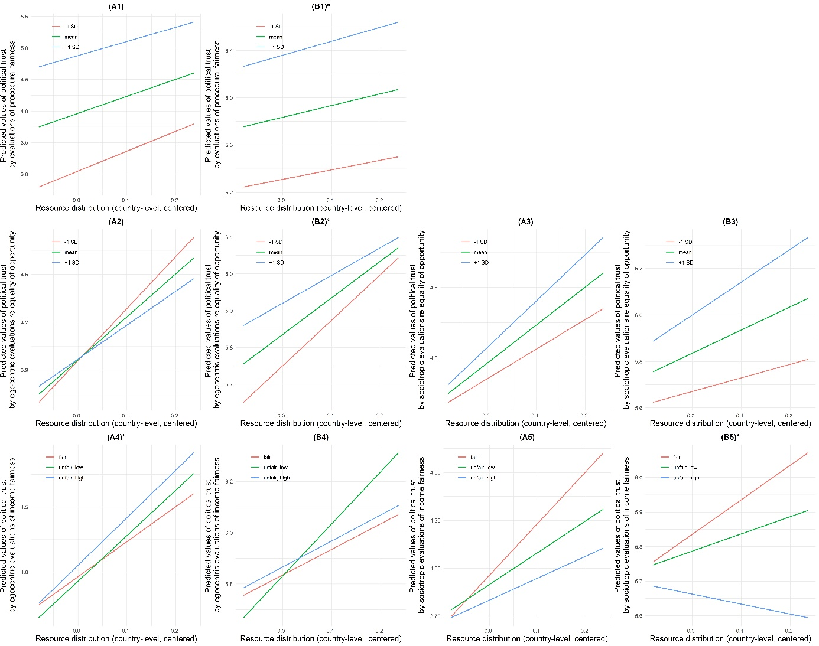

Figure A4. Predicted values of trust in representative (Panels A) and regulative (Panels B) authorities and institutions across different levels of equal resource distribution, holding model covariates constant. All predictions based on Model 3a (Panels A1-5) and Model 4a (Panels B1-5) in Table 2. Panels marked with an asterisk indicate statistically non-significant cross-level interactions (see Figures A1 and A2).