**Supplementary material**

**Supplementary Table 1. List of antibodies used in this study**

|  |  |  |  |
| --- | --- | --- | --- |
| Antibody | Supplier | Clone | Catalogue number |
| anti-human CD3-PE-CF594 | BD biosciences | UCHT1 | 562280 |
| anti-human CD4-BV421 | BD biosciences | RPA-T4 | 562424 |
| anti-human CD8-APC | Biolegend | RPA-T8 | 301014 |
| anti-human-γδ-TCR-PECy7 | Biolegend | B1 | 331222 |
| anti-human CLA-BV605 | BD biosciences | HECA-452 | 563960 |
| anti-human CD45RO-BV650 | BD biosciences | UCHL1 | 563750 |
| anti-human CD69-BUV737 | BD biosciences | FN50 | 564439 |
| anti-human MHC class II HLA-DR, DP, DQ blocking antibody | BD biosciences | Tu39 | 555556 |
| mouse IgG2a, κ Isotype Control for anti-MHC class II blocking antibody | BD biosciences | G155-178 | 554645 |



**Supplementary figure 1. Click-iT EdU assay tracks *S. aureus*-specific CD4+ Tsrm cell proliferation*.*** Representative dot plots showing surface expression of CD45RO and CLA on proliferating CD4+ T cells (CD4+EdU+), gated on live CD3+CD4+CD8- cells.

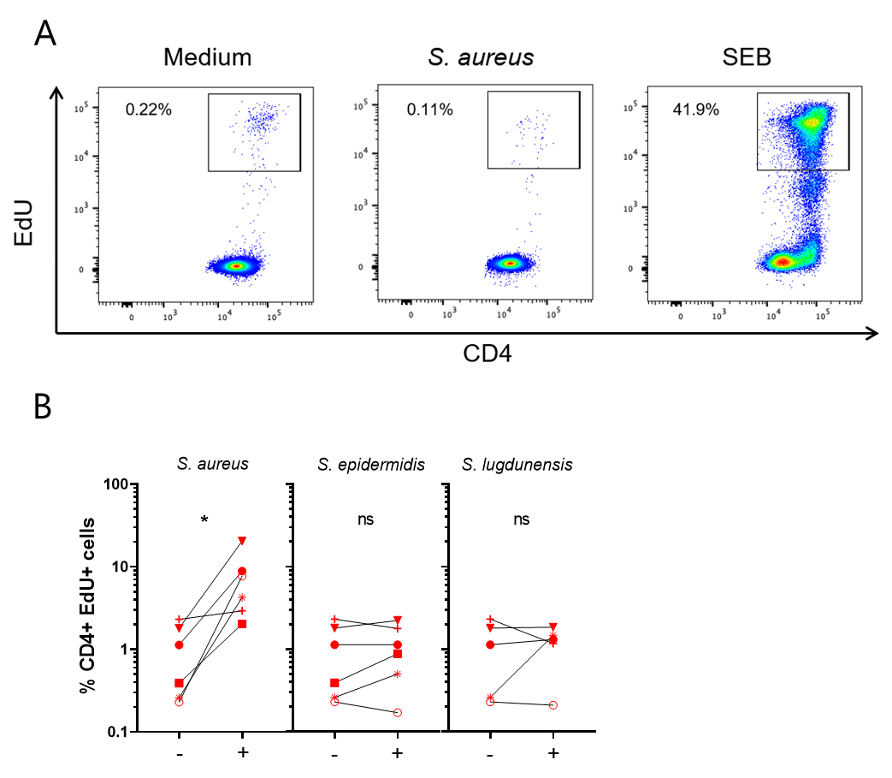

**Supplementary figure 2. Specificity of CD4+ Tsrm cell proliferation in response to *S. aureus*.** (A) Representative dot-plots showing CD4+EdU+ cells in PBMCs stimulated for 4 days with heat-killed (HK) *S. aureus*, the T cell superantigen *S. aureus* enterotoxin B (SEB, 1 µg/ml Sigma-Aldrich), or left unstimulated (medium). (B) CD4+ Tsrm proliferation in response to different HK staphylococcal species: *S. aureus* USA300 LAC, *S. epidermidis* 1457 strain, and *S. ludgunensis* SL13 strain. Per donor, each stimulated group, indicated by a +, was compared to the non-stimulated group (medium), indicated by a -, by paired Wilcoxon test, *p<0.05.