Supplementary Materials
Berberine-loaded Carboxylmethyl Chitosan Nanoparticles ameliorate DSS-induced colitis and remodel gut microbiota in mice
Luqing Zhao¹, Xueying Du², Jiaxin Tian², Xiuhong Kang¹, Yuxin Li¹, Wenlin Dai³, Danyan Li¹, Shengsheng Zhang^{1*}, Chao Li^{2*}
¹Digestive Disease Center, Beijing Hospital of Traditional Chinese Medicine, Capital Medical University, Beijing, 100010, P. R. China
²State Key Laboratory of Chemical Resource Engineering, Beijing University of Chemical Technology, Beijing 100029, P. R. China
³Center for Applied Statistics, Institute of Statistics and Big Data, Renmin University of China, Beijing 100872, P. R. China
* Correspondence:
Shengsheng Zhang
zhangshengsheng@bjzhongyi.com
Chao Li
lichao@mail.buct.edu.cn

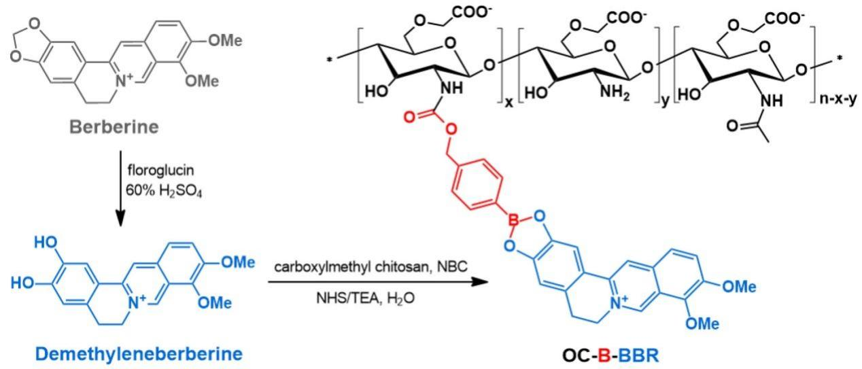
Scheme S1. The structure and synthetic route of OC-B-BBR nanoparticle.

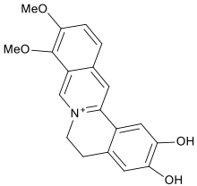

22
24
2
1
7
10
18
11
12
15
b
a
a
b
7
10
1 2
18
15
11
12
22 24
Figure S1. ¹H-NMR of spectrum demethyleneberberine

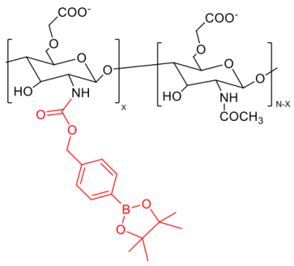
3’
5‘
4’
1
2
3
4
5
6
7
3’
4’
5‘
1
3-6
2
7
Figure S2. ¹H-NMR spectrum of OC-NBC

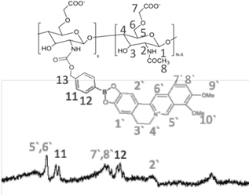
1，7，4’
3，5，6，9‘，10’
2，3‘
8
4
Figure S3. ¹H-NMR spectrum of OC-B-BBR

