Supplementary material
Predominant biphenyl dioxygenase from legacy polychlorinated biphenyl (PCB)-contaminated soil is a part of unusual gene cluster and transforms flavone and flavanone
Jachym Suman^{1,}, Michal Strejcek¹, Andrea Zubrova¹, Jan Capek¹, Jiri Wald¹, Klara Michalikova², Miluse Hradilova³, Kamila Sredlova², Jaroslav Semerad^{2,4}, Tomas Cajthaml^{2,4}, Ondrej Uhlik^{1,}
¹University of Chemistry and Technology, Prague, Faculty of Food and Biochemical Technology, Department of Biochemistry and Microbiology, Prague, Czech Republic
²Institute of Microbiology, Academy of Sciences of the Czech Republic, v.v.i., Prague, Czech Republic
³Institute of Molecular Genetics, Academy of Sciences of the Czech Republic, v.v.i., Prague, Czech Republic
⁴Institute for Environmental Studies, Faculty of Science, Charles University, Prague, Czech Republic

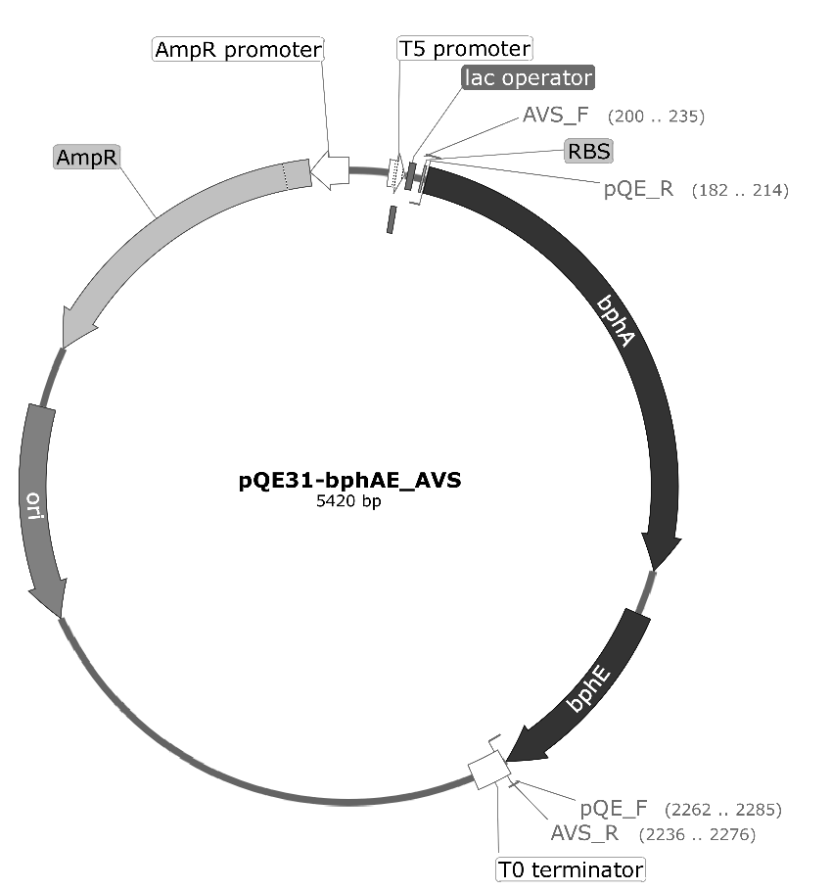
Figure S1: The map of the plasmid pQE31-bphAE_AVS used for the heterologous expression of the bphAE_AVS genes in E. coli. The plasmid enabled IPTG-inducible selection of transgenes and the ampicillin-based selection of transformants. The primers used for the construction as described in the Methods section are indicted. AmpR, β-lactamase gene; RBS, E. coli ribosome binding site; ori, origin of replication.

SV3(59%) 1 QFCSDMYHAGTMSHLSGILAGLPPELDLSNAQTPMKGQQFRAQWGGHGTGWFVNE--PGMAMVTTGSKVAQYWMDSPAARHAQSRLGST-MPVLGMFGQHMTVFPTCSFLAGVNTIRSWHPRGPNETEVWVFTIV
SV167(<1%) 1 QFCSDMYHAGTMSHLSGILAGMPPDMDLSQAPMPTAGYQFRAAWGGHGTGWFEDE--AGFLATVVGPKAAAYWYGSEASKRTAERLADRLPRFLRMSGQHMTVFPTCSFLPGINTIRSWHPRGPNEIEVWAFTVV
ARHD_LA-4 231 QFCSDMYHAGTMSHLSGILAGMPPDMDLSQAPMPTAGYQFRAAWGGHGTGWFEDE--AGFLATVVGPKAAAYWYGSEASKRTAERLADRLPRFLRMSGQHMTVFPTCSFLPGINTIRSWHPRGPNEIEVWAFTVV
SV27 (18%) 1 QFCSDMYHAGTMSHLSGILAGMPPEMDLSDAQVPTKGNQFRASWGGHGTGWYVDE--PGMLMAVMGPKVTQYWTEGPAADLAEKRLGHT-MPARRMFGQHMSVFPTCSFLPAINTIRTWHPRGPNEIEVWAFTLV
SV75 (3%) 1 QFCSDMYHAGTMSHLSGILAGMPPEMDLSNAQVPTKGNQFRANWGGHGTGWFVDE--PGMLMAVMGPKVTQYWTEGPAADLAERRLGQT-MPVRRMFGQHMNIFPTCSFLPAINTIRSWHPRGPNEIEVWAFTLV
BphA B-357 104 QFCSDMYHAGTMSHLSGILAGMPPEMDLSNAQVPTKGNQFRANWGGHGTGWFVDE--PGMLMAVMGPKVTQYWTEGPAADLAEKRLGQT-MPVRRMFGQHMNIFPTCSFLPAINTIRSWHPRGPNEIEVWAFTLV
ARHD WS 226 QFCSDMYHAGTMSHLSGILAGMPPEMDLSNAQVPTKGNQFRANWGGHGTGWFVDE--PGLLMATMGPKVTQYWTEGPAADLAEKRLGQT-MPVRRMFGQHMNIFPTCSFLPAVNTIRSWHPRGPNEIEVWAFTLV
BphA KF707 226 QFCSDMYHAGTMSHLSGILAGMPPEMDLSHAQVPTKGNQFRAGWGGHGSGWFVDE--PGMLMAVMGPKVTQYWTEGPAADLAEQRLGHT-MPVRRMFGQHMSVFPTCSFLPAINTIRTWHPRGPNEIEVWAFTLV
SV39 (1%) 1 QFCSDMYHAGTTTHLSGILAGIPPEMDLSQAQIPTKGNQFRAAWGGHGSGWYVDE--PGSLLAVMGPKVTQYWTEGPAAELAEQRLGHTGMPVRRMVGQHMTIFPTCSFLPTFNNIRIWHPRGPNEIEVWAFTLV
BphA_LB400 226 QFCSDMYHAGTTTHLSGILAGIPPEMDLSQAQIPTKGNQFRAAWGGHGSGWYVDE—-PGSLLAVMGPKVTQYWTEGPAAELAEQRLGHTGMPVRRMVGQHMTIFPTCSFLPTFNNIRIWHPRGPNEIEVWAFTLV
SV23 (9%) 1 QFCSDMYHA-PLSHMSAILAVLPDGVPPEAARWPTEGLQWRSPNAGHGTGFHTPDDQGQLLAAIVGPSVAQYLME-SRP-RVAARLGNA--RTTAVNGAHMTIFPTCSFLPGINTLRVWHPRGPNEIEVWAMAIV
SV79 (4%) 1 QFCSDMYHA-PLSHMSAILAVLPEGVPPEAAQWPTEGLQWRSPNAGHGAGWHTPDDQGQLLGAIVGPSVAQYLME-SRP-RVTARLGNE--RTTAVNGAHMTIFPTCSFLPGINTLRVWHPRGPNEIEVWAMAIV
SV122 (2%) 1 QFCSDMYHA-PLSHMSAILAVLPDGVPPEAAQWPTEGLQWRSPNAGHGTGFHTPDDQGQLLGAIVGPSVAQYLME-SRP-RVAARLGNA--RTTAVNGAHMTIFPTCSFLPGINTLRVWHPRGPNEIEVWALAIV
ARHD Gsoil 142 212 QFCSDMYHA-PLSHMSAILAVLPEGVPPEAAQWPTEGLQWRSPNAGHGTGFHTPDDQGQLLAAIVGPSVAQYLME-SRP-RVAARLGNA--RTTAVNGAHMTIFPTCSFLPGINTLRVWHPRGPNEIEVWAMAIV
SV40 (<1%) 1 QFCSDMYHAGTVSHLSGILAGLPEDVELGDVQIPTSGFQFRSDGGGHGTGFYVAE--PAMLQAIMGPRVTEYWTDSPAAQTAESRLGSAE-RARELMAQHMTIFPTCSFLPGINTVRTWHPRGPGEIEVWAFTVV
ARHD CCH12-A3 213 QFCSDMYHAGTVSHLSGILAGLPEDVELGDVQIPTSGFQFRSDGGGHGTGFYVAE--PAMLQAIMGPRVTEYWTDSPAAQAAESRLGSAE-RACKLMAQHMTIFPTCSFLPGINTVRTWHPRGPGEIEVWAFTVV
BphA JB1 226 QFCSDMYHAGTMSHLSGVLAGLPPEMDLTQIQLSKNGNQFRSAWGGHGAGWFIND--SSILLSVMGPKITQYWTQGPAAEKAAS-VPQL--PILDMFGQHMTVFPTCSFLPGINTIRTWHPRGPNEVEVWAFVLV
BphA B-356 226 QFCSDMYHAGTMSHLSGVLAGLPPEMDLTQIQLSKNGNQFRSAWGGHGAGWFIND--SSILLSVVGPKITQYWTQGPAAEKAARRVPQL--PILDMFGQHMTVFPTCSFLPGINTIRTWHPRGPNEVEVWAFVLV
BphA KKS102 227 QFCSDMYHAGTMAHLSGVLSSLPPEMDLTQVQMSKNGSQFRAAWGGHGSGWFIND--AAILMAVMGPKITQYWTQGPAAEKAAKRLNQM--PTQTMFGQHMTVFPTCSFLPGINTIRSWHPRGPNEVECGPSWSS
BphA TK102 227 QFCSDMYHAGTMSHVSGVLASLPPNMELTDVQMPKNGAQFRAAWGGHGTGWYIND--PDILMAVMGPKITQFWTEGPAAEKAAKRLNQM--PTQTMFGQHMTVFPTCSFLPGINTIRTWHPRGPNEVECGPSWSS
SV63 (1%) 1 QFCSDMYHA-PFSHSSPVLASLPPDVDPGQAGWPMKGKQFSS-ALGHGTGFFMDT--PEFLFPLLGETAAGYYMQ-SGATAVTERLGDV--RGVRMNGAHMTVFPTLSFLPGINTLRVWHPRGPGEIEIWAWTLV
SV115 (<1%) 1 QFCSDMYHA-PFSHSSPVLASLPPDIDPSQAGWPMKGKQFSS-ALGHGTGFFMDT--PEFLFPLLGETAAGYYMQ-SGATAVTERLGDV--RGVRMNGAHMTVFPTLSFLPGINTLRVWHPRGPDEIEIWAWTLV
SV117 (<1%) 1 QFCSDMYHA-PFSHSSPVLASLPPDIDPSQAGWPMKGKQFSS-ALGHGTGFFMDT--PQFLFPLLGETAAGYYLQ-SGATAVTERLGDV--RAQRMNGAHMTVFPTLSFLPGINTLRVWHPRGPDEIEIWAWTLV
SV116 (<1%) 1 QFCSDMYHA-PFSHSSPVLASLPPDIDPSQAGWPMKGKQFSS-ALGHGTGFFMDT--PEFLFPLLGETAAGYYMQ-SGA-AAAERLGEV--RGARMNGAHMTVFPTLSFLPGINTLRVWHPRGPDEIEIWAWTLV
ARHD TR3.2 205 QFCSDMYHA-PFSHSSPVLASLPPDIDPGQAGWPMKGKQFSS-ALGHGTGFFMDT--PEFLFPLLGETAAGYYMQ-SGATAVTERLGEL--RGVRMNGAHMTVFPTLSFLPGINTLRVWHPRGPDEIEIWAWTLV
BphA P6 218 QFCSDMYHVGTTSHLSGLLAGLPDEIDIREVQPPTTGIQYSAPWGGHGSGFYIGE--MGTLAAVMGMKILEYYTSGPAAEKAAKRLGSAV-RGSQATGQHMTVFPTCSFLPGINTIRTWHPRGPHEIEVWSFTVV
BphA RHA1 217 QFCSDMYHAGTTSHLSGILAGLPDGVDLSELAPPTEGIQYRATWGGHGSGFYIGD--PNLLLAIMGPKVTEYWTQGPAAEKASERLGSTE-RGQQLMAQHMTIFPTCSFLPGINTIRAWHPRGPNEIEVWAFTVV
BedC1 ML2 215 QFCSDMYHAGTTAHLSGIIAGLPEDLELADLAPPKFGKQYRASWGGHGSGFYIGD--PNMMLAMMGPKVTSYLTEGPAAEKAAERLGSIE-RGTKIMLEHMTVFPTCSFLPGVNTIRTWHPRGPNEVEVWAFTVV
BpdC1 M5 218 QFCSDMYHVGTTSHLSGLLAGLPDEIDIREVQPPTTGIQYSAPWGGHGSGFYIGE--MGTLAAVMGMKILEYYTSGPAAEKAAKRLGSAV-RGSQATGQHITVFPTCSFLPGINTIRTWHPRGPHEIEVWSFTVV
TodC1 F1 215 QFCSDMYHAGTTSHLSGILAGLPEDLEMADLAPPTVGKQYRASWGGHGSGFYVGD--PNLMLAIMGPKVTSYWTEGPASEKAAERLGSVE-RGSKLMVEHMTVFPTCSFLPGINTVRTWHPRGPNEVEVWAFTVV
CumA1 IPOl 227 QFCSDMYHAGTMAHLSGVLSSLPPEMDLSQVKLPSSGNQFRAKWGGHGTGWFNDD--FALLQAIMGPKVVDYWTKGPAAERAKERLGKV-LPADRMVAQHMTIFPTCSFLPGINTVRTWHPRGPNEIEVWSFIVV
Figure S2: Multiple alignment of SVs of BphA sequences from the ¹³C-metagenome and their close homologues as shown in the phylogeny reconstruction in the Figure 2. The percentage of abundance of the SVs in the dataset is indicated in round brackets. Regions III as discussed by Vezina et al. (2008) is highlighted by the grey background. Highly conserved regions are shown in red. Residues with greater than 50% identities are shown in blue. Abbreviation, source organism [Genbank accession no.]: ARHD LA-4, Dyella ginsengisoli LA-4 [WP_043599105.1]; BphA B-357, Pseudomonas alcaligenes B-357 [ABR08355.1]; ARHD W5, Cupriavidus sp. WS [WP_029044275.1]; BphA KF707, Pseudomonas furukawaii KF707 [BAU73321.1]; BphA LB400, Paraburkholderia xenovorans LB400 [AAB63425.1]; ARHD Gsoil 142, Panacagrimonas perspica Gsoil 142 [WP_133883168]; ARHD CCH12-A3, Novosphingobium sp. CCH12-A3 [WP_082734399.1]; BphA JB1, Burkholderia sp. JB1 [AJ010057]; BphA B-356, Pandoraea pnomenusa B-356 [AAC44526.1]; BphA KKS102, Pseudomonas sp. KKS102 [D17319]; BphA TK102, Commamonas testosteronii TK102 [BAC01052.1]; ARHD TR3.2, Immundisolibacter cernigliae TR3.2 [WP_068806964.1]; BphA P6, Rhodococcus globerulus P6 [CAA56346.1]; BphA RHA1, Rhodococcus jostii RHA1 [Q53122.1]; BedC1 ML2, Pseudomonas putida ML2 [Q07944]; BpdC1 M5, Rhodococcus sp. M5 [AAB07750.1]; TodC1 F1, Pseudomonas putida F1 [AAA26005.1]; CumA1 IP01, Pseudomonas fluorescens IPOl [BAA07074.1].

Figure S3: Dendrogram showing position of BphA_AVS in the phylogeny reconstruction of exemplary ARHD large subunits. Protein sequences the function of which was experimentally evidenced, were manually retrieved from Genbank (accession numbers shown in square brackets). Bootstrapping was used to test the tree topology (500 bootstraps), only the bootstrap values > 50 are shown. The tree is drawn to scale, branch lengths represent the number of substitutions per site. There were the total of 913 positions in the final dataset. The percent AA identity/similarity values with BphA_AVS of sequences discussed in the text (shown in bold) are indicated in round brackets.

Figure S4: Chromatograms of the PCB congeners depleted by E. coli cells expressing BPDO_AVS. PCBs in the commercial mixture Delor 103 were analyzed using GC-MS (Garrido-Sanz et al., 2020). Cut-outs from the original chromatograms are shown due to the scale differences caused by the varying concentrations of the congeners in the mixture.

Table S1: Taxonomic assignment of ORFs identified in the scaffold bearing bphA_AVS according to NCBI and GTDB system.
NCBI Taxonomy | GTDB Taxonomy [Genus] | Number of ORFs | Average AA identity [%]
Burkholderia sp. OLGA172 | Paraburkholderia | 11 | 97.1
Cupriavidus |  | 7 | 67.0
Burkholderia insecticola | Caballeronia | 6 | 84.2
Burkholderiales |  | 4 | 74.3
Pseudomonas |  | 4 | 68.0
Paraburkholderia aromaticivorans | Paraburkholderia | 2 | 100.0
Paraburkholderia hospita | Paraburkholderia_A | 2 | 97.4
Bacteria |  | 2 | 86.2
Pandoraea oxalativorans | Pandoraea | 2 | 85.8
Pseudoxanthomonas spadix | Pseudoxanthomonas_A | 2 | 78.1
Cupriavidus malaysiensis | Cupriavidus | 2 | 62.6
Thauera sp. K11 | Thauera | 2 | 62.2
Paraburkholderia fungorum | Paraburkholderia | 1 | 92.6
Paraburkholderia |  | 1 | 90.8
Cupriavidus necator | Cupriavidus | 1 | 90.3
Pandoraea |  | 1 | 83.6
Thiomonas intermedia | Thiomonas | 1 | 79.6
Burkholderia cepacia complex |  | 1 | 72.5
Burkholderia lata | Burkholderia | 1 | 71.7
Paraburkholderia sp. SOS3 | Paraburkholderia_A | 1 | 70.9
Azospirillum sp. TSA2s |  | 1 | 69.2
Thauera sp. MZ1T | Thauera | 1 | 69.0
Cupriavidus sp. USMAHM13 | Cupriavidus | 1 | 63.5
unclassified Chelatococcus |  | 1 | 63.3
Celeribacter indicus | Celeribacter | 1 | 48.1

Table S2: List of PCB congeners that were analyzed but not degraded by BPDO_AVS-bearing E. coli cells during resting cell assay.
Dichlorobiphenyls (diCB) | sum of 2,2'-diCB and 2,6-diCB, 2,3'-diCB, 4,4'-diCB
Trichlorobiphenyls  (triCB) | 2,2',3-triCB, 2,2',4-triCB, 2,2',6-triCB, 2,3,4'-triCB, sum of 2,3',4-triCB and 2,3',5-triCB, sum of 2,3,6-triCB and 2,3',6-triCB, 2,4',6-triCB, 3,4,4'-triCB
Tetrachlorobiphenyls  (tetraCB) | 2,2',3,3'-tetraCB, sum of 2,2',3,4-tetraCB and 2,3',4',6-tetraCB, 2,2',3,4'-tetraCB, 2,2',3,5'-tetraCB, 2,2',3,6-tetraCB, 2,2',3,6'-tetraCB, sum of 2,2',4,4'-tetraCB and 2,2',4,5-tetraCB, 2,2',4,5'-tetraCB, 2,2',4,6'-tetraCB, 2,2',5,5'-tetraCB, 2,2',5,6'-tetraCB, 2,3,3',4-tetraCB, sum of 2,3,3',4'-tetraCB and 2,3,4,4'-tetraCB, 2,3,4',5-tetraCB, sum of 2,3',4,4'-tetraCB and 2,3',4',5-tetraCB, 2,3',4,5-tetraCB, sum of 2,3',5,5'-tetraCB and 2,3,4',6-tetraCB, 2,4,4',5-tetraCB, 2,3',4',5'-tetraCB, 3,3',4,4'-tetraCB
Pentachlorobiphenyls  (pentaCB) | 2,2',3,3',4-pentaCB, sum of 2,2',3,3',6-pentaCB and 2,2',3,5,5'-pentaCB, 2,2',3,4,5'-pentaCB, 2,2',3,4',6-pentaCB, 2,2',3,5',6-pentaCB, 2,2',3,4',5'-pentaCB, 2,2',4,4',5-pentaCB, sum of 2,2',4,5,5'-pentaCB and 2,3,3',5',6-pentaCB, 2,3,3',4,4'-pentaCB, 2,3,3',4',6-pentaCB, 2,3,3',5,5'-pentaCB, 2,3',4,4',5-pentaCB
Hexachlorobiphenyls  (hexaCB) | sum of 2,2',3,4,4',5'-hexaCB and 2,3,3',4',5,6-hexaCB, 2,2',3,4',5,6'-hexaCB, 2,2',3,4',5',6-hexaCB, 2,2',4,4',5,5'-hexaCB
Heptachlorobiphenyl  (heptaCB) | 2,2',3,4,4',5,5'-Heptachlorobiphenyl

References:
Garrido-Sanz, D., Sansegundo-Lobato, P., Redondo-Nieto, M., Suman, J., Cajthaml, T., Blanco-Romero, E., et al. (2020). Analysis of the biodegradative and adaptive potential of the novel polychlorinated biphenyl degrader Rhodococcus sp. WAY2 revealed by its complete genome sequence. Microbial Genomics. doi: https://doi.org/10.1099/mgen.0.000363.
Vezina, J., Barriault, D., and Sylvestre, M. (2008). Diversity of the C-terminal portion of the biphenyl dioxygenase large subunit. J. Mol. Microbiol. Biotechnol. 15(2-3), 139-151.

