Supplementary Material for

**Transient deformation and stress patterns induced by the 2010 Maule earthquake in the Illapel segment**

Carlos Peña1, 2*, Oliver Heidbach1, Marcos Moreno3,4, Daniel Melnick4,5, Onno Oncken1,2

1Helmholtz Centre Potsdam, GFZ German Research Centre for Geosciences, Potsdam, Germany

2Freie Universität Berlin, Berlin, Germany

3Departamento de Geofísica, Universidad de Concepción, Chile

4Millenium Nucleus CYCLO “The Seismic Cycle along Subduction Zones”

5Instituto de Ciencias de la Tierra, TAQUACh, Universidad Austral de Chile, Valdivia, Chile

**\* Correspondence:**Corresponding Author  
carlosp@gfz-potsdam.de

# Supplementary Figures and Tables

**Table S1.** Elastic properties and dislocation creep parameters.

|  |  |  |  |  |  |
| --- | --- | --- | --- | --- | --- |
| **Rock type b** | **Young´s modulus E [GPa] a** | **Poisson´s ratio ν a** | **Pre-exponent A [MPa –n s -1 ] b** | **Stress exponent n b** | **Activation energy Q  [kJ mol -1] b** |
| Wet quartzite | 100 | 0.265 | 3.2 x 10-4 | 2.3 | 154 |
| Wet olivine 1* | 160 | 0.25 | 5.6 x 106 | 3.5 | 480 |
| Wet olivine 2* | 160 | 0.25 | 1.6 x 105 | 3.5 | 480 |
| Diabase | 120 | 0.3 | 2.0 x 10-4 | 3.4 | 260 |

a Reference source from Christensen (1996) and Moreno et al. (2012)

b Reference source from Hirth and Kohlstedt (2003), Ranalli (1997)

* Wet olivine 1 and 2 contain 0.1 and 0.005% of water, respectively.

**Table S2.** Configuration of simulations.

|  |  |  |  |  |  |
| --- | --- | --- | --- | --- | --- |
| **Simulation** | **Rheology** | **Continental crust** | **Continental mantle** | **Slab** | **Oceanic mantle** |
| PL1 | Power-law | Wet quartzite | Wet olivine 1 | Diabase | Wet olivine 2 |
| LI5 | Linear Maxwell | Elastic* | 1.3×1019 Pa s | Elastic* | 1.3×1019 Pa s |

* Elastic properties (Young´s modulus and Poisson´s ratio) for the continental crust and slab as described in table 1 for wet quartzite and diabase, respectively.

## Supplementary Figures

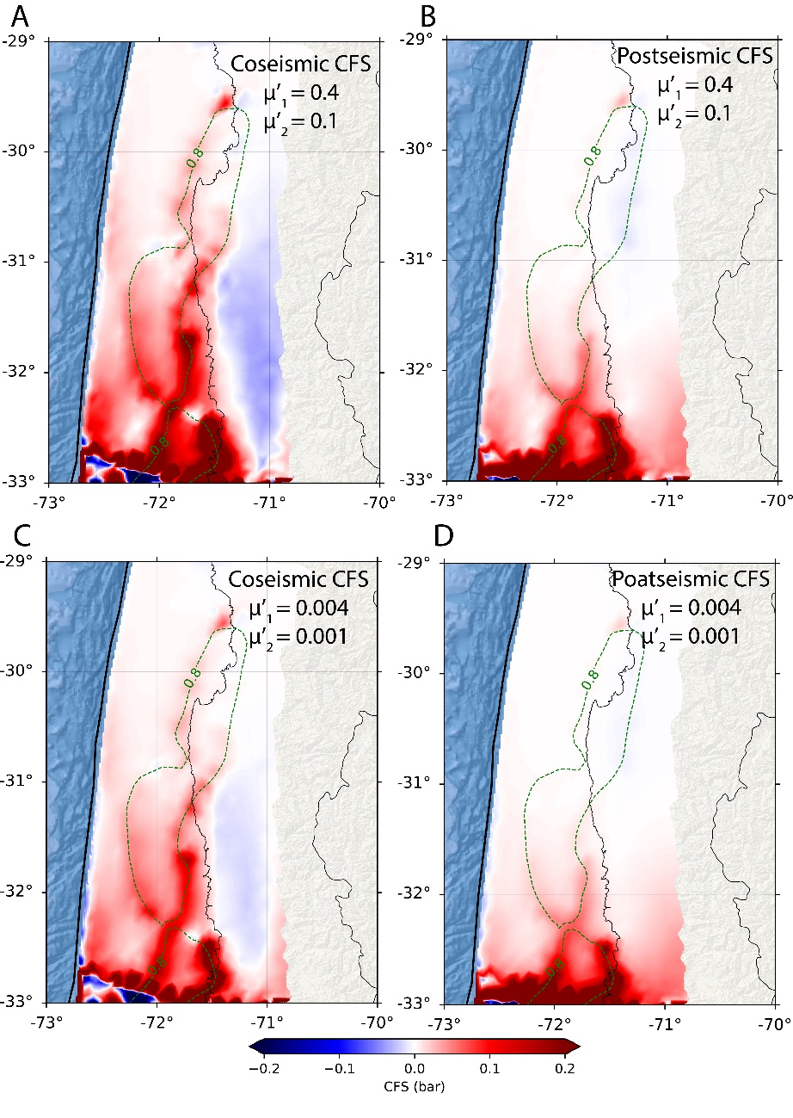

**Figure S1.** Impact of end-member values for the effective coefficient of friction µ’ on the CFS calculations on the fault interface for our preferred model. The values of µ’1 and µ’2 are assigned to regions of the fault interface where the locking coefficient is ≥ 0.8 and < 0.8, respectively.

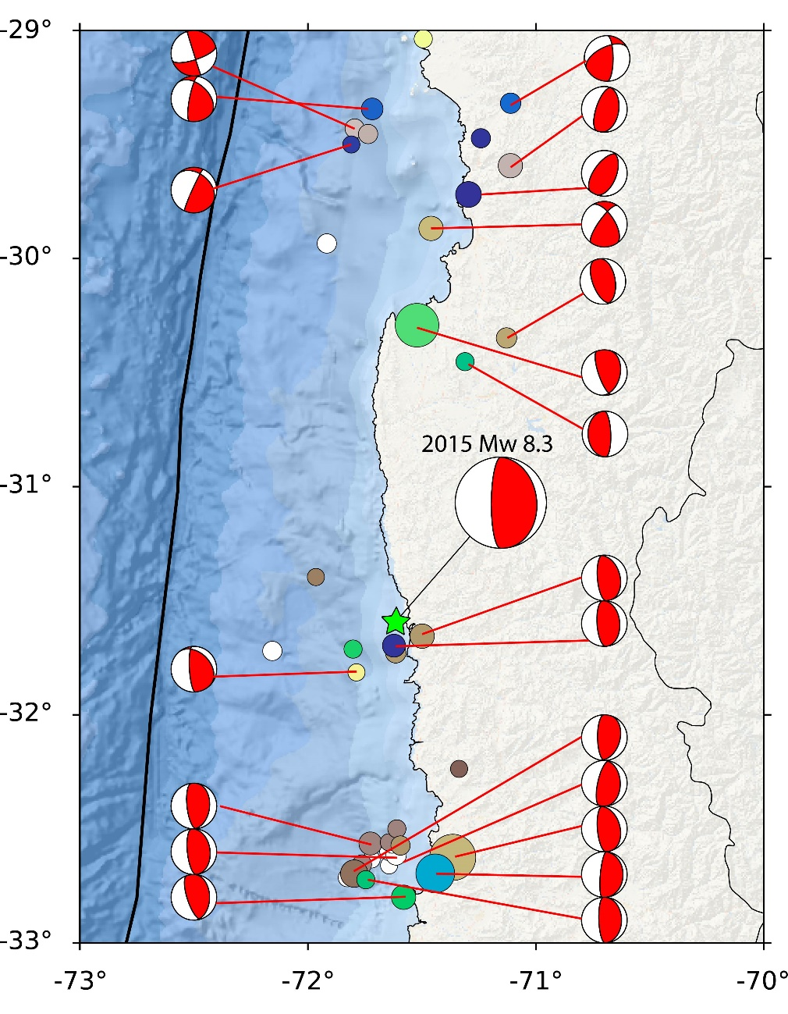

**Figure S2.** Available focal mechanisms from NEIC-USGS catalog for the seismicity between the 2010 Maule and 2015 Illapel events. Note that most of them share the same nodal plane as the 2015 Illapel main shock, particularly those in the southern region of the Illapel segment.

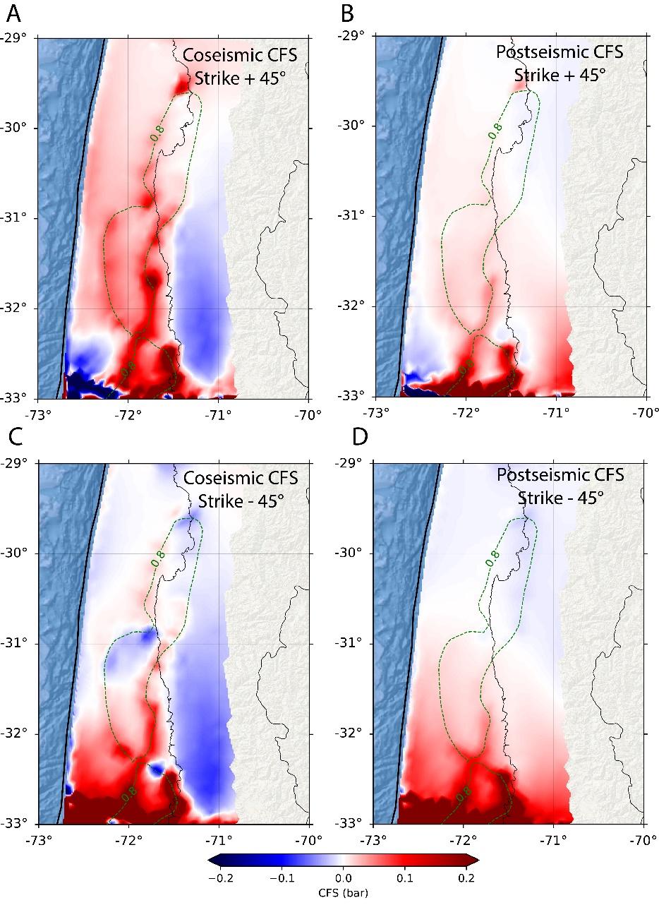

**Figure S3.** Impact of strike on CFS calculations. Dip and rake parameters remain identical as the ones of the Illapel main shock, i.e., a dip of 19° and a rake of 83°, while the strike varies ± 45° con respect to the one of the Illapel event (353°).

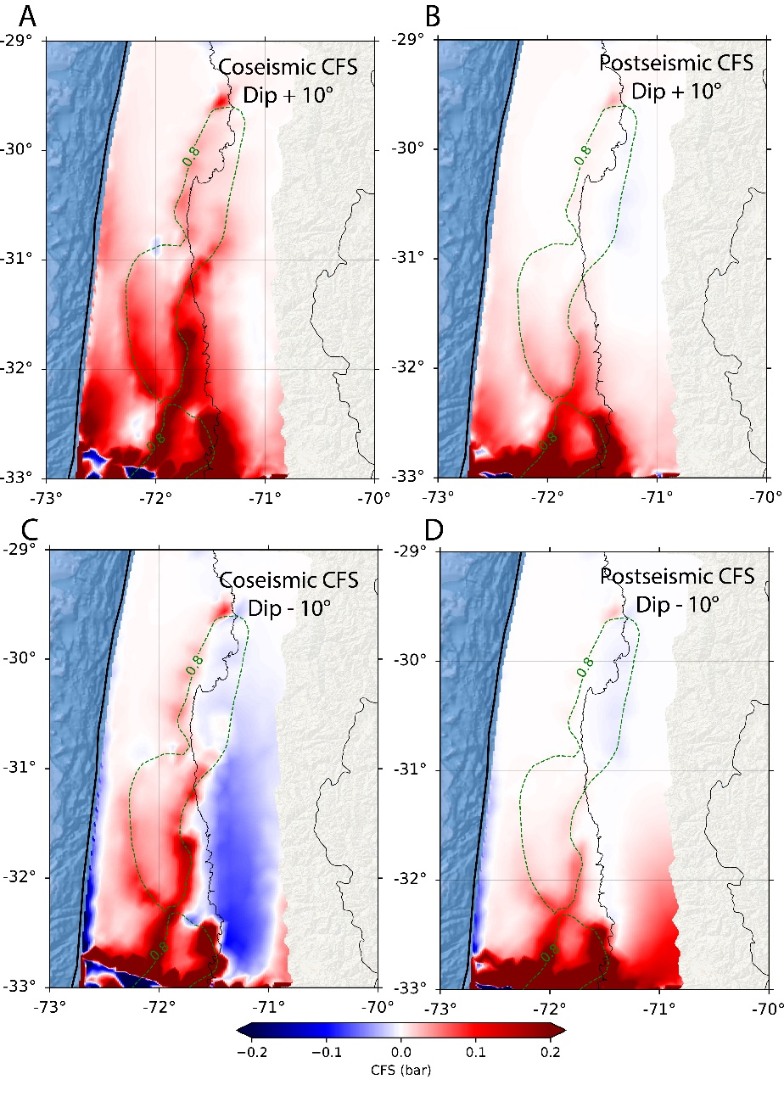

**Figure S4.** Impact of dip on CFS calculations. Strike and rake parameters remain identical as the ones of the Illapel main shock, i.e., a strike of 353° and a rake of 83°, while the dip varies ± 10° con respect to the one of the Illapel event (19°).

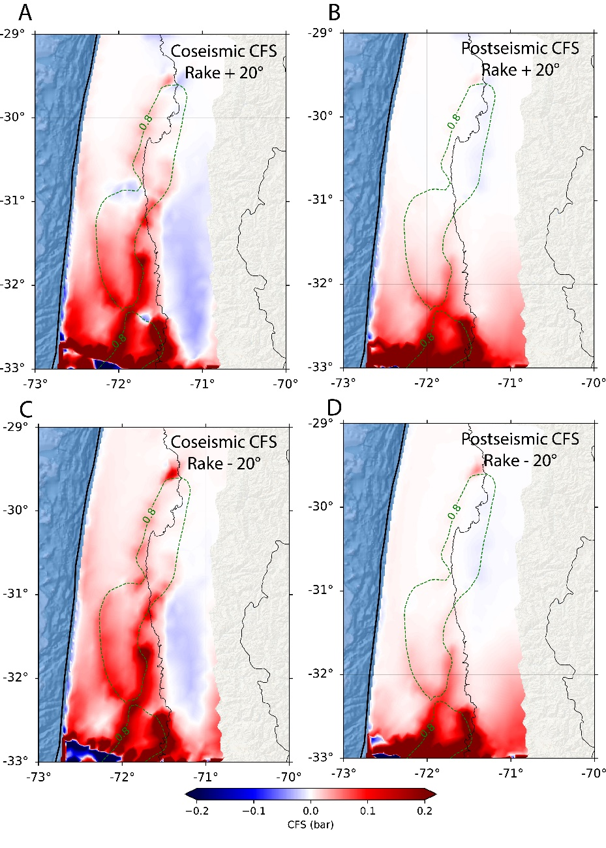

**Figure S5.** Impact of rake on CFS calculations. Strike and dip parameters remain identical as the ones of the Illapel main shock, i.e., a strike of 353° and a dip of 19°, while the rake varies ± 20° con respect to the one of the Illapel event (83°).

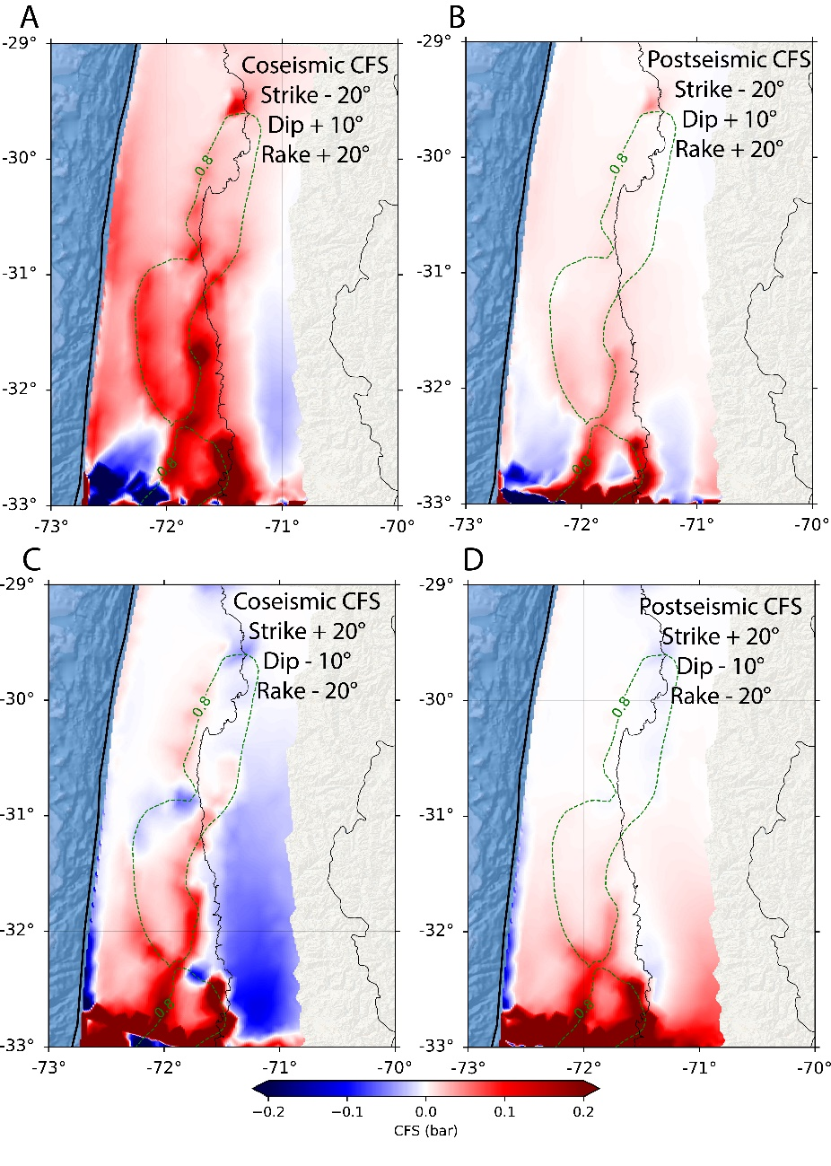

**Figure S6.** Impact of strike, dip, and rake on CFS calculations. Strike, dip, and rake vary ± 20°, ± 10°, and ± 20° con respect to the ones of the Illapel event.

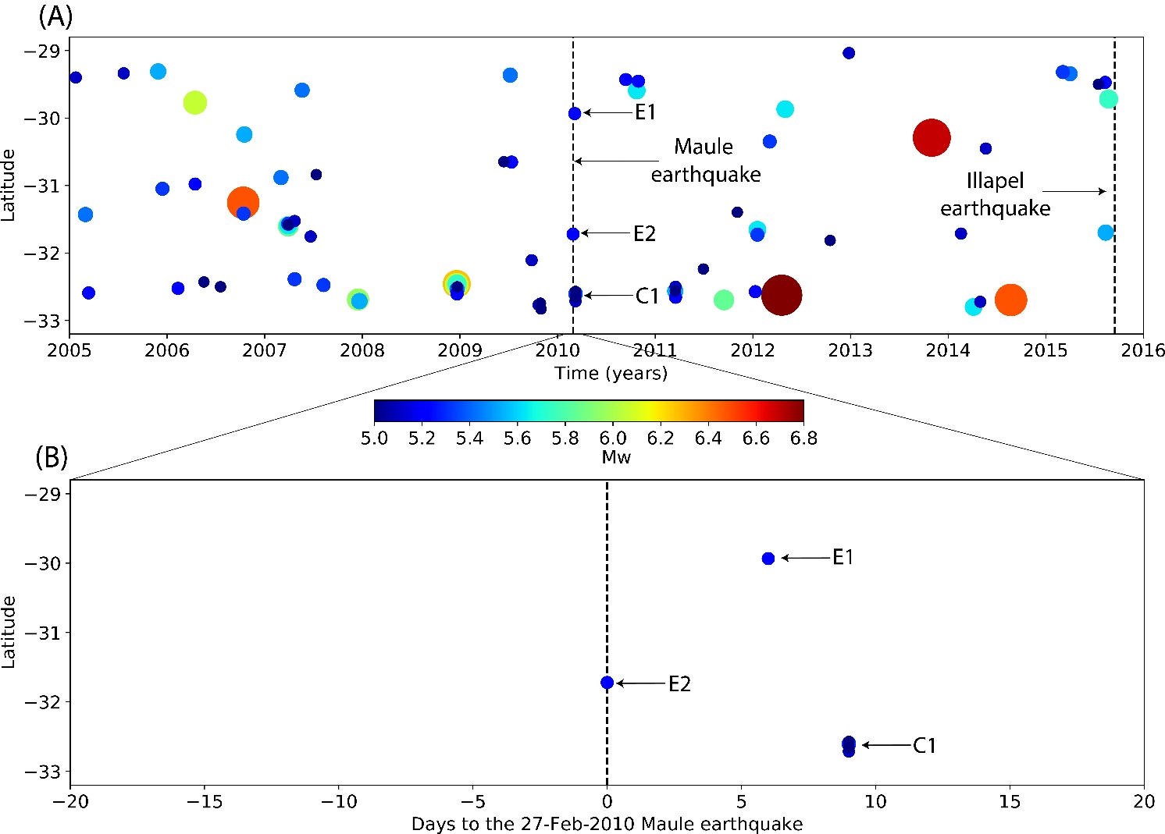

**Figure S7.** Seismicity over time in the Illapel segment between 2005 and 2016.

**References**

Christensen, N. (1996). Poisson´s ratio and crustal seismology. J. Geophys. Res., 101(B2), 3139 –3156. <https://doi.org/10.1029/95JB03446>

Hirth, G., and Kohlstedt, D. (2003). Rheology of the upper mantle and the mantle wedge: A view from the experimentalists. Inside the subduction Factory, 83-105. https://doi.org/10.1029/138GM06

Ranalli, G. (1997). Rheology and deep tectonics. Annali di Geofisica, XL (3), 671–780. <https://doi.org/10.4401/ag-3893>