Supplementary Material

# Supplementary Data

The datasets generated and analyzed for this study can be found at https://github.com/wyattmillion/Frontiers3Dmorphology.

## Supplementary Figures

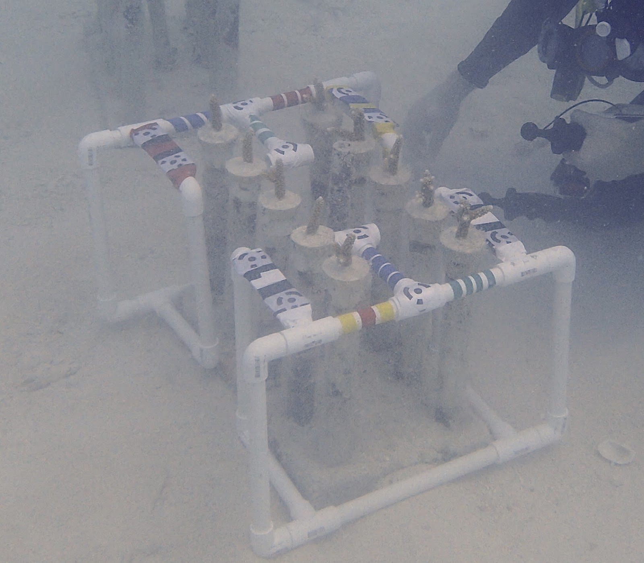

Figure S1: A group of ten coral fragments prepared for outplanting in the Mote Marine Laboratory *in situ* nursery. The entire array was photographed and 3D models were built to include all ten fragments in one model. A PVC frame was used to bring Agisoft Metashape markers in line with coral fragments.

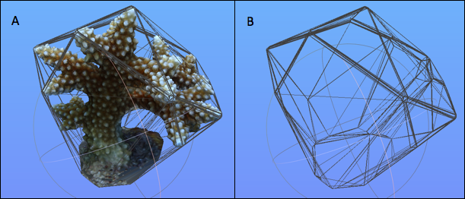

Figure S2: A) Convex hull (wire-like projection) overlaid over a coral model and B) convex hull alone with coral removed viewed in MeshLab.

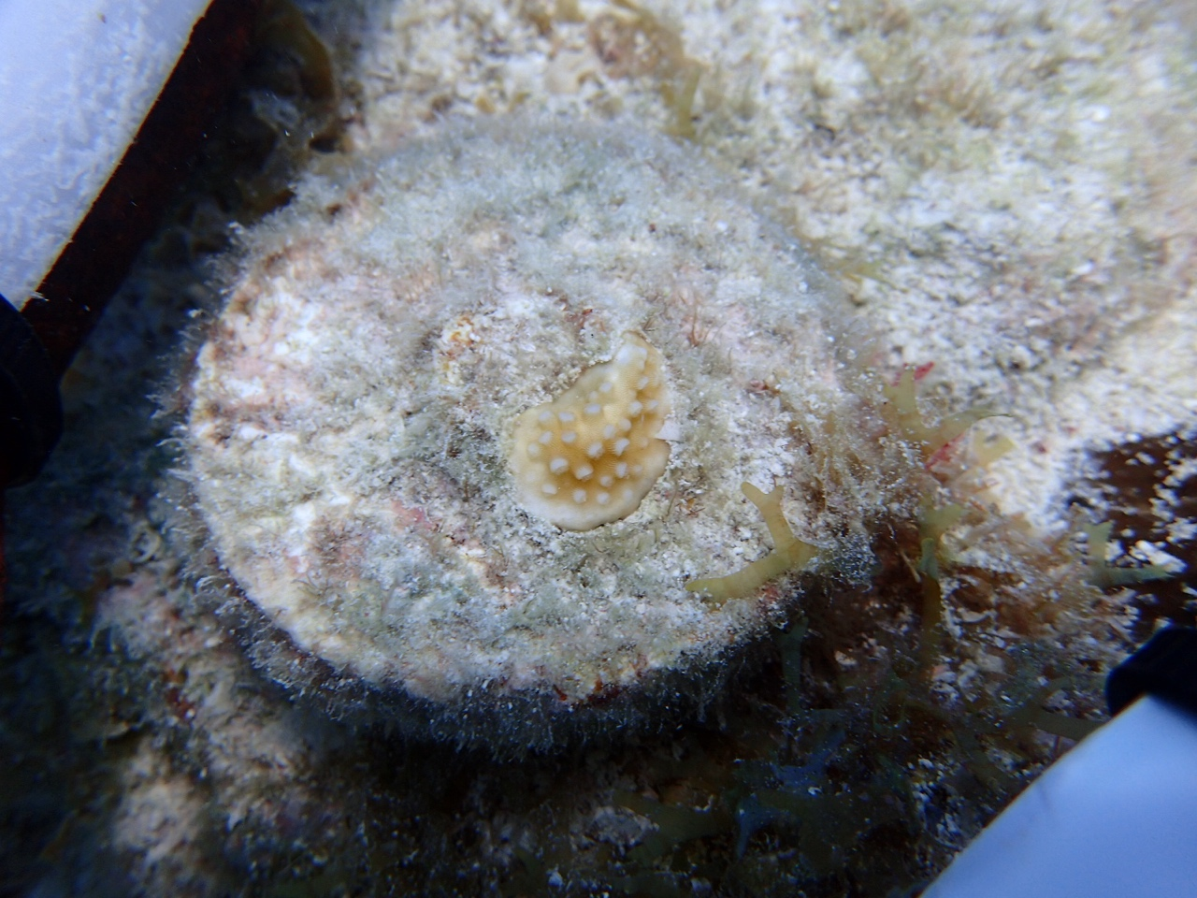

Figure S3. Example coral colony where breakage and partial mortality reduced the area of living tissue to less than 5 cm2. V and Vinter were assumed to be 0 because a lack of photographic coverage prevented model building and because of the limited living 3D structure present.

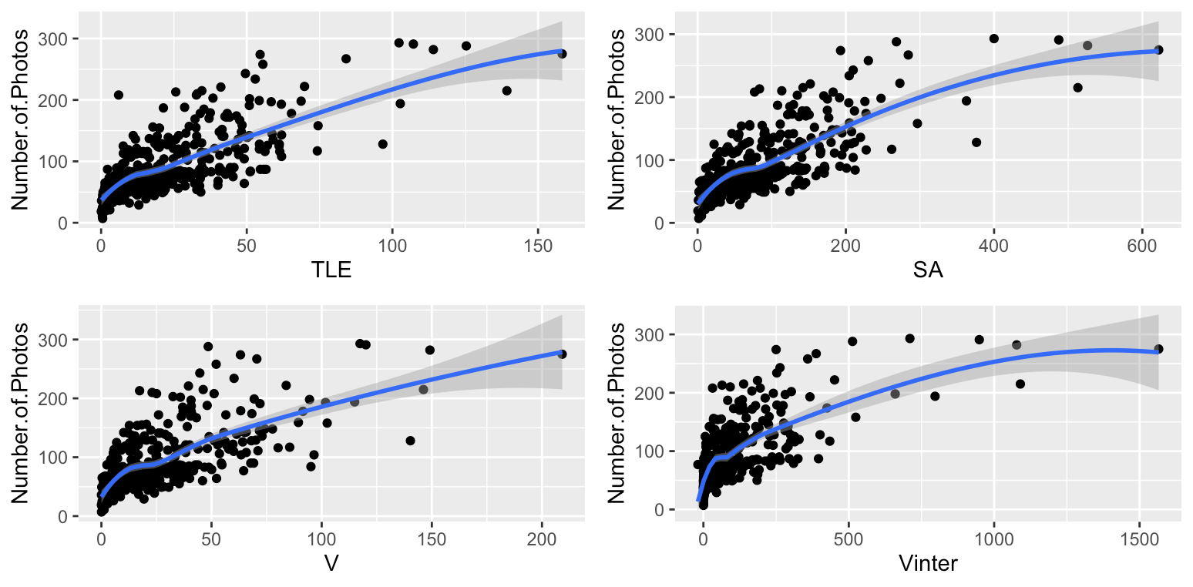

Figure S4. Relationship between the number of photos taken for each 3D model and the coral size measured in TLE (A), SA (B), V (C), Vinter (D). (n=427). Blue lines represent a moving local regression applied using method = loess in ggplot2. Shaded areas represent the 95% confidence intervals.

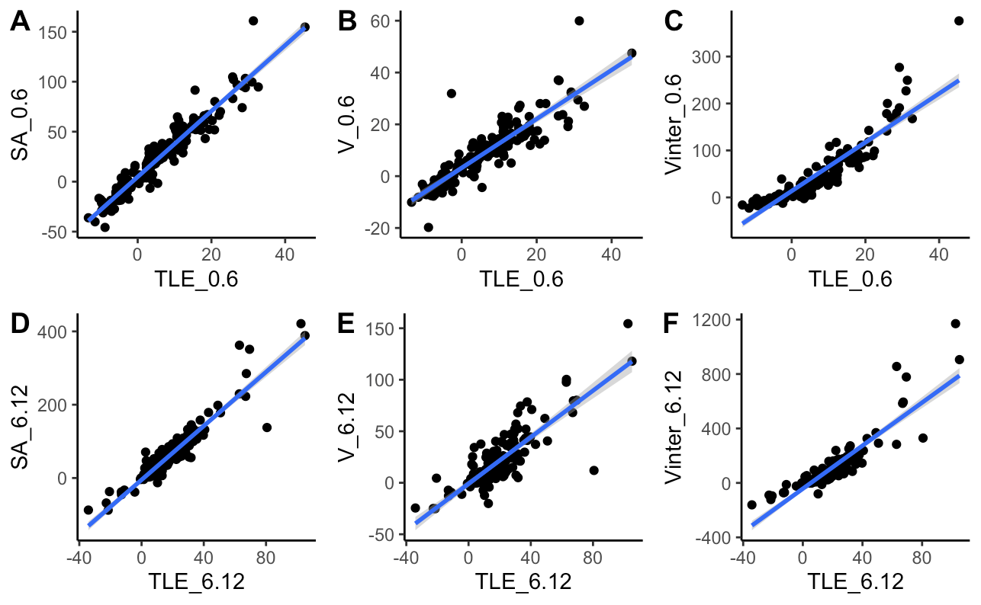

Figure S5. Scatter plots showing growth in TLE measured in centimeters compared to growth in SA in cm2 (A, D), V in cm3 (B, E), and Vinter in cm3 (C, F) within as single time point (0.6 = zero to 6 months; 6.12 = 6 to 12 months). Blue lines represent linear regressions over the relationship between trait growth to show nonlinear relationships. Shaded areas represent 95% confidence intervals.

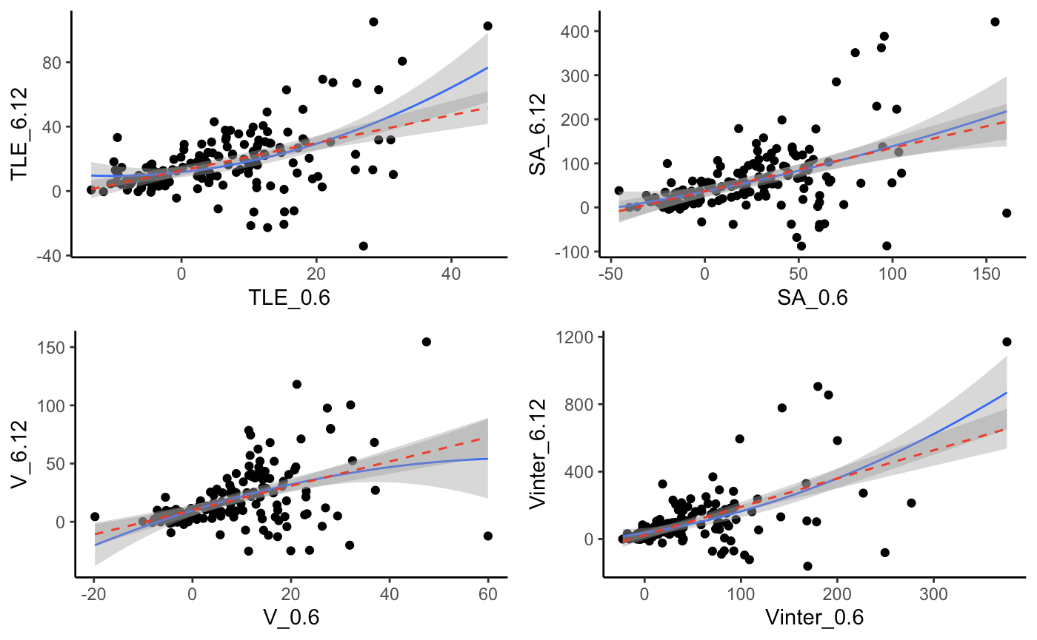

Figure S6. Second order polynomials (solid blue line) fit over the predictive relationship between initial and subsequent growth in TLE (A), SA (B), V (C), and Vinter (D) compared to the linear model (dashed red line).

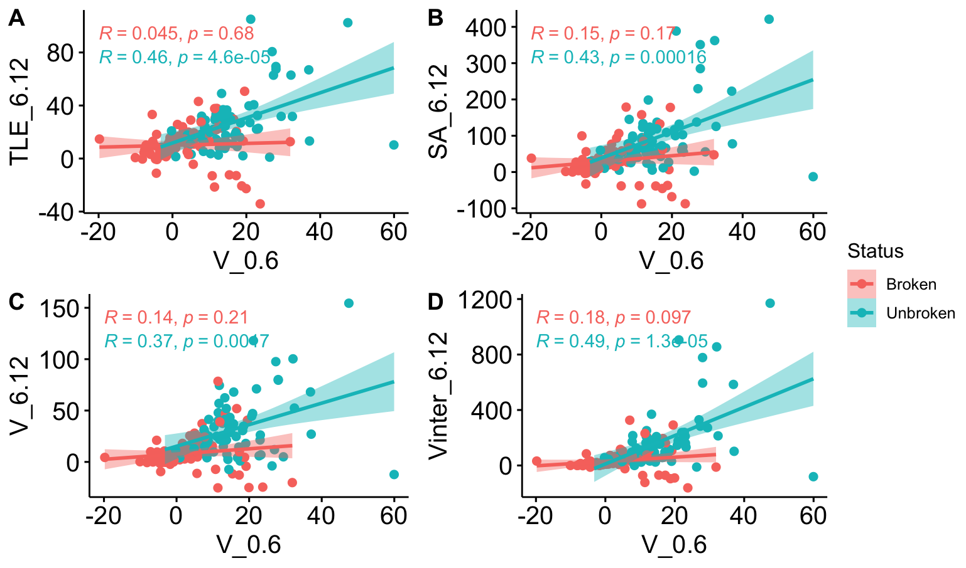

Figure S7. The relationship between initial growth in V compared to subsequent growth in TLE (A), SA (B), V (C), and Vinter (D). Regressions were fit by whether a coral was broken (pink) or not (turquoise). R values represent Kendall’s tau correlation coefficients and p values represents significance of each relationship.

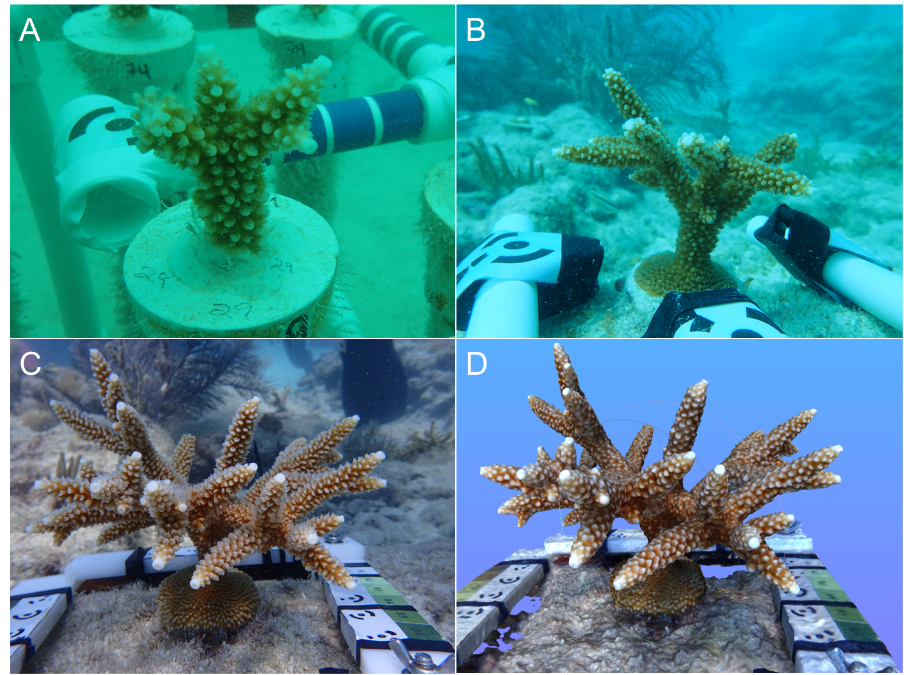

Figure S8. Photographs of colony EDR9 in immediately before outplanting (A) and 6 months (B) and 12 months (C) post-outplant and the 3D model of EDR9 after 12 months post-outplant viewed in MeshLab. This colony was identified as an outlier but was verified to be a result of biological variation instead of methodological error.

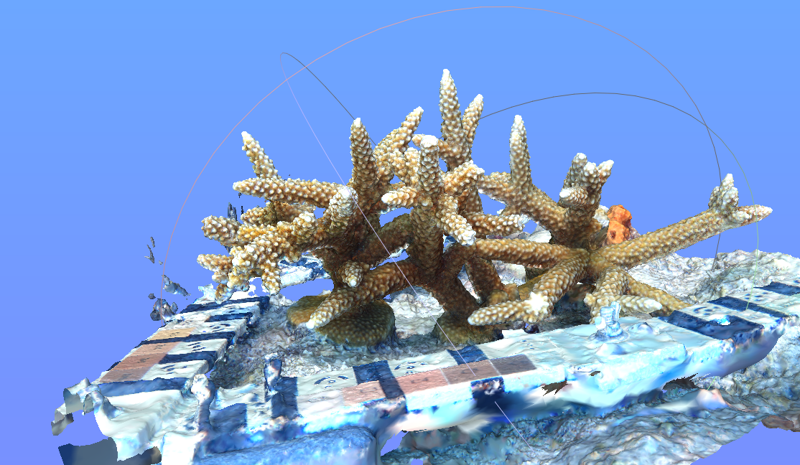

Figure S9: View of the 3D model in MeshLab made with 151,132 tie points and 5,337,592 faces from 293 photographs. This represents two colonies intertwined after an unknown colony (right) dislodged and landed next to a tagged individual used in the current study (left). The unknown colony was removed manually to leaving the focal colony able to be measured.