Table S2. Representative computed tomography (CT) scans of the thymus of each subtype of TET.
Patient ID | Histological Class | Masaoka Stage | TNM Stage | CT scan
P1 | A | I | T1N0M0, I | 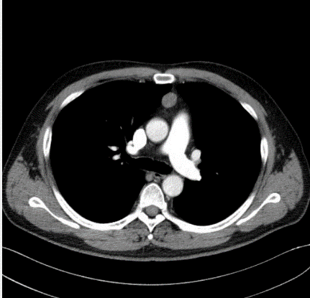
P3 | AB | I | T1N0M0, I | 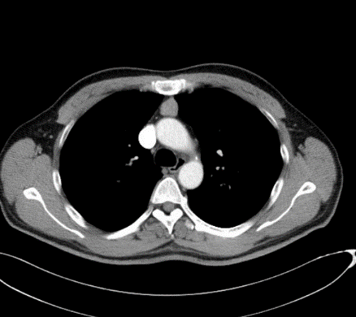
P9 | B1 | I | T1N0M0, I | 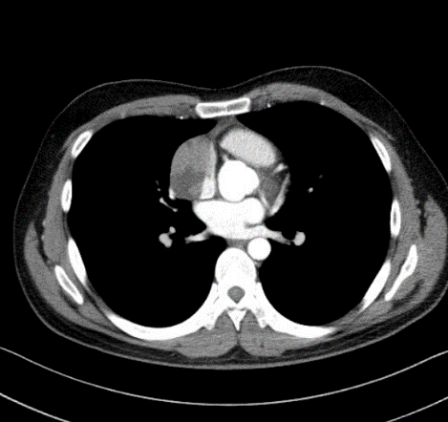
P18 | B2 | II | T2N0M0, II | 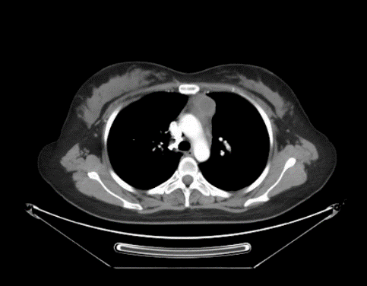
P20 | B3 | III | T3N0M0, IIIA | 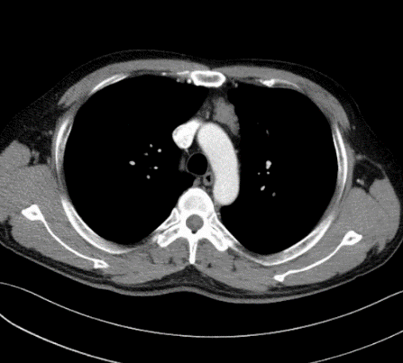
P27 | TC (squamous carcinoma) | III | T3N0M0, IIIA | 