*Supplement for,*

**Limited pairwise synergistic and antagonistic interactions impart stability to microbial communities**

**Page No.**

**S1. Fluctuation in population size.** 2

**S2. Growth rate calculations.** 4

**S3. A higher connectance and a higher fraction of synergistic interactions, both,**

**independently, facilitate coexistence.** 5

**S4. Cooperative interactions help the system retain diversity.** 6

**S5. Species description.** 7

**Supplement references.** 8

**S1. Fluctuation in population size.**

Population sizes in an ecological niche fluctuate. These fluctuations might be due to physical and chemical environmental cues, or due to biological interventions (like presence of a predator). We investigate to what extent does introduction of such a shock change and the subsequent recovery of the system once the shock is removed dictate the steady state of the system. To simulate this, we followed the approach as described below.

1. A population of a 3species with a fixed population size *N* with an interaction matrix **P** and a vector of innate growth rates **r** was chosen. The choice of **P** and **r** was such that the system was at a stable steady state at equilibrium. The steady state composition of the population is given by the vector **xss**.
2. At the steady state of the system, a shock was mimicked which affects the population of the three sizes quantitatively differently. The shock, overall, reduces the population by a factor of 1000. The populations of the three species decrease by a factor *K1*, *K2*, and *K3.* The composition of the population changes to vector **x**.
3. After the shock is removed, the system recovers to its carrying capacity. This dynamics is dictated by the following equations,
$$\frac{d N_{1}}{dt}= N_{1} \left(r_{1}+ P_{12 }N_{2}+P_{13 }N_{3}\right)(1- \frac{N_{1}+N_{2}+N_{3}}{K})$$

$$\frac{d N_{2}}{dt}= N_{2} \left(r_{2}+ P_{21 }N_{1}+P_{23 }N_{3}\right)(1- \frac{N_{1}+N_{2}+N_{3}}{K})$$

$$\frac{d N_{3}}{dt}= N_{3} \left(r_{3}+ P_{31 }N_{1}+P_{32 }N_{2}\right)(1- \frac{N_{1}+N_{2}+N_{3}}{K})$$

4. Upon the system reaching its steady state as described in the equations above, the further dynamics of the system is simulated via equation (4) in the main text.
5. Equation (4) is solved for steady state, and the composition of the population compared with that of the starting composition (as described by **xss** in (a)).

5000 systems of three-species, starting from their steady state, were simulated. In each simulation, the population shrunk by a factor of 1000, upon an environmental shock. Only systems which for a given **r** and **P** exhibited steady state. In each case, if the system is characterized as stable via the criteria described in Section 2.3 of the manuscript, the shock introduced in the simulation does not have any effect on the final composition of the population.

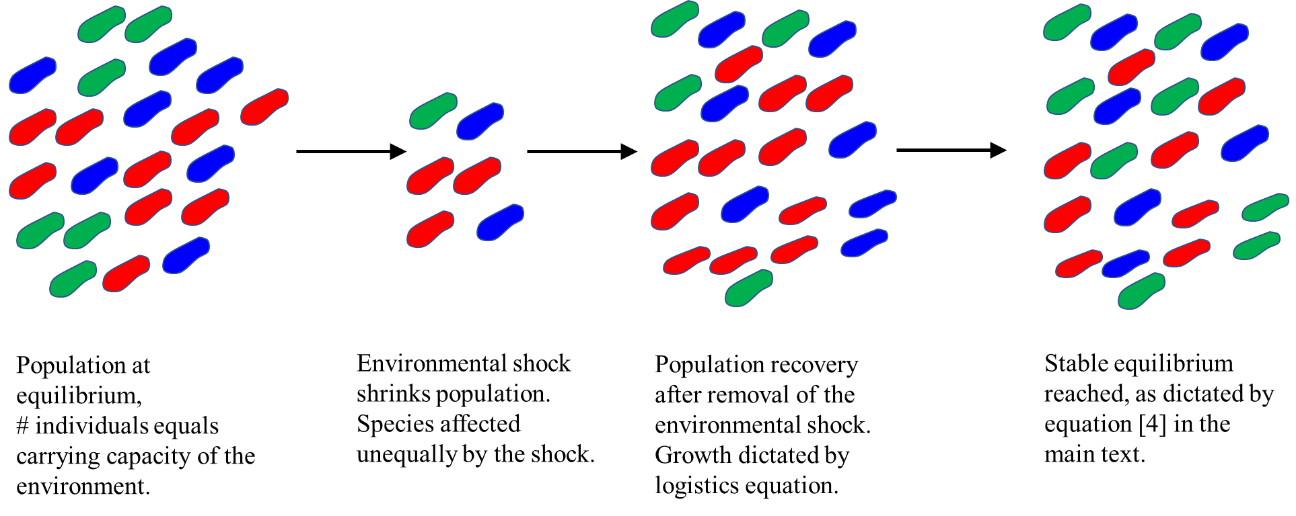

**S2. Growth rate calculations.**

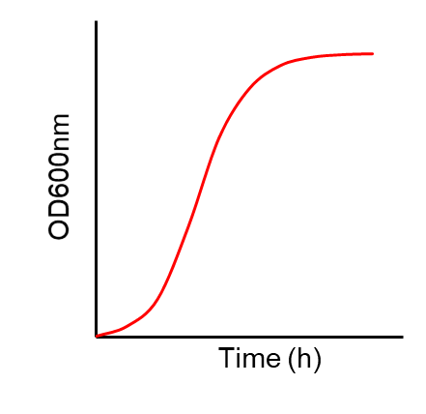

Two time points in the growth curve were noted (t1 and t2) and the corresponding absorbance at 600nm measured. The growth rate of a strain (*ri*) was then calculated as given in the following equation.

$$r_{i}= \frac{\log\left({OD}_{2}\right)-log⁡({OD}_{1})}{t_{2}- t_{1}}$$

**S3. A higher connectance and a higher fraction of synergistic interactions, both, independently, facilitate coexistence.**

**A. B.**

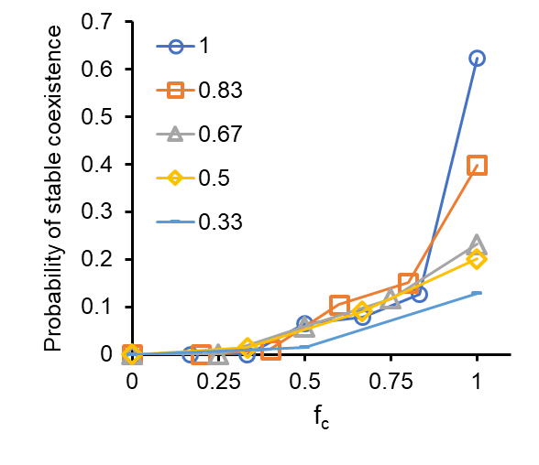 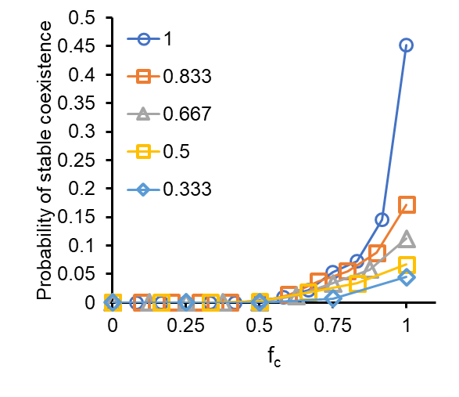

**C. D.**

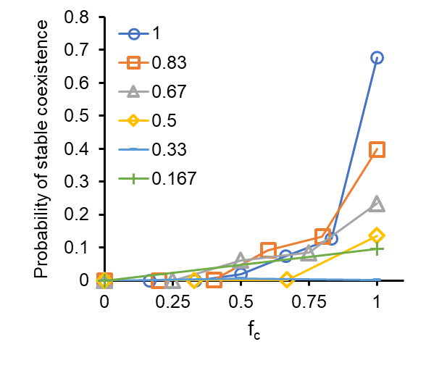 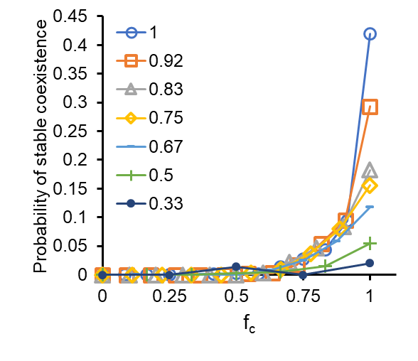

**E. F.**

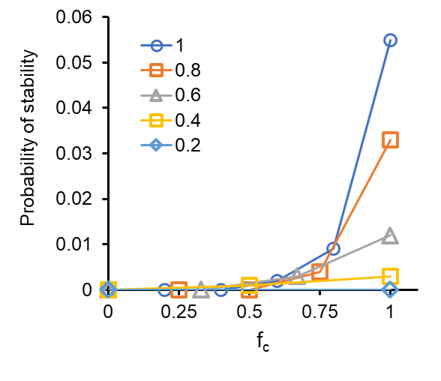 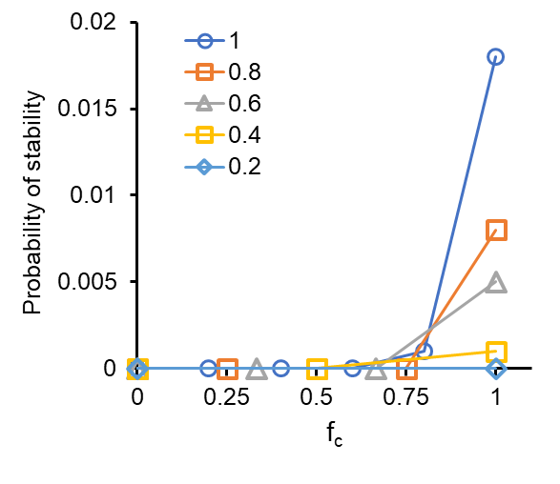

**A higher connectance and a higher fraction of synergistic interactions, both, independently, facilitate coexistence.** In the replicator formulation, three- (**A**) and four-species (**B**) systems exhibit greater likelihood of coexistence as the number of interactions which are positive increases. In the Lotka-Volterra formulation, three- **(C) and four-species (D)** systems exhibit greater likelihood of coexistence as the number of interactions which are positive increases. The strength of interactions in the randomized networks is chosen from a uniform distribution. The legend describes the value of *c* for each set of simulations. **(E** and **F**) Probability of stable solution for communities of size *N* equal to 5 (E) and 6 (F). In these simulations, interaction strengths are sampled from an exponential distribution. The likelihood of stable solution increases as *fc* and *c* increase.

**S4. Cooperative interactions help the system retain diversity.**

**A. B.**

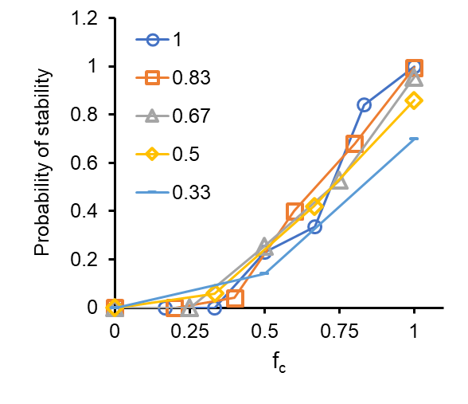 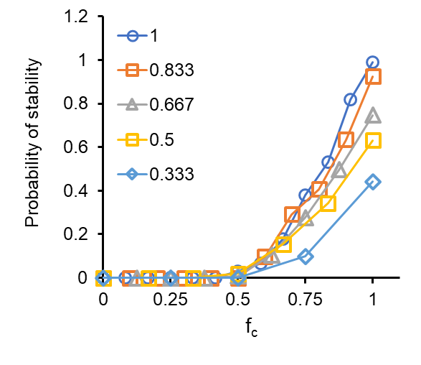

**C. D.**

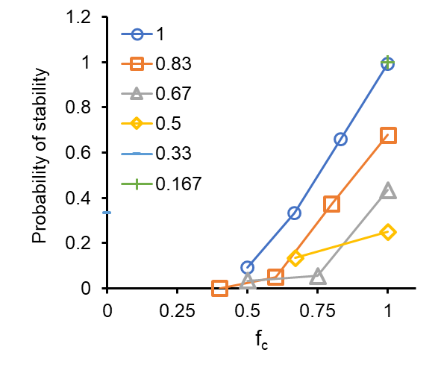 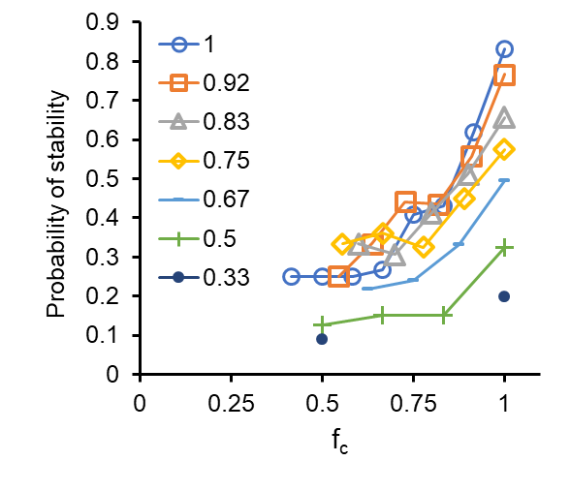

**Cooperative interactions help the system retain diversity.** Upon removal of a species from an *N-*sized network, the remaining *N*-1 species are allowed to reach the new equilibrium. If the new steady state comprises of all *N*-1 species, the system is classified as stable. (**A**) three-species network, and (**B**) four-species network when analysed in a replicator equation framework. (**C**) three-species network, and (**D**) four-species network when analysed in a Lotka-Volterra framework. All interactions are sampled from a uniform distribution. The data represents data from 1000simulations of randomized *P* matrices for each pair of *c* and *fc.* The legend describes the value of *c* for each set of simulations.

**S5. Species description.**

*Bacillus megaterium* is a gram-positive, spore-forming, neutralophilic bacterium found in soil, seawater, rice paddies, dried food, honey, and milk. It can utilize a wide variety of carbon sources and grow at a temperature range of 3 to 45°C (Vary et al., 2007). It is largest of all bacilli (~1.5 by 4 μm; 5300 genes in a 5.1-Mbp genome), and, is used as a production strain and expression host(Vary, 1994). Due to its large size it is well studied for research on cell morphology, sporulation, cellular organization, DNA partitioning, and protein localization etc (Foerster and Foster, 1966;Christie et al., 2010). Unlike the most popular Gram-negative bacteria *E. coli*, *B. megaterium* does not produce endotoxins and hence is widely used for pharmaceutical productions such as penicillin acylase and vitamin B12 (Vary, 1994;Panbangred et al., 2000;Vary et al., 2007). *B. megaterium* has a G+C content of 38 to 39% and is distantly related to the *B. cereus* and *B. subtilis* groups(Porwal et al., 2009). *Bacillus firmus* produces endospore under adverse conditions. It is extremely alkaliphilic bacteria that grows as well at pH 10.5 as at pH 7.5 on malate containing medium(Guffanti and Hicks, 1991;Sturr et al., 1994). They are mainly present in soil and provide protection against plant-parasitic nematodes(Ioannis O.Giannakoua, 2004). It has a genome size of 4.9 Mbp and the G+C content is 41.70%(Ce Geng, 2014;Susic et al., 2020). *Bacillus haikouensis*, on the other hand, is an endospore-forming facultative anaerobic and halotolerant bacterium. It grows optimally at 37°C and pH 7.0 in the presence of 4% NaCl (w/v). The G+C content of the species is 45.4% and a size of 4.68Mbp(Jibing Li, 2014).

**Supplement References.**

Ce Geng, Z.T., Donghai Peng, Zongze Shao, Lei Zhu, Jinshui Zheng, Huan Wang, Lifang Ruan, Mingsun (2014). Draft genome sequence of Bacillus firmus DS1. *Journal of Biotechnology* 177**,** 20-21.

Christie, G., Gotzke, H., and Lowe, C.R. (2010). Identification of a receptor subunit and putative ligand-binding residues involved in the Bacillus megaterium QM B1551 spore germination response to glucose. *J Bacteriol* 192**,** 4317-4326.

Foerster, H.F., and Foster, J.W. (1966). Response of Bacillus spores to combinations of germinative compounds. *J Bacteriol* 91**,** 1168-1177.

Guffanti, A.A., and Hicks, D.B. (1991). Molar growth yields and bioenergetic parameters of extremely alkaliphilic Bacillus species in batch cultures, and growth in a chemostat at pH 10.5. *J Gen Microbiol* 137**,** 2375-2379.

Ioannis O.Giannakoua, D.G.K., Demetra Prophetou-Athanasiadou (2004). A novel non-chemical nematicide for the control of root-knot nematodes. *Applied Soil Ecology* 26**,** 69-79.

Jibing Li, G.Y., Qin Lu, Yong Zhao, Shungui Zhou (2014). Bacillus haikouensis sp. nov., a facultatively anaerobic halotolerant bacterium isolated from a paddy soil. *Antonie van Leeuwenhoek* 106**,** 789-794.

Panbangred, W., Weeradechapon, K., Udomvaraphant, S., Fujiyama, K., and Meevootisom, V. (2000). High expression of the penicillin G acylase gene (pac) from Bacillus megaterium UN1 in its own pac minus mutant. *J Appl Microbiol* 89**,** 152-157.

Porwal, S., Lal, S., Cheema, S., and Kalia, V.C. (2009). Phylogeny in aid of the present and novel microbial lineages: diversity in Bacillus. *PLoS One* 4**,** e4438.

Sturr, M.G., Guffanti, A.A., and Krulwich, T.A. (1994). Growth and bioenergetics of alkaliphilic Bacillus firmus OF4 in continuous culture at high pH. *J Bacteriol* 176**,** 3111-3116.

Susic, N., Janezic, S., Rupnik, M., and Stare, B.G. (2020). Whole Genome Sequencing and Comparative Genomics of Two Nematicidal Bacillus Strains Reveals a Wide Range of Possible Virulence Factors. *G3 (Bethesda)* 10**,** 881-890.

Vary, P.S. (1994). Prime time for Bacillus megaterium. *Microbiology (Reading)* 140 ( Pt 5)**,** 1001-1013.

Vary, P.S., Biedendieck, R., Fuerch, T., Meinhardt, F., Rohde, M., Deckwer, W.D., and Jahn, D. (2007). Bacillus megaterium--from simple soil bacterium to industrial protein production host. *Appl Microbiol Biotechnol* 76**,** 957-967.